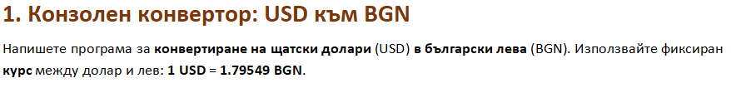

using System;

public class Program

{

public static void Main()

{

double usd = double.Parse(Console.ReadLine());

double bgn = usd \* 1.79549;

Console.WriteLine(bgn);

}

}

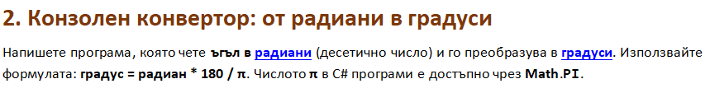

using System;

public class Program

{

public static void Main()

{

double radians = double.Parse(Console.ReadLine());

double degrees = radians\*180/Math.PI;

Console.WriteLine(degrees);

}

}

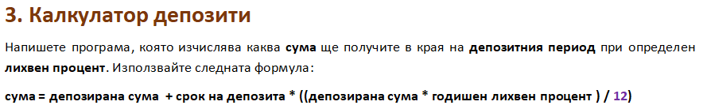

using System;

public class Program

{

public static void Main()

{

double deposit = double.Parse(Console.ReadLine());

int months = int.Parse(Console.ReadLine());

double percentage = double.Parse(Console.ReadLine());

double finalPrice = (double)(deposit + months \* ((deposit \* (percentage)/100) / 12));

Console.WriteLine(finalPrice);

}

}

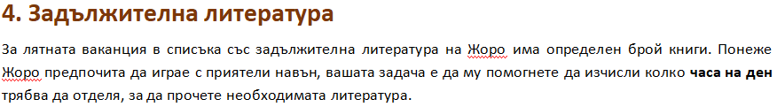

using System;

public class Program

{

public static void Main()

{

int pages = int.Parse(Console.ReadLine());

int pagesPerMinute = int.Parse(Console.ReadLine());

int days = int.Parse(Console.ReadLine());

int hoursPerDay = (pages / pagesPerMinute) / days;

Console.WriteLine(hoursPerDay);

}

}

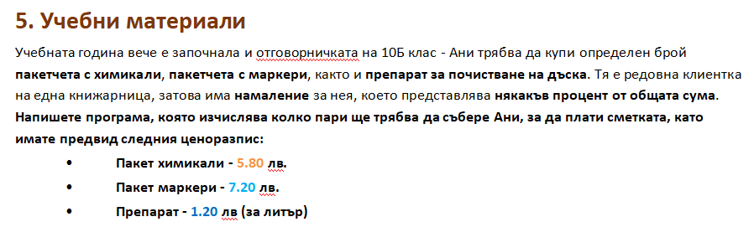

using System;

public class Program

{

public static void Main()

{

int pages = int.Parse(Console.ReadLine());

int pagesPerMinute = int.Parse(Console.ReadLine());

int days = int.Parse(Console.ReadLine());

int hoursPerDay = (pages / pagesPerMinute) / days;

Console.WriteLine(hoursPerDay);

}

}

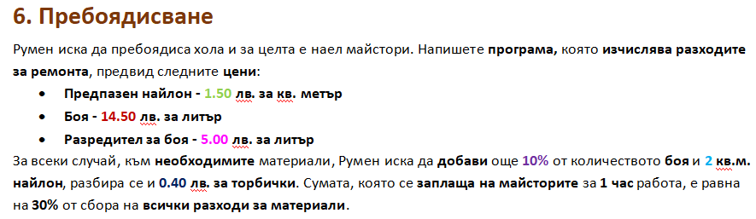

using System;

public class Program

{

public static void Main()

{

int nylon = int.Parse(Console.ReadLine());

int paint = int.Parse(Console.ReadLine());

int thinner = int.Parse(Console.ReadLine());

int hours = int.Parse(Console.ReadLine());

double allNylon = (nylon + 2) \* 1.5;

double allPaint = (paint + 0.1\*paint) \* 14.5;

double allThinner = (thinner \* 5);

double beforePrice = ((nylon + 2) \* 1.5) + ((paint + 0.1\*paint) \* 14.5) + (thinner \* 5) + 0.4;

double peoplePrice = (beforePrice \* 0.3) \* hours ;

Console.WriteLine(peoplePrice + beforePrice);

}

}

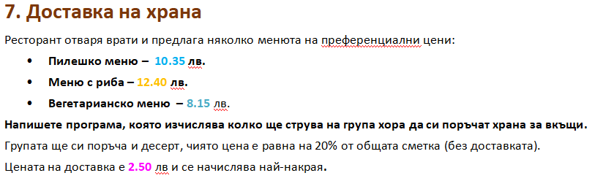

using System;

public class Program

{

public static void Main()

{

int chicken = int.Parse(Console.ReadLine());

int fish = int.Parse(Console.ReadLine());

int veggies = int.Parse(Console.ReadLine());

double foodPrice = (chicken \* 10.35) + (fish \* 12.4) + (veggies \* 8.15) ;

double wholePrice = foodPrice + (foodPrice \* 0.2) + 2.5 ;

Console.WriteLine(wholePrice);

}

}

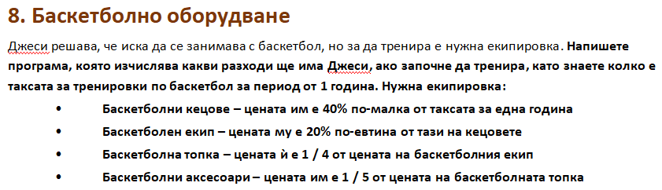

using System;

public class Program

{

public static void Main()

{

int yearlyPayment = int.Parse(Console.ReadLine());

double shoes = yearlyPayment - (yearlyPayment\*0.4);

double clothes = shoes - (shoes\*0.2);

double ball = clothes / 4;

double accesories = ball / 5;

Console.WriteLine(yearlyPayment + shoes + clothes + ball + accesories );

}

}

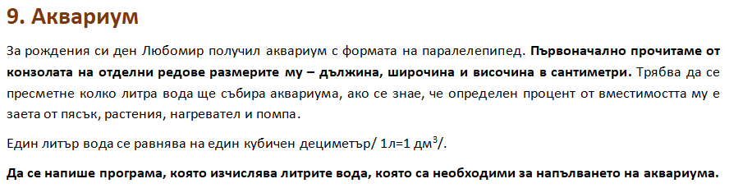

using System;

public class Program

{

public static void Main()

{

int lenght = int.Parse(Console.ReadLine());

int width = int.Parse(Console.ReadLine());

int height = int.Parse(Console.ReadLine());

double percentage = double.Parse(Console.ReadLine());

double volume = (lenght \* width \* height) \* 0.001;

double water = volume \* (1 - (percentage/100)) ;

Console.WriteLine( water );

}

}