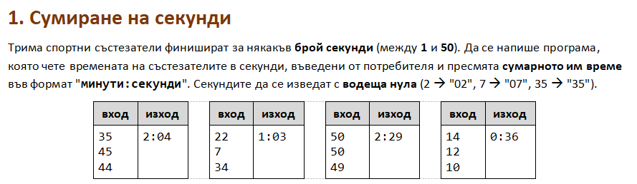

using System;

public class Program

{

public static void Main()

{

int first = int.Parse(Console.ReadLine());

int second = int.Parse(Console.ReadLine());

int third = int.Parse(Console.ReadLine());

int total = first + second + third;

int minutes = total / 60;

int seconds = total % 60;

if (seconds < 10){

Console.WriteLine( $"{minutes}:0{seconds}" );

}else{

Console.WriteLine( $"{minutes}:{seconds}" );

}

}

}

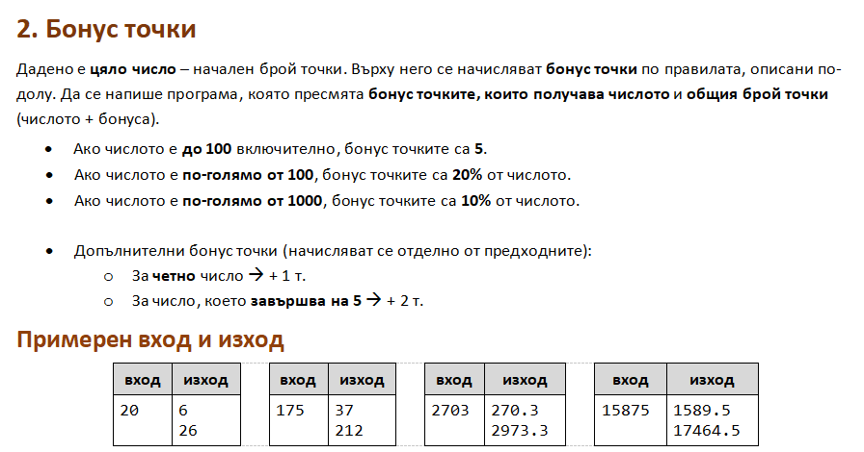

using System;

public class Program

{

public static void Main()

{

int number = int.Parse(Console.ReadLine());

double bonus = 0;

if (number <= 100){

bonus = 5;

}else if (number > 1000){

bonus = number \* 0.1;

}

else{

bonus = number \* 0.2;

}

if((number % 2) == 0){

bonus = bonus + 1;

}

if ((number % 10) == 5){

bonus = bonus + 2;

}

Console.WriteLine(bonus);

Console.WriteLine(bonus + number);

}

}

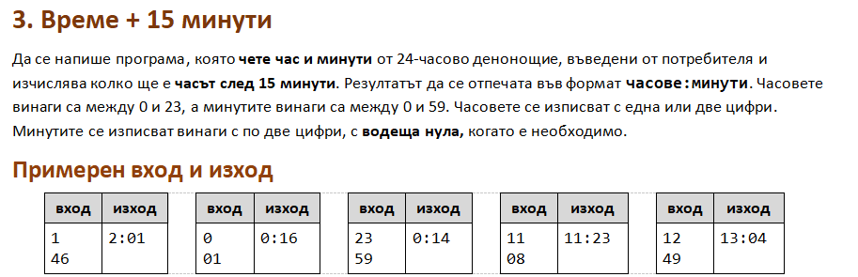

using System;

public class Program

{

public static void Main()

{

int hour = int.Parse(Console.ReadLine());

int minutes = int.Parse(Console.ReadLine());

int newHour = 0;

int newMinutes = 0;

if (minutes < 45){

newMinutes = minutes + 15;

newHour = hour;

Console.WriteLine(newHour + ":" + newMinutes);

}

else if (minutes >= 45 && minutes <= 59) {

newMinutes = minutes + 15 - 60;

newHour = hour + 1;

if (newHour > 23){

newHour = 0;

}

if (newMinutes < 10) {

Console.WriteLine(newHour + ":0" + newMinutes);

}else{

Console.WriteLine(newHour + ":" + newMinutes);

}

}

}

}

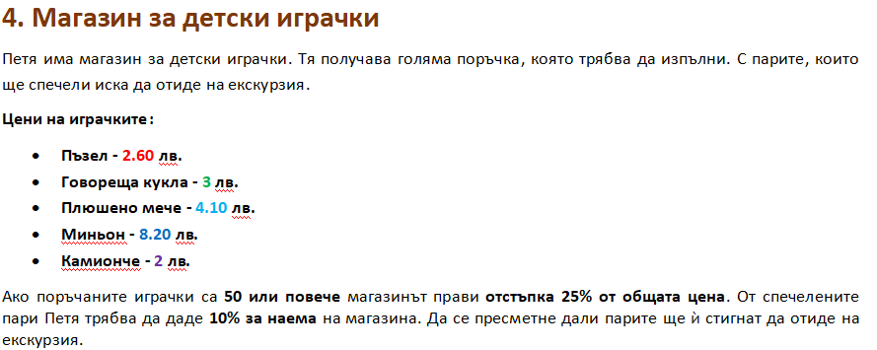

using System;

public class Program

{

public static void Main()

{

double vacationPrice = double.Parse(Console.ReadLine());

int puzzles = int.Parse(Console.ReadLine());

int dolls = int.Parse(Console.ReadLine());

int bears = int.Parse(Console.ReadLine());

int minions = int.Parse(Console.ReadLine());

int trucks = int.Parse(Console.ReadLine());

int allToys = puzzles + dolls + bears + minions + trucks;

double price = (puzzles \* 2.6) + (dolls \* 3) + (bears \* 4.1) + (minions \* 8.2) + (trucks \* 2);

double total = 0;

double rent = 0;

if (allToys >= 50) {

total = price - (price \* 0.25);

} else {

total = price;

}

rent = total \* 0.1;

double profit = total - rent;

if (profit >= vacationPrice){

Console.WriteLine($"Yes! {(profit - vacationPrice):F2} lv left.");

}else {

Console.WriteLine($"Not enough money! {(vacationPrice - profit):F2} lv needed.");

}

}

}

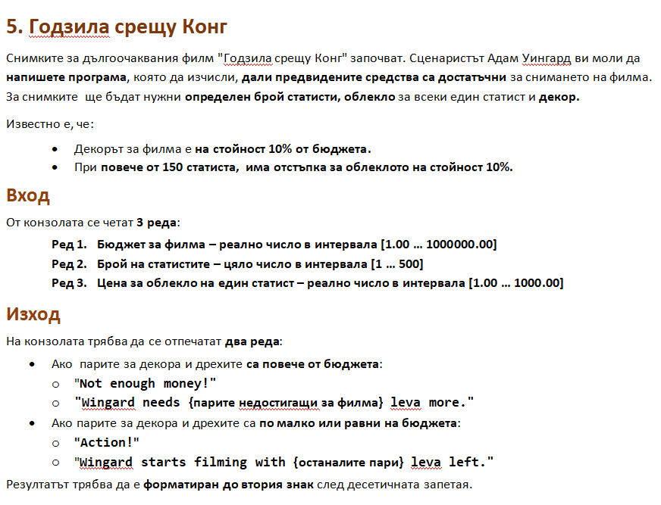

using System;

public class Program

{

public static void Main()

{

double budget = double.Parse(Console.ReadLine());

int actors = int.Parse(Console.ReadLine());

double clothes = double.Parse(Console.ReadLine());

double decorPrice = budget \* 0.1;

double clothesPrice = actors \* clothes;

if (actors > 150) {

clothesPrice = clothesPrice - (clothesPrice \* 0.1);

}

double total = decorPrice + clothesPrice;

if (total <= budget) {

Console.WriteLine("Action!");

Console.WriteLine ($"Wingard starts filming with {(budget - total):F2} leva left.");

}else {

Console.WriteLine("Not enough money!");

Console.WriteLine ($"Wingard needs {(total - budget):F2} leva more.");

}

}

}

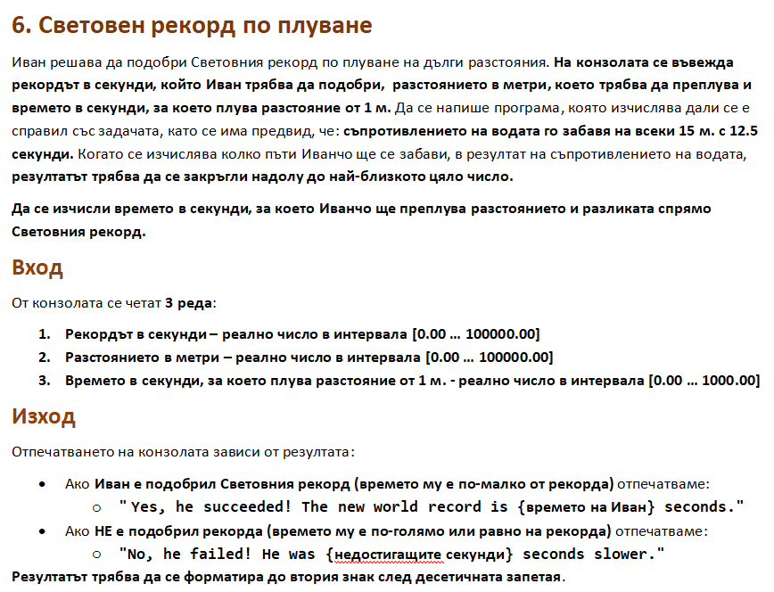

using System;

public class Program

{

public static void Main()

{

double worldRecordSeconds = double.Parse(Console.ReadLine());

double distance = double.Parse(Console.ReadLine());

double timePerMeter = double.Parse(Console.ReadLine());

double totalTime = (distance \* timePerMeter) + ((Math.Floor(distance/15)) \* 12.5);

if (totalTime > worldRecordSeconds) {

Console.WriteLine($"No, he failed! He was {(totalTime - worldRecordSeconds):F2} seconds slower.");

} else {

Console.WriteLine($"Yes, he succeeded! The new world record is {(totalTime):F2} seconds.");

}

}

}

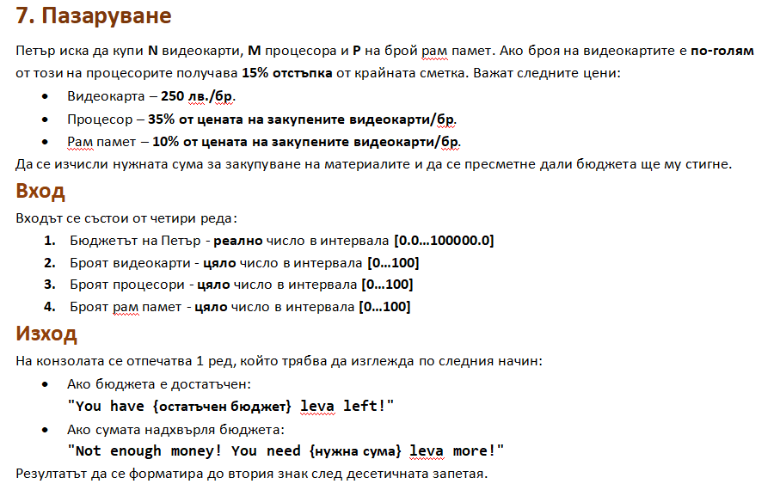

using System;

public class Program

{

public static void Main()

{

double budget = double.Parse(Console.ReadLine());

int videoCards = int.Parse(Console.ReadLine());

int processors = int.Parse(Console.ReadLine());

int ram = int.Parse(Console.ReadLine());

double priceVideo = videoCards \* 250;

double priceProcessor = processors \* priceVideo \* 0.35;

double priceRam = ram \* priceVideo \* 0.1;

double total = priceVideo + priceProcessor + priceRam;

if (videoCards > processors){

total = total - (total\*0.15);

}

if (total <= budget){

Console.WriteLine($"You have {(budget - total):F2} leva left!");

} else {

Console.WriteLine($"Not enough money! You need {(total - budget):F2} leva more!");

}

}

}

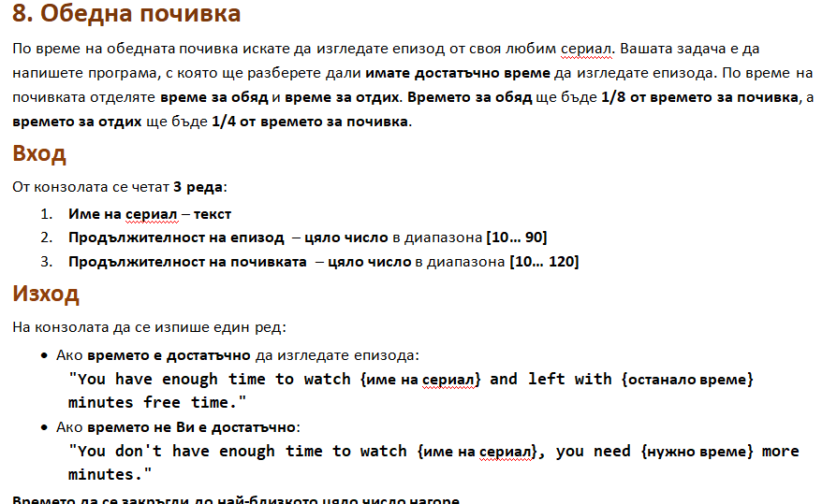

using System;

public class Program

{

public static void Main()

{

string movieName = Console.ReadLine();

int movieDuration = int.Parse(Console.ReadLine());

int lunchBreak = int.Parse(Console.ReadLine());

double eatingTime = lunchBreak / 8;

double relaxTime = lunchBreak / 4;

double timeLeft = lunchBreak - eatingTime - relaxTime;

if (timeLeft >= movieDuration){

Console.WriteLine($"You have enough time to watch {movieName} and left with {(Math.Ceiling(timeLeft) - movieDuration)} minutes free time.");

} else {

Console.WriteLine($"You don't have enough time to watch {movieName}, you need {(movieDuration + 1 - Math.Ceiling(timeLeft))} more minutes.");

}

}

}