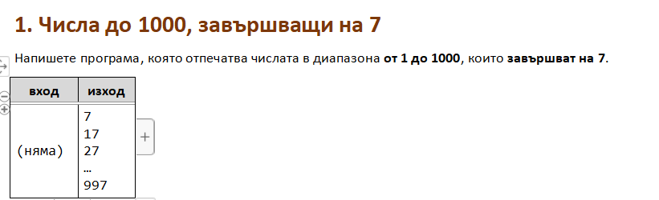

using System;

public class Program

{

public static void Main()

{

for (int i = 1; i <= 1000 ; i++){

if (i % 10 == 7){

Console.WriteLine(i);

}

}

}

}

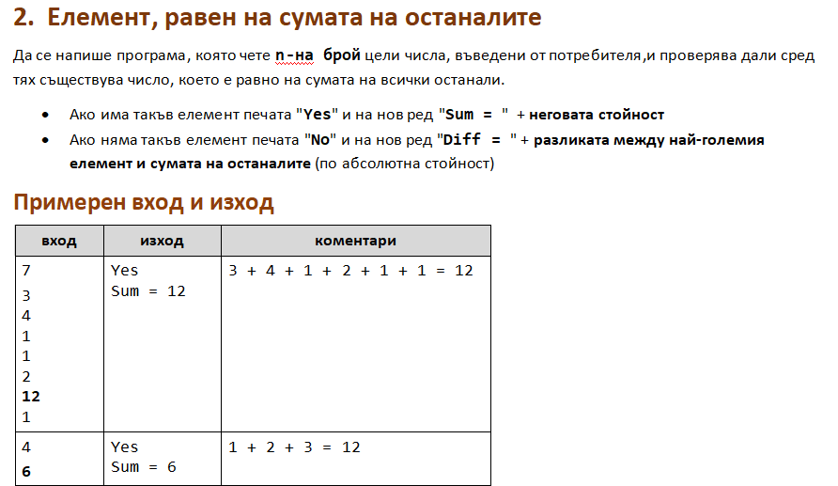

using System;

public class Program

{

public static void Main()

{

int n = int.Parse(Console.ReadLine());

int sum = 0;

int max = int.MinValue;

for (int i = 0; i < n ; i++){

int num = int.Parse(Console.ReadLine());

sum += num;

if (num > max){

max = num;

}

}

int sumNums = sum - max;

if (max == sumNums){

Console.WriteLine("Yes");

Console.WriteLine("Sum = " + max);

} else {

int diff = Math.Abs(max - sumNums);

Console.WriteLine("No");

Console.WriteLine("Diff = " + diff);

}

}

}

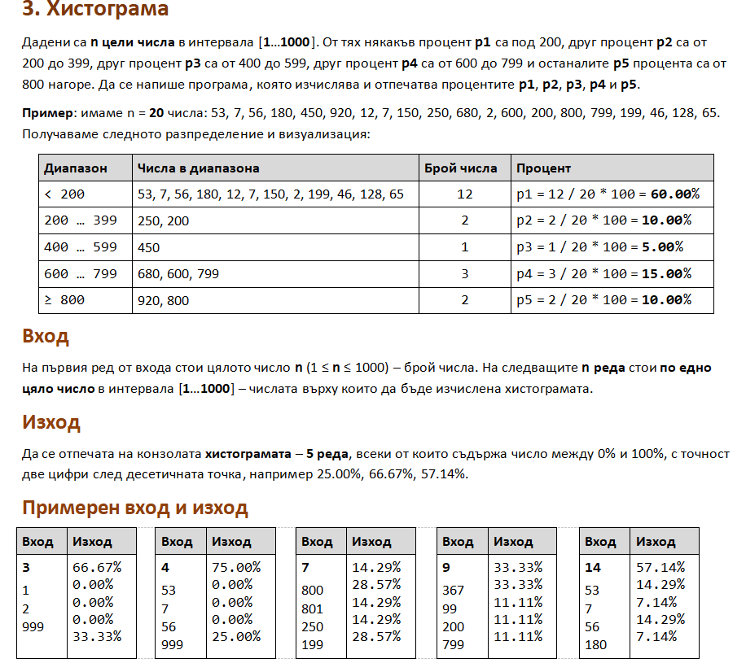

using System;

public class Program

{

public static void Main()

{

int n = int.Parse(Console.ReadLine());

int p1nums = 0;

int p2nums = 0;

int p3nums = 0;

int p4nums = 0;

int p5nums = 0;

for (int i = 0; i < n ; i++){

int num = int.Parse(Console.ReadLine());

if(num < 200){

p1nums ++;

}else if (num >= 200 && num <= 399){

p2nums ++;

}else if (num >= 400 && num <= 599){

p3nums ++;

}

else if (num >= 600 && num <= 799){

p4nums ++;

}else if (num >= 800){

p5nums ++;

}

}

double p1 = ((double)p1nums / n) \* 100;

double p2 = ((double)p2nums / n) \* 100;

double p3 = ((double)p3nums / n) \* 100;

double p4 = ((double)p4nums / n) \* 100;

double p5 = ((double)p5nums / n) \* 100;

Console.WriteLine($"{(p1):F2}%");

Console.WriteLine($"{(p2):F2}%");

Console.WriteLine($"{(p3):F2}%");

Console.WriteLine($"{(p4):F2}%");

Console.WriteLine($"{(p5):F2}%");

}

}

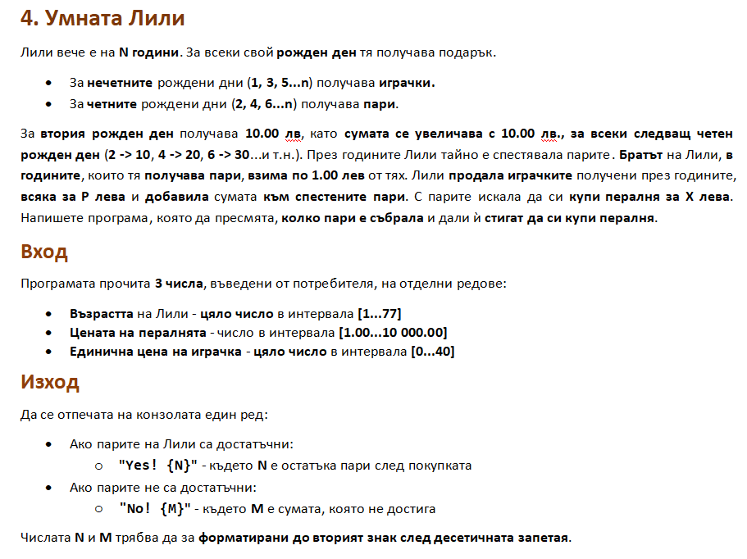

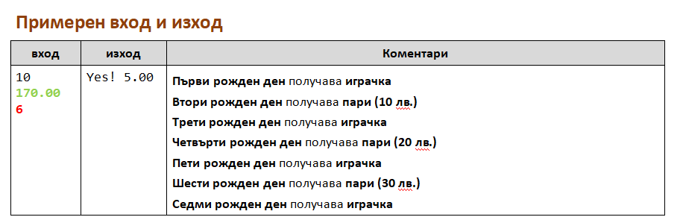

using System;

public class Program

{

public static void Main()

{

int age = int.Parse(Console.ReadLine());

double washMashine = double.Parse(Console.ReadLine());

int toySinglePrice = int.Parse(Console.ReadLine());

double piggyBank = 0;

double cashGift = 10;

int toysNum = 0;

for (int birthday = 1; birthday <= age; birthday++){

if (birthday % 2 == 0){

piggyBank += cashGift;

piggyBank--;

cashGift += 10;

}else {

toysNum ++;

}

}

int totalFromToys = toysNum \* toySinglePrice;

double totalForMashine = totalFromToys + piggyBank;

if (totalForMashine >= washMashine){

double change = totalForMashine - washMashine;

Console.WriteLine($"Yes! {change:f2}");

} else {

double insufficient = washMashine - totalForMashine;

Console.WriteLine($"No! {insufficient:f2}");

}

}

}

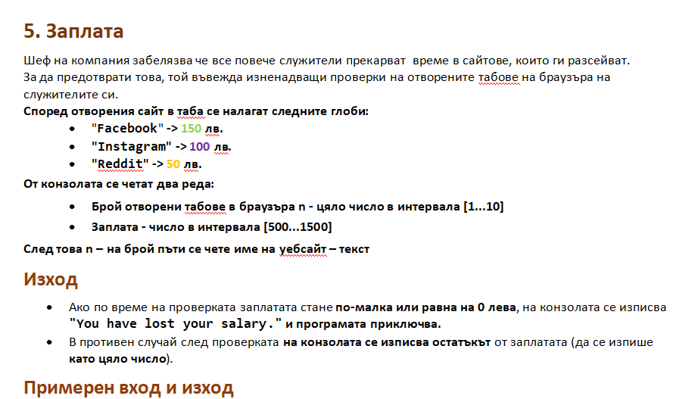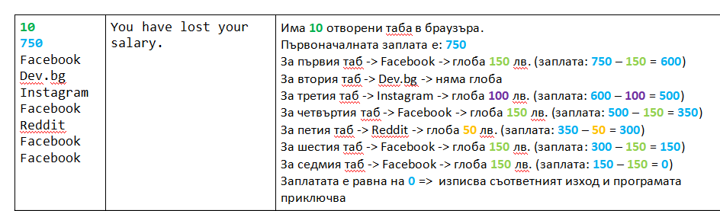

using System;

public class Program

{

public static void Main()

{

int openTabsNum = int.Parse(Console.ReadLine());

int salary = int.Parse(Console.ReadLine());

for (int i = 1; i <= openTabsNum; i++)

{

string websiteName = Console.ReadLine();

switch (websiteName){

case "Facebook":

salary -= 150;

break;

case "Instagram":

salary -= 100;

break;

case "Reddit":

salary -= 50;

break;

}

if (salary <= 0){

break;

}

}

if (salary <= 0){

Console.WriteLine("You have lost your salary.");

} else {

Console.WriteLine($"{salary}");

}

}

}

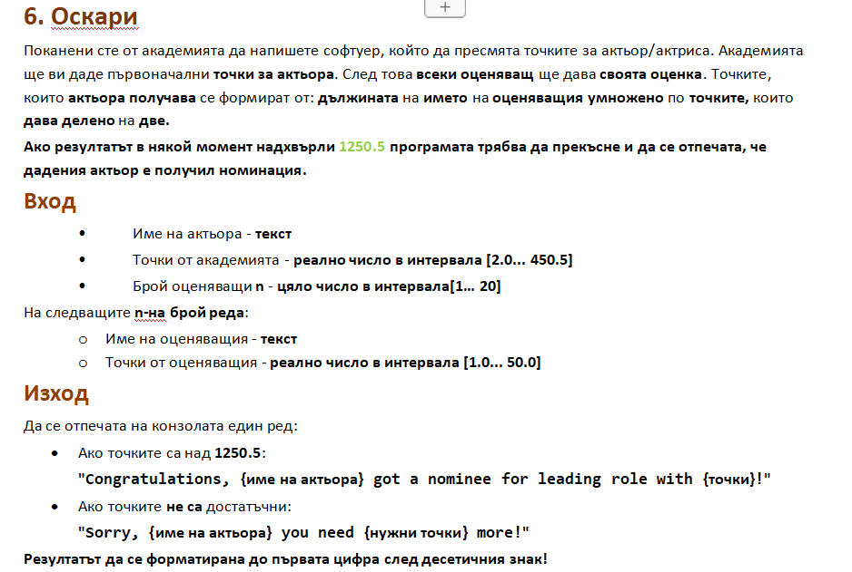

using System;

public class Program

{

public static void Main()

{

string actorName = Console.ReadLine();

double lastYearsPoints = double.Parse(Console.ReadLine());

int juryMembersNum = int.Parse(Console.ReadLine());

double finalPoints = lastYearsPoints;

for(int i=1; i<=juryMembersNum; i++){

string juryMemName = Console.ReadLine();

double points = double.Parse(Console.ReadLine());

double totalMemberPoints = juryMemName.Length \* points /2;

finalPoints += totalMemberPoints;

if (finalPoints > 1250.5){

break;

}

}

if (finalPoints > 1250.5){

Console.WriteLine($"Congratulations, {actorName} got a nominee for leading role with {finalPoints:f1}!");

} else{

double insufficient = 1250.5 - finalPoints;

Console.WriteLine($"Sorry, {actorName} you need {insufficient:f1} more!");

}

}

}

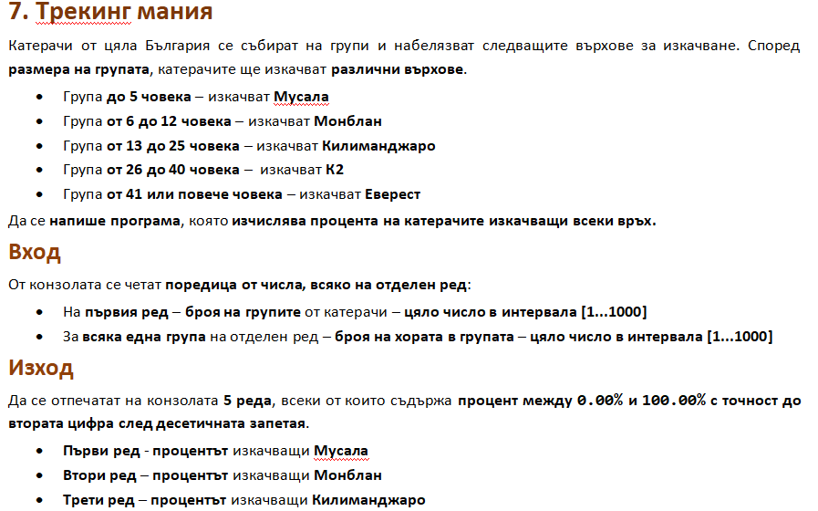

using System;

public class Program

{

public static void Main()

{

int groupsNum = int.Parse(Console.ReadLine());

int goingToMusala = 0;

int goingToMontblanc = 0;

int goingToKilimandjaro = 0;

int goingToK2 = 0;

int goingToEverest = 0;

int allPeople = 0;

for (int i = 1; i <= groupsNum; i++){

int peopleInGroupNum = int.Parse(Console.ReadLine());

allPeople += peopleInGroupNum;

if (peopleInGroupNum >= 1 && peopleInGroupNum <= 5){

goingToMusala += peopleInGroupNum;

} else if (peopleInGroupNum >= 6 && peopleInGroupNum <= 12){

goingToMontblanc += peopleInGroupNum;

} else if (peopleInGroupNum >= 13 && peopleInGroupNum <= 25){

goingToKilimandjaro += peopleInGroupNum;

} else if (peopleInGroupNum >= 26 && peopleInGroupNum <= 40){

goingToK2 += peopleInGroupNum;

} else if (peopleInGroupNum >= 41 && peopleInGroupNum <= 1000){

goingToEverest += peopleInGroupNum;

}

}

double percentageMusala = (goingToMusala / (allPeople \* 1.0)) \* 100.00;

Console.WriteLine($"{percentageMusala:f2}%");

double percentageMontblank = (goingToMontblanc / (allPeople \* 1.0)) \* 100.00;

Console.WriteLine($"{percentageMontblank:f2}%");

double percentageKilimandjaro = (goingToKilimandjaro / (allPeople \* 1.0)) \* 100.00;

Console.WriteLine($"{percentageKilimandjaro:f2}%");

double percentageK = (goingToK2 / (allPeople \* 1.0)) \* 100.00;

Console.WriteLine($"{percentageK:f2}%");

double percentageEverest = (goingToEverest / (allPeople \* 1.0)) \* 100.00;

Console.WriteLine($"{percentageEverest:f2}%");

}

}

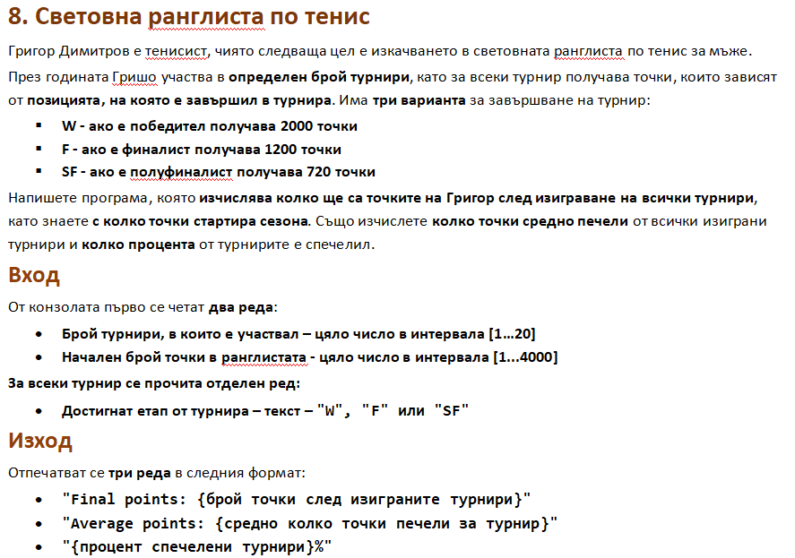

using System;

public class Program

{

public static void Main()

{

int tournamentsNum = int.Parse(Console.ReadLine());

int initianlPoints = int.Parse(Console.ReadLine());

int thisYearsPoints = 0;

int winsCounter = 0;

for (int i = 1; i <= tournamentsNum; i++){

string position = Console.ReadLine();

switch(position){

case "W":

thisYearsPoints += 2000;

winsCounter ++;

break;

case "F":

thisYearsPoints += 1200;

break;

case "SF":

thisYearsPoints += 720;

break;

}

}

int finalPoints = initianlPoints + thisYearsPoints;

Console.WriteLine($"Final points: {finalPoints}");

double average = Math.Floor(thisYearsPoints / (tournamentsNum \* 1.0));

Console.WriteLine($"Average points: {average}");

double percentage = (winsCounter / (tournamentsNum \* 1.0)) \* 100.00;

Console.WriteLine($"{percentage:f2}%");

}

}