How to use git the right way in a team

# Git Workflow:

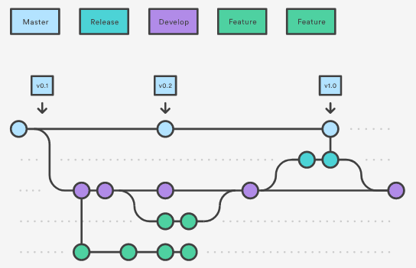

# Links for research:

<https://www.atlassian.com/git/tutorials/comparing-workflows/gitflow-workflow>

# Starting a project:

1. Create repository (Github etc.) and clone it on the pc
2. E.g. add a README.md file and use it for the initial commit
3. Create a develop(er) branch
4. Add files to the develop branch and generate a pull request with the team.
5. Merge the branch back to the master