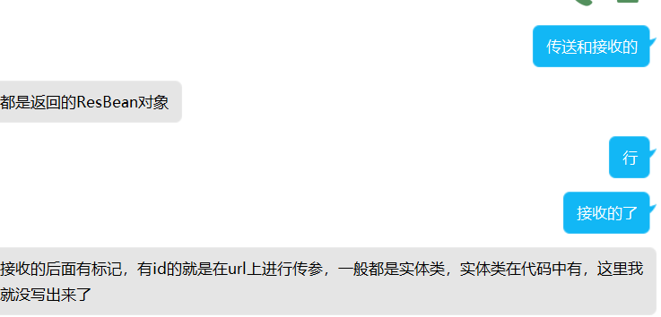

1：返回实体类ResBean

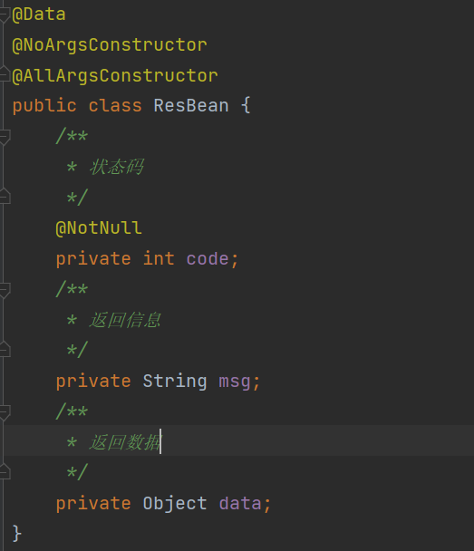

2：排班Controller

1：创建排班表

<http://localhost:8080/schedule/create> post ---传递排班表实体类

2：修改排班表

[http://localhost:8080/schedule/u](http://localhost:8080/schedule/create)pdate post ---传递排班表实体类，根据id进行修改

3：用户Controller

1：增加用户

<http://localhost:8080/users/addUser> post ---传递用户实体类

2：删除用户

<http://localhost:8080/users/deleteUser>?id=#{} delete ---在url上给出用户的id，根据该id对用户进行删除

3：查询所有用户

<http://localhost:8080/users/selectUsers> get ---查询所有用户

4：店铺Controller

1：增加店铺

<http://localhost:8080/store/addStore> post ---传递一个店铺实体类

2：删除店铺

<http://localhost:8080/store/storeById>?id=#{} delete ---根据传入的id对店铺进行删除

3：查询所有店铺

<http://localhost:8080/store/selectAll> get ---查询所有店铺