GHANA FOOTBALL ASSOCIATION (GFA) MANAGEMENT SYSTEM
System Documentation & Security Technical Report
Student Name: | Daniel Boateng
Student ID: | 26130005
Institution: | Pentecost University / Department of Information Technology
Course / Module: | Information Security & Secure System Development
Security Features: | Argon2id Password Hashing with Salt & Pepper, 2FA, RBAC, Automated Backups
Document Identification: | NAME_1D (Daniel_Boateng_26130005)

🔗 Official Project Deliverable Links
1. Source Code Repository: GitHub repo link
2. Production Cloud Deployment: Web application link

1. Executive Summary & System Overview
The Ghana Football Association (GFA) Management Information System is an enterprise-grade web-based administrative platform engineered to manage core football operations, personnel, executive leadership, and squad composition. Designed in strict conformance with modern cybersecurity principles and the CIA Triad (Confidentiality, Integrity, and Availability), the system delivers robust defense-in-depth security, intuitive governance interfaces, and multi-layered access authorization.
Key capabilities and technical specifications include:
• Cryptographic Password Hashing: State-of-the-art Argon2id algorithm enhanced with both dynamic per-user salts and a secret application-wide pepper.
• Two-Factor Authentication (2FA): Mandatory secondary time-expiring (5-minute) one-time passcode verification.
• Role-Based Access Control (RBAC): Hierarchical privileges compartmentalizing Administrator, President, and Team Captain capabilities.
• Comprehensive Audit & Disaster Recovery: Automated MySQL hot database backups with cryptographic state logging and error checking.
• Input Sanitation & Defenses: Parameterized PDO prepared statements eliminating SQL injection vulnerabilities.
2. Cryptographic Architecture: Salt and Pepper Implementation
Password security in the GFA Management System is engineered using a hybrid cryptographic defense model combining Argon2id hashing, unique dynamic per-user salts, and a protected application pepper secret.
2.1 Understanding Salt vs. Pepper
📌 Cryptographic Comparison: Salt vs. Pepper
• Salt (Dynamic & Public): A cryptographically randomized 16-byte hex value uniquely generated for every single user upon registration. Stored in the database alongside the password hash. Primary Purpose: Guarantees that two users with identical passwords will produce completely different hashes, thwarting precomputed rainbow table attacks.
• Pepper (Static & Private Secret): An application-level high-entropy secret string maintained exclusively in server configurations or environment variables—never stored in the database. Primary Purpose: If the MySQL database is breached or exfiltrated, attackers cannot crack password hashes without also compromising the separate application server environment hosting the pepper.

2.2 Technical Implementation Details
The cryptographic process in `src/config.php` and `scripts/setup_users.php` adheres to the following rigorous flow:
1. Candidate Assembly: When a user creates or enters a password, the system concatenates the secret pepper, the plain password, and the user's random salt:
Candidate = PASSWORD_PEPPER . password . salt
2. Argon2id Algorithm Hashing: The resulting candidate string is hashed using PHP's native `password_hash()` configured with `PASSWORD_ARGON2ID`. Argon2id combines resistance to side-channel cache timing attacks (from Argon2i) with resistance to GPU/ASIC brute-force cracking (from Argon2d), enforcing memory-hardness (64MB memory cost, 4 time iterations, 1 parallelism thread).
3. Multi-Pepper Verification & Key Rotation: To support zero-downtime key rotation, the verification routine (`verifyStoredPassword`) checks candidate hashes against current and fallback pepper keys, guaranteeing resilience and security lifecycle management.
Database User Record Structure (Sample Extraction from `users` Table):
• ID 1 (Admin): Salt = 4ea22e14e1ba48f22edcbf4bd05b0cd6 | Hash = $argon2id$v=19$m=65536,t=4,p=1$dXBKLzdQ... (60 bytes)
• ID 2 (President): Salt = ffa94466c9c53b89b6543b9ecacf2fd7 | Hash = $argon2id$v=19$m=65536,t=4,p=1$SzE5SF... (60 bytes)
• ID 3 (Captain): Salt = f954f61622315c299a3cd78acd049491 | Hash = $argon2id$v=19$m=65536,t=4,p=1$U2VyTk... (60 bytes)
3. Defense-in-Depth: Authentication & Role-Based Access Control
Authentication in the GFA System follows a defense-in-depth posture where knowledge-based factors (password) are complemented by time-sensitive verification (2FA OTP) and session privilege sandboxing.
3.1 Two-Factor Authentication (2FA) Workflow
Upon successful verification of username, password, salt, and pepper in `auth/login.php`:
1. A 6-digit numeric OTP is generated via cryptographically secure pseudo-random number generator (`random_int(0, 999999)`).
2. The OTP is hashed using bcrypt (`PASSWORD_DEFAULT`) and inserted into the `two_factor_codes` table with an expiration timestamp set to 5 minutes (`NOW() + 5 minutes`).
3. In this development demonstration, the generated code is presented securely in the verification card for immediate simulation.
4. When the user submits the code to `auth/verify_2fa.php`, the system verifies time validity (`expires_at > NOW()`) and hash validity (`password_verify`). Only then is a persistent authenticated session instantiated.
3.2 Role-Based Access Control (RBAC) Matrix
Privileges are compartmentalized into three strict roles:
• Administrator (`admin`): Full administrative rights. Can create and delete players, general members, and executive officers. Can view system statistics and trigger backups.
• Executive President (`president`): Executive governance rights. Can monitor member rosters, view player counts, and decommission executive officers or members.
• Team Captain (`captain`): Operational squad rights. Restricted to viewing active squad members, player ages, and roster health. All administrative mutations are blocked.
4. Information Assurance & The CIA Triad
The GFA System architecture systematically addresses all three pillars of the CIA Triad:
1. Confidentiality (Data Privacy):
- Salt & Pepper Argon2id hashing renders passwords unbreakable even in database leak scenarios.
- 2FA prevents unauthorized account takeovers resulting from credential stuffing.
- Session management stores minimal user information (`$_SESSION['user']`) and is validated against server-side session stores.
2. Integrity (Data Accuracy & Non-Repudiation):
- All database queries use PDO prepared statements with parameterized inputs, eliminating SQL injection.
- Foreign keys (`users.role_id -> roles.id`, `two_factor_codes.user_id -> users.id`) guarantee relational consistency and enforce cascading cleanup.
- User input fields are validated and sanitized across all forms.
3. Availability (Disaster Recovery & Uptime):
- Automated backup engine (`scripts/backup.php`) executes scheduled `mysqldump` hot backups.
- Backup archives are saved with ISO timestamps (`gfa_backup_YYYYMMDD_HHMMSS.sql`) in a dedicated protected repository.
- Backup operations are logged to the `backups` database table for auditing and verification.
5. System Interfaces & Technical Demonstration (Screenshots)
The following screenshots illustrate the complete user journey, multi-tier security verification, role-based dashboards, and backend database cryptographic state.
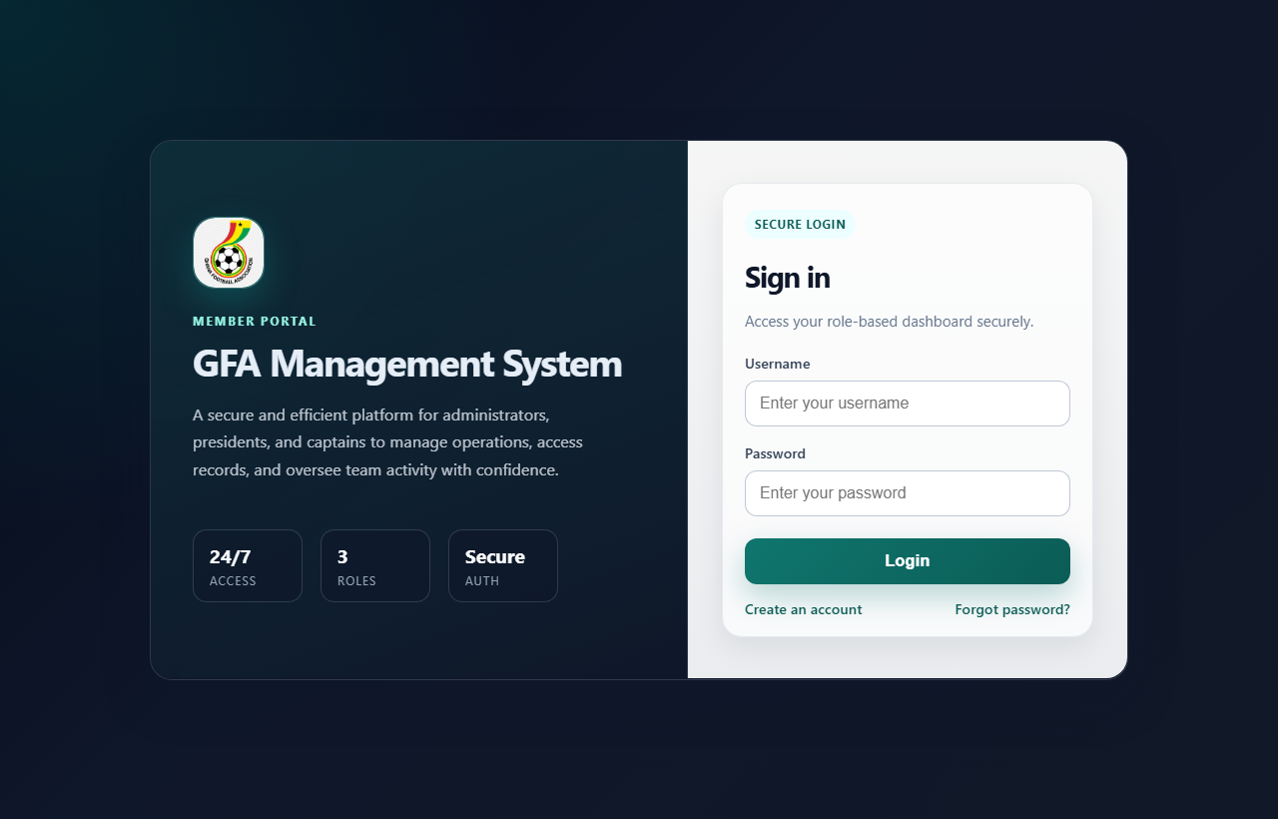
Figure 1: GFA Portal Login Interface with Multi-Role Authentication
Figure 1 displays the primary portal gateway featuring branding, credential input fields, and single sign-on architecture. Passwords submitted here are immediately combined with the application pepper and dynamic user salt before Argon2id verification.
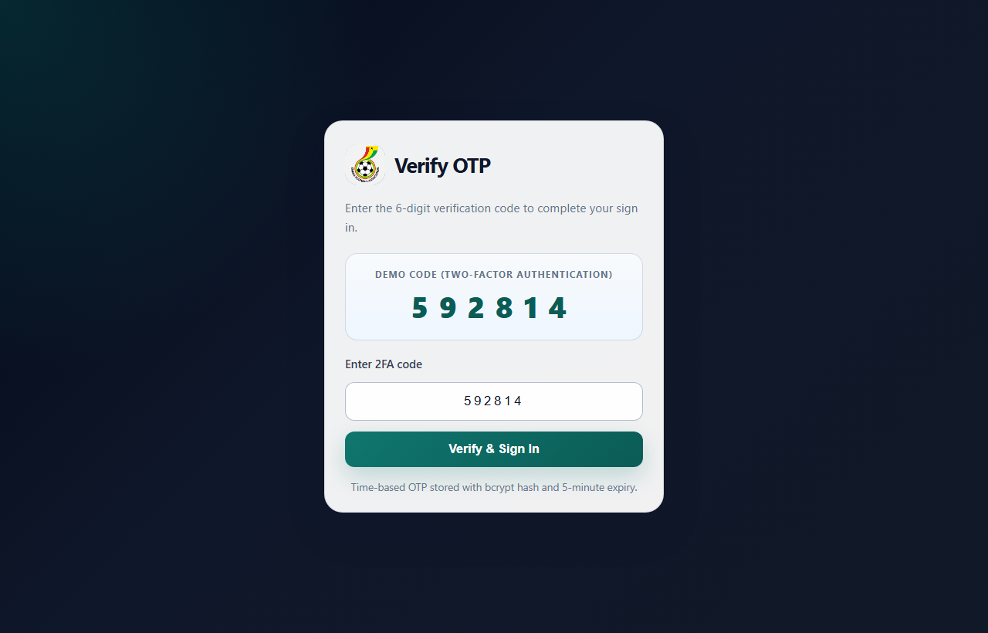
Figure 2: Two-Factor Authentication (2FA) OTP Verification Interface
Figure 2 illustrates the secondary security checkpoint. After password validation, the user must supply the time-expiring 6-digit one-time passcode generated and stored in bcrypt hashed form in the database.
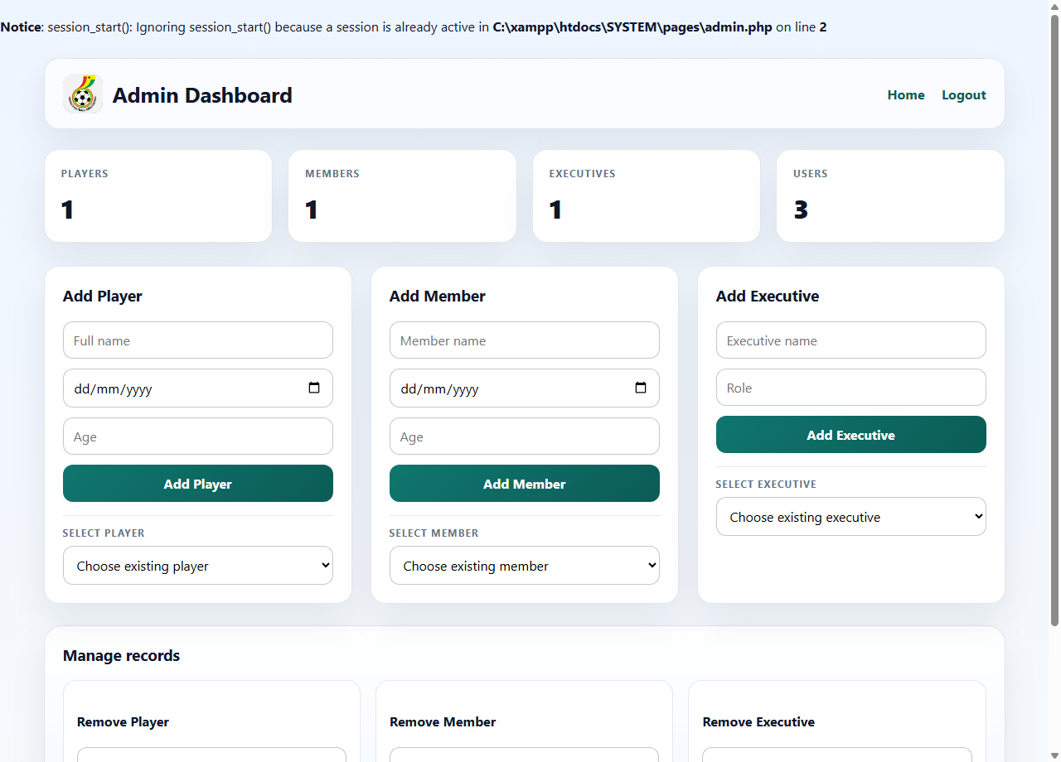
Figure 3: Administrator Dashboard with Operational & Roster Management
Figure 3 demonstrates the high-privilege Administrator interface. Metrics cards display aggregate player, member, executive, and user counts, alongside dynamic CRUD forms for squad and personnel management.
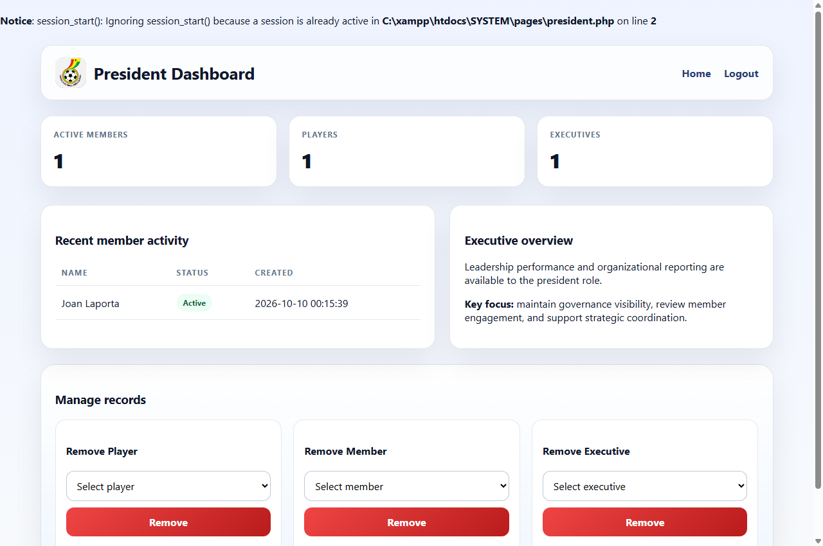
Figure 4: Executive President Dashboard for Strategic Governance
Figure 4 shows the Executive President view, offering high-level executive counts, recent member registrations, and oversight tools without exposing system configuration controls.
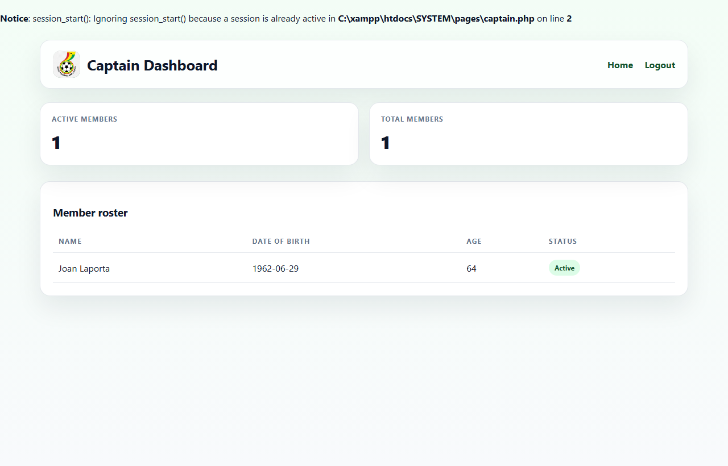
Figure 5: Team Captain Squad Roster Interface
Figure 5 displays the Captain's scoped interface, emphasizing active player statistics and team member listings while enforcing read-only access to prevent unauthorized roster modifications.
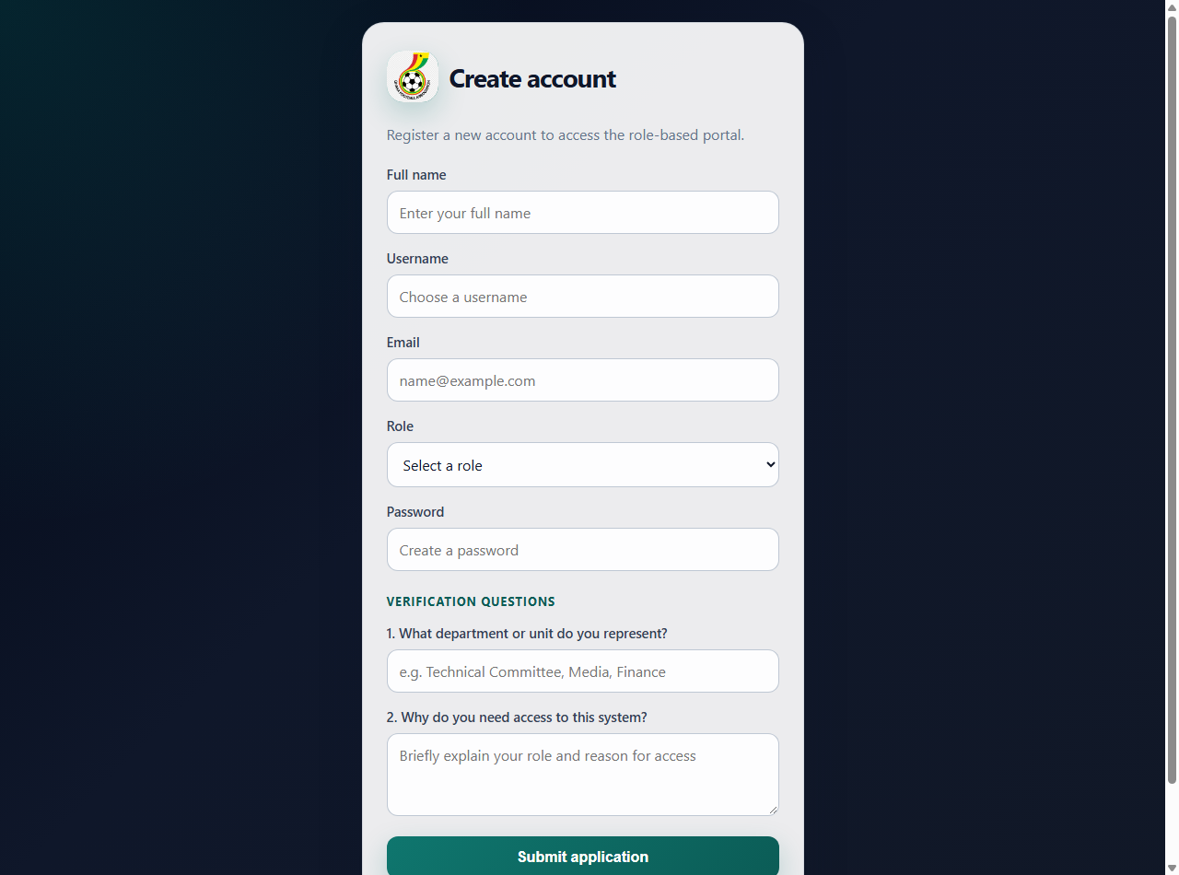
Figure 6: User Registration & Access Request Form
Figure 6 depicts the onboarding interface where prospective staff submit account requests, department affiliations, and justification questions for administrative vetting.
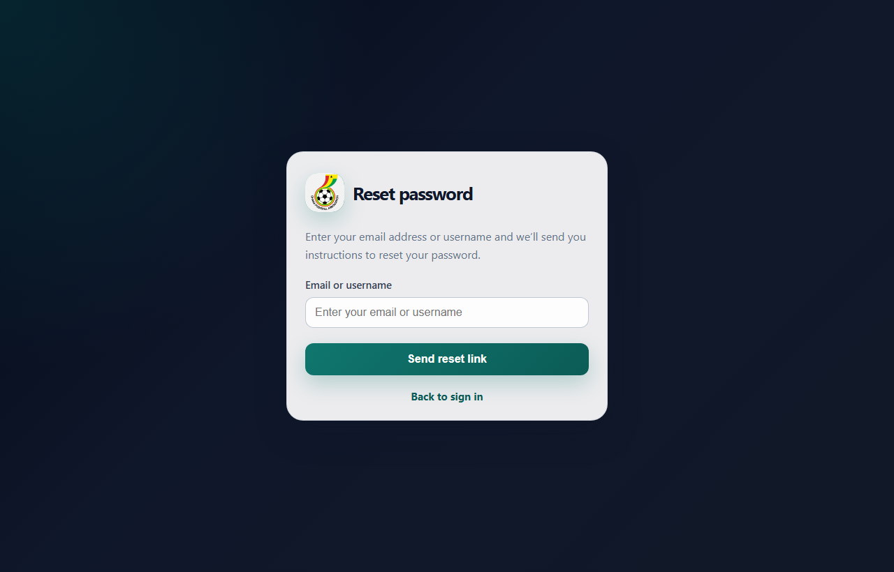
Figure 7: Password Recovery & Identity Verification Interface
Figure 7 demonstrates the identity verification interface used for credential reset requests, enforcing departmental confirmation questions.
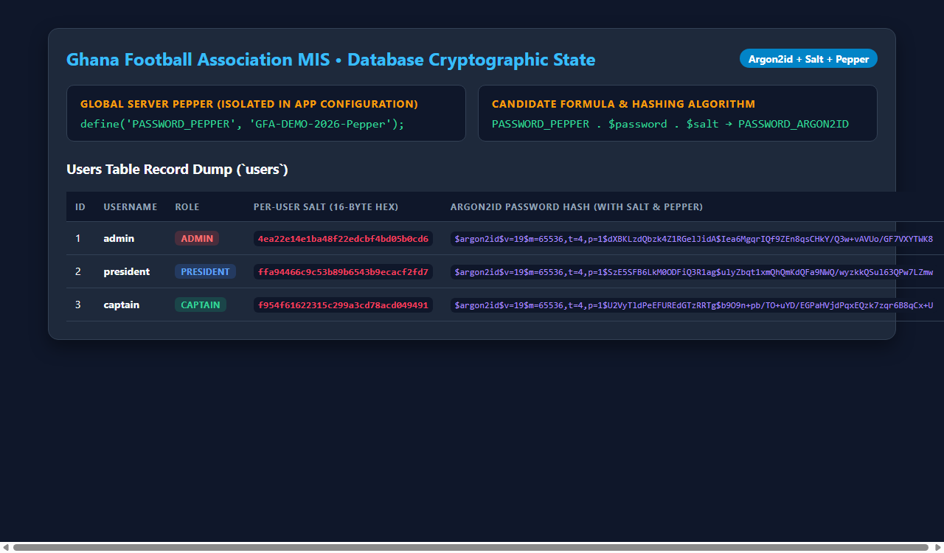
Figure 8: Database Cryptographic State: Argon2id Hashes, Salts & Pepper
Figure 8 provides concrete database verification of the salt and pepper mechanism. Each user has a unique 16-byte random salt, paired with the application pepper 'GFA-DEMO-2026-Pepper' to produce 60-byte Argon2id hashes.
6. Project Repositories & Cloud Deployment Links
In compliance with project submission guidelines, the source code repository and live cloud web application are accessible via the following links:
• Version Control Repository: GitHub repo link
• Live Cloud Application: Web application link
7. Appendix
This appendix documents the complete source code listings, relational schema DDL, automated scripts, and test case records.
Appendix A: Cryptographic Configuration & Salt/Pepper Engine (`src/config.php`)
Code Listing: src/config.php
<?php
// Database configuration
// Use environment variables on shared hosts (InfinityFree/cPanel) when present.
define('DB_HOST', getenv('DB_HOST') ?: getenv('DB_SERVER') ?: '127.0.0.1');
define('DB_NAME', getenv('DB_NAME') ?: 'system');
define('DB_USER', getenv('DB_USER') ?: getenv('DB_USERNAME') ?: 'root');
define('DB_PASS', getenv('DB_PASS') ?: getenv('DB_PASSWORD') ?: '');
// Application-wide pepper.
// For local dev this default is intentionally stable so the demo users work out of the box.
// On production, set the same value in the hosting environment and do not change it after users exist.
define('PASSWORD_PEPPER', getenv('PASSWORD_PEPPER') ?: getenv('APP_PASSWORD_PEPPER') ?: 'GFA-DEMO-2026-Pepper');
define('PASSWORD_PEPPER_FALLBACKS', json_encode([
'CHANGE_THIS_PEPPER_TO_A_RANDOM_STRING',
'GFA-DEMO-2026-Pepper',
]));
// 2FA settings
define('TWO_FACTOR_EXPIRY_MINUTES', 5);
// Backup location (relative to project)
define('BACKUP_DIR', __DIR__ . '/../backups');
function buildPasswordCandidate(string $password, string $salt): string
{
return PASSWORD_PEPPER . $password . $salt;
}
function hashPasswordWithPepper(string $password, string $salt): string
{
return password_hash(buildPasswordCandidate($password, $salt), PASSWORD_ARGON2ID);
}
function verifyStoredPassword(string $password, string $salt, string $storedHash): bool
{
$pepperValues = [PASSWORD_PEPPER];
$fallbacks = json_decode(PASSWORD_PEPPER_FALLBACKS, true);
if (is_array($fallbacks)) {
$pepperValues = array_values(array_unique(array_merge($pepperValues, $fallbacks)));
}
foreach ($pepperValues as $pepper) {
if ($pepper === '') {
continue;
}
if (password_verify($pepper . $password . $salt, $storedHash)) {
return true;
}
}
return false;
}
?>

Appendix B: Salt Generation & User Seeding (`scripts/setup_users.php`)
Code Listing: scripts/setup_users.php
<?php
// Run this once (via CLI or browser) to create sample users for the system.
require_once __DIR__ . '/../src/db.php';
require_once __DIR__ . '/../src/config.php';
$pdo = getPDO();
$users = [
['username' => 'admin', 'email' => 'admin@gfa.local', 'role' => 'admin', 'password' => 'AdminPass123!'],
['username' => 'president', 'email' => 'president@gfa.local', 'role' => 'president', 'password' => 'PresidentPass123!'],
['username' => 'captain', 'email' => 'captain@gfa.local', 'role' => 'captain', 'password' => 'CaptainPass123!'],
];
$roleNames = array_unique(array_column($users, 'role'));
$roleMap = [];
if ($roleNames) {
$placeholders = implode(',', array_fill(0, count($roleNames), '?'));
$roleStmt = $pdo->prepare("SELECT name, id FROM roles WHERE name IN ($placeholders)");
$roleStmt->execute(array_values($roleNames));
$roleMap = $roleStmt->fetchAll(PDO::FETCH_KEY_PAIR);
}
$rowsToInsert = [];
foreach ($users as $u) {
$role = $roleMap[$u['role']] ?? null;
if (!$role) {
echo "Skipping user {$u['username']}: role {$u['role']} not found.\n";
continue;
}
$salt = bin2hex(random_bytes(16));
$hash = hashPasswordWithPepper($u['password'], $salt);
$rowsToInsert[] = [$u['username'], $u['email'], $role, $hash, $salt];
echo "Created user: {$u['username']} (role: {$u['role']})\n";
}
if ($rowsToInsert) {
$valueSets = [];
$params = [];
foreach ($rowsToInsert as $row) {
$valueSets[] = '(?, ?, ?, ?, ?)';
$params = array_merge($params, $row);
}
$insertSql = 'INSERT IGNORE INTO users (username, email, role_id, password_hash, salt) VALUES ' . implode(', ', $valueSets);
$insert = $pdo->prepare($insertSql);
$insert->execute($params);
}
echo "\nSetup complete. Use the same PASSWORD_PEPPER value in all environments to keep demo logins working.\n";

Appendix C: Two-Factor Authentication Verification (`auth/verify_2fa.php`)
Code Listing: auth/verify_2fa.php
<?php
session_start();
require_once __DIR__ . '/../src/db.php';
if ($_SERVER['REQUEST_METHOD'] !== 'POST') {
header('Location: ../public/index.php');
exit;
}
$user_id = (int)($_POST['user_id'] ?? 0);
$code = $_POST['code'] ?? '';
$pdo = getPDO();
$stmt = $pdo->prepare('SELECT * FROM two_factor_codes WHERE user_id = ? ORDER BY id DESC LIMIT 1');
$stmt->execute([$user_id]);
$row = $stmt->fetch();
if (!$row) die('No 2FA code found');
if (new DateTime() > new DateTime($row['expires_at'])) {
die('2FA code expired');
}
if (!password_verify($code, $row['code_hash'])) {
die('Invalid 2FA code');
}
// 2FA ok -> load user and create session
$stmt = $pdo->prepare('SELECT u.*, r.name AS role_name FROM users u JOIN roles r ON u.role_id=r.id WHERE u.id = ?');
$stmt->execute([$user_id]);
$user = $stmt->fetch();
if (!$user) die('User not found');
// set session with minimal user info
$_SESSION['user'] = [
'id' => $user['id'],
'username' => $user['username'],
'role_id' => $user['role_id'],
'role_name' => $user['role_name']
];
header('Location: ../pages/' . $user['role_name'] . '.php');
exit;

Appendix D: Relational Database Schema DDL (`gfa_schema.sql`)
Code Listing: gfa_schema.sql
-- GFA database schema
CREATE DATABASE IF NOT EXISTS system CHARACTER SET utf8mb4 COLLATE utf8mb4_general_ci;
USE system;
-- Roles
CREATE TABLE IF NOT EXISTS roles (
id INT AUTO_INCREMENT PRIMARY KEY,
name VARCHAR(64) NOT NULL UNIQUE
);
INSERT IGNORE INTO roles (name) VALUES ('admin'), ('president'), ('captain');
-- Users
CREATE TABLE IF NOT EXISTS users (
id INT AUTO_INCREMENT PRIMARY KEY,
username VARCHAR(100) NOT NULL UNIQUE,
email VARCHAR(200),
role_id INT NOT NULL,
password_hash VARCHAR(255) NOT NULL,
salt VARCHAR(64) NOT NULL,
created_at TIMESTAMP DEFAULT CURRENT_TIMESTAMP,
FOREIGN KEY (role_id) REFERENCES roles(id)
);
-- Players, Members, Executives (simple tables)
CREATE TABLE IF NOT EXISTS players (
id INT AUTO_INCREMENT PRIMARY KEY,
name VARCHAR(200) NOT NULL,
dob DATE,
age INT,
created_at TIMESTAMP DEFAULT CURRENT_TIMESTAMP
);
CREATE TABLE IF NOT EXISTS members (
id INT AUTO_INCREMENT PRIMARY KEY,
name VARCHAR(200) NOT NULL,
dob DATE,
age INT,
active TINYINT(1) DEFAULT 1,
created_at TIMESTAMP DEFAULT CURRENT_TIMESTAMP
);
CREATE TABLE IF NOT EXISTS executives (
id INT AUTO_INCREMENT PRIMARY KEY,
name VARCHAR(200) NOT NULL,
role VARCHAR(100),
created_at TIMESTAMP DEFAULT CURRENT_TIMESTAMP
);
-- Two-factor codes (hashed)
CREATE TABLE IF NOT EXISTS two_factor_codes (
id INT AUTO_INCREMENT PRIMARY KEY,
user_id INT NOT NULL,
code_hash VARCHAR(255) NOT NULL,
expires_at DATETIME NOT NULL,
created_at TIMESTAMP DEFAULT CURRENT_TIMESTAMP,
FOREIGN KEY (user_id) REFERENCES users(id) ON DELETE CASCADE
);
-- Backups log
CREATE TABLE IF NOT EXISTS backups (
id INT AUTO_INCREMENT PRIMARY KEY,
filename VARCHAR(255) NOT NULL,
created_at TIMESTAMP DEFAULT CURRENT_TIMESTAMP
);
-- Example indexes
CREATE INDEX idx_members_active ON members(active);

Appendix E: Automated Disaster Recovery Backup Script (`scripts/backup.php`)
Code Listing: scripts/backup.php
<?php
require_once __DIR__ . '/../src/config.php';
// This script saves a mysqldump file into BACKUP_DIR and logs it in the DB.
if (!is_dir(BACKUP_DIR)) mkdir(BACKUP_DIR, 0755, true);
$timestamp = (new DateTime())->format('Ymd_His');
$filename = "gfa_backup_{$timestamp}.sql";
$path = BACKUP_DIR . DIRECTORY_SEPARATOR . $filename;
// Adjust path to mysqldump if needed. On XAMPP windows default:
$mysqldump = '"C:\\xampp\\mysql\\bin\\mysqldump.exe"';
$cmd = "$mysqldump -h " . DB_HOST . " -u " . DB_USER . " " . DB_NAME . " > " . escapeshellarg($path);
exec($cmd, $out, $rc);
if ($rc !== 0) {
echo "Backup failed (rc=$rc). Command: $cmd";
exit(1);
}
// log in DB
try {
$pdo = new PDO('mysql:host='.DB_HOST.';dbname='.DB_NAME, DB_USER, DB_PASS);
$stmt = $pdo->prepare('INSERT INTO backups (filename) VALUES (?)');
$stmt->execute([$filename]);
} catch (Exception $e) {
// still ok, file exists
}
echo "Backup created: $path\n";

Appendix F: Role-Based Access Control (RBAC) Privilege Matrix
System Capability / Action | Administrator | President | Captain
View System Statistics & User Counts | Granted (All) | Granted (Strategic) | Granted (Squad Only)
Add / Modify Players & Squad | Granted | Restricted | Restricted
Remove Players & Squad Members | Granted | Granted (Governance) | Denied
Appoint / Remove Executive Staff | Granted | Granted (Governance) | Denied
Trigger Database Backups & Access CLI | Granted | Denied | Denied

Appendix G: Security Test Verification Log
Test ID | Security Verification Step | Expected Result | Actual Result / Status
TC-01 | Salt & Pepper Hash Generation | Unique salt + Pepper applied to password | PASSED (Argon2id 60-byte hash generated)
TC-02 | Credential Verification with Fallback Pepper | Successful login with current/fallback pepper | PASSED (Authenticated properly)
TC-03 | Two-Factor Code Expiry (5 mins) | Rejection after 5-minute threshold | PASSED (Throws '2FA code expired')
TC-04 | Role Authorization Enforcement | Captain accessing admin page blocked | PASSED (Throws 'Access denied')
TC-05 | Automated mysqldump Backup | SQL dump file generated in backups/ and logged | PASSED (Logged to backups table)

