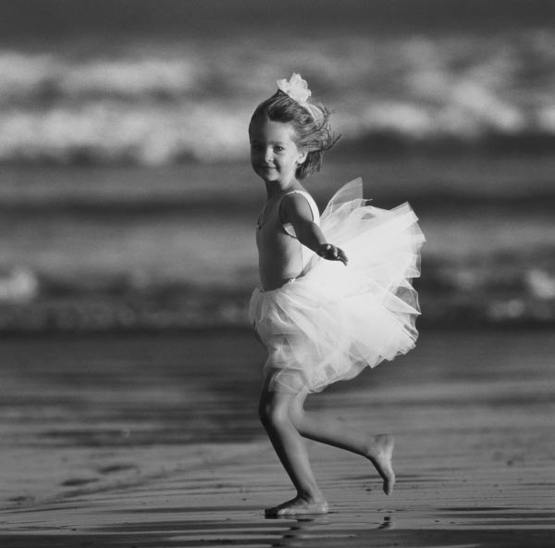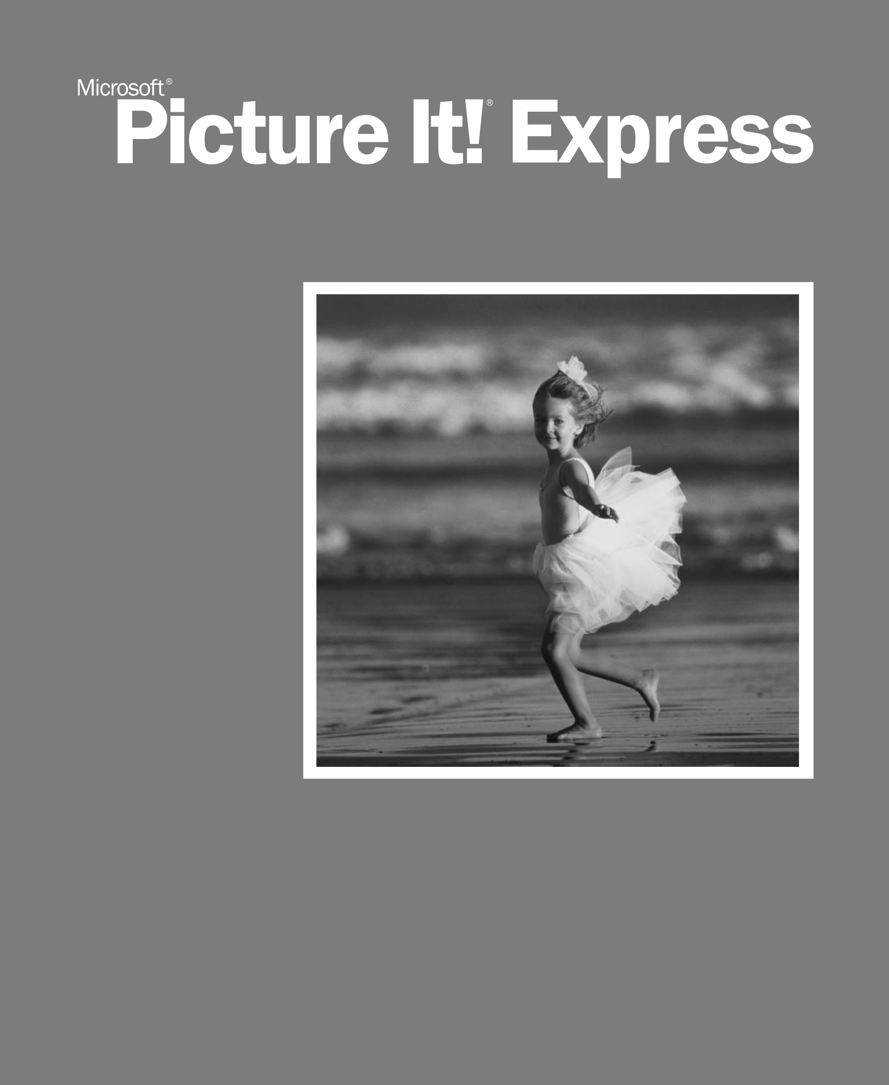

*User’s Manual*  M

*Microsoft*  
 *®*

*Picture It!® Express*

*User’s Manual*

Information in this document, including URL and other Internet Web site references, is subject to change without notice. Unless otherwise noted, the example companies, organizations, products, domain names, e-mail addresses, logos, people, places, and events depicted herein are fictitious, and no association with any real company, organization, product, domain name, e-mail address, logo, person, place, or event is intended or should be inferred. Complying with all applicable copyright laws is the responsibility of the user. Without limiting the rights under copyright, no part of this document may be reproduced, stored in or introduced into a retrieval system, or transmitted in any form or by any means (electronic, mechanical, photocopying, recording, or otherwise), or for any purpose, without the express written permission of Microsoft Corporation.

Microsoft may have patents, patent applications, trademarks, copyrights, or other intellectual property rights covering subject matter in this document. Except as expressly provided in any written license agreement from Microsoft, the furnishing of this document does not give you any license to these patents, trademarks, copyrights, or other intellectual property.

© 2004 Microsoft Corporation. All rights reserved.

Microsoft, Picture It!, and Windows are either registered trademarks or trademarks of Microsoft Corporation in the United States and/or other countries.

This product contains images from PhotoDisc/Getty Images, Inc.; Dave Johnson; Tony Chor; Tim Hedlund; Charlotte Lowrie; David Parlin; and Tom Simmons.

This software is based in part on the work of the independent JPEG Group.

GIF decompression code, copyright 1990, David Koblas.

Portions of graphic filter software used with the permission of Eastman Kodak Company. Copyright © 1996 Eastman Kodak Company.

ImageStream Graphics & Presentation Filters Copyright © 1991-1996 ImageMark Software Labs, Inc. All Rights Reserved.

Graphic filters licensed from Access Softek, Inc. Copyright © 1996 Access Softek, Inc.

This product contains Macromedia Flash™ Player software by Macromedia, Inc., Copyright © 1996-2002 Macromedia, Inc. All rights reserved. Macromedia, Flash, and the Flash Player logo are trademarks of Macromedia, Inc.

Portions of this product were created using LEADTOOLS Copyright© 1991-2002, LEAD Technologies, Inc.

© 2000 Gina B. Designs, Inc., © Adjoa J. Burrowes/EthnoGraphics, © Alice Briggs Illustration, © Allport Editions, © Amberley Greeting Card Company, © Antoinette Simmons Hodges/EthnoGraphics, © Athena Hampton/EthnoGraphics, © Betty Biggs/EthnoGraphics, © Bonnie Zuponcic, © Carla Golembe/EthnoGraphics, © Cathy L. Schubert/EthnoGraphics. © Colors By Design, © Emma Raley, © Fish & Webster, © Fravessi Greetings, Inc., © Gary Craig, © Georgia Rettmer and Kimberly Rinehart, © Great Arrow Graphics, © Jay P. Morgan, © Jeanine M. Frazier/EthnoGraphics, © Jesus & Margaret Flores/EthnoGraphics, © Jim Z. Zhang/EthnoGraphics, © Joann Pecoraro/ EthnoGraphics, © Joseph Polevoi/EthnoGraphics, © Karen Gutowsky, © Kay Erickson/EthnoGraphics, © Keith Henry Brown/Ethno-Graphics, © Kersti Wells, © Kiki Oberstenfeld de Suarez, © KOKO New York, © Kristin Elliott, © Kristin Nelson Tinker/EthnoGraphics, © Larry LaBonte© Laura Schuman © Leeann Lidz/EthnoGraphics, © Linda G. Fisher/EthnoGraphics, © linneadesign.com, © Lisa R.

Foster/EthnoGraphics, © Liz Kahlenberg Bordow, © Lorie L. Clark/EthnoGraphics, © Madison Park Greetings, © MARA-MI, © Mar-ian Heath Greeting Cards, © Maril Delly/EthnoGraphics, © Marisela Godoy/EthnoGraphics, © Mark Downey/EthnoGraphics, © ME GRAPHICS, © Northern Exposure, © NRN Designs Corporation, © Painted Hearts & Friends, © Palm Press, Inc., © Paula Doherty 2001, Advocate-Art © Penny Laine Papers, © Pinx A Card Co., Inc., © Rebecca Pavlenko, © Red Farm Studio, © Roobee, © Sally Martin do Gastelum/EthnoGraphics, © Sandi Carpenter/EthnoGraphics, © Sara Schneidman, © Snafu Designs, © Socially Yours, © Steve Haskamp, © Steve Katz, © Suzanne Tornquist/EthnoGraphics, © Xiaoxing Yu/EthnoGraphics, Bottman Design, Inc. © Chris Roberts-Antieau, Bottman Design, Inc. © Paris Bottman, Fan Mail Greeting Card Co © Dona Rozanski, LARKSPUR GRAPHICS © Andie Thrams, Off Ramp(TM), Silk Spiral Designs © G.B., Steve Lovi © 2000, TWENTY-FOUR CARROT, INC. ® © Jennifer Blomgren, © Andrea Beloff, © Dorothy Strait, © Carmel Bartz.

The names of actual companies and products mentioned herein may be the trademarks of their respective owners.

Table of Contents

**Chapter 1: Installation.................................................................................................................................... 1**  Starting Setup............................................................................................................................................. 1 Completing the Installation Wizard........................................................................................................... 2 Installation Folder Dialog Box............................................................................................................ 2 Installation Options Dialog Box ......................................................................................................... 2 Special Circumstances ............................................................................................................................... 3 Upgrading from a Different Picture It! Product ................................................................................. 3 Reinstalling or Removing Picture It! ................................................................................................. 3 **Chapter 2: Welcome to Picture It! Express ................................................................................................ 5**  Other Helpful Resources ............................................................................................................................ 6 **Chapter 3: Opening and Importing Pictures ............................................................................................... 7**  Importing Pictures...................................................................................................................................... 7 Launching the Import Pictures Wizard automatically ...................................................................... 7 Starting the Import Pictures Wizard manually .................................................................................. 8 Opening Pictures for Editing ..................................................................................................................... 9 Using the file browser.......................................................................................................................... 9 Troubleshooting tips for opening pictures from a camera.................................................................. 13 Opening from a scanner...................................................................................................................... 14 Opening a Photo Sent Through E-mail...................................................................................................... 16 Opening a Picture from a Web Page.......................................................................................................... 17 **Chapter 4: Picture It! Basics.......................................................................................................................... 19**  Startup Window.......................................................................................................................................... 19 Examining the Work Area ........................................................................................................................ 21 Image Formatting....................................................................................................................................... 23 Changing picture size.......................................................................................................................... 23 Applying Text............................................................................................................................................. 25 Help Resources........................................................................................................................................... 26 Online Help ......................................................................................................................................... 26 Using the table of contents.................................................................................................................. 27 Using the index.................................................................................................................................... 27 Using the search .................................................................................................................................. 28 Product Tour........................................................................................................................................ 28 Technical Support .............................................................................................................................. 28

**Chapter 5: Basic Touchup............................................................................................................................... 29** Adjusting Brightness and Contrast ............................................................................................................ 29 Correcting a Color Cast.............................................................................................................................. 30 Fixing Red Eye ........................................................................................................................................... 31 Straightening a Picture............................................................................................................................... 32 Cropping .................................................................................................................................................... 33 Using the rule of thirds ....................................................................................................................... 34 **Chapter 6: Batch Editing in the Mini Lab .................................................................................................. 35 Chapter 7: Adding Edges................................................................................................................................ 37** Edge Effects................................................................................................................................................ 37 **Chapter 8: Saving and Printing Pictures...................................................................................................... 39** Saving Pictures........................................................................................................................................... 39 Saving Multiple Versions ........................................................................................................................... 40 Choosing a File Format .............................................................................................................................. 41 Setting PNG Plus Options................................................................................................................... 42 Saving for E-mail and the Web .................................................................................................................. 43 Printing Pictures......................................................................................................................................... 44 Printing Single Pictures ...................................................................................................................... 44 Printing Multiple Pictures................................................................................................................... 44 Selecting Print Quality........................................................................................................................ 46 Selecting a Print Size .......................................................................................................................... 47 Choosing Photo Paper ......................................................................................................................... 47 Creating Long-lasting Prints............................................................................................................... 48 Ordering Prints and Gifts on MSN Photos................................................................................................ 49 **Chapter 9: Organizing and Archiving in Picture It! Library.................................................................... 51** Opening Picture It! Library........................................................................................................................ 51 Adding Pictures to Picture It! Library ....................................................................................................... 52 Scanning for Pictures.......................................................................................................................... 53 Adding Keywords....................................................................................................................................... 54 Viewing Your Photos.................................................................................................................................. 55 Viewing by Folder............................................................................................................................... 55 Viewing by Date.................................................................................................................................. 55

Viewing by Keyword .......................................................................................................................... 56 Using the Thumbnail Slider ................................................................................................................ 56 Showing Thumbnail Data .......................................................................................................................... 57 Tiles View............................................................................................................................................ 57 Thumbnails View................................................................................................................................ 57 Thumbnails with Text View................................................................................................................ 57 Grouping Your Pictures.............................................................................................................................. 58 Showing the Table of Contents ........................................................................................................... 58 Using the Preview Pane.............................................................................................................................. 59 Editing and File Management from Picture It! Library............................................................................. 60 Editing in a Photo Editor..................................................................................................................... 60 Editing in Mini Lab............................................................................................................................. 61 Batch File Management ...................................................................................................................... 61 **Index.................................................................................................................................................................. 63**

|  |  |  |
| --- | --- | --- |
| 1 | Installation | 1 |

Starting Setup

To install Picture It! Express, you must be running Windows 98, Windows Millennium Edition, Windows 2000, or Windows XP or later. On Windows 2000 and Windows XP systems, you must have administrative privileges. For information regarding privileges, please refer to the operating system Help.

On most computers, Picture It! setup will begin automatically when you insert the Picture It! CD into your disk drive.

To begin automatic setup:

1. Turn off any antivirus software that you’re using, and close any programs that are running.

2. Insert the Picture It! CD into your disk drive. The Installation Wizard begins automatically.

If the above procedure does not start the setup process, you can start it manually.

To begin setup manually:

1. Turn off any antivirus software that you’re using, and close any programs that are running.

2. Insert the Picture It! CD into your disk drive.

3. Click **Start**, and then click **Run**.

4. If your CD-ROM drive is listed as letter D, type *d:\setup.exe*. If your CD-ROM drive has a letter other than D, replace D with the correct letter when you type the path.

5. Click **OK**.

The Installation Wizard begins.

*Microsoft Picture It! Expres User’s Manual*

|  |  |
| --- | --- |
| 2 | Chapter 1: Installation |

Completing the Installation Wizard

The Installation Wizard will show you a series of dialog boxes that provide setup status and some installation preference options. For most users, the default preferences will be appropriate. Information about the different setup options is provided below.

Installation Folder Dialog Box

The Installation Folder dialog box allows you to choose where the program will be installed on your computer. To install the program to a folder other than the folder in the Installation folder box, do one of the following:

• Type a different path in the **Installation folder** box.

• Click **Change**, select a folder in the **Change Installation Folder** dialog box, and then click **OK**.

Note that some files will be installed to the Program Files drive even if you choose to install the program to a different drive.

Installation Options Dialog Box

The Installation Options dialog box allows you to choose between Typical installation and Full installation.

• **Typical installation** takes up less space on your hard drive, and is recom-mended for most users. With Typical installation, you will have to insert the Picture It! CD in your CD-ROM drive to use some of the projects and clip art while you are using the program.

• **Full installation** copies all of the Picture It! projects and clip art to your hard drive, so you will not have to reinsert a Picture It! CD while you are using the program. Look under **Description** for the disk space required for this option.

*Microsoft Picture It! Express User’s Manual*

|  |  |
| --- | --- |
| Chapter 1: Installation | 3 |

Special Circumstances

Upgrading from a Different Picture It! Product

If you already have a Picture It! product installed on your machine, any of several scenarios may occur when you try to install another Picture It! product:

• **Previous versions** If you have a Picture It! product previous to version 10 already installed, installing a version 10 product will make both programs available on your computer.

• **Upgrade from another version 10 product** You can install a Picture It! version 10 product that has more features than a version 10 product already installed. The version of Picture It! with fewer features will be uninstalled automatically before the new installation begins. Your pictures and projects will not be deleted.

• **Blocked downgrade** If you have a Picture It! version 10 product   
installed, you will not be able to automatically install a version 10 product with fewer features. To install the version with fewer features, you must first uninstall the version with more features.

Reinstalling or Removing Picture It!

If you are having problems running Picture It!, reinstalling the program may help it to run better on your computer.

MSN Photos Plus is made of two separate programs: the image editor and the Library. These programs must be reinstalled or removed separately.

You should not attempt to remove Picture It! by deleting the program files from your hard disk. Instead, use the Picture It! Installation Wizard to properly uninstall the program.

To remove or reinstall Picture It! on Windows XP:

1. Log on to the computer as an administrator.

2. From the Windows **Start** menu, click **Control Panel**.

3. Click **Add or remove programs**.

4. From the list of installed programs, click the version of Picture It! you want to remove or reinstall. Picture It! and Picture It! Library will be listed as separate programs and must be removed separately.

5. Click **Change/Remove**.

The Installation Wizard opens.

6. Follow the instructions on the screen.

*Microsoft Picture It! Express User’s Manual*

|  |  |
| --- | --- |
| 4 | Chapter 1: Installation |

To remove or reinstall Picture It! from Windows 98, Windows 2000, or Windows Millennium Edition:

1. From the Windows **Start** menu, point to **Settings**, and then click **Control**  **Panel**.

2. Click **Add/Remove Programs**.

3. From the list of installed programs, click the version of Picture It! you want to remove or reinstall.

4. Click **Add/Remove**.

The Installation Wizard opens.

5. Follow the instructions on the screen.

*Microsoft Picture It! Express User’s Manual*

|  |  |  |
| --- | --- | --- |
| 2 | Welcome to Picture It! Express | 5 |

Congratulations on your purchase of Microsoft Picture It! Express. Microsoft Picture It! makes it easy to edit and enhance your digital photos. With just a few clicks, you can:

• Correct brightness, contrast, and tint

• Fix red eye

• Rotate, flip, and crop

• Add effects such as text and highlighted edges

Picture It! makes it easy for you to work with all your photos, from any source: digital camera, scanner, picture CD, or the Web. When you’re finished editing photos, Picture It! makes it easy to print them or send them through e-mail. Picture It! Library helps you to search by keywords, dates, ratings, and more so you can find just the pictures you want from your entire collection.

*Microsoft Picture It! Express User’s Manual*

|  |  |
| --- | --- |
| 6 | Chapter 2: Welcome to Picture It! Express |

Other Helpful Resources

This User’s Manual is not an exhaustive resource for everything you can do in Picture It!. For step-by-step instructions about using all the program’s features, check out the online Help system, available from the Startup Window or from the Help menu.

Digital photography is exciting and fun, and Picture It! makes it easy to get great results, even if you’re just beginning.

*Microsoft Picture It! Express User’s Manual*

|  |  |  |  |
| --- | --- | --- | --- |
| 3 | Opening and Importing Pictures | | 7 |
| Picture It! makes it easy to import and open your pictures quickly. To transfer pictures from your camera or storage media to your computer, use the new Import Pictures Wizard. This wizard is designed to streamline the file transfer | | *Cataloging pictures in the Library* |  |

|  |  |
| --- | --- |
| process, allowing you to name the destination folder, rename the picture files, and add the pictures to Picture It! Library. To open pictures for editing, use the file browser. The file browser displays thumbnails of all your pictures, so you can quickly choose the ones you want. | See the “Organizing and Archiving in Picture It!  Library” chapter to learn more about cataloging |

|  |  |
| --- | --- |
| Importing Pictures | your pictures as you  import them. |

The Import Pictures Wizard is a convenient way to transfer pictures and video clips from your digital camera or other storage location to your computer. The Import Pictures Wizard helps you rename the files so that they have recogniz-able file names. Also, the Import Pictures Wizard automatically catalogs pictures in Picture It! Library.

Launching the Import Pictures Wizard automatically

Picture It! can automatically detect compatible cameras and other media such as photo CDs. This detection should occur when you:

• Connect a compatible camera to the computer and turn on the camera.

• Connect a compatible scanner to the computer and turn on the scanner.

• Connect a compatible card reader to the computer and insert media.

• Insert a photo CD, DVD, or other storage media into a drive on the computer.

This automatic detection feature is only available on computers running Windows Millennium Edition or Windows XP.

*Microsoft Picture It! Express User’s Manual*

|  |  |
| --- | --- |
| 8 | Chapter 3: Opening and Importing Pictures |

To set Windows to launch the Import Pictures Wizard automatically:

1. Connect your compatible camera or device to the computer, and then turn on the camera or device.

- or -  
Insert the storage media into a drive on the computer.

2. When Windows detects the picture files, Windows will ask you what you want to do with the pictures.

3. Click Import pictures using **Microsoft Picture It! Import Wizard**.

4. Check **Always do the selected action**.

5. Click **OK**.

6. Click the device you want to use, and then click **OK**.

Starting the Import Pictures Wizard manually

If Windows does not automatically detect your device or other media, you can start the Import Pictures Wizard from Picture It! or Picture It! Library.

To start the Import Pictures Wizard manually:

1. On the **File** menu, click **Import Pictures**.

2. Click the device you want to use, and then click **OK**.

*Microsoft Picture It! Express User’s Manual*

|  |  |
| --- | --- |
| Chapter 3: Opening and Importing Pictures | 9 |

Opening Pictures for Editing   
With Picture It!, you can open pictures for editing from a variety of sources, including your computer, storage media, and most cameras and scanners.

Using the file browser   
You can use the file browser to locate your photos and open them for editing.

The file browser can be used to open photos from:

• The hard drive on a computer.

• An external hard drive.

• A digital camera that is a USB Mass Storage Class device. (A USB Mass Storage Class device works as a "virtual drive," letting you browse and open photos from the device as you would from a hard disk or floppy disk.) Though you can open pictures from a camera in this way, you will probably prefer to use the Import Pictures feature, discussed later.

• A card reader.

• A USB drive.

• A photo CD or DVD.

• A floppy disk.

• A network location.

*Microsoft Picture It! Express User’s Manual*

|  |  |
| --- | --- |
| 10 | Chapter 3: Opening and Importing Pictures |

This picture identifies the main features of the file browser:

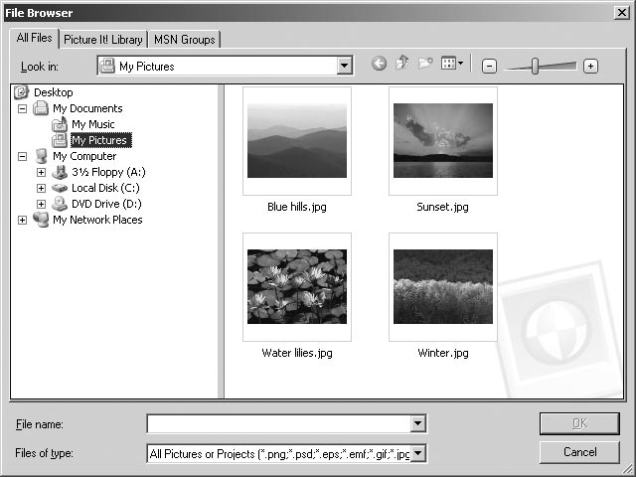

1. **All Files tab** Click the **All Files** tab to view the folder structure on your computer. Click a folder to display its contents and subfolders. The folder structure includes internal and external drives on your computer, including disk drives, card readers, and USB Mass Storage Class digital cameras.

2. **Picture It! Library tab** Click the **Picture It! Library** tab to find any picture you have cataloged in the Library. You can also use the Library’s View By and Group By features to filter and group your pictures, making it easier to find the pictures you want.

3. **MSN Groups tab** Click the **MSN Groups** tab to open pictures that you have stored on MSN Groups.

4. **Look in box** Displays the name of the current folder selected on the All Files tab.

5. **View menu** Use this menu to change the way the image files are displayed.

6. **Thumbnail size slider** Move the slider to change the size of the thumb- nails.

7. **File name box** Displays the file name of a selected thumbnail.

8. **Files of type menu**  Use this menu to change the types of image files to be displayed.

9. **Thumbnails** Small versions of your photos stored in the current folder.

10. **OK** Opens the selected thumbnails.

11. **Cancel** Closes the file browser without opening any photos.

*Microsoft Picture It! Express User’s Manual*

|  |  |  |
| --- | --- | --- |
| Chapter 3: Opening and Importing Pictures | | 11 |
| To open pictures with the file browser: | *File formats* | |
| 1. If opening pictures from a USB Mass Storage Class camera, read your | *compatible with* | |
| camera’s documentation and make sure that you have installed the camera’s software and drivers properly. Make sure your camera is turned on and connected to your computer.  2. On the **File** menu, click **Open**.  3. Click the **All Files** tab.  4. In the **Look in list**, click the drive, folder, or network location that contains the picture you want to open.  5. In the folder list, locate and open the folder or location that contains the | *Picture It!*  Picture It! can open  photo files in any of the following formats:  • Adobe Photoshop (.psd)  • AutoCAD (.dxf) | |
| pictures. | • CorelDraw (.cdr) | |

|  |  |
| --- | --- |
| Thumbnails of pictures in that folder appear in the right pane.  6. Select the picture you want to open. To select multiple pictures, press CTRL as you click the thumbnails.  7. Click **Open**. | • Enhanced Metafile (.emf) • EPS (.eps) • FlashPix (.fpx) |

|  |
| --- |
| • GIF (.gif) |

• Home Publishing   
 (.php)  
• JPEG (.jpg)  
• Kodak Photo CD   
 (.pcd)  
• Macintosh PICT (.pct)  
• Micrografx Designer   
 (.drw)  
• PC Paintbrush (.pcx)  
• Picture It! (.png, .php,   
 .mix, .fpx)  
• PNG (.png)  
• TIFF (.tif)  
• Targa (.tga)  
• Windows Bitmap   
 (.bmp)  
• Windows Metafile   
 (.wmf)

*Microsoft Picture It! Express User’s Manual*

|  |  |  |
| --- | --- | --- |
| 12 | Chapter 3: Opening and Importing Pictures | |
| *Using your*  *camera’s software*  Some digital  cameras—especially  older models—may not | | Opening pictures from other cameras  If your camera does not show up as a drive in the file browser, it is probably designed to work using TWAIN or WIA support. For many cameras, Picture It! works with TWAIN and WIA and your camera’s software so that you can open photos directly into Picture It!. |

|  |  |
| --- | --- |
| function as a virtual  drive or be TWAIN or  WIA compliant. For  these cameras, use the software provided by  the camera to download the photos to a folder  your computer. Then  open them with the file browser. | To open photos from a camera that uses WIA support:  1. Make sure that you have installed all the drivers that came with your camera.  2. Connect your digital camera to your computer, and then turn on the camera.  3. On the **File** menu, point to **Import Pictures**.  4. If more than one device appears in the dialog box, click the one that represents your camera.  5. Select **Copy them to my computer or network**. Then, to launch the Mini |

Lab after opening the pictures, click **Yes** under **Open the pictures for editing**.

6. Click **Next**.

7. By default, all of your pictures are selected. To select just some, click the pictures you want to import. If you want to import more than one picture, press CTRL as you click the pictures.

8. Click **Next**.

9. Type a name for this group of pictures. If you want to name all the   
pictures using this group name, check Use this name to rename the pictures. You can also specify which folder on your hard drive to copy the pictures. To erase the camera’s memory after the pictures are safely on the computer, click **Delete pictures from my device after copying them**.

10. Click **Next**.

The pictures stored on the camera appear in the workspace. If you chose to edit your pictures, they will also appear automatically in the Mini Lab.

*Microsoft Picture It! Express User’s Manual*

|  |  |
| --- | --- |
| Chapter 3: Opening and Importing Pictures | 13 |

Troubleshooting tips for opening pictures from a camera

• Your camera must be connected and turned on before you start the digital camera task, or it will not appear in the list of cameras and drives.

• If you've connected your digital camera to your computer, but can't see your pictures, make sure the connections are secure, the camera is turned on, and the batteries are charged. The camera might not start download-ing unless its batteries are fully charged. Some cameras are equipped with an A/C adapter that you can use instead of batteries.

• If your camera does not appear in the list of cameras and drives, or if you receive an error message when you click Download, start your camera software from the operating system Start menu.

• For more information about downloading photos using the software included with your camera, consult your camera's manual.

*Microsoft Picture It! Express User’s Manual*

|  |  |  |
| --- | --- | --- |
| 14 | Chapter 3: Opening and Importing Pictures | |
| *About TWAIN*  *and WIA*  TWAIN is interface  software that allows  communication  between a camera and your computer. Many digital cameras come | | Opening from a scanner  Picture It! supports two types of scanner formats: TWAIN and WIA. If your scanner doesn't use a TWAIN or WIA interface, you need to use the software designed specifically for the make and model of your scanner. Many scanner manufacturers provide free updates to their drivers on the Web.  Before you attempt to scan a picture, make sure your scanner is connected properly. The first time you connect your scanner, the **Identify Scanner Type** dialog box will open, asking you to identify the type of scanner. |

|  |  |
| --- | --- |
| with a TWAIN driver.  WIA is a newer interface that works similarly  to TWAIN, but often  provides more control over the device. WIA is | To connect your scanner  1. Install the software that came with your scanner.  2. Turn off your scanner and computer.  3. Attach the connector cable from your scanner to your computer. 4. Turn on your scanner and computer. |

|  |  |
| --- | --- |
| compatible with TWAIN, but is only available  on some computer | Once the scanner is connect and recognized by your computer, you’re ready to scan. |

|  |
| --- |
| operating systems. |

*Microsoft Picture It! Express User’s Manual*

|  |  |
| --- | --- |
| Chapter 3: Opening and Importing Pictures | 15 |

To scan a photo with a flatbed TWAIN or WIA scanner:

1. Connect your scanner to your computer, and then turn on the scanner.

2. Place your picture on the scanner.

3. On the **File** menu, click **Import Pictures**.

4. If more than one device appears in the dialog box, click the one that represents your scanner.

5. Depending upon the type of scanner you have, you will either see the **Scan Picture** pane or the **Import Pictures Wizard**.

If you see the **Scan Picture** pane:

1. Select your scanner from the list

2. Choose the **Automatic Scan** option from **Click a scanning method**.

3. Click **Scan**.

If you see the **Import Pictures Wizard**:

1. If you want to immediately open the scanned picture for editing, click **Open the picture for editing**.

2. Click **Next**.

3. Specify the group into which you want the scanned picture to be stored. Also select a place on your hard drive where the scanned picture will be stored and specify a file format. The default JPEG format is usually an excellent choice for scanned pictures.

4. Select a scanning method. Most of the time, you should choose Automatic Scan to get a high quality, color picture.

5. Click **Next**

*Microsoft Picture It! Express User’s Manual*

|  |  |  |
| --- | --- | --- |
| 16 | Chapter 3: Opening and Importing Pictures | |
| *Can this photo be* | | Opening a Photo Sent Through E-mail |
| *printed?* | Many friends and family members enjoy sending photos through e-mail. When | |
| To find out if a photo has enough resolution to | | you receive photos through e-mail, you can save them to your computer and then work on them with Picture It!. |

|  |  |
| --- | --- |
| print, see the “How large a print can you get”  section of the Printing | Many photos sent through e-mail are low-resolution photos, which are not suit-able for large prints. But low-resolution photos may be fine for online viewing or printing at small sizes. |
| Photos chapter. | To open a photo sent through e-mail: |

Use your e-mail program to save the photo to a folder on your computer. Save the photo to a folder that will be easy for you to locate later, such as the My Pictures folder.

1. In Picture It!, click **Open** on the **File** menu.

2. The File Browser dialog box opens.

3. Click the All Files tab.

4. On the **All Files** tab, browse to the folder containing the photo, and then click the folder.

5. Select the photo, and then click **Open**.

*Microsoft Picture It! Express User’s Manual*

|  |  |  |
| --- | --- | --- |
| Chapter 3: Opening and Importing Pictures | | 17 |
| Opening a Picture from a Web Page | *Watch for* |
| When you surf the Internet, you may come across photos and other images that | *copyrights* |

|  |  |
| --- | --- |
| you would like to use in your photo projects. You might find photos of celebri-ties, vacation spots that you want to visit, or graphics that would look good as part of one of your photo projects. Unless the Web site uses image protection, you can capture these images and use them for your own projects. Web images are usually low resolution, so they may not be suitable for printing. But you could still use the images in a project to be viewed online. | Pictures you see  on the Web may be  copyrighted, so be sure to read the site's legal information before you use an image. |

To capture an image from a Web page, you can drag it from the Web page to the Picture It! Files palette.

To open a photo from a Web page:

1. Make sure that both Picture It! and your Web browser (either Microsoft Internet Explorer or MSN Explorer) are open and running on your computer.

A button for each program appears in the taskbar at the edge of your screen.

2. On the Picture It! **File** menu, click **New**.

3. Select a canvas size, and then click **Done**.   
 A blank canvas opens in the workspace.

4. On the taskbar, click the button for your Web browser program.

5. In your Web browser, locate the Web page that contains the picture you want.

6. Right-click the picture, and then click **Copy**.

7. On the taskbar, click the button for Picture It!.

8. On the Picture It! **Edit** menu, click **Paste**.   
The new picture appears on the canvas.

Once the photo is opened in Picture It!, you can edit it as you would any other photo and save it to your computer.

*Microsoft Picture It! Express User’s Manual*

|  |  |  |
| --- | --- | --- |
| 4 | Picture It! Basics | 19 |

This chapter covers some of the fundamental aspects of Picture It! that you’ll need to get started. You’ll find information on the Startup Window, the work area, basic image manipulation, applying text, and Help resources.

Startup Window

The Startup Window is a quick launching point to photos, Mini Lab, the Library, recently opened files, and Help.

By default, the Startup Window opens every time you start Picture It!. After closing the Startup Window, you can open it at any time from the main work area by clicking the Startup Window button in the Common Tasks list. This diagram points out the main features of the Startup Window.

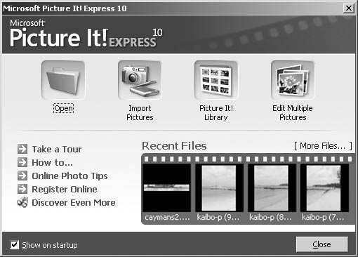

1. **Open** Click the Open button to open the file browser, where you can open photos from your hard drive, a network drive, a digital photo card reader, a CD or DVD, or a floppy disk.

2. **Import Pictures** Click this button to launch the digital camera task, so you can open photos from a digital camera using Picture It! or your camera’s software.

3. **Picture It! Library**  Click this button to open the Library, where you can find and organize your pictures.

4. **Edit Multiple Pictures** Click this button to open the Mini Lab. The Mini Lab helps you perform routine editing task—such as rotating, levels auto fix, cropping, and saving—on multiple pictures at the same time.

*Microsoft Picture It! Express User’s Manual*

|  |  |
| --- | --- |
| 20 | Chapter 4: Picture It! Basics |

5. **Show on startup checkbox** Check this box to have the Startup Window open every time you start Picture It!.

6. **Help links** Click these links to go directly to resources that can help you get the most out of Picture It! and digital imaging.

• **Take a Tour** launches the product Tour.

• **How to…** displays a collection of image editing lessons.

• **Online Photo Tips** links you directly to the Tips & Tricks section of the MSN Photos Web site.

• **Register Online** links you to the registration page of the Microsoft Web site.

• **Discover Even More** connects you to information about other Micro- soft products, including the complete Digital Image Pro Suite.

7. **Recent Files** See thumbnails of the last four pictures that you have edited. Click on one of the thumbnails to open that file.

8. **More Files** Click **More Files** to open the file browser, where you can open photos from your hard drive, a network drive, a digital photo card reader, a CD or DVD, or a floppy disk.

9. **Close** Click to go close the Startup Window and go to the main work area.

*Microsoft Picture It! Express User’s Manual*

|  |  |
| --- | --- |
| Chapter 4: Picture It! Basics | 21 |

Examining the Work Area

Most of the photo-editing tasks you perform in Picture It! will be in the main work area. When you open Picture It! and close the Startup Window, you see the main work area. The picture below identifies the key elements of the Picture It! work area.

|  |  |  |  |  |  |  |
| --- | --- | --- | --- | --- | --- | --- |
| 2 | 1 | 5 | 6 | 7 | 8 |  |
|  | | | |
|  | 3  4 | 9 |

1. **Menus**   
Menus provide access to all of the Picture It! features. The Help menu gives you access to the Help window, and the Picture It! Tour.

2. **Toolbar**   
The toolbar contains shortcut buttons for single-click access to some of the most common commands. To see the name of a toolbar button, hover the mouse pointer over the button.

3. **Workspace Toolbar**   
This toolbar contains buttons for the Common Tasks list, Stack, and Files palette. You can create more room in the workspace by hiding any of these tools.

4. **Common Tasks list**   
The Common Tasks list is an easy way to locate features. This list provides convenient access to some of the most common tasks, as well as single-click access to the Mini Lab and the Startup Window. All of the features found in the Common Tasks list—as some additional features—are also available in the menus.

5. **Workspace**   
The gray area represents the workspace, the area that the canvas sits within. You can use the zoom controls to magnify or reduce the canvas so that it covers more or less of the workspace.

*Microsoft Picture It! Express User’s Manual*

|  |  |
| --- | --- |
| 22 | Chapter 4: Picture It! Basics |

6. **The canvas**   
The white area is called the canvas, and it represents the printable area of the page. When you open a photo, the canvas is often not visible since it is covered entirely by the picture. You can use the zoom controls to magnify or reduce the canvas so that it covers more or less of the workspace.

7. **Zoom controls**   
The zoom controls magnify or reduce your photo so that you can see it in more or less detail.

8. **Stack**   
The Stack displays a thumbnail of each object in your picture. You can rearrange the order of the objects by dragging a thumbnail up or down within the Stack.

9. **Files palette**   
The Files palette displays a thumbnail of all of the currently open pictures. You can switch your active picture by clicking a thumbnail in the Files palette. You can also add a picture to the one you’re working on by dragging the thumbnail from the Files palette to the canvas.

*Microsoft Picture It! Express User’s Manual*

|  |  |
| --- | --- |
| Chapter 4: Picture It! Basics | 23 |

Image Formatting

When you have a picture open on the canvas, there are a number of ways to re-size or re-orient it.

Changing picture size

When you open an image onto the canvas, the on-screen representation of the image is automatically sized so that it fills the workspace. As a result, a high resolution image, such as 1600 x 1200 pixels, will look as large as a low resolu-tion image that’s only 640 x 480 pixels. For this reason, viewing a picture on the canvas is not a reliable way of judging an image’s resolution.

Whenever you resize an image, consider these three factors:

• *Image size*, which is the size of the printed image.

• *Pixel dimensions*, which is how many colored dots (pixels) make up the picture.

• *Resolution*, which is the density of the pixels in the picture.

The image size is the product of the pixel dimensions multiplied by the resolu-tion. For example, if you have a picture made of 1200 x 1800 pixels and print it at a resolution of 300 pixels per inch, it will print at a size of 4" x 6". Given this relationship, if you change one of the three settings, one of the other settings will also have to change to keep the relationship equal. If you enlarged the picture in the previous example from 4" x 6" to 8" x 12"—and you kept the pixel dimensions the same—then the resolution would decrease from 300 pixels per inch to 150 pixels per inch.

When you resize a picture, it is generally not a good idea to try to increase or decrease the pixel dimensions since this reduces image quality. In most cases, it’s not necessary to adjust the image size, since that can be handled automati-cally during printing. For high-quality prints, it’s generally good to keep the picture’s resolution at least 300 pixels per inch. But depending on you printer model and the image quality you desire, you may be satisfied with prints at only 150 pixels per inch. For Web use, 72 pixels per inch is usually considered sufficient.

*Microsoft Picture It! Express User’s Manual*

|  |  |
| --- | --- |
| 24 | Chapter 4: Picture It! Basics |

To resize a picture:

1. On the **Format** menu, click **Resize Image**.

2. Click one of the following to lock the setting:  
 • **Image size**  
 • **Pixel dimensions**  
 • **Resolution**   
 3. Enter amounts for the settings you want to change. 4. Click **Done**.

*Microsoft Picture It! Express User’s Manual*

|  |  |
| --- | --- |
| Chapter 4: Picture It! Basics | 25 |

Applying Text

You can add text to any picture and easily change the text font, font color, font size, alignment, and emphasis. You start by adding a text box, and then you edit the text in the box. A text box is its own layer on the Stack.

To add text:

1. On the Text menu, click Insert Text.   
 A text box appears.

2. Type your text. As you add text, the text box will automatically expand vertically to fit all of your text.

3. To change the width of the text box, select the text box and drag one of the side resize handles.

4. To move the text box, select it, hover the mouse pointer over the edge of the text box until the move handle appears, and then drag the move handle.

Once you've added the text, you can select the text to edit it. You can also select the text and use the toolbar buttons to change formatting. When text is selected, the following tools are available on the toolbar for formatting:

• The font menu  lets you choose between 140 different fonts.

• The font size menu  lets you choose font sizes from 8 to 620 points.

• The font color button  lets you choose from a standard palette of colors or choose a custom color.

• The Bold button  adds bold formatting to the text.

• The Italic button  adds italic formatting to the text.

• The Underline button  underlines the text.

• The Alignment button  has menu choices for Left, Right, Center, and Justify.

*Microsoft Picture It! Express User’s Manual*

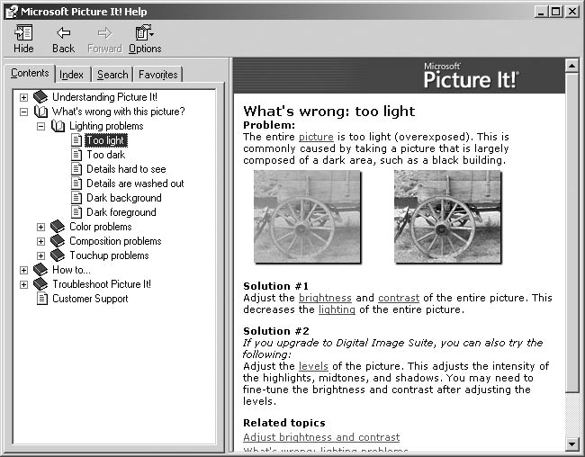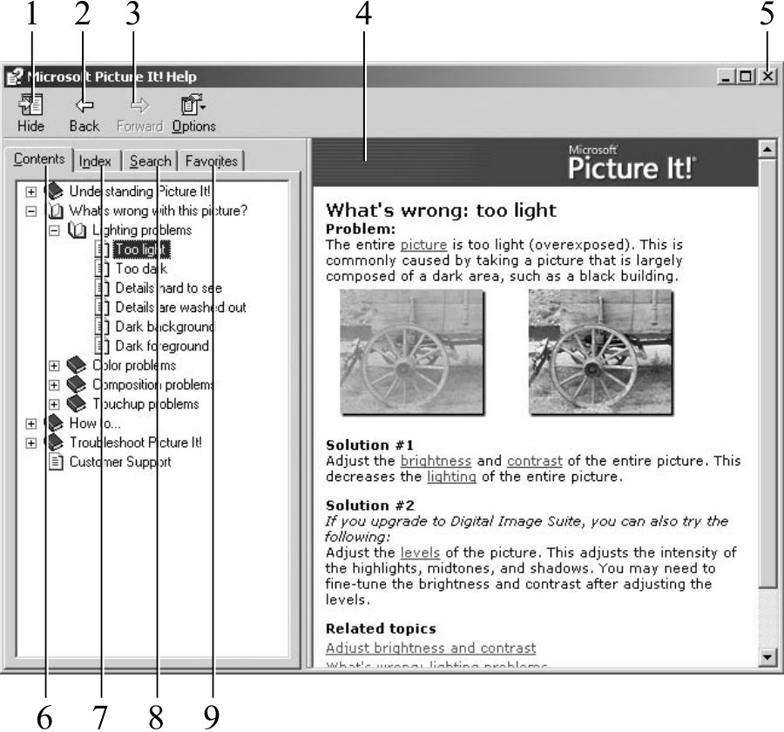

|  |  |  |
| --- | --- | --- |
| 26 | Chapter 4: Picture It! Basics | |
| *Accessing Help* | | Help Resources |
| *from the keyboard* | | There are multiple ways that you can learn more about using Picture It!. In |

|  |  |
| --- | --- |
| You can access the  online Help system at any time by pressing F1 on the keyboard. | addition to this User's Manual, there is the online Help system, and the product Tour. The following sections describe the types of information available.  Online Help |

Picture It! online Help is the most comprehensive of the Help resources. It provides step-by-step instructions, overviews, troubleshooting topics, techni-cal support, and the “What’s wrong with this picture” diagnostic tool. Help includes several ways to find information, including a table of contents, a keyword index, and a full-text search.

This diagram identifies the main features of the Help window.

1. **The Show/Hide button** Click this button to expand or collapse the left pane of the Help window.

2. **The Back button** Click this button to go back to the last Help topic.

3. **The Options menu** This menu has options to print a topic or to set options such as **Internet Options**, where you can change the font size in the Help window.

4. **The content pane** Displays the current Help topic.

5. **The close button** closes the Help window.

*Microsoft Picture It! Express User’s Manual*

|  |  |
| --- | --- |
| Chapter 4: Picture It! Basics | 27 |

6. **The Contents tab** displays the Help table of contents.

7. **The Index tab** lets you find keywords in the index list.

8. **The Search tab** finds topics that contain words that you enter. 9. **The Favorites tab** lets you save topics for quick access later.

To access online Help:

1. On the **Help** menu, click **Help Topics**.

Using the table of contents   
You can use the table of contents to locate information by subject. The table of contents is a useful way to see all of the features available in each category of features.

To use the table of contents:

1. In the left pane of the Help window, click the Contents tab. 2. To expand a book in the contents, click the plus sign next to it. 3. To display a topic, in the contents list, click the topic title.

Using the index   
You can use the index when you are looking for information about a specific term or keyword.

To use the index:

1. In the left pane of the Help window, click the Index tab.

2. In the Type in the keyword to find box, type the word you want to find. 3. In the results list, select the word you want to find, and then click Display.

*Microsoft Picture It! Express User’s Manual*

|  |  |
| --- | --- |
| 28 | Chapter 4: Picture It! Basics |

Using the search   
You can use the search function to find all the topics in Help that contain a word or combination of words.

To use the search:

1. In the left pane of the Help window, click the **Search** tab.

2. In the **Type in the keyword to find** box, type the word for which you want to search, and then click **List Topics**.

3. In the **Select topic to display** list, select the topic you want to view, and then click **Display**.

Product Tour   
The Picture It! Tour uses pictures and text to demonstrate popular features and new features of the program.

To take the product tour:

1. On the **Help** menu, click **Take a Tour**.

The Tour opens, displaying icons to represent different categories of features.

2. Click an icon.

A feature list appears on the left side of the window.

3. Click a feature.

Graphics and text appear that explain the feature.

4. Repeat steps 2-4 to learn about more features.

5. To close the Tour, click **Close**.

Technical Support   
The type of Technical Support resources available vary based on where you live and how you obtained your Picture It! product.

To view Technical Support information:

1. On the **Help** menu, click **About Picture It! Express 10.0**. 2. Click **Tech Support**.

*Microsoft Picture It! Express User’s Manual*

|  |  |  |  |
| --- | --- | --- | --- |
| 5 | Basic Touchup |  | 29 |
| Almost all photos can be improved with basic touchup tools. Picture It! touchup | | *Making a copy to* |  |
| tools can be used to correct common photo problems such as red eye, crooked | |
| *touch up* |
| pictures, lighting problems or similar distractions that can ruin a photo. In | |

|  |  |
| --- | --- |
| many cases, Picture It! helps you eliminate basic problems with just a few clicks. | Never edit your only copy of a photo. Always make |

|  |  |
| --- | --- |
| Adjusting Brightness and Contrast  When you take a photo with an automatic camera, the camera’s automatic exposure feature measures the available light and determines how much light is required to take the photo. Sometimes, the exposure meter’s measurement is slightly too low or too high, creating problems with brightness and contrast in the photo. Picture It! provides tools to fix the levels of brightness and contrast. | a copy or choose Save As to save the edited file with a different name.  If you aren't satisfied  with the results, you can always start again from the original. |

To correct brightness and contrast:

1. On the **Touchup** menu, click **Brightness and Contrast**.

2. Click **Exposure Auto Fix**.

3. If you are not satisfied with the result of the levels auto fix, click **Contrast**  **Auto Fix**.

4. If you are not satisfied with the results, fine-tune the settings with the **Brightness** and **Contrast** sliders.

5. Click **Done**.

|  |  |
| --- | --- |
|  |  |

The picture on the left is both too dark and too low contrast. The Exposure auto fix tool was applied to the version on the right, correcting both the brightness and contrast levels.

*Microsoft Picture It! Express User’s Manual*

|  |  |  |
| --- | --- | --- |
| 30 | Chapter 5: Basic Touchup | |
| *Setting the white* | | Correcting a Color Cast |
| *balance on a* | | When you take photographs, the source of the light can create a colored cast in |
| *digital camera* | | the photo. We tend to think of light being white, but nearly every light source |
| Many digital cameras allow you to set the  white balance for | | has its own unique color. For example, natural sunlight has a large component of blue in it, while incandescent (tungsten) lights—including most household light bulbs—give off a reddish or yellowish cast. |

|  |  |
| --- | --- |
| specific types of light, such as sunlight,  incandescent, and  flash. Using this feature can help reduce tint  problems in your  photos. | When taking a photo, you can compensate for these different colors of light by setting the white balance (with a digital camera), or using special filters (on a film camera). But if you still end up with a cast in your photos, use the adjust tint task to correct the balance of colors to make the lighting look more natural.  In this task, you locate a point that should be white, and then Picture It! bal-ances all of the colors in the picture based on the white point you set.  If you have already used the Levels auto fix or Color auto fix tool, the tint |

problems in the picture may already be corrected. Use the adjust color task to make additional adjustments to the tint.

|  |  |
| --- | --- |
| *Zooming in to*  *find white*  If there are no  significant areas of  white in your photo, use the zoom controls to  magnify the picture on the screen. When you zoom in, you may be  able to use a very small | To adjust tint:  1. On the **Touchup** menu, click **Adjust Color**.  The mouse pointer becomes an eyedropper when positioned over the picture.  2. With the eyedropper, click an area in the picture that should be grey or neutral—in other words, not too colorful, too dark, or too light.  Picture It! automatically corrects the colors.  3. If you are not satisfied with the results, use the sliders for fine-tuning.  4. Click **Done**. |

|  |
| --- |
| area of white, such as |

the whites of a person’s

|  |
| --- |
| eyes. |

*Microsoft Picture It! Express User’s Manual*

|  |  |
| --- | --- |
| Chapter 5: Basic Touchup | 31 |

Fixing Red Eye

Using your flash in low light situations can give your subjects red, unnatural-looking eyes. The Fix Red Eye tool darkens the red spots in the eyes to reduce or eliminate the redness.

To fix red eye:

1. On the **Touchup** menu, click **Fix Red Eye**.

2. Use the pan and zoom controls to magnify your picture and focus on the red eyes in the photo.

3. Click the red part of the eyes. You can click up to two eyes at once.

4. Click **Fix selected red eyes**.

The redness in the eyes is removed.

5. Repeat steps 3 and 4 until the red is eliminated.

6. Click **Done**.

*Microsoft Picture It! Express User’s Manual*

|  |  |
| --- | --- |
| 32 | Chapter 5: Basic Touchup |

Straightening a Picture

If you took a photograph while unintentionally holding the camera at an angle, the horizon or other straight lines will appear tilted. This tilt can be a distrac-tion in the picture, but is easily fixed with the Straighten Picture tool.

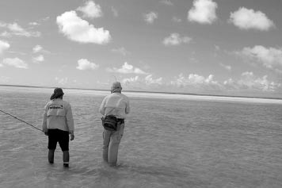

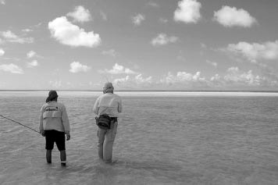

The Straighten Picture tool rotates the picture to make the horizon level.

To make the horizon level, the Straighten Picture tool rotates the picture on the canvas. When rotated, part of the picture overlaps the edge of the canvas, and these areas would be removed during printing. The rotation also creates empty areas at the corners of the canvas. Fortunately, these problems are solved by the Auto Crop feature which is part of the Straighten Picture tool. After you straighten the picture, Auto Crop trims the edges of the picture so that it becomes aligned with the canvas.

To straighten a picture with Auto Crop:

1. On the **Format** menu, click **Straighten Picture**, and then click **Canvas**.

2. Identify a line in the picture that should be straight (such as the horizon), and then click one end of the line.

3. Click the other end of the line.

The picture is automatically straightened.

4. Make sure the **Auto Crop** check box is selected.

The area of the picture that will be cropped is shown in lightened color around the edges.

5. Click **Done**.

*Microsoft Picture It! Express User’s Manual*

|  |  |
| --- | --- |
| Chapter 5: Basic Touchup | 33 |

Cropping

Cropping is an easy way to improve the composition of a photograph. For example, if your picture has distracting background elements along the top, bottom, or side, you can crop away these parts of the background to focus the attention on the subject.

When you crop a photo, you are removing pixels, and therefore lowering the effective resolution (although the dots per inch will stay the same). If you crop a significant portion of the original, you’re limiting the extent to which you will be able to enlarge the picture for printing. This is why it’s better to compose the picture as best you can when you take it, rather than relying on heavy cropping later.





Cropping a picture allows you to eliminate distractions and improve the composition.

Cropping your picture to a specific proportion lets you control exactly where the picture will be cut. Otherwise, if your picture is not the same proportion as the print size, some of the picture may be trimmed during printing to fit into the printable area of the page.

*Microsoft Picture It! Express User’s Manual*

|  |  |
| --- | --- |
| 34 | Chapter 5: Basic Touchup |

Using the rule of thirds

When composing a photograph, many beginning photographers consistently center their subject directly in the middle of the frame. While this technique may be the easiest way to get the subject in focus with a point-and-shoot camera, it is not always the most interesting way to present the subject.

Most advanced photographers follow the *rule of thirds* when composing the space inside a picture frame. The rule of thirds is used throughout the graphic design world, because it helps to create balance between the subject and the background. When you compose a picture according to the rule of thirds, you mentally divide the frame into thirds both horizontally and vertically (imagine a tic-tac-toe grid), and place the point of interest on one of the four spots where the lines intersect.

If the photo includes a person or animal, you can place the face on one of the four points, looking toward the center of the scene. If the photo includes the horizon, it should run about one-third from the top or one-third from the bot-tom, depending on whether the terrain or the sky is the center of focus.

|  |  |  |
| --- | --- | --- |
|  |  |  |

The cropped picture is a more interesting composition since it follows the rule of thirds.

To crop a photo using the rule of thirds:

1. On the **Format** menu, point to **Crop**, and then click **Canvas**.

2. Under **Select a proportion**, click a proportion.

3. Select the **Show guidelines for the rule of thirds** check box.

4. Click a starting point on your photo, and then drag the outline to the opposite corner of the area to be cropped.

The guidelines show the cropped area divided into thirds vertically and horizontally.

5. Move and resize the cropped area so a focal point in the picture is positioned at one of the intersections of the guidelines.

6. Click **Done**.

*Microsoft Picture It! Express User’s Manual*

|  |  |  |
| --- | --- | --- |
| 6 | Batch Editing in the Mini Lab | 35 |

If you take photos regularly, it can become time consuming to perform basic editing to all of your pictures after you download them from your camera. Mini Lab contains tools that can help you save time with routine editing that needs to be done to many or all of the photos in a batch.

If you have a high-capacity storage medium in your camera, you may have dozens or more photos to download at once to your hard disk. Some of these photos may be excellent “keepers” that you will want to spend some time editing carefully later on. But many of the photos only need a few quick edits: changes such as rotation and resizing.

Opening each photo individually, performing basic edits, and then saving each one could take a lot of time. Mini Lab lets you perform these routine editing tasks to many photos at once. Mini Lab lets you select multiple photos to perform the following tasks:

• Color auto fix

• Exposure auto fix

• Camera Phone auto fix

• Rotate

• Save as (to save copies of the originals, change file format, and rename files)

• Print

Mini Lab displays all of your open photos, and includes a list of editing options that you can perform on multiple photos. This diagram identifies the main features of Mini Lab.

*Microsoft Picture It! Express User’s Manual*

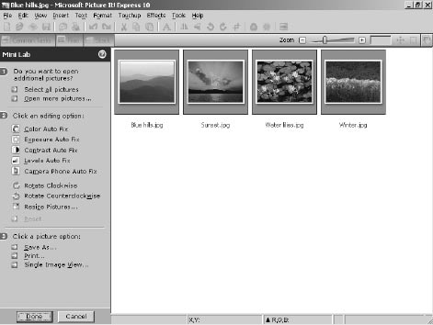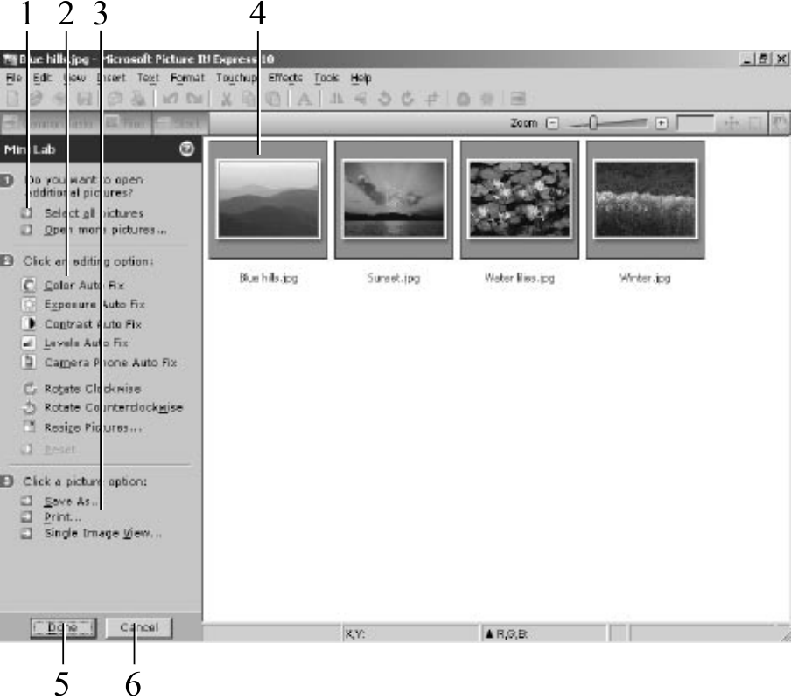

|  |  |
| --- | --- |
| 36 | Chapter 6: Batch Editing in Mini Lab |

1. The **Open more files** button opens the file browser to let you find more pictures to edit.

2. The editing options list shows all of the tasks available for batch editing.

3. File options let you save or print multiple photos.

4. The **Workspace** in Mini Lab contains thumbnails of all of your opened pictures.

5. The **Done** button closes Mini Lab, keeping the photos open and maintain-ing the changes you have made. To save photos before leaving Mini Lab, select the thumbnails and click **Save** before you click **Done**.

6. The Cancel button closes Mini Lab, undoing any unsaved changes.

To open Mini Lab from Picture It!:

1. On the **Touchup** menu, click **Batch Edit in Mini Lab**.

To open Mini Lab from the Library:

1. In the Thumbnail pane, select the pictures you want to edit.

2. On the **Tasks** menu, click **Batch Edit in Mini Lab**.

When the Mini Lab starts, it automatically displays all pictures that were open in the application. Select the photos you want to edit, and then click one or more editing tasks For the changes t6o be applied automatically.

*Microsoft Picture It! Express User’s Manual*

|  |  |  |  |
| --- | --- | --- | --- |
| 7 | Adding Edges |  | 37 |
| When you’ve finished editing a photo, you add a polishing touch by surround- | | *Shrinking a* |  |
| ing it with soft or highlighted edges. | |
| *picture to show* |
| Edge Effects | | *the edge effect* |
| Some edge effects |

|  |  |  |
| --- | --- | --- |
| Edge effects alter the outside edge of a photo. For portrait photos, try the soft edge effect. To draw attention to photos that you post on a Web site, try apply-ing one of the highlighted edges. | | appear only behind and outside the picture. So if your picture reaches the edge of the canvas, you might not be able to see the edge effect when  you print it or save it to the Web.  To make sure you can  see an edge you’ve  added, make sure the  object is not locked to  the canvas, and then  the press the CTRL key while you drag in one of the photo’s corner resize handles. This will shrink the photo proportionally on the canvas, so that |
|  |  |
| The photo on the left has highlighted edges applied, which work great for photos on the Web and in e-mail. The photo on the right has been enhanced with soft edges. | |
| To add an edge effect: | | the border lies within the printable area. |

1. On the **Stack**, click the layer to which you want to add the edge effect. 2. On the **Effects** menu, point to **Edges**, and then click an edge effect or border.

3. If available, click a specific edge or border.

4. Follow the instructions on the screen to customize the size or color of the edge or border.

5. Click **Done**.

*Microsoft Picture It! Express User’s Manual*

|  |  |  |
| --- | --- | --- |
| 8 | Saving and Printing Pictures | 39 |

Saving Pictures

If you’re like most people, you can't stand to throw photos away, even if they’re imperfect. You probably have a large box or two filled with envelopes of old negatives and photographic prints. Keeping track of all of your old prints and negatives can be a formidable task.

Fortunately, digital photography makes saving, storing, and organizing photos much easier. However, there are some important things you should know about saving your photos to make sure they’ll be in good condition whenever you want to enjoy them.

*Microsoft Picture It! Express User’s Manual*

|  |  |
| --- | --- |
| 40 | Chapter 8: Saving and Printing Pictures |

Saving Multiple Versions

Once you’ve downloaded a photo to your computer and erased it from your camera, your computer’s hard disk contains the only copy of that photo. This original version should be treated like a film negative: You don’t want to do anything to it that will alter the original content. Except rotation to correct orientation or renaming the file, the original version should be left alone.

When you want to edit a photo or add it to a project, you should always make a copy of the original and work with the copy. That way, if you make some edit-ing changes that you regret later, you can always go back to the original, make a new copy, and start over.

To make a copy of a photo:

1. Open the picture.

2. On the **File** menu, click **Save As**.   
 The Save As dialog box opens.

3. Click the folder where you want to save the copy of the original.

4. In the **File name** box, enter a name for the copy.

5. Click **Save.**

The Save As dialog box closes, with the new copy of the picture open in the workspace.

*Microsoft Picture It! Express User’s Manual*

|  |  |
| --- | --- |
| Chapter 8: Saving and Printing Pictures | 41 |

Choosing a File Format

Picture It! allows you to save photos in a number of image file formats. You can determine the best format for saving your photos based on what you will use the photos for, compatibility with other computers, and file size. To help you understand the difference between file formats, here are some important characteristics of three common image formats:

• **Picture It! PNG Plus (.png)** saves the individual objects in your photo projects so you can edit them later. PNG offers lossless compression, but not all computers have the software to open PNG files.

• **TIFF (.tif)** is a common format for cameras that produce lossless images. TIFF does not support layers, but is a good format for saving important photos, although the files are relatively large.

• **JPEG (.jpg)** is the most common format for images, since the files can be opened on practically any computer. JPEG does not support layers.

Too much JPEG compression can reduce image quality, but JPEG is a format that makes relatively small files that work well for most purposes, especially for e-mail and the Web.

To save a photo in a specific file format:

1. On the **File** menu, click **Save As**.   
The Save As dialog box opens.

2. In the **Save as type** box, click a file type.

3. Click **Save**.

*Microsoft Picture It! Express User’s Manual*

|  |  |
| --- | --- |
| 42 | Chapter 8: Saving and Printing Pictures |

Setting PNG Plus Options

Only Picture It! and Digital Image can read individual objects saved in PNG Plus files. However, a PNG Plus file contains a flattened PNG version of the pic-ture that can be read by many other programs, including Internet Explorer. By default, Picture It! saves the flattened version of the picture at the same size as the original, multi-object picture. But while this flattened version of the picture allows the file to be opened by other programs, it does increase overall file size.

If you don’t need to have a full-size, flattened version of the picture embedded in each PNG Plus file, you can choose to have the flattened version of picture be saved at a smaller size. Limiting the dimensions of the embedded file can decrease the overall file size.

To limit the size of the embedded, flattened PNG file:

1. On the **Tools** menu, click **Options**.

2. Click **PNG Plus options**.

3. Click **No Larger Than**, and then enter values to limit the width and height.

4. Click **OK**, and then click **OK**.

*Microsoft Picture It! Express User’s Manual*

|  |  |  |
| --- | --- | --- |
| Chapter 8: Saving and Printing Pictures | | 43 |
| Saving for E-mail and the Web | *Avoid sending large* | |
| Unlike photos for printing, photos for e-mail and the Web work best if they are | *photos in e-mail* | |

|  |  |
| --- | --- |
| relatively low resolution. Low-resolution photos, such as one that is 440 x 330 pixels, move faster through dial-up modems, and they are the right dimensions for viewing on most computer monitors. | Sending high-resolution photos in e-mail may  cause problems for your |
| To save a photo for e-mail or the Web:  1. On the **File** menu, point to **Save a Copy For**, and then click **Save for**  **E-mail or Web**.  2. Do one of the following:  • Click a picture size  • Set maximum dimensions  3. Click **Save As**.  The Save As dialog box opens.  4. Click the folder to which you want to save the photo.  5. In the **File name** box, type a file name, and then click **Save**. | recipients. For example, a single 5-megabyte  (MB), high-resolution  image will take over 20 minutes to download on a 28.8-Kbps modem.  Also, some e-mail  programs limit the size of attachments, and may, for example, block e-mail with attachments larger than 1 MB. |

*Microsoft Picture It! Express User’s Manual*

|  |  |  |  |
| --- | --- | --- | --- |
| 44 | Chapter 8: Saving and Printing Pictures | | |
| *Printing from* | | Printing Pictures | |
| *Picture It! Library*  Picture It Library uses the same printing tools as Picture It!. To start the print task, use the | | | Printing Single Pictures  Picture It! has a simple process for printing single images. When using the single-picture printing task, one copy of the picture will print on the page, and the picture will be centered on the paper. |

|  |  |
| --- | --- |
| Thumbnail pane to  select the picture or  pictures that you want to print. Then click Print on the File menu. | To print a single picture:   1. Make sure your printer is turned on and connected to your computer. 2. On the **File** menu, click **Print**.  3. Under **Select a printer**, click a printer. |

4. To specify printer settings, click **Change printer settings**.

5. Select the number of copies, and then select a print size.

|  |  |  |
| --- | --- | --- |
| *Installing printer* | 6. Click an orientation, and then click **Print**. | |
| *drivers*  When adding a new  printer, make sure that you install all the printer software and drivers.  If you’re installing an  older printer, you may be able to find updated printer drivers on the manufacturer’s Web  site. | Printing Multiple Pictures  Picture It! has a wide variety of templates that allow you to print multiple pictures on a page. You can print multiple copies of the same picture or multiple pictures together at the same time. | |
|  |  |

Printing on a multi-photo sheet saves paper and is a convenient way to create prints to give to family and friends.

*Microsoft Picture It! Express User’s Manual*

|  |  |
| --- | --- |
| Chapter 8: Saving and Printing Pictures | 45 |

To print multiple photos on the same page:

1. Make sure your printer is turned on and connected to your computer. 2. Open all the pictures that you want to print so that they are on the Files palette.

3. On the **File** menu, click **Print**.

4. Under **You can also**, click **Print multiple pictures**.

5. Under **Select a printer**, click a printer.

6. To specify printer settings, click **Change printer settings**.

7. Select a category of page layout, and then click an orientation.

8. Click a layout in the right pane, and then click **Next**.

9. Drag pictures from the **Files** palette onto the layout.

10. Click an option for fitting the selected picture to the area, and then click **Next**.

11. Preview the page layout, and then enter the number of copies you want to print.

12. Click **Print**.

*Microsoft Picture It! Express User’s Manual*

|  |  |  |
| --- | --- | --- |
| 46 | Chapter 8: Saving and Printing Pictures | |
| *Turning on color management*  Check your printer’s  manual to see  if it offers color  management. Color  management can help | | Selecting Print Quality  Most desktop printers are capable of printing in a range of qualities, from a low-quality draft mode to a high-quality setting that requires more time and uses more ink. Printer settings for quality and color vary, but you may be able to specify your paper type, ink type, dots per inch required, color management preferences. Some printers have simplified printing options such as “Good,” “Better,” and “Best.” Make sure to read your printer’s manual to find out how to take advantage of these different settings. |
| your printer to produce | | |

|  |  |
| --- | --- |
| colors that match the ones on your monitor. If your printer offers color management, click Change picture settings while | To select print quality for your printer: 1. On the **File** menu, click **Print**.  2. Click **Change printer settings**.  Your printer’s dialog box opens.  3. Adjust your printer’s quality settings, and then click **OK**. |

|  |
| --- |
| performing the Print |

task. Your printer’s   
dialog box will open,   
and you can adjust   
the settings for color   
management.

*Microsoft Picture It! Express User’s Manual*

|  |  |
| --- | --- |
| Chapter 8: Saving and Printing Pictures | 47 |

Selecting a Print Size

The quality of photo prints is directly related to the number of pixels in the picture. A high-resolution picture contains a lot of detailed visual information, and can be printed at larger sizes. For example, a picture whose dimensions are 2048 x 1536 pixels (3.1-megapixel) would look good even when printed as large as 8” x 10” on most printers.

A low-resolution picture has less detailed visual information, and therefore can-not be printed in larger sizes. A picture with pixel dimensions of 1280 x 960, for example, lacks the detail needed to fill an 8” x 10” print. The result would be a grainy, pixelated image. But printing this picture at a smaller size, such as 4” x 6”, would give you a sharp, detailed print.

As a general rule, try to print around 200 dots per inch (dpi). Take your picture’s pixel dimensions and divide by 200 to see how large the print can be in inches.

Choosing Photo Paper

If you want your images to look like traditional photographs, choose paper that is clearly labeled as photo paper. Photo paper comes in a range of thickness and texture. Paper weight ranges from ordinary office-document weight to a fairly heavy watercolor paper. If you choose a heavyweight paper, check your printer's manual to make sure that your printer can handle it.

The quality of the image will be affected by the kind of paper stock you choose. As a rule, you'll see the widest range of colors and get the deepest blacks from paper that has been specially coated to accept inkjet inks. The range of colors appears to be widest on the whitest papers. Glossy surfaces also create the illusion of deeper blacks. However, if you're going to display your prints, glossy surfaces can cheapen the look of the work, and surface glare can make the images more difficult to view.

Paper formulations also contribute greatly to resisting fading and color shifting. If you're using "fade-resistant" or "archival" inks, look for coated, acid-free papers that are also advertised as fade-resistant or archival.

*Microsoft Picture It! Express User’s Manual*

|  |  |
| --- | --- |
| 48 | Chapter 8: Saving and Printing Pictures |

Creating Long-lasting Prints

How long can you expect a print to last? With some inkjet prints, you can only expect a fade-free lifespan of two months to two years. All of the major printer manufacturers are beginning to advertise greater image stability for the output of certain printer/ink combinations, but few of these manufacturers claim that prints will last more than about four years.

When buying supplies for your printer, check which types of ink and paper are recommended by the manufacturer of your printer, and find out about the ink’s lifespan rating. Some six-color printers use inks specially formulated for long life. When printed on high-quality heavyweight matte paper, photos from these printers can last approximately 40 years before perceptible fading occurs.

Fade ratings are given as the amount of time before any color shift in the print can be seen by the naked eye. The actual time it would take for the print to become unacceptably discolored would be several times that. These ratings are based on indoor exhibition under glass in an atmosphere that is not chemically polluted. Ozone is especially harmful to dye-based printing inks. Do not display these prints in rooms where oxygen tanks or electric air fresheners are used—both produce high amounts of ozone.

*Microsoft Picture It! Express User’s Manual*

|  |  |
| --- | --- |
| Chapter 8: Saving and Printing Pictures | 49 |

Ordering Prints and Gifts on MSN Photos

Order prints of your photos online at MSN Photos and have the prints sent to you or your family and friends. On MSN Photos, you can also use your photos to create a variety of photo gifts.

To order prints and enlargements:

1. On the File menu in Picture It!, point to **Print Professionally OnlineOr-der Gifts and Prints**, and then click **Prints and EnlargementsOrder Professional Prints**. On the Web, click **Order Prints**.

2. If necessary, sign in with your Passport e-mail address and password.

3. Choose to print either the current picture or all opened pictures in the Files palette.

4. To open additional photos for ordering prints and enlargements, click **Add or remove pictures**, and then follow the instructions on the screen.

5. Click **Next**.

6. Follow the instructions on the screen to order the prints and enlargements you want.

7. Click **Done**.

To order photo gifts:

1. On the **File** menu in Picture It!, point to **Order Gifts and PrintsPrint**  **Professionally Online**, and then click **Photo Gifts**.

2. On the Web, choose a gift product to order.

3. If necessary, sign in with your Passport e-mail address and password.

4. Choose to print either the current picture or all opened pictures in the Files palette.

5. To open additional photos for ordering prints and enlargements, click **Add or remove pictures**, and then follow the instructions on the screen.

6. Click **Next**.

7. Order the photo gifts you want.

8. Click **Done**.

*Microsoft Picture It! Express User’s Manual*

|  |  |  |
| --- | --- | --- |
| 9 | Organizing and Archiving in | 51 |
| Picture It! Library |

Picture It! Library is a powerful tool that helps you organize, find, and archive your pictures. Picture It! Library does not store your pictures. Instead, Picture It! Library stores information about your pictures, including a thumbnail version of each picture. So you can conveniently organize the pictures on your computer.

Picture It! Library automatically tracks information about each picture you add to the library, including date taken, file size, image size, and the folder where the picture is stored. Then you can add your own picture information, such as ratings, keywords, and captions. Tools like the Keyword Painter and the Selec-tion Preview pane make it easy to add this information to many pictures at the same time.

With all of this information about each picture, Picture It! Library helps you locate your pictures with powerful filtering and grouping. Even if you have added pictures from many occasions over the years, you can locate pictures that share the same keywords, dates, ratings and more.

Picture It! Library also allows you to make simple changes to multiple pictures at the same time, such as batch editing in the Mini Lab, batch rename, convert-ing file format, and batch resize.

Opening Picture It! Library

The Picture It! Library can be opened from the Windows Start menu or from the Picture It! Startup Window or File menu.

*Microsoft Picture It! Express User’s Manual*

|  |  |  |
| --- | --- | --- |
| 52 | Chapter 9: Organizing and Archiving in Picture It! Library | |
| *Adding Pictures* | | Adding Pictures to Picture It! Library |
| *from CDs and* | | Any pictures you have in your My Pictures folder—and its subfolders—are |
| *other removable* | | automatically added to Picture It! Library’s database. You can also add pictures |
| *media* | from other folders on your computer. | |

|  |  |
| --- | --- |
| You can use Picture It! Library to help catalog your pictures located on CDs or other removable media. To import these photos into the Library, click the Import button [graphic] on the toolbar to launch the Import  Pictures Wizard. | To add pictures from a folder on your computer:   1. On Picture It! Library’s **File** menu, click **Add Pictures to Library**.  The **Add Pictures to Library** window opens. The folders already cataloged in Picture It! Library are displayed.  2. Click **Browse**.  3. Navigate to the folder containing the pictures you want to add, click the folder, and then click **OK**.  4. Click **Done**. |

*Microsoft Picture It! Express User’s Manual*

|  |  |
| --- | --- |
| Chapter 9: Organizing and Archiving in Picture It! Library | 53 |

Scanning for Pictures

Picture It! Library can scan your computer’s hard disk drive to locate pictures to add to Picture It! Library. This feature is helpful if you have pictures stored in multiple locations or if you don’t remember where your pictures are stored. The scanning process can take some time if there are many picture files on your computer.

To scan for pictures on your computer:

1. On Picture It! Library’s **File** menu, click **Add Pictures to Library**. The Add Pictures to Picture It! Library window opens. The folders already cataloged in Picture It! Library are displayed.

2. Click **Scan**.

3. In the **Beginning Picture Scan** dialog box, click **OK**.

The hard disk drive is scanned, and the folders containing pictures are displayed.

4. Clear the check box next to any folder you don’t want to add.

5. Click OK, and then click **Done**.

*Microsoft Picture It! Express User’s Manual*

|  |  |
| --- | --- |
| 54 | Chapter 9: Organizing and Archiving in Picture It! Library |

Adding Keywords

Adding keywords to your pictures is one of the most powerful ways to organize and later locate your pictures. You create your own keywords to identify the subjects of your pictures. You can add multiple keywords to one picture, and add the same keyword to multiple pictures.

The Keyword Painter is a fast way to add multiple keywords to pictures in Picture It! Library.

Applying keywords with the Keyword Painter

1. On the **Tools** menu, click **Keyword Painter**.

2. If desired, add a new keyword to the list by clicking <**click here to add**  **keyword**>.

3. Click the keyword or keywords you want apply to pictures.

4. Click the pictures you want to assign those keywords to.

5. To close the Keyword Painter, click the close button on the Keyword Painter title bar.

*Microsoft Picture It! Express User’s Manual*

|  |  |
| --- | --- |
| Chapter 9: Organizing and Archiving in Picture It! Library | 55 |

Viewing Your Photos

Once you have added your pictures to Picture It! Library, you can customize the way you view the pictures. The left pane of Picture It! Library is called the View By pane. The View By pane allows you to filter the pictures displayed in the Thumbnail pane. Using the View By pane is helpful if you have a large number of pictures in Picture It! Library.

If you are viewing by date or by folder, you can click the All Pictures View so that all of your pictures show up in the Thumbnail pane.

Viewing by Folder

Viewing by folder allows you to filter your pictures based on where the pictures are stored. Remember, Picture It! Library does not actually store pictures, it just remembers where they are located. When viewing by folder, the folders shown mimic the folder structure on your computer and removable media. When you click a folder or drive in the View By pane, only pictures in that folder (and its subfolders) are displayed in the Thumbnail pane.

To filter by folder:

1. On the **View By** menu, click **Folder**.

2. In the folder structure, click a folder or drive.

Pictures in that folder or on that drive are displayed in the Thumbnail pane.

3. To view pictures from all folders and removable media, click **All**  **Pictures View**.

Viewing by Date

Viewing by date allows you to filter your pictures based the dates the pictures were taken. You can set the filter to display pictures taken in a particular year, month, or even a single day. When you click a year, month, or date in the View By pane, only pictures taken during that timeframe are displayed in the main viewing area.

To filter by date:

1. On the **View By** menu, click **Date**.

2. Click a year to display the months within that year.

3. To display the days in a month, click a month.

4. To display the pictures from a particular day, click the day.

5. To view pictures from all dates, click **All Pictures View**.

*Microsoft Picture It! Express User’s Manual*

|  |  |
| --- | --- |
| 56 | Chapter 9: Organizing and Archiving in Picture It! Library |

Viewing by Keyword   
Viewing by keyword allows you to filter pictures based on keywords you assigned.

To filter by keyword:

1. On the **View By** menu, click **Keyword**.

2. Click either **With at least one selected keyword** or **With all selected**  **keywords**.

3. Click the keyword or keywords you want to find pictures for.

Pictures with those keywords assigned appear in the Thumbnail pane. 4. To deselect a keyword from the filter, click the keyword to clear its check box.

5. To find pictures with no keywords assigned, click the **Unassigned** keyword.

6. To view all pictures regardless of keywords, click Folder on the **View By**  menu, and then click **All Pictures View**.

Using the Thumbnail Slider   
The thumbnail slider, in the upper right of the Thumbnail pane, allows you to change the size of the thumbnails. With larger thumbnails, you must scroll more to see all your pictures, but more detail is visible. With smaller thumbnails, you scan see more pictures at once.

To use the thumbnail slider:

1. To increase the size of the thumbnails, do one of the following: • Drag the slider to the right.

• Click the plus (+) button.

2. To decrease the size of the thumbnails, do one of the following: • Drag the slider to the left.

• Click the minus (-) button.

*Microsoft Picture It! Express User’s Manual*

|  |  |
| --- | --- |
| Chapter 9: Organizing and Archiving in Picture It! Library | 57 |

Showing Thumbnail Data   
There are three ways to view the thumbnails and their associated data in the Thumbnail pane.

Tiles View   
Along with the thumbnail, the tiles view displays:

• Caption  
• Time and date taken  
• File size  
• Image size (pixel dimensions)  
• File name  
• Rating

Thumbnails View   
The thumbnails view displays only the thumbnail with no data.

Thumbnails with Text View   
The thumbnails with text view displays the thumbnail and the field that the pictures are arranged by.

To switch views in the Thumbnail pane:

On the View menu, click one of the following:  
• **Tiles**  
• **Thumbnails**  
• **Thumbnails with text**

*Microsoft Picture It! Express User’s Manual*

|  |  |
| --- | --- |
| 58 | Chapter 9: Organizing and Archiving in Picture It! Library |

Grouping Your Pictures

You can group the pictures in the Thumbnail pane according to date, ratings, keywords, or other information.

Grouping by rating, for example, will separate all the one-star pictures into one group, the two-star pictures into another group, and so on.

To group your pictures:

1. On the **Group By** menu above the Thumbnail pane, click a grouping option.

Showing the Table of Contents

You can open the table of contents, which is hidden by default, to list all of the groups currently in the Thumbnail pane. The table of contents is located along the left of the Thumbnail pane. To see the pictures of a particular set, just click the group in the table of contents.

To show the table of contents:

1. On the **View** menu, click **Show Table of Contents**.

*Microsoft Picture It! Express User’s Manual*

|  |  |  |
| --- | --- | --- |
| Chapter 9: Organizing and Archiving in Picture It! Library | | 59 |
| Using the Preview Pane | *Showing the* |
| The Preview pane, located under the Thumbnail pane, is a convenient way | *Preview pane* |

|  |  |
| --- | --- |
| to view and edit information about a picture or pictures. The Preview pane displays the information about the pictures selected in the Thumbnail pane. You can click any of the fields (except file size and image size) in the Preview pane to edit the information. | The Preview pane can be hidden from view to make more room in the Thumbnail pane. If the |
| To use the Preview pane:   1. In the Thumbnail pane, select the picture you want to preview. To multiple-select pictures, press CRTL while you click the thumbnails. | Preview pane is hidden, you can show it again by checking Preview Pane on the View menu. |

2. Click one of the following fields:  
 • **File name** will change the file name for all selected pictures. If more than one picture is selected, the file names will be the base name that you enter followed by a sequential number.

• **Caption** will apply a new caption that you enter to all selected pictures, replacing any previously associated captions.

• **Date taken** will change the date taken field for all selected pictures, which is useful if your camera recorded incorrect dates.

• **Keywords** opens the Keyword Editor to add new keywords to the selected pictures; existing keywords will not be deleted.

• **Flags** display convenient keywords that you can use as personal reminders to edit, email, print, or perform other actions on indicated pictures.

• **Rating** assigns a new rating to each selected picture, replacing any preexisting rating.

*Microsoft Picture It! Express User’s Manual*

|  |  |
| --- | --- |
| 60 | Chapter 9: Organizing and Archiving in Picture It! Library |

Editing and File Management from Picture It! Library

With its powerful organizational tools, Picture It! Library is an easy way to locate pictures in your collection. Once you have found the pictures you want to work with, you can select those pictures for editing and file management.

Editing in a Photo Editor

From Picture It! Library, you can open pictures in a photo editor, perform your editing tasks, and then return to Picture It! Library.

To edit pictures in a photo editor:

1. In the Thumbnail pane, select the pictures you want to edit.

2. On the **Tasks** menu, click **Edit**.   
 The pictures open in the photo editor.

3. Edit and save the pictures.

4. Close the photo editor.

Thumbnails in Picture It! Library will be updated to show your edits.

By default, Picture It! Library will open the pictures to be edited in Picture It!. But you can set Picture It! Library to open a different photo editor.

To change the photo editor associated with Picture It! Library:

1. On the **Tools** menu, click **Options**.

2. Click the **General** tab.

3. Under **Change Picture Editor**, do one of the following:

• Click **Use Picture It! 10.0**.

• Click **Use a different picture editor**, and then click **Browse** to locate a different editing program.

*Microsoft Picture It! Express User’s Manual*

|  |  |
| --- | --- |
| Chapter 9: Organizing and Archiving in Picture It! Library | 61 |

Editing in Mini Lab

Mini Lab allows you to perform the most common editing tasks to multiple pictures at the same time. Some of these tasks include:

• Color auto fix

• Contrast auto fix

• Rotate

• Crop

The Mini Lab you can access from Picture It! Library is the same Mini Lab you can access from Picture It!.

To batch edit pictures in Mini Lab:

1. In the Thumbnail pane, select the pictures you want to edit.

2. On the **Tasks** menu, click **Batch Edit in Mini Lab**. Mini Lab opens with the selected pictures.

3. For each batch-editing task, select the pictures you want to edit, and then click an editing option.

4. Click **Done**.

Mini Lab closes and thumbnails in Picture It! Library will be updated to show your edits.

Batch File Management

Picture It! Library has its own tools for batch file management. These tools include batch rename, batch convert file format, and batch resize. These file management options save you time when you need to perform the same task on multiple files.

To begin batch file management:

1. In the Thumbnail pane, select the pictures you want to manage.

2. On the **File** menu, click one of the following:

• **Batch Rename**

• **Batch Convert File Format**

• **Batch Resize**

3. Follow the instructions on the screen.

*Microsoft Picture It! Express User’s Manual*

|  |  |
| --- | --- |
| 62 | Chapter 9: Organizing and Archiving in Picture It! Library |

*Microsoft Picture It! Express User’s Manual*

|  |  |  |
| --- | --- | --- |
| Index | tint adjustments 30 | 63 |
| A | E |
| adding | white balance 30 | e-mailed pictures 16, 43 |
| keywords 54 | color management, printer 46 | edge effects 37 |
| pictures to canvas 22 | Common Tasks list 21 | editing pictures. *See* also objects; special |
| pictures to Photo Library 52 | compatibility, automatic detection 7 | effects |
| text to pictures 25 | composition 33 | brightness 29 |
| Adobe Photoshop files 11 | connecting scanners 14 | contrast 29 |
| aligning text 25 | contrast | cropping 33 |
| archival paper and inks 47 | correcting 29 | Mini Lab 35, 61 |
| AutoCAD files 11 | converting file formats 61 | opening 7 |
| automatic media detections 7 | copying original versions 40 | photo editor 60 |
| automatic Picture It! setup 1 | copying pictures. *See* scanners | red eye 31 |
| B | copyrights 17 | text 25 |
| CorelDraw files 11 | tint 30 |
| balancing colors 30 | cropping pictures 33 | touchup tools 29 |
| batch editing 35, 61 | currently open pictures 22 | workspace area 21 |
| batch file management 61 | customizing picture viewing 55 | editing picture information 59 |
| BMP files 11 | D | Edit Multiple Pictures button 19 |
| bold formatting 25 | EMF files 11 |
| brightness, correcting 29 | dates |
| enlargements, ordering 49 |
| bulleted lists 25 | grouping pictures by 58 |
| EPS files 11 |
| buttons 19, 26 | viewing pictures by 55 |
| eye redness 31 |
| default photo editor 60 |
| C | detecting compatibile media 7 | F |
| cameras | device compatibility 7 |
| fade-resistant paper 47 |
| compatibility 7 | digital cameras | fade ratings 48 |
| opening pictures from 9, 12 | opening pictures from 9, 12 | Files palette 22 |
| canvas 22 | Digital Image Library | file browser 9, 19 |
| cataloging pictures. *See* Digital Image | overview 61 | file formats supported 11, 41 |
| Library; *See* Photo Library | digital photo card readers 9 | file format conversions 61 |
| CDR files 11 | digitizing prints. *See* scanners | file management options 61 |
| CDs | discolored prints 48 | file transfers |
| importing to Photo Library 52 | displaying. *See* viewing | importing 7 |
| opening pictures from 9 | drivers 44 | filtering lighting colors 30 |
| closing Startup Window 20 | DRW files 11 | filtering pictures by |
| colored casts 30 | DVDs | dates 55 |
| colors. *See* also painting pictures | importing to Photo Library 52 | folders 55 |
| print lifespan ratings 48 | opening pictures from 9 | keywords 56 |
| red eye 31 | DXF files 11 | thumbnails 57 |
| text 25 |

*Microsoft Picture It! ExpressUser’s Manual*

|  |  |  |  |
| --- | --- | --- | --- |
| 64 | Index | index, online Help 27 | TWAIN support 12 |
| finding pictures. *See* locating pictures | |

|  |  |  |
| --- | --- | --- |
| Fix Red Eye tool 31 | information, picture. *See* Digital Image | WIA support 12 |
| flash 31 | Library; *See* Photo Library | low-quality printer settings 46 |
| FlashPix files 11 | ink options 48 | low resolution pictures 16, 47 |
| flatbed scanners, opening pictures | Installation Wizard 2 | M |
| from 14 | installing Picture It! 1 |
| Macintosh PICT files 11 |
| flattened PNG files 42 | Internet, opening pictures from 17 |
| floppy disks 9 | isolating picture parts. *See* selection | manual Import Pictures Wizard starts 8 |
| folders | tools | manual Picture It! setup 1 |
| grouping pictures by 58 | italic formatting 25 | media, storage 7 |
| viewing pictures by 55 | J | menus 21, 26 |
| fonts 25 | Micrografx Designer files 11 |
| JPEG files 11, 41 | Mini Lab 35, 61 |
| formats supported 11, 41 |
| formatting text 25 | K | MIX files 11 |
| format conversions 61 | month, viewing pictures by 55 |
| keywords |
| FPX files 11 | More Files button 20 |
| grouping pictures by 58 | MSN Photos Web site 49 |
| G | overview 54 | multiple |
| GIF files 11 | viewing pictures by 56 | keywords 54 |
| glossy paper 47 | Keyword Painter 54 | pictures edited 35, 61 |
| gray area, workspace 21 | Kodak Photo CD files 11 | pictures printed 44 |
| L |
| grouping pictures 58 | pictures selected 59 |
| H | picture versions 40 |
| larger print sizes 47 |
| My Pictures folder 52 |
| hard drive, opening pictures from 9 | layers. *See* objects |
| Help links 20 | library. *See* Digital Image Library; *See* | N |
| Help resources 26 | Photo Library | naming batches 61 |
| Hide button 21 | lifespan ratings, print 48 | naming pictures 54 |
| hiding screen items 58 | lighting | natural light 30 |
| high-quality printer settings 46 | colors 30 | numbered lists 25 |
| highlighted edges 37 | incandescent 30 | O |
| high resolution pictures 47 | problems 29 |
| historical information. *See* Digital | red eye 31 | online Help 26 |
| Image Library; *See* Photo Library | white balance 30 | online print and gift ordering 49 |
| Home Publishing files 11 | locating pictures | opening pictures |
| I | Digital Image Library 61 | cameras 12 |
| file browser 9 | e-mail 16 |
| identifying pictures 54 | overview 7 | file browser 9 |
| importing pictures 7, 52 | Photo Library 51 | overview 7 |

incandescent lights 30

*Microsoft Picture It! Express User’s Manual*

|  |  |  |  |  |
| --- | --- | --- | --- | --- |
| photo editor 60 | Thumbnail pane 57 | cropping 33 | Index | 65 |

|  |  |  |
| --- | --- | --- |
| scanners 14 | viewing pictures 55 | lifespan ratings 48 |
| troubleshooting 13 | photo paper options 47 | multiple images 44 |
| TWAIN support 12 | photo quality | paper options 47 |
| Web pages 17 | red eye 31 | Photo Library 44 |
| WIA support 12 | PHP files 11 | quality settings 46 |
| opening Startup Window 19 | pictures. *See* also photo quality | single image 44 |
| Open from Camera button 19 | editing 60 | size 47 |
| ordering prints and gifts 49 | formats supported 11, 41 | prints, ordering 49 |
| organizing pictures. *See* Digital Image | grouping 58 | product tours 28 |
| Library; *See* Photo Library | identifying 54 | program modes. *See* automatic |
| outside edges, photo 37 | importing 7 | camera modes |
| ozone 48 | opening 7 | proportional cropping 33 |
| P | ordering prints and gifts 49 | PSD files 11 |
| organizing 51, 61 | Q |
| paper options 47 |
| resizing 23 |
| partial picture selections. *See* selection | quality enhancements. *See* editing |
| text 25 |
| tools | viewing 55 | pictures |
| parts of pictures. *See* objects | Picture It! | quality ranges, printer 46 |
| PCD files 11 | file formats supported 11, 41 | R |
| PCT files 11 | installing 1 |
| ratings, grouping by 58 |
| PCX files 11 | Picture It! Tour 28 |
| PC Paintbrush files 11 | rearranging objects 22 |
| pixels |
| photo. *See* photo quality; pictures | red eye 31 |
| cropping 33 |
| photo card readers 9 | reinstalling Picture It! 3 |
| picture resizing 23 |
| photo editors 60 | removingPicture It! 3 |
| print sizes 47 |
| Photo Library | renaming batches 61 |
| PNG files 11 |
| adding pictures 52 | resizing |
| PNG Plus files 41 |
| editing information 59 | batches 61 |
| portrait photography 37 |
| editing pictures 60 | picture cropping 33 |
| precise editing. *See* also objects; special |
| folders 55 | picture size 23 |
| effects |
| grouping pictures 58 | thumbnails 56 |
| printers |
| keywords 54, 56 | resolution |
| color management 46 |
| opening 51 | cropping 33 |
| drivers 44 |
| overview 51 | e-mail quality 16, 43 |
| options 48 |
| photo editors 60 | picture resizing 23 |
| quality settings 46 |
| printing pictures 44 | print size 47 |
| printing pictures |
| Selection Preview pane 59 | Web quality 43 |
| alignment on page 44 |
| rule of thirds 34 |

*Microsoft Picture It! Express User’s Manual*

|  |  |  |  |
| --- | --- | --- | --- |
| 66 | Index | thumbnails | viewing picture information 59 |
| S | |
| saving pictures 39 | | Files palette 22 | viewing thumbnails 57 |
| scanners | | rearranging order 22 | virtual drives 9 |
| opening pictures from 14 | | resizing 56 | W |
| searching online Help 28 | | viewing options 57 |
| Web pages, opening pictures from 17 |
| Selection Preview pane 59 | | Thumbnail pane |
| grouping pictures 58 | Web quality resolutions 43 |
| sending prints or gifts 49 | |
| hiding/showing items 58 | weight ranges, paper 47 |
| sharp prints 47 | |
| Selection Preview pane 59 | white area, canvas 22 |
| showing screen items 58 | |
| view options 57 | white balance 30 |
| Show button 21 | |
| thumbnail slider 56 | WIA 12 |
| Show on startup checkbox 20 | |
| TIF files 11, 41 | Windows Bitmap files 11 |
| shrinking picture to show edge 37 | |
| tiles view 57 | Windows Metafile files 11 |
| single picture printing 44 | |
| time | wizards |
| size | |
| print lifespan ratings 48 | Import Pictures 7 |
| batches 61 | |
| viewing pictures by 55 | Installation 2 |
| e-mails 43 | |
| tint adjustments 30 | workspace area 21 |
| flattened PNG files 42 | |
| picture cropping 33 | | toolbar 21, 25 | Y |
| picture resizing 23 | | touching up pictures. *See* editing |
| year, viewing pictures by 55 |
| prints 47 | | pictures |
| text 25 | | touchup tools 29 |
| thumbnails 56 | | tracking information. *See* Digital Image |
| smaller print sizes 47 | | Library; *See* Photo Library |
| soft edge effect 37 | | transferring files |
| special effects. *See* also objects | | importing 7 |
| Stack 22 | | TWAIN 12 |

|  |  |
| --- | --- |
| Startup Window 19  storage media 7  storing information. *See* Digital Image Library; *See* Photo Library  T  table of contents 27, 58  tabs 26  technical support 28  text, adding to pictures 25 TGA files 11 | U  upgrading Picture It! 3  USB Mass Storage Class devices 9  V  viewing pictures by   dates 55   folders 55   keywords 56   overview 55   thumbnails 57 |

*Microsoft Picture It! Express User’s Manual*