**StartPIC18**

The StartPIC18 is a PIC development board for beginners and advanced. When designing the board, emphasis was placed on the fact that it is cheap to buy but still offers sufficient possibilities for many applications. The following photo shows the StartPIC18 fully assembled and shows a small overview of the essential components of the board.

Accompanying the StartPIC18 development board, a new section will be opened on my website: The [program examples](https://github.com/GreatCowBASIC/Demonstration_Sources/tree/main/Vendor_Boards/StartPIC18_Board) – In this section I would like to present all kinds of problems and solutions in the form of source code. This section will complement my tutorials, which mainly introduce the theory behind mechanisms of a PIC controller, with the necessary application.

**Functionality**

The heart of the StartPIC18 board is of course the PIC controller. I chose the **PIC18F26K22**. When researching a suitable type, I did not dwell longer than necessary. The PIC18F26K22 offers basically everything you could want from an 8-bit microcontroller, except USB and CAN. You will see that you can handle a lot of tasks with this controller. It will probably take a long time until you ever reach the limits of the controller (assuming you are not an old hand when it comes to dealing with microcontrollers).

A small summary of the possibilities of StartPIC18:

* PIC18F26K22 controller with 64 kB flash memory
* Reverse polarity protection by mini-USB socket
* Power LED for signaling the supply voltage
* Piezo buzzer for sound editions
* Reset button for the controller
* 2×8-character LCD display with LED illumination*
* freely usable button
* Support for USART (RS232)
* User LEDs
* ICSP interface (connection PICKit 2/3 or ICD2/3 with adapter)
* Expansion options via I2C bus interface
* DS18S20 1-Wire Temperature Sensor on Board
* Potentiometers for ADC applications
* many example programs for learning

* The backlight can be dimmed by PWM or turned off completely.

However, the most important feature of the StartPIC18 development board is the documentation you are reading. We will start later with example programs where you can learn to work optimally with the PIC.

**Schematic**

Below is the schematic for the StartPIC18 board. The schematic also specifies the pin assignment of the user interface. The circuit diagram was created with the software EAGLE.

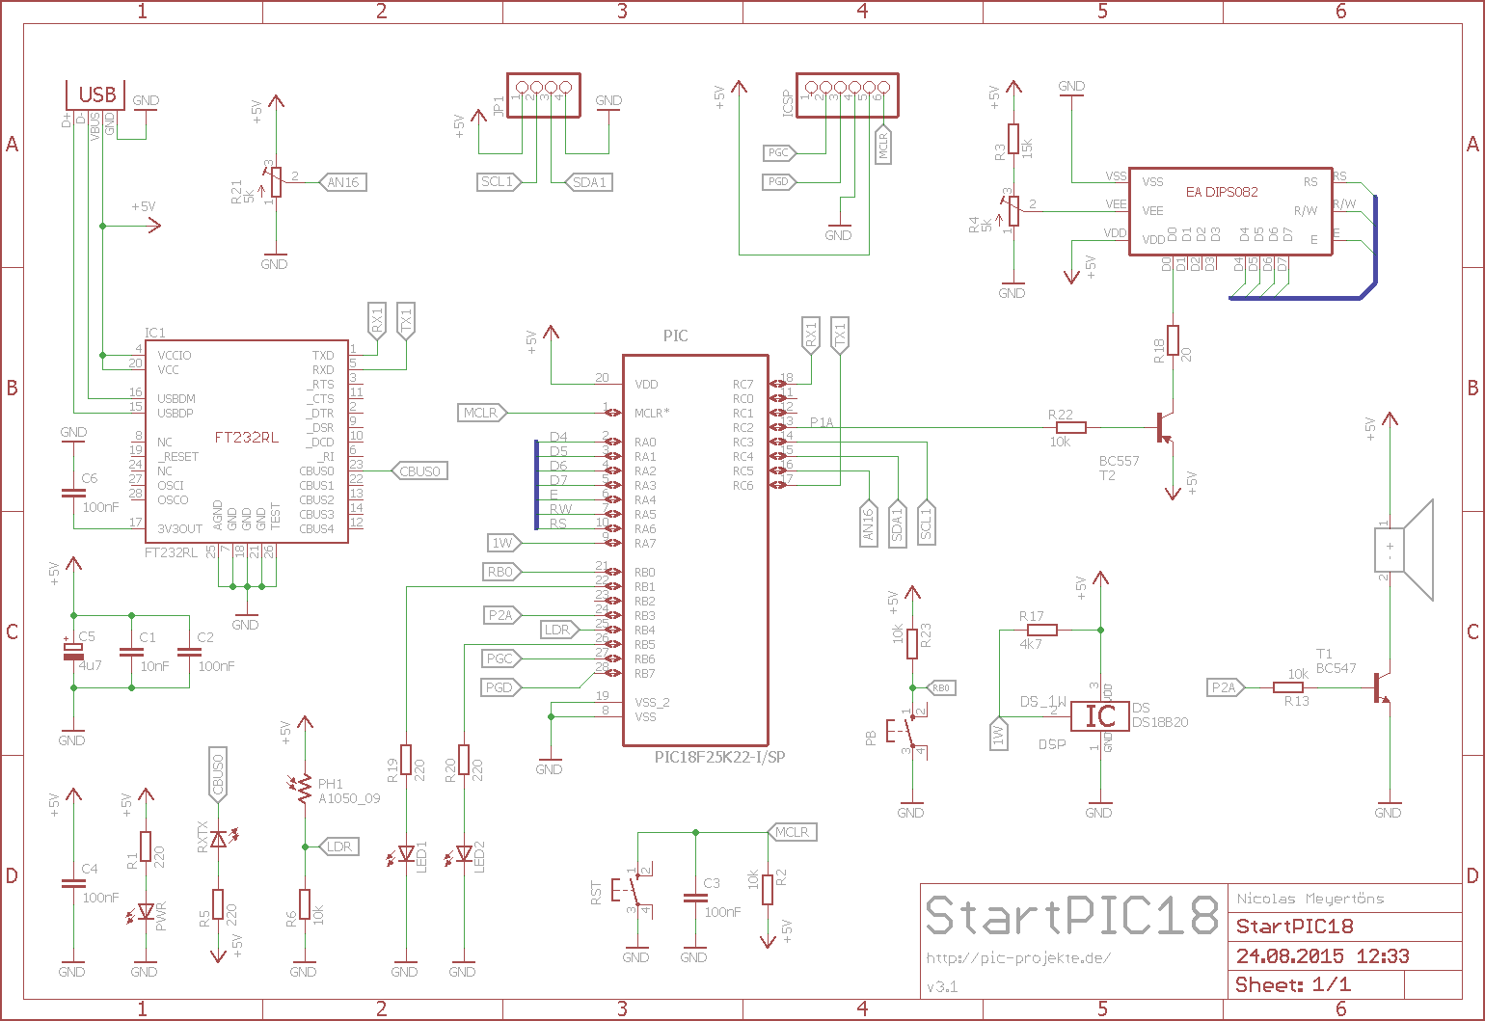

## Devices

All components of the StartPIC18 can be ordered from the distributor Reichelt. So that you do not have to search for every component yourself,

You will need a UBS cable for some applications where the programmer alone is not sufficient to power the StarPIC18* and for the data connection to the PC. If you don't have a mini-USB cable yet, you can also order it from ~~[Reichelt](https://web.archive.org/web/20201001033916/http:/www.reichelt.de/USB-Kabel/AK-673-A/3/index.html?&ACTION=3&LA=2&ARTICLE=45361&GROUPID=6099&artnr=AK+673-A&SEARCH=MINI+USB+KABEL)~~ for just under one euro.

* For example, the PICKit3 can provide a maximum of 30 mA of current.

## Preparations

To work with StartPIC18 you need the following things:

* PCB to StartPIC18
* Programmer (e.g. PICKit3 or PICKit2)

In order for us to be able to control the backlight of the display (sooner or later we want to regulate the lighting via PWM), the following **adjustments** must be made:

**Programming**

When you have made all preparations for the start PIC18 (all components equipped and the display adapted for PWM control), then you can work through all program examples. The examples you will find under the link refer (with a few exceptions) all to the StartPIC18 board, so that you can work without stumbling blocks. Together with my two tutorials, the [PIC18](https://web.archive.org/web/20201001033916/https:/pic-projekte.de/blog/pic18-tutorial-einleitung/) tutorial and the [PIC-C tutorial](https://web.archive.org/web/20201001033916/https:/pic-projekte.de/blog/pic-c-tutorial-einleitung/), you should get started into the microcontroller world well.

## Bootloader

There is a bootloader for PIC16 and PIC18. See application note AN1310, to transfer your firmware comfortably via USB (without additional programming device) to the PIC. Due to the fact that the StartPIC18 is aimed more at beginners,

## FAQ

Here is a collection of the most frequently asked questions about StartPIC18. If your question is not answered, it is best to report directly as a comment with your problem (writing as a guest is possible).

## What do I need to work with StartPIC18?

In addition to the StartPIC18 itself, you only need a programming device to transfer the programs to the PIC of the StartPIC18 and possibly a mini-USB cable. I recommend the [PICKit2](http://www.pickitplus.co.uk) from PICKitPlus for transferring programs. The programmer is not only good for the StartPIC18 – you can use it for all the projects you still want to realize. So a worthwhile investment.

## What can I do with the StartPIC18?

A good deal. It helps beginners take their first steps in the PIC microcontroller world. Even beyond the beginner's stage, there are plenty of possibilities. Have a look at the program examples. Here are many examples to use the possibilities of StartPIC18.If you work with BASIC to install the StartPIC18 with programs, then you will find in this repository some examples created with the Great Cow Basic compiler for the StartPIC18. In addition to the sample codes shown there, you need the entire Great Cow Basic Package for Windows.

## My program is not working, what can I do?

In this case, I would recommend that you report your problem via the appropriate forum. We then find out together what exactly is wrong.

## Why should I buy the StartPIC18 and not another development board?

You don't have to, but the StartPIC18 offers many possibilities for comparatively little money. As a rule, the start is rather bumpy, which is often due to the fact that the documentation is always written in English. Due to the very detailed documentation of the StartPIC18 on german you will find the ideal introduction to the world of microcontrollers.

## Can I use other PIC types?

But of course why? The PIC intended for the board can fully exploit all the possibilities of the board. If your ambitions are to know several controllers, then let me tell you that the different PIC hardly differ..

## Aren't the PIC18 types a bit fierce for a beginner?

## No.