For LT768x, we have serval development boards.

The schematics that I sent to you the other days is for an LT768x only board.

This board supports to connect MCU in 4-wire SPI, 8/16bits parallel interface.

In addition, there are two LCD connectors, 40Pin and 50Pin, for RGB panels.

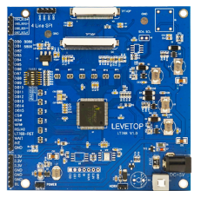 PCB size: 102 x 101.5 mm

There is similar board which only support 4-wire SPI and 8bits parallel interface and 40/50 pin LCD connector.

but its size is smaller. You may find the introduction document and schematics as attached.

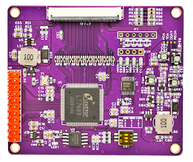 PCB size (50pin): 70x60mm

                                                      PCB size (40pin): 60x56mm