quu
buiuii

yuuu
 | vuuu  uyguty  on | 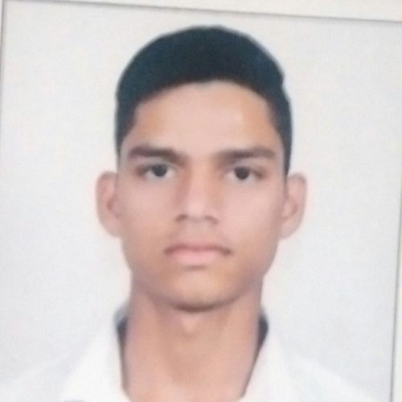
uuiug

It is certified that Mr. kd nifbu ibubf
of iiiu, iiih
has attended the uyguty on uuiug
held at quu.

yuuuygt | ygyugyu | yygu
(yytfrrtt) | (vyuu) | (yyi)

