EL-20 BIOS settings (Goal enable on board storage / Set to Legacy BIOS in Linux mode ):

DEL key during boot up to get us to Setup Utility:
1) First disable trusted computing (no hardware present)

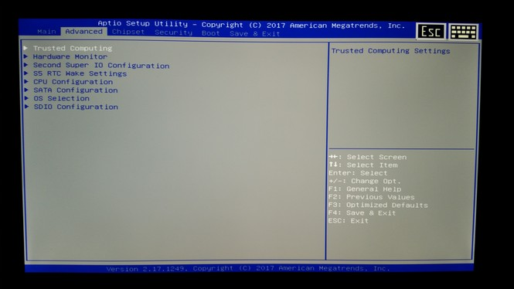
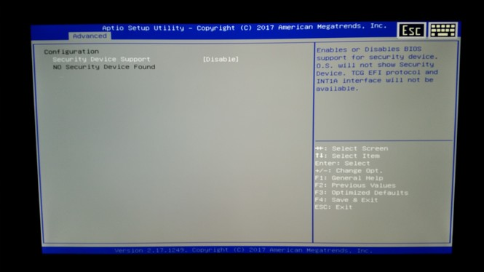

2) Lets enable BIOS mode and flip the Linux bit:

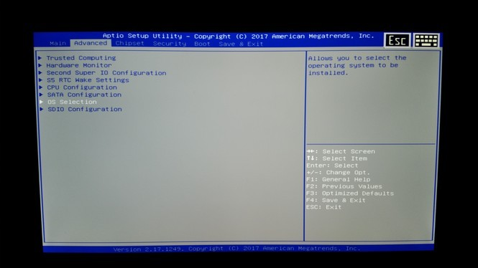

NOTE THE PXE OpROM setting:

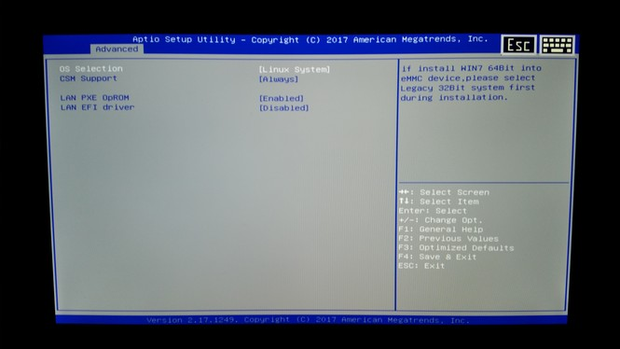

3) Head over to Chipset and let’s enable on-board storage:

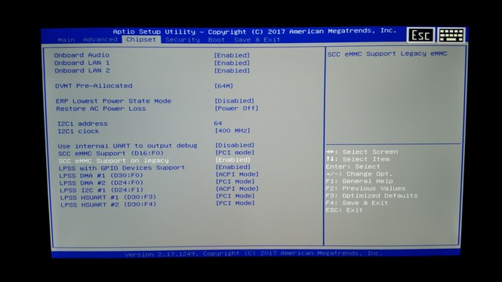
4) Head over to Boot. NOTE we can not set PXE at this point so hit F4 to Save and reboot

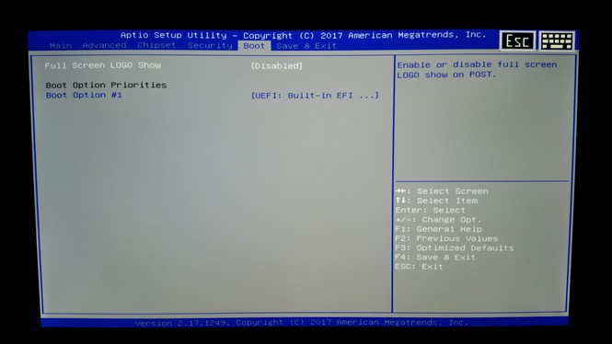

5) F4 to reboot with a SAVE and exit
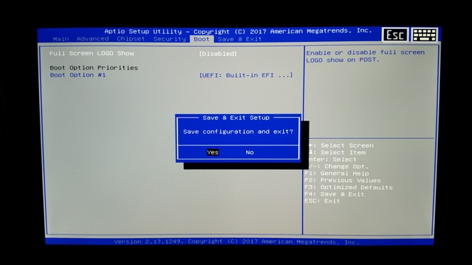
REBOOT happens here be ready for the
DEL key to get back into BIOS
Final step… Back to the Boot tab and alter to PXE boot on 003 with the MMC secondary. F4 for save and exit.

