**FITNESS TRACKING APP**

**-Abhay Gupta (23BCI0101)**

**-Pathak Hriday Avinash(23BCE0477)**

**Aim and Objective of the Project**

**Aim:**

The primary aim of this fitness tracking webpage is to provide users with a comprehensive and user-friendly platform to monitor and enhance their overall health and wellness. By enabling individuals to track key fitness activities such as sleep patterns, dietary habits, yoga practices, weightlifting routines, and cardiovascular exercises, the platform seeks to foster a disciplined and structured approach to health. The webpage is designed to encourage consistency in fitness practices, provide motivation through progress tracking, and help users achieve their fitness goals effectively.

Through the integration of multiple health aspects, users can gain a holistic view of their fitness journey, identifying strengths and areas for improvement. Additionally, the platform leverages data-driven insights to personalize recommendations, making the experience more engaging and result-oriented. Whether users are beginners or experienced fitness enthusiasts, this webpage aims to provide the necessary tools and resources to support their commitment to a healthier lifestyle.

**Objectives:**

1. **Track Progress:** The platform enables users to log and review their progress in various fitness domains, including sleep quality, dietary habits, yoga practices, weightlifting, and cardio routines. By maintaining detailed records of their fitness activities, users can monitor improvements over time, identify patterns, and make necessary adjustments to optimize their health journey. Regular progress tracking helps in staying accountable and maintaining motivation.

2. **Personalized Insights:** To enhance the user experience, the platform incorporates data-driven insights and analytics. By analyzing user inputs, the webpage provides personalized feedback and recommendations tailored to individual fitness goals. This feature allows users to make informed decisions, track calorie intake and expenditure, assess sleep quality, and evaluate the effectiveness of their exercise regimen. Custom insights also help users in modifying their routines to achieve better results.

3. **User-Friendly Interface:** A key focus of this platform is its intuitive and interactive user interface. Designed with simplicity and accessibility in mind, the webpage ensures seamless navigation and efficient tracking for all users, regardless of their technological proficiency. The interface will include easy-to-use dashboards, progress charts, and interactive elements that provide a smooth user experience. Mobile responsiveness and cross-platform compatibility will further enhance accessibility.

4. **Holistic Wellness Approach:** Unlike conventional fitness apps that focus solely on exercise or diet, this platform integrates multiple aspects of health and wellness, including sleep management, balanced nutrition, yoga, strength training, and cardiovascular workouts. By adopting a well-rounded approach, users can maintain a sustainable and balanced lifestyle, addressing all facets of their physical well-being. This holistic perspective ensures that users do not just focus on one aspect of fitness but cultivate overall health improvements.

5. **Goal Setting:** Setting clear, measurable goals is crucial for maintaining fitness motivation. The webpage allows users to set specific fitness targets, such as weight loss, muscle gain, endurance improvement, or better sleep patterns. Users can track their achievements over time and receive milestone notifications to celebrate their progress. This goal-oriented approach fosters motivation, helping users stay committed to their fitness journey.

**Flow Chart and Explanation**

**Flow Chart:**

**Explanation:**

1. **Homepage:**
   * The homepage serves as the landing page where users can explore the platform.
   * Key sections include "About Us," "Contact Us," and "Join Now."
   * The "Join Now" option directs users to a registration form where they input their name, age, sex, weight, and height.
   * The platform then calculates their Body Mass Index (BMI) and provides an initial fitness assessment.
2. **About Us:**
   * This section provides information about the purpose of the website, its benefits, and how users can utilize it to improve their fitness journey.
3. **Progress Section:**
   * This section is divided into multiple tracking categories, each providing users with tools to log and analyze their fitness activities:
   * **Sleep Tracking:**
     + Users enter their sleep time, wake-up time, and sleep quality.
     + JavaScript processes the inputs to calculate total sleep duration.
     + A bar graph (created using React) visualizes sleep trends.
     + Sleep data is stored on a calendar interface within the page.
   * **Diet Management:**
     + Users can select meals from a food library.
     + The system tracks protein, carbohydrates, and fat intake.
     + A calendar (implemented using JavaScript and React) logs daily dietary records.
   * **Yoga Tracking:**
     + Users can choose yoga exercises from a predefined list.
     + The system records total yoga duration and logs it on a calendar.
     + The platform generates consistency reports, highlighting the most frequently practiced yoga routines.
   * **Weight Training and Cardio Tracking:**
     + Similar to yoga, users log their weight training and cardio sessions.
     + Data is stored in a calendar, and the system tracks workout consistency and trends.

By integrating these objectives into a single, cohesive platform, this fitness tracking webpage aims to be a valuable tool for individuals seeking to improve their health and wellness. With a focus on ease of use, comprehensive tracking, and personalized insights, users can take control of their fitness journey and work towards a healthier lifestyle with confidence.

**Modules/Functionalities & Their Explanation:**

**1. Homepage**

* The **Homepage** serves as the entry point of the fitness tracking platform.
* It includes key sections such as:
  + **About Us** – Provides an overview of the website’s purpose and benefits.
  + **Contact Us** – Allows users to get in touch for queries or feedback.
  + **Join Now** – Enables new users to register and create a fitness profile.

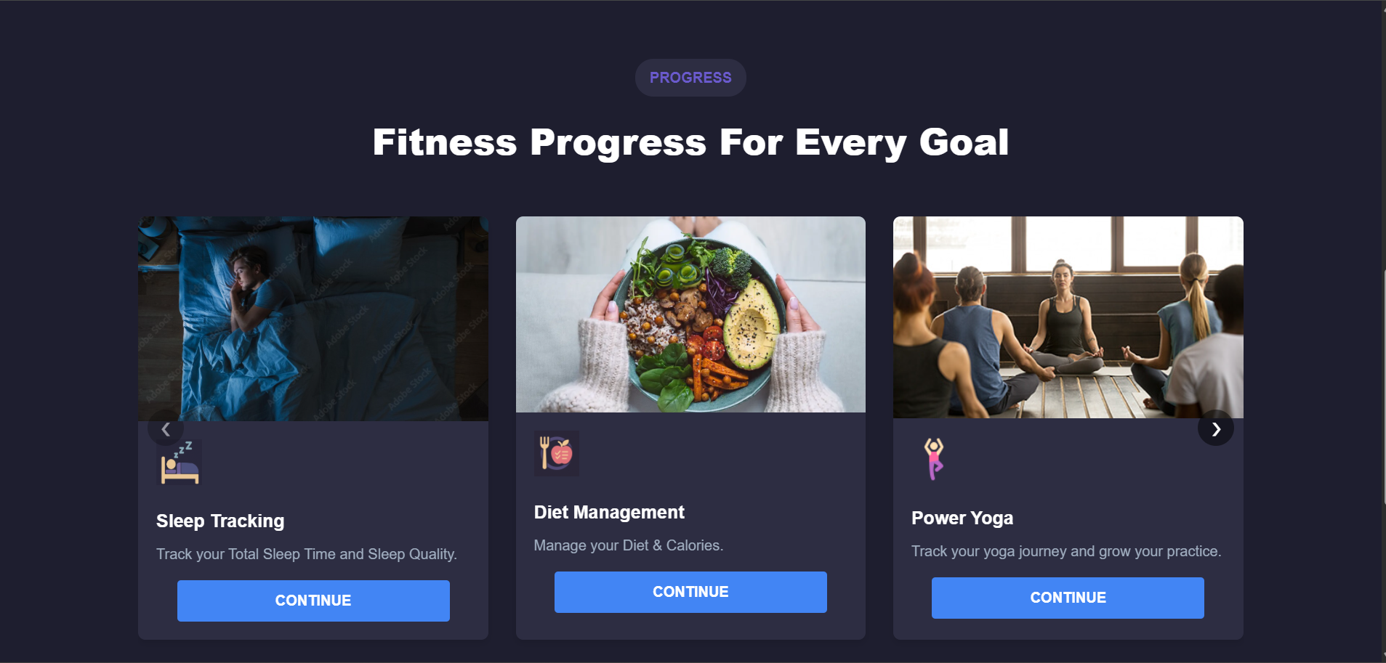

**2. User Registration & BMI Calculation (Join Now Module)**

* When a user clicks "Join Now," they are redirected to a registration page.
* Users need to enter their **Name, Age, Sex, Weight, and Height**.
* The **BMI (Body Mass Index)** is automatically calculated based on weight and height.
* This helps users understand their fitness level before they start tracking progress.

**3. Sleep Tracking Module**

**Functionalities:**

Users input **sleep time, wake-up time, and sleep quality.**  
 JavaScript calculates the **total sleep duration** based on inputs.  
 A **bar graph (React-based)** displays sleep patterns.  
 Data is stored in a **calendar** for tracking historical sleep records.

**How HTML, CSS, JS & React Helped:**

🔹 **HTML** – Created the input fields for **sleep time, wake-up time, and sleep quality**.  
🔹 **CSS** – Styled the page for a **clean UI**, including a **responsive design** for different devices.  
🔹 **JavaScript** –

* Captured **user inputs** and computed **total sleep duration** dynamically.
* Used the **Date object** to calculate sleep time differences.  
  🔹 **React** –
* Rendered **bar graphs** for sleep trends.
* Implemented a **calendar view** to store and display sleep records.

**4. Diet Management Module**

**Functionalities:**

Users select **meals from a food library.**  
 The system calculates **total protein, carbohydrates, and fat intake.**  
 Data is saved in a **calendar** for meal tracking.

**How HTML, CSS, JS & React Helped:**

🔹 **HTML** – Provided dropdowns & selection options for **food items from the library**.  
🔹 **CSS** – Designed a **clear and organized layout** for food tracking.  
🔹 **JavaScript** –

* Handled **meal selection logic** and **macronutrient calculations.**
* Implemented **local storage** or a temporary database to save food logs.
* Allowed users to **view/edit past meal logs using a calendar component.**

**5. Yoga Tracking Module**

**Functionalities:**

Users choose **yoga exercises from a list** and log their practice time.  
The system records **most practiced yoga poses.**

Consistency is tracked with a **calendar-based record.**

**How HTML, CSS, JS & React Helped:**

🔹 **HTML** – Created a **dropdown menu** for users to select yoga exercises.  
🔹 **CSS** – Designed **aesthetic yoga tracking cards** for better UX.  
🔹 **JavaScript** –

* Captured **session duration** and computed **most practiced yoga pose.**
* Stored **yoga records** for **daily, weekly, and monthly analysis.**  
  🔹 **React** –
* Used **React Calendar** to display yoga history.

**6. Weight Training & Cardio Module**

**Functionalities:**

Users log **workout type, duration, and intensity.**  
 System tracks **progress over time** using graphical representation.  
 Data is stored in a **calendar for reference.**

**How HTML, CSS, JS & React Helped:**

🔹 **HTML** – Built input fields for users to enter **workout type, weight lifted, reps, and duration.**  
🔹 **CSS** – Designed a **modern fitness UI.**

🔹 **JavaScript** –

* Captured **exercise details** and calculated **total calories burned.**
* Used **event listeners** to update progress dynamically.  
  🔹 **React** –
* Created a **dashboard for tracking past workout sessions.**

**Key Role of React in Enhancing Functionalities**

**React’s Component-Based Architecture** enabled modular development for **Sleep, Diet, Yoga, and Workout Tracking.**  
**React Calendar** stored & displayed **daily progress records.**

**Final Summary**

Each fitness module—**Sleep, Diet, Yoga, and Weight Training**—leveraged **HTML, CSS, JavaScript, and React** for a seamless and interactive experience.  
🔹 **JavaScript** handled logic (calculations, validations).  
🔹 **React** ensured **fast updates, graphs, and interactive UI.**  
🔹 **Calendars & Charts** improved **progress visualization.**

This combination makes the **fitness tracking webpage** an efficient, user-friendly, and **data-driven** platform for monitoring **health and wellness.**