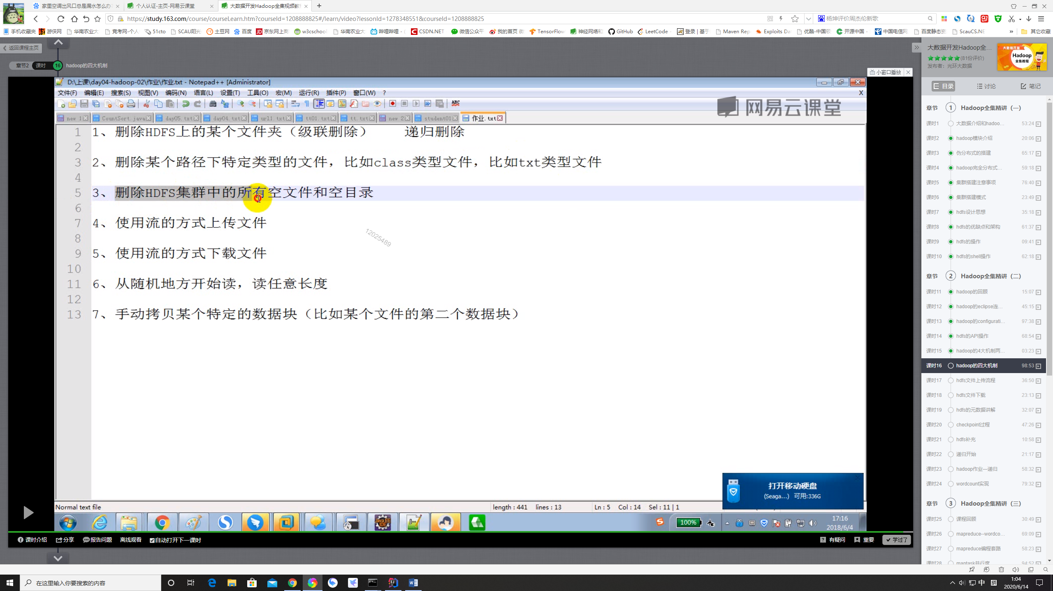

1. hadoop fs -rm –rf \

3、

//删除空文件和空目录

public static void Checkfiles(FileSystem fs, Path path) throws Exception {

// Configuration configuration = new Configuration();

// FileSystem fs = FileSystem.get(new URI("hdfs://localhost:9000"), configuration, "zhang");//分布式文件系统

//

// Path path = new Path("/");

FileStatus[] listStatus = fs.listStatus(path);

if (listStatus.length <= 0) {

fs.delete(path, false);

} else {

for (FileStatus fileStatus : listStatus) {

//为文件

if (fileStatus.isFile()) {

if (fileStatus.getLen() <= 0)

fs.delete(fileStatus.getPath(), false);

} else {//为文件夹

Checkfiles(fs, fileStatus.getPath());

}

}

}

listStatus = fs.listStatus(path);

if (listStatus.length <= 0) {

fs.delete(path, false);

}

}

4、5、6

public static void IOHDFS() throws Exception {

Configuration configuration = new Configuration();

FileSystem fs = FileSystem.get(new URI("hdfs://localhost:9000"), configuration, "zhang");//分布式文件系统

//文件上传：本地（输入流）-----》hdfs（输出流）

//本地的输入流：普通的输入流 hdfs输出流：hdfs专用的输出流,必须指定一个文件名

FileInputStream in = new FileInputStream(new File("C:\\Users\\zhang\\Desktop\\XX.pdf"));

FSDataOutputStream fsDataOutputStream = fs.create(new Path("/IOs/jianli.pdf"));

IOUtils.copyBytes(in, fsDataOutputStream, 4096);

//文件下载

FSDataInputStream fsDataInputStream = fs.open(new Path("/IOs/jianli.pdf"));

FileOutputStream fileOutputStream = new FileOutputStream(new File("C:\\Users\\zhang\\Desktop\java.pdf"));

IOUtils.copyBytes(fsDataInputStream,fileOutputStream,4096);

fs.close();

}