**NETWORK PROGRAMMING**

**Lab Assignment- 4**

**(UCS413)**



**Submitted By:**

Name: Rishabh Jain

Roll Number: 102083054

**Q1)**

**TCP Server:**

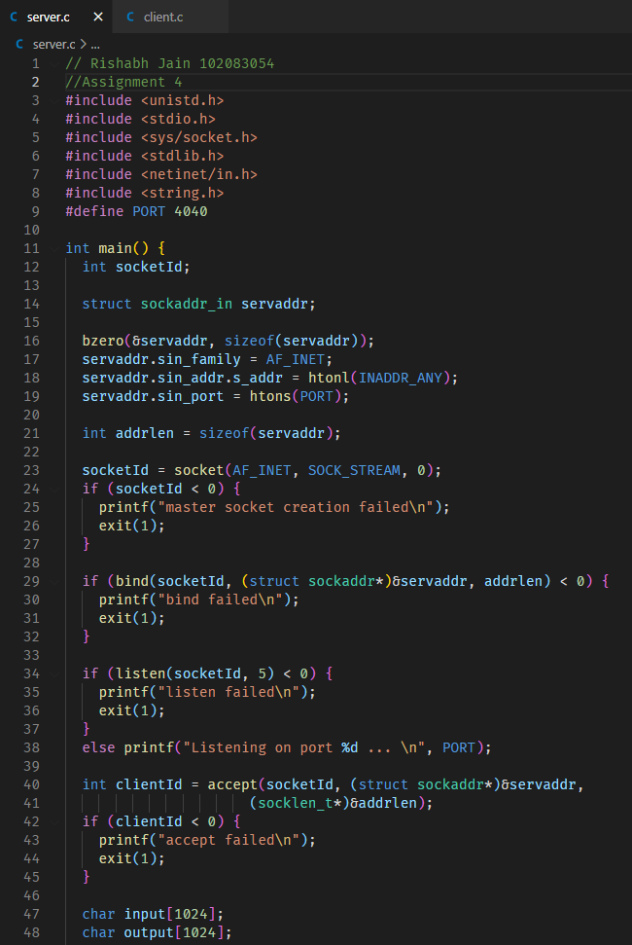

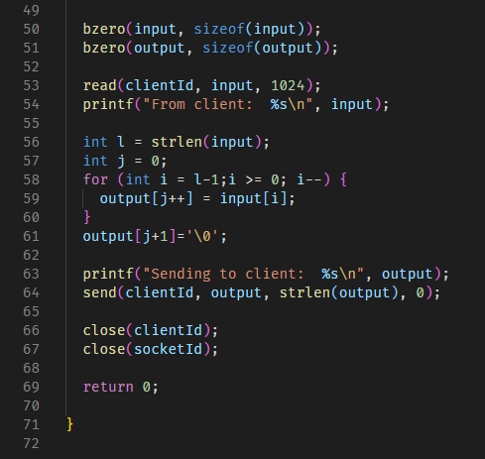

**TCP Client:**

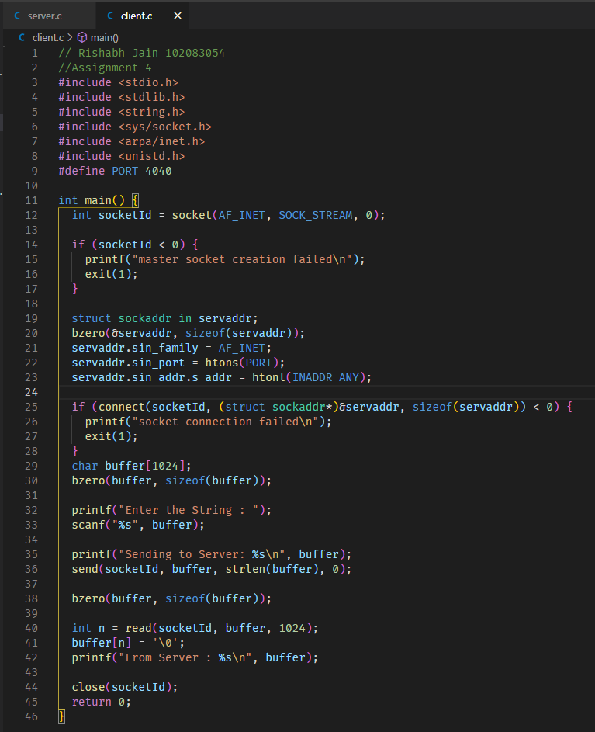

**Output:**

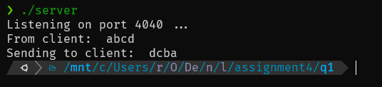

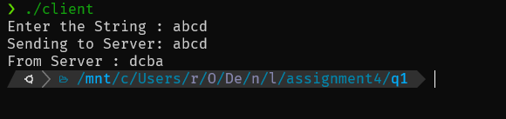

**Q2)**