**NETWORK PROGRAMMING**

**Lab Assignment- 7**

**(UCS413)**



**Submitted By:**

Name: Rishabh Jain

Roll Number: 102083054

**Q1) Multicasting:**

**Server:**

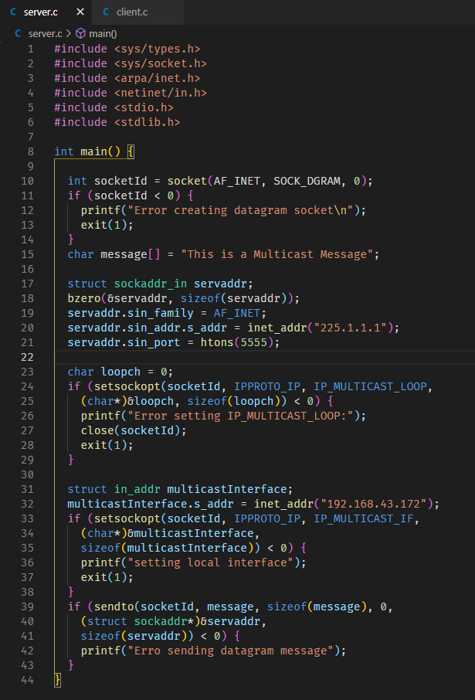

**Client:**

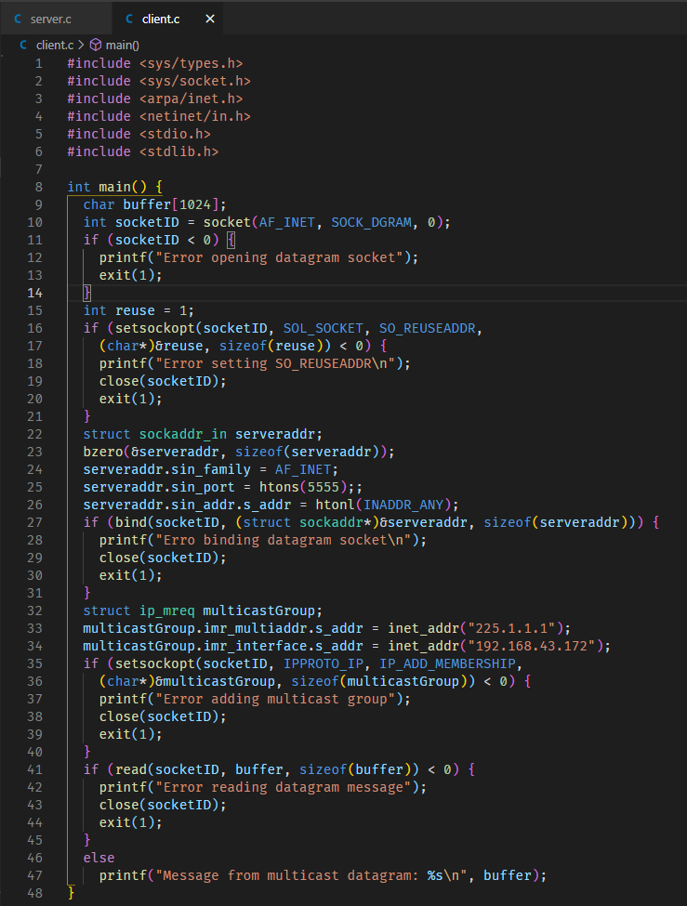

**Q2) Broadcasting:**

**Server:**

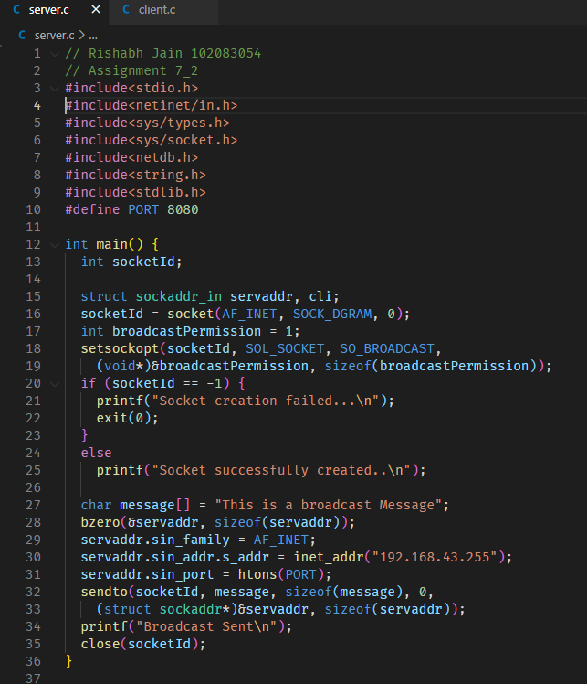

**Client:**

