OTA流程

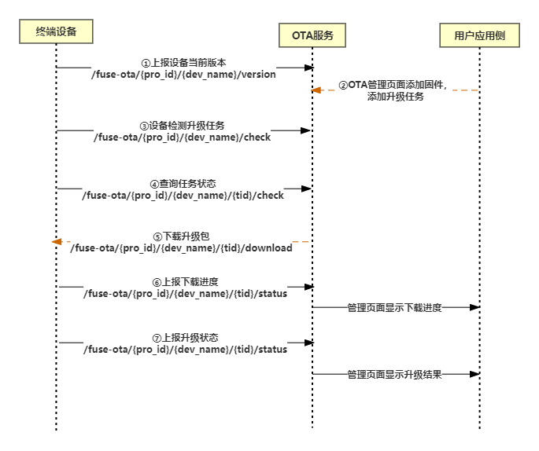

服务器：iot-api.heclouds.com:80

s_version：MCU单片机的版本号

f_version：模块的版本号

1. 上报设备版本号: 1

发送示例： 1

接收：315字节 1

2. 检测升级任务 2

发送示例： 2

接收 ： 2

3. 下载升级包 3

发送示例： 3

4. AT指令实现(1) 3

5. AT指令实现(2) 4

6. 文件夹程序使用流程 5

**简易效果图：** 6

# 上报设备版本号:

## 发送示例：

（下划线加粗字体为需要修改的地方）

（保留原有空行，一般最后都要俩回车换行）

POST /fuse-ota**/RUUPvSGLQd**/**One**/version HTTP/1.1

Content-Type:application/json

Authorization:**version=2022-05-01&res=userid%2F447128&et=1969281206&method=md5&sign=E9gCDQbH30%2BFhkm0xqkbxg%3D%3D**

host:iot-api.heclouds.com

Content-Length:41

{"s_version":"V1.0", "f_version": "V1.0"}

## 接收：315字节

HTTP/1.1 200 OK

Date: Sun, 27 Jul 2025 09:44:14 GMT

Content-Type: application/json;charset=UTF-8

Content-Length: 71

Connection: keep-alive

Access-Control-Allow-Headers: *

Access-Control-Allow-Origin: *

Server: nginx

Pragma: no-cache

{"code":0,"msg":"succ","request_id":"7fd4360bcde44d4a869b65563220f6a4"}

# 检测升级任务

## 发送示例：

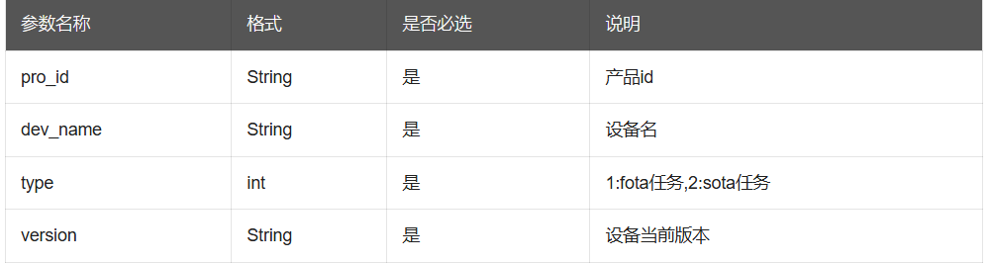

GET /fuse-ota/**RUUPvSGLQd**/**One**/check?type=**2**&version=1.0 HTTP/1.1

Content-Type:application/json

Authorization: **version=2022-05-01&res=userid%2F447128&et=1969281206&method=md5&sign=E9gCDQbH30%2BFhkm0xqkbxg%3D%3D**

host:iot-api.heclouds.com

## 接收 ：

（1）无任务时：324

HTTP/1.1 200 OK

Date: Sun, 27 Jul 2025 10:27:19 GMT

Content-Type: application/json;charset=UTF-8

Content-Length: 80

Connection: keep-alive

Access-Control-Allow-Headers: *

Access-Control-Allow-Origin: *

Server: nginx

Pragma: no-cache

{"code":12012,"msg":"not exist","request_id":"b7a39f99f56640f897ba00f343e4c9b4"}

（2）有任务：429

HTTP/1.1 200 OK

Date: Sun, 27 Jul 2025 10:42:25 GMT

Content-Type: application/json;charset=UTF-8

Content-Length: 184

Connection: keep-alive

Access-Control-Allow-Headers: *

Access-Control-Allow-Origin: *

Server: nginx

Pragma: no-cache

{"code":0,"msg":"succ","data":{"target":"v1.2","tid":1241932,"size":14832,"md5":"99bedb46e3982c4176a57cd3ae907d97","status":1,"type":1},"request_id":"28fb1cb200764703b45305324345bdeb"}

# 下载升级包

## 发送示例：

GET /fuse-ota/**RUUPvSGLQd**/**One**/ **1241932**/download HTTP/1.1

Authorization: **version=2022-05-01&res=userid%2F447128&et=1969281206&method=md5&sign=E9gCDQbH30%2BFhkm0xqkbxg%3D%3D**

host:iot-api.heclouds.com

Range:bytes=0-255

# AT指令实现(1)

（以下指令实现仅针对A区，但Bootloader同理）

1. AT+RST 复位
2. AT+CWMODE=1 设置为station模式
3. AT+CWJAP="axx","hjh1008611" 联网
4. AT+CIPSTART="TCP","iot-api.heclouds.com",80 建立TCP连接
5. AT+CIPMODE=1 设置为透传模式
6. AT+CIPSEND 进入 Wi-Fi 透传模式
7. 然后发送如示例中的信息

上传版本号

POST /fuse-ota/RUUPvSGLQd/One/version HTTP/1.1\r\n

Content-Type:application/json\r\n

Authorization:version=2022-05-01&res=userid%2F447128&et=1969281206&method=md5&sign=E9gCDQbH30%2BFhkm0xqkbxg%3D%3D\r\n

host:iot-api.heclouds.com\r\n

Content-Length:41\r\n

\r\n

{"s_version":"v1.0", "f_version": "V1.0"}\r\n\r\n

检测升级任务

GET /fuse-ota/RUUPvSGLQd/One/check?type=2&version=1.0 HTTP/1.1

Content-Type:application/json

Authorization: version=2022-05-01&res=userid%2F447128&et=1969281206&method=md5&sign=E9gCDQbH30%2BFhkm0xqkbxg%3D%3D

host:iot-api.heclouds.com\r\n\r\n

1. +++ 退出透传

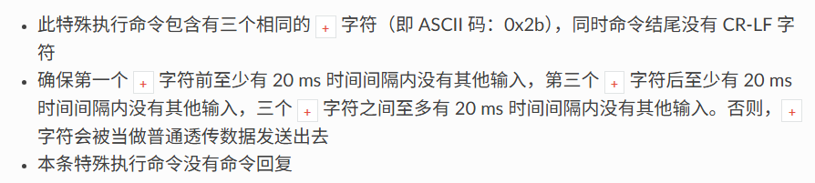

1. AT+CIPCLOSE 关闭TCP连接

# AT指令实现(2)

1. AT+RST 复位
2. AT+CWMODE=1 设置为station模式
3. AT+CWJAP="axx","hjh1008611" 联网
4. AT+CIPSTART="TCP","iot-api.heclouds.com",80 建立TCP连接
5. AT+CIPSEND=287(后面数字代表将要发送数据的字节数)
6. 上传版本号

POST /fuse-ota/RUUPvSGLQd/One/version HTTP/1.1\r\n

Content-Type:application/json\r\n

Authorization:version=2022-05-01&res=userid%2F447128&et=1969281206&method=md5&sign=E9gCDQbH30%2BFhkm0xqkbxg%3D%3D\r\n

host:iot-api.heclouds.com\r\n

Content-Length:41\r\n

\r\n

{"s_version":"v1.0", "f_version": "V1.0"}\r\n\r\n

1. AT+CIPSEND=242
2. 检测升级任务

GET /fuse-ota/RUUPvSGLQd/One/check?type=2&version=1.0 HTTP/1.1\r\n

Content-Type:application/json\r\n

Authorization: version=2022-05-01&res=userid%2F447128&et=1969281206&method=md5&sign=E9gCDQbH30%2BFhkm0xqkbxg%3D%3D\r\n

host:iot-api.heclouds.com\r\n\r\n

# 文件夹程序使用流程

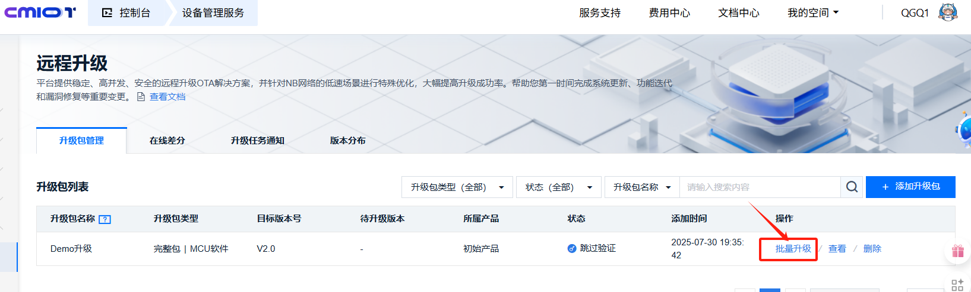

每次实验前同样需要点一次批量升级，因为一个设备只能升级一次。

**简易效果图：**

