Graphical Analysis and Visualization of Sorting and Fibonacci Algorithms

1. Objective
The objective of this analysis is to visually compare the performance of different sorting and Fibonacci algorithms. Graphs are used to analyze the relationship between input size, execution time, and memory consumption.
The visualizations help in understanding how algorithm performance changes as the input size increases and how different input conditions affect sorting algorithms.

2. Graph Generation Code
The experimental results obtained from the sorting and Fibonacci algorithms were visualized using the Matplotlib library. The following code was used to generate graphs comparing execution time and memory usage.
import matplotlib.pyplot as plt
import pandas as pd
The experimental result data was organized using Pandas DataFrames and then plotted using Matplotlib.

2.1 Sorting Algorithms Execution Time Graph
The following code was used to generate the execution time comparison graph for the sorting algorithms using random input data.
random_data = sorting_df[
sorting_df["Input Condition"] == "Random"
]

plt.figure(figsize=(10, 6))

for algorithm in random_data["Algorithm"].unique():

algorithm_data = random_data[
random_data["Algorithm"] == algorithm
]

plt.plot(
algorithm_data["Input Size"],
algorithm_data["Execution Time (seconds)"],
marker="o",
label=algorithm
)

plt.xlabel("Input Size")
plt.ylabel("Execution Time (seconds)")
plt.title("Sorting Algorithms: Execution Time vs Input Size (Random Data)")
plt.legend()
plt.grid(True)

plt.savefig(
"graphs/sorting_execution_time_random.png",
bbox_inches="tight"
)

plt.show()
This graph compares the execution time of Bubble Sort, Insertion Sort, Merge Sort, and Quick Sort for different input sizes using random input data.

2.2 Sorting Algorithms Memory Usage Graph
The following code was used to generate the memory usage comparison graph for sorting algorithms.
plt.figure(figsize=(10, 6))

for algorithm in random_data["Algorithm"].unique():

algorithm_data = random_data[
random_data["Algorithm"] == algorithm
]

plt.plot(
algorithm_data["Input Size"],
algorithm_data["Memory Usage (KB)"],
marker="o",
label=algorithm
)

plt.xlabel("Input Size")
plt.ylabel("Peak Memory Usage (KB)")
plt.title("Sorting Algorithms: Memory Usage vs Input Size (Random Data)")
plt.legend()
plt.grid(True)

plt.savefig(
"graphs/sorting_memory_usage_random.png",
bbox_inches="tight"
)

plt.show()
This graph compares the peak memory usage of the sorting algorithms for different input sizes.

2.3 Sorting Algorithms Under Different Input Conditions
The following code was used to compare the execution time of each sorting algorithm under sorted, reverse-sorted, and random input conditions.
sorting_algorithms = [
"Bubble Sort",
"Insertion Sort",
"Merge Sort",
"Quick Sort"
]

for algorithm in sorting_algorithms:

algorithm_data = sorting_df[
sorting_df["Algorithm"] == algorithm
]

plt.figure(figsize=(10, 6))

for condition in algorithm_data["Input Condition"].unique():

condition_data = algorithm_data[
algorithm_data["Input Condition"] == condition
]

plt.plot(
condition_data["Input Size"],
condition_data["Execution Time (seconds)"],
marker="o",
label=condition
)

plt.xlabel("Input Size")
plt.ylabel("Execution Time (seconds)")
plt.title(
f"{algorithm}: Execution Time Under Different Input Conditions"
)
plt.legend()
plt.grid(True)

filename = (
algorithm.lower()
.replace(" ", "_")
+ "_conditions.png"
)

plt.savefig(
f"graphs/{filename}",
bbox_inches="tight"
)

plt.show()
This code generates separate graphs for Bubble Sort, Insertion Sort, Merge Sort, and Quick Sort under different input conditions.

2.4 Fibonacci Algorithms Execution Time Graph
The following code was used to generate the execution time comparison graph for Recursive Fibonacci, Iterative Fibonacci, and Dynamic Programming Fibonacci.
plt.figure(figsize=(10, 6))

for algorithm in fibonacci_df["Algorithm"].unique():

algorithm_data = fibonacci_df[
fibonacci_df["Algorithm"] == algorithm
]

plt.plot(
algorithm_data["Input Size (n)"],
algorithm_data["Execution Time (seconds)"],
marker="o",
label=algorithm
)

plt.xlabel("Input Size (n)")
plt.ylabel("Execution Time (seconds)")
plt.title("Fibonacci Algorithms: Execution Time vs Input Size")
plt.legend()
plt.grid(True)

plt.savefig(
"graphs/fibonacci_execution_time.png",
bbox_inches="tight"
)

plt.show()
This graph compares how the execution time of the three Fibonacci algorithms changes as the value of n increases.

2.5 Fibonacci Algorithms Memory Usage Graph
The following code was used to generate the memory usage comparison graph for the Fibonacci algorithms.
plt.figure(figsize=(10, 6))

for algorithm in fibonacci_df["Algorithm"].unique():

algorithm_data = fibonacci_df[
fibonacci_df["Algorithm"] == algorithm
]

plt.plot(
algorithm_data["Input Size (n)"],
algorithm_data["Memory Usage (KB)"],
marker="o",
label=algorithm
)

plt.xlabel("Input Size (n)")
plt.ylabel("Peak Memory Usage (KB)")
plt.title("Fibonacci Algorithms: Memory Usage vs Input Size")
plt.legend()
plt.grid(True)

plt.savefig(
"graphs/fibonacci_memory_usage.png",
bbox_inches="tight"
)

plt.show()
This graph compares the peak memory usage of Recursive Fibonacci, Iterative Fibonacci, and Dynamic Programming Fibonacci.

3. Sorting Algorithms: Execution Time Analysis
The following graph compares the execution time of Bubble Sort, Insertion Sort, Merge Sort, and Quick Sort for different input sizes using random input data.
The execution time of each algorithm was measured experimentally. The graph demonstrates the effect of increasing input size on the performance of different sorting algorithms.

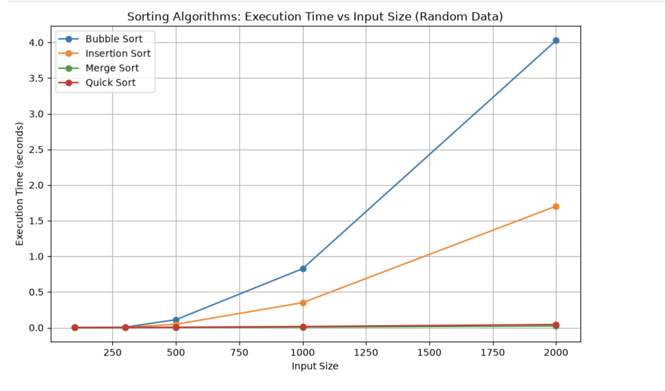
Execution Time Comparison of Sorting Algorithms for Random Input Data

Observation
The graph shows that the execution time of the sorting algorithms changes as the input size increases. Bubble Sort and Insertion Sort generally show a faster increase in execution time because their average-case time complexity is O(n²).
Merge Sort and Quick Sort generally scale more efficiently for larger input sizes because their average-case complexity is O(n log n).
The experimental results demonstrate the practical difference between quadratic and logarithmic-linear sorting algorithms.

4. Sorting Algorithms: Memory Usage Analysis
The following graph compares the peak memory usage of the sorting algorithms for different input sizes using random input data.
Memory usage was measured using the Python tracemalloc module.

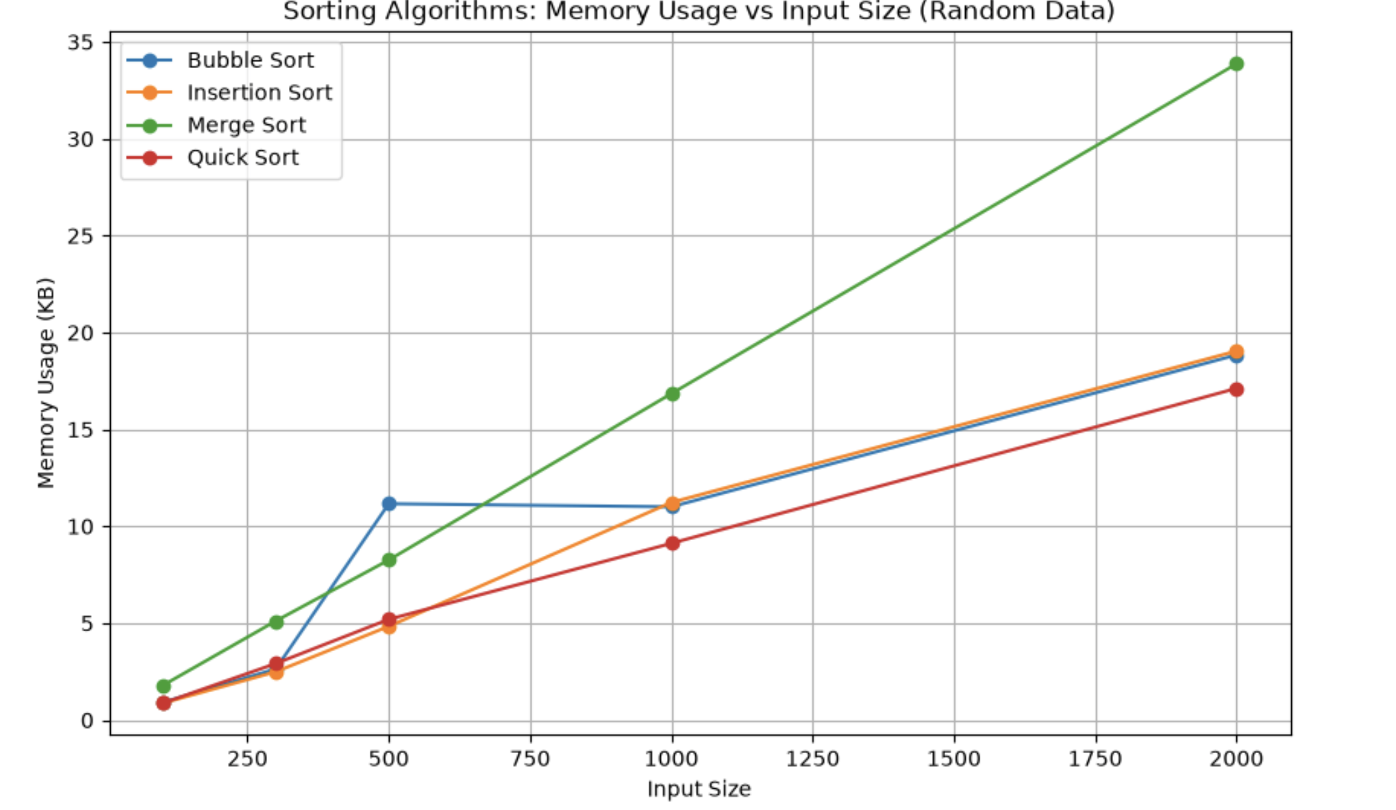

Memory Usage Comparison of Sorting Algorithms for Random Input Data

Observation
The graph demonstrates that different algorithms require different amounts of additional memory during execution.
Merge Sort generally requires additional memory because temporary arrays are created during the merging process.
Bubble Sort and Insertion Sort generally require less additional memory because they perform most operations directly within the original array.
Quick Sort requires additional memory due to recursive function calls and partitioning operations.

5. Bubble Sort Under Different Input Conditions
The following graph shows the execution time of Bubble Sort for sorted, reverse-sorted, and random input data.
This comparison demonstrates how the initial arrangement of elements affects the performance of Bubble Sort.
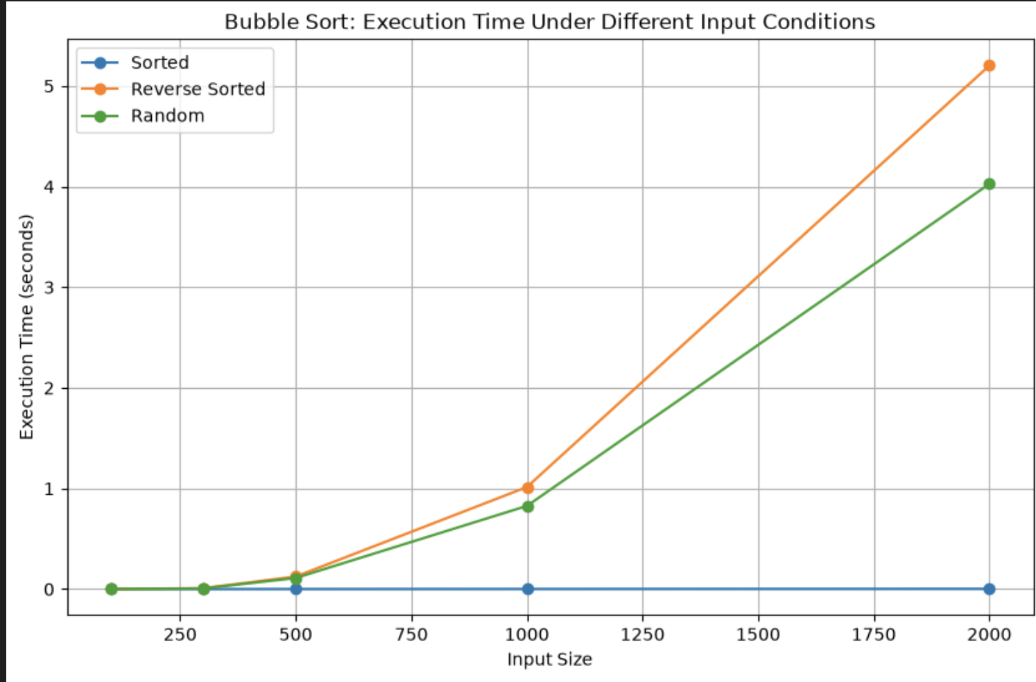

Bubble Sort Execution Time Under Different Input Conditions

Observation
Insertion Sort generally performs well when the input data is already sorted or nearly sorted because fewer element shifts are required.
Reverse-sorted input generally requires more shifting operations, increasing execution time.
The graph demonstrates that the initial arrangement of the data can significantly affect the practical performance of Insertion Sort.

6. Insertion Sort Under Different Input Conditions
The following graph compares the execution time of Insertion Sort for sorted, reverse-sorted, and random input data.
Insertion Sort builds a sorted portion of the array by taking one element at a time and inserting it into its correct position.
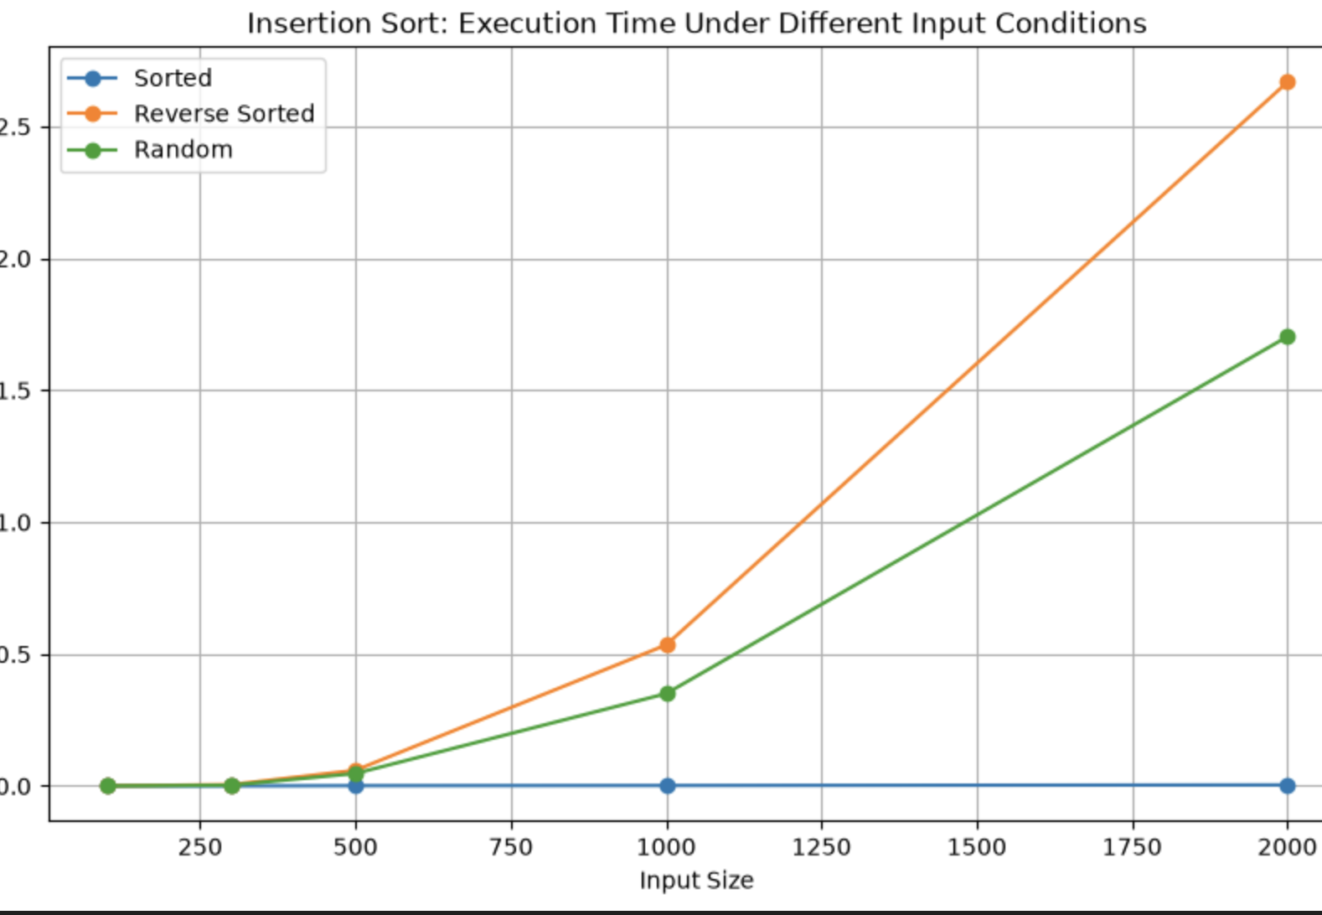Insertion Sort Execution Time Under Different Input Conditions

Observation
The experimental results show that the performance of Insertion Sort is affected by the initial arrangement of the input data.
For sorted input data, Insertion Sort performs efficiently because each element is already in its correct position. Therefore, very few comparisons and no significant shifting operations are required. This represents the best-case behavior of the algorithm.
For reverse-sorted input data, Insertion Sort requires the maximum number of shifting operations because each new element must be moved towards the beginning of the sorted portion. Therefore, reverse-sorted data generally requires more execution time and represents the worst-case behavior.
For random input data, the execution time generally lies between the sorted and reverse-sorted cases. The number of comparisons and shifts depends on how far each element is from its correct position.
The graph demonstrates that the initial order of the input data has a significant effect on the practical performance of Insertion Sort. The theoretical best-case time complexity of Insertion Sort is O(n) for already sorted data, while the average-case and worst-case time complexities are O(n²).

Conclusion
Insertion Sort is efficient for small datasets and performs particularly well when the input data is already sorted or nearly sorted. However, its performance becomes less efficient as the input size increases, especially for reverse-sorted and randomly ordered data.
The experimental results support the theoretical complexity analysis and demonstrate how input conditions influence the execution time of Insertion Sort.

7. Merge Sort Under Different Input Conditions
The following graph shows the performance of Merge Sort under sorted, reverse-sorted, and random input conditions.
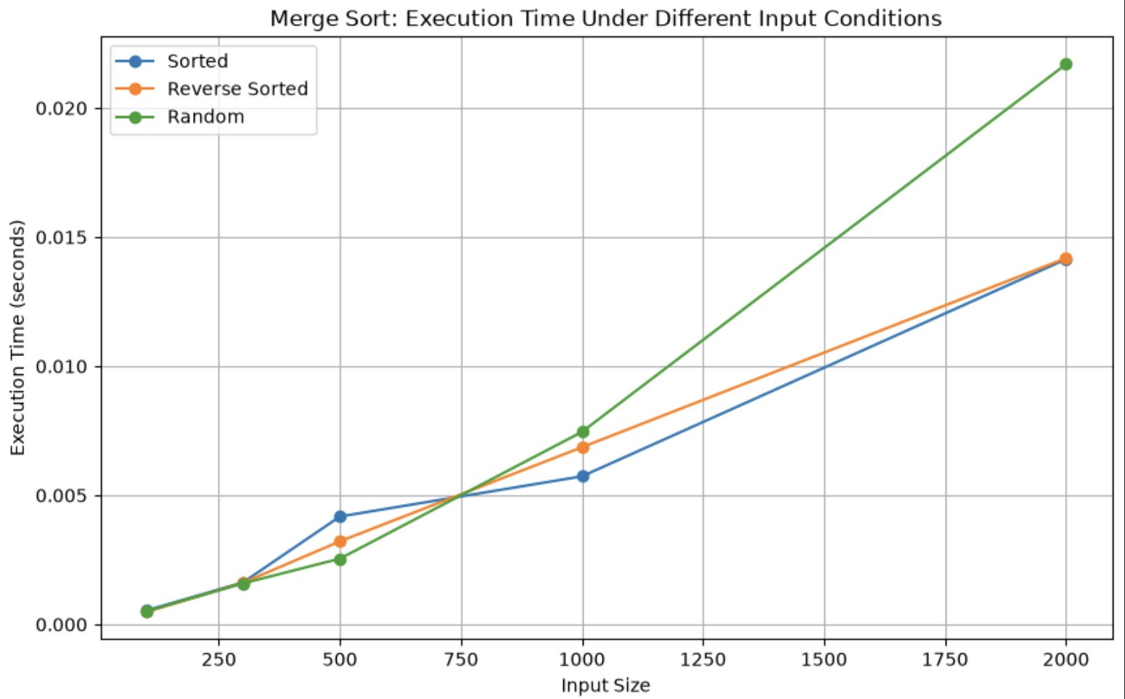Merge Sort Execution Time Under Different Input Conditions

Observation
Merge Sort provides relatively consistent performance across different input conditions.
Its divide-and-conquer approach ensures that the input is repeatedly divided into smaller subproblems and merged in a structured manner.
Therefore, the initial order of the input data has less effect on its overall performance compared with Bubble Sort and Insertion Sort.

8. Quick Sort Under Different Input Conditions
The following graph compares Quick Sort performance for sorted, reverse-sorted, and random input data.
The experimental implementation uses a middle-element pivot strategy.
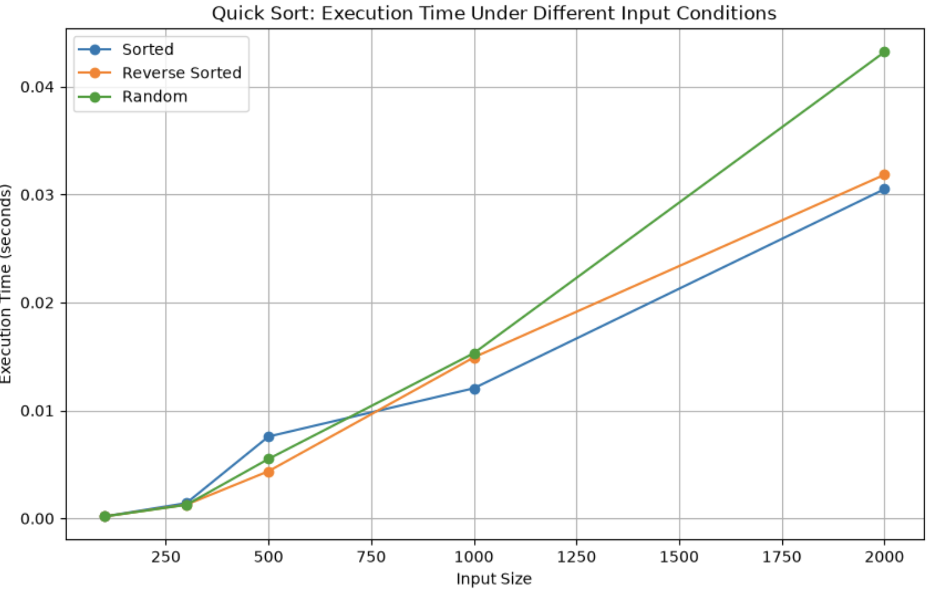

Quick Sort Execution Time Under Different Input Conditions

Observation
Quick Sort performance depends on pivot selection and the distribution of input values.
The implementation used in the experiment selects a middle element as the pivot. This reduces the possibility of highly unbalanced partitions for sorted and reverse-sorted input data.
Therefore, the experimental graph may show relatively stable performance across the tested input conditions. The theoretical worst-case complexity of Quick Sort remains O(n²) when highly unbalanced partitions occur.

9. Fibonacci Algorithms: Execution Time Analysis
The following graph compares the execution time of Recursive Fibonacci, Iterative Fibonacci, and Dynamic Programming Fibonacci.

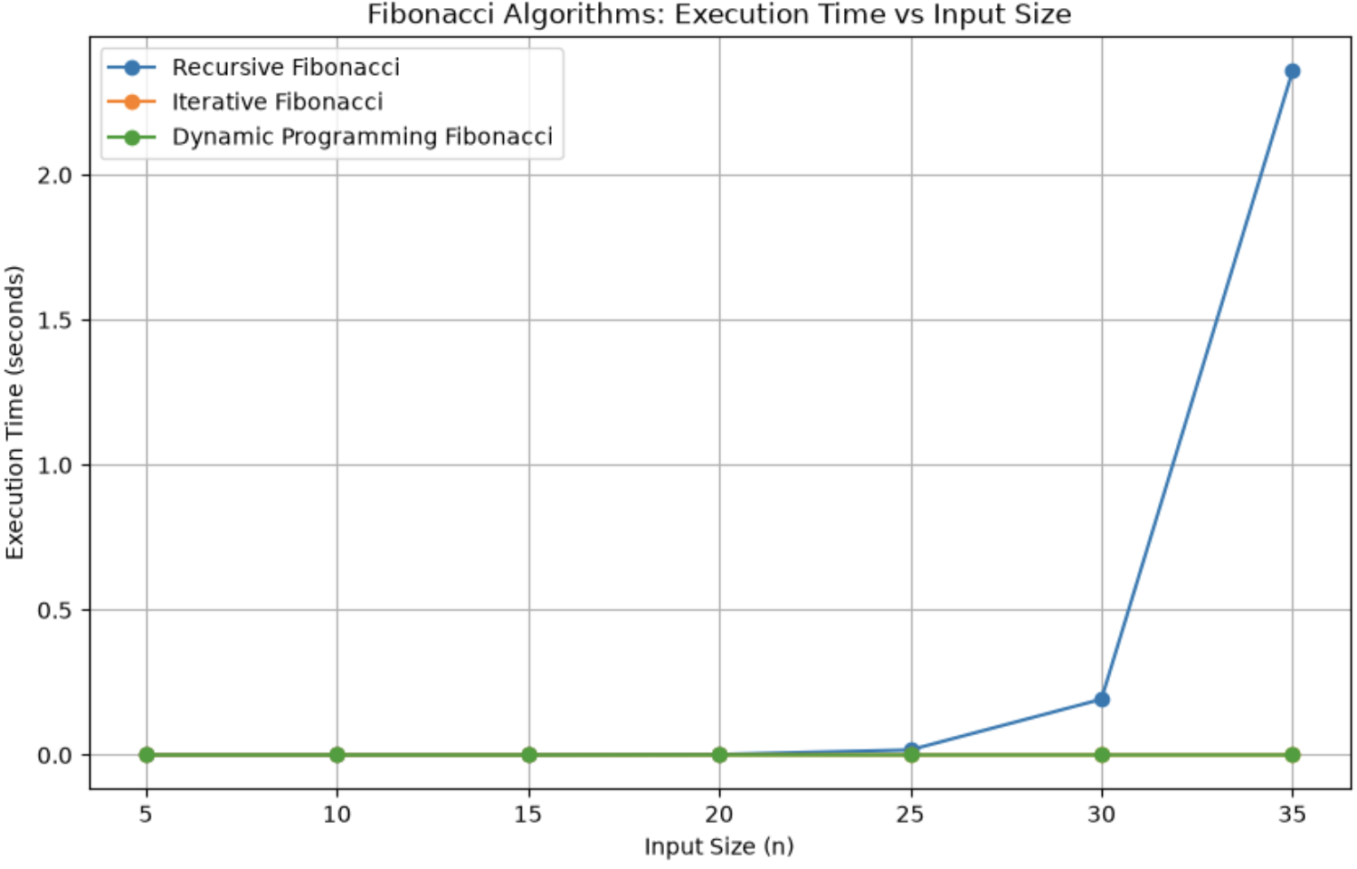
Execution Time Comparison of Fibonacci Algorithms

10. Fibonacci Algorithms: Memory Usage Analysis
The following graph compares the memory consumption of the three Fibonacci implementations.
Memory Usage Comparison of Fibonacci Algorithms
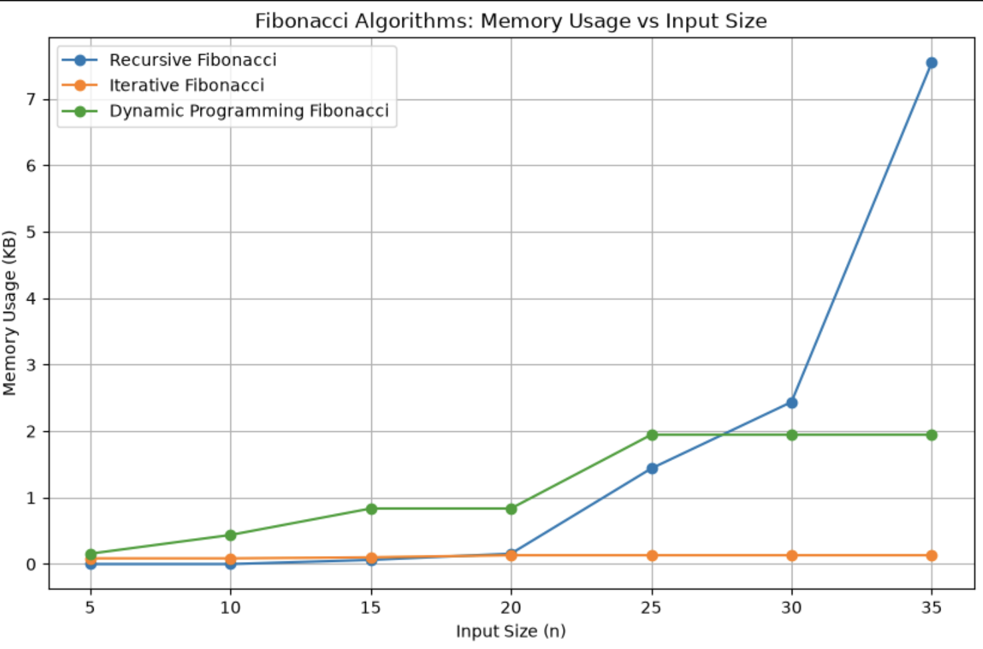
Memory Usage Comparison of Fibonacci Algorithms

Observation
The recursive Fibonacci implementation uses additional memory because multiple recursive function calls are stored in the call stack.
The iterative implementation generally requires minimal additional memory because it uses only a few variables.
Dynamic Programming Fibonacci may require more memory than the iterative approach because previously calculated values are stored for reuse.
The graph demonstrates that improving execution time can sometimes require additional memory.

11. Overall Observations
The graphical analysis demonstrates the relationship between theoretical algorithm complexity and practical performance.
- Execution time generally increases as the input size increases.
- Bubble Sort and Insertion Sort show higher growth in execution time for larger input sizes because of their quadratic time complexity.
- Merge Sort provides more consistent performance across different input conditions because of its O(n log n) time complexity.
- Quick Sort generally provides efficient performance, but its performance depends on pivot selection.
- Input conditions have a significant effect on Bubble Sort and Insertion Sort.
- Recursive Fibonacci becomes inefficient for larger input values because the same subproblems are repeatedly calculated.
- Iterative and Dynamic Programming Fibonacci algorithms provide significantly better execution time for larger input values.
- Memory consumption differs between algorithms depending on whether temporary arrays, recursive calls, or memoization structures are used.

12. Conclusion
The graphs and visualizations provide a clear representation of the performance differences between the implemented algorithms.
The experimental results show that algorithm efficiency is strongly influenced by input size, input conditions, and implementation strategy.
Sorting algorithms with O(n²) complexity become less suitable as input size increases, while O(n log n) algorithms generally scale more efficiently.
For Fibonacci computation, the recursive approach becomes significantly slower for larger values of n, whereas iterative and dynamic programming approaches provide better performance.
Overall, the graphical analysis confirms the importance of selecting algorithms based on both execution time and memory requirements.

13. GitHub Repository Link
The complete source code used for generating the experimental results and visualizations is available in the following GitHub repository:
GitHub Repository:
https://github.com/Greaty01/Algorithm-Efficiency-Analysis-Repository

The repository contains the complete Jupyter Notebook, sorting and Fibonacci algorithm implementations, graph-generation code, generated visualizations, and CSV result files.

