Complexity Comparison of Sorting and Fibonacci Algorithms

1. Objective
The objective of this comparison is to analyze the theoretical time and space complexities of all implemented sorting and Fibonacci algorithms. The algorithms are compared based on their best-case, average-case, worst-case, and space complexities.

2. Performance Measurement and Complexity Analysis Code
The following Python code was used to measure the execution time and peak memory usage of the implemented algorithms. The measured experimental results were then compared with the theoretical best-case, average-case, worst-case, and space complexities.
import time
import tracemalloc
def measure_performance(func, *args):
tracemalloc.start()

start_time = time.perf_counter()

result = func(*args)

end_time = time.perf_counter()

current_memory, peak_memory = tracemalloc.get_traced_memory()

tracemalloc.stop()

execution_time = end_time - start_time
memory_usage_kb = peak_memory / 1024

return result, execution_time, memory_usage_kb
The measure_performance() function accepts an algorithm and its input arguments. It records the execution time using time.perf_counter() and measures the peak memory usage using tracemalloc.

3. Complexity Comparison Code
The following code was used to organize the theoretical complexity information into a comparison table.
import pandas as pd

complexity_data = {
"Algorithm": [
"Bubble Sort",
"Insertion Sort",
"Merge Sort",
"Quick Sort",
"Recursive Fibonacci",
"Iterative Fibonacci",
"Dynamic Programming Fibonacci"
],

"Best Case": [
"O(n)",
"O(n)",
"O(n log n)",
"O(n log n)",
"O(2ⁿ)",
"O(n)",
"O(n)"
],

"Average Case": [
"O(n²)",
"O(n²)",
"O(n log n)",
"O(n log n)",
"O(2ⁿ)",
"O(n)",
"O(n)"
],

"Worst Case": [
"O(n²)",
"O(n²)",
"O(n log n)",
"O(n²)",
"O(2ⁿ)",
"O(n)",
"O(n)"
],

"Space Complexity": [
"O(1)",
"O(1)",
"O(n)",
"O(log n)",
"O(n)",
"O(1)",
"O(n)"
]
}

complexity_df = pd.DataFrame(complexity_data)

complexity_df
This code creates a Pandas DataFrame containing the theoretical complexity comparison of all implemented sorting and Fibonacci algorithms.

4. Complexity Comparison Table
The following table compares the computational complexities of the implemented algorithms.

Sorting Algorithms and Fibonacci Algorithms
Algorithm | Best Case | Average Case | Worst Case | Space Complexity
Bubble Sort | O(n) | O(n²) | O(n²) | O(1)
Insertion Sort | O(n) | O(n²) | O(n²) | O(1)
Merge Sort | O(n log n) | O(n log n) | O(n log n) | O(n)
Quick Sort | O(n log n) | O(n log n) | O(n²) | O(log n)
Recursive Fibonacci | O(2ⁿ) | O(2ⁿ) | O(2ⁿ) | O(n)
Iterative Fibonacci | O(n) | O(n) | O(n) | O(1)
Dynamic Programming Fibonacci | O(n) | O(n) | O(n) | O(n)

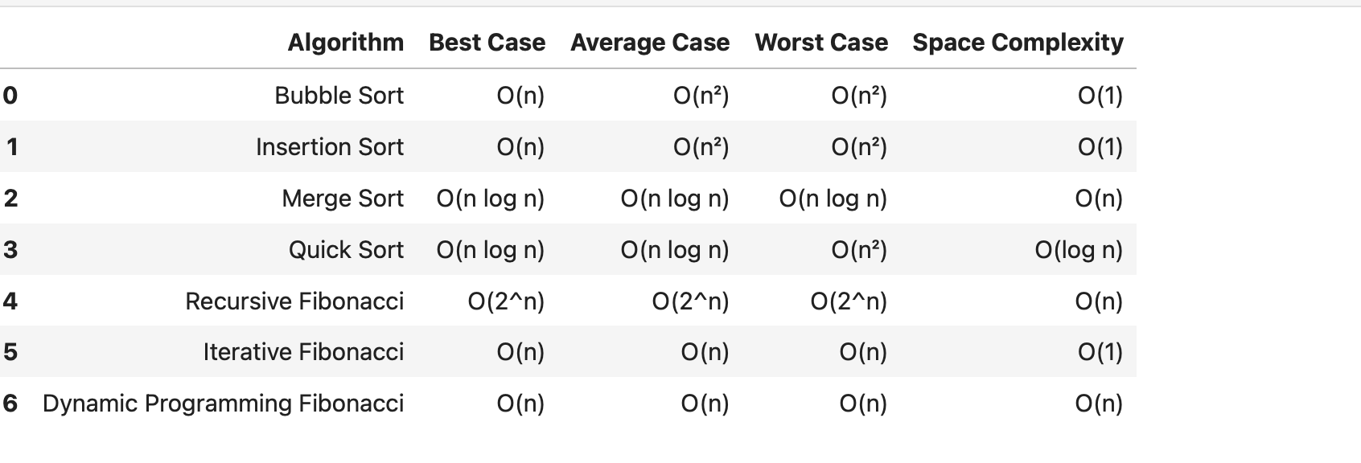

5. Analysis of Sorting Algorithm Complexities

Bubble Sort
Bubble Sort has a best-case time complexity of O(n) when the input data is already sorted and the optimized implementation detects that no swaps are required. Its average-case and worst-case time complexities are O(n²). Bubble Sort requires O(1) additional space because it performs sorting in place.

Insertion Sort
Insertion Sort has a best-case time complexity of O(n) when the input data is already sorted. In the average and worst cases, its time complexity is O(n²). It requires O(1) additional space because only a small number of variables are used during execution.

Merge Sort
Merge Sort has a time complexity of O(n log n) in the best, average, and worst cases. Its performance is more consistent than Bubble Sort and Insertion Sort for larger input sizes. However, Merge Sort requires O(n) additional space because temporary arrays are created during the merging process.

Quick Sort
Quick Sort has a best-case and average-case time complexity of O(n log n). However, its worst-case time complexity is O(n²) when highly unbalanced partitions occur. The performance of Quick Sort depends on the pivot selection strategy. The experimental implementation used a middle-element pivot to reduce the possibility of highly unbalanced partitions.

6. Analysis of Fibonacci Algorithm Complexities

Recursive Fibonacci
Recursive Fibonacci has exponential time complexity, O(2ⁿ), because it repeatedly calculates the same subproblems. As the value of n increases, the number of recursive function calls increases rapidly. The recursive implementation requires O(n) space because of the recursion call stack.

Iterative Fibonacci
Iterative Fibonacci has O(n) time complexity because the algorithm calculates each Fibonacci value sequentially only once. It requires O(1) additional space because only a few variables are used.

Dynamic Programming Fibonacci
Dynamic Programming Fibonacci has O(n) time complexity because previously calculated Fibonacci values are stored and reused instead of being recalculated. The implementation requires O(n) additional space for storing the computed values.

7. Comparison and Discussion
The complexity comparison shows that the choice of algorithm has a significant effect on performance as the input size increases.
Bubble Sort and Insertion Sort have quadratic time complexity in their average and worst cases. Therefore, their execution time increases rapidly when larger input sizes are used.
Merge Sort provides O(n log n) time complexity in all cases, making its performance more consistent for different input conditions. The trade-off is its O(n) additional space requirement.
Quick Sort generally provides efficient performance with O(n log n) best and average-case complexity. However, its theoretical worst case is O(n²), which can occur when pivot selection produces highly unbalanced partitions.
For Fibonacci computation, Recursive Fibonacci is significantly less efficient for larger input values because of its exponential time complexity and repeated calculations.
Iterative Fibonacci and Dynamic Programming Fibonacci both provide O(n) time complexity. The iterative approach requires less additional memory, while the dynamic programming approach stores computed values to avoid repeated calculations.

8. Conclusion
The theoretical complexity comparison supports the experimental analysis performed in this assignment. Algorithms with lower time complexity generally scale better as the input size increases.
Among the sorting algorithms, Merge Sort and Quick Sort provide better scalability than Bubble Sort and Insertion Sort for larger input sizes. However, memory requirements and input characteristics must also be considered.
For Fibonacci computation, the Iterative and Dynamic Programming approaches are more efficient than the Recursive approach for larger values of n. The comparison demonstrates the importance of considering both time complexity and space complexity when selecting an appropriate algorithm.

Experimental Results Supporting the Complexity Comparison
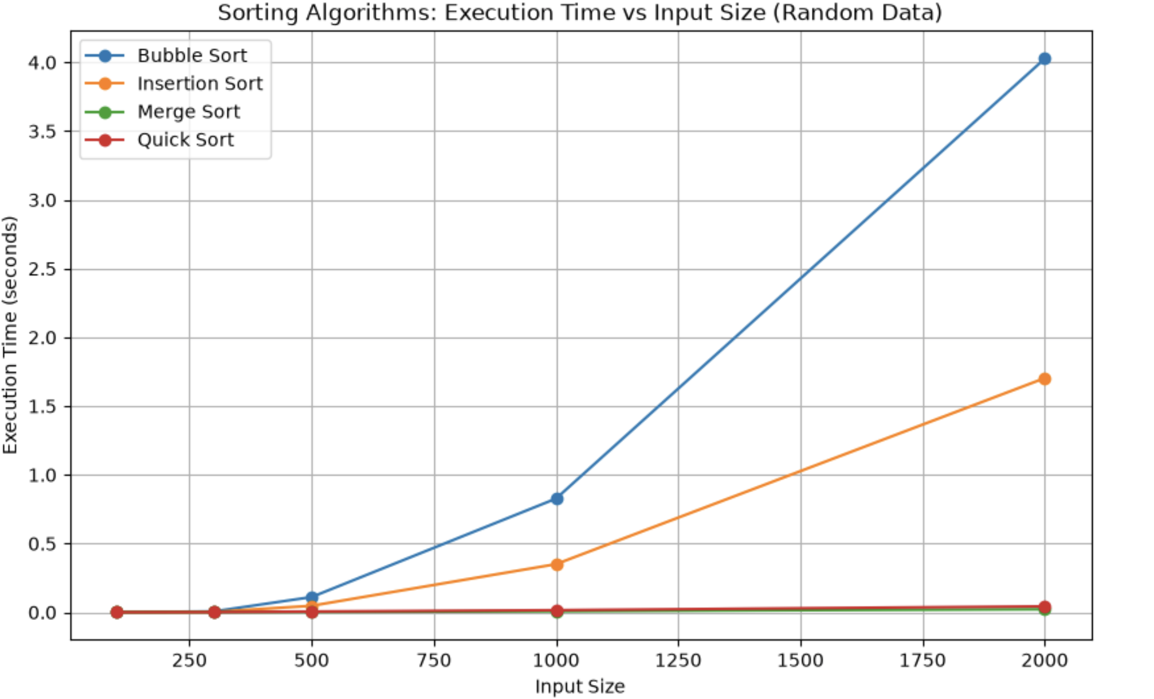

Experimental comparison of sorting algorithm execution time for different input sizes.
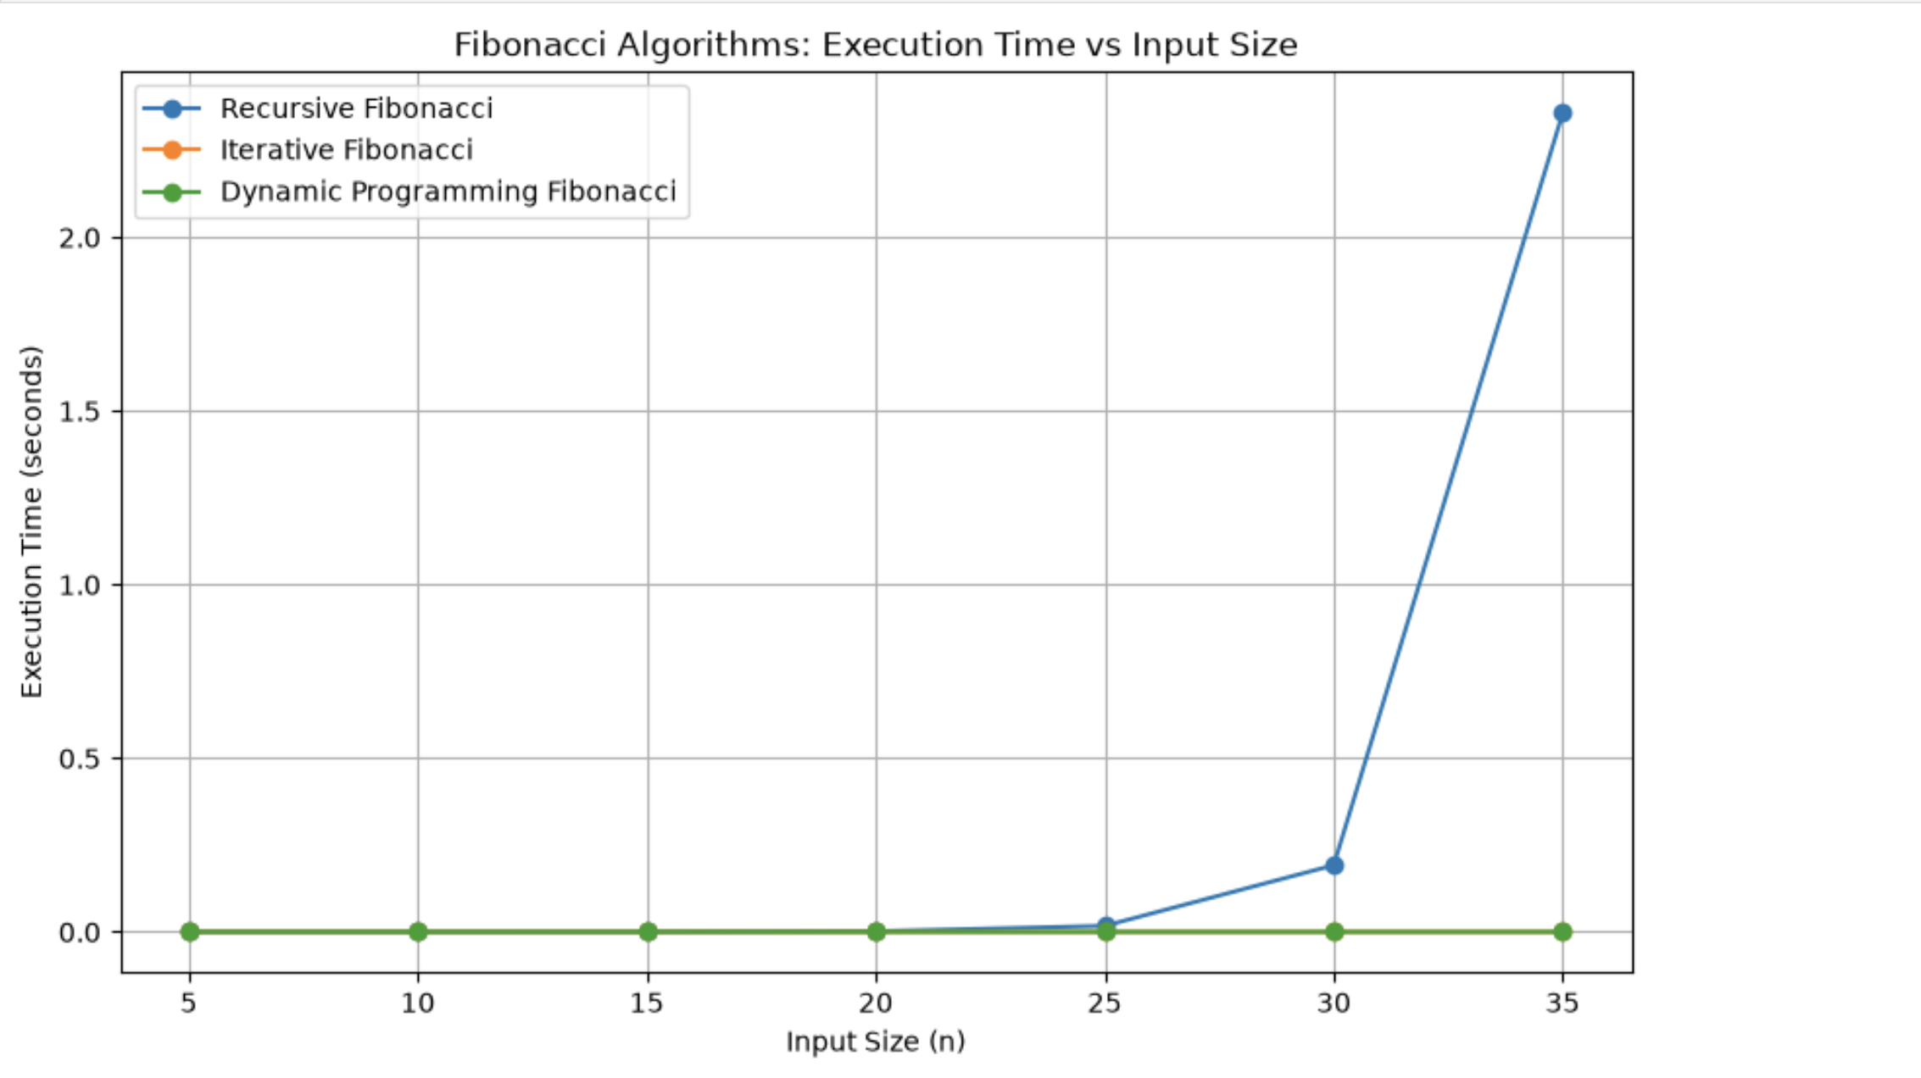

GitHub Repository Link
The complete source code, performance measurement implementation, complexity comparison data, experimental results, and generated graphs used in this analysis are available in the following GitHub repository:
GitHub Repository:
https://github.com/Greaty01/Algorithm-Efficiency-Analysis-Repository
The repository contains the complete Jupyter Notebook implementing the sorting and Fibonacci algorithms, the performance measurement code, CSV result files, complexity comparison data, and generated visualizations.

