Experimental Analysis of Sorting and Fibonacci Algorithms

- Objective

To perform experimental analysis of different sorting and Fibonacci algorithms using different input sizes and input conditions. The execution time and memory usage of each algorithm are measured, recorded, and compared.

- Experimental Setup

The experiments were performed using Python 3.12.9 in a Jupyter Notebook environment. The execution time of each algorithm was measured using Python's time.perf_counter() function. Peak memory usage was measured using the tracemalloc module.

Sorting Algorithms Tested
- Bubble Sort
- Insertion Sort
- Merge Sort
- Quick Sort

Fibonacci Algorithms Tested
- Recursive Fibonacci
- Iterative Fibonacci
- Dynamic Programming Fibonacci

3. Algorithm Implementation
The following sorting and Fibonacci algorithms were implemented in Python for the experimental analysis. Each algorithm was tested for correctness before performing the performance experiments.

3.1 Bubble Sort
Bubble Sort repeatedly compares adjacent elements and swaps them if they are in the incorrect order. The optimized implementation stops early when no swaps are required.
def bubble_sort(arr):
arr = arr.copy()
n = len(arr)

for i in range(n):
swapped = False

for j in range(0, n - i - 1):
if arr[j] > arr[j + 1]:
arr[j], arr[j + 1] = arr[j + 1], arr[j]
swapped = True

if not swapped:
break

return arr

3.2 Insertion Sort
Insertion Sort builds a sorted portion of the array by inserting each element into its correct position.
def insertion_sort(arr):
arr = arr.copy()

for i in range(1, len(arr)):
key = arr[i]
j = i - 1

while j >= 0 and arr[j] > key:
arr[j + 1] = arr[j]
j -= 1

arr[j + 1] = key

return arr

3.3 Merge Sort
Merge Sort uses the divide-and-conquer approach. The array is divided into smaller subarrays, which are recursively sorted and then merged.
def merge(left, right):
result = []
i = 0
j = 0

while i < len(left) and j < len(right):
if left[i] <= right[j]:
result.append(left[i])
i += 1
else:
result.append(right[j])
j += 1

result.extend(left[i:])
result.extend(right[j:])

return result

def merge_sort(arr):
if len(arr) <= 1:
return arr

mid = len(arr) // 2

left = merge_sort(arr[:mid])
right = merge_sort(arr[mid:])

return merge(left, right)

3.4 Quick Sort
Quick Sort uses a divide-and-conquer strategy by selecting a pivot element and partitioning the array around it. A middle-element pivot strategy was used in this implementation.
def partition(arr, low, high):
mid = (low + high) // 2

arr[mid], arr[high] = arr[high], arr[mid]

pivot = arr[high]

i = low - 1

for j in range(low, high):
if arr[j] <= pivot:
i += 1
arr[i], arr[j] = arr[j], arr[i]

arr[i + 1], arr[high] = arr[high], arr[i + 1]

return i + 1

def quick_sort_recursive(arr, low, high):
if low < high:
pivot_index = partition(arr, low, high)

quick_sort_recursive(arr, low, pivot_index - 1)
quick_sort_recursive(arr, pivot_index + 1, high)

def quick_sort(arr):
arr = arr.copy()

quick_sort_recursive(arr, 0, len(arr) - 1)

return arr

3.5 Recursive Fibonacci
The recursive Fibonacci algorithm calculates the Fibonacci value by recursively calculating the two previous Fibonacci values.
def fib_recursive(n):
if n <= 1:
return n

return fib_recursive(n - 1) + fib_recursive(n - 2)

3.6 Iterative Fibonacci
The iterative Fibonacci algorithm calculates the Fibonacci sequence using a loop and stores only the two most recent values.
def fib_iterative(n):
if n <= 1:
return n

a, b = 0, 1

for _ in range(2, n + 1):
a, b = b, a + b

return b

3.7 Dynamic Programming Fibonacci
The Dynamic Programming approach stores previously calculated Fibonacci values so that the same subproblems are not calculated repeatedly.
def fib_dp(n, memo=None):
if memo is None:
memo = {}

if n in memo:
return memo[n]

if n <= 1:
return n

memo[n] = fib_dp(n - 1, memo) + fib_dp(n - 2, memo)

return memo[n]

  - Input Sizes and Input Conditions

Different input sizes were selected to observe how the performance of each algorithm changes as the input size increases.

Sorting Input Sizes
100, 300, 500, 1000, 2000

Sorting Input Conditions
The sorting algorithms were tested under the following conditions:
- Sorted Data — Elements were already arranged in ascending order.
- Reverse-Sorted Data — Elements were arranged in descending order.
- Random Data — Elements were generated in random order.

Fibonacci Input Sizes
5, 10, 15, 20, 25, 30, 35

Larger values were avoided for recursive Fibonacci because its execution time grows exponentially and can make the experiment take an impractically long time.

5. Performance Metrics

Execution Time
Execution time represents the time taken by an algorithm to complete its computation. It was measured in seconds using time.perf_counter().

Memory Usage
Memory usage represents the peak memory consumed during the execution of an algorithm. It was measured in kilobytes (KB) using the tracemalloc module.

6.Sorting Experimental Results

Sorted data

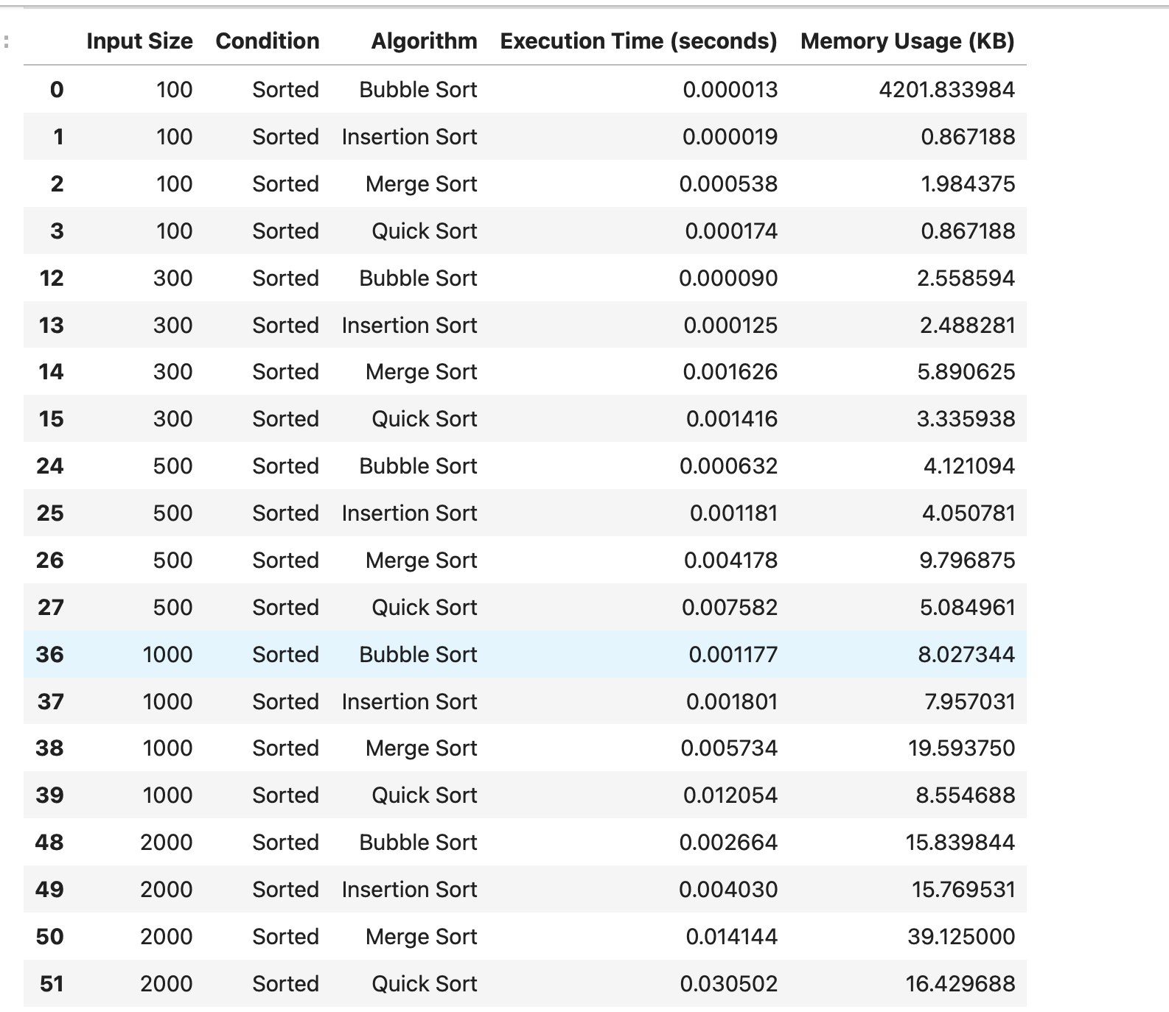

Reverse-sorted data

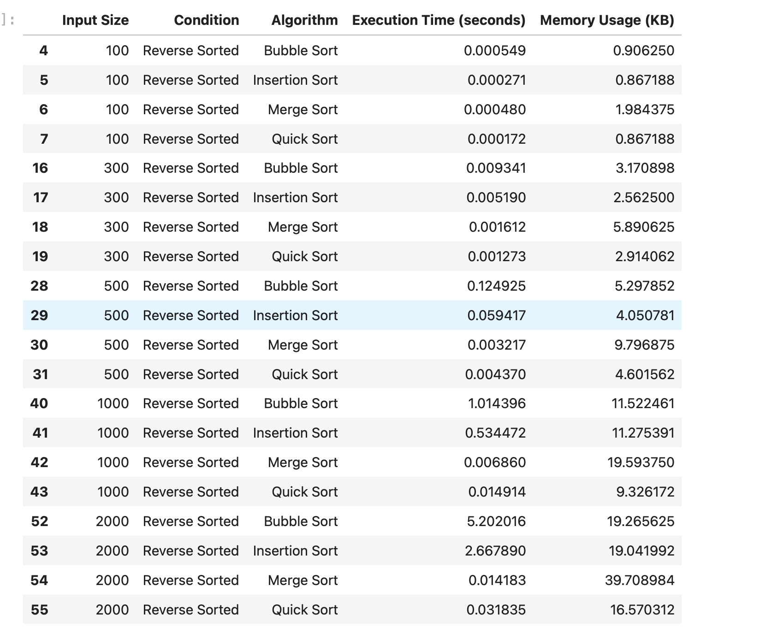

Random data

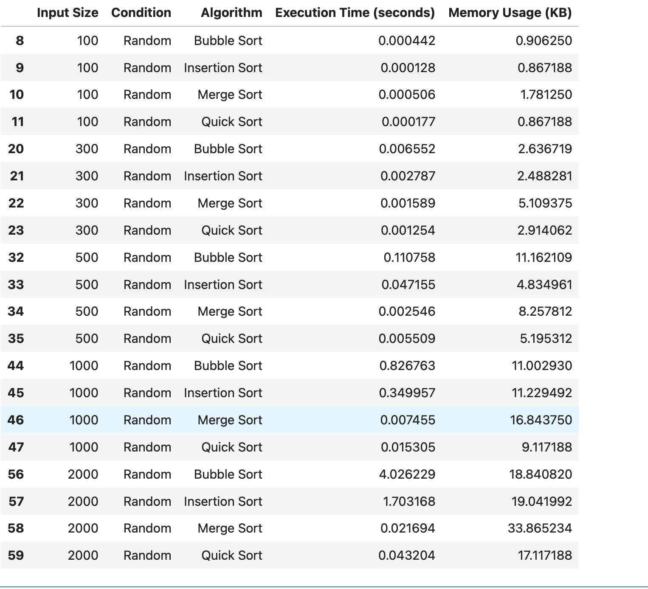

7. Fibonacci Experimental Results

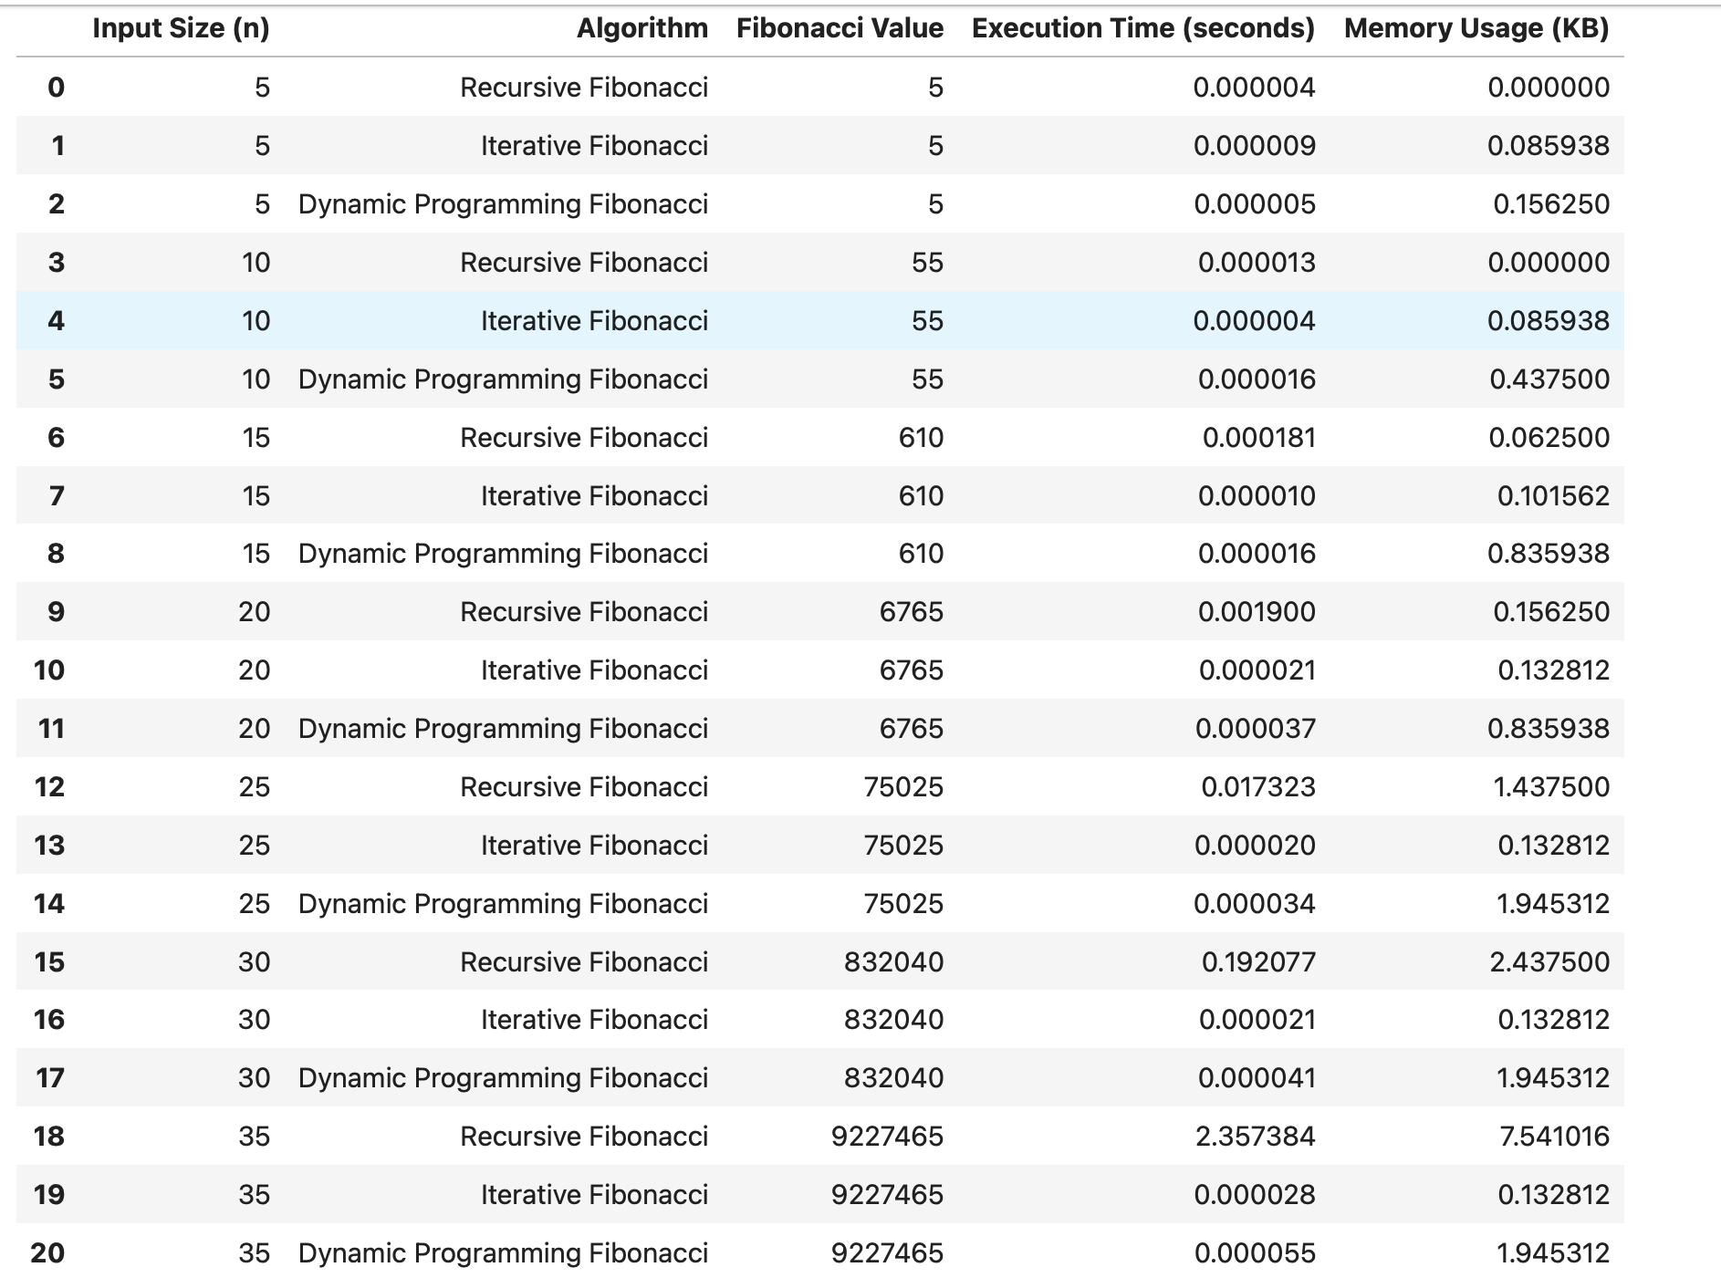

8. Observations

Sorting Algorithms
- Bubble Sort and Insertion Sort showed an increase in execution time as the input size increased.
- Bubble Sort performed relatively well on already sorted data because the optimized implementation stops when no swaps are required.
- Insertion Sort generally performed better on sorted data because fewer element shifts were needed.
- Merge Sort showed more consistent performance across sorted, reverse-sorted, and random input conditions.
- Quick Sort performance depended on the input distribution and pivot selection.
- Merge Sort generally required more additional memory because temporary arrays are used during the merging process.

Fibonacci Algorithms
- Recursive Fibonacci became significantly slower as the value of n increased.
- The recursive approach repeatedly calculated the same subproblems, resulting in high execution time.
- Iterative Fibonacci remained efficient as n increased.
- Dynamic Programming Fibonacci avoided repeated calculations by storing previously computed values.
- Iterative Fibonacci generally required less additional memory than the recursive and dynamic programming approaches.

9. Conclusion The experimental analysis demonstrated that algorithm performance is strongly affected by input size, input conditions, and implementation strategy. Sorting algorithms with quadratic time complexity showed a more rapid increase in execution time as input size increased, whereas Merge Sort and Quick Sort generally scaled more efficiently. For Fibonacci computation, the recursive approach became inefficient for larger values because of repeated calculations, while iterative and dynamic programming approaches provided significantly better performance. The experiment demonstrates the practical importance of analyzing both execution time and memory usage when selecting an algorithm.

10. GitHub Repository Link
The complete source code, experimental analysis, generated graphs, and result files used in this assignment are available in the following GitHub repository:
GitHub Repository:
https://github.com/Greaty01/Algorithm-Efficiency-Analysis-Repository
The repository contains the Python implementations of Bubble Sort, Insertion Sort, Merge Sort, Quick Sort, Recursive Fibonacci, Iterative Fibonacci, and Dynamic Programming Fibonacci, along with the experimental results and generated graphs.

