
Fundamentals Of Operating
System Lab (ENCA252)

Lab File
Submitted by: Mayank Chauhan
(2401201136)

Submitted to
Ms. Jyoti Yadav

School of Engineering & Technology

OPERATING SYSTEM LAB – ASSIGNMENT 2

Topic: Implementation of Banker’s Algorithm for Deadlock Avoidance

Aim

To implement Banker’s Algorithm and determine whether the system is in a safe state, and to find the safe sequence of processes.

Theory

Deadlock is a condition in which a set of processes are unable to proceed because each process is waiting for resources held by others.

Banker’s Algorithm is a deadlock avoidance technique used by the operating system. It checks whether granting a resource request keeps the system in a safe state.

A system is said to be in a safe state if there exists a sequence of processes such that each process can complete execution without causing deadlock.

Algorithm
- Input the number of processes and resource types.
- Input Allocation Matrix, Maximum Matrix, and Available Resources.
- Calculate the Need Matrix using:

Need = Maximum − Allocation
- Initialize:
o Work = Available o Finish = False for all processes
- Find a process such that:

Need ≤ Work
- If found:
  - Add process to safe sequence o Update Work = Work + Allocation o Mark process as finished
- Repeat until:
  - All processes are completed → System is SAFE o No process can proceed → System is UNSAFE

Code
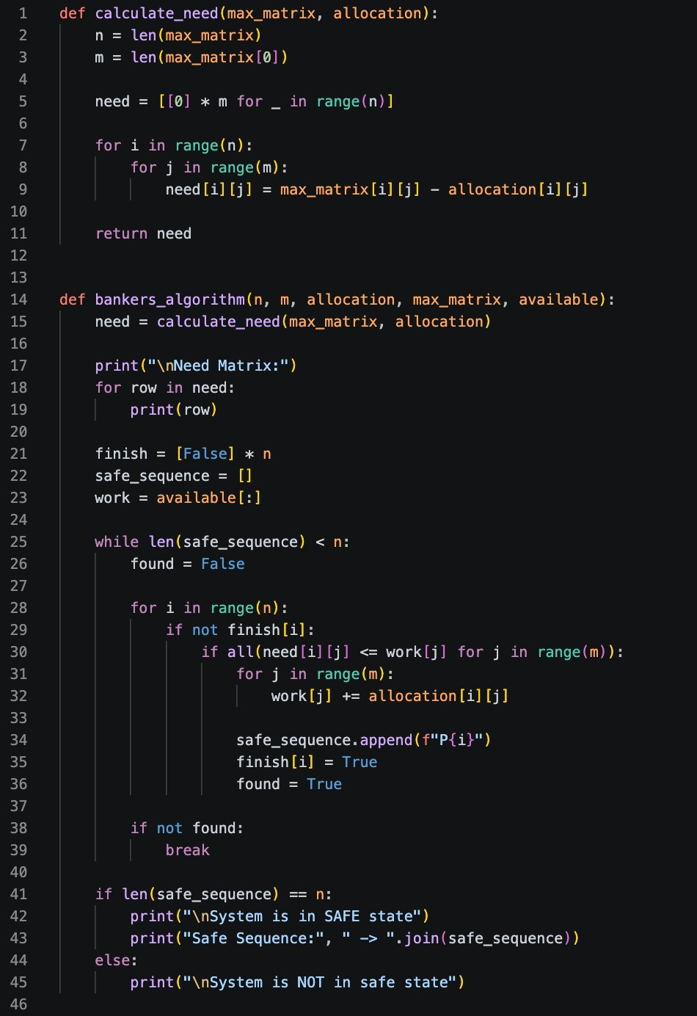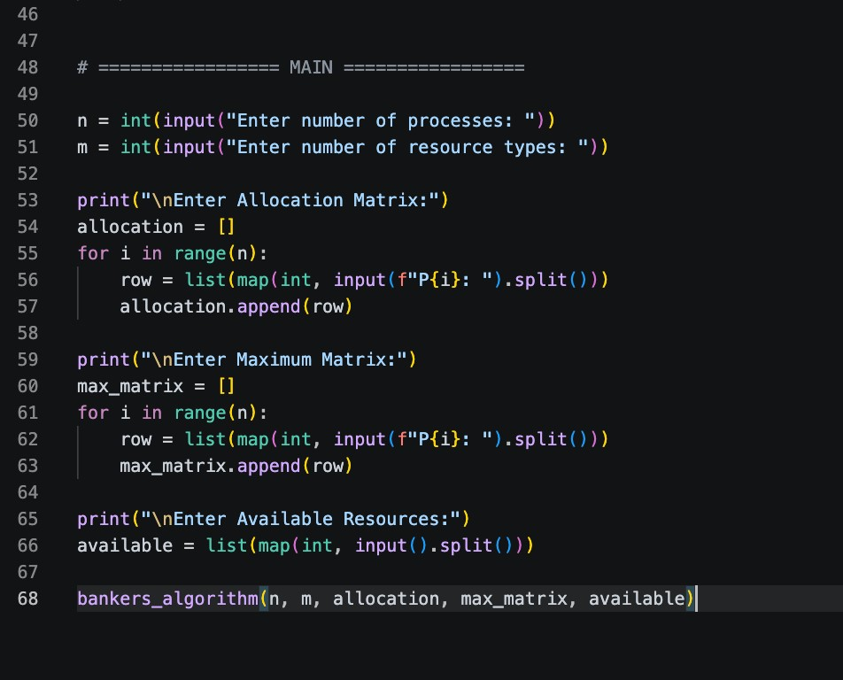

Input Used

Number of Processes = 5
Number of Resource Types = 3

Allocation Matrix

Process A B C
P0 0 1 0
P1 2 0 0
P2 3 0 2
P3 2 1 1
P4 0 0 2
Maximum Matrix

Process A B C
P0 7 5 3
P1 3 2 2
P2 9 0 2
P3 2 2 2
P4 4 3 3

Available Resources

3 3 2

Output

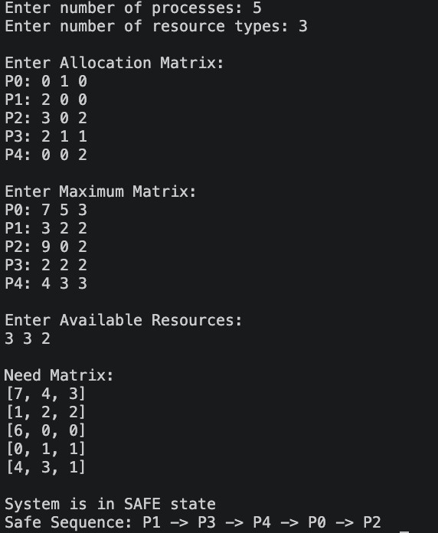

Result Analysis

The Need Matrix is calculated using the formula:

Need = Maximum − Allocation

After applying Banker’s Algorithm, the system is found to be in a safe state because a safe sequence exists.

The safe sequence obtained is:

P1 → P3 → P4 → P0 → P2

This indicates that all processes can complete execution without causing deadlock.

If no such sequence existed, the system would be considered unsafe.

Thus, Banker’s Algorithm successfully prevents deadlock by ensuring safe resource allocation.

Conclusion

Banker’s Algorithm is an effective method for deadlock avoidance.
It ensures that the system always remains in a safe state before allocating resources.

This algorithm helps in efficient resource management and prevents system failure due to deadlock.

GitHub Link

(https://github.com/MayankCh-Work/os-lab-assignments.git )

