MATCH p=(b:Bike)-[]->()where b.bikeid=134 RETURN p LIMIT 25

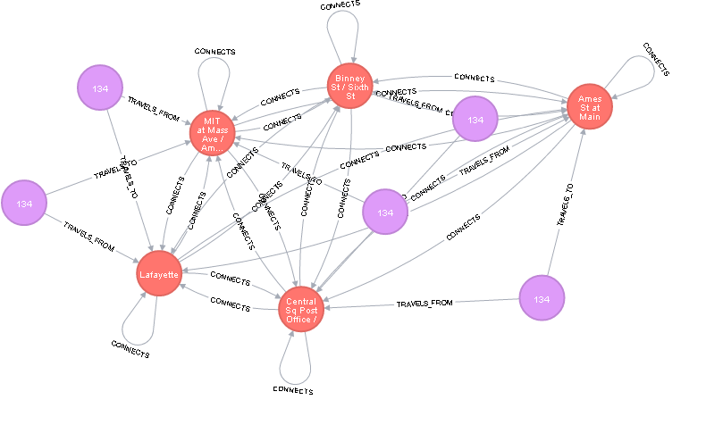

MATCH p=(b:Bike)-[]->() RETURN p LIMIT 25

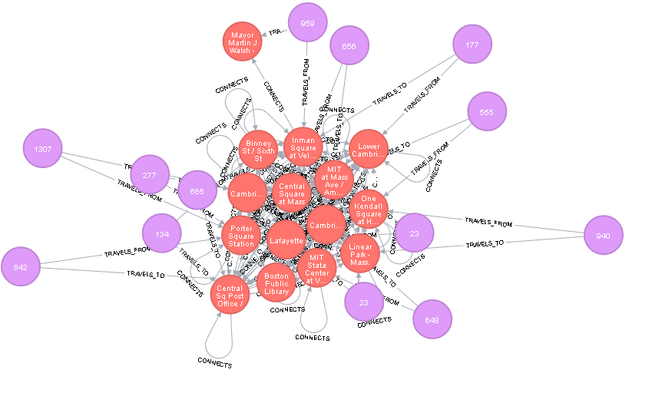

MATCH p=()-[r:TRAVELS_FROM]->() RETURN p LIMIT 25

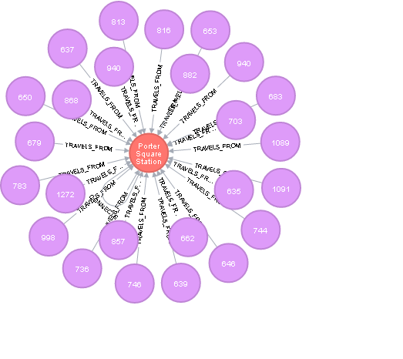

Match (s:station)-->(n) Where s.id=96 return n limit 5

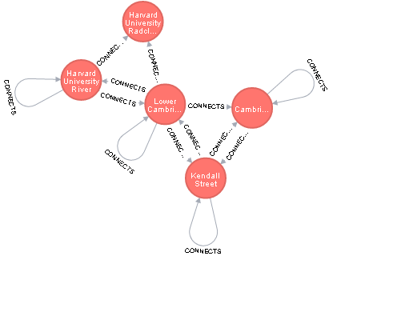

Match (s:station)-->(n) Where s.id=96 return n limit 25

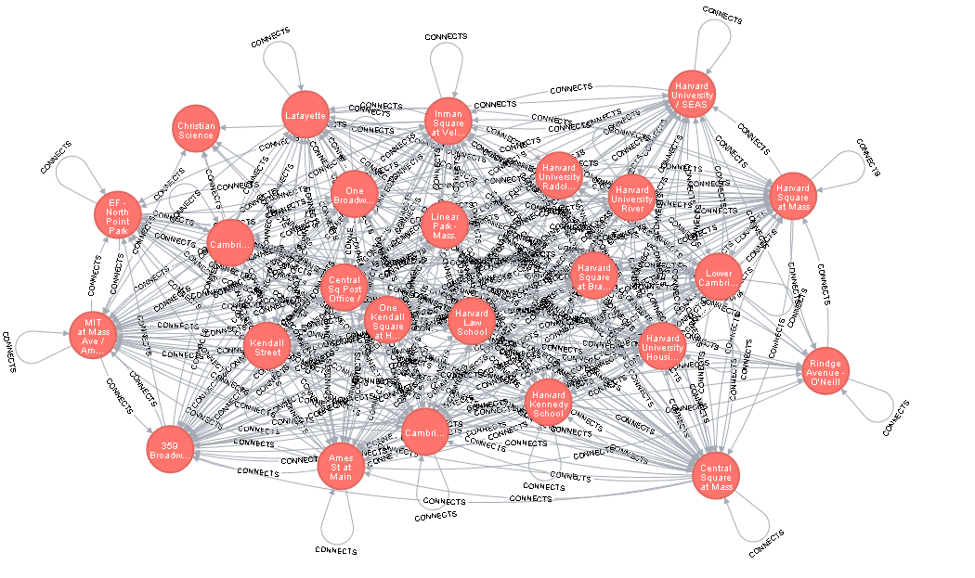

MATCH (n:station) RETURN n LIMIT 25

