1, CREATE TABLE customers (

customer_id INT PRIMARY KEY,

name VARCHAR(50),

age INT,

city VARCHAR(50)

);

INSERT INTO customers (customer_id, name, age, city) VALUES

(1, 'John Doe', 28, 'New York'),

(2, 'Jane Smith', 34, 'Los Angeles'),

(3, 'Samuel Green', 40, 'Chicago'),

(4, 'Alice Johnson', 25, 'Houston'),

(5, 'Bob Brown', 32, 'Phoenix');

2,CREATE TABLE customers (

customer_id INT PRIMARY KEY,

name VARCHAR(50),

age INT,

city VARCHAR(50)

);

INSERT INTO customers (customer_id, name, age, city) VALUES

(1, 'John Doe', 28, 'New York'),

(2, 'Jane Smith', 34, 'Los Angeles'),

(3, 'Samuel Green', 40, 'Chicago'),

(4, 'Alice Johnson', 25, 'Houston'),

(5, 'Bob Brown', 32, 'Phoenix');

3,CREATE TABLE products (

product_id INT PRIMARY KEY,

product_name VARCHAR(50),

price DECIMAL(10, 2)

);

INSERT INTO products (product_id, product_name, price) VALUES

(101, 'Laptop', 899.99),

(102, 'Smartphone', 499.99),

(103, 'Tablet', 299.99),

(104, 'Monitor', 199.99),

(105, 'Keyboard', 49.99);

CREATE TABLE products (

product_id INT PRIMARY KEY,

product_name VARCHAR(50),

price DECIMAL(10, 2)

);

INSERT INTO products (product_id, product_name, price) VALUES

(101, 'Laptop', 899.99),

(102, 'Smartphone', 499.99),

(103, 'Tablet', 299.99),

(104, 'Monitor', 199.99),

(105, 'Keyboard', 49.99);

CREATE TABLE products (

product_id INT PRIMARY KEY,

product_name VARCHAR(50),

price DECIMAL(10, 2)

);

INSERT INTO products (product_id, product_name, price) VALUES

(101, 'Laptop', 899.99),

(102, 'Smartphone', 499.99),

(103, 'Tablet', 299.99),

(104, 'Monitor', 199.99),

(105, 'Keyboard', 49.99);

CREATE TABLE employees (

employee_id INT PRIMARY KEY,

name VARCHAR(50),

salary DECIMAL(10, 2),

manager_id INT,

department_id INT

);

INSERT INTO employees (employee_id, name, salary, manager_id, department_id) VALUES

(1, 'Alice Johnson', 75000, NULL, 1),

(2, 'Bob Brown', 50000, 1, 2),

(3, 'Charlie Davis', 60000, 1, 1),

(4, 'Diana Evans', 80000, NULL, 2),

(5, 'Ethan Harris', 45000, 4, 1);

CREATE TABLE departments (

department_id INT PRIMARY KEY,

department_name VARCHAR(50)

);

INSERT INTO departments (department_id, department_name) VALUES

(1, 'HR'),

(2, 'IT');

CREATE TABLE projects (

project_id INT PRIMARY KEY,

project_name VARCHAR(50),

employee_id INT,

FOREIGN KEY (employee_id) REFERENCES employees(employee_id)

);

INSERT INTO projects (project_id, project_name, employee_id) VALUES

(1, 'Project Alpha', 2),

(2, 'Project Beta', 3),

(3, 'Project Gamma', 5);

### **Exercises**

1. Retrieve the names and ages of customers who are between 30 and 40 years old.

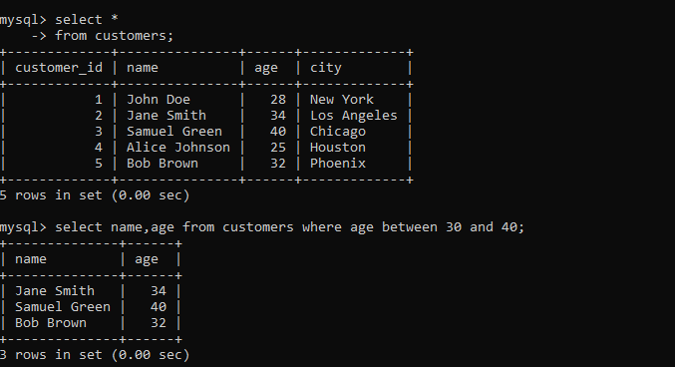

1. Retrieve the product names and prices, ordered by price in descending order and then by product name in ascending order.

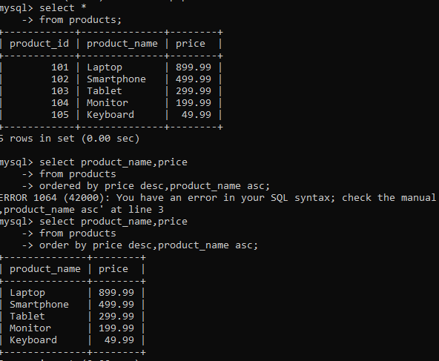

1. Retrieve the top 3 highest-paid employees.

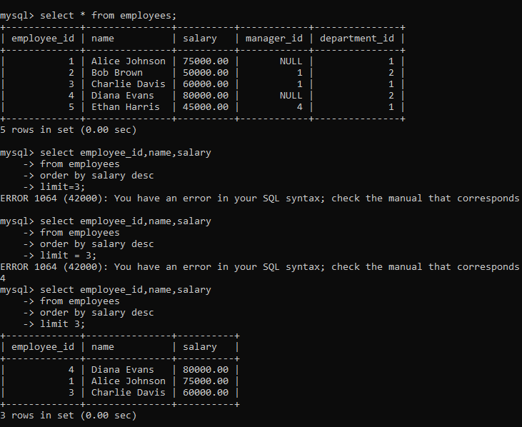

1. Retrieve the names of cities and the count of customers in each city, but only for cities with more than 2 customers.

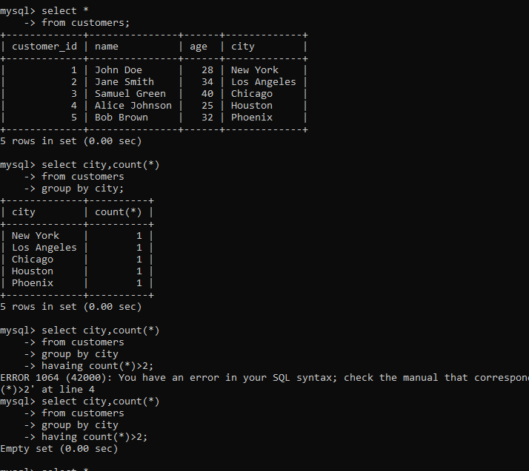

1. Retrieve the names of customers who have placed an order for a product that costs more than $500.

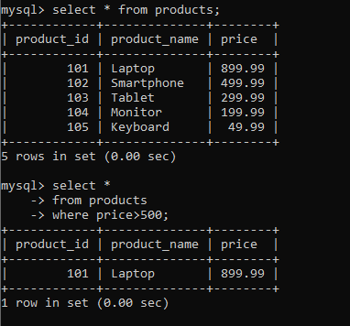

1. Retrieve a list of unique customer ages.

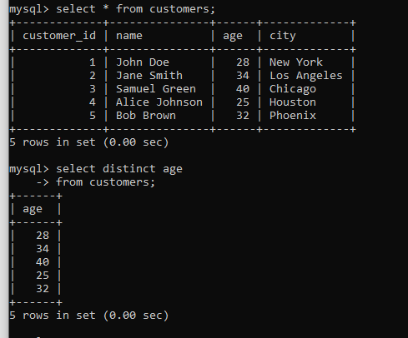

1. Retrieve the names and salaries of employees who earn more than the average salary in the company.

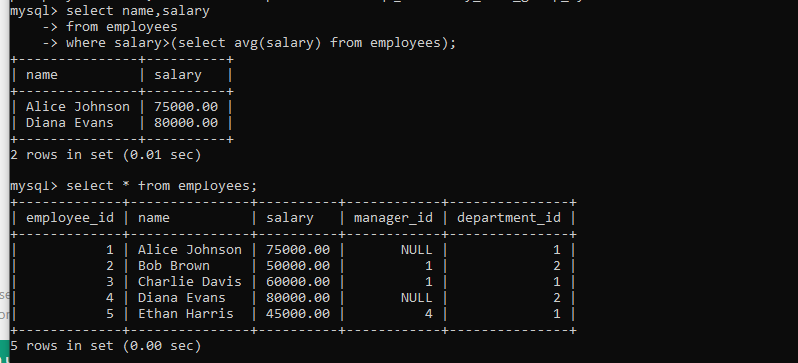

1. Retrieve the total number of distinct products that have been ordered.

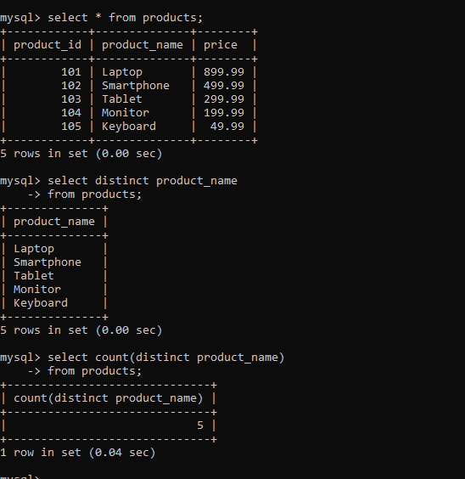

1. Retrieve the product names and prices for products priced between $10 and $100.

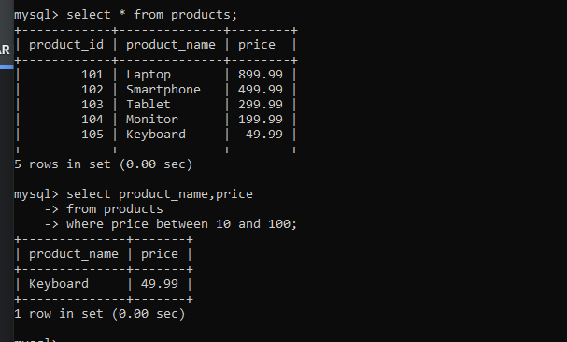

1. Retrieve all customers who have placed an order in 2024.

