Scenario 1:

You have two tables: users and orders. Each user can have multiple orders. Write a SQL query to fetch the names of users along with the total number of orders they have placed.

Exercise 1 Prerequisites: Basic knowledge of SQL SELECT statement

Understanding of JOINs and GROUP BY clause

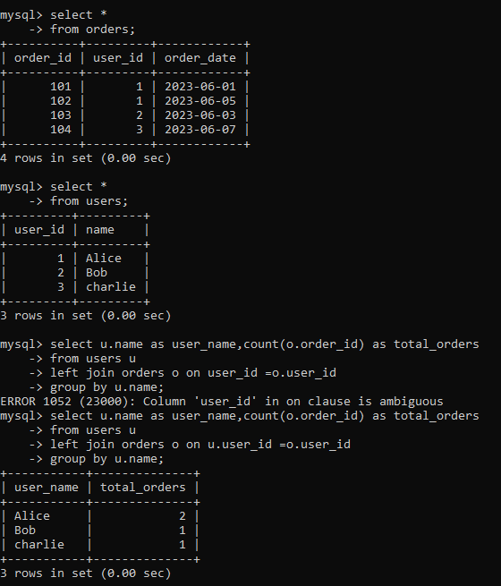

Scenario 2:

You are working with a database that stores information about students and their courses. There are three tables: students, courses, and enrollments. Write a SQL query to display the names of students along with the courses they have enrolled in.

Exercise 2 Prerequisites:

* Familiarity with INNER JOINs and WHERE clause
* Understanding of relational database schema design

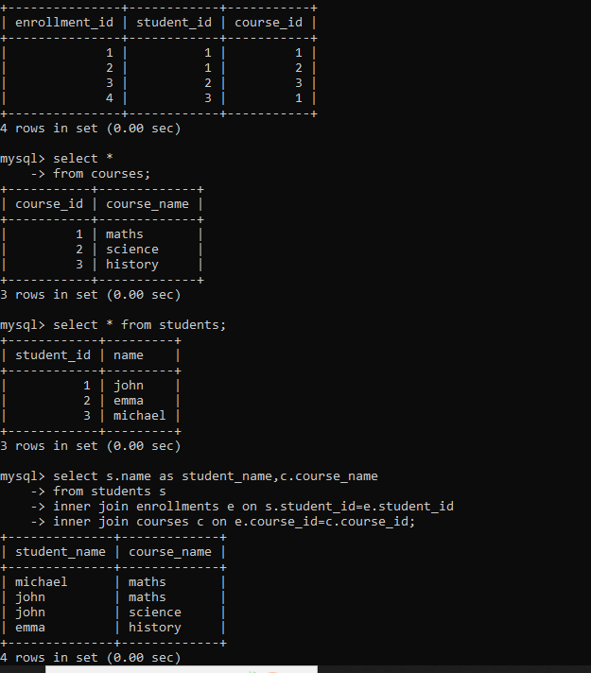

Scenario 3:

You need to retrieve data from a database that tracks product sales. There are tables for products, sales, and customers. Write a SQL query to show the total sales amount for each product category.

Exercise 3 Prerequisites:

* Knowledge of SQL aggregate functions like SUM()
* Ability to use JOINs with multiple tables

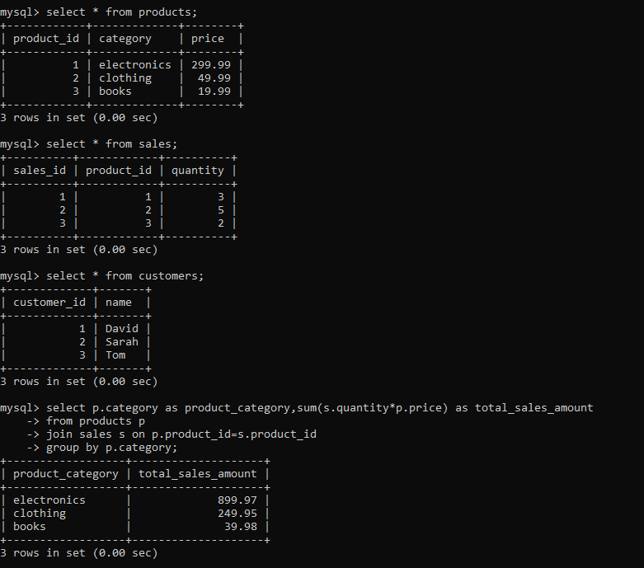

Scenario 4:

You have a database containing information about employees in a company. Write a SQL query to list the names of employees along with their respective managers' names.

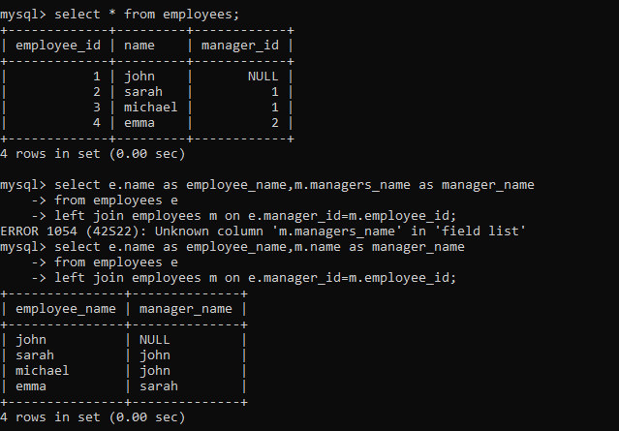

Other answer by using two tables:

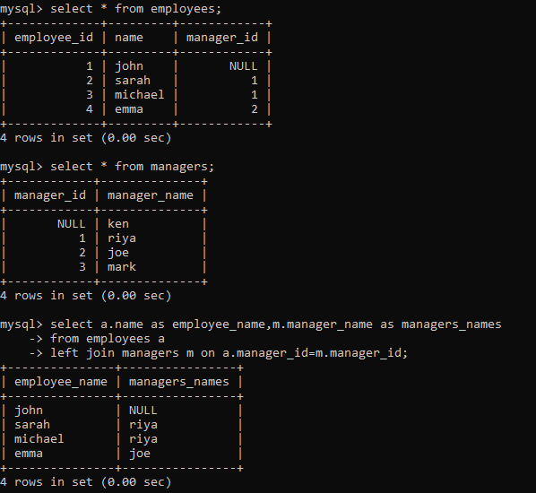

Scenario 5:

You are managing a database for an online store. Write a query to retrieve the top 10 bestselling products based on the total number of units sold.

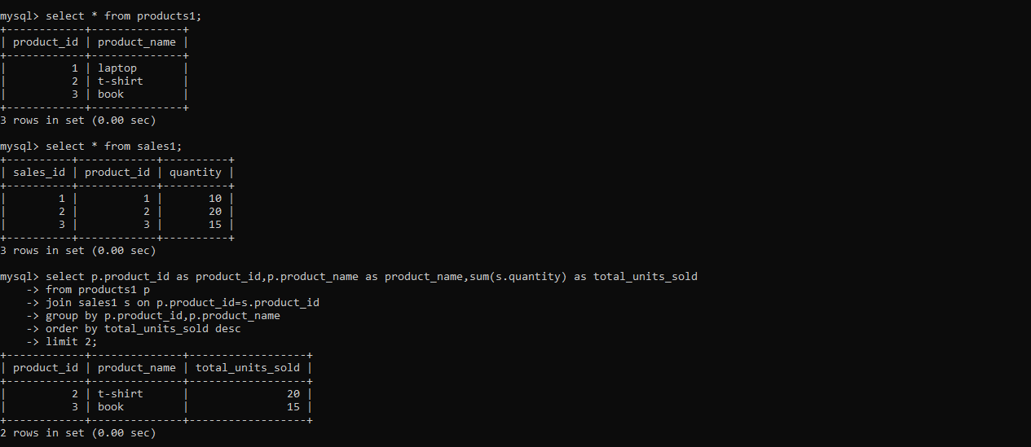

Scenario 6:

You have tables for students, courses, and grades. Write a SQL query to display the average grade for each student.

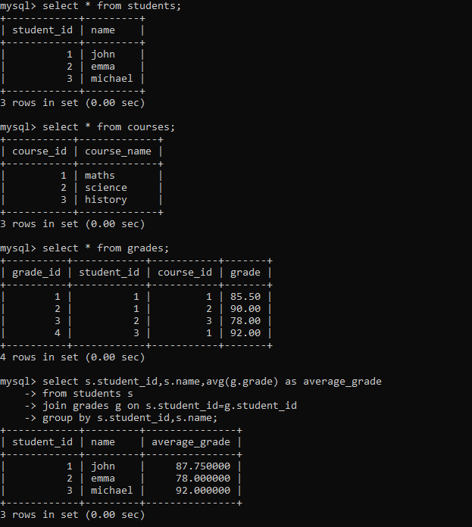

Scenario 7:

In a database tracking library books and borrowed history, write a query to find out which books are currently borrowed and by whom.

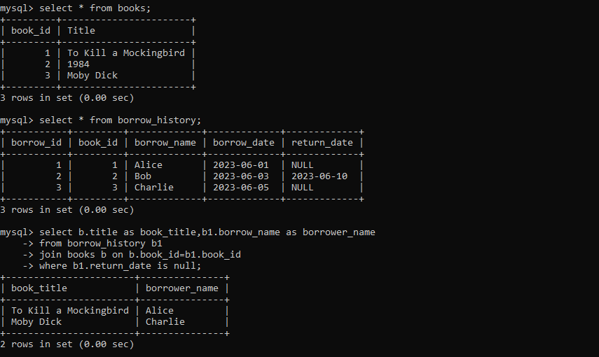

Scenario 8:

You are working with a database for a social media platform. Write a query to show the users who have the most friends.

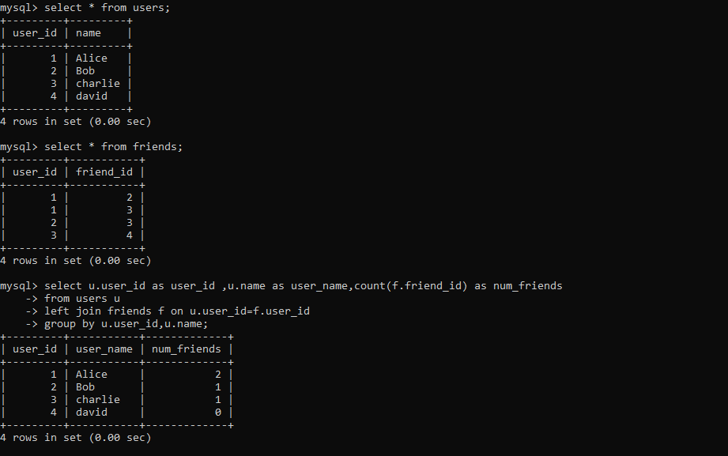

Scenario 9:

You have tables for employees and departments. Write a query to display the department names along with the total number of employees in each department.

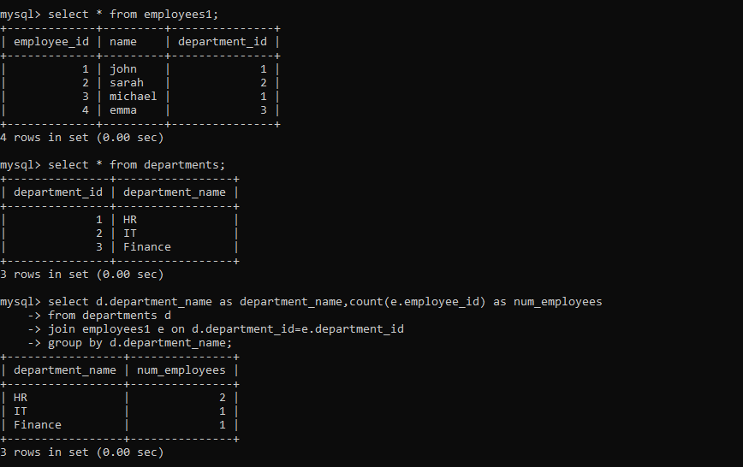

Scenario 10:

In a forum database with tables for posts and comments, write a query to show the most commented posts.

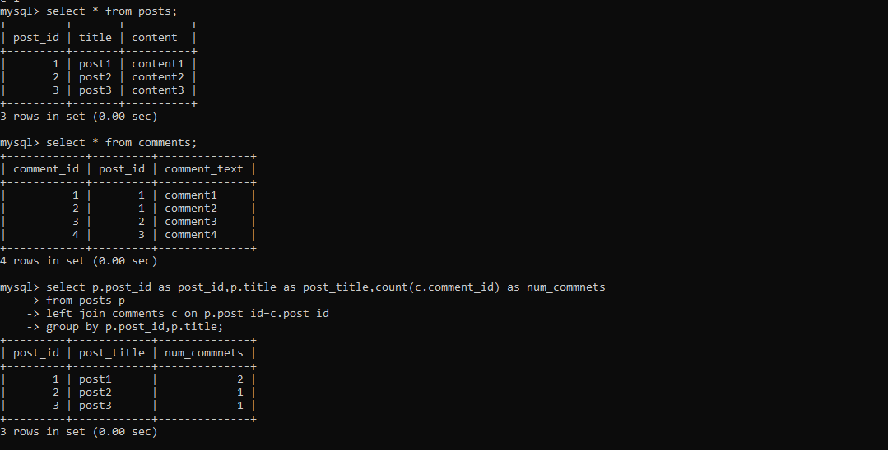

Scenario 11:

You need to retrieve data from a database tracking product inventory. Write a query to display products with low stock (less than 10 units).

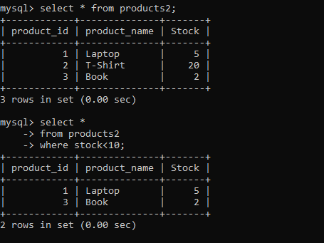

Scenario 12:

You have tables for customers and orders. Write a query to show the average order value for each customer.

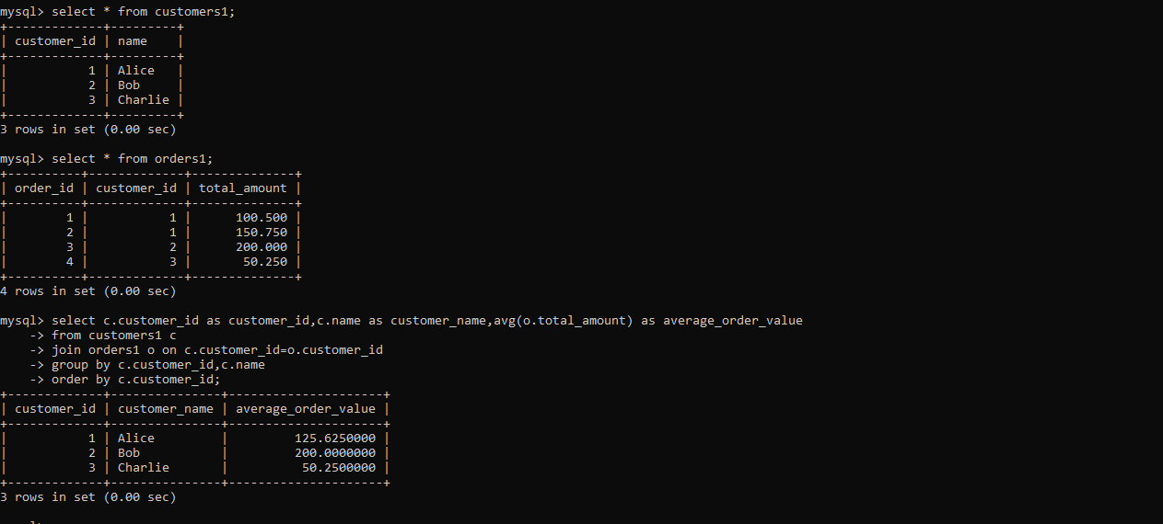

Scenario 13:

In a database storing movie information, write a query to show the top 5 highest-rated movies by users.

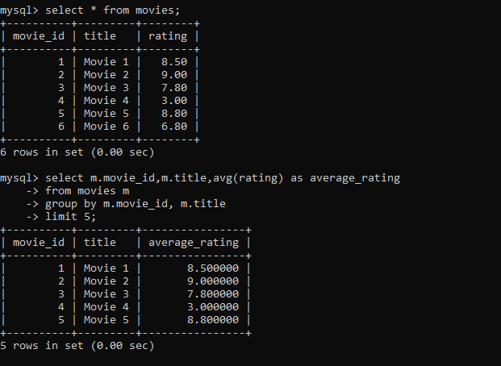

Scenario 14:

You are managing a database for a blog platform. Write a query to display the number of posts created by each user.

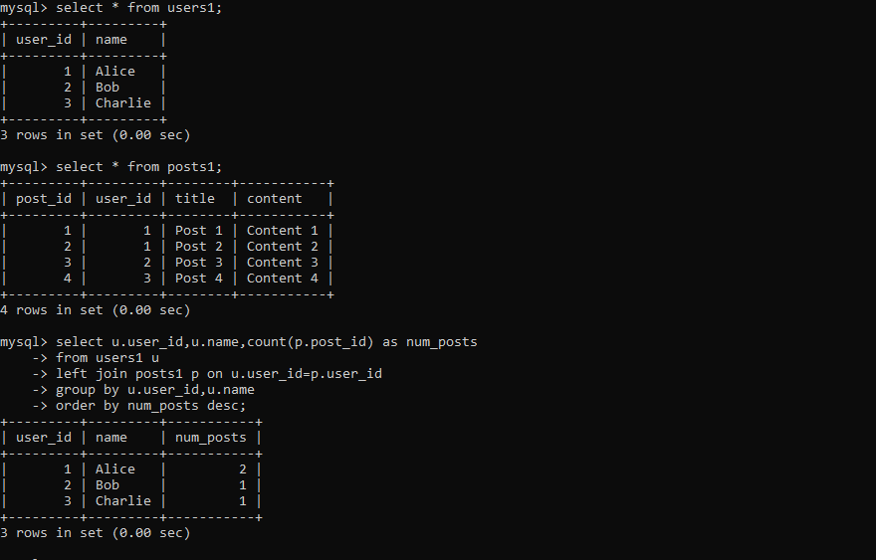

Scenario 15:

You have tables for invoices and payments. Write a query to show the unpaid invoices and their total amount.

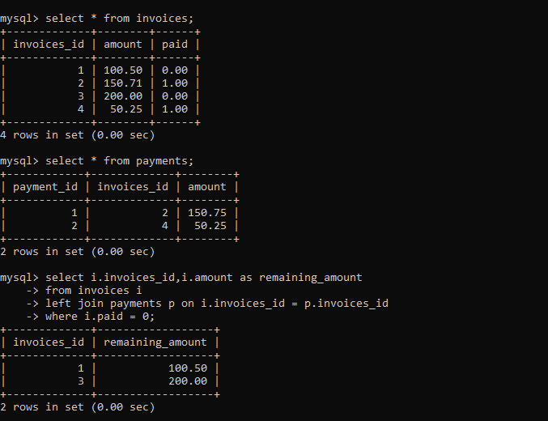

### **Scenario 1: Users and Orders**

**Users Table:**

|  |  |
| --- | --- |
| **user_id** | **name** |
| 1 | Alice |
| 2 | Bob |
| 3 | Charlie |

**Orders Table:**

|  |  |  |
| --- | --- | --- |
| **order_id** | **user_id** | **order_date** |
| 101 | 1 | 2023-06-01 |
| 102 | 1 | 2023-06-05 |
| 103 | 2 | 2023-06-03 |
| 104 | 3 | 2023-06-07 |

### **Scenario 2: Students and Courses**

**Students Table:**

|  |  |
| --- | --- |
| **student_id** | **name** |
| 1 | John |
| 2 | Emma |
| 3 | Michael |

**Courses Table:**

|  |  |
| --- | --- |
| **course_id** | **course_name** |
| 1 | Math |
| 2 | Science |
| 3 | History |

**Enrollments Table:**

|  |  |  |
| --- | --- | --- |
| **enrollment_id** | **student_id** | **course_id** |
| 1 | 1 | 1 |
| 2 | 1 | 2 |
| 3 | 2 | 3 |
| 4 | 3 | 1 |

### **Scenario 3: Products, Sales, and Customers**

**Products Table:**

|  |  |  |
| --- | --- | --- |
| **product_id** | **category** | **price** |
| 1 | Electronics | 299.99 |
| 2 | Clothing | 49.99 |
| 3 | Books | 19.99 |

**Sales Table:**

|  |  |  |
| --- | --- | --- |
| **sale_id** | **product_id** | **quantity** |
| 1 | 1 | 3 |
| 2 | 2 | 5 |
| 3 | 3 | 2 |

**Customers Table:**

|  |  |
| --- | --- |
| **customer_id** | **name** |
| 1 | David |
| 2 | Sarah |
| 3 | Tom |

### **Scenario 4: Employees and Managers**

**Employees Table:**

|  |  |  |
| --- | --- | --- |
| **employee_id** | **name** | **manager_id** |
| 1 | John | NULL |
| 2 | Sarah | 1 |
| 3 | Michael | 1 |
| 4 | Emma | 2 |

### **Scenario 5: Top 10 Bestselling Products**

**Products Table:**

|  |  |
| --- | --- |
| **product_id** | **product_name** |
| 1 | Laptop |
| 2 | T-Shirt |
| 3 | Book |

**Sales Table:**

|  |  |  |
| --- | --- | --- |
| **sale_id** | **product_id** | **quantity** |
| 1 | 1 | 10 |
| 2 | 2 | 20 |
| 3 | 3 | 15 |

### **Scenario 6: Students, Courses, and Grades**

**Students Table:**

|  |  |
| --- | --- |
| **student_id** | **name** |
| 1 | John |
| 2 | Emma |
| 3 | Michael |

**Courses Table:**

|  |  |
| --- | --- |
| **course_id** | **course_name** |
| 1 | Math |
| 2 | Science |
| 3 | History |

**Grades Table:**

|  |  |  |  |
| --- | --- | --- | --- |
| **grade_id** | **student_id** | **course_id** | **grade** |
| 1 | 1 | 1 | 85.5 |
| 2 | 1 | 2 | 90.0 |
| 3 | 2 | 3 | 78.0 |
| 4 | 3 | 1 | 92.0 |

### **Scenario 7: Library Books and Borrowed History**

**Books Table:**

|  |  |
| --- | --- |
| **book_id** | **title** |
| 1 | To Kill a Mockingbird |
| 2 | 1984 |
| 3 | Moby Dick |

**Borrow History Table:**

|  |  |  |  |  |
| --- | --- | --- | --- | --- |
| **borrow_id** | **book_id** | **borrower_name** | **borrow_date** | **return_date** |
| 1 | 1 | Alice | 2023-06-01 | NULL |
| 2 | 2 | Bob | 2023-06-03 | 2023-06-10 |
| 3 | 3 | Charlie | 2023-06-05 | NULL |

Let me know if you need any other scenarios or more information!

### **Scenario 8: Social Media Platform - Users and Friends**

**Users Table:**

|  |  |
| --- | --- |
| **user_id** | **name** |
| 1 | Alice |
| 2 | Bob |
| 3 | Charlie |
| 4 | David |

**Friends Table:**

|  |  |
| --- | --- |
| **user_id** | **friend_id** |
| 1 | 2 |
| 1 | 3 |
| 2 | 3 |
| 3 | 4 |

### **Scenario 9: Employees and Departments**

**Employees Table:**

|  |  |  |
| --- | --- | --- |
| **employee_id** | **name** | **department_id** |
| 1 | John | 1 |
| 2 | Sarah | 2 |
| 3 | Michael | 1 |
| 4 | Emma | 3 |

**Departments Table:**

|  |  |
| --- | --- |
| **department_id** | **department_name** |
| 1 | HR |
| 2 | IT |
| 3 | Finance |

### **Scenario 10: Forum Posts and Comments**

**Posts Table:**

|  |  |  |
| --- | --- | --- |
| **post_id** | **title** | **content** |
| 1 | Post 1 | Content 1 |
| 2 | Post 2 | Content 2 |
| 3 | Post 3 | Content 3 |

**Comments Table:**

|  |  |  |
| --- | --- | --- |
| **comment_id** | **post_id** | **comment_text** |
| 1 | 1 | Comment 1 |
| 2 | 1 | Comment 2 |
| 3 | 2 | Comment 3 |
| 4 | 3 | Comment 4 |

### **Scenario 11: Product Inventory**

**Products Table:**

|  |  |  |
| --- | --- | --- |
| **product_id** | **product_name** | **stock** |
| 1 | Laptop | 5 |
| 2 | T-Shirt | 20 |
| 3 | Book | 2 |

### **Scenario 12: Customers and Orders**

**Customers Table:**

|  |  |
| --- | --- |
| **customer_id** | **name** |
| 1 | Alice |
| 2 | Bob |
| 3 | Charlie |

**Orders Table:**

|  |  |  |
| --- | --- | --- |
| **order_id** | **customer_id** | **total_amount** |
| 1 | 1 | 100.50 |
| 2 | 1 | 150.75 |
| 3 | 2 | 200.00 |
| 4 | 3 | 50.25 |

### **Scenario 13: Movie Information**

**Movies Table:**

|  |  |  |
| --- | --- | --- |
| **movie_id** | **title** | **rating** |
| 1 | Movie 1 | 8.5 |
| 2 | Movie 2 | 9.0 |
| 3 | Movie 3 | 7.8 |

### **Scenario 14: Blog Platform**

**Users Table:**

|  |  |
| --- | --- |
| **user_id** | **name** |
| 1 | Alice |
| 2 | Bob |
| 3 | Charlie |

**Posts Table:**

|  |  |  |  |
| --- | --- | --- | --- |
| **post_id** | **user_id** | **title** | **content** |
| 1 | 1 | Post 1 | Content 1 |
| 2 | 1 | Post 2 | Content 2 |
| 3 | 2 | Post 3 | Content 3 |
| 4 | 3 | Post 4 | Content 4 |

### **Scenario 15: Invoices and Payments**

**Invoices Table:**

|  |  |  |
| --- | --- | --- |
| **invoice_id** | **amount** | **paid** |
| 1 | 100.50 | 0 |
| 2 | 150.75 | 1 |
| 3 | 200.00 | 0 |
| 4 | 50.25 | 1 |

**Payments Table:**

|  |  |  |
| --- | --- | --- |
| **payment_id** | **invoice_id** | **amount** |
| 1 | 2 | 150.75 |
| 2 | 4 | 50.25 |