### **JavaScript and React Basics MCQs**

#### **JavaScript MCQs**

1. **Which of the following is not a valid JavaScript variable name?**
   * A) _name
   * B) 2name
   * C) $name
   * D) name_2
2. **Which of the following methods is used to access HTML elements using JavaScript?**
   * A) getElementById()
   * B) getElementsByClassName()
   * C) getElementsByTagName()
   * D) All of the above
3. **What is the correct syntax for referring to an external script called "app.js"?**
   * A) <script href="app.js">
   * B) <script name="app.js">
   * C) <script src="app.js">
   * D) <script file="app.js">
4. **How do you create a function in JavaScript?**
   * A) function myFunction()
   * B) function:myFunction()
   * C) function = myFunction()
   * D) function => myFunction()
5. **How do you call a function named "myFunction"?**
   * A) call myFunction()
   * B) call function myFunction()
   * C) myFunction()
   * D) Call.myFunction()

#### **React MCQs**

1. **What is React?**
   * A) A JavaScript library for building user interfaces
   * B) A JavaScript framework for building server-side applications
   * C) A JavaScript library for data manipulation
   * D) A JavaScript framework for building mobile applications
2. **Which of the following is used to pass data to a component from outside in React?**
   * A) setState
   * B) render with arguments
   * C) props
   * D) PropTypes
3. **What is the purpose of render() in React?**
   * A) To initialize state
   * B) To update state
   * C) To return HTML to be rendered to the DOM
   * D) To define default props
4. **Which method in React component lifecycle is called after the component is rendered for the first time?**
   * A) componentWillMount
   * B) componentDidMount
   * C) componentWillUpdate
   * D) componentDidUpdate
5. **In React, what is the method used to update the state of a component?**
   * A) this.setState
   * B) this.updateState
   * C) this.changeState
   * D) this.stateUpdate

### **JavaScript Exercises**

1. **Sum of Two Numbers:** Write a function sum that takes two numbers as arguments and returns their sum.

function sum(a, b) {

    let c = a + b;

    console.log("Sum of " + a + " and " + b + " is " + c);

}

sum(10, 15);

**Output:**

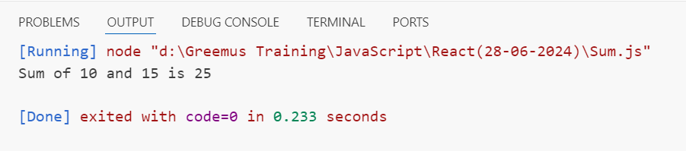

1. **Factorial of a Number:** Write a function factorial that takes a number as an argument and returns its factorial.

function factorial(num) {

    let fact = 1;

    for (let i = 1; i <= num; i++ ) {

        fact *= i;

    }

    console.log("Factorial of " + num + " is : " + fact);

}

factorial(5);

**Output:**

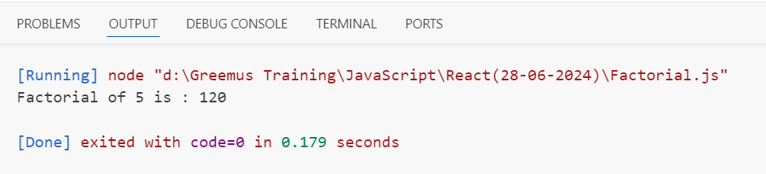

1. **Palindrome Check:** Write a function isPalindrome that checks if a given string is a palindrome.

function isPalindrome(str) {

    let rev = "";

    for (let i = str.length-1; i >= 0; i--) {

        rev += str[i];

    }

    if (rev == str) {

        console.log(str + " is a palindrome");

    }

    else {

        console.log(str + " is not a palindrome");

    }

}

isPalindrome("racecar");

isPalindrome("laptop");

**Output:**

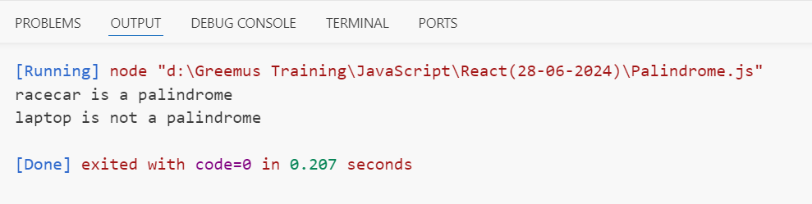

1. **Array Filtering:** Write a function filterEvenNumbers that takes an array of numbers and returns a new array containing only the even numbers.

function filterEvenNumbers(array) {

    let evens = [];

    for (let i = 0; i < array.length; i++) {

        if (array[i] % 2 == 0) {

            evens.push(array[i]);

        }

    }

    console.log("Given array is:");

    console.log(array);

    console.log("Even numbers in array are:");

    console.log(evens);

}

const a = [1,3,4,6,7,8,12,13,14];

filterEvenNumbers(a);

**Output:**

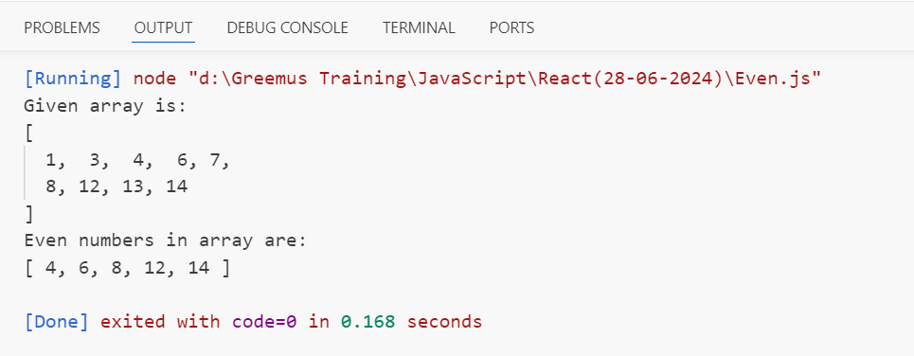

1. **Object Property Count:** Write a function countProperties that takes an object and returns the number of properties it has.

function countProperties(Obj) {

    let count = Object.entries(x).length;

    console.log("Given object is:");

    console.log(Obj);

    console.log("Number of properties in object are: " + count);

}

const x = {

    Name : "Mahesh",

    Age : 25,

    Year : 2024,

    Place : "Hyderabad",

    Get : function() {

        return this.Age;

    }

}

countProperties(x);

**Output:**

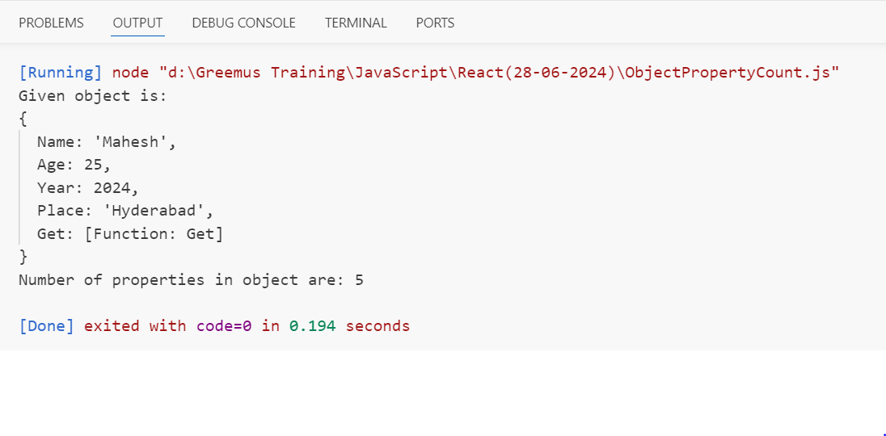

1. **Reverse a String:** Write a function reverseString that takes a string as an argument and returns the string reversed.

function reverseString(str) {

    let reverse = "";

    for (let i = str.length - 1; i >= 0; i--) {

        reverse += str[i];

    }

    console.log("Given string is : " + str);

    console.log("Reverse of string is : " + reverse);

}

reverseString("Greemus Software");

**Output:**

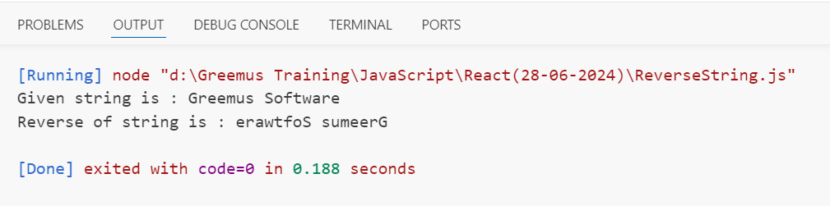

1. **Fibonacci Sequence:** Write a function fibonacci that returns the first n numbers of the Fibonacci sequence.

function fibonacci(n) {

    let fibo = [0, 1];

    if (n <= 1) {

        return fibo;

    }

    while (fibo.length < n) {

        let x = fibo[fibo.length-1] + fibo[fibo.length-2];

        fibo.push(x);

    }

    console.log("The first " + n + " numbers of fibonacci series is :\n" + fibo );

}

fibonacci(7);

**Output:**

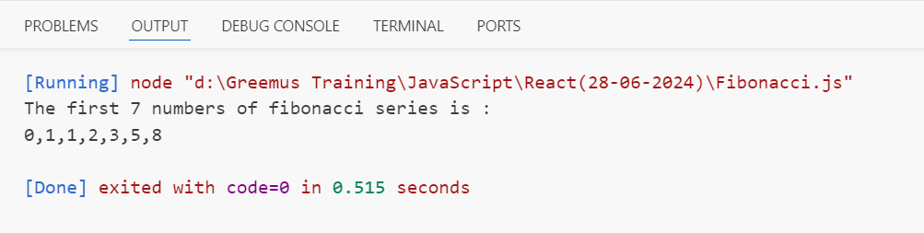

1. **Find Maximum Number:** Write a function findMax that takes an array of numbers and returns the maximum number.

function findMax(arr) {

    let max = -Infinity;

    for (let i = 0; i < arr.length; i++) {

        if (arr[i] > max) {

            max = arr[i];

        }

    }

    console.log("Given array is :");

    console.log(arr);

    console.log("Maximum number in array is : " + max);

}

const a = [76,103,54,23,305,209,304];

findMax(a);

**Output:**

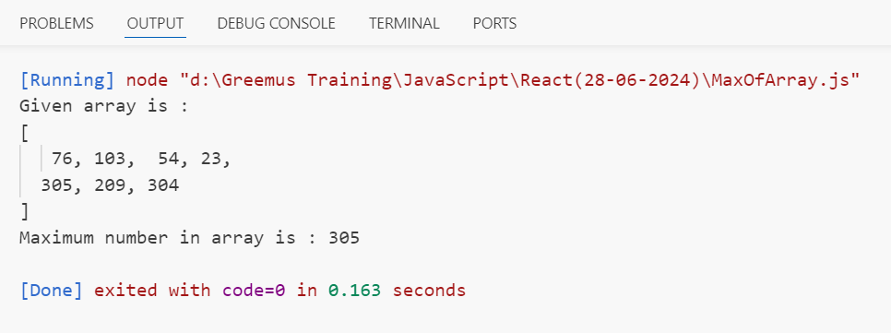

1. **Prime Number Check:** Write a function isPrime that takes a number as an argument and returns true if the number is prime, and false otherwise.

function isPrime(x) {

    let prime = true;

    for (let i = 2; i < x; i++) {

        if (x % i == 0) {

            prime = false;

            break;

        }

    }

    console.log(x + " is a prime number");

    console.log(prime);

}

isPrime(17);

isPrime(21);

**Output:**

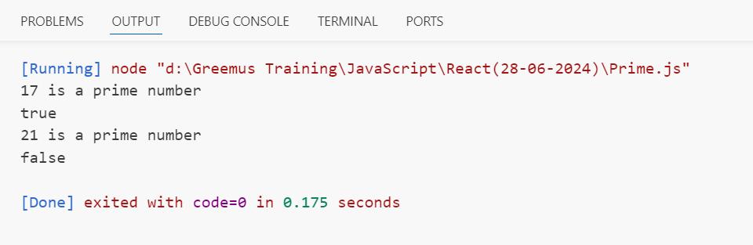

1. **Array Sum:** Write a function arraySum that takes an array of numbers and returns the sum of all the numbers.

function arraySum(array) {

    let sum = 0;

    for (let i = 0; i < array.length; i++) {

        sum += array[i];

    }

    console.log("Given array is :");

    console.log(array);

    console.log("Sum of all numbers in array is : " + sum);

}

let x = [2,4,6,3,1,7,10];

arraySum(x);

**Output:**

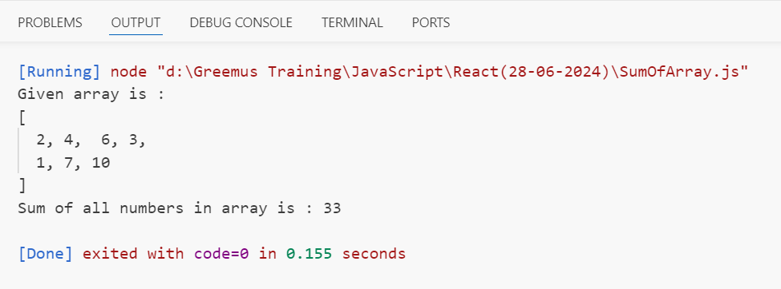

1. **Count Vowels:** Write a function countVowels that takes a string as an argument and returns the number of vowels in the string.

function countVowels(str) {

    let count = 0;

    let vowels = "AaEeIiOoUu";

    for (let i = 0; i < str.length; i++) {

        if (vowels.includes(str[i])) {

            count += 1;

        }

    }

    console.log("Given string is : " + str);

    console.log("Number of vowels in string are : " + count);

}

countVowels("My name is Nithish Kumar");

**Output:**

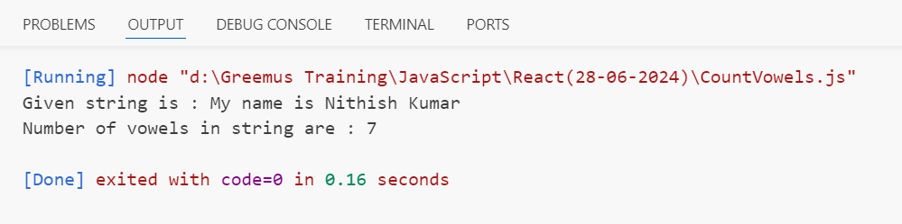

1. **Merge Arrays:** Write a function mergeArrays that takes two arrays and returns a new array that combines both arrays.

function mergeArrays(array1, array2) {

    let merge = array1.concat(array2);

    console.log("Given arrays are:");

    console.log(array1);

    console.log(array2);

    console.log("Merge of both arrays is :");

    console.log(merge);

}

const a = [1,2,3,4,5];

const b = [6,7,8,9,10];

mergeArrays(a, b);

**Output:**

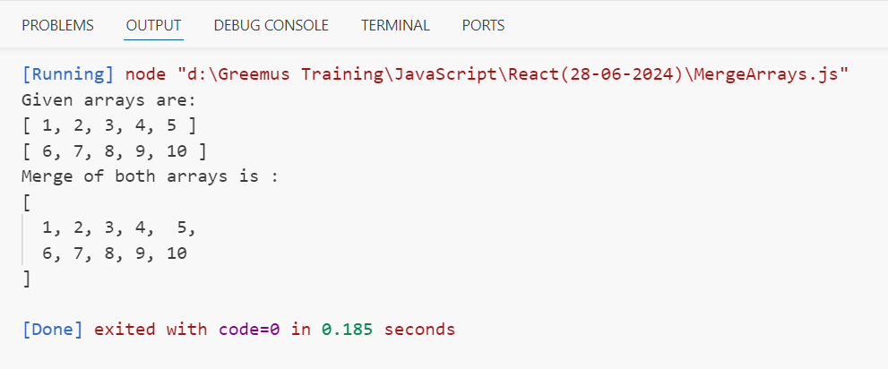

1. **Square of Each Number:** Write a function squareNumbers that takes an array of numbers and returns a new array with the square of each number.

function squareNumbers(arr) {

    let squares = [];

    for (let i = 0; i < arr.length; i++) {

        let a = arr[i]**2;

        squares.push(a);

    }

    console.log("Given array is :");

    console.log(arr);

    console.log("Squares of each number of array are :");

    console.log(squares);

}

let a = [1,2,3,4,5,6,7,8,9,10];

squareNumbers(a);

**Output:**

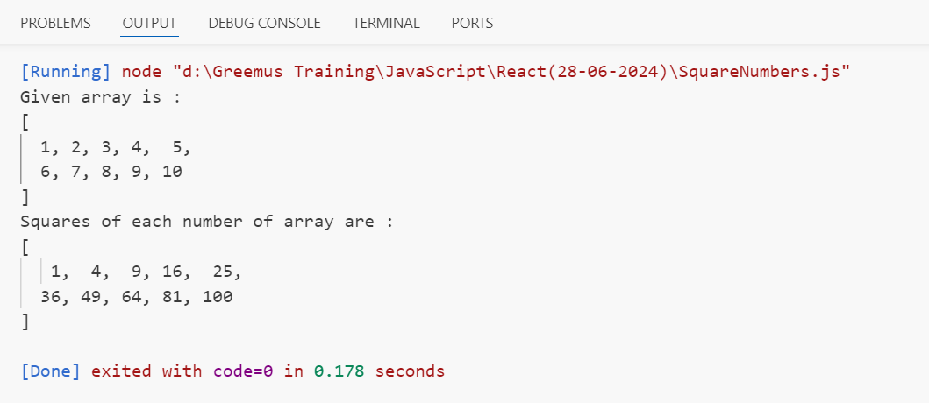

1. **Find Longest Word:** Write a function findLongestWord that takes a string and returns the longest word in the string.

function findLongestWord(str) {

    let s = str.split(" ");

    let longest = s[0];

    for (let i = 1; i < s.length; i++) {

        if (s[i].length > longest.length) {

            longest = s[i];

        }

    }

    console.log("Given string is :");

    console.log(str);

    console.log("Longest word in string is : " + longest);

}

var a = "My name is Nithish Kumar";

findLongestWord(a);

**Output:**

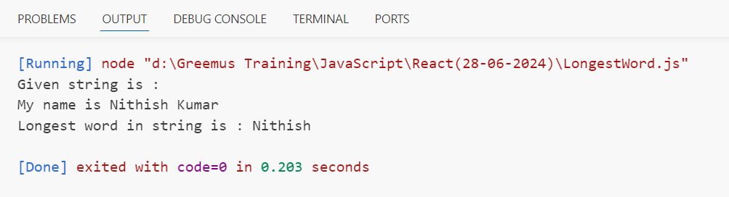

1. **Sort Numbers:** Write a function sortNumbers that takes an array of numbers and returns a sorted array in ascending order.

function sortNumbers(num) {

    console.log("Given array is :");

    console.log(num);

    let sort = num.sort();

    console.log("Sorted array in ascending order is :");

    console.log(sort);

}

let x = [8, 2, 5, 7, 1, 4, 6, 3];

sortNumbers(x);

**Output:**

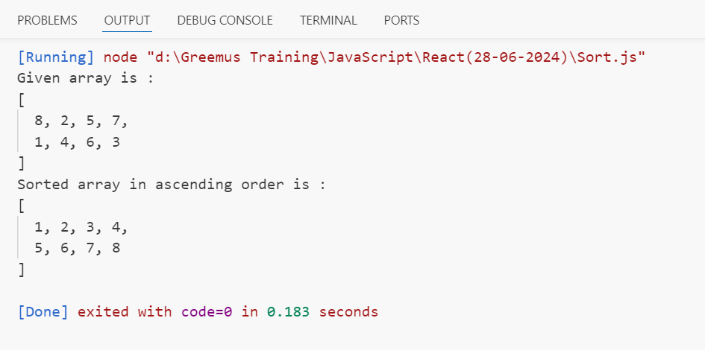

Create react app app name Travell service.print Welcome to cab with green color highlighted using html

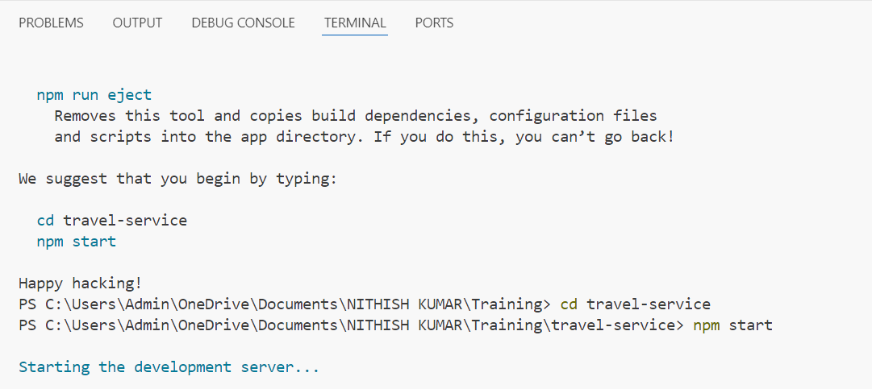

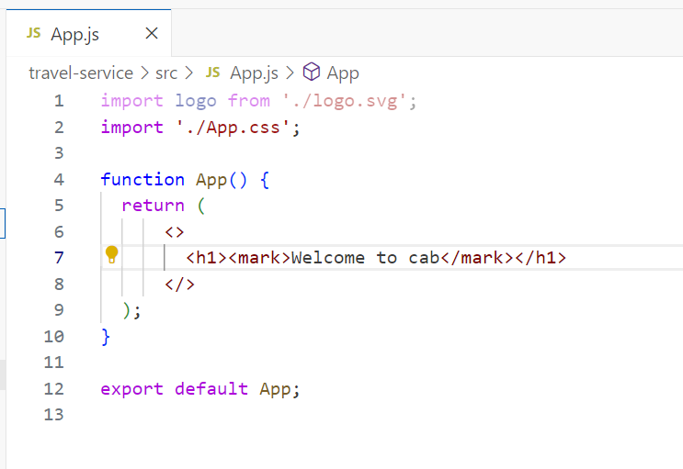

Output:

