### **Multiple-Choice Questions (MCQs):**

JavaScript Fundamentals:

What does the typeof operator return when used with typeof 42?

**A) number**

B) string

C) object

D) undefined

Which keyword is used to declare a variable in JavaScript?

**A) var**

B) int

C) let

D) const

What is the result of "5" + 2 in JavaScript?

**A) "52"**

B) 7

C) "7"

D) Error

How do you comment a single line in JavaScript?

**A) // This is a comment**

B) <!-- This is a comment -->

C) /* This is a comment */

D) # This is a comment

Which function is used to display a message in a popup box in JavaScript?

**A) alert()**

B) confirm()

C) prompt()

D) console.log()

What will be the output of console.log(3 === '3') in JavaScript?

A) true

B) false

**C) undefined**

D) Error

How do you declare a function in JavaScript?

**A) function myFunction() {}**

B) def myFunction():

C) void myFunction() {}

D) function = myFunction() {}

What is the correct way to include an external JavaScript file named script.js in an HTML document?

A) <script href="script.js"></script>

**B) <script src="script.js"></script>**

C) <script include="script.js"></script>

D) <script import="script.js"></script>

Which loop is used for iterating over the properties of an object in JavaScript?

A) for loop

B) while loop

C) do-while loop

**D) for...in loop**

What is the result of NaN === NaN in JavaScript?

A) true

**B) false**

C) undefined

D) Error

Bootstrap Basics:

Which CSS framework is Bootstrap built on top of?

A) Sass

B) Less

**C) CSS**

D) None of the above

Which class is used to create a responsive navigation bar in Bootstrap?

A) .navbar-fixed

B) .navbar-responsive

**C) .navbar-expand**

D) .navbar

How do you create a grid layout in Bootstrap?

A) Using <table> tags

B) Using <div> tags with custom CSS

**C) Using .container and .row classes**

D) Using inline CSS styles

Which class is used to create a responsive image in Bootstrap?

A) .img-fluid

B) .responsive-img

**C) .img-responsive**

D) .fluid-image

How do you create a button in Bootstrap with rounded corners?

A) .btn

B) .btn-primary

**C) .btn-rounded**

D) .btn-rounded-corners

Which grid class is used to create a full-width column in Bootstrap?

A) .col-md-12

B) .col-sm-12

C) .col-lg-12

**D) .col-12**

How do you create a modal dialog in Bootstrap?

A) Using <dialog> tags

B) Using <div> tags with custom CSS

**C) Using .modal and .modal-dialog classes**

D) Using JavaScript alert() function

Which class is used to create a dropdown menu in Bootstrap?

A) .dropdown-toggle

B) .dropdown-menu

**C) .dropdown**

D) .drop-menu

How do you create a responsive table in Bootstrap?

A) Using <table> tags with custom CSS

**B) Using .table and .table-responsive classes**

C) Using <div> tags with inline styles

D) Using JavaScript to dynamically adjust table size

Which class is used to create a carousel (image slider) in Bootstrap?

A) .carousel-item

B) .carousel-slide

C) .slider

**D) .carousel**

Answer: D) .carousel

### **Exercise Questions:**

Create a simple JavaScript program that prompts the user to enter two numbers, then displays their sum in an alert box.

**Sum.html**

<!DOCTYPE html>

<html>

<body>

<h2>Sum of 2 numbers</h2>

<script>

num1 = prompt("Enter the first number:");

num2 = prompt("Enter the second number:");

sum = parseFloat(num1) + parseFloat(num2);

alert("The sum of given 2 numbers is: " + sum);

</script>

</body>

</html>

**Output:**

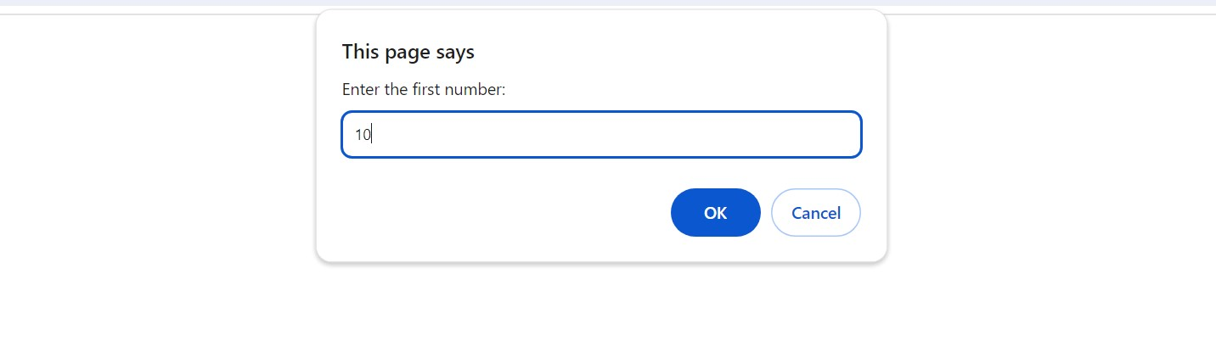

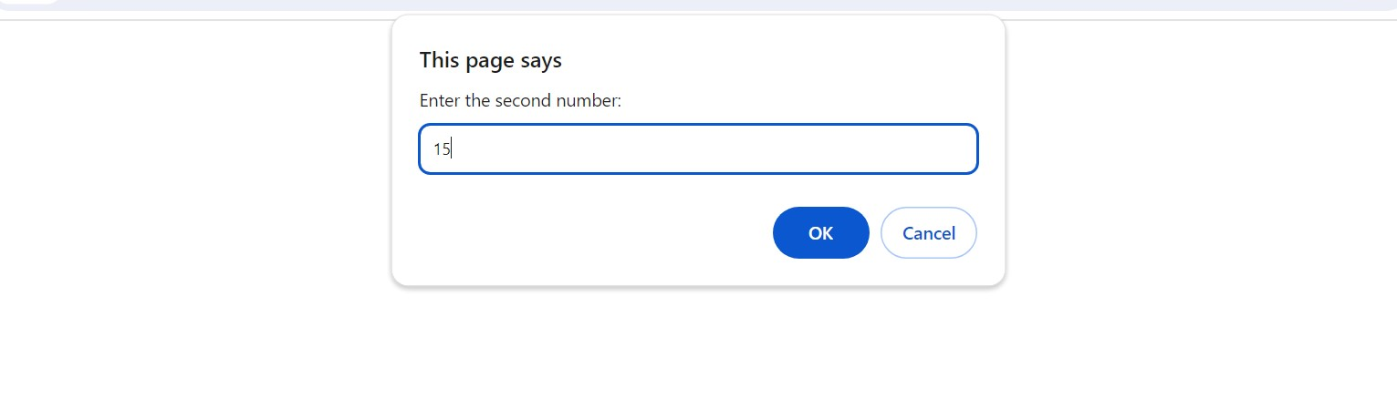

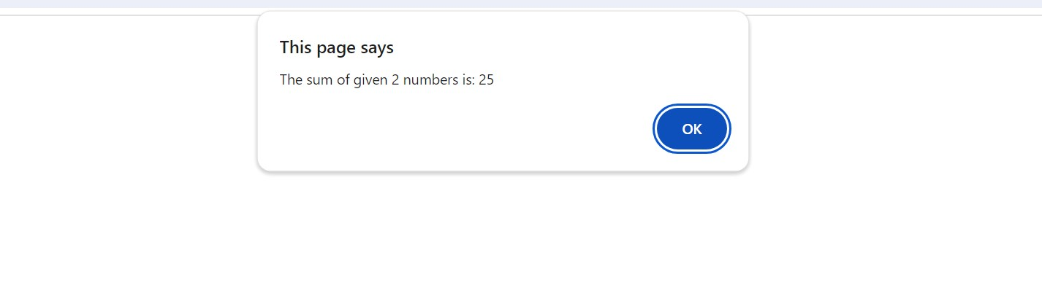

Develop a JavaScript function that takes a Celsius temperature as input and converts it to Fahrenheit, then logs the result to the console.

**Temp.html**

<!DOCTYPE html>

<html>

<head>

  <title>Celsius to Fahrenheit</title>

</head>

<body>

  <h1>Celsius to Fahrenheit Converter</h1>

  <p>Enter temperature in Celsius:</p>

  <input type="number" id="celsius" placeholder="enter celsius">

  <button onclick="convertCelsiusToFahrenheit()">Convert</button>

  <p id="fahrenheit"></p>

  <script>

  function celsiusToFahrenheit(celsius) {

  const fahrenheit = (celsius * 9 / 5) + 32;

  return fahrenheit.toFixed(1);

  }

  function convertCelsiusToFahrenheit() {

  const celsiusInput = document.getElementById("celsius");

  const celsiusValue = parseFloat(celsius.value);

  if (isNaN(celsiusValue)) {

    alert("Please enter a valid number.");

    return;

  }

  const fahrenheit = celsiusToFahrenheit(celsiusValue);

  const outputElement = document.getElementById("fahrenheit");

  outputElement.textContent = `${celsiusValue}°C is equal to ${fahrenheit}°F`;

  }

  </script>

</body>

</html>

**Output:**

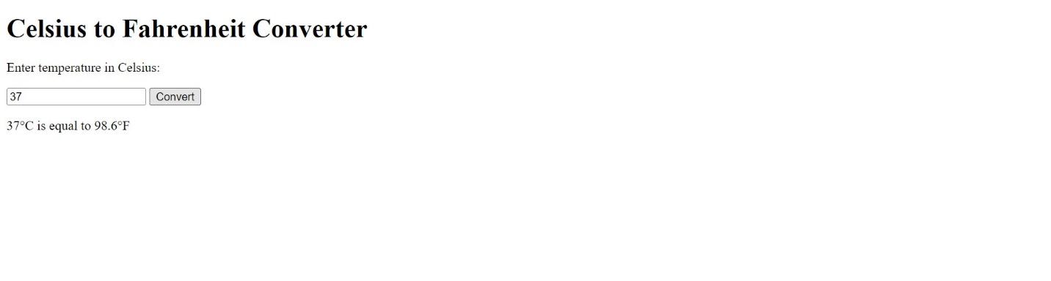

Build a basic Bootstrap webpage with a responsive navigation bar (navbar), a Jumbotron (jumbotron), and a grid layout (container and row).

**Bootstrap.html**

<!DOCTYPE html>

<html lang="en">

<head>

  <meta charset="UTF-8">

  <meta name="viewport" content="width=device-width, initial-scale=1.0">

  <title>Bootstrap page</title>

  <link href="https://cdn.jsdelivr.net/npm/bootstrap@5.1.3/dist/css/bootstrap.min.css" rel="stylesheet" integrity="sha384-1BmE4kWBq78iYhFldvKuhfTAU6auU8tT94WrHftjDbrCEXSU1oBoqyl2QvZ6jIW3" crossorigin="anonymous">

<style>

  .jumbotron{

    text-align: center;

    color: rgb(46, 48, 180);

    background-color: rgb(111, 186, 74);

  }

</style>

</head>

<body>

  <nav class="navbar navbar-expand-sm bg-light">

    <div class="container">

      <a class="navbar-brand" href="#">My Website</a>

      <button class="navbar-toggler" type="button" data-bs-toggle="collapse" data-bs-target="#navbarNav" aria-controls="navbarNav" aria-expanded="false" aria-label="Toggle navigation">

        <span class="navbar-toggler-icon"></span>

      </button>

      <div class="collapse navbar-collapse" id="navbarNav">

        <ul class="navbar-nav ms-auto">

          <li class="nav-item">

            <a class="nav-link active" aria-current="page" href="#">Home</a>

          </li>

          <li class="nav-item">

            <a class="nav-link" href="#">About</a>

          </li>

          <li class="nav-item">

            <a class="nav-link" href="#">Contact</a>

          </li>

        </ul>

      </div>

    </div>

  </nav>

  <div class="jumbotron">

    <div class="container">

      <h1 class="display-4">Welcome to my website!</h1>

      <p class="lead">This is a basic Bootstrap website.</p>

      <hr class="my-4">

      <p>It includes a responsive navbar, a Jumbotron, and a grid layout.</p>

      <a class="btn btn-warning btn-lg" href="#" role="button">Learn More</a><br><br>

    </div>

  </div>

  <div class="container">

    <div class="row">

      <div class="col-md-4">

        <h3>Section 1</h3>

        <p>This is first column.</p>

      </div>

      <div class="col-md-4">

        <h3>Section 2</h3>

        <p>This is second column.</p>

      </div>

      <div class="col-md-4">

        <h3>Section 3</h3>

        <p>This is third column.</p>

      </div>

    </div>

  </div>

  <script src="https://cdn.jsdelivr.net/npm/bootstrap@5.1.3/dist/js/bootstrap.bundle.min.js" integrity="sha384-ka7Sk0Gln4gmtz2MlQnikT1wXgYsOg+OMhuP+IlRH9sENBO0LRn5q+8nbTov4+1p" crossorigin="anonymous"></script>

</body>

</html>

**Output:**

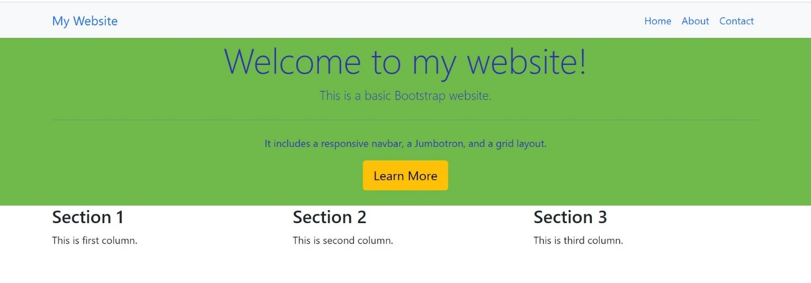

Implement a Bootstrap form with text input fields and a submit button, then use JavaScript to display the entered values in an alert box upon submission.

**Bootstrap_form.html**

<!DOCTYPE html>

<html lang="en">

<head>

    <meta charset="UTF-8">

    <meta name="viewport" content="width=device-width, initial-scale=1.0">

    <meta http-equiv="X-UA-Compatible" content="IE=edge">

    <title>Bootstrap Form</title>

    <link href="https://cdn.jsdelivr.net/npm/bootstrap@5.4.3/dist/css/bootstrap.min.css" rel="stylesheet">

</head>

<body>

    <div class="container">

        <h2>Form</h2>

        <form id="myForm">

          <div class="mb-3">

            <label for="Name">Name:</label>

            <input type="text" id="Name" name="Name" required><br><br>

          </div>

          <div class="mb-3">

            <label for="email">Email:</label>

            <input type="text" id="email" name="email" required><br><br>

          </div>

          <div>

            <label for="Phone">Phone:</label>

            <input type="number" name="number" id="number" required><br><br>

          </div>

          <button type="submit">Submit</button>

        </form>

      </div>

      <!-- Bootstrap JS -->

      <script src="https://cdn.jsdelivr.net/npm/bootstrap@5.4.3/dist/js/bootstrap.bundle.min.js"></script>

      <script>

        document.getElementById("myForm").addEventListener("submit", function(event)

        {

          event.preventDefault();

          var Name = document.getElementById("Name").value;

          var Email = document.getElementById("email").value;

          var Phone = document.getElementById("number").value;

          var message = "Name: " + Name + "\nEmail: " + Email+"\nPhone"+Phone;

          alert(message);

        });

      </script>

</body>

</html>

**Output:**

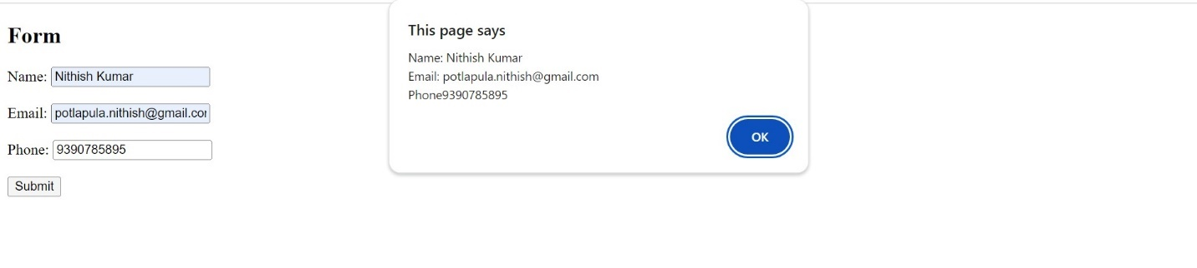

Create a Bootstrap modal dialog that opens when a button is clicked, displaying a message or additional content.

**Modal.html**

<!DOCTYPE html>

<html lang="en">

<head>

    <meta charset="UTF-8">

    <meta name="viewport" content="width=device-width, initial-scale=1.0">

    <link rel="stylesheet" href="https://maxcdn.bootstrapcdn.com/bootstrap/3.4.1/css/bootstrap.min.css">

    <script src="https://ajax.googleapis.com/ajax/libs/jquery/3.7.1/jquery.min.js"></script>

    <script src="https://maxcdn.bootstrapcdn.com/bootstrap/3.4.1/js/bootstrap.min.js"></script>

    <title>Bootstrap Modal</title>

</head>

<body>

    <div class="container">

        <h2>Modal Dialog</h2>

        <button type="button" class="btn btn-success btn-lg" data-toggle="modal" data-target="#myModal">Open Modal</button>

        <div class="modal fade" id="myModal" role="dialog">

          <div class="modal-dialog">

            <div class="modal-content">

              <div class="modal-header">

                <button type="button" class="close" data-dismiss="modal">&times;</button>

                <h4 class="modal-title">Modal Header</h4>

              </div>

              <div class="modal-body">

                <p>This is text in the modal.</p>

              </div>

              <div class="modal-footer">

                <button type="button" class="btn btn-default" data-dismiss="modal">Close</button>

              </div>

            </div>

          </div>

        </div>

      </div>

</body>

</html>

**Output:**

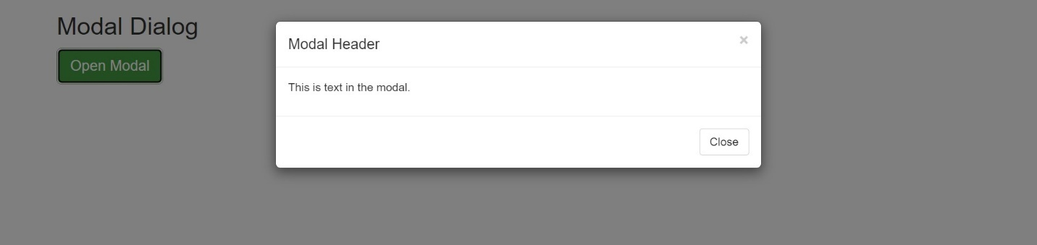

Design a Bootstrap card layout (card) with multiple cards displaying images and text content.

**Card.html**

<!DOCTYPE html>

<html lang="en">

<head>

    <meta charset="UTF-8">

    <meta name="viewport" content="width=device-width, initial-scale=1.0">

    <link href="https://cdn.jsdelivr.net/npm/bootstrap@5.3.3/dist/css/bootstrap.min.css" rel="stylesheet">

    <script src="https://cdn.jsdelivr.net/npm/bootstrap@5.3.3/dist/js/bootstrap.bundle.min.js"></script>

    <title>Card layout</title>

</head>

<body>

    <div class="container mt-3">

        <h2>Card Layout Images</h2>

        <div class="row">

        <div class="col-md-6">

        <div class="card">

          <img style="width: 200px;height: 200px;" src="https://www.reliancedigital.in/medias/HP-Laptop-494267989-i-1-1200Wx1200H?context=bWFzdGVyfGltYWdlc3w0NzAwODd8aW1hZ2UvanBlZ3xpbWFnZXMvaDI4L2hlYS8xMDA1OTA1NzYyNzE2Ni5qcGd8MTAxNzlhZTI2N2IzNmEwZGNjYTZlYWM4MzViNGYxZGJjYjg0NWExY2EzOGYwZjQ1Nzk1MWIyZGFjOGFkNTYxNg" alt="Card image" style="width:100%">

          <div class="card-body">

            <h4 class="card-title">Laptop</h4>

            <p class="card-text">A laptop computer or notebook computer, also known as a laptop or notebook, is a small, portable personal computer (PC). Laptops typically have a clamshell form factor with a flat-panel screen on the inside of the upper lid and an alphanumeric keyboard and pointing device on the inside of the lower lid.</p>

            <a href="#" class="btn btn-primary">See more</a>

          </div>

        </div>

        </div>

        <br>

        <div class="col-md-6">

        <div class="card">

            <img style="width: 200px;height: 200px;" src="https://rukminim2.flixcart.com/image/850/1000/kngd0nk0/mobile/r/w/w/z4-le000z93p-z4-lava-original-imag24fbqfdqszuw.jpeg?q=20" alt="Card image" style="width:100%">

            <div class="card-body">

              <h4 class="card-title">Mobile</h4>

              <p class="card-text">A mobile phone (or cellphone[a]) is a portable telephone that can make and receive calls over a radio frequency link while the user is moving within a telephone service area, as opposed to a fixed-location phone (landline phone).</p>

              <a href="#" class="btn btn-primary">See more</a>

            </div>

          </div>

        </div>

        </div>

</body>

</html>

**Output:**

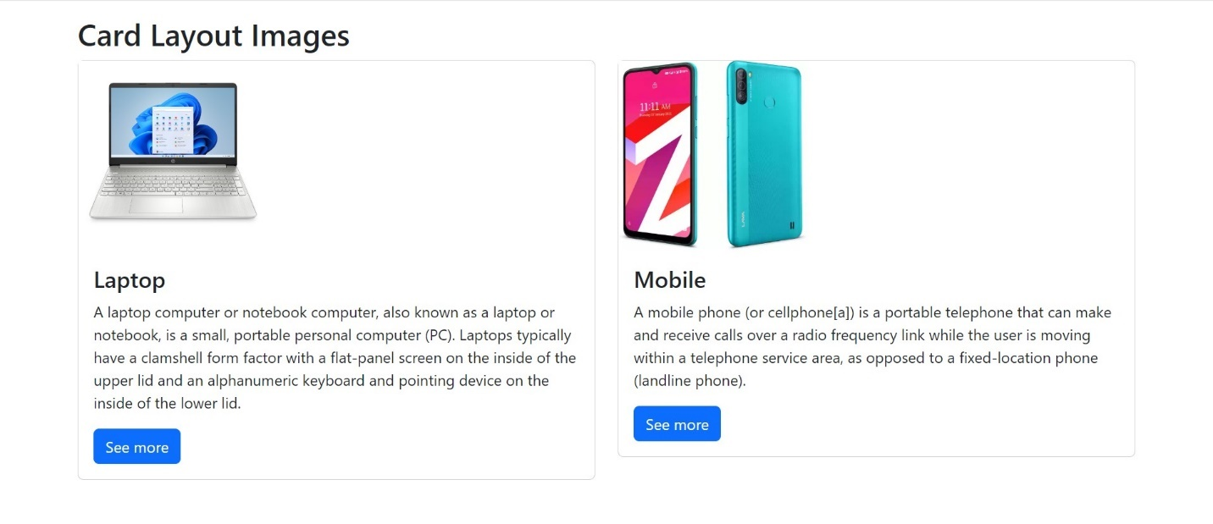

Develop a Bootstrap dropdown menu (dropdown) with multiple menu items that link to different sections or pages.

**Dropdown.html**

<!DOCTYPE html>

<html lang="en">

<head>

    <meta charset="UTF-8">

    <meta name="viewport" content="width=device-width, initial-scale=1.0">

    <link href="https://cdn.jsdelivr.net/npm/bootstrap@5.3.3/dist/css/bootstrap.min.css" rel="stylesheet">

    <script src="https://cdn.jsdelivr.net/npm/bootstrap@5.3.3/dist/js/bootstrap.bundle.min.js"></script>

    <title>Dropdown</title>

</head>

<body>

    <div class="container mt-3">

        <h2>Dropdown menu</h2>

        <p>Dropdown menu links to different sections or pages</p>

        <div class="dropdown">

          <button type="button" class="btn btn-primary dropdown-toggle" data-bs-toggle="dropdown">Dropdown</button>

          <ul class="dropdown-menu">

            <li><a class="dropdown-item" href="https://luminous-kringle-45aeb8.netlify.app/">Home</a></li>

            <li><a class="dropdown-item" href="https://luminous-kringle-45aeb8.netlify.app/#about-section">About</a></li>

            <li><a class="dropdown-item" href="https://luminous-kringle-45aeb8.netlify.app/#contact-section">Contact</a></li>

        </ul>

        </div>

      </div>

</body>

</html>

**Output:**

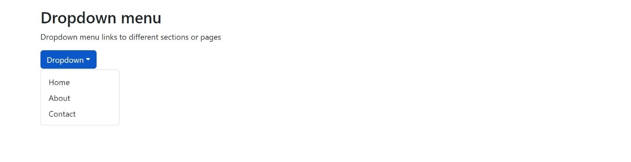

Build a responsive table using Bootstrap (table and table-responsive) to display tabular data.

**Table.html**

<!DOCTYPE html>

<html lang="en">

<head>

  <title>Table</title>

  <meta charset="utf-8">

  <meta name="viewport" content="width=device-width, initial-scale=1">

  <link href="https://cdn.jsdelivr.net/npm/bootstrap@5.3.3/dist/css/bootstrap.min.css" rel="stylesheet">

</head>

<body>

<div class="container mt-3">

  <h2>States</h2>

  <table class="table table-bordered">

    <thead>

      <tr>

        <th>State</th>

        <th>Capital</th>

        <th>Language</th>

      </tr>

    </thead>

    <tbody>

      <tr>

        <td>Telangana</td>

        <td>Hyderabad</td>

        <td>Telugu</td>

      </tr>

      <tr>

        <td>Tamilnadu</td>

        <td>Chennai</td>

        <td>Tamil</td>

      </tr>

      <tr>

        <td>Karnataka</td>

        <td>Bangalore</td>

        <td>Kannada</td>

      </tr>

    </tbody>

  </table>

</div>

</body>

</html>

**Output:**

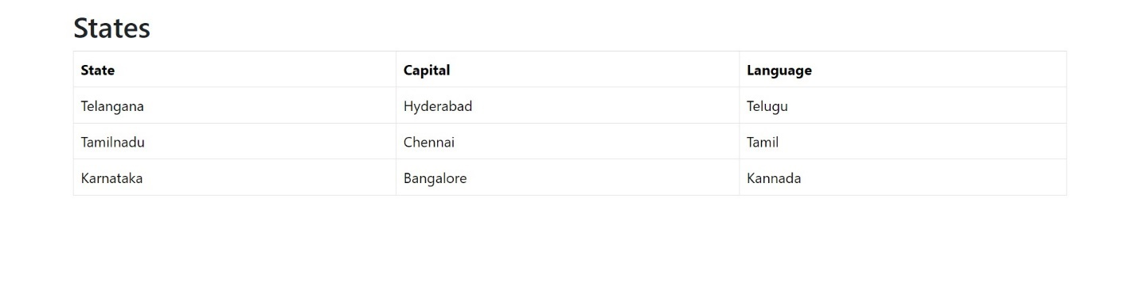

Design a Bootstrap carousel (carousel) with multiple slides/images that automatically cycle through.

**Carousel.html**

<!DOCTYPE html>

<html lang="en">

<head>

    <meta charset="UTF-8">

    <meta name="viewport" content="width=device-width, initial-scale=1.0">

    <link href="https://cdn.jsdelivr.net/npm/bootstrap@5.3.3/dist/css/bootstrap.min.css" rel="stylesheet">

    <script src="https://cdn.jsdelivr.net/npm/bootstrap@5.3.3/dist/js/bootstrap.bundle.min.js"></script>

    <title>Carousel</title>

</head>

<body>

<div id="demo" class="carousel slide" data-bs-ride="carousel">

    <div class="carousel-indicators">

      <button type="button" data-bs-target="#demo" data-bs-slide-to="0" class="active"></button>

      <button type="button" data-bs-target="#demo" data-bs-slide-to="1"></button>

      <button type="button" data-bs-target="#demo" data-bs-slide-to="2"></button>

    </div>

    <div class="carousel-inner">

      <div class="carousel-item active">

        <img src="https://images.ctfassets.net/hrltx12pl8hq/3Z1N8LpxtXNQhBD5EnIg8X/975e2497dc598bb64fde390592ae1133/spring-images-min.jpg" alt="welcome" class="d-block" style="width:100%" height="20%">

      </div>

      <div class="carousel-item">

        <img src="https://t4.ftcdn.net/jpg/03/60/89/09/360_F_360890991_Ykybj5JO5HYBaqWeROz9cR2jWXN8HZxf.jpg" alt="Company" class="d-block" style="width:100%" height="20%">

      </div>

      <div class="carousel-item">

        <img src="https://media.istockphoto.com/id/505239248/photo/humayun-tomb-new-delhi-india.jpg?s=612x612&w=0&k=20&c=UQTU6YOnVsSklzHi34cOhNW5AhsACDxKLiD9--T-3Kg=" alt="Team" class="d-block" style="width:100%" height="20%">

      </div>

    </div>

    <button class="carousel-control-prev" type="button" data-bs-target="#demo" data-bs-slide="prev">

      <span class="carousel-control-prev-icon"></span>

    </button>

    <button class="carousel-control-next" type="button" data-bs-target="#demo" data-bs-slide="next">

      <span class="carousel-control-next-icon"></span>

    </button>

  </div>

  <div class="container-fluid mt-3">

    <h3>Carousel</h3>

    <p>The images will slides automatically.</p>

  </div>

</body>

</html>

**Output:**

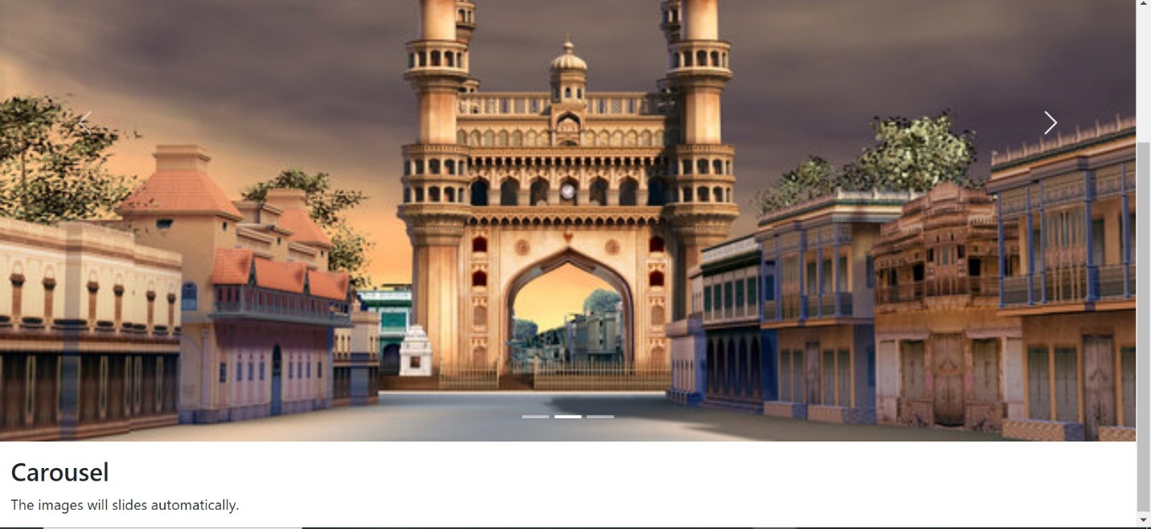

Combine JavaScript and Bootstrap to create a dynamic webpage that updates content based on user interactions (e.g., show/hide elements, change styles).

**Dynamic.html**

<!DOCTYPE html>

<html lang="en">

<head>

  <meta charset="UTF-8">

  <meta name="viewport" content="width=device-width, initial-scale=1.0">

  <title>Dynamic</title>

  <link href="https://cdn.jsdelivr.net/npm/bootstrap@5.1.3/dist/css/bootstrap.min.css" rel="stylesheet" integrity="sha384-1BmE4kWBq78iYhFldvKuhfTAU6auU8tT94WrHftjDbrCEXSU1oBoqyl2QvZ6jIW3" crossorigin="anonymous">

</head>

<body>

  <div class="container">

    <h1>Dynamic page</h1>

    <button type="button" class="btn btn-primary" id="toggleButton">Show</button>

    <p id="details" class="d-none">This is hidden text.</p>

    <div class="row">

      <div class="col-md-4" id="colorBox"><br>

        <h2>Change Color</h2><br>

        <select class="form-select" id="colorSelect">

          <option value="primary">Blue</option>

          <option value="success">Green</option>

          <option value="danger">Red</option>

        </select>

      </div>

    </div>

  </div>

  <script>

    const toggleButton = document.getElementById("toggleButton");

const detailsElement = document.getElementById("details");

const colorSelect = document.getElementById("colorSelect");

const colorBox = document.getElementById("colorBox");

toggleButton.addEventListener("click", function() {

  detailsElement.classList.toggle("d-none");

  if (detailsElement.classList.contains("d-none")) {

    toggleButton.textContent = "Show";

  } else {

    toggleButton.textContent = "Hide";

  }

});

colorSelect.addEventListener("change", function() {

  const selectedColor = colorSelect.value;

  colorBox.classList.remove("bg-primary", "bg-success", "bg-danger");

  colorBox.classList.add(`bg-${selectedColor}`);

});

  </script>

  <script src="https://cdn.jsdelivr.net/npm/bootstrap@5.1.3/dist/js/bootstrap.bundle.min.js" integrity="sha384-ka7Sk0Gln4gmtz2MlQnikT1wXgYsOg+OMhuP+IlRH9sENBO0LRn5q+8nbTov4+1p" crossorigin="anonymous"></script>

</body>

</html>

**Output:**

