MCQ

What command is used to initialize a Git repository locally?

a) git clone

b) git init

c) git commit

d) git push

**ans:b**

How can you check the status of your changes in a Git repository?

a) git status

b) git check

c) git diff

d) git log

**ans:a**

What command is used to stage files for a commit in Git?

a) git add

b) git stage

c) git commit

d) git push

**ans:a**

What is the purpose of forking a repository on GitHub?

a) To create a new branch in the original repository

b) To merge changes from one repository to another

c) To copy a repository under your GitHub account

d) To revert changes in a repository

**ans:c**

What is a Pull Request used for in GitHub?

a) Requesting changes to be pulled into a repository

b) Submitting changes for approval and merging

c) Deleting branches in a repository

d) Checking the status of commits in a repository

**ans:b**

What does a 'Merge Conflict' indicate in a GitHub pull request?

a) Successful merging of changes

b) Inconsistencies between branches that need to be resolved

c) Rejection of a pull request

d) Approval of changes for merging

**ans:b**

Which command is used to create a new branch in Git?

a) git branch

b) git commit

c) git checkout

d) git merge

**ans:a**

What command is used to view the commit history in Git?

a) git log

b) git history

c) git show

d) git status

**ans:a**

How can you undo the last commit in Git?

a) git amend

b) git reset

c) git revert

d) git undo

**ans:b**

What is a repository in GitHub?

a) A folder on your local machine

b) A collection of project files and revision history

c) A social media platform for developers

d) A code editor tool

**ans:b**

How can you clone a repository from GitHub to your local machine?

a) git clone

b) git fetch

c) git init

d) git pull

**ans:a**

What is the purpose of the 'Issues' tab in GitHub repositories?

a) To track and discuss bugs, enhancements, and tasks

b) To view commit history

c) To create new branches

d) To merge changes into the main branch

**ans:a**

Which GitHub feature allows multiple people to collaborate on a project simultaneously?

a) Pull Requests

b) Forking

c) Issues

d) Branches

**ans:a**

What does the 'README.md' file in a GitHub repository contain?

a) Detailed instructions for using the project

b) A list of contributors

c) Commit history

d) License information

**ans:a**

How can you update your local repository with changes from a remote repository in Git?

a) git merge

b) git fetch

c) git update

d) git commit -u origin

**ans:b**

What is the purpose of the 'git push' command in Git?

a) To stage changes for commit

b) To download changes from a remote repository

c) To update the remote repository with local changes

d) To switch between branches

**ans:c**

What is git and github?

**Ans:**

Git

Git is vcs that helps to manage and keep track of our code:

It allows to two aspects:

1.Version control System: It allows developers to tract changes, collaborate on projects and manage code.

2.Collaboration: git provides tools for collaboration to pull requestion, code review.

What is CVCS and DVCS ?

**Ans:**

**Cvcs:**

* CVCS control hosts different versions of the code in a centralized repository.
* If it corrupted, retrieval can be difficult.
* CVCS holds only current version of data.
* Ex: svn, Tfvc

**DVCS:**

* DVCS stores files across multiple repositories.
* Each developer has a full copy of the repository including entire history.
* Ex: git

Create a project of any and push the project

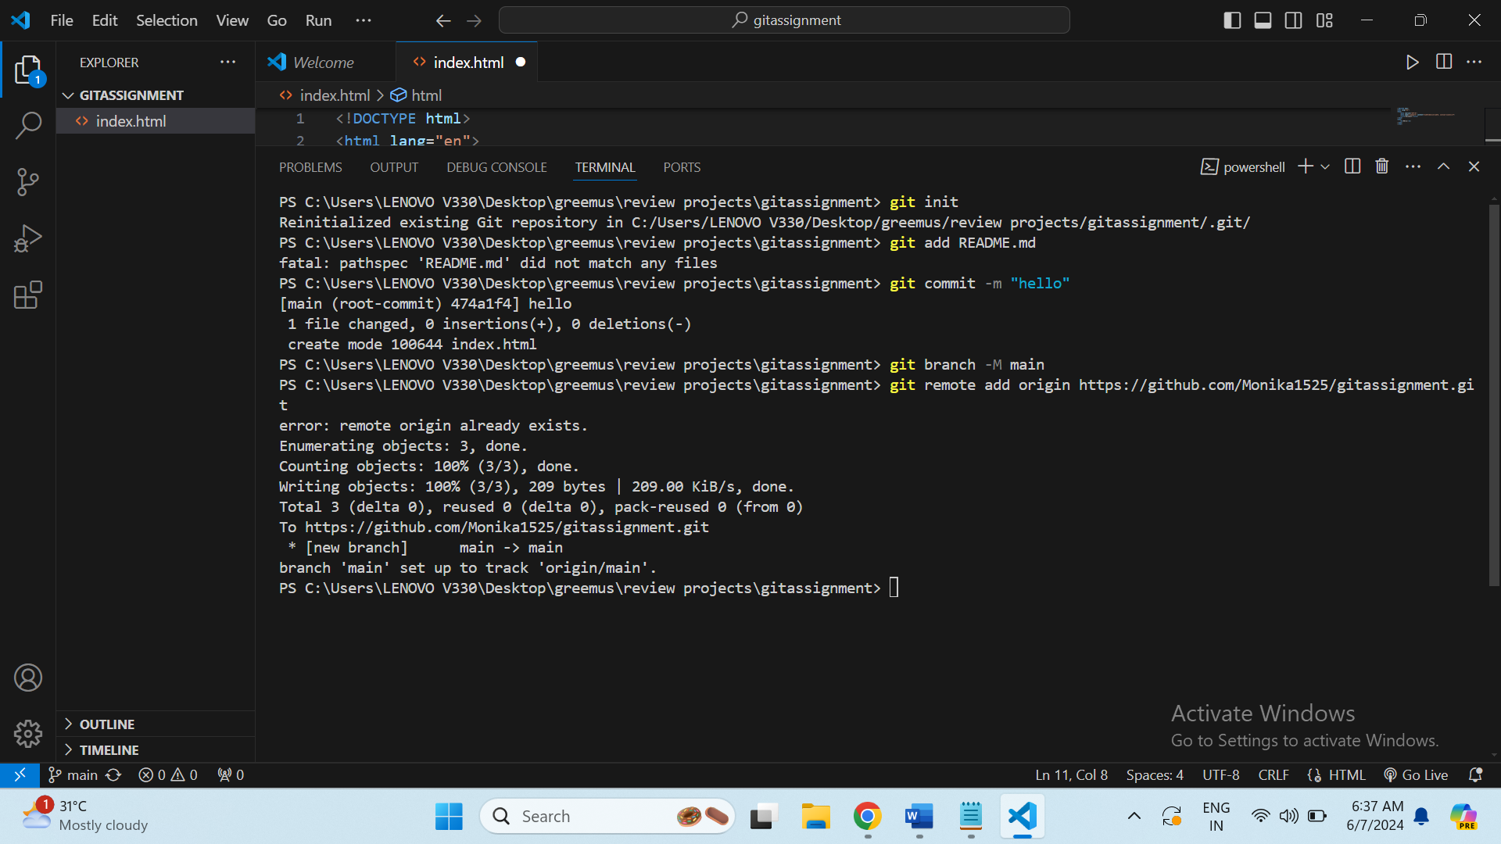 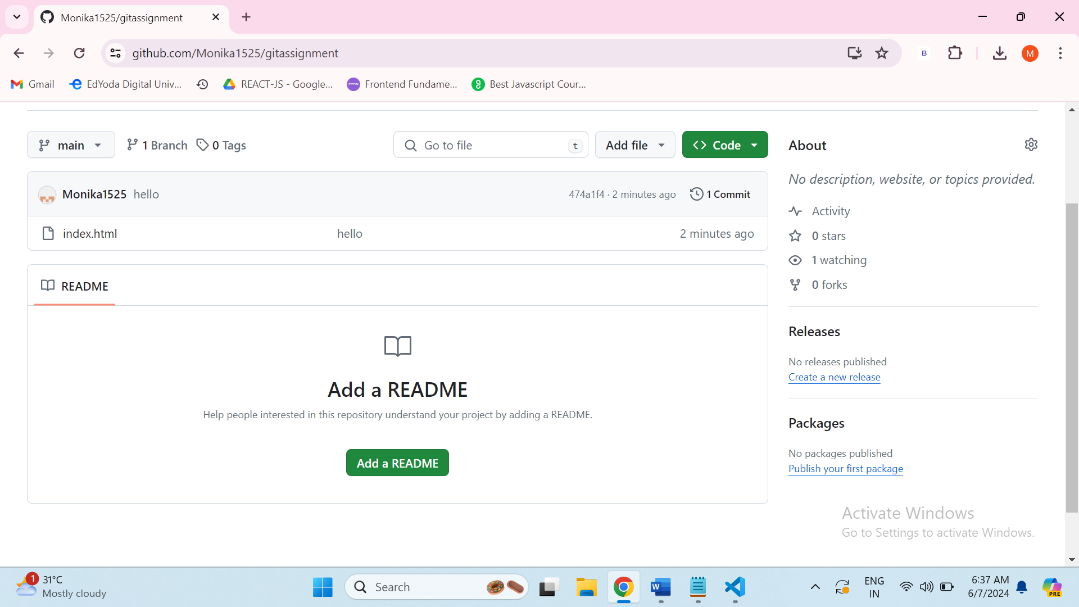

Create 3 branches and 5 tags

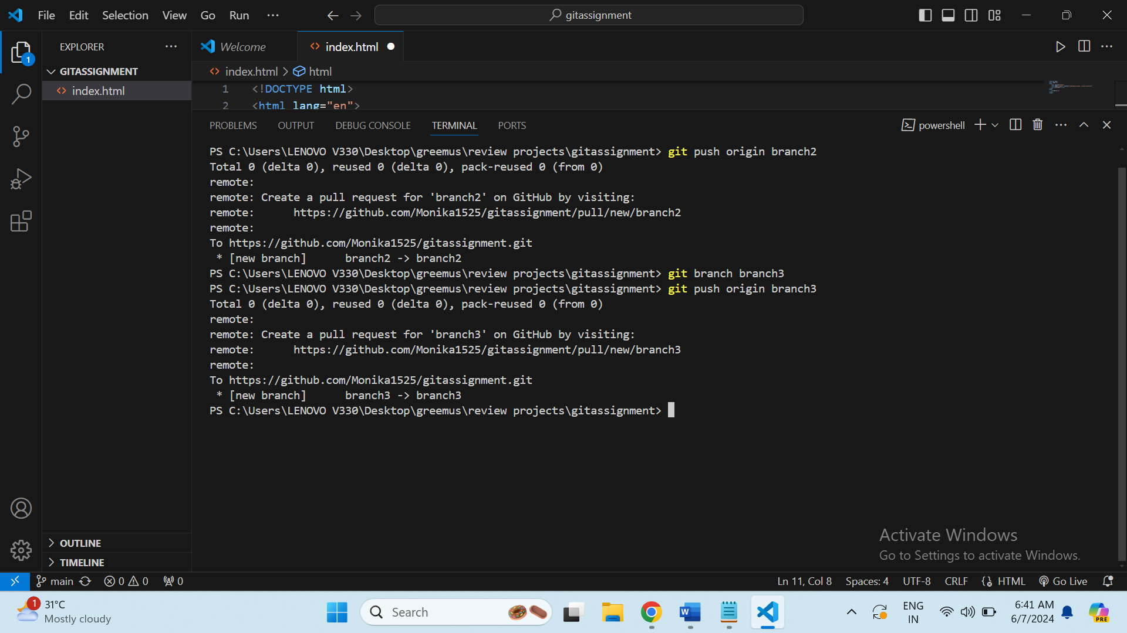 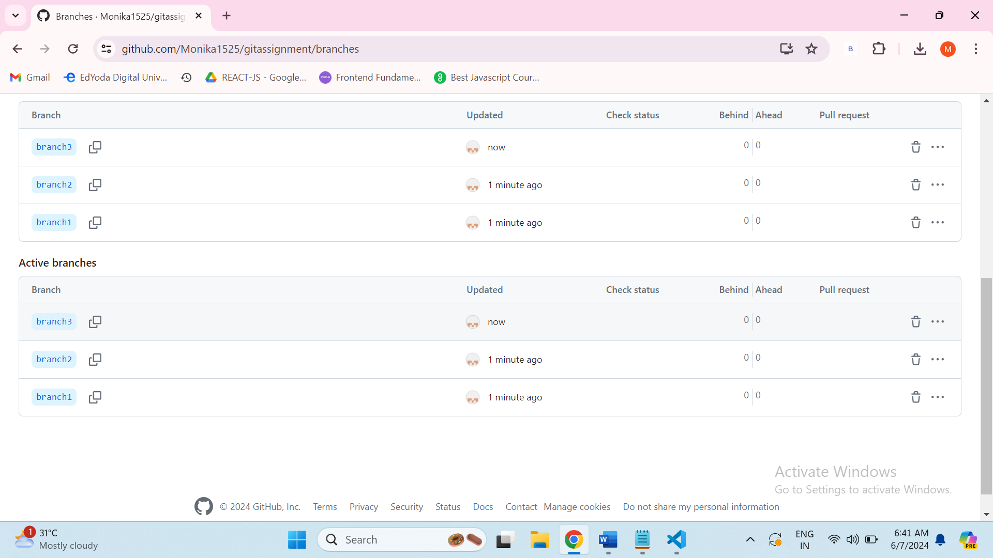

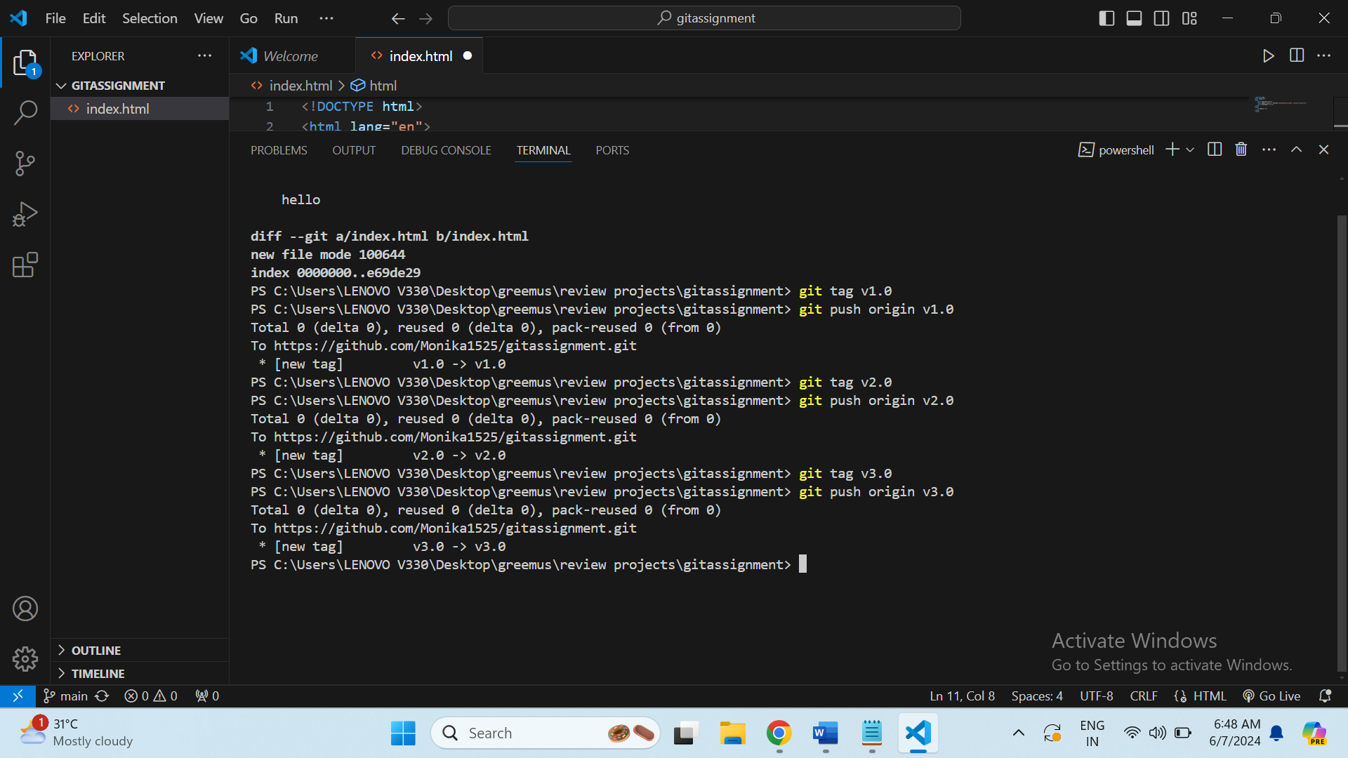 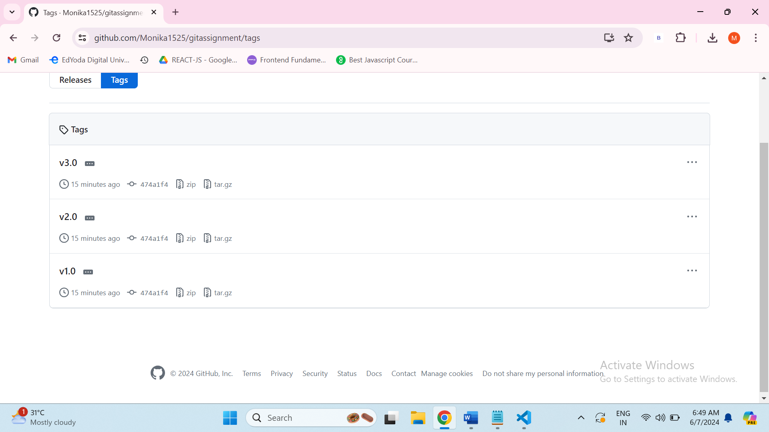

Create a Keygen and push using ssh

