1.

<body>

  <div id="form">

  <h2>Form:</h2>

  <form >

    <label id="name">Name:</label>

    <input type="text"><br>

    <label id="email">Email:</label>

    <input type="email"><br>

    <label id="message">Message:</label><br>

    <textarea cols="45" rows="5" >Type here..</textarea><br><br>

    <button type="submit">submit</button>

  </form>

</div>

</body>

</html>

body{

    display: flex;

    justify-content: center;

    align-items: center;

    box-sizing: border-box;

    background-color: lightblue;

    height: 100vh;

}

#form{

    width:400px;

    height: 400px;

    padding: 20px;

    flex-direction: column;

    box-sizing: border-box;

    background-color: bisque;

    align-items: center;

    justify-content: center;

    border: 1px solid black;

    border-radius: 6px;

}

input{

    width: 98%;

    height: 25px;

}

button{

  width: 99%;

  height: 30px;

  outline: 1px;

}

Output:

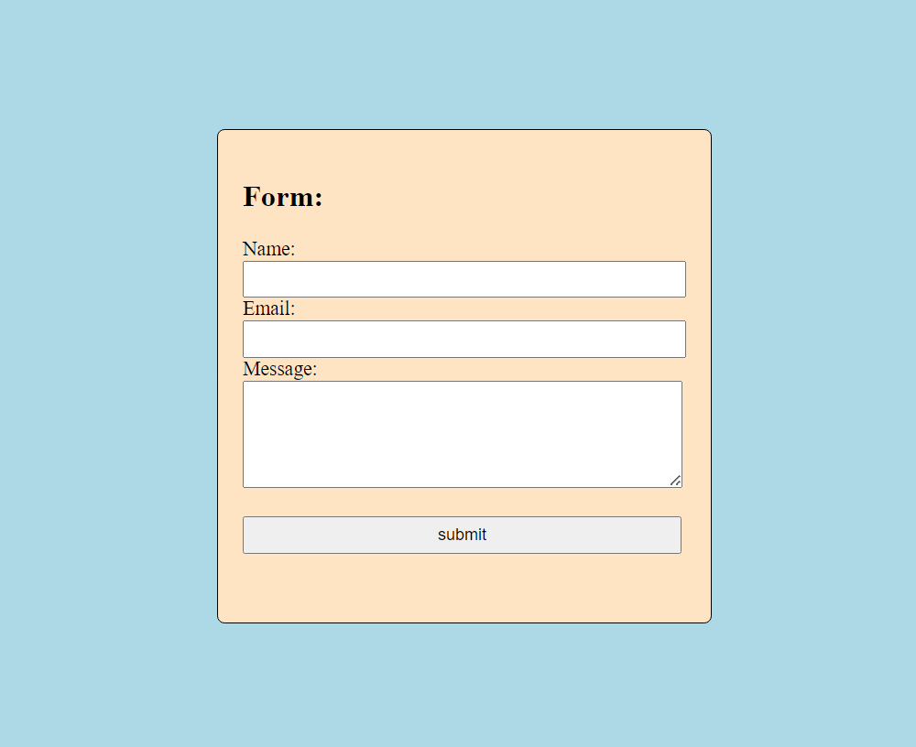

2.

</head>

<body>

  <h2 align="center">Three column layout:</h2>

  <div id="parent">

   <div class="child" id="c1">column 1</div>

   <div class="child" id="c2">column 2</div>

   <div class="child" id="c3">column 3</div>

</div>

</body>

</html>

#parent{

display: flex;

justify-content: center;

}

.child{

    flex-direction: column;

    height: 300px;

    width: 100px;

    border: 1px black solid;

}

#c1{

    background-color: lightcoral;

}

#c2{

    background-color: orchid;

}

#c3{

    background-color:steelblue

}

Output:

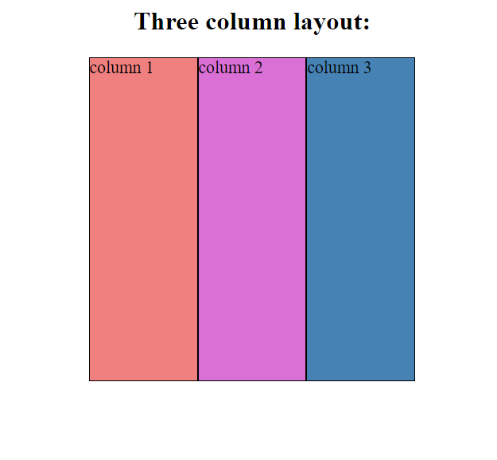

3.

<body>

    <div class="container">

   <div class="navbar">

       <a href="#" class="logo">WELCOME!!</a>

       <ul>

   <li><a href="#">Home</a></li>

   <li><a href="#">About us</a></li>

   <li><a href="#">Contact us</a></li>

       </ul>

   </div>

   <div class="content">

       <h1>PAIN WILL GAIN.</h1><br>

       <p>Peace within you</p>

   </div>

    </div>

</body>

</html>

\*{

    margin:0;

    padding:0;

    font-family: sans-serif;

}

.container{

    width: 100%;

    height: 100vh;

    background-image: linear-gradient(rgba(31, 31, 31, 0),rgba(31,31,31,0)),url(http://wallpapercave.com/wp/xUObkiE.jpg);

    background-size: cover;

    background-position: center;

}

.navbar{

    width: 50%;

    margin: auto;

    padding: 30px 0;

    display: flex;

    align-items: center;

    justify-content: space-between;

    position: relative;

}

.logo{

    font-size: medium;

    font-weight: bolder;

    cursor: pointer;

    text-decoration: none;

    color: rgb(6, 75, 87);

}

.navbar ul li{

    list-style: none;

    display:inline-block;

    margin: 0 20px;

    position:relative;

}

.navbar ul li a{

    text-decoration: dotted;

    color: teal;

    font-weight: bolder;

    font-style: oblique;

}

.content{

    width:100%;

    color:rgb(14, 6, 6);

    position: absolute;

    top: 50%;

    text-align: center;

    transform: translateY(-50%);

    font: italic;

}

@media screen and (max-width:768px) {

    body{

        font-size: 14px;

    }

}

Output:



4.

<body>

 <h2>Button:</h2>

 <button type="submit">Submit</button>

</body>

</html>

\*{

   padding: 20px;

   margin: 10px;

   text-align: center;

}

button{

    height: 20px;

    width: 100px;

    background-color: rgb(171, 11, 43);

    border-radius: 5px;

}

button:hover{

    background-color: rgb(196, 102, 102);

}

Output: 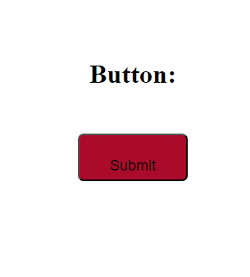

5.

<body>

 <h2>Drop-down menu:</h2>

<div id="list">

  <label for="dropdown" id="menu">Choose Language:</label>

   <select>

   <option id="o"></option>

   <option id="r">Reactjs</option>

   <option id="p">Python</option>

   <option id="a">AI</option>

   <option id="s">SAP</option>

   <option id="j">Java</option>

   </select>

</div>

</body>

</html>

body{

    padding: 20px;

    text-align: center;

    box-sizing: border-box;

    background-color: lightblue;

   border: 2px black solid;

   height: 300px;

   width: 300px;

}

#o{

    background-color: darkseagreen;

}

#r{

    background-color:cornflowerblue;

}

#p{

    background-color:darkseagreen;

}

#a{

    background-color:indianred;

}

#s{

    background-color:rgb(162, 18, 66);

}

#j{

    background-color:cornflowerblue;

}

Output:

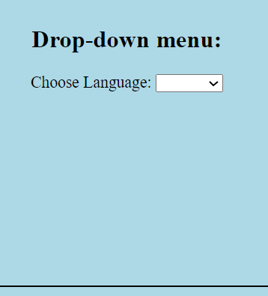

6. Involved Uncovered topic(Javascript.)

7.

<body><h2 align="center">Netflix Plan</h2>

  <table  border="2" cellpadding="4" cellspacing="4" align="center" style="border-collapse: collapse; ">

    <tr>

      <th>Features</th>

      <th>Basic</th>

      <th>Standard</th>

      <th>Premium</th>

    </tr>

    <tr>

      <td>Monthly Price</td>

      <th>199</th>

      <th>499</th>

      <th>649</th>

    </tr>

    <tr>

      <td>HD Available</td>

      <td>No</td>

      <td>Yes</td>

      <td>Yes</td>

    </tr>

    <tr>

      <td>UltraHD Available</td>

      <td>No</td>

      <td>No</td>

      <td>Yes</td>

    </tr>

    <tr>

      <td>Screen Limit</td>

      <td>1</td>

      <td>2</td>

      <td>4</td>

    </tr>

  </table>

</body>

</html>

body{

    background-color:ivory;

}

h2{

    color:red;

    background-color: black;

}

table{

    padding: 10px;

    text-align: center;

    height: 400px;

    width: 500px;

    background-color: black;

    color: red;

    border:red 1px solid

}

Output:

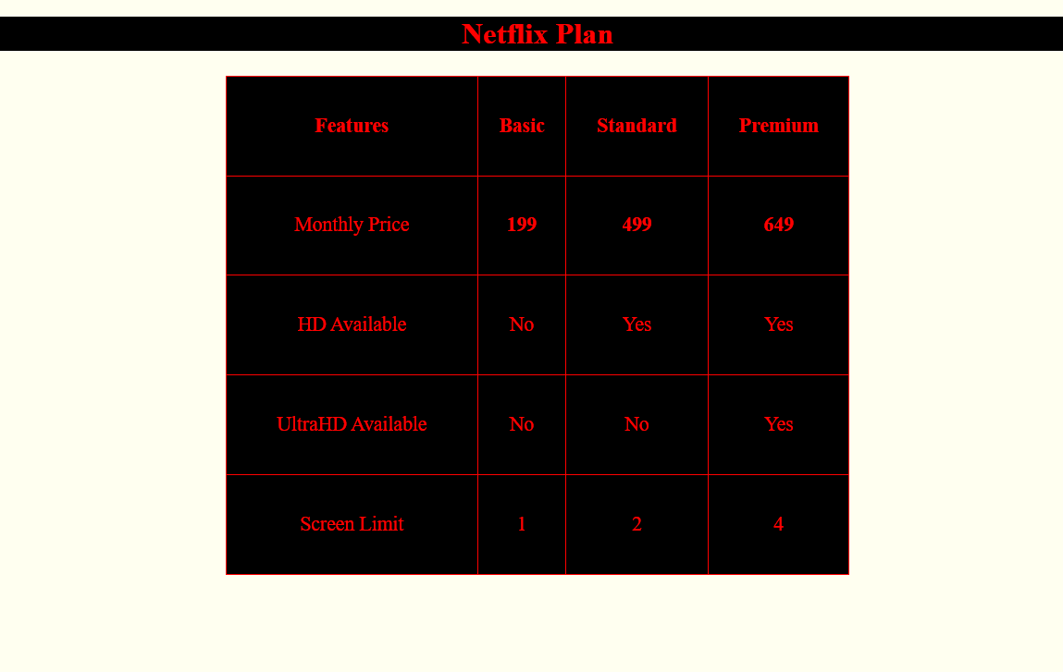

8.

<body>

  <div class="container">

    <div class="navbar">

      <a href="#welcome"><h2>Vanam's Welcomes You!!</h2></a>

      <ul>

        <li><a href="#menu">Menu</a></li>

        <li><a href="#newstyle">New Stock</a></li>

        <li><a href="#ontrend">Trending</a></li>

        <li><a href="#sale">Sale</a></li>

        <li><a href="#contact">Contact</a></li>

      </ul>

    </div>

    <div id="content">

      <h3>Tejasree Presents..</h3>

      Lorem ipsum dolor sit amet consectetur adipisicing elit. Sequi sed illo officia perferendis, eaque dolores. Laudantium a perferendis quisquam necessitatibus sequi? Molestiae facilis doloribus minus odio tempore velit vitae obcaecati commodi iusto deserunt? Nemo totam sequi soluta! Dicta explicabo dolore cum laborum maiores placeat voluptate unde ratione? Sed, beatae optio?

    </div>

  </div>

</body>

</html>

\*{

    padding: 0px;

    margin: 5px;

    background-color: rgb(231, 193, 180);

}

.container{

    width: 100%;

    height: 100vh;

    background-position: center;

    background-size: cover;

}

.navbar{

    display:flex;

    background-color: rgb(228, 237, 241);

    align-items: center;

    justify-content: space-between;

    position: fixed;

    width:100%;

    margin:auto;

}

.navbar ul li{

    list-style: none;

    display: inline-block;

    margin: 0 20px;

    position: relative;

    color: black;

}

#content{

    padding: 50px;

    align-content: center;

}

Output:

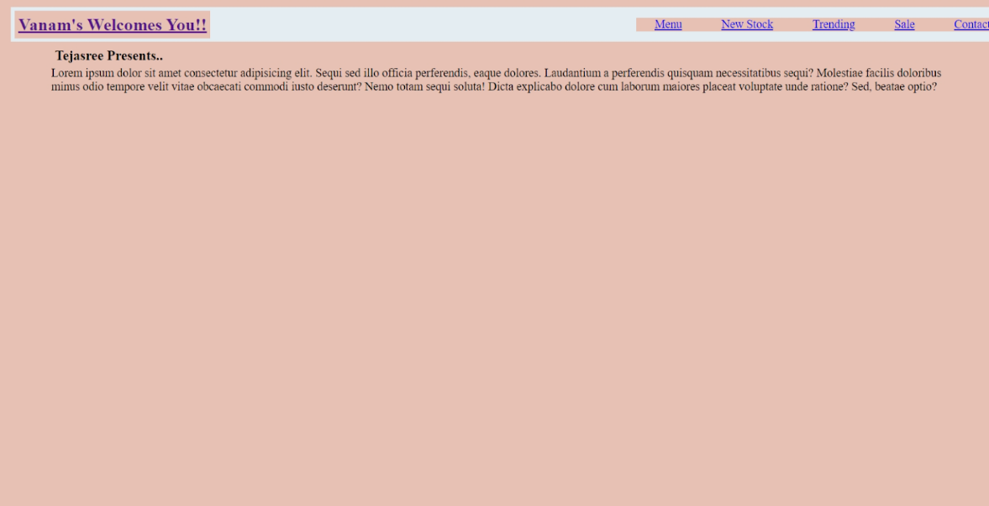

9.

</head>

<body>

<h2>Image Hovering:</h2>

<img src="/html/images/lotus.jpeg"><br>

<img src="/html/images/OIP.jpg">

</body>

</html>

img{

    width:300px;

    height: 300px;

}

img:hover{

    transform: scale(1.1);

    border: black 4px solid;

    box-shadow: 2px;

}

Output:

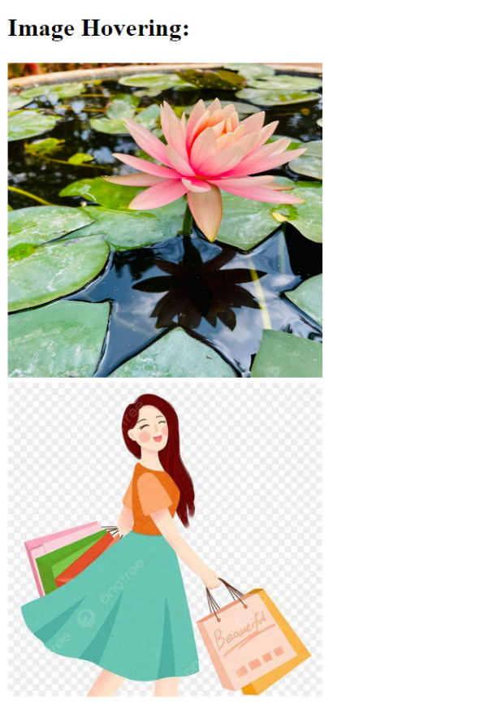

10.

<body>

    <div id="form">

      <h4>Vanams Welcomes</h4>

       <img id="img" src="/html/images/OIP.jpg">

      <div class="f1"><label>Username:</label>

       <input type="text"></div>

       <div class="f1"><label>Password:</label>

       <input type="password"></div>

       <button>Submit</button>

    </div>

  </body>

</html>

\*{

    margin: 0;

    padding: 0;

    box-sizing: border-box;

}

body{

    justify-content: center;

    align-items: center;

    display: flex;

    background-color: rgb(169, 210, 169);

    height: 100vh;

}

#form{

    width: 350px;

    background-color: azure;

    border: 1px solid rgb(15, 124, 15);

    display: flex;

    flex-direction: column;

    align-items: center;

    border-radius: 7px;

    padding: 20px;

    gap: 10px;

}

.f1 {

    display: flex;

    flex-direction: column;

    width: 100%;

}

.f1 input {

    width:100%;

    outline:none;

    border: 1px grey solid;

    border-radius: 3px;

    padding: 10px;

}

button{

    width: 100%;

    background-color: rgb(134, 219, 134);

    border-radius: 3px;

    padding: 7px;

    margin: 10px;

  outline: none;

  border: none;

  opacity: 0.7;

}

#img{

    width:50px;

}

Output:

11.

<body>

   <div id="photos">

   <img src="/html/images/icons8-google-web-search-100.png" id="img1">

   <img src="/html/images/lotus.jpeg" id="img2">

   <img src="/html/images/OIP.jpg" id="img3">

   <img src="/html/images/lotus.jpeg" id="img2">

   <img src="/html/images/OIP.jpg" id="img3">

   <img src="/html/images/lotus.jpeg" id="img2">

   <img src="/html/images/OIP.jpg" id="img3">

   </div>

  </body>

</html>

\*{

    box-sizing: border-box;

}

#photos{

    display: grid;

    grid-gap: 10px;

    grid-template-columns: repeat(auto-fill, minmax(250px, 1fr));

}

#photos img{

    width: 100%;

    height: auto;

}

Output:

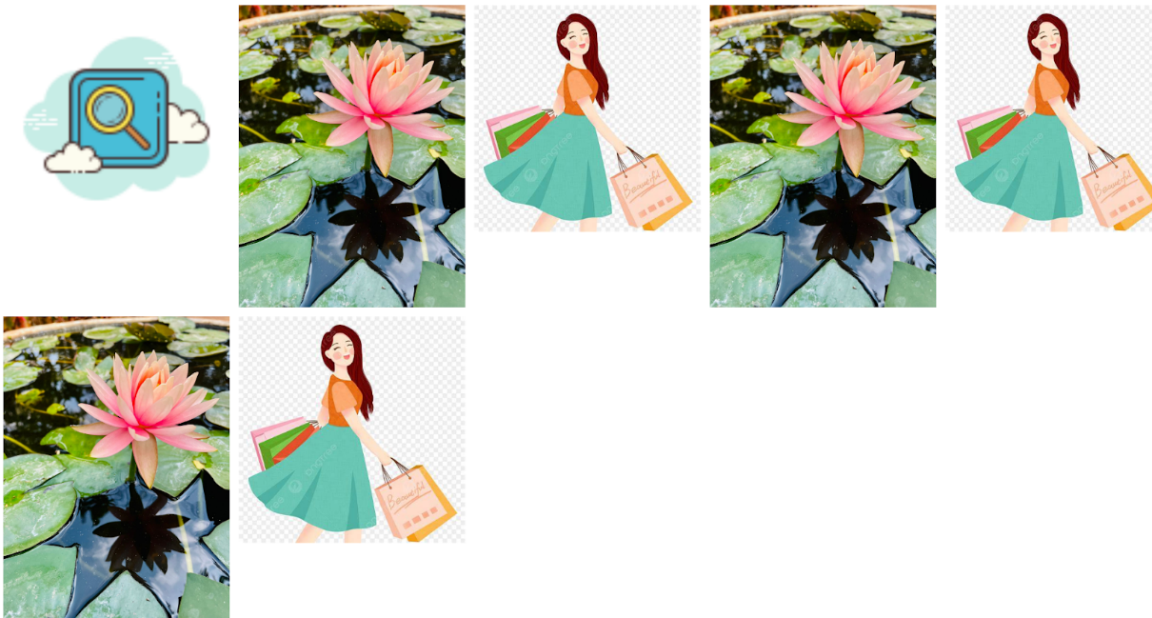

12.

<body>

  <h1 id="f1">"This is h2 font styling"</h2>

  <h2 id="f2">"This is h2 font styling"</h2>

  <h3 id="f3">"This is h2 font styling"</h2>

  <h4 id="f4">"This is h2 font styling"</h2>

  <h5 id="f5">"This is h2 font styling"</h2>

  <h6 id="f6">"This is h2 font styling"</h2>

  </body>

</html>

#f1{

    font-family: 'Franklin Gothic Medium', 'Arial Narrow', Arial, sans-serif;

    color: darkcyan;

}

#f2{

    font-family:'Gill Sans', 'Gill Sans MT', Calibri, 'Trebuchet MS', sans-serif;

    color:blueviolet;

}

#f3{

    font-family:'Trebuchet MS', 'Lucida Sans Unicode', 'Lucida Grande', 'Lucida Sans', Arial, sans-serif;

    color:darkgoldenrod

}

#f4{

    font-family: Impact, Haettenschweiler, 'Arial Narrow Bold', sans-serif;

    color:brown

}

#f5{

    font-family: Cambria, Cochin, Georgia, Times, 'Times New Roman', serif;

    color: aquamarine;

}

#f6{

    font-family: Verdana, Geneva, Tahoma, sans-serif;

    color:teal

}

Output:

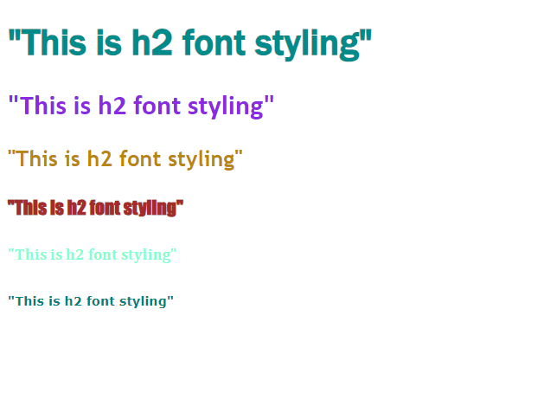

13.

<body>

    <div id="parent">

      <div id="content">

        Lorem ipsum dolor sit amet consectetur adipisicing elit. Voluptatum, nemo totam, harum autem architecto magnam itaque, magni nam voluptate delectus molestias similique et ullam consequatur eos. Possimus doloribus eaque aliquam!

      </div>

      <div></div>

      <div id="footer">This is footer.</div>

    </div>

  </body>

</html>

body{

    margin:0;

    padding: 20px;

    background-color: rgb(198, 219, 231);

}

#footer{

    background-color: cornflowerblue;

    padding: 20px;

    width: 100%;

    bottom: 0;

    align-self: flex-end;

    position: absolute;

}

#parent{

    display:flex;

    flex-direction:column;

    min-height: 100%;

}

Output:

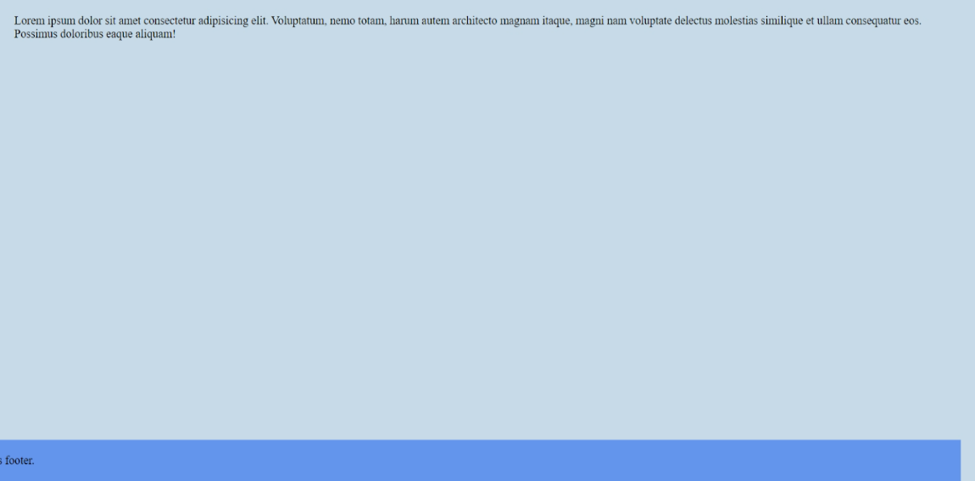

14.

<body>

  <div id="parent">

<div id="img">

  <img src="/html/images/lotus.jpeg">

</div>

</div>

  </body>

</html>

#img{

    height: 500px;

    width:500px;

    display: inline-block;

}

#parent{

    background-color: bisque;

    overflow-x: auto;

    width:900px;

}

Output:

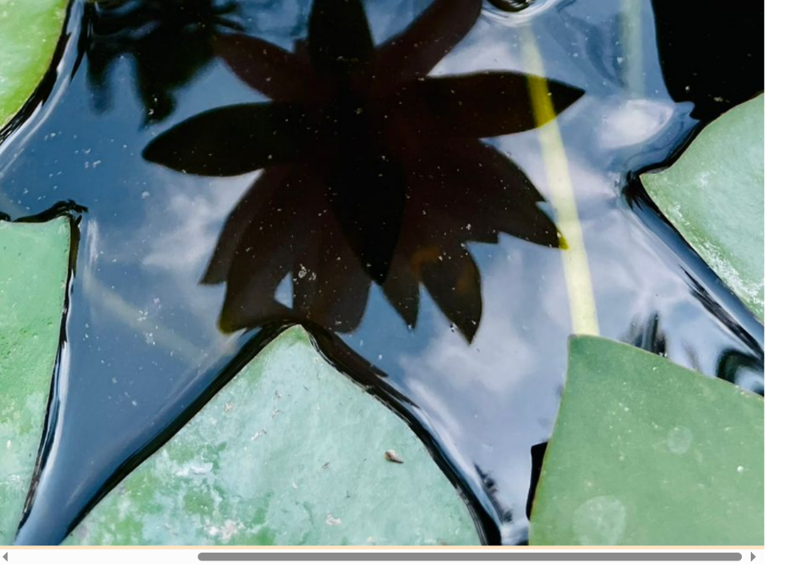

15.

<body>

<div id="container">

  <div id="parent" >

    <div id="d1">Teja 100%</div><br>

    <div id="d2">Ramya 80%</div><br>

    <div id="d3">Mamtha 50%</div><br>

    <div id="d4">Rakesh 70%</div><br>

    <div id="d5">Sanjay 60%</div><br>

    <div id="d6">Prabha 90%</div><br>

    <div id="d7">Ram 70%</div><br>

    <div>

      <h3>Progress bar of Employees performance.</h3>

    </div>

  </div>

</div>

  </body>

</html>

#container{

    display: flex;

    align-content: center;

    height: 450px;

    width:400px;

    box-sizing: border-box;

    border: 2px black solid;

}

#parent{

    padding:10px;

    margin: 10px;

    text-align: center;

}

#d1{

    width: 350px;

    height: 30px;

    border: 2px black solid;

    border-radius: 20px;

    background-color: indianred;

}

#d2{

    width: 330px;

    height: 30px;

    border: 2px black solid;

    border-radius: 20px;

    background-color: darkcyan;

}

#d3{

    width: 200px;

    height: 30px;

    border: 2px black solid;

    border-radius: 20px;

    background-color: hotpink;

}

#d4{

    width: 300px;

    height: 30px;

    border: 2px black solid;

    border-radius: 20px;

    background-color:rgb(176, 121, 121);

}

#d5{

    width: 290px;

    height: 30px;

    border: 2px black solid;

    border-radius: 20px;

    background-color:turquoise;

}

#d6{

    width: 340px;

    height: 30px;

    border: 2px black solid;

    border-radius: 20px;

    background-color:steelblue;

}

#d7{

    width: 290px;

    height: 30px;

    border: 2px black solid;

    border-radius: 20px;

    background-color:darkseagreen;

}

Output:

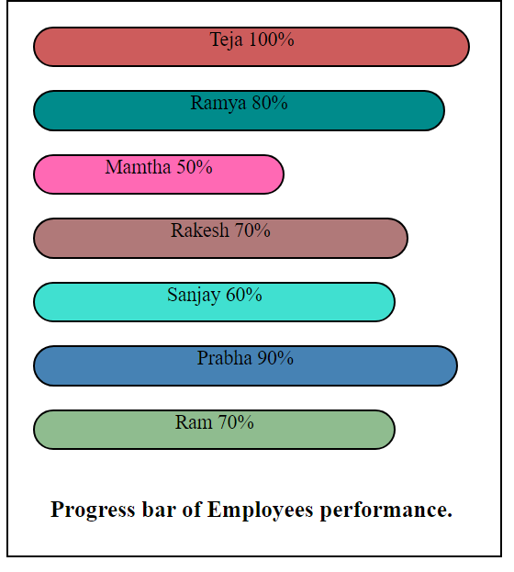

16.

</head>

<body>

   <div id="spin">Spinning</div>

  </body>

</html>

#spin{

    width: 100px;

    height: 100px;

    background-color: blueviolet;

    animation: spin 4s linear infinite;

}

@keyframes spin{

    from{

        transform: rotate(0deg);

    }

    to {

        transform: rotate(360deg);

    }

}

Output:

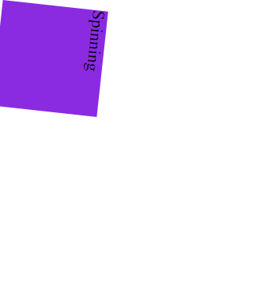

17. Involved uncovered topic(javascript).

18.

19.

<label >Choose item:</label>

   <div id="list">

   <ul start="circle">

    <li class="list" id="l1">Rice</li>

    <li class="list" id="l2">Pulav</li>

    <li class="list" id="l3">Dal Rice</li>

    <li class="list" id="l4">Mushroom</li>

    <li class="list" id="l5">Curd</li>

    <li class="list" id="l6">Meals</li>

   </ul>

  </div>

  </div>

  </body>

</html>

#container{

    display: flex;

    box-sizing: border-box;

    justify-content: center;

}

.list{

    width: 80px;

    height: fit-content;

    border: 1px black solid;

    border-radius: 4px;

}

#l1{

    background-color: coral;

}

#l2{

    background-color:cornflowerblue;

}

#l3{

    background-color:darkgreen;

}

#l4{

    background-color:indianred;

}

#l5{

    background-color:steelblue;

}

#l6{

    background-color:violet;

}

Output:

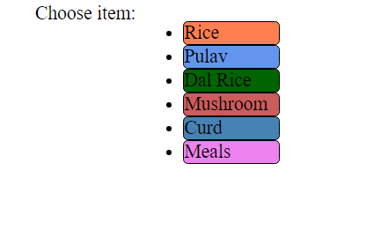

20.

<body>

 <div class="nav">

  <a href="#about">About</a>

  <a href="#home">Home</a>

  <a href="#check">Check</a>

  <a href="#contact">Contact</a>

 </div>

</body>

</html>

  .nav{

    height:100%;

    width: 150px;

    background-color: darksalmon;

    position: fixed;

    z-index: 1;

}

.nav a{

    font-size: 30px;

    color: rgb(45, 45, 197);

    display: block;

    padding: 20px;

}

.nav a:hover{

    color: darkblue;

}

Output:



21.

<body>

   <div id="d1">Varaible</div><br>

   <div id="d2" >Hoisting</div>

      </body>

    </html>

</body>

</html>

#d1{

   padding: 40px;

   width: 100px;

   height: 50px;

   border: 2px black solid;

   text-align: center;

   border-radius: 5px;

   background-color: rgb(140, 203, 182);

}

#d2{

    padding: 40px;

    width: 100px;

    height: 50px;

    border: 2px black solid;

    text-align: center;

    border-radius: 5px;

    background-color: rgb(171, 117, 221);

 }

 #d1::after{

    content: "Variable has a Global scope.";

    display: none;

    position: absolute;

    background-color: aliceblue;

    border: black 2px solid;

    padding: 5px;

    border-radius: 5px;

 }

 #d1:hover::after{

    display: block;

 }

Output:

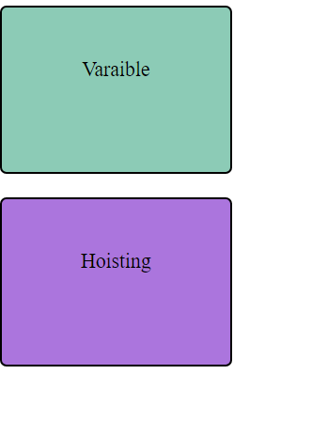

22. <body>

  <div class="card">

    <img src="/html/images/lotus.jpeg" alt="Lotus">

    <h2>Lotus</h2>

    <p>Lorem ipsum, dolor sit amet consectetur adipisicing elit. Sint, reiciendis.</p>

  </div>

  </body>

</html>

img{

    width:300px;

    height: 400px;

}

.card{

    border: 2px black solid;

    border-radius: 4px;

    overflow: hidden;

    box-shadow: 3px;

}

Output:

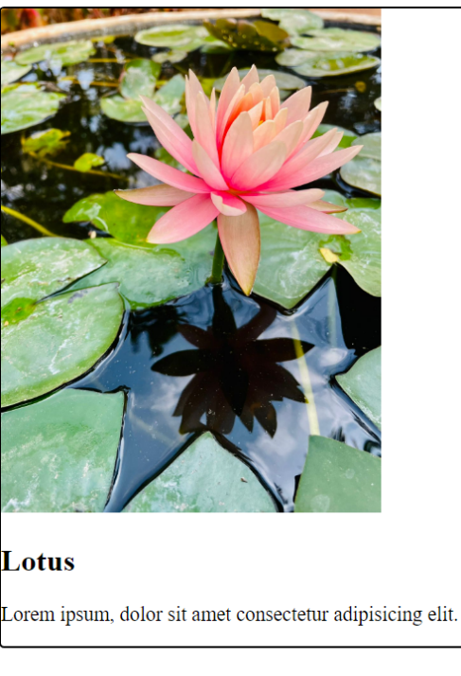

23.

<!DOCTYPE html>

<html lang="en">

<head>

  <meta charset="UTF-8">

  <meta name="viewport" content="width=device-width, initial-scale=1.0">

  <title>Document</title>

  <link rel="stylesheet" href="/style.css">

</head>

<body align="center">

 <button>Button</button>

  </body>

</html>

button{

    padding: 20px;

    margin: 30px;

    width:100px;

    border-radius: 6px;

    background-color: darkcyan;

}

button:hover{

    background-color: rgb(93, 160, 160);

}

Output:

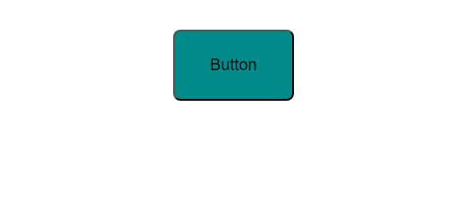

25.

<body>

<table border="2px" cellspacing="4px" width="200px" height="100px" align="center" style="border-collapse:collapse ">

  <tr id="teja">

    <td>x</td>

    <td>y</td>

    <td>z</td>

  </tr>

  <tr id="mamtha">

    <td>1</td>

    <td>2</td>

    <td>3</td>

  </tr>

  <tr id="ramya">

    <td>a</td>

    <td>b</td>

    <td>c</td>

  </tr>

</table>

  </body>

</html>

#teja{

    background-color: blueviolet;

}

#mamtha{

    background-color: cornflowerblue;

}

#ramya{

    background-color: lightcoral;

}

#teja:hover{

    background-color: rgb(170, 120, 215);

}

#mamtha:hover{

    background-color: rgb(140, 167, 219);

}

#ramya:hover{

    background-color: rgb(214, 136, 136);

}

Output:

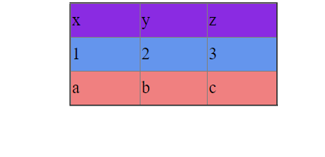

26. <body>

    <div id="container">

      <div id="parent" >

        <div id="d1"></div><br>

        <div id="d2"></div><br>

        <div id="d3"></div><br>

        <div id="d4"></div><br>

        <div>

          <h3>Progress Tracker.</h3>

        </div>

      </div>

    </div>

      </body>

    </html>

</body>

</html>

#container{

    display: flex;

    align-content: center;

    height: 300px;

    width:400px;

    box-sizing: border-box;

    border: 2px black solid;

}

#parent{

    padding:10px;

    margin: 10px;

    text-align: center;

}

#d1{

    width: 350px;

    height: 30px;

    border: 2px black solid;

    border-radius: 7px;

    background-color: indianred;

}

#d2{

    width: 330px;

    height: 30px;

    border: 2px black solid;

    border-radius: 7px;

    background-color: darkcyan;

}

#d3{

    width: 200px;

    height: 30px;

    border: 2px black solid;

    border-radius: 7px;

    background-color: hotpink;

}

#d4{

    width: 300px;

    height: 30px;

    border: 2px black solid;

    border-radius: 7px;

    background-color:rgb(176, 121, 121);

}

Output:

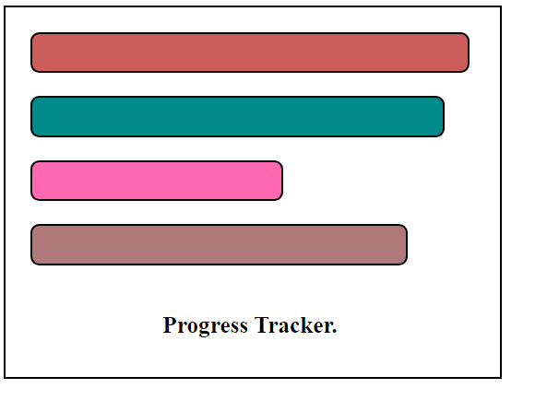

28.

<body>

 <h2>Drop-down menu:</h2>

<div id="list">

  <label for="dropdown" id="menu">Choose Language:</label>

   <select>

   <option id="o"></option>

   <option id="r">Reactjs</option>

   <option id="p">Python</option>

   <option id="a">AI</option>

   <option id="s">SAP</option>

   <option id="j">Java</option>

   </select>

</div>

</body>

</html>

body{

    padding: 20px;

    text-align: center;

    box-sizing: border-box;

    background-color: lightblue;

   border: 2px black solid;

   height: 300px;

   width: 300px;

}

#o{

    background-color: darkseagreen;

}

#r{

    background-color:cornflowerblue;

}

#p{

    background-color:darkseagreen;

}

#a{

    background-color:indianred;

}

#s{

    background-color:rgb(162, 18, 66);

}

#j{

    background-color:cornflowerblue;

}

Output:

