Create a Simple Contact Form:

1. Create a basic contact form with fields for name, email, subject, and message.
2. <!DOCTYPE html>
3. <html>
4. <head>
5. <title>Contact Form</title>
6. </head>
7. <body>
8. <h2>Contact Us</h2>
9. <form action="/submit-form" method="post">
10. <label for="name">Name:</label><br>
11. <input type="text" id="name" name="name" required><br>
12. <label for="email">Email:</label><br>
13. <input type="email" id="email" name="email" required><br>
14. <label for="subject">Subject:</label><br>
15. <input type="text" id="subject" name="subject" required><br>
16. <label for="message">Message:</label><br>
17. <textarea id="message" name="message" rows="4" required></textarea><br>
18. <input type="submit" value="Submit">
19. </form>
20. </body>
21. </html>

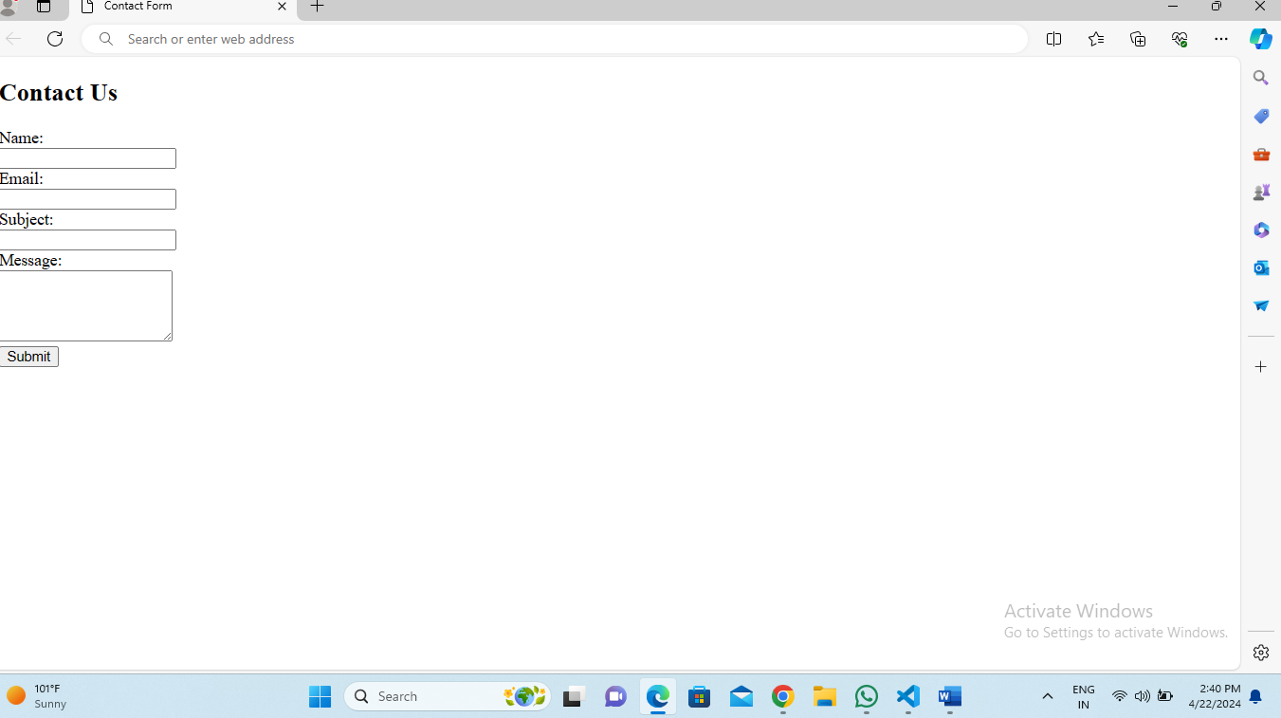

Login Form with Username and Password:

1. Create a login form with fields for username and password.
2. <!DOCTYPE html>
3. <html lang="en">
4. <head>
5. <meta charset="UTF-8">
6. <meta name="viewport" content="width=device-width, initial-scale=1.0">
7. <title>Login Form</title>
8. </head>
9. <body>
10. <h2>Login Form</h2>
11. <form action="login form" method="post">
12. <label for="username">Username:</label><br>
13. <input type="text" id="username" name="username" required><br><br>
14. <label for="password">Password:</label><br>
15. <input type="password" id="password" name="password" required><br><br>
16. <input type="submit" value="Login">
17. </form>
18. </body>
19. </html>

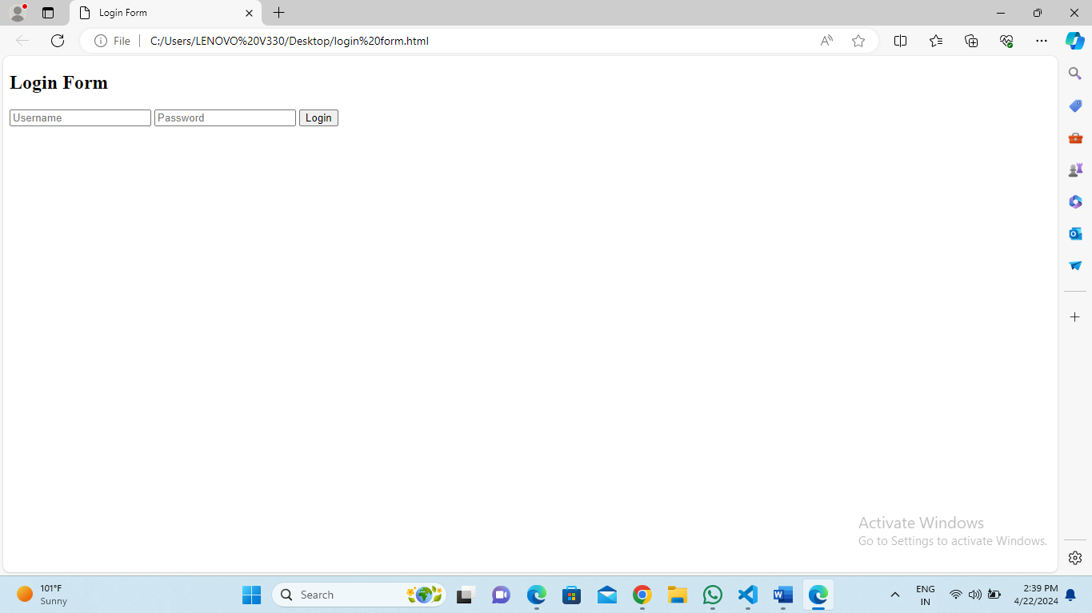

Subscription Form with Email Field:

3.Create a subscription form with a field for email address.

<!DOCTYPE html>

<html lang="en">

<head>

    <meta charset="UTF-8">

    <meta name="viewport" content="width=device-width, initial-scale=1.0">

    <title>Subscription Form</title>

</head>

<body>

    <h2>Subscription Form</h2>

    <form action="subscribe form" method="post">

        <label for="email">Email Address:</label><br>

        <input type="email" id="email" name="email" required><br><br>

        <input type="submit" value="Subscribe">

    </form>

</body>

</html>

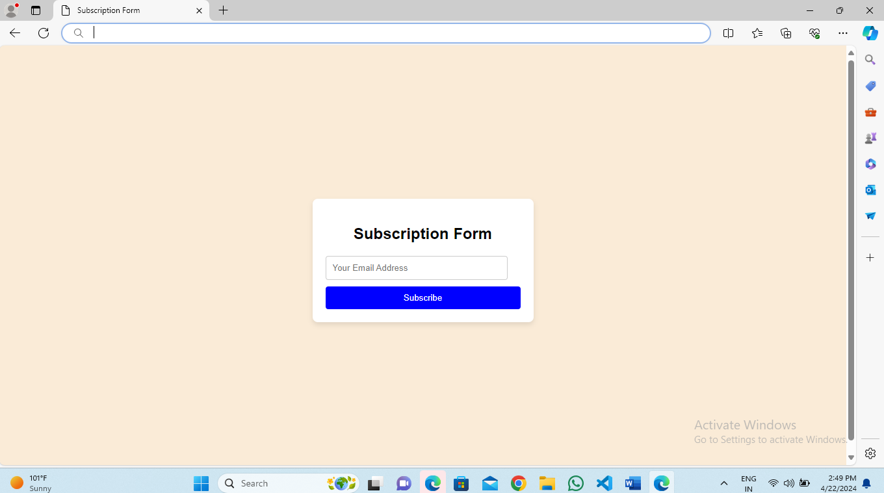

Registration Form with First Name, Last Name, Email, and Password Fields:

4.Create a registration form with fields for first name, last name, email, and password.

<!DOCTYPE html>

<html lang="en">

<head>

    <meta charset="UTF-8">

    <meta name="viewport" content="width=device-width, initial-scale=1.0">

    <title>Registration Form</title>

</head>

<body>

    <h2>Registration Form</h2>

    <form action="submit_registration form" method="post">

        <label for="firstname">First Name:</label><br>

        <input type="text" id="firstname" name="firstname" required><br><br>

        <label for="lastname">Last Name:</label><br>

        <input type="text" id="lastname" name="lastname" required><br><br>

        <label for="email">Email:</label><br>

        <input type="email" id="email" name="email" required><br><br>

        <label for="password">Password:</label><br>

        <input type="password" id="password" name="password" required><br><br>

        <input type="submit" value="Register">

    </form>

</body>

</html>

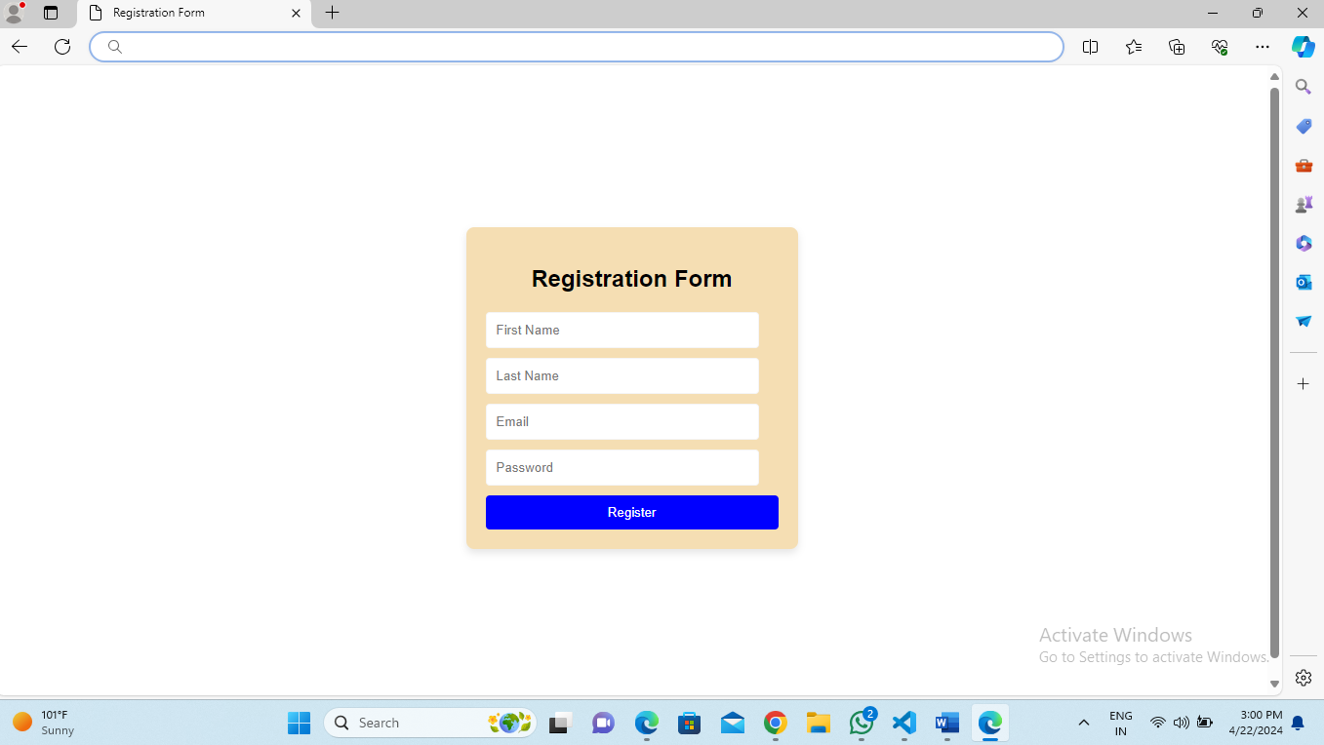

Feedback Form with Rating and Comments:

1. Create a feedback form with a rating scale (e.g., 1 to 5 stars) and a textarea for comments.
2. head>
3. <meta charset="UTF-8">
4. <meta name="viewport" content="width=device-width, initial-scale=1.0">
5. <title>Feedback Form</title>
6. </head>
7. <body>
8. <h2>Feedback Form</h2>
9. <form action="submit-feedback form" method="post">
10. <label for="rating">Rating:</label><br>
11. <input type="radio" id="star5" name="rating" value="5">
12. <label for="star5">5 stars</label><br>
13. <input type="radio" id="star4" name="rating" value="4">
14. <label for="star4">4 stars</label><br>
15. <input type="radio" id="star3" name="rating" value="3">
16. <label for="star3">3 stars</label><br>
17. <input type="radio" id="star2" name="rating" value="2">
18. <label for="star2">2 stars</label><br>
19. <input type="radio" id="star1" name="rating" value="1">
20. <label for="star1">1 star</label><br><br>
22. <label for="comments">Comments:</label><br>
23. <textarea id="comments" name="comments" rows="4" cols="50" placeholder="Enter your comments here..." required></textarea><br><br>
24. <input type="submit" value="Submit">
25. </form>
26. </body>
27. </html>

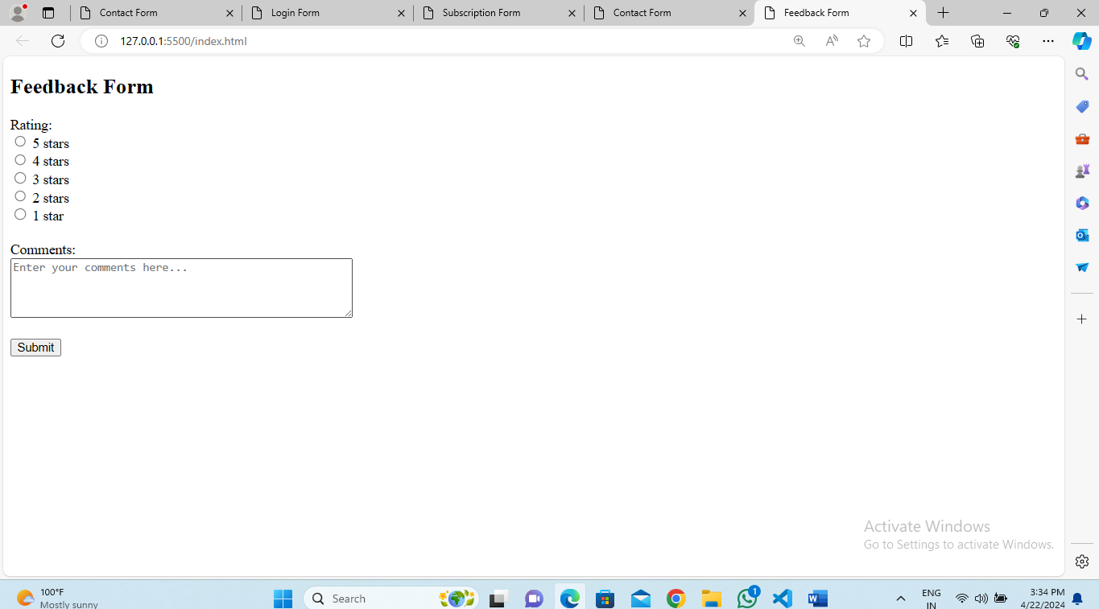

Search Form with Single Input Field:

1. Create a search form with a single input field for entering search queries.
2. <!DOCTYPE html>
3. <html lang="en">
4. <head>
5. <meta charset="UTF-8">
6. <meta name="viewport" content="width=device-width, initial-scale=1.0">
7. <title>Search Form</title>
8. </head>
9. <body>
10. <h2>Search Form</h2>
11. <form action="search query" method="get">
12. <label for="search_query">Search:</label>
13. <input type="text" id="search_query" name="q" placeholder="Enter your search query..." required><br><br>
14. <input type="submit" value="Search">
15. </form>
16. </body>
17. </html>

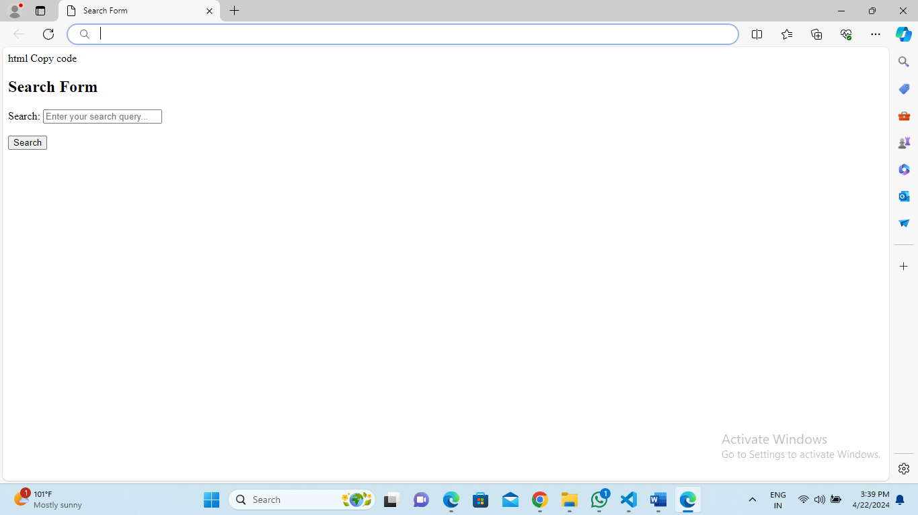

Survey Form with Multiple Choice Questions:

1. Create a survey form with multiple choice questions and radio buttons or checkboxes for selecting answers.
2. <!DOCTYPE html>
3. <html lang="en">
4. <head>
5. <meta charset="UTF-8">
6. <meta name="viewport" content="width=device-width, initial-scale=1.0">
7. <title>Survey Form</title>
8. </head>
9. <body>
10. <h2>Survey Form</h2>
11. <form action="submit_survey form" method="post">
12. <h3>Question 1: What is your favorite place ?</h3>
13. <input type="radio" id="place_goa" name="place" value="goa">
14. <label for="place_goa">goa</label><br>
15. <input type="radio" id="place_chennai" name="place" value="chennai">
16. <label for="place_chennai">chennai</label><br>
17. <input type="radio" id="place_bangalore" name="place" value="bangalore">
18. <label for="place_bangalore">bangalore</label><br>
19. <input type="radio" id="place_hyderabad" name="place" value="hyderabad">
20. <label for="place_hyderabad">hyderabad</label><br><br>
21. <h3>Question 2: Which is your favorite food?</h3>
22. <input type="checkbox" id="food_panipuri" name="food" value="panipuri">
23. <label for="food_panipuri">panipuri</label><br>
24. <input type="checkbox" id="food_biriyani" name="food" value="biriyani">
25. <label for="food_biriyani">biriyani</label><br>
26. <input type="checkbox" id="food_curd rice" name="food" value="curd rice">
27. <label for="food_curd rice">curd rice</label><br>
28. <input type="checkbox" id="food_dosa" name="food" value="dosa">
29. <label for="food_dosa">dosa</label><br><br>
30. <h3>Question 3: what is your favorite fruit?</h3>
31. <input type="radio" id="fruit_mango" name="fruit" value="mango">
32. <label for="fruit_mango">mango</label><br>
33. <input type="radio" id="fruit_guava" name="fruit" value="guava">
34. <label for="fruit_guava">guava</label><br>
35. <input type="radio" id="fruit_watermelon" name="furit" value="watermelon">
36. <label for="fruit_watermelon">watermelon</label><br>
37. <input type="radio" id="fruit_all the above" name="furit" value="all the above">
38. <label for="fruit_all the above">all the above</label><br>
39. <input type="submit" value="Submit">
40. </form>
41. </body>
42. </html>

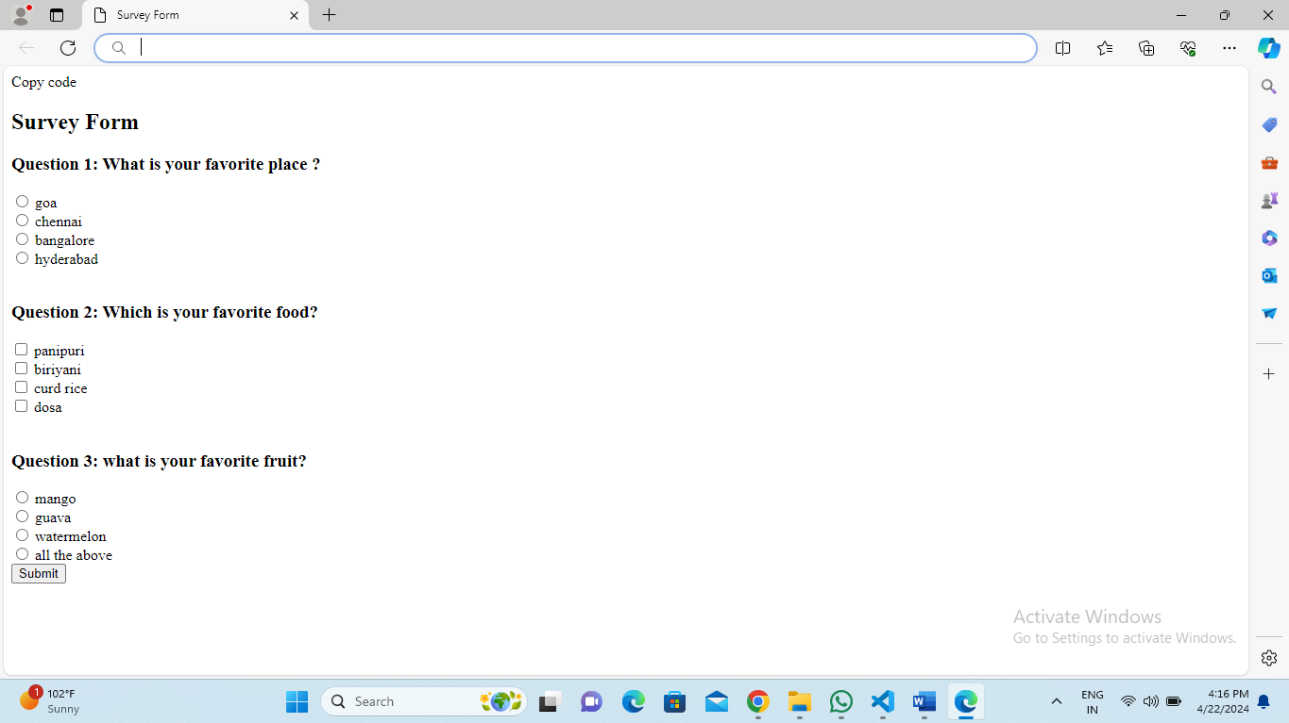

Order Form with Dropdown Menus for Selecting Products:

8. Create an order form with dropdown menus for selecting products, quantities, and shipping options.

<!DOCTYPE html>

<html lang="en">

<head>

    <meta charset="UTF-8">

    <meta name="viewport" content="width=device-width, initial-scale=1.0">

    <title>Order Form</title>

</head>

<body>

    <h2>Order Form</h2>

    <form action="submit_order form" method="post">

        <label for="product">Select Product:</label>

        <select id="product" name="product">

            <option value="product1">Product 1</option>

            <option value="product2">Product 2</option>

            <option value="product3">Product 3</option>

        </select><br><br>

        <label for="quantity">Select Quantity:</label>

        <select id="quantity" name="quantity">

            <option value=" choose1">choose 1</option>

            <option value="choose2">choose 2</option>

            <option value="choose3">choose 3</option>

            <option value="choose4">choose 4</option>

            <option value="choose5">choose 5</option>

        </select><br><br>

        <label for="shipping">Select Shipping Option:</label>

        <select id="shipping" name="shipping">

            <option value="standard">Standard Shipping</option>

            <option value="express">Express Shipping</option>

            <option value="overnight">Overnight Shipping</option>

        </select><br><br>

        <input type="submit" value="Place Order">

    </form>

</body>

</html>

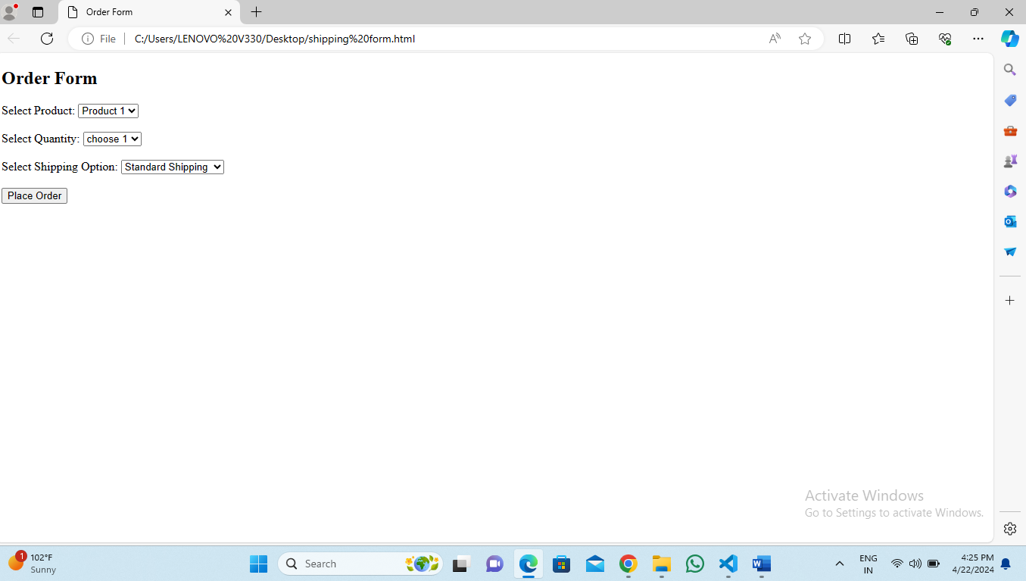

Booking Form with Date and Time Pickers:

1. Create a booking form with date and time pickers for selecting appointment or reservation details.
2. <!DOCTYPE html>
3. <html lang="en">
4. <head>
5. <meta charset="UTF-8">
6. <meta name="viewport" content="width=device-width, initial-scale=1.0">
7. <title>Booking Form</title>
8. </head>
9. <body>
10. <h2>Booking Form</h2>
11. <form action="submit_booking form" method="post">
12. <label for="date">Select Date:</label><br>
13. <input type="date" id="date" name="date" required><br><br>
14. <label for="time">Select Time:</label><br>
15. <input type="time" id="time" name="time" required><br><br>
16. <input type="submit" value="Book Appointment">
17. </form>
18. </body>
19. </html>

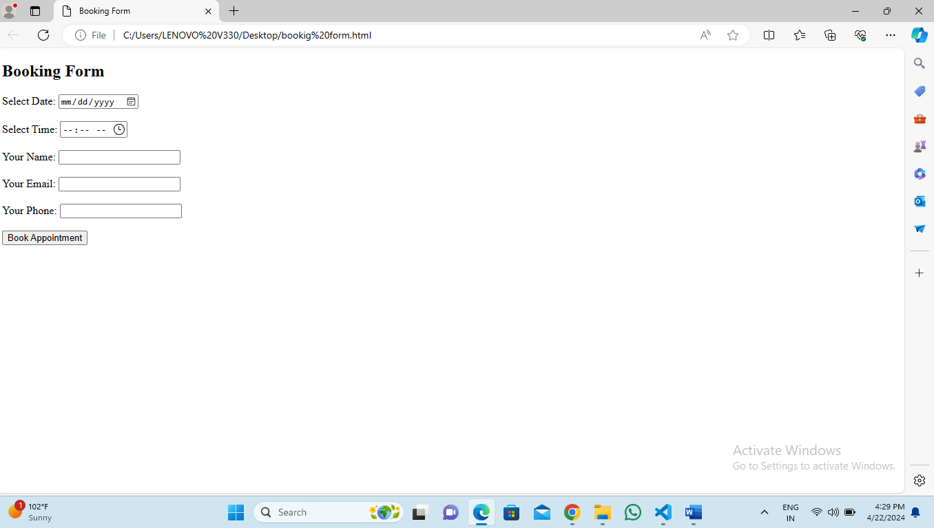

Contact Information Form with Address, Phone Number, and Website Fields:

10.Create a form for providing contact information, including fields for address, phone number, and website URL

<!DOCTYPE html>

<html lang="en">

<head>

    <meta charset="UTF-8">

    <meta name="viewport" content="width=device-width, initial-scale=1.0">

    <title>Contact Information Form</title>

</head>

<body>

    <h2>Contact Information Form</h2>

    <form action="submit_contact form" method="post">

        <label for="address">Address:</label><br>

        <textarea id="address" name="address" rows="4" cols="50" required></textarea><br><br>

        <label for="phone">Phone Number:</label><br>

        <input type="tel" id="phone" name="phone" required><br><br>

        <label for="website">Website URL:</label><br>

        <input type="url" id="website" name="website" required><br><br>

        <input type="submit" value="Submit">

    </form>

</body>

</html>

