MCQ

What command is used to initialize a Git repository locally?

a) git clone

**b) git init**

c) git commit

d) git push

How can you check the status of your changes in a Git repository?

**a) git status**

b) git check

c) git diff

d) git log

What command is used to stage files for a commit in Git?

**a) git add**

b) git stage

c) git commit

d) git push

What is the purpose of forking a repository on GitHub?

a) To create a new branch in the original repository

b) To merge changes from one repository to another

**c) To copy a repository under your GitHub account**

d) To revert changes in a repository

What is a Pull Request used for in GitHub?

a) Requesting changes to be pulled into a repository

**b) Submitting changes for approval and merging**

c) Deleting branches in a repository

d) Checking the status of commits in a repository

What does a 'Merge Conflict' indicate in a GitHub pull request?

a) Successful merging of changes

**b) Inconsistencies between branches that need to be resolved**

c) Rejection of a pull request

d) Approval of changes for merging

Which command is used to create a new branch in Git?

**a) git branch**

b) git commit

c) git checkout

d) git merge

What command is used to view the commit history in Git?

**a) git log**

b) git history

c) git show

d) git status

How can you undo the last commit in Git?

a) git amend

**b) git reset**

c) git revert

d) git undo

What is a repository in GitHub?

a) A folder on your local machine

**b) A collection of project files and revision history**

c) A social media platform for developers

d) A code editor tool

How can you clone a repository from GitHub to your local machine?

**a) git clone**

b) git fetch

c) git init

d) git pull

What is the purpose of the 'Issues' tab in GitHub repositories?

**a) To track and discuss bugs, enhancements, and tasks**

b) To view commit history

c) To create new branches

d) To merge changes into the main branch

Which GitHub feature allows multiple people to collaborate on a project simultaneously?

a) Pull Requests

b) Forking

c) Issues

**d) Branches**

What does the 'README.md' file in a GitHub repository contain?

**a) Detailed instructions for using the project**

b) A list of contributors

c) Commit history

d) License information

How can you update your local repository with changes from a remote repository in Git?

a) git merge

**b) git fetch**

c) git update

d) git commit -u origin

What is the purpose of the 'git push' command in Git?

a) To stage changes for commit

b) To download changes from a remote repository

**c) To update the remote repository with local changes**

d) To switch between branches

**What is git and github?**

**Ans:** Git is a version control system it is installed locally on the system it is open source.

GitHub is a hosting service for git repository GitHub provide desktop user interface and it is hosted on the web.

**What is CVCS and DVCS ?**

**Ans:** **CVCS** stands for Centralized Version Control System relies on a central repository .

**DVCS** stands for Distributed Version Control System provides each developer with a complete copy of the poject.

**Create a project of any and push the project**

**Ans:**  Create a repo in GitHub

Clone that repo in your local system

~ git clone repo_url.

Make some changes in that repo like add some files

And commit that files by using commit command

~ Git commit "msg".

After that push that code to github using

~ git push origin main / master . Depends on your branch name.

(“**PS C:\Users\LENOVO V330\Desktop\New folder (11)> git init**

**Initialized empty Git repository in C:/Users/LENOVO V330/Desktop/New folder (11)/.git/**

**PS C:\Users\LENOVO V330\Desktop\New folder (11)> git add push.html**

**PS C:\Users\LENOVO V330\Desktop\New folder (11)> git commit -m "my first commit"**

**[master (root-commit) ce6de60] my first commit**

**1 file changed, 12 insertions(+)**

**create mode 100644 push.html**

**PS C:\Users\LENOVO V330\Desktop\New folder (11)> git remote add origin https://github.com/sharvanireddy23/developer.git**

**PS C:\Users\LENOVO V330\Desktop\New folder (11)> git push origin master**

**Enumerating objects: 3, done.**

**Counting objects: 100% (3/3), done.**

**Delta compression using up to 4 threads**

**Compressing objects: 100% (2/2), done.**

**Writing objects: 100% (3/3), 387 bytes | 387.00 KiB/s, done.**

**Total 3 (delta 0), reused 0 (delta 0), pack-reused 0 (from 0)**

**To https://github.com/sharvanireddy23/developer.git**

**\* [new branch] master -> master**

**PS C:\Users\LENOVO V330\Desktop\New folder (11)>”)**

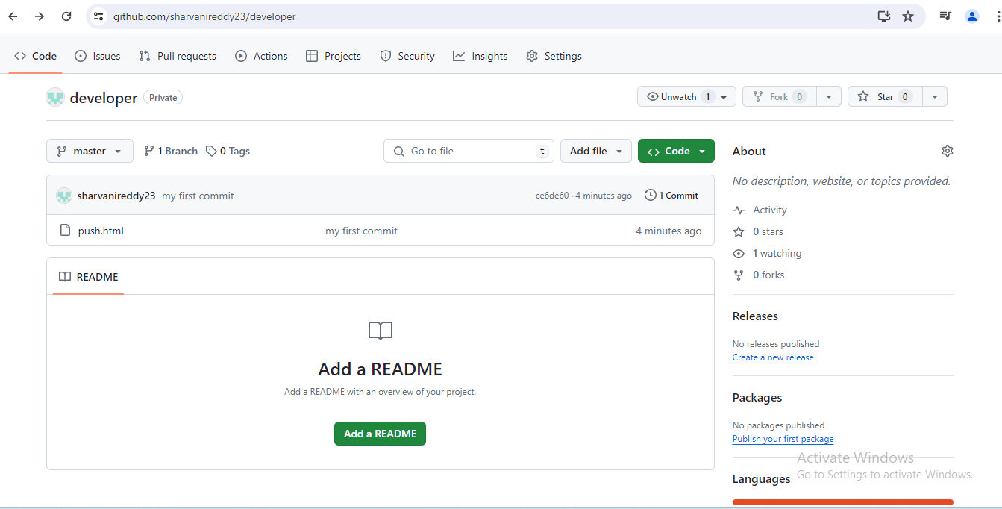

**Create 3 branches and 5 tags**

**Ans:** To create 3 branches in the branch name change names accordingly.

~ git branch "branch name"

~ git push origin “branch name”

To create tags

~ git tag -a (version) -m “my first version”

~git push origin (version)

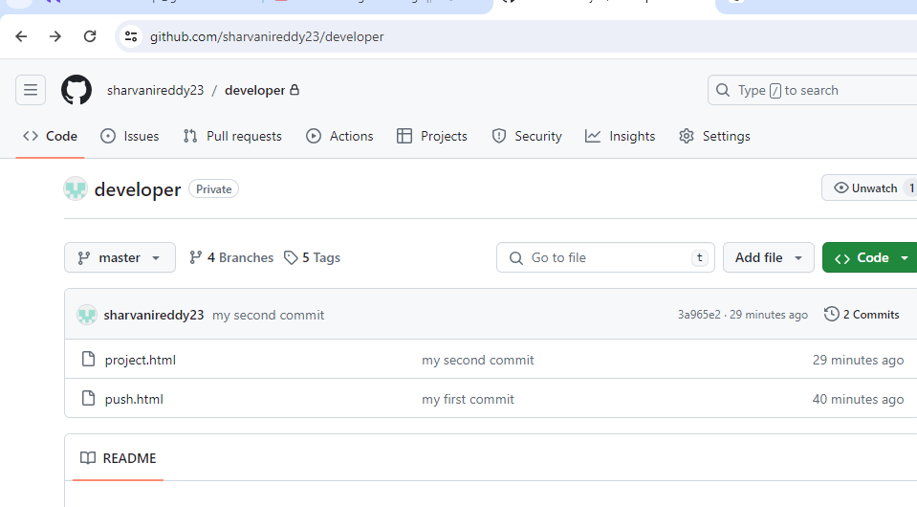

**Create a Keygen and push using ssh**

