**CSS Borders:**

CSS borders are known these properties allow you to specify the style, width, and color of elements border.

There are different styles of borders are there:

Solid –specifies a solid border

Dashed –specifies a dashed border

Dotted – specifies a dotted border

Groove –specifies a 3D grooved border

Double –specifies a double border

Ridge –specifies a 3D ridged border

Inset –specifies a 3D inset border

Outset –specifies a 3D outset border

Initial –default value

Inherit –inherits this property from its parent element

Hidden

None – specifies no border

**Html:**

<!DOCTYPE html>

<html lang="en">

<head>

    <meta charset="UTF-8">

    <meta name="viewport" content="width=device-width, initial-scale=1.0">

    <title>borders</title>

    <link rel="stylesheet" href="border.css">

</head>

<body>

    <div class="css-borders">

        <h1>types of boders in css:</h1>

             <p class="solid">specifies a solid border</p>

             <p class="dashed">specifies a dashed border</p>

             <p class="dotted">specifies a dotted border</p>

            <p class="groove">specifies a 3D grooved border</p>

            <p class="double">specifies a double border</p>

            <p class="ridge">specifies a 3D ridged border</p>

    </div>

</body>

</html>

**Css:**

*{

    margin: 0px;

    padding: 0px;

    box-sizing: border-box;

}

.css-borders{

    justify-content: space-around;

    align-items: center;

    height: 100vh;

    margin-right: 70%;

}

.css-borders h1{

    color: blueviolet;

    font-style: inherit;

    padding-bottom: 20px;

}

.css-borders .solid{

    border-width: 5px;

    border-style: solid;

    border-color: palevioletred;

    background-color: aqua;

    padding: 20px;

}

.css-borders .dashed{

    border-style: dashed;

    border-top-color: black;

    border-bottom-color: pink;

    border-right-color: aqua;

    border-left-color: rgb(21, 158, 44);

    border-width: 10px;

    padding: 10px;

    margin-top: 10px;

}

.css-borders .dotted{

    border-style:dotted;

    border-top-color: black;

    border-bottom-color: rgb(11, 14, 8);

    border-right-color: rgb(8, 12, 12);

    border-left-color: rgb(9, 17, 10);

    border-width: 10px;

    padding: 10px;

    margin-top: 10px;

}

.css-borders .groove{

    border-style:groove;

    border-top-color: pink;

    border-bottom-color: rgb(11, 14, 8);

    border-right-color: rgb(8, 12, 12);

    border-left-color: rgb(9, 17, 10);

    border-width: 10px;

    padding: 10px;

    margin-top: 10px;

}

.css-borders .double{

    border-style:double;

    border-top-color: rgb(102, 209, 125);

    border-bottom-color: rgb(11, 14, 8);

    border-right-color: rgb(8, 12, 12);

    border-left-color: rgb(9, 17, 10);

    border-width: 10px;

    padding: 10px;

    margin-top: 10px;

}

.css-borders .ridge{

    border-style:ridge;

    border-top-color: rgb(136, 73, 73);

    border-bottom-color: rgb(11, 14, 8);

    border-right-color: rgb(8, 12, 12);

    border-left-color: rgb(9, 17, 10);

    border-width: 10px;

    padding: 10px;

    margin-top: 10px;

}

**Output:**

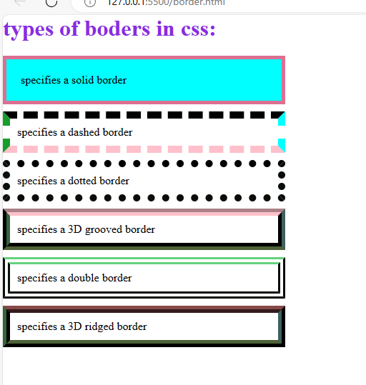

**CSS Margins** are nothing but these properties are used to create space around elements, outside of any defined borders.

There are four types margins are there:

Margin-top

Margin-right

Margin-bottom

Margin- left

**Html:**

<!DOCTYPE html>

<html lang="en">

<head>

    <meta charset="UTF-8">

    <meta name="viewport" content="width=device-width, initial-scale=1.0">

    <title>margins</title>

    <link rel="stylesheet" href="magins.css">

</head>

<body>

    <div class="margins">

        <h1>types of margins</h1>

        <h2>there are four types of margins</h2>

    </div>

</body>

</html>

**Css:**

*{

    margin: 0px;

    padding: 0px;

    box-sizing: border-box;

}

.margins h1{

    margin-top: 10px;

    margin-bottom: 10px;

    margin-left: 5px;

    margin-right: 5px;

    background-color: aquamarine;

    padding: 20px;

}

.margins h2{

    margin-top: 20px;

    margin-bottom: 20px;

    margin-right: 5px;

    margin-left: 5px;

    background-color: rgb(180, 75, 154);

}

**Output:**

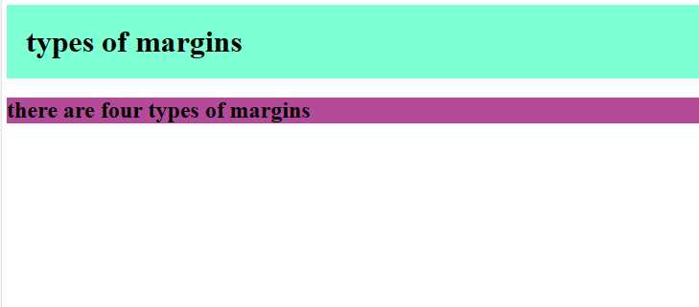

**CSS Margins** are nothing but these properties are used to create space around elements, outside of any defined borders.

There are four types margins are there:

Margin-top

Margin-right

Margin-bottom

Margin-left

**Html:**

<!DOCTYPE html>

<html lang="en">

<head>

    <meta charset="UTF-8">

    <meta name="viewport" content="width=device-width, initial-scale=1.0">

    <title>background</title>

    <link rel="stylesheet" href="background.css">

</head>

<body>

    <div class="ground">

        <h1>background image</h1>

        <p>Dinosaur evolution after the Triassic followed changes in vegetation and the location of continents. In the Late Triassic and Early Jurassic, the continents were connected as the single landmass Pangaea, and there was a worldwide dinosaur fauna mostly composed of coelophysoid carnivores and early sauropodomorph herbivores.[122] Gymnosperm plants (particularly conifers), a potential food source, radiated in the Late Triassic. Early sauropodomorphs did not have sophisticated mechanisms for processing food in the mouth, and so must have employed other means of breaking down food farther along the digestive tract.[123] The general homogeneity of dinosaurian faunas continued into the Middle and Late Jurassic, where most localities had predators consisting of ceratosaurians, megalosauroids, and allosauroids, and herbivores consisting of stegosaurian ornithischians and large sauropods. Examples of this include the Morrison Formation of North America and Tendaguru Beds of Tanzania. Dinosaurs in China show some differences, with specialized metriacanthosaurid theropods and unusual, long-necked sauropods like Mamenchisaurus.[122] Ankylosaurians and ornithopods were also becoming more common, but primitive sauropodomorphs had become extinct. Conifers and pteridophytes were the most common plants. Sauropods, like earlier sauropodomorphs, were not oral processors, but ornithischians were evolving various means of dealing with food in the mouth, including potential cheek-like organs to keep food in the mouth, and jaw motions to grind food.[123] Another notable evolutionary event of the Jurassic was the appearance of true birds, descended from maniraptoran coelurosaurians.[14]

            By the Early Cretaceous and the ongoing breakup of Pangaea, dinosaurs were becoming strongly differentiated by landmass. The earliest part of this time saw the spread of ankylosaurians, iguanodontians, and brachiosaurids through Europe, North America, and northern Africa. These were later supplemented or replaced in Africa by large spinosaurid and carcharodontosaurid theropods, and rebbachisaurid and titanosaurian sauropods, also found in South America. In Asia, maniraptoran coelurosaurians like dromaeosaurids, troodontids, and oviraptorosaurians became the common theropods, and ankylosaurids and early ceratopsians like Psittacosaurus became important herbivores. Meanwhile, Australia was home to a fauna of basal ankylosaurians, hypsilophodonts, and iguanodontians.[122] The stegosaurians appear to have gone extinct at some point in the late Early Cretaceous or early Late Cretaceous. A major change in the Early Cretaceous, which would be amplified in the Late Cretaceous, was the evolution of flowering plants. At the same time, several groups of dinosaurian herbivores evolved more sophisticated ways to orally process food. Ceratopsians developed a method of slicing with teeth stacked on each other in batteries, and iguanodontians refined a method of grinding with dental batteries, taken to its extreme in hadrosaurids.[123] Some sauropods also evolved tooth batteries, best exemplified by the rebbachisaurid Nigersaurus.[124]

            There were three general dinosaur faunas in the Late Cretaceous. In the northern continents of North America and Asia, the major theropods were tyrannosaurids and various types of smaller maniraptoran theropods, with a predominantly ornithischian herbivore assemblage of hadrosaurids, ceratopsians, ankylosaurids, and pachycephalosaurians. In the southern continents that had made up the now-splitting supercontinent Gondwana, abelisaurids were the common theropods, and titanosaurian sauropods the common herbivores. Finally, in Europe, dromaeosaurids, rhabdodontid iguanodontians, nodosaurid ankylosaurians, and titanosaurian sauropods were prevalent.[122] Flowering plants were greatly radiating,[123] with the first grasses appearing by the end of the Cretaceous.[125] Grinding hadrosaurids and shearing ceratopsians became very diverse across North America and Asia. Theropods were also radiating as herbivores or omnivores, with therizinosaurians and ornithomimosaurians becoming common.[123]

            The Cretaceous–Paleogene extinction event, which occurred approximately 66 million years ago at the end of the Cretaceous, caused the extinction of all dinosaur groups except for the neornithine birds. Some other diapsid groups, including crocodilians, dyrosaurs, sebecosuchians, turtles, lizards, snakes, sphenodontians, and choristoderans, also survived the event.[126]

            The surviving lineages of neornithine birds, including the ancestors of modern ratites, ducks and chickens, and a variety of waterbirds, diversified rapidly at the beginning of the Paleogene period, entering ecological niches left vacant by the extinction of Mesozoic dinosaur groups such as the arboreal enantiornithines, aquatic hesperornithines, and even the larger terrestrial theropods (in the form of Gastornis, eogruiids, bathornithids, ratites, geranoidids, mihirungs, and "terror birds"). It is often stated that mammals out-competed the neornithines for dominance of most terrestrial niches but many of these groups co-existed with rich mammalian faunas for most of the Cenozoic Era.[127] Terror birds and bathornithids occupied carnivorous guilds alongside predatory mammals,[128][129] and ratites are still fairly successful as mid-sized herbivores; eogruiids similarly lasted from the Eocene to Pliocene, becoming extinct only very recently after over 20 million years of co-existence with many mammal groups.[130] Dinosaurs belong to a group known as archosaurs, which also includes modern crocodilians. Within the archosaur group, dinosaurs are differentiated most noticeably by their gait. Dinosaur legs extend directly beneath the body, whereas the legs of lizards and crocodilians sprawl out to either side.[30]

            Collectively, dinosaurs as a clade are divided into two primary branches, Saurischia and Ornithischia. Saurischia includes those taxa sharing a more recent common ancestor with birds than with Ornithischia, while Ornithischia includes all taxa sharing a more recent common ancestor with Triceratops than with Saurischia. Anatomically, these two groups can be distinguished most noticeably by their pelvic structure. Early saurischians—"lizard-hipped", from the Greek sauros (σαῦρος) meaning "lizard" and ischion (ἰσχίον) meaning "hip joint"—retained the hip structure of their ancestors, with a pubis bone directed cranially, or forward.[37] This basic form was modified by rotating the pubis backward to varying degrees in several groups (Herrerasaurus,[131] therizinosauroids,[132] dromaeosaurids,[133] and birds[14]). Saurischia includes the theropods (exclusively bipedal and with a wide variety of diets) and sauropodomorphs (long-necked herbivores which include advanced, quadrupedal groups).[29][134]

            By contrast, ornithischians—"bird-hipped", from the Greek ornitheios (ὀρνίθειος) meaning "of a bird" and ischion (ἰσχίον) meaning "hip joint"—had a pelvis that superficially resembled a bird's pelvis: the pubic bone was oriented caudally (rear-pointing). Unlike birds, the ornithischian pubis also usually had an additional forward-pointing process. Ornithischia includes a variety of species that were primarily herbivores.

            Despite the terms "bird hip" (Ornithischia) and "lizard hip" (Saurischia), birds are not part of Ornithischia. Birds instead belong to Saurischia, the "lizard-hipped" dinosaurs—birds evolved from earlier dinosaurs with "lizard hips".[30

            </p>

</body>

</html>

**Css:**

*{

margin: 0px;

padding: 0px;

box-sizing: border-box;

}

.ground h1{

    background-color:black;

    color: white;

    text-align: center;

    padding: 6px;

    margin: 10px;

}

.ground p{

    background-image: url(dainosar.jpeg);

    color:black;

    background-size: 300px 500px;

    background-repeat:repeat;

    background-position: right;

    background-attachment: fixed;

    font-display: left;

}

**Output:**

