1. Write a JavaScript program that prints all even numbers from 1 to 20.

**Code:**

<!DOCTYPE html>

<html lang="en">

<head>

    <meta charset="UTF-8">

    <meta name="viewport" content="width=device-width, initial-scale=1.0">

    <title>prints</title>

</head>

<body>

    <script>

    for (var x = 0; x <= 100; x++) {

        if (x % 2 == 0) {

          document.write("this is a even number =", x,"<br>");

        }

      }

    </script>

</body>

</html>

**Output:**

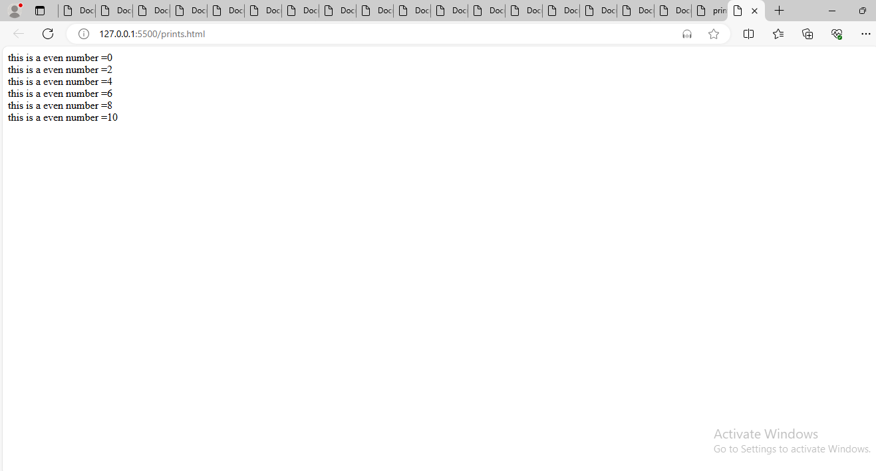

1. Create a JavaScript function that checks if a given number is prime.

**Code:**

1. <!DOCTYPE html>
2. <html lang="en">
3. <head>
4. <meta charset="UTF-8">
5. <meta name="viewport" content="width=device-width, initial-scale=1.0">
6. <title>Document</title>
7. </head>
8. <body>
9. <script>
10. let prime = parseInt(prompt("Enter the number"));
11. let isPrime = true;
12. if (prime === 1) {
13. document.write("this is a prime number or composite number");
14. } else if (prime > 1) {
15. for (let i = 2; i < prime; i++) {
16. if (prime % i == 0) {
17. isPrime = false;
18. break;
19. }
20. }
21. if (isPrime) {
22. document.write( "is a prime number",prime);
23. } else {
24. document.write("is a not prime number",prime);
25. }
26. } else {
27. document.write("The number is not a prime number.");
28. }
29. </script>
30. </body>
31. </html>

**Output:**

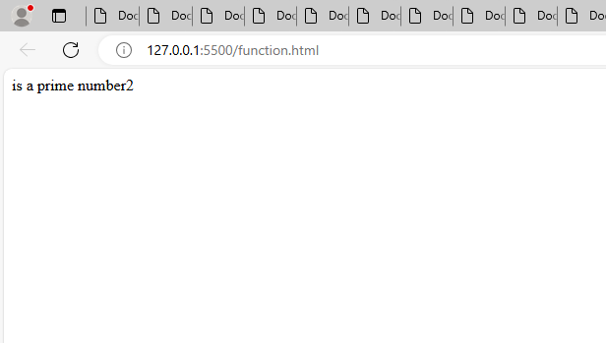

1. **Write a JavaScript program to find the largest of three numbers.**

**Code:**

<!DOCTYPE html>

<html lang="en">

<head>

    <meta charset="UTF-8">

    <meta name="viewport" content="width=device-width, initial-scale=1.0">

    <title>Document</title>

</head>

<body>

    <script>

        var x = 123;

      var y = 12;

      var z = 66;

      if (x >= y && x >= z) {

        document.write("is a largest number",x);

      } else if (y >= x && y >= z) {

        document.write(" is a largest number",y);

      } else {

        document.write(" is a largest number",z);

      }

    </script>

</body>

</html>

**Output:**

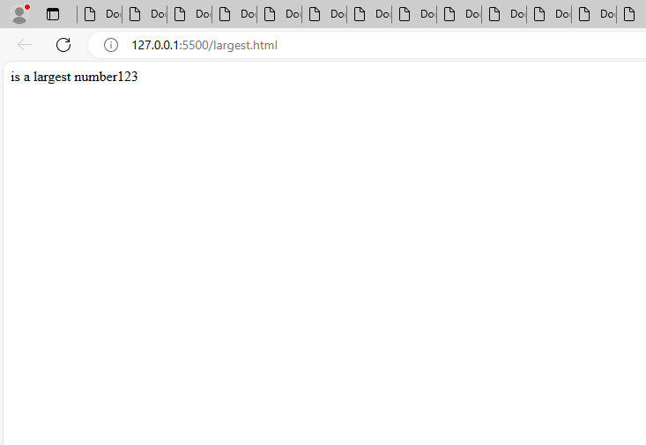

1. Develop a JavaScript function to calculate the factorial of a number using a for loop.

**Code:**

<!DOCTYPE html>

<html lang="en">

<head>

    <meta charset="UTF-8">

    <meta name="viewport" content="width=device-width, initial-scale=1.0">

    <title>Document</title>

</head>

<body>

    <script>

        let factorial = parseInt(prompt("enter the number here!"));

      if (factorial === 0) {

        document.write("factorial does not exit using zero");

      } else {

        let fact = 1;

        for (i = 1; i <= factorial; i++) {

          fact *= i;

        }

        document.write("factorial of" ,factorial, "is ",fact);

      }

    </script>

</body>

</html>

**Output:**

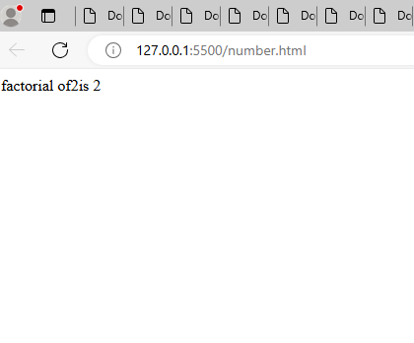

1. Create a JavaScript program that reverses a given string.

**Code:**

<!DOCTYPE html>

<html lang="en">

<head>

    <meta charset="UTF-8">

    <meta name="viewport" content="width=device-width, initial-scale=1.0">

    <title>Document</title>

</head>

<body>

    <script>

        const string = prompt("Enter a string: ");

      function reverseString(str) {

        let newString = "";

        for (let i = str.length - 1; i >= 0; i--) {

          newString += str[i];

        }

        return newString;

      }

      const result = reverseString(string);

      document.write(result);

    </script>

</body>

</html>

**Output:**

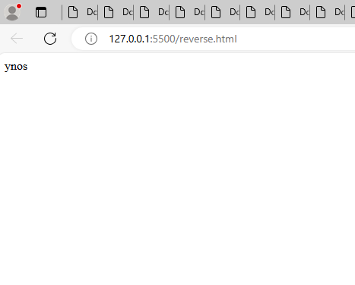

1. Write a JavaScript function that checks if a given string is a palindrome.

**Code:**

<!DOCTYPE html>

<html lang="en">

<head>

    <meta charset="UTF-8">

    <meta name="viewport" content="width=device-width, initial-scale=1.0">

    <title>Document</title>

</head>

<body>

    <script>

        const str = prompt("Enter a string: ");

      function Palindrome(str) {

        const len = str.length;

        for (let i = 0; i < len / 2; i++) {

          if (str[i] !== str[len - 1 - i]) {

            return "It is not a palindrome";

          }

        }

        return "It is a palindrome";

      }

      const result = Palindrome(str);

      document.write(result);

    </script>

</body>

</html>

**Output:**

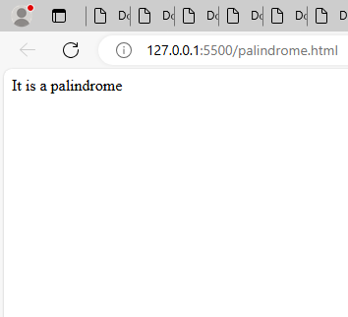

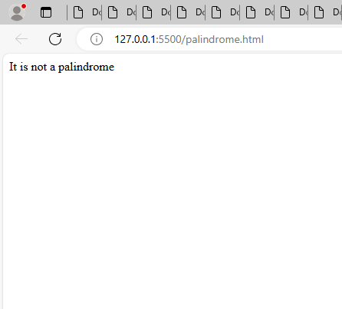

1. Implement a JavaScript program to find the sum of all elements in an array.

**Code:**

<!DOCTYPE html>

<html lang="en">

<head>

    <meta charset="UTF-8">

    <meta name="viewport" content="width=device-width, initial-scale=1.0">

    <title>Document</title>

</head>

<body>

    <script>

        let arr = [11, 22, 33, 44, 55, 66, 67,7, 8, 39];

      let sum = 0;

      for (i = 0; i < arr.length; i++) {

        sum += arr[i];

      }

      document.write("sum of arr is",sum);

    </script>

</body>

</html>

**Output:**

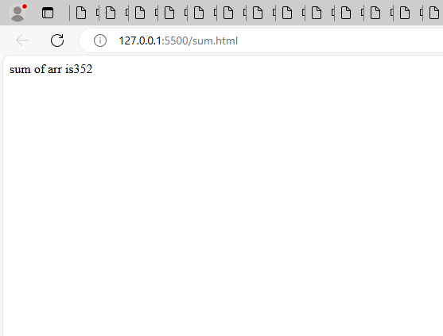

1. Write a JavaScript function to remove duplicates from an array.

**Code:**

<!DOCTYPE html>

<html lang="en">

<head>

    <meta charset="UTF-8">

    <meta name="viewport" content="width=device-width, initial-scale=1.0">

    <title>Document</title>

</head>

<body>

    <script>

        let array = [

        1, 2, 3, 4, 5, 1, 2, 2, 3, 4, 5, 3, 4, 5, 6, 3, 4, 7, 8, 9, 6,

      ];

      function removeDuplicates(arr) {

        let newArr = [...new Set(arr)];

        document.write(newArr);

      }

      removeDuplicates(array);

    </script>

</body>

</html>

**Output:**

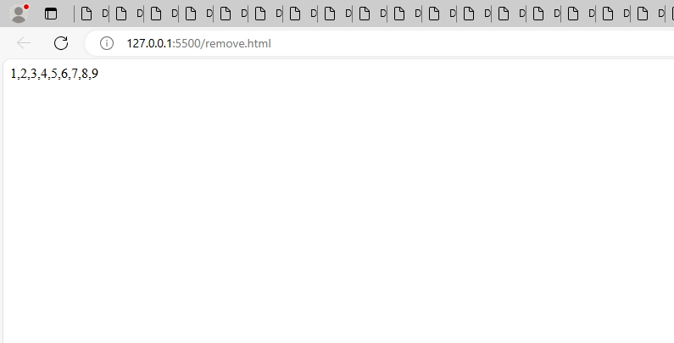

1. Develop a JavaScript program to find the second largest number in an array.

**Code:**

<!DOCTYPE html>

<html lang="en">

<head>

    <meta charset="UTF-8">

    <meta name="viewport" content="width=device-width, initial-scale=1.0">

    <title>Document</title>

</head>

<body>

    <script>

        var x = 234;

      var y = 45;

      var z = 67;

      if (x >= y && x >= z) {

        if (y >= z) {

          document.write( "is the second largest number",y);

        } else {

          document.write( "is the second largest number",z);

        }

      } else if (y >= x && y >= z) {

        if (x >= z) {

          document.write( "is the second largest number",x);

        } else {

          document.write( "is the second largest number",z);

        }

      } else {

        if (x >= y) {

          document.write(" is the second largest number",x);

        } else {

          document.write(" is the second largest number",y);

        }

      }

    </script>

</body>

</html>

**Output:**

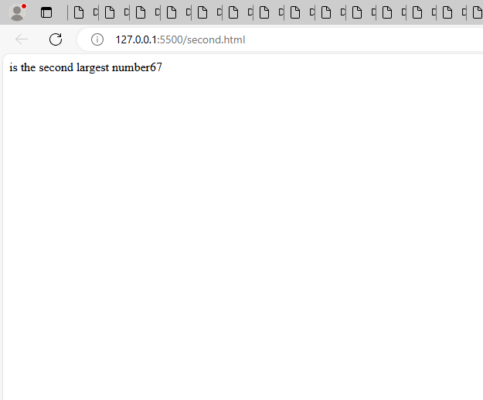

1. Create a JavaScript function that checks if a number is even or odd.

**Code:**

<!DOCTYPE html>

<html lang="en">

<head>

    <meta charset="UTF-8">

    <meta name="viewport" content="width=device-width, initial-scale=1.0">

    <title>Document</title>

</head>

<body>

    <script>

        for (let i = 1; i <= 30; i++) {

        if (i % 2 === 0) {

          document.write("is a even number",i ,"<br>");

        } else {

          document.write("is a odd number",i,"<br>" );

        }

      }

    </script>

</body>

</html>

**Output:**

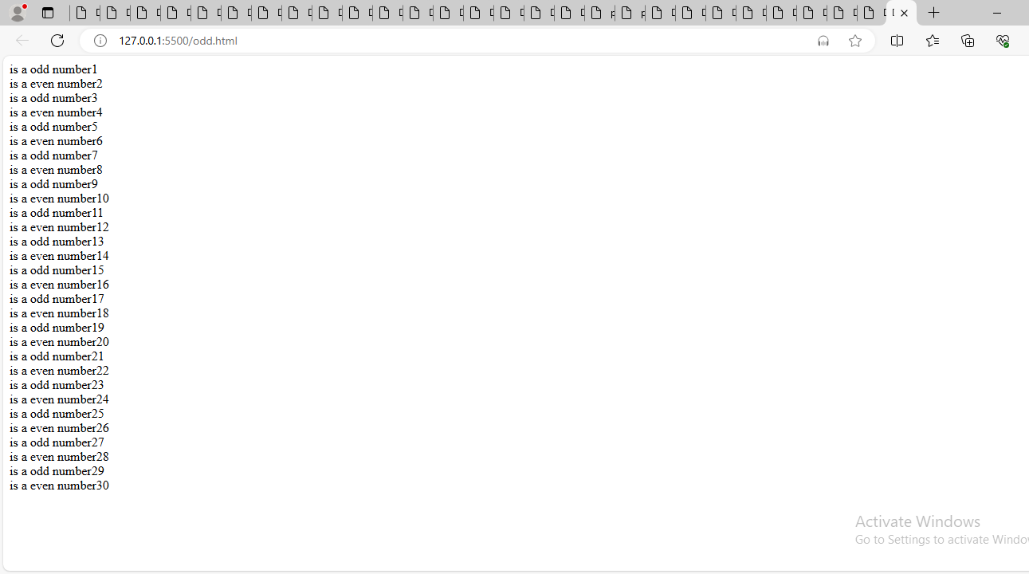

1. Write a JavaScript program to merge two arrays and remove duplicates.

**Code:**

<!DOCTYPE html>

<html lang="en">

<head>

    <meta charset="UTF-8">

    <meta name="viewport" content="width=device-width, initial-scale=1.0">

    <title>Document</title>

</head>

<body>

    <script>

        let array = [

        1, 2, 3, 4, 5, 1, 2, 2, 3, 4, 5, 3, 4, 5, 6, 3, 4, 7, 8, 9, 6,

      ];

      function removeDuplicates(arr) {

        let newArr = [...new Set(arr)];

        document.write(newArr);

      }

      removeDuplicates(array);

    </script>

</body>

</html>

**Output:**

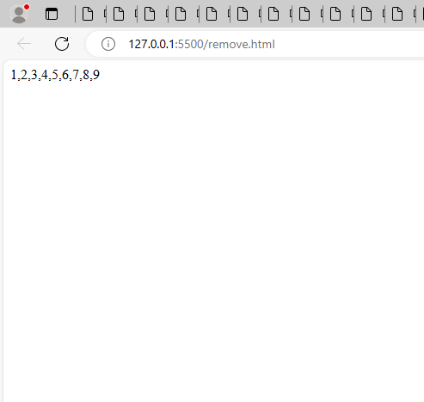

1. Create a JavaScript function to find the GCD of two numbers using a while loop.

**Code:**

<!DOCTYPE html>

<html lang="en">

<head>

    <meta charset="UTF-8">

    <meta name="viewport" content="width=device-width, initial-scale=1.0">

    <title>Document</title>

</head>

<body>

    <script>

        const num1 = prompt("Enter a num1 here: ");

      const num2 = prompt("Enter a num2 here: ");

      let gcd;

      for (let i = 1; i <= num1 && i <= num2; i++) {

        if (num1 % i == 0 && num2 % i == 0) {

          gcd = i;

        }

      }

      document.write("gcd of" ,num1 ,"and" ,num2, "is",gcd);

    </script>

</body>

</html>

**Output:**

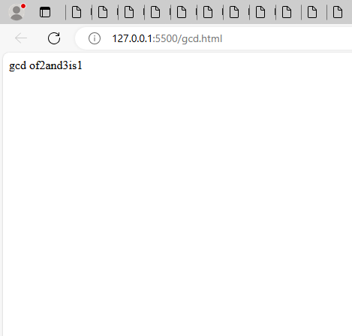

1. Write a JavaScript program to print the Fibonacci series up to a given number.

**Code:**

<!DOCTYPE html>

<html lang="en">

<head>

    <meta charset="UTF-8">

    <meta name="viewport" content="width=device-width, initial-scale=1.0">

    <title>Document</title>

</head>

<body>

    <script>

        const number = parseInt(prompt("Enter the number of terms: "));

      let n1 = 0,

        n2 = 1,

        nextTerm;

      for (let i = 1; i <= number; i++) {

        document.write(n1);

        nextTerm = n1 + n2;

        n1 = n2;

        n2 = nextTerm;

      }

    </script>

</body>

</html>

**Output:**

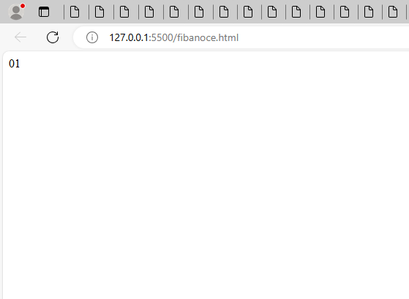

1. Develop a JavaScript function to sort an array of numbers in ascending order.

**Code:**

1. <!DOCTYPE html>
2. <html lang="en">
3. <head>
4. <meta charset="UTF-8">
5. <meta name="viewport" content="width=device-width, initial-scale=1.0">
6. <title>Document</title>
7. </head>
8. <body>
9. <script>
10. let arr = [1, 3, 6, 7, 9, 2, 5, 8, 4];
11. var newArr = arr.sort();
12. document.write(newArr);
13. </script>
14. </body>
15. </html>

**Output:**

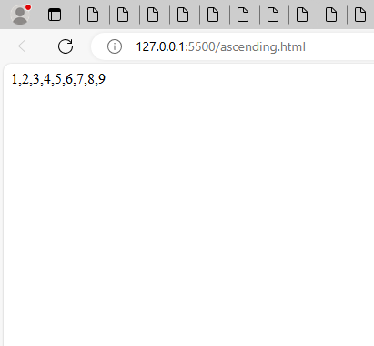

15.Write a JavaScript program to count the number of vowels in a given string

**Code:**

<!DOCTYPE html>

<html lang="en">

<head>

    <meta charset="UTF-8">

    <meta name="viewport" content="width=device-width, initial-scale=1.0">

    <title>Document</title>

</head>

<body>

    <script>

        const nameStr = prompt("Enter a name here: ");

      function vowel(str) {

        const count = str.match(/[aeiou]/gi).length;

        return count;

      }

      const result = vowel(nameStr);

      document.write(result);

    </script>

</body>

</html>

**Output:**

