CineHub

Fabio Buracchi (0253822)

Massimo Mazzetti (0253467)

Ivan Palmieri 0259244)

##### 

##### TTBMP

Index

1 Introduction 2

1.1 Aim of the document 2

1.2 Overview of the defined system 2

1.3 Operational settings 2

1.4 Related systems 3

1.4.1 POSitive® Cinema 3

1.4.2 SAP® & Microsoft Dynamics 3

2 User Stories 4

2.1 Fabio Buracchi 4

2.2 Massimo Mazzetti 4

2.3 Palmieri Ivan 4

3 Functional Requirements 5

3.1 Fabio Buracchi 5

3.2 Massimo Mazzetti 5

3.3 Ivan Palmieri 5

4 Use Case: Overview Diagram 6

5 Dictionary 7

# Introduction

## Aim of the document

In the following document we will introduce the CineHub project, developed for the Software Engineering and Web Design course of the academic year 2020-21.

## Overview of the defined system

CineHub is an ERP system aimed to the cinema industry which offers the automation and assisted management of movie theater chains through several ERP modules.

The e-commerce and human resource modules have been designed and developed for the current version.

## Operational settings

The system provides as artifacts a stand-alone desktop executable and a web application executable.

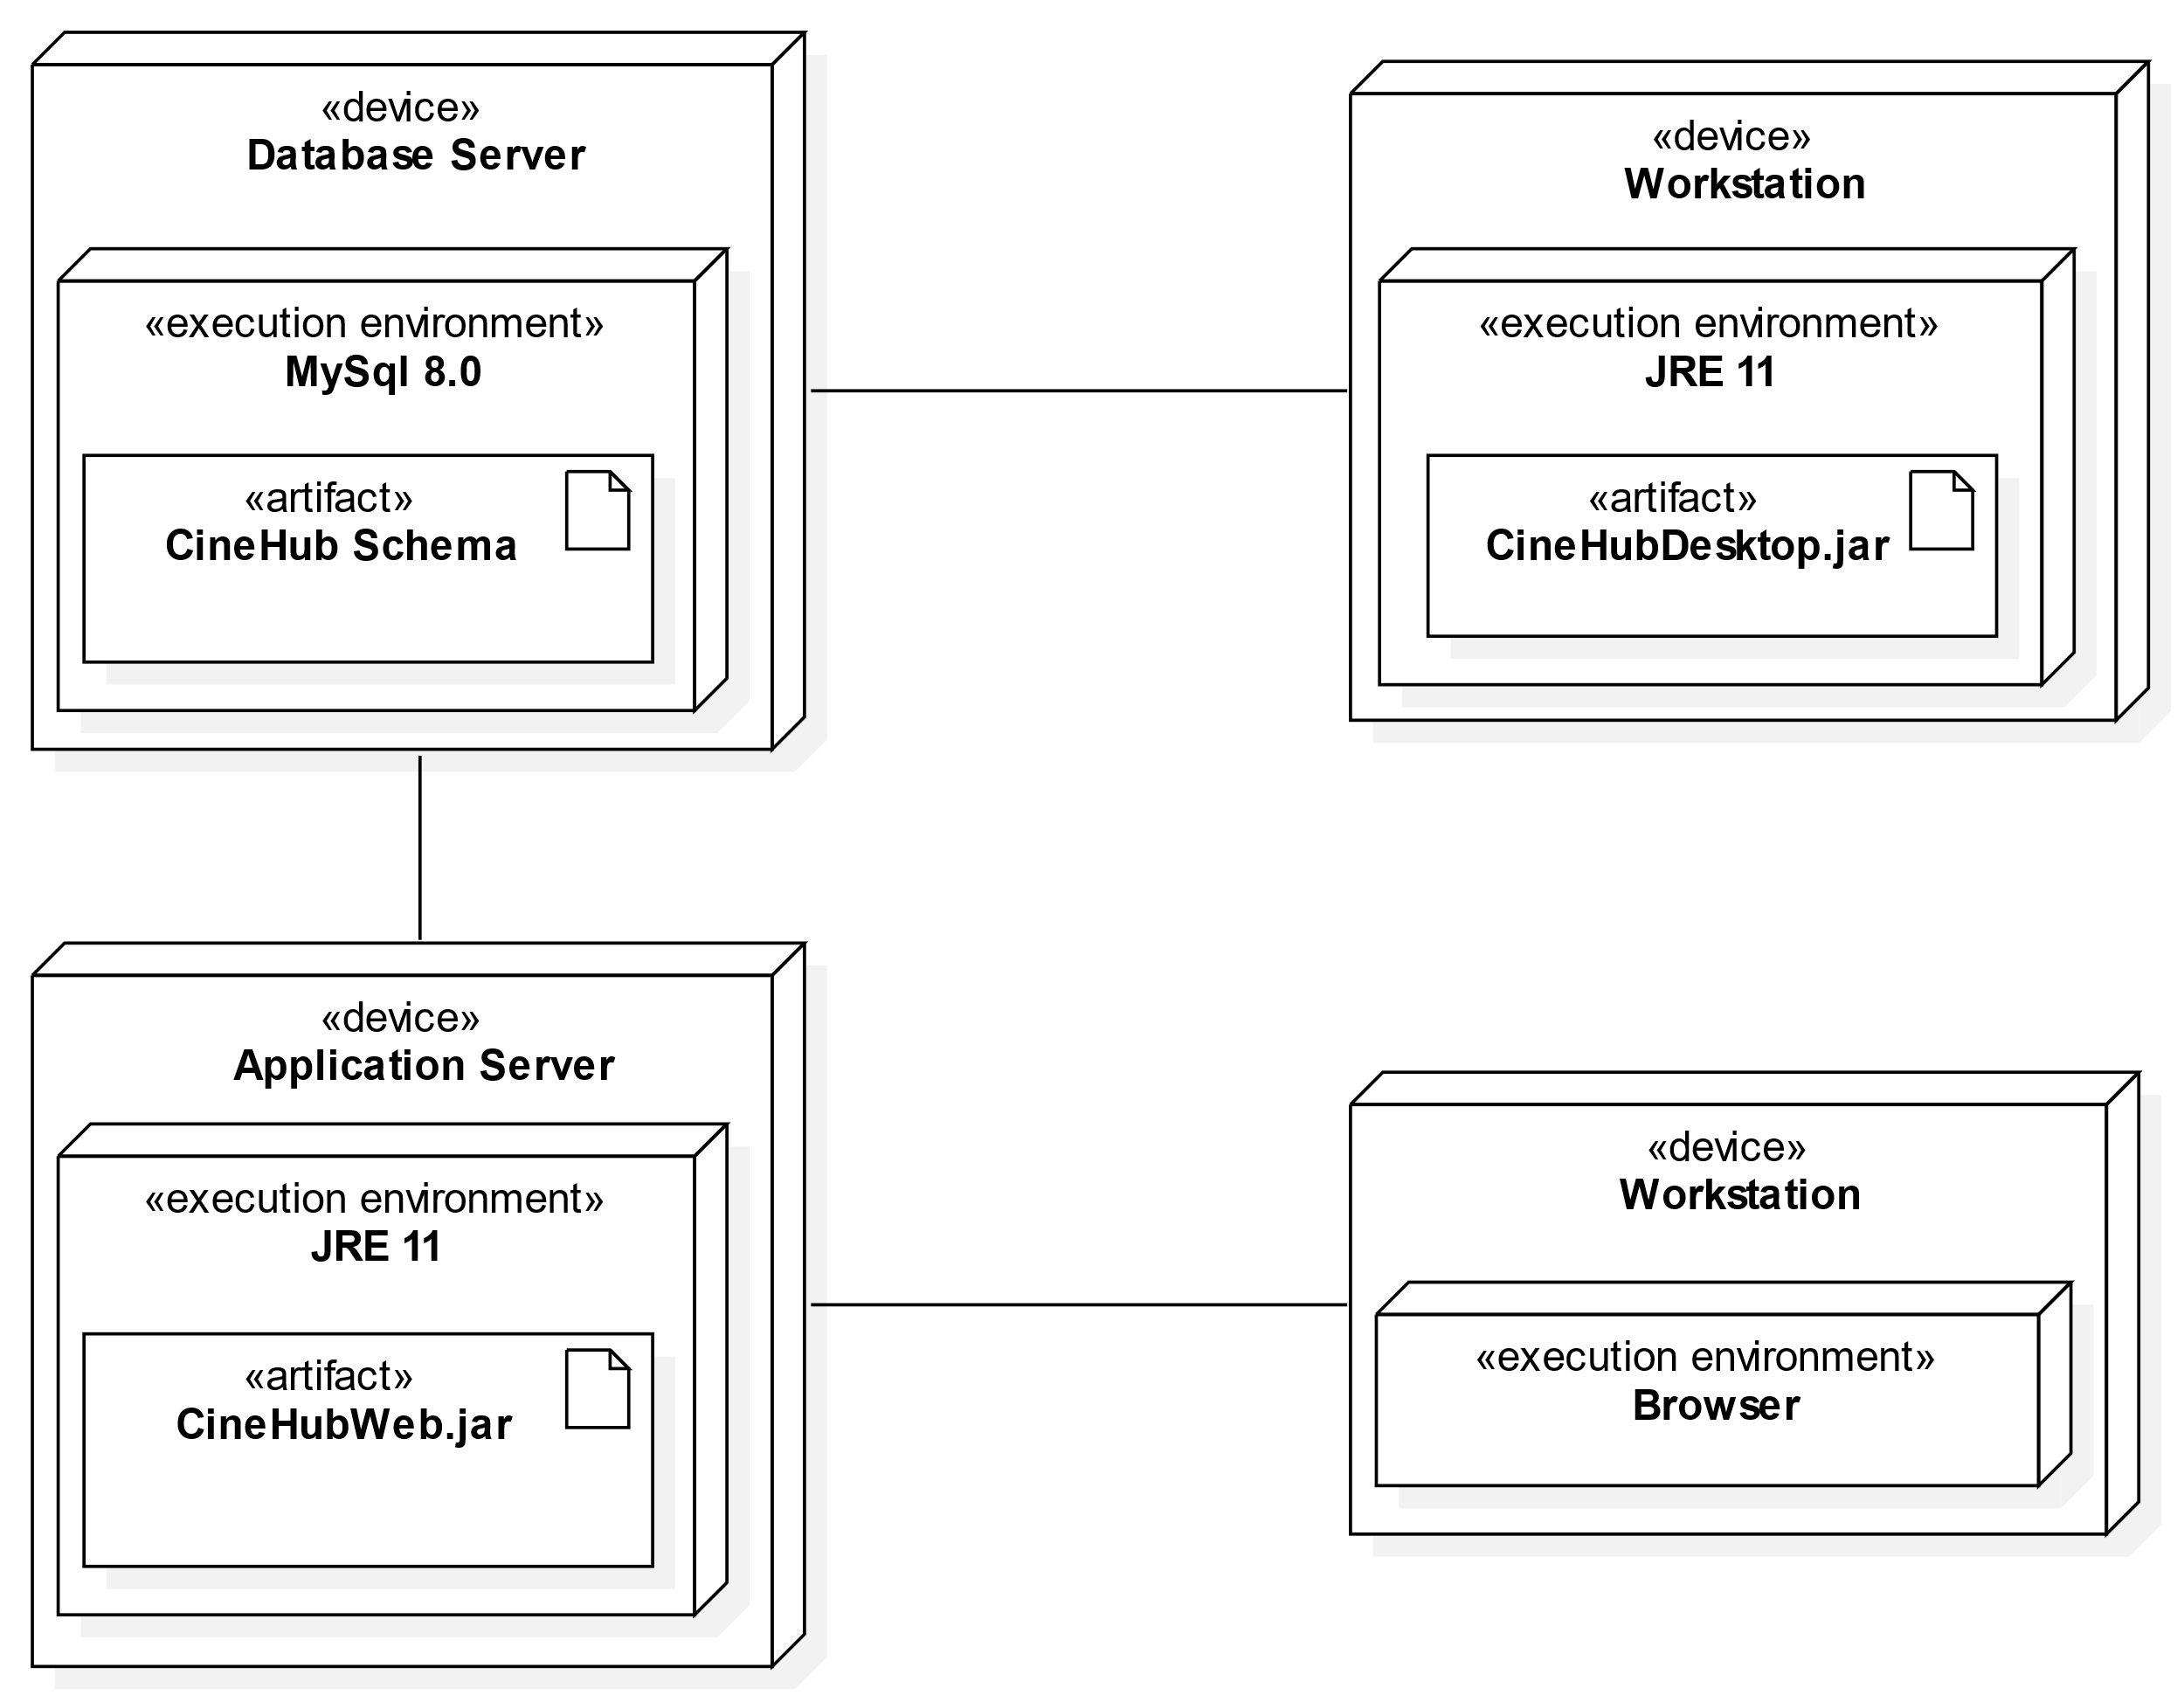To deploy the system is needed a node where it is installed MySql 8.0 version or greater to host the CineHub schema.

The desktop artifact requires to be deployed in a node where it is installed the JRE 11 / JDK 11 version or greater.

The web-app artifact requires to be deployed in a node where it is installed the JRE 11 / JDK 11 version or greater.

To interact with the web-app is required a node where it is installed a latest, stable release of any major browser and platform. On and Android Browser & WebView is required Android version 6.0 or greater. Internet Explorer and Safari are not supported.

The system has been tested on the following platforms:

1. Windows 10 Pro version 20H2 [64 bit]

* CPU: Intel® Core™ i7-4770K
* RAM: 16GB
* MySql version: 8.0.22
* Browser: Chrome 91

1. Windows 10 Enterprise version 21H1 [64 bit]
   * CPU: AMD Ryzen™ 5 3600
   * RAM: 16GB

* MySql version: 8.0.22
* Browser: MS Edge 91, Chrome 91

1. Windows
2. MacOs

* CPU: Intel® Core™ i5 dual core
  + RAM: 8GB
* MySql version: 8.0.22
* Browser: Chrome 91

1. Ubuntu 20.04

* CPU: virtualized 2-core
* RAM: 7GB
* MySql version: 8.0.25
* Browser: Chrome 91
* JDK: Azul Zulu JDK 11.48.21

## Related systems

### POSitive® Cinema

CineHub’s main competitor is [POSitive Cinema](https://positivecinema.com), a more mature ERP solution aimed for the cinema industry.

The pros of choosing CineHub instead of this product are […].

The cons of choosing CineHub instead of this product are the lack of several modules and dedicated hardware solutions.

### SAP® & Microsoft Dynamics

[Sap](https://www.sap.com/) and [Microsoft Dynamics](https://dynamics.microsoft.com/) are the world’s ERP product leaders […]

The pros of choosing CineHub instead of these products are […].

The cons of choosing CineHub instead of these products are […].

# User Stories

## Fabio Buracchi

* As user, I want to.
* As a user, I want to.
* As a user, I want to.

## Massimo Mazzetti

* As an unlogged user, I want to see the cinema projection, so that I can choose whether to go to the cinema to watch a movie.
* As an administrator, I want to define work shifts, so that I can manage the employees.
* As an administrator, I want to see a report on the employee status of the show, so that I can assert the right amount of usher and projectionist for the show.

## Palmieri Ivan

* As user, I want to buy a ticket online, so I can see the movie.
* As a user, I want to be able to choose (additional options*) for the reserved seat, so that I can feel at ease.
* As a user, I want to cancel my booking, to get a refund in case of unexpected events.

* Additional option = {seat heated; folding chair; skip the line}

# Functional Requirements

## Fabio Buracchi

* The system shall provide.
* The system shall provide.
* The system shall provide.

## Massimo Mazzetti

* The system shall provide the availability of seats in the cinema hall.
* The system shall keep track of employee shifts.
* The system shall provide general report every 15 of the month.

## Ivan Palmieri

* The system shall provide you to a search for movie.
* The system shall provide you to choose your seat in the cinema hall.
* The system shall provide a login service with firebase.

# Use Case: Overview Diagram

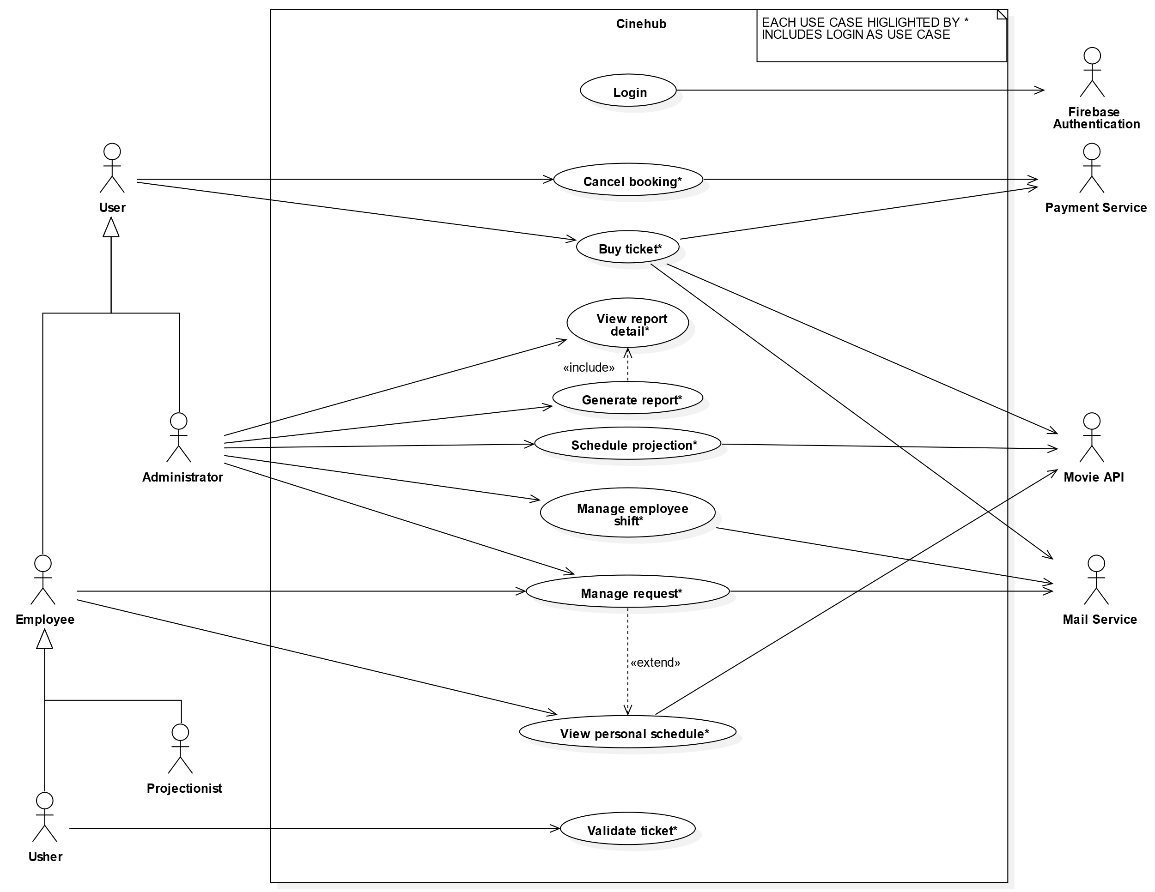

# Dictionary