Assumptions Document

Key Assumptions
1. Assume a broad range of typical IT software applications, broader categories include:

- Transaction Processing System (TPS) - Transactions are defined as any activity or event that affects the organisation, and include things like deposits, withdrawals, shipping, billing customers, order entry, and placing orders. TPS supports these business transactions

- Office Automation System (OAS) - The OAS covers office transactions and supports official activity at every level in the organization, e.g email, chat etc.

- Knowledge Work System (KWS) - The Knowledge Work System aids workers in creating and disseminating new information using graphics, communication, and document management tools.

- Management Information System (MIS) - Management Information Systems are specially designed to help middle managers and supervisors make decisions, plan, and control the workflow. The MIS pulls transactional data from various Transactional Processing Systems, compiles the information, and presents it in reports and displays.

- Decision Support System (DSS) - Decision Support Systems use different decision models to analyze or summarize large pieces of data into an easy-to-use form that makes it easier for managers to compare and analyze information. Often, these summaries come in the form of charts and tables.

- Executive Support System (ESS) - The ESS is like the MIS but for executive-level decision-making.
We also need to consider architecture of IT applications.
2. Assume tools and calculators that are developed by the Green Software Foundation (GSF) as well as other solutions available on the market. ( applying concepts rather than the tools / add bookmarks for future review )
3. To guarantee that the solution is independent of the organization's size.
4. The maturity matrix model provides inputs into this framework. The assessment is to understand the organisation’s current capabilities, determine intermediary steps and target states, and develop a roadmap towards improved sustainable IT practices and outcomes.

IT Development Lifecycle
We will build the framework to work with IT development lifecycles and not bind it to one particular approach.

The following are examples of DevOps and SDLC lifecycles. The first part of the analysis would consider the overlaps between all the major lifecycles to help change managers adopt the framework to fit their organisational development approaches.
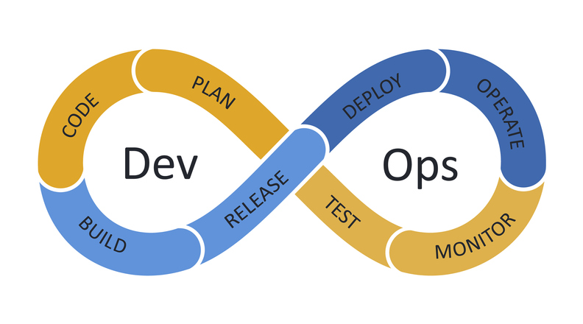
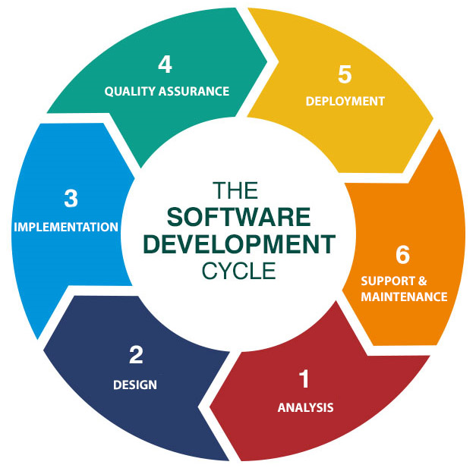

Analysis across the GSF Pillars
The following table outlines the questions that need to be resolved to help design the framework and decision-making matrix, incorporating the GSF pillars.

