程序设计系统
课程设计报告

题目： 基于区块链思想的银行存储系统
学院： 国际教育学院
专业： 计算机科学与技术
班级： 183609班
学号： 20181173 20181172 20181186
姓名： 高一钧 冯垚 钱景宁
指导老师： 韩旭明
设计日期：2019.12.23-2019.12.27

1. 课程设计题目及实现功能
基于区块思想的银行管理系统
程序能提供以下功能：
- 完成账户开户销户。
- 储存账户用户的个人信息并以输入输出流写入文件和读取文件。
- 完成账户的资金结算以及存取情况。
- 设计了简单的加密算法，防止从文件改变个人信息。
2. 程序设计涉及的主要知识点
设计出哪些类，应用了哪些程序设计系统设计思想，主要解决什么问题。是否应用了类、类的继承与派生、符号重载、虚函数、抽象类、函数模板、类模板等知识点。
- 本程序有基类账户类（用于写入用户个人信息），基类ATM类(用于执行办理各种手续的操作),以及他们的派生类储蓄卡类(写入文件并从文件中读取储蓄卡信息)。
- 运用到类的继承与派生，友元函数，函数模版，多态，虚函数等操作。
- 主要通过文件的读入读取实现对用户账户的信息及存款进行位运算加密保存。

3. 总体设计
3.1 系统功能模块图

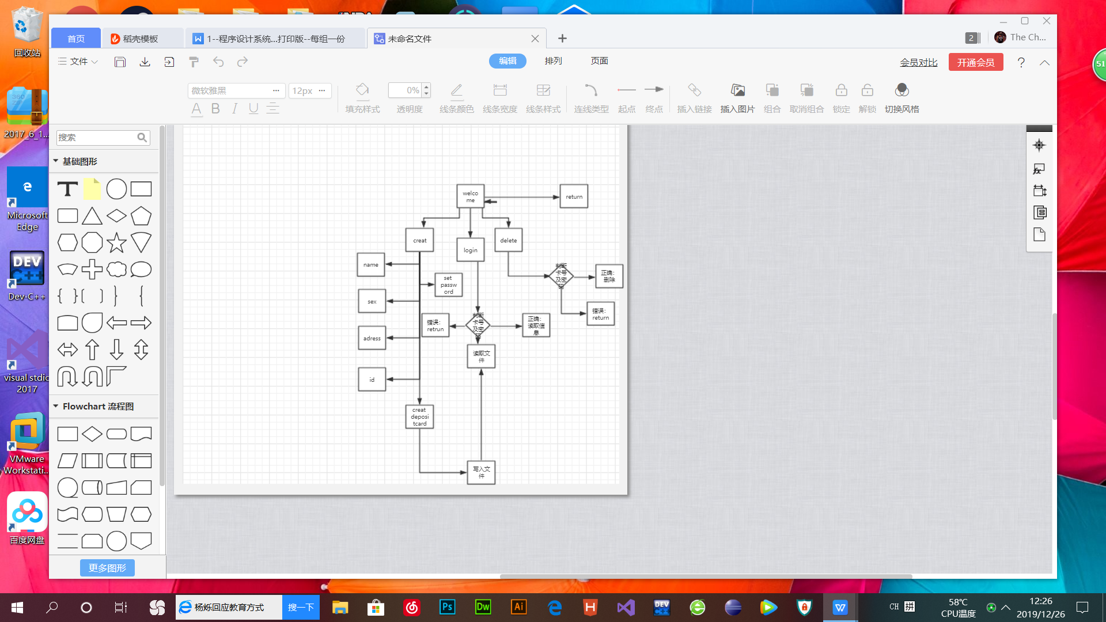

3.2 设计思想
- 运用面向对象的设计思想，account类中存储用户个人信息，ATM类中存储对储蓄卡进行操作的成员方法，最后以派生类depositcard的实例化对象实现各种操作以及文件存储。
- 在设计的过程中，考虑到从文件里面直接修改账户余额过于简单，于是我们在每个账户里面加了一个整型变量，只要是合法操作就会更新这个变量，每次登录的时候，都会把金额进行加密运算与变量进行对比，若不一致，则会被弹出。
- 原本打算调用区块链的sha256算法，但是考虑到金额一定为整数且不会出现很多奇怪的字符串，于是便自己用位运算进行简单加密即可。为了方便使用，本程序除了用于加密的变量和金额外均适用string类型进行存储，这样也可以解决输入非法数据会导致程序崩溃。在每次输入都加入了判断让这个程序变得更加稳定与完善。
- 加密算法的核心设计思想：s=原数和1取异或，然后再将s左移两位，再将倒数第二位取反然后整体取反（s=s^1;s==s<<2;s=s^(1<<2-1);s=~s;)
4. 主要问题的解决方法及技术关键
4.1 类设计
三个类，两个基类，一个派生类，两个互为友元类；
4.2 类实现
通过depositcard类对account类的构造函数进行赋值，再调用depositcard的友元类ATM实现对depositcard的各种操作，在主函数中调用ATM的实例化对象，并通过ATM类的菜单实现用户手动输入信息，系统自动调用depositcard构造函数同时为account的保护成员赋值，并通过文件写入将数据导入文件。
5. 详细设计说明和部分界面
进入菜单选项：
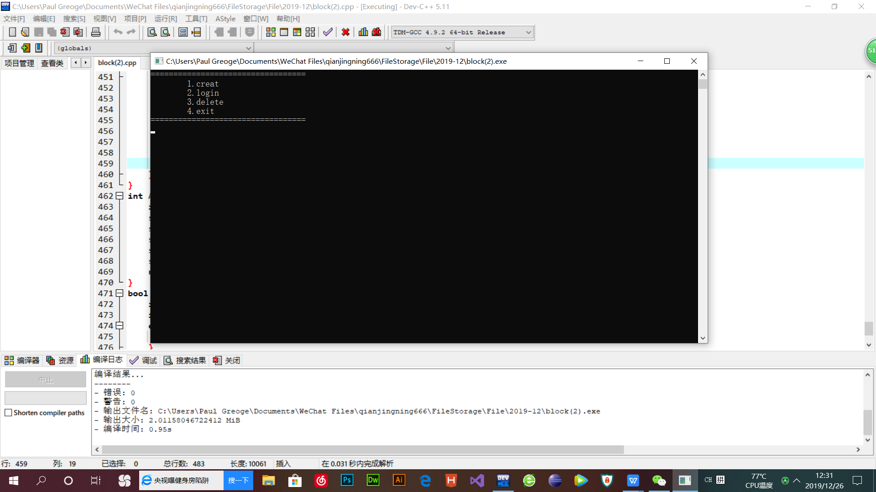
按1进入创建账户：
如图正在设置用户个人信息：
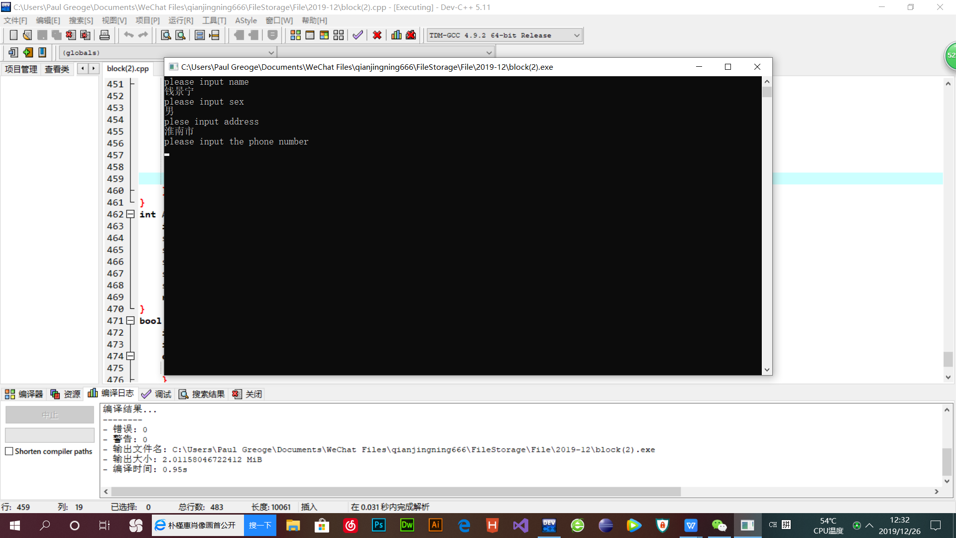
按2进入登录界面：
输入刚才创建的账户：
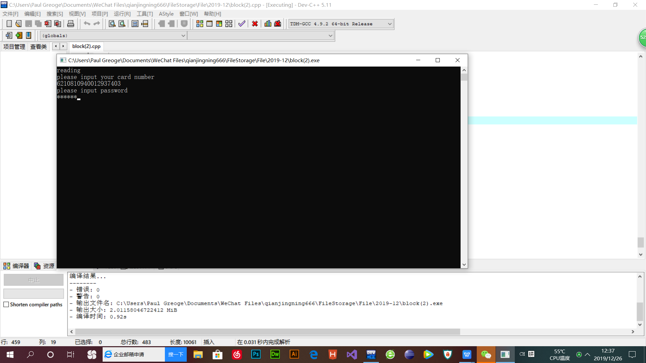
登录成功进入个人用户界面：
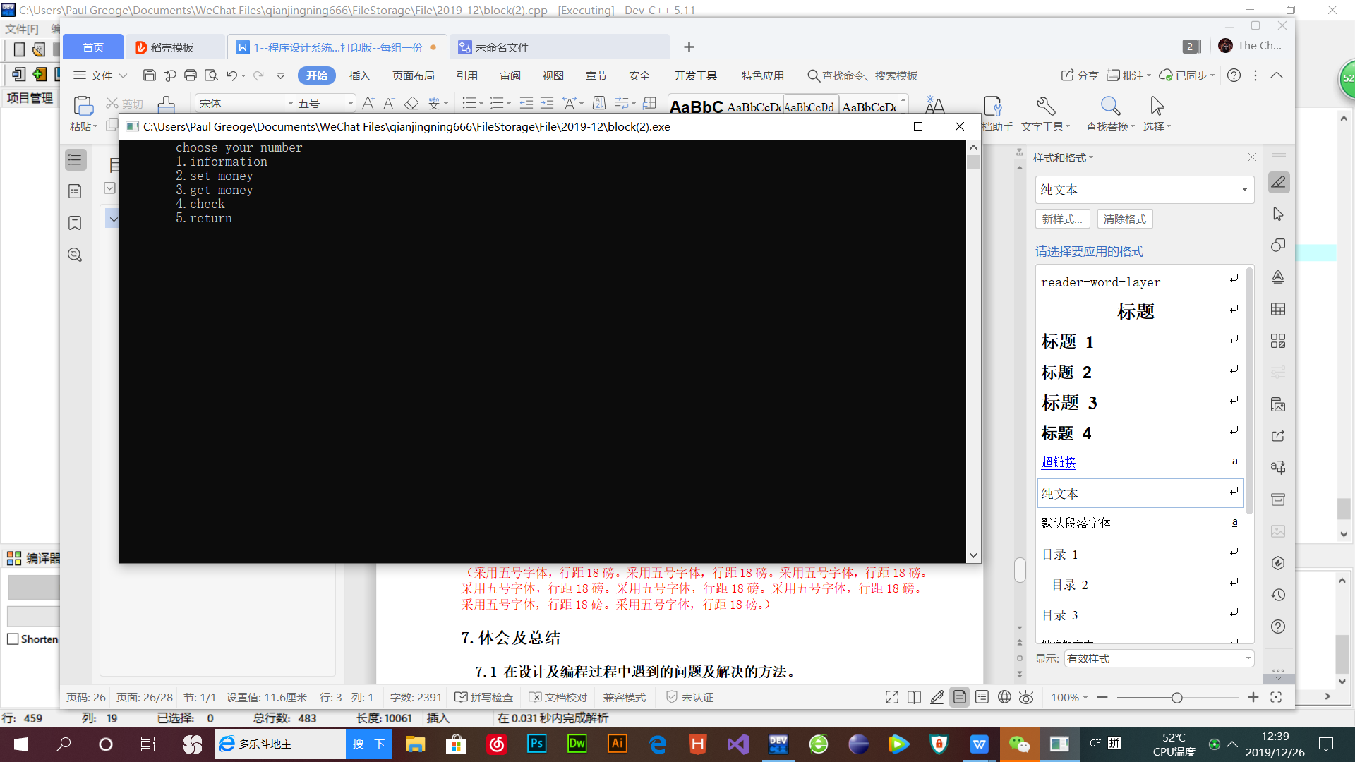
按1显示用户个人信息：
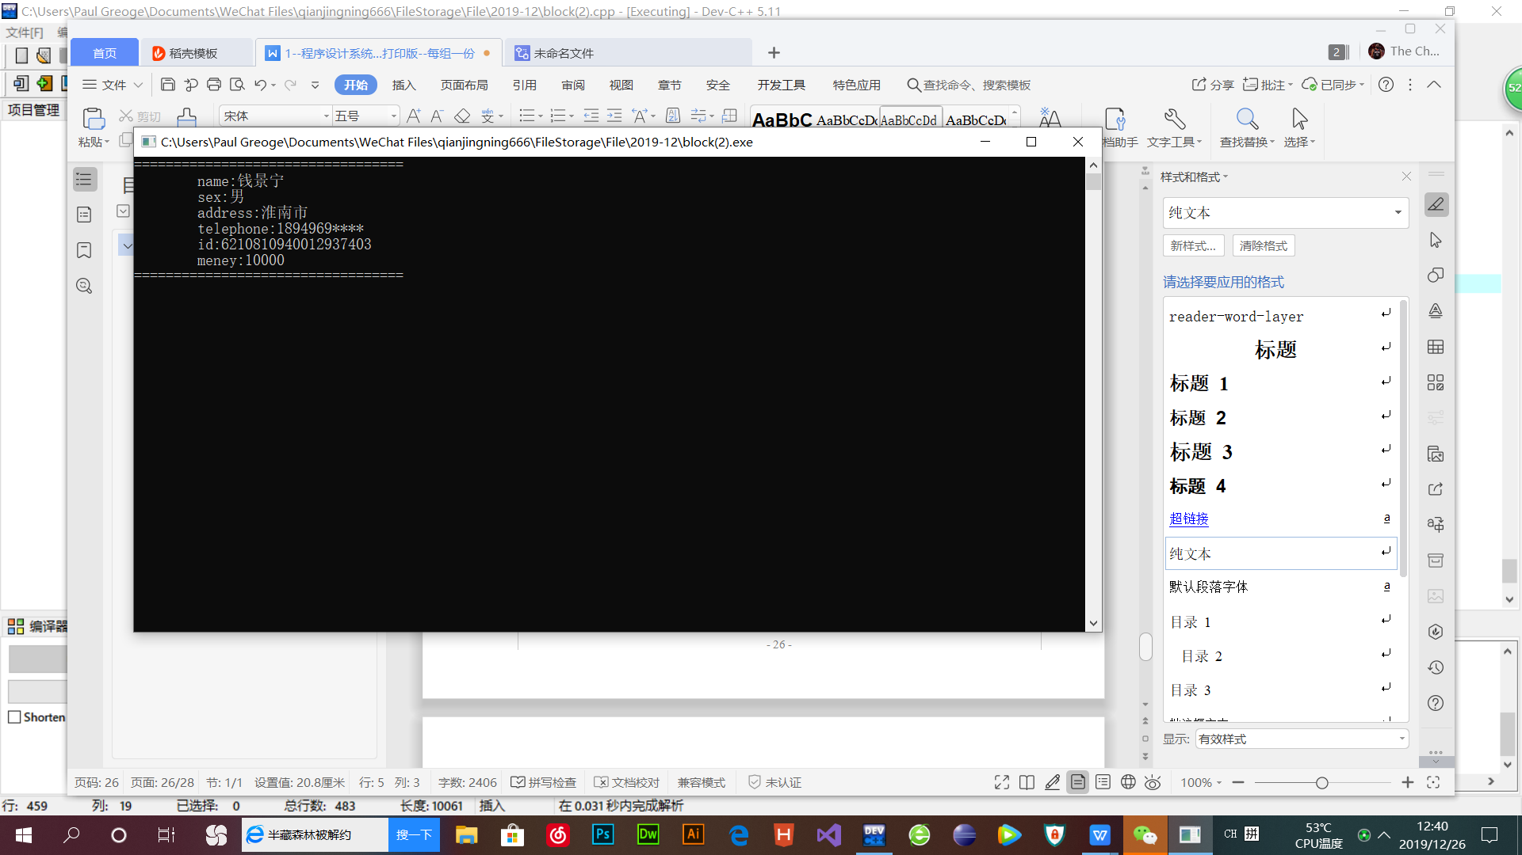
按2和3分别是存款和取款
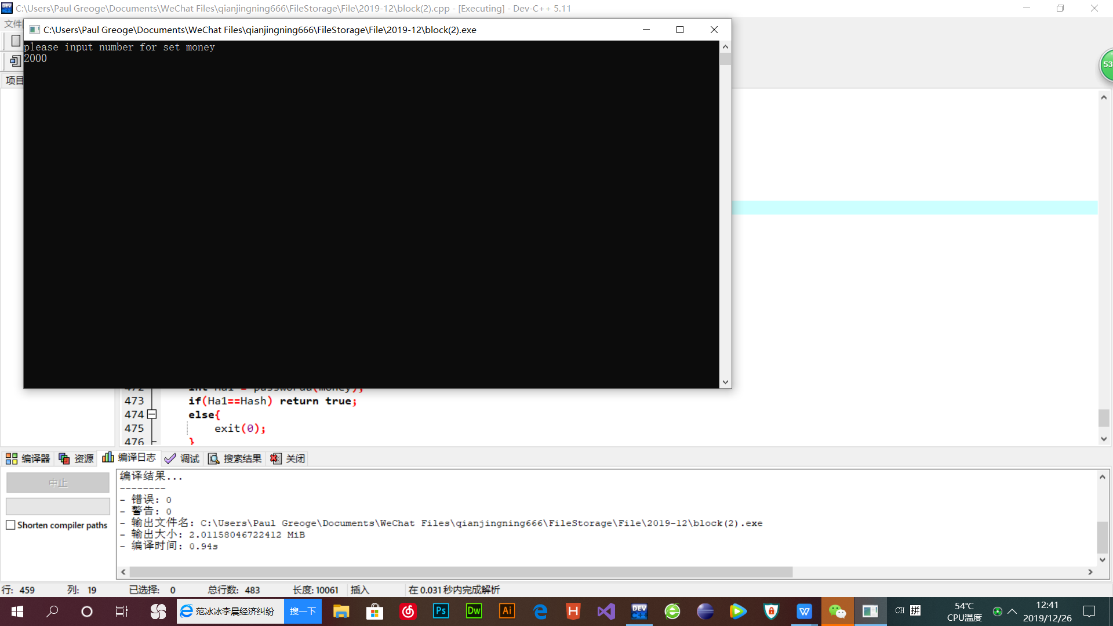
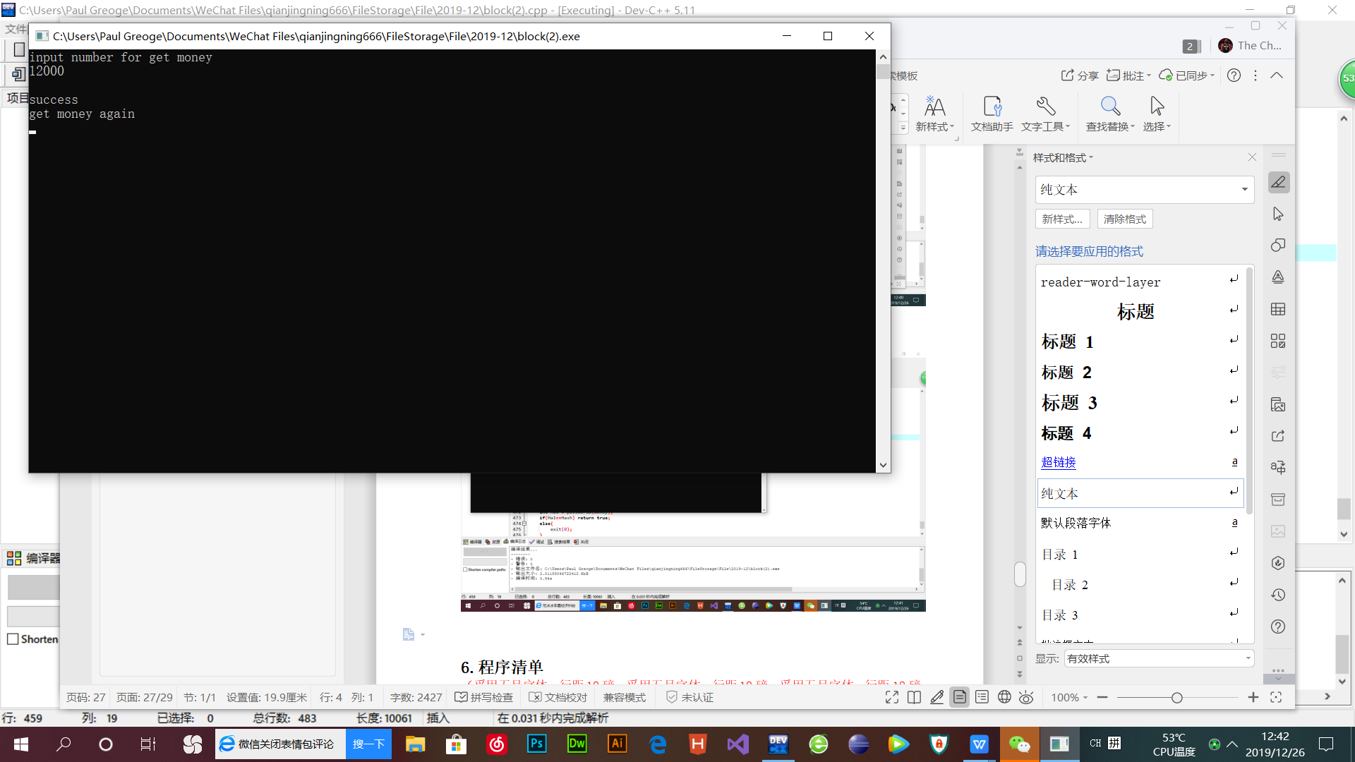
- 程序清单
#include<iostream>
#include<cstring>
#include<cstdlib>
#include<sstream>
#include<fstream>
#include<ctime>
#include<conio.h>

#define account0 6210810940012937393
#define random(a,b) (rand()%(b - a + 1) + a)

using namespace std;

int number = 0;
int n = 0;
class ATM;
class depositcard;
class account{
public:
account(string i, string n, int h,string se, string a, string t, string s, string p,double m){
id = i;
name = n;
sex = se;
address = a;
tele = t;
shenfen = s;
password = p;
money = m;
Hash=h;
}
string getid(){
return id;
}
void display();
void querymoney();
protected:
string id;
string name;
string address;
string tele;
string shenfen;
string password;
string sex;
double money;
int Hash;
};

class ATM{
public:
template<class A>
A a(A b){return b;}
virtual void c()=0;
void setdeposit();
void enterdeposit();
void delaccount();
void exitatm();
bool passwordeq(int Hash, double money);
int passworda(double m);
void dsave();
void dread();
string inputpassword();
bool checkshen(string str);
void menu();
protected:
depositcard *deposit[50];
static int depositcount;
};

class depositcard:public account, public ATM{
public:
friend class ATM;
depositcard(string i, string n, int h, string se, string a, string t, string s, string p,double m):account(i,n,h,se,a,t,s,p,m){}
void save();
void fetch();
string getp(){
return password;
}
};
int ATM::depositcount = 0;
void ATM::dsave(){
ofstream infile("deposit.txt", ios::out);
ofstream outfile("deposit.txt", ios::out);
outfile << depositcount << " ";
for(n = 0; n < depositcount; n++){
outfile << deposit[n] -> id << " ";
outfile << deposit[n] -> money << " ";
outfile << deposit[n] -> name << " ";
outfile << deposit[n] -> password << " ";
outfile << deposit[n] -> shenfen << " ";
outfile << deposit[n] -> tele << " ";
outfile << deposit[n] -> address << " ";
outfile << deposit[n] -> sex << " ";
outfile<<deposit[n]->Hash<<" ";
}
outfile.close();
}
void ATM::dread(){
string id;
string sex;
string nam;
string passw;
string tele;
string adress;
string shenfen;
double money;
int Hash;
ifstream infile("deposit.txt", ios::in);
infile >> depositcount;
if(!infile){
cerr << "Error no data" << endl;
return;
}
for(n = 0; n < depositcount; n++){
infile >> id;
infile >> money;
infile >> nam;
infile >> passw;
infile >> shenfen;
infile >> tele;
infile >> adress;
infile >> sex;
infile>>Hash;
depositcard * acc = new depositcard(id, nam, Hash,sex, adress, tele, shenfen, passw, money);
deposit[n] = acc;
}
infile.close();
cout << "reading" << endl;
}
string ATM::inputpassword(){
string s;
char ch;
while((ch = getch()) != '\r'){
s += ch;
cout << "*";
}
return s;
}
void account::display(){
cin.get();
system("cls");
cout << "==================================" << endl;
cout << " name:" << name << endl;
cout << " sex:" << sex << endl;
cout << " address:" << address << endl;
cout << " telephone:" << tele << endl;
cout << " id:" << id << endl;
cout << " meney:" << money << endl;
cout << "==================================" << endl;
}
bool ATM::checkshen(string str){
int len = str.length();
if(len != 18){
return false;
}
else{
int i;
for(i = 0; i < 18; i++){
if(str[i] < '0' || str[i] > '9'){
if(i == 17 && str[i] != 'x' && str[i] != 'X'){
return false;
}
else if(i != 17){
return false;
}
else
return false;
}
}
}
return true;
}
void ATM::exitatm(){
cout << "bye" << endl;
exit(-1);
}
void ATM::menu(){
cout << " welcome" << endl;
getch();
do{
system("cls");
cout << "==================================" << endl;
cout << " 1.creat" << endl;
cout << " 2.login" << endl;
cout << " 3.delete" << endl;
cout << " 4.exit" << endl;
cout << "==================================" << endl;
int u = 0;
cin >> u;
while(u < 1 || u > 4){
cout << "please input a true number" << endl;
cin >> u;
}
system("cls");
switch(u){
case 1:
setdeposit();
break;
case 2:
enterdeposit();
break;
case 3:
delaccount();
break;
case 4:
exitatm();
break;
}
}while(1);
system("cls");
}
void ATM::setdeposit(){
srand((unsigned)time(NULL));
string i, n, a, t, s, se, p;
int h;
double m;
int find = 1;
cin.get();
cout << "please input name" << endl;
getline(cin,n);
cout << "please input sex" << endl;
cin >> se;
cin.get();
cout << "plese input address" << endl;
getline(cin,a);
cout << "please input the phone number" << endl;
cin >> t;
while(1){
cout << "please input your id card number" <<endl;
cin >> s;
if(!checkshen(s)){
cout << "error" << endl;
continue;
}
else
break;
}
while(1){
int x = 2;
cout << "please input 6 number" << endl;
p = inputpassword();
cout << endl;
string p1;
cout << "please input again" << endl;
p1 = inputpassword();
cout << endl;
while(p != p1 && x != 0){
cout << "wrong you still have " << x << "time" << endl;
p1 = inputpassword();
x--;
cout << endl;
}
if(p1 == p)
break;
if(x == 0){
find = 0;
break;
}
}
if(find == 0)
return ;
cout << "please input number for set money" << endl;
cin >> m;
while(m <= 0){
cout << "please input true number" << endl;
cin >> m;
}
cin.get();
h = passworda(m);
long long acc = account0 + random(1,100) + number;
number++;
cout << "success" << endl;
cout << "your id number is" << acc << "don't forget it" <<endl;
stringstream str;
str << acc;
str >> i;
deposit[depositcount] = new depositcard(i,n,h,se,a,t,s,p,m);
depositcount++;
dsave();
cout << "input key to continue" <<endl;
cin.get();
return;
}
void ATM::enterdeposit(){
dread();
string id, p;
int f1 = 1;
int flag = 1;
int j;
int i = 0;
int x = 2;
int y = 2;
cout << "please input your card number" << endl;
cin >> id;
while(flag && x != 0){
for(int i = 0; i < depositcount; i++){
if(id == deposit[i] -> getid()){
flag = 0;
j = 1;
break;
}
}
if(flag == 1){
cout << "wrong card number you still have " << x << "time" <<endl;
cin >> id;
x--;
}
if(x == 0)
cout << "return last GUI" << endl;
}
if(x == 0)
return;
while(1){
cout << "please input password" << endl;
p = inputpassword();
// cout << p << endl;
// cout << deposit[j] -> passw;
if(p != deposit[i] -> getp()){
cout << endl << "wrong, you still have" << y << "time" << endl;
p = inputpassword();
y--;
}
else
break;
if(y == 0){
f1 = 0;
cout << "return last GUI" << endl;
break;
}
}
if(f1 == 0)
return;
int n;
do{
system("cls");
cout << " choose your number" << endl;
cout << " 1.information" << endl;
cout << " 2.set money" << endl;
cout << " 3.get money" << endl;
cout << " 4.check" << endl;
cout << " 5.return" << endl;
cin >> n;
while(n < 1 || n > 5){
cout << "please input a true number" << endl;
cin >> n;
}
switch(n){
case 1:
deposit[i] -> display();
break;
case 2:
deposit[i] -> save();
dsave();
break;
case 3:
deposit[i] -> fetch();
dsave();
break;
case 4:
deposit[i] -> querymoney();
dsave();
break;
case 5:
return;
}
cin.get();
}while(1);
}
void depositcard::save(){
if(passwordeq(Hash, money)){
cin.get();
system("cls");
double a;
cout << "please input number for set money" << endl;
cin >> a;
while(a <= 0){
cout << "please input a true number";
cin >> a;
}
cout << "success" << endl;
money += a;
Hash = passworda(money);
cout << "type ket to continue" << endl;
cin.get();
}
}
void account::querymoney(){
system("cls");
cout << "money" << money << endl;
cin.get();
}
void depositcard::fetch(){
if(passwordeq(Hash, money)){
system("cls");
double a;
int b;
do{
cout << "input number for get money";
cin >> a;
while(a < 0){
cout << "please input a true number" << endl;
cin >> a;
}
if(money < a)
cout << "sorry you don't have too much money" << endl;
else{
money = money - a;
cout << endl << "success" << endl;
}
cout << "get money again" << endl;
cin >> b;
while(b != 0 && b != 1){
cout << "please input a true numebr" << endl;
cin >> b;
}
}while(b == 0);
Hash = passworda(money);
cout << "input key to continue" << endl;
cin.get();
}
}
void ATM::delaccount(){
int n;
int i = 0;
int j;
int k;
int flag = 1;
string id;
string p;
if(n == 0){
while(flag){
cout << "please input id card number" << endl;
cin >> id;
for(i = 0; i < depositcount; i++){
if(id == deposit[i] -> getid()){
j = i;
flag = 0;
break;
}
}
if(flag == 1){
cout << "wrong" << endl;
cin >> id;
}
}
while(1){
cout << "please input password" << endl;
cout << deposit[j] -> getp() << endl;
if(p != deposit[j] -> getp()){
cout << "wrong" << endl;
p = inputpassword();
}
else
break;
}
delete deposit[j];
for(k = j; k < depositcount; k++)
deposit[k] = deposit[k + 1];
deposit[depositcount - 1] = NULL;
depositcount--;
cout << "success" << endl;
dsave();
cin.get();
}
}
int ATM :: passworda(double m){
int s;
s = m;
s = s ^ 1;
s = s << 2;
s = s ^ (1 << 2-1);
s = ~s;
return s;
}
bool ATM :: passwordeq(int Hash , double money){
int Ha1 = passworda(money);
if(Ha1==Hash) return true;
else{
exit(0);
}

}
int main(){
ATM atm;
atm.menu();
return 0;
}
7.体会及总结
7.1 在设计及编程过程中遇到的问题及解决的方法。
在对个人用户信息进行加密时，起初准备运用哈希256加密算法对数据进行加密，因为种种原因无法获取到文件信息以及存储数据的地址，后来转为使用位运算对数据进行加密。
7.2 收获及心得。
经过一学期的程序设计系统课程的学习，掌握了面向对象程序设计方法。精通了对函数重载，构造函数，友元函数，纯虚函数，抽象类，派生类等方法和面向对象思想。通过一周的课程设计，掌握了应用Visual C++6.0语言编写一个小的面向对象应用程序，完成了对银行的信息系统的存储，开拓了视野，对学好计算机充满信心。

