Kevin Java QAP3
Code outputs
Task1: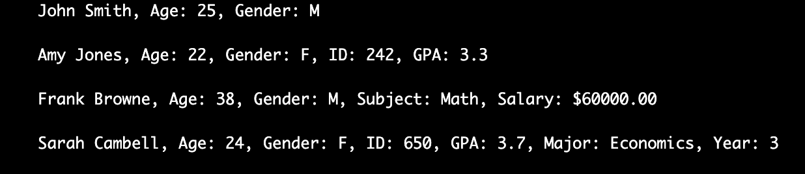
Task2:
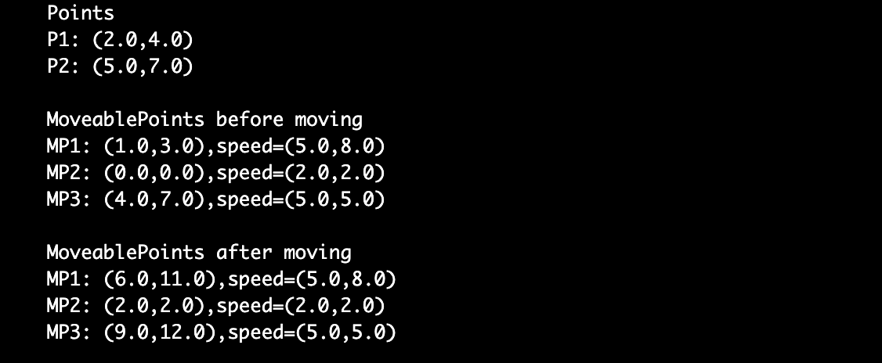
Task3:
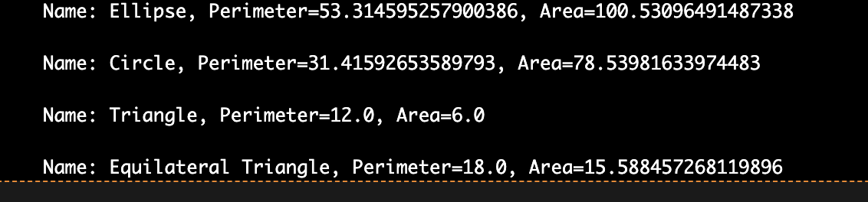
Task4:
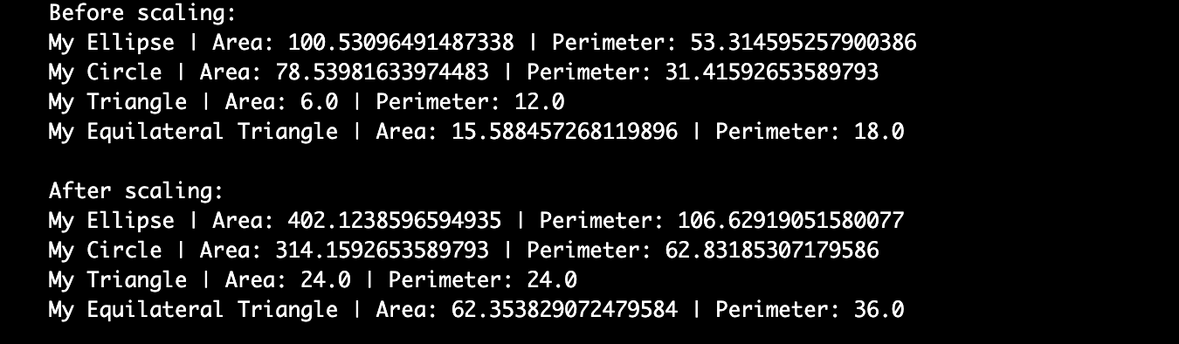

Questions:
1: It took me about 2-3 hours
2: Really only had to go back to past classes codes for the Interfaces, rest was fairly straight forward
3: N/A
4: N/A
5:
Problem 1 - 3/10 was not very difficult
Problem 2 - 3/10 was not very difficult
Problem 3 - 5/10 most code was not very difficult, trying to figure out exactly how to code getArea and getPerimeter for ellipses was a bit strange.
Problem 4: 6/10 – Need to do some more practices on interfaces for sure, once I looked at past classes code I figured it out and wasn’t too bad but did take me a minute to figure out exactly what I needed to do.

