QAP1 Documentation

- Clean code examples:
A) Class names are descriptive nouns that make it easy to understand what they are being used for
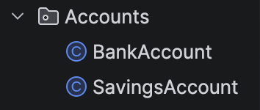
B) Functions each do just one simple thing to avoid messiness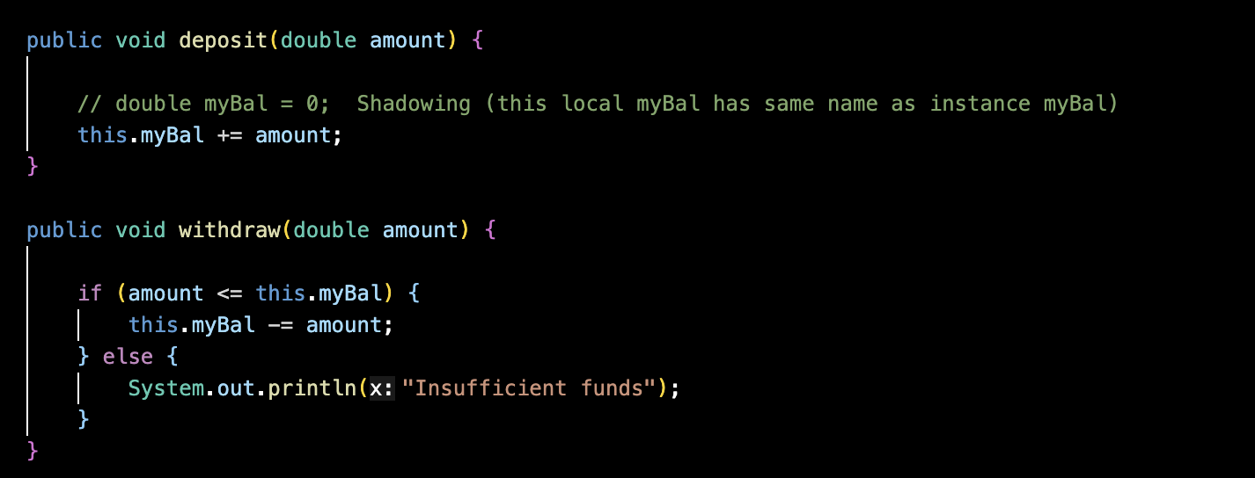 C) Tests are clearly named rather than trying to keep them short, so you know exactly what is being tested 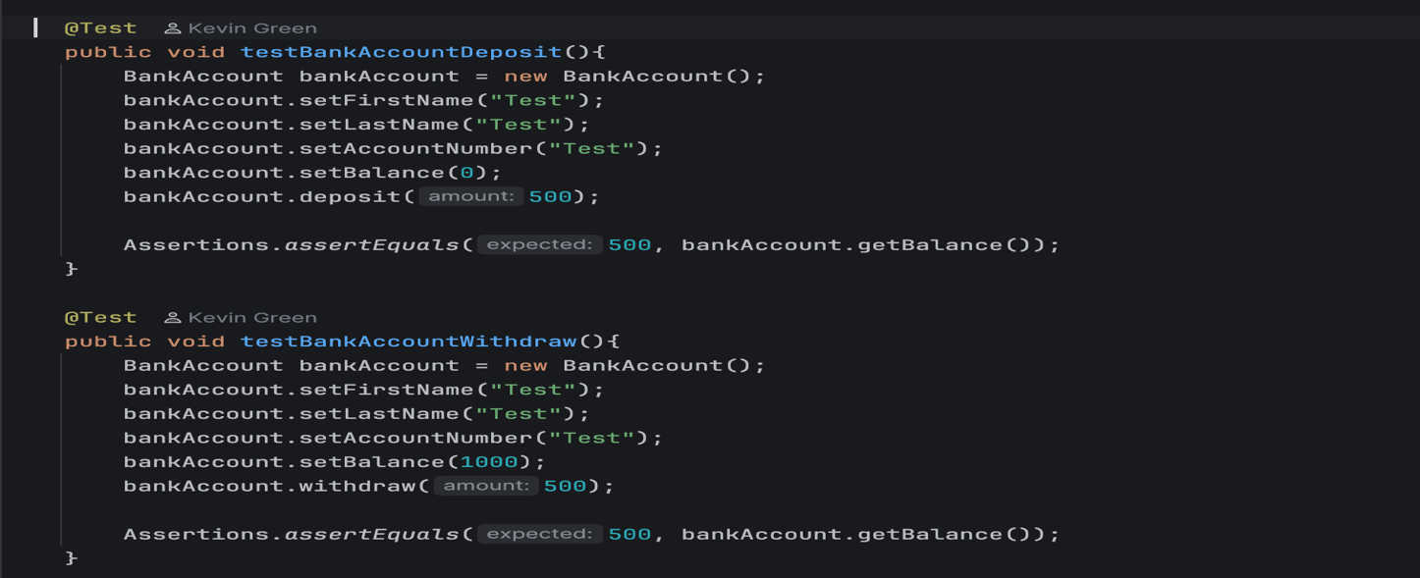

- This project is a simple banking application. It has two different classes, BankAccount and SavingsAccount. BankAccount is the super class that has all the basic methods such as, getters and setters, a withdraw method, and a deposit method. The SavingsAccount is the sub class that extends BankAccount. It can use all BankAccounts methods plus an additional method to apply an interest rate they get on all deposits, and a method to increase the interest rate every 6 months. It also uses junit for testing purposes to test that all the created methods work as expected.

- Only dependency needed was the junit dependency which I got from https://mvnrepository.com/artifact/org.junit.jupiter/junit-jupiter-api/6.0.2

- Never really had many problems, figuring out how to write the insufficient funds test took a bit more thinking, but once I changed it to return a Boolean it was easy.

