# Veiligheid

In technische systemen staat veiligheid voorop en daarom wordt in dit onderzoek uitgebreid gekeken naar de handhaving van de veiligheid.

## Wat is veiligheid?

Wanneer er wordt gesproken over veiligheid wordt er bedoelt dat er geen mensen en objecten worden beschadigd.

## Hoe wordt de veiligheid gehandhaafd?

Om de veiligheid te handhaven zal er een veiligheidszone worden ingericht. Dit omvat het maximale bereik van de robotarm inclusief de lengte van het batje en een kleine buffer. Deze veiligheidszone zal worden aangegeven met een lint. Deze grenzen mogen niet worden overschreden door onbevoegden.

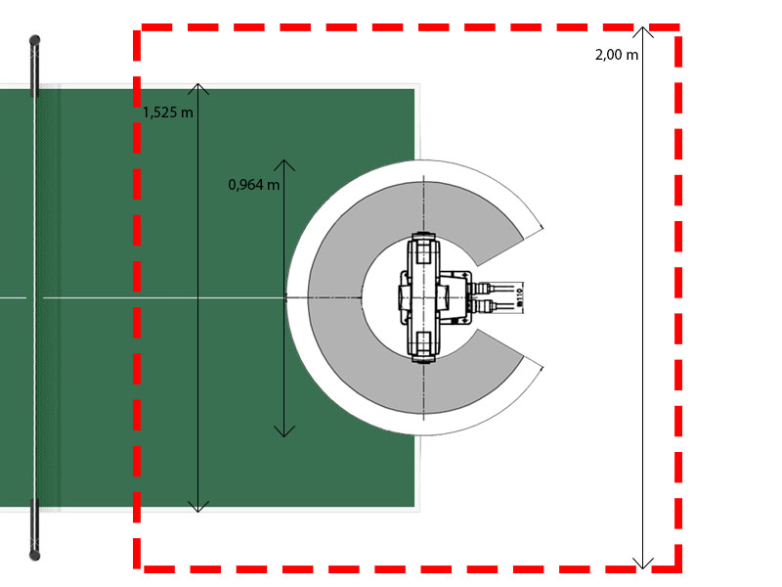

Het is op dit moment voor de robot mogelijk om bewegingen te maken waarbij hij zichzelf kan raken. Om de veiligheid voor de robot te garanderen zullen er grenzen worden vastgesteld voor de draaihoeken van de scharnieren.

Om de veiligheid en de werking van de hardware te garanderen zal er elke dag een ‘Daily inspection’ worden gehouden en elke maand een ‘Periodic inspection’. Voor deze twee inspecties zijn twee lijsten met verschillende onderdelen die worden gecontroleerd. Deze lijsten staan in de bijlagen.

## Daily inspection items

Carry out the daily inspections with the procedures given in Table 5-1.

Table 5-1： Daily inspection items (details)

|  |  |  |  |
| --- | --- | --- | --- |
| Procedure | Inspection item (details) | | Remedies |
| Before turning power ON (Check the following items before turning the power ON.) | | | |
| 1 | Are any of the robot installation bolts loose? | (Visual) | Securely tighten the bolts. |
| 2 | Are any of the cover tightening screws loose? | (Visual) | Securely tighten the screws. |
| 3 | Are any of the hand installation bolts loose? | (Visual) | Securely tighten the bolts |
| 4 | Is the power supply cable securely connected? | (Visual) | Securely connect. |
| 5 | Is the machine cable between the robot and controller securely connected?  (Visual) | | Securely connect. |
| 6 | Are there any cracks, foreign contamination or obstacles on the robot and controller cover? | | Replace with a new part, or take remedial measures. |
| 7 | Is any grease leaking from the robot arm? | (Visual) | After cleaning, replenish the grease. |
| 8 | Is there any abnormality in the pneumatic system? Are there any air leaks, drain clogging or hose damage? Is the air source normal?  (Visual) | | Drain the drainage, and remedy the air leaks (replace the part). |
| After turning the power ON (Turn the power ON while monitoring the robot.) | | | |
| 1 | Is there any abnormal motion or abnormal noise when the power is turned ON? | | Follow the troubleshooting section. |
| During operation (try running with an original program) | | | |
| 1 | Check whether the movement points are deviated? Check the following points if there is any deviation.  1. Are any installation bolts loose?   1. Are any hand installation section bolts loose? 2. Are the positions of the jigs other than the robot deviated? 3. If the positional deviation cannot be corrected, refer to "Troubleshooting", check and remedy. | | Follow the troubleshooting section. |
| 2 | Is there any abnormal motion or abnormal noise? | (Visual) | Follow the troubleshooting section. |

## Periodic inspection

Carry out periodic inspection with the procedures given in Table 5-2.

Table 5-2 ： Periodic inspection items (details)

|  |  |  |
| --- | --- | --- |
| Procedure | Inspection item (details) | Remedies |
| Monthly inspection items | | |
| 1 | Are any of the bolts or screws on the robot arm loose? | Securely tighten the bolts. |
| 2 | Are any of the connector fixing screws or terminal block terminal screws loose? | Securely tighten the screws. |
| 3 | Remove the cover at each section, and check the cables for wear damage and adherence of foreign matter. | Check and eliminate the cause.  If the cables are severely damaged, contact the Mitsubishi Service Department. |
| 3-month inspection items | | |
| 1 | Is the timing belt tension abnormal? | If the timing belt is loose or too tense, adjust it. |
| 6-month inspection items | | |
| 1 | Is the friction at the timing belt teeth severe? | If the teeth are missing or severe friction is found, replace the timing belt. |
| Yearly inspection items | | |
| 1 | Replace the backup battery in the robot arm. | Exchange it referring to "5.3.5 Replacing the backup battery" on page 54. |
| 2-year inspection items | | |
| 1 | Lubricate the grease at the harmonic reduction gears for each axis. | Lublicate it referring to "5.3.4 Lubrication" on page  52. |