{{ generation_date }}s

Page 1 of 2

NRQZ ID: {{ nrqz_ids }}

{{ case.contact.name }}

{{ case.applicant.name }}

{{ case.applicant.street }}

{{ case.applicant.city }}, {{ case.applicant.state}} {{ case.applicant.zipcode }}

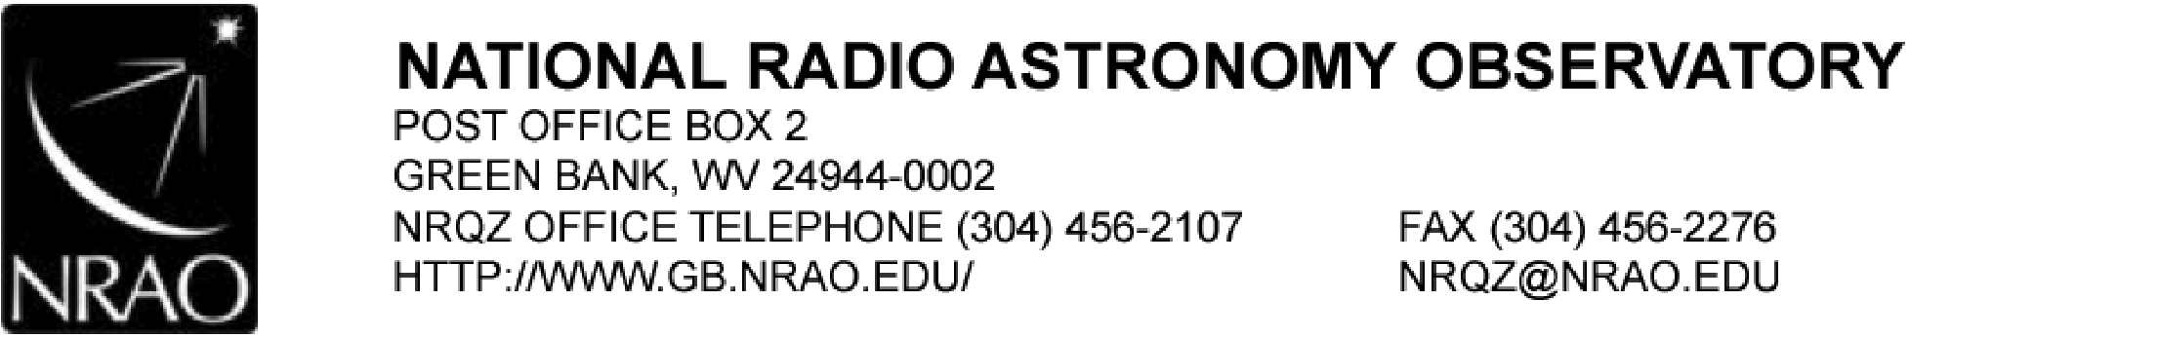

|  |  |
| --- | --- |
|  |  |
| Application Reason/Purpose | Prior coordination notification |
| File Number | {{ case.case_num }} |
| Applicant Name | {{ case.applicant.name }} |
| Call Sign | {{ case.facilities.values_list(“call_sign”, flat=True).distinct() | list }} |
| Site Name or Loc | See attached “Site Specific Data” |
| Previous NRAO Coordination No. |  |
| Current NRAO Coordination No. | TODO |

Dear {{ case.applicant.name }}:

The National Radio Quiet Zone (NRQZ) has evaluated these facilities to determine the interference impact on our highly sensitive radio astronomy operations.

The NRQZ Office requests that:

1. The FCC places the Special Condition on the Station License.
2. This Letter of Concurrence be attached to the FCC application.
3. The applicant provides the NRQZ Office with notice of its official filing with the FCC per section 47CFR1.924 (a) (2).

The National Radio Astronomy Observatory (NRAO) site located at Green Bank, Pocahontas County, WV, {% if case.nrao_approval == True %}

has no objection to this frequency assignment

{% elif case.nrao_approval == False %}

has no objection to this frequency assignment provided the special conditions are met.

{% for facility in case.facilities.filter(nrao_approval=False) %}

**Special Condition: {{ facility.site_name }} ({{ facility.main_beam_orientation }})**

The National Radio Astronomy Observatory (NRAO), Green Bank, WV, objects unless the Applicant's license is restricted to an Effective Radiated Power (ERP) of {{ facility.nrao_aerpd | round(2) }} Watts per {{ facility.bandwidth }} MHz unit bandwidth at Azimuth {{ facility.az_bearing }} degrees True.

{% endfor %}

{% else %}

**NRAO APPROVAL NEEDS TO BE FILLED OUT IN DATABASE!**

{% endif %}

The Sugar Grove Research Station, the former Naval Radio Research Observatory (NRRO), located at Sugar Grove, Pendleton County, WV {% if case.sgrs_approval == True %}

has no objections to this frequency assignment.

{% elif case.sgrs_approval == False %}

has no objection to this frequency assignment provided the special conditions are met.

{% for facility in case.facilities.filter(nrao_approval=False) %}

**Special Condition: {{ facility.site_name }} ({{ facility.main_beam_orientation }})**

TODO

{% endfor %}

{% else %}

**SGRS APPROVAL NEEDS TO BE FILLED OUT IN DATABASE!**

{% endif %}

This letter constitutes coordination of assignment in the National Radio Quiet Zone as required by the FCC Rules and Regulations 47CFR1.924.

If I may be of assistance, please feel free to contact me.

Sincerest regards,



{{ nrqz_admin_name }}

NRQZ Office Administrator

PWW:pww

cc: TODO

file: TODO

Attachments: Final Engineering

Site Specific Data* Amended Frequency Low (MHz)

This concurrence remains valid provided the data contained within is consistent with the applicant’s filing at the Commission. Any discrepancy in system parameters, such as geographical coordinates (Latitude, Longitude, AMSL), antenna height above ground level (AGL), antenna gains or directivity (orientation), channel (operating frequency or frequency bands), emission type, and power requires re-coordination. If the Commission has questions regarding the validity of this or any concurrence, please direct inquiries to nrqz@nrao.edu or 304-456-2107.



|  |  |  |  |  |  |  |  |  |  |  |  |  |
| --- | --- | --- | --- | --- | --- | --- | --- | --- | --- | --- | --- | --- |
| NRQZ ID | Site Name | Max TX  Pwr  (W) | Max  Gain  (dBi) | Antenna Model | Lat N  NAD83 | Lon W NAD83 | MSL (m) | AGL (m) | Freq Low (MHz) | Bandwidth BW (MHz) | AZ ° True | Mechanical-DT |
| {%tr for facility in case.facilities.all() %} | | | | | | | | | | | | |
| {{ facility.nrqz_id }} | {{ facility.site_name }} | {{ facility.max_tx_power }} | {{ facility.max_gain }} | {{ facility.antenna_model_number }} | {{ facility.latitude }} | {{ facility.longitude }} | {{ facility.amsl }} | {{ facility.agl }} | {{ facility.freq_low }} | {{ facility.freq_high }} | {{ facility.az_bearing }} | {{ facility.mechanical_downtilt }} |
| {%tr endfor %} | | | | | | | | | | | | |