Pultruding Tests

Washing Tests
Removing labels
2021-11-24
Four 2-L bottles and one 24-oz bottle and one 500-mL bottle of Pepsi. One 16-oz bottle of Wild Cherry Pepsi. The 2-L bottles referenced NY, while the others did not reference a location.

Heated 2 L water to 70 C and poured into sink. Added 200 ml baking soda (Arm & Hammer). Stirred.

Held long end of label away from bottle to expose adhesive. Adhesive started to yield within seconds. Gently pulled back as it gave way.

Heat made labels easy to remove in one piece. Only one of the 7 bottles left label behind on adhesive. Suggest slicing label 2 cm from one’s dominant side of adhesive. Baking soda at 100 ml per 1000 ml water has no discernable effect, even after 5 min soaking. Directly applied baking soda and scrubbed. also no effect, except to slightly roughen surface of adhesive.

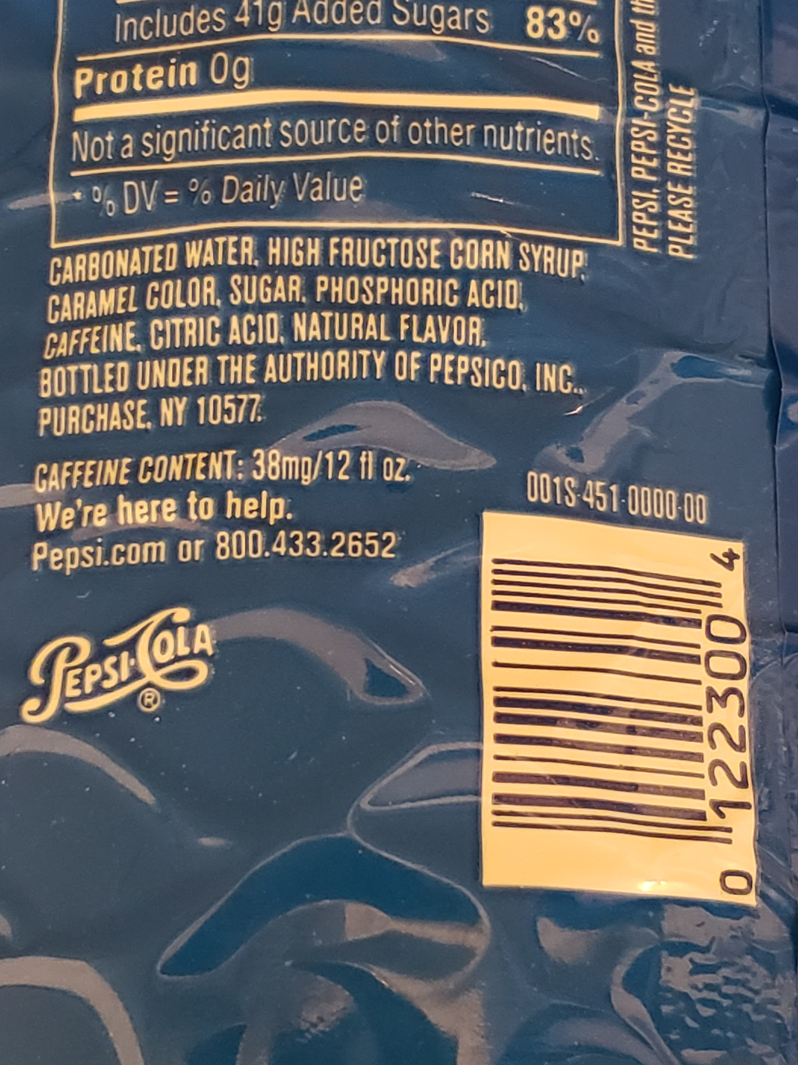

2021-11-26
The answer might be not to remove the adhesive. Looks like the nozzle might remove some of it in the nozzle, and the remainder can be wiped off after the filament passes the cooling fan. Downside is that it clogs the nozzle.

Here is my nozzle after about 6 bottles. Only the first two bottles had all the reside cleaned off.
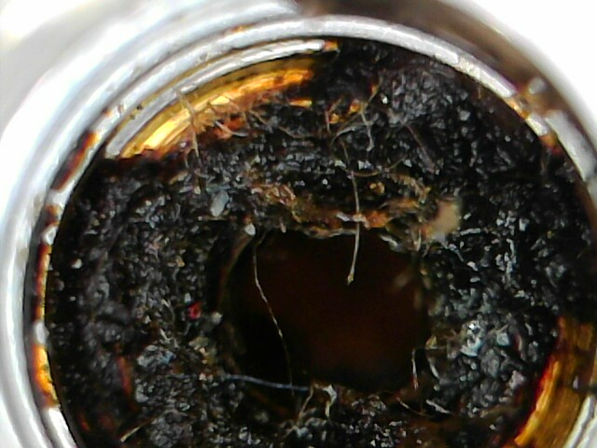
Here it is after “cleaning”. Turns out there’s still considerable debris in the center.
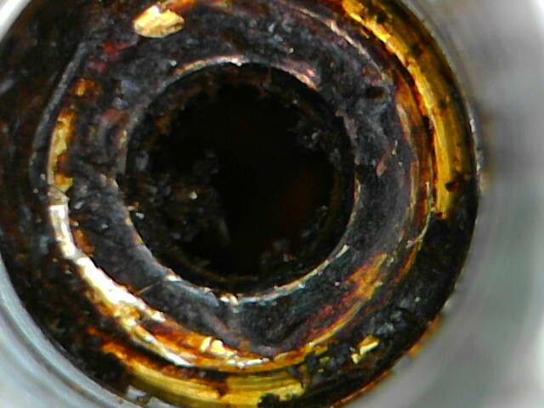
Checking it again after three bottles which did not have residue removed (Bottles #3, 4 and 5):

