Member-signup
https://dev.gem.properties/member-signup
- on click register button sing up page crash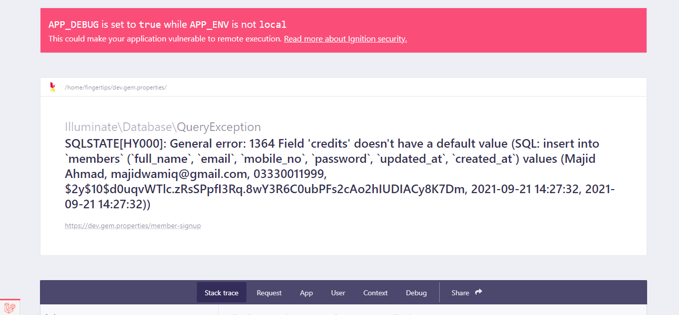
Demo-admin
- As I refresh my login page after first time login to page. it will show email and pass word which is already save.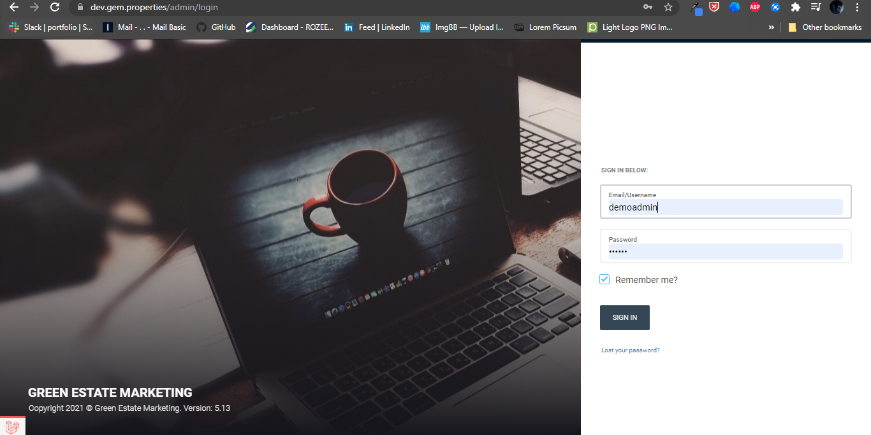

- https://dev.gem.properties/admin/posts
login->press blog button-> select posts option ->edit any one post from list->in detail section->in content heading->press add media button->filter dropdown not work properly (shows all content after applying filter).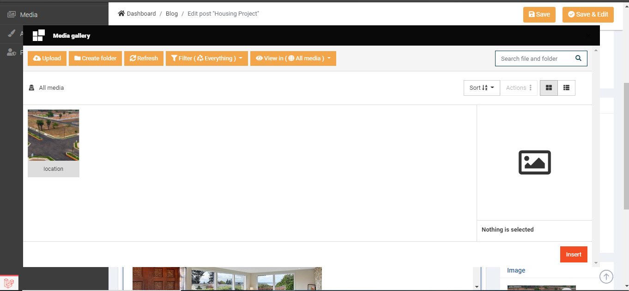

- login->press blog button-> select posts option ->edit any one post from list->in detail section->in content heading->add media button->after searching the other content become invisible.

- login->press blog button-> select posts option ->edit any one post from list->in detail section->in content heading->press shortcode button->give error of authentication of its some points. Such as payment form, google map, YouTube video, blogpost and contact form.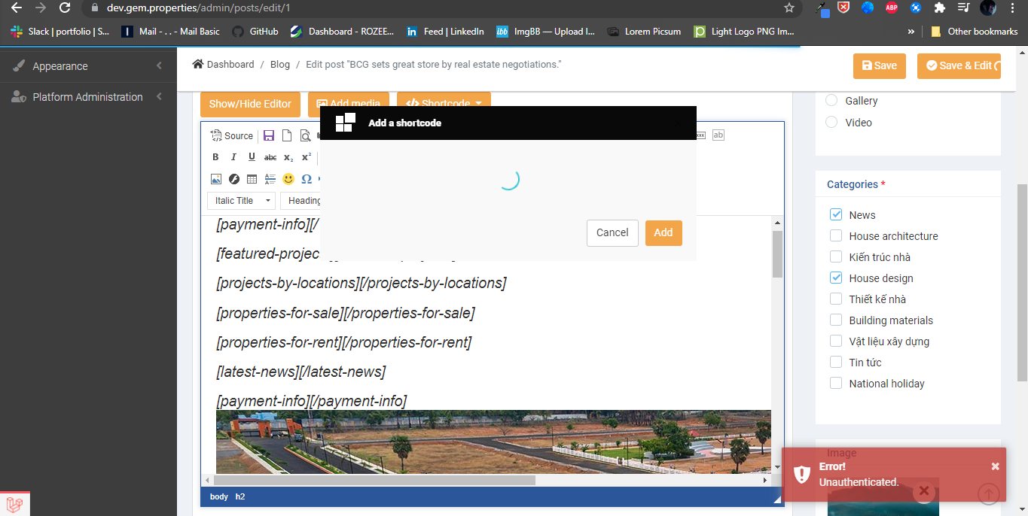

- login->press blog button->select posts option->press export button->select excel option->not download the file and page loading continually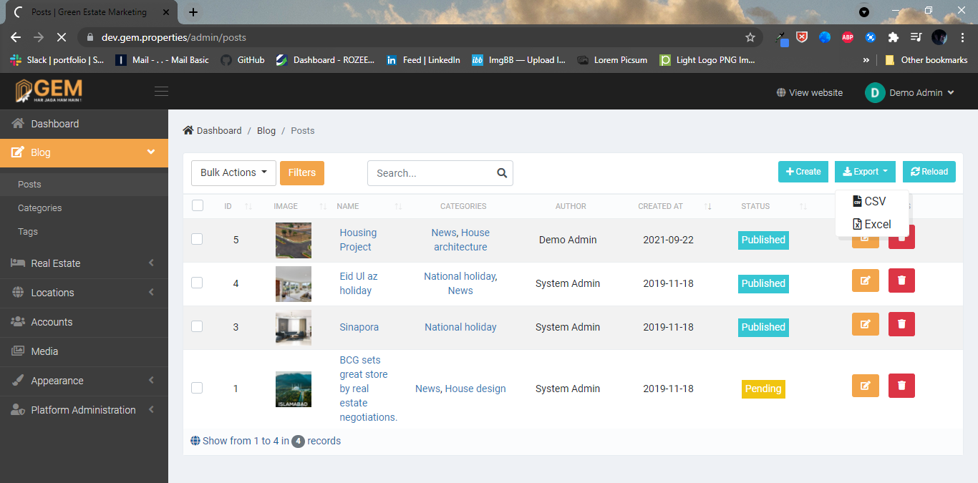

- login->press blog button-> select categories option ->press filters button->a new search bar appears->enter any keyword->press apply button-> it shows all data along with searching keyword.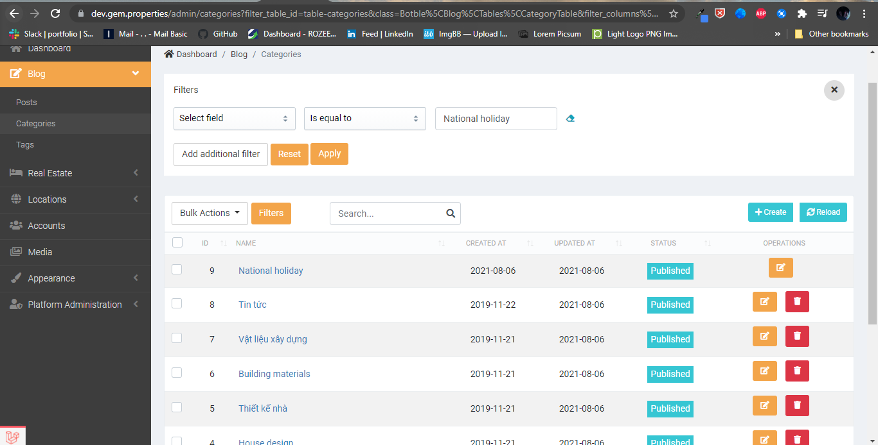

- login->press Real Estate button-> select properties option->press head-phone icon it navigates to dashboard.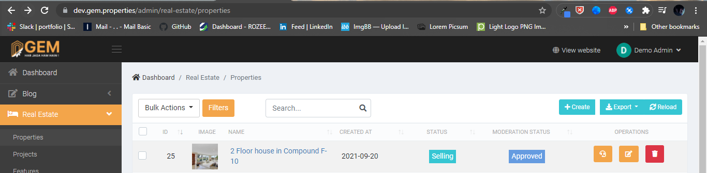

- login->press Real Estate button-> select properties option->press create buttonFill title fieldpress save buttonpage crash. https://dev.gem.properties/admin/real-estate/properties/create
Note: in this scenario machine location is turned off
If user on his machine location than it creates or save a new property in list
\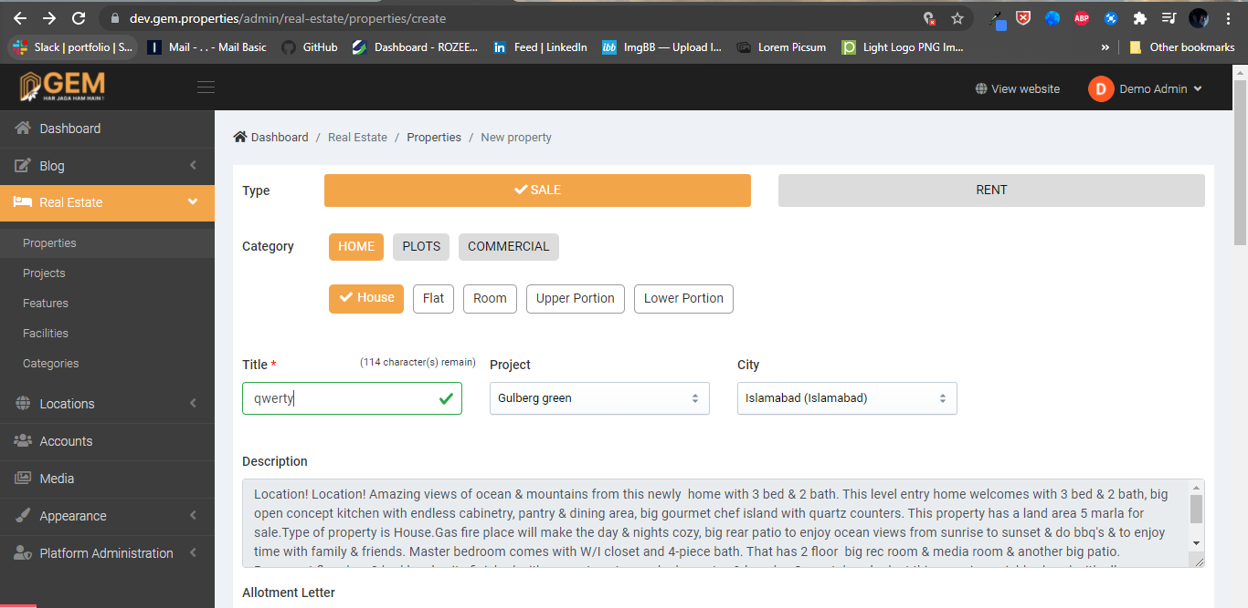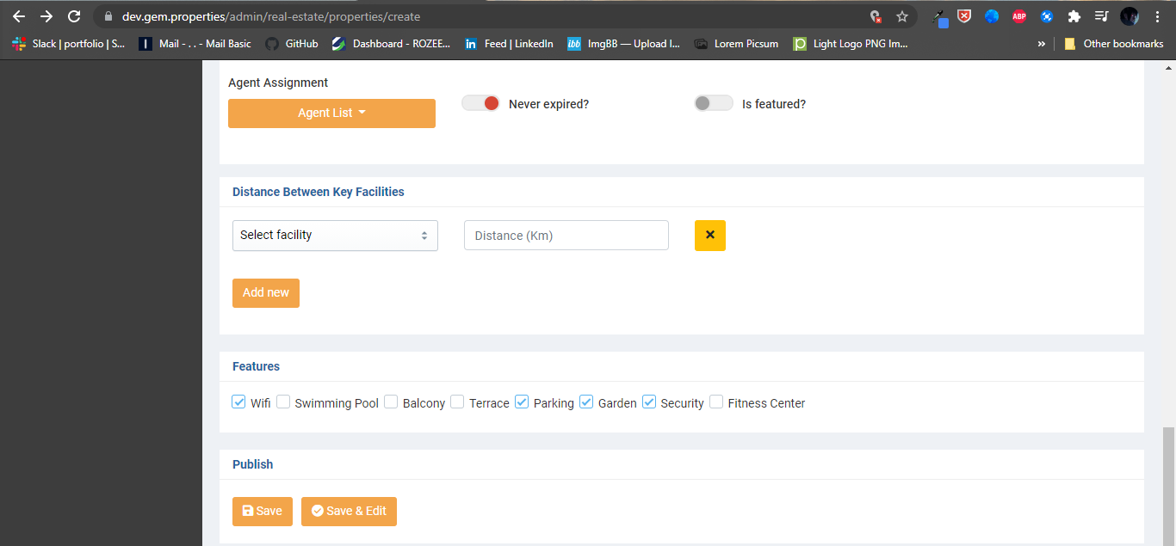
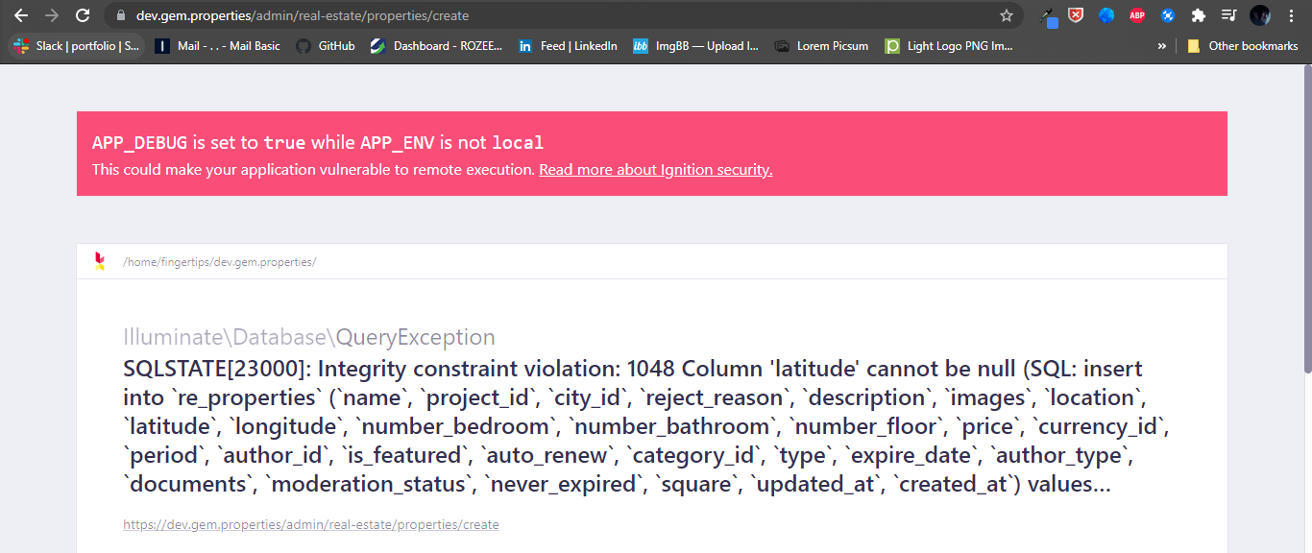
- login->press Real Estate button-> select properties option-> select excel option->not download the file and page loading continually

- login->press Real Estate button-> select properties option->select any property from listselect type salewithout any changes click on save button page crash

https://dev.gem.properties/admin/real-estate/properties/edit/34
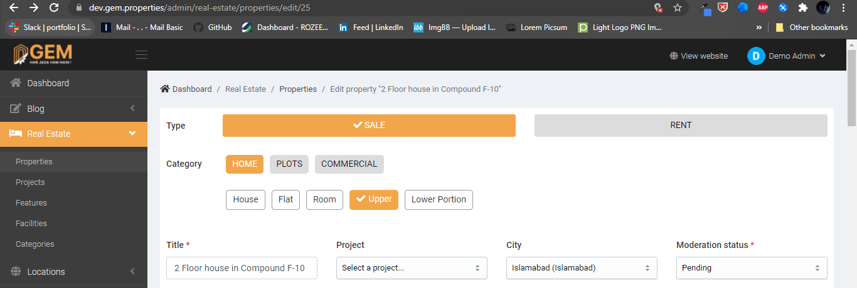

- login->press Real Estate button-> select properties option->select any property from list (I selected 25# edit mood)->select type salechange category from house to upper portion->press save buttonpage crash

make any changes it causes crash of page


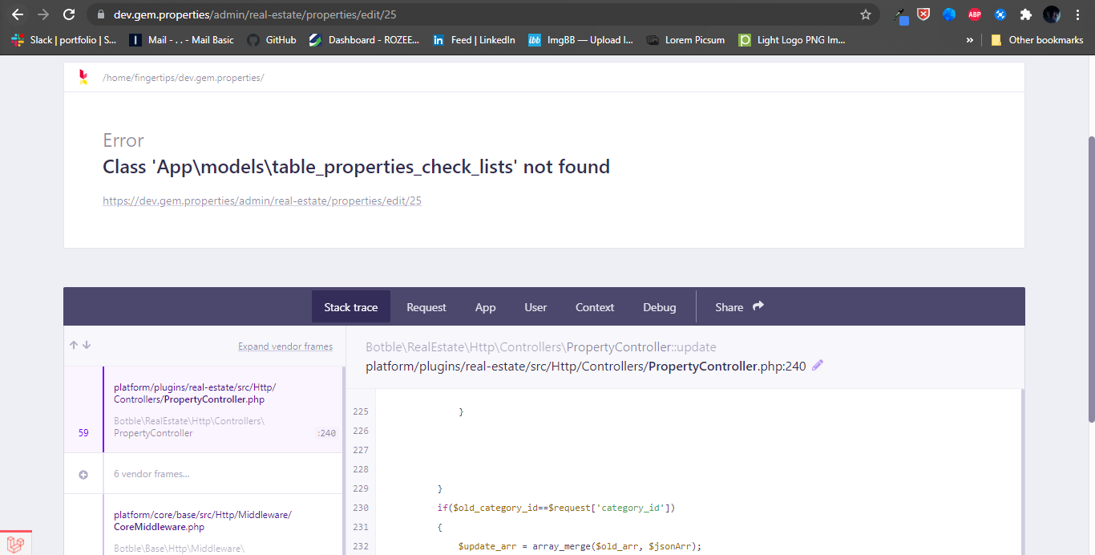

- login->press Real Estate button-> select properties option->select any property from list ->select type rentwithout any changes click on save button page crash.
https://dev.gem.properties/admin/real-estate/properties/edit/33

- login->press Real Estate button-> select properties option->select any property from list ->select type salewithout any changes click on save & edit button page crash.
https://dev.gem.properties/admin/real-estate/properties/edit/33
- login->press Real Estate button-> select properties option->select any property from list to edit->page popup a message of checklistselect check box press enterautomatically select two boxes of sub category

https://dev.gem.properties/admin/real-estate/properties/edit/35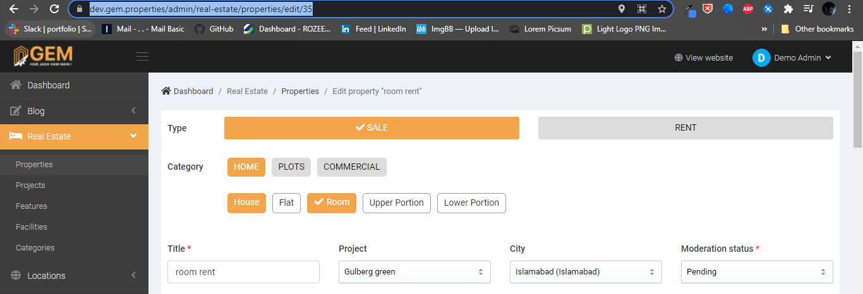

- login->press Real Estate button-> select properties option->select the property (room if admin edit the room property) from list to edit->page popup a message of checklistselect check box press enterautomatically select two boxes of sub category
https://dev.gem.properties/admin/real-estate/properties/edit/14