Table of Contents
Evaluation 2
Testing to Inform Evaluation 2
Success of the Solution 5
Evaluation of solution against success criteria for client 5
Evaluation of solution against success criteria for programmer 12
Evidence of usability features 14
Maintenance and Future Development 15
Future Development of Usability features 15
Maintenance issues and limitations 16

Evaluation

Testing to Inform Evaluation
For post development testing, I have put together a selection of tasks that the user could want to do whilst using the solution. I have documented these tasks with a test plan below. The data that I selected to test the scenario has been included during the iterative development stage. All the data that will be used here has been tested independently and all subset of the task has been tested independently as well.
Test | Scenario | Justification | Data Used
1 | Teacher wants to log into the system | All teacher options and data access should not be accessible by students. So, by having an account system with secure log ins stops students being able to access data they should not be able to access | Username: JessicaBowman  Password: ABC123
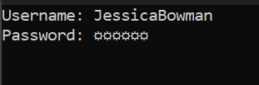
Functionality of hiding the password as the user types it keeps accounts secure from other people
Clear space to enter username and password which is similar to other systems that exist

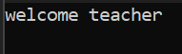
This shows evidence of functionality by entering the teacher menu
Robustness is tested in iteration 0.5 where the log in scripts is fully tested
2 | Student wants to log into the system | The system contains information about the student that the student will want access to. Such as being able to view their timetable or attendance. So, by having an account system and a log in system it allows for students to log into their own space and view only their data | Username: RobertCole  Password: ABC123
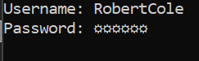
Functionality of hiding the password as the user types it keeps accounts secure from other people

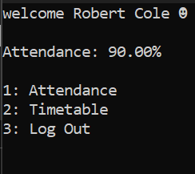
Robustness is tested in iteration 0.5 where the log in scripts is fully tested
This shows evidence of functionality by entering the student menu
3 | Students wanting to be able to view their timetable | Each student needs to know which class they have an when it is so that they can cross reference that with their attendance marks or if they need to know what lessons they have and when. | Username: RobertCole  Password: ABC123  Select menu option 2
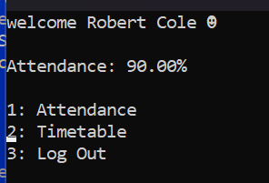
The cursor is constrained to the menu options demonstrating robustness of the solution
Menu controlled by the arrow keys and then pressing enter to select making it more user friendly and convenient to use

Timetable is displayed in a way which is easy for the user to interpret and get the data they need easily

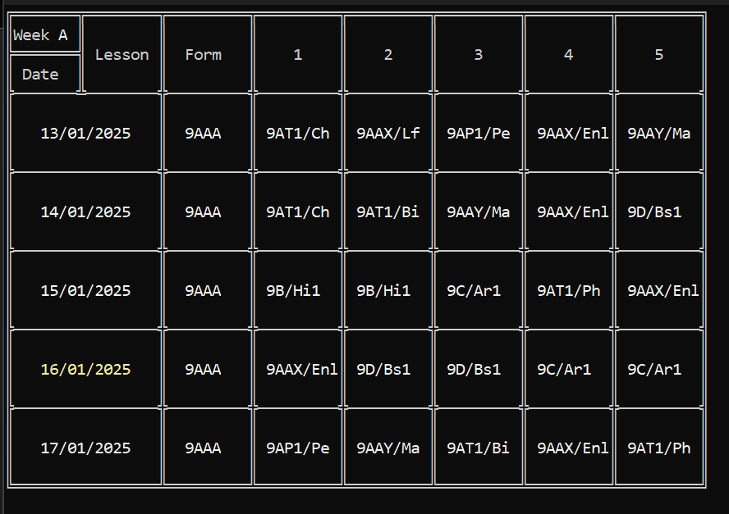
Highlights the current date to allow the user to easily see which day it is
Functionality of the menu displayed as it displays the timetable

Success of the Solution
In creating a solution for my client, the following success criteria identified below were met. However, in developing the solution there were many complex success criteria that had to be met by the programmer to start working on the client success criteria

Evaluation of solution against success criteria for client
Success Criteria (Feature) | Description | Measurable Criterion | Criteria met? | Evidence of test data | Future Development
Log in page | This will ask for a username and password, and depending on the status logins in depends on the tasks offered to the user | This is measurable as it should either out put a menu for a teacher or a menu for the student.  When a teacher logs in the functions will be:  View Attendance  Take a Register  And if it was a student that logs in the list of functions will be:  Attendance attendance percent: …%  Timetable | This criterion is partially met the login works for both student and teachers. And the student menu is complete with a slight redesign of the UI. But there is no teacher menu | Iterations 0.5 and 6 shows the log in section working. Iteration 4 shows the students menu. And iteration 5 shows that there is no teacher menu yet. This evidence shows that the criterion was partially met as some of the procedures were completed but not all. | . The menu design will be like the students though and can be easily completed using the create menu script demonstrated in iteration 0.8
Display register | This will display a list of student’s names in that class with a choice of marks next to each student name | This is measurable as it should return all the students in the class with the options to mark them here or not  This will display the names in a format of  Name1 - [present] [absent with reason] [absent no reason] [late]  Name2 - [present] [absent with reason] [absent no reason] [late]…  And there will be the same number of names as students in that class which can be check by outputting the number of students in that class from the class file.  With a mark all as present, mark all as absent and a submit button at the bottom | This criterion was not met. | There is no evidence to show as no part of this section has been developed yet. | For future development the craeteMenu script could be modified to allow for horizontal menus in different designs
Select different register marks | This will allow the user to move the cursor between each student and each option and selecting the option just by moving on to the next student. And them submitting by pressing enter | The end display will look like  Name1 - [present] [absent with reason] [absent no reason] [late]  Name2 - [present] [absent with reason] [absent no reason] [late]  Name3 - [present] [absent with reason] [absent no reason] [late]…  [Mark All Present]  [Mark All Absent]  [Submit Register] | This criterion was not met | There is no evidence to support any of this being done | A menu linking script could be used along with the cursor grid script to control the cursor in such a way that allows you to select each different option for each student. Or you can run it in a while loop storing the results in a 2d array corresponding to the position selected and looping until submit register is pressed
Display teacher timetable | This will display the teachers timetable and highlight the current lesson that it is. The timetable will be displayed with day along the top with date above that and then lesson numbers down the sides | The data will look something like this with classes and the highlighted one is the current lesson that they need to do the register for | This criterion was partially met. The timetable was redesigned to having the dates down the side and the lesson number on the top. Also, the timetable was never complete for the teacher but is very similar to the student one. | Evidence in Iteration 0.6 shows that the generic timetable can be written out. Then evidence in iteration 4 for the students shows that code has been developed to fill the timetable with data. This shows that it is partially met
   | 01/07/24 | 02/07/2024 | 03/07/2024 | 04/07/2024 | 05/07/2024
  1 | 9AT1/Ch | 9AT2/Ch | 9AT1/Ch | 9BT1/Ch
  2 | 9AT1/Ch | 9AT1/Bi |  | 9BT1/Ch
  3 |  | 9AT1/Bi | 9BT1/Bi |  | 9AT1/Ch
  4 | 9BT1/Ch |  | 9AT1/Bi | 9BT2/Bi
  5 | 9BT2/Bi |  |  | 9AT2/Ch
Search for student | There will be a search bar provided that can be typed into and will display all students which are close to what they have typed in, they can then navigate down to each student and then select the student | Search for name: R  Robert Cole  Rita Gamble  Rose Roberts  Robert Flores…  This will refine as more letters are typed in, the selected one can then be selected by pressing enter and you will enter the overview for that student | This criterion has not been met | No evidence | For future development you can do a repeat until loop with a read key for the user typing in. Then using a string subset search, search student file for that substring. Then write all results storing in an array that resets itself each time a key is pressed. If the Down key is pressed then convert the list of names into a menu which the user can then select from
Display form attendance | This will display a list of all students in that teachers form with their attendance next to their name and colour coded to highlight the students that need talking to. This will also be ordered from lowest attendance to highest attendance | Wendell Hulslander – 75%  Marylouise Brooks – 83%  Rose Roberts – 92%  Tracy Boyd – 95%  Velma Morris – 99.8%  This is what an example set of data should look like when looking through the teachers for attendance | This criterion is not met | There is no evidence for any section of this. | For future development a search can be done on the students file to get all the students in that form and then an insertion sort can be done to sort the students by attendance with lowest attendance first with the student id attached to the attendance using parallel arrays. This array can then be iterated through with a case statement to control the colour of the text to write all students and their attendance
attendance certificate | This will display all information about the student’s attendance. Including percentages and a table of where they missed lesson. | Name: Wendell Hulslander  Attendance: 75%  Authorised absences attendance: 89%  Unauthorised absences: 14  Lates: 12  …  IT should show the students name, attendance, attendance with authorised absences, unauthorised absences, and late marks. It should then also have a table and all marks in that year. | This criterion was partially met, all the independent sections of this can be easily achieved. The table can be easily written using writeDesign. The filling for the table is already done and the information at the top is just read and write from the file | In the iteration 4 there is demonstration of a timetable being filled in. There is also evidence of being able to read and write attendance data. And iteration 4 shows an example of writing out the timetable. These pieces of evidence show that some of this is done just scattered in other places | For future development reads and writes from the attendance file can display the information at the top. writeDesign can be used to draw the table. A similar algorithm to the one that fills out the students timetable can be used for the attendance marks. And then using a cursor grid you can use the output of that to change the start date in the timetable by a week at a time
   | 1 | 2 | 3 | 4 | 5
  05/07/24 | /\ | L | A | L | /\
  04/07/24 | L | A | A | /\ | /\
  03/07/24 | /\ | /\ | /\ | /\ | L
  02/07/24 | L | /\ | A | /\ | /\
  01/07/24 | L | L | A | /\ | A
Attendance timetable (teacher) | This will provide a timetable for the student with all register marks for a ser period | Name: Erica Hernandez  …  This is a display of all register marks between two time periods set by the teacher when entering this view | This criterion was not met | There is no evidence for anything similar to this except the timetable layout shown in iteration 4. Showing that this criterion was not met due to it lacking the critical information | This would be a copy of what the student would see, so I would make a procedure in writeDesigns to write the attendance data starting on a certain date for a week
   | 1 | 2 | 3 | 4 | 5
  05/07/24 | /\ | L | A | L | /\
  04/07/24 | L | A | /\ | /\ | /\
  03/07/24 | /\ | /\ | /\ | /\ | L
  02/07/24 | L | /\ | A | /\ | /\
  01/07/24 | /\ | /\ | /\ | /\ | A
Attendance overview (teacher) | This will bring up a display giving the name of the student, overall attendance, Attendance with authorised absences, Unauthorised absences, and late marks | Name: Ann Lavoie  Attendance: 85%  Authorised absences attendance: 93%  Unauthorised absences: 4  Lates: 2 | This criterion is not met | No evidence | For future development, after selecting Attendance overview in the students’ options after the teacher searched for that student. Just read the attendance data for that student and write it out
Attendance overview (student) | This will give the student a quick overview of all their attendance statistics, which is the same as what the teacher will see. It will display overall attendance, attendance with authorised absences, Unauthorised absences, and late marks | Attendance: 89%  Authorised absences attendance: 96.4%  Unauthorised absences: 1  Lates: 0 | This criterion is partially met. In the main menu for the students, that students overall attendance is displayed at the top. | Evidence for this is shown in iteration 4. There is no entire overview for the students attendance. But in the main menu it does show overall attendance. This shows that some of the data can be outputted thus proving the criterion was partially met | For future development a sub menu in the students attendance menu, then another option called “attendance overview” which then reads from the attendance file and displays the information out.
Attendance timetable (student) | This will give the student a week-by-week view of all their register marks over the entire year which they can cycle through to see when they have missed lessons or were marked as late | This will display a 5-day week from Monday to Friday with lesson numbers as headings and it will display all the register marks that have been marked down that week. So, from my example data one example could look like this. | This criterion was not met | No evidence | For future development reads and writes from the attendance file can display the information at the top. writeDesign can be used to draw the table. A similar algorithm to the one that fills out the students timetable can be used for the attendance marks. And then using a cursor grid you can use the output of that to change the start date in the timetable by a week at a time
   | 1 | 2 | 3 | 4 | 5
  01/07/24 | /\ | L | A | /\ | /\
  02/07/24 | /\ | /\ | /\ | /\ | /\
  03/07/24 | /\ | /\ | /\ | /\ | L
  04/07/24 | /\ | /\ | /\ | /\ | /\
  05/07/24 | /\ | /\ | /\ | /\ | A
Timetable (student) | This will give the student a week-by-week view of their timetable and their classes. This is so they can cross reference what register marks they got for which class | This will display a 5-day week from Monday to Friday with lesson numbers as headings and it will display the class that the student has at that time. So, from my example data one example could look like this. | This criterion has been fully met. In the students menu they can select timetable to view their timetable for that week. | This is shown in iteration 4 which shows evidence of the students timetable being displayed in the correct format. Which proves this to be fully met by outputting the same result | n/a
   | 1 | 2 | 3 | 4 | 5
  01/07/24 | 9AT1/Bi | 9AT1/Bi | 9D/Dt1 | 9D/Dt1 | 9AAX/Ma
  02/07/24 | 9AAX/Ma | 9ABY/En | 9B/Fr1 | 9C/Pe1 | 9C/Pe1
  03/07/24 | 9BAY/Lf | 9A/Dr1 | 9ABY/En | 9B/Fr1 | 9B/Fr1
  04/07/24 | 9D/Dt1 | 9AAX/Ma | 9A/Dr1 | 9AT1/Bi | 9ABY/En
  05/07/24 | 9ABY/En | 9C/Pe1 | 9D/Dt1 | 9AAX/Ma | 9A/Dr1

Evaluation of solution against success criteria for programmer
Success Criteria (Feature) | Description | Measurable Criterion | Criteria met? | Evidence of test data | Future Developments
Developing a data set with as much realism as possible | Develop a set a of data that mimics a real set of data from a school. This data set is also very large to see if my solution can cope with large amounts of data like it will have to in school | The data should match what my client has access to and uses for the registration system. So, it is based on client feedback. There should also be large amount data, which is more than 100 students, full timetable with multiple class on at each time | When the CreateFiles.pas  A series of files is created with all the data that is needed for the system to operate. I asked my client to review the data, and she said that this data is adequate for the system | Iteration 1 shows evidence of all the data being generated correctly for each file which then got approved by my client | n/a
Developing a general sort and search algorithm for the files | Each file should be able to be sorted and searched. Since .dta file are stored using records you have to read each file into a different variable with the structure that matches that of the file being read | This is measurable by having a single search and sort algorithm that each file can use to search and sort itself. | This criterion was also fully met. The class structure that I developed for each file uses inheritance to have a generic search and sort algorithm which each child class having specific methods to extract the data from the files | Iteration 2 shows the development of my class structure for the files. It also shows the sorts and searchers working showing the criterion is fully met. | n/a
Developing a module to control the cursor | Due to the solution containing controls with the cursor it was necessary to develop a universal script which could be used to control the cursor in many ways such as bounding conditions, different step sizes and starting positions. | With a single call, using parameters to control step size, boundaries and start position the script should allow the user to control the cursor for as long as they need until the press enter to submit. The script should then return the new position of the cursor for further handling | This criterion was fully met. When the script runs it allows full control of the cursor using the arrow keys and exits when you press enter | Iteration 0.7 for the cursor control. And to prove it returns the correct position there is evidence in iteration 0.8 with a menu to help prove it. The evidence shows the success of this criterion by demonstrating that the user can control the cursor. | n/a
Develop a method to design an interface in a text file and then have that written to the screen | Due to the solution containing needing to contain many tables and other graphical forms it would be simpler to design an outline of the structure in a text file and have that written to the screen to then be filled with data | Design a method to take a text file or file path to a text file and write out the design inside the text file with a method to add delays into the output to add an animation effect | This criterion was fully met. When I call the writeDesign script passing in a path to a text file, it will read that and display it to the screen | Iteration 0.6 shows evidence for creating a UI procedure. This shows this by running different designs through it proving it can do any text file thus meaning the criterion | n/a

Evidence of usability features
Usability feature | Description | Evidence | Success of usability feature
Clear way to enter username and password | Clear box for the user to type in the username and then immediately type in the password | Evidence of this is shown in iteration 0.5 which is where I test in depth the login screen | This was very effective as a useability feature due to the design of it mimicking most other forms of login making it intuitive to use and operate.
Hidden password on entry | The password is hidden while being typed | Evidence for this is also shown in iteration 0.5 | This was also very effective as a usability feature as it hides the password so other people cannot log into your account
Easy keyboard navigation within the menus | Allows you to use the keyboard to navigate the menu without the cursor being able to leave the menu | Evidence for this is shown in iteration 0.7 where I test the menu creation and the cursor moving functions which is tested in more depth in iteration 0.6 | This was partially effective as a usability feature as while it is nice and intuitive to use the most common method of navigation is the mouse making it only partially effective
Tabular designs | Displaying information in a table or in similar forms such as graphical. | Evidence of this is shown in both iteration 0.6 and iteration 4 which also shows evidence of the table being completed | This was a very effective usability feature as the most common way of represent data is in a table due to it being easy to read and interpret for everyone making this a highly effective usability feature
Predictive searching | As you type to search for a student or something else it provides a list of everything that matches so far | There is no evidence for this feature as I ran out of time to develop it | This is not a very effective usability feature as it doesn’t exist so it can not be used machining it ineffective
Colour coded attendance | In the overview of attendance for a form group the students will be sorted from lowest to highest attendance and colour coded to show if any actions should be taken | There is no evidence for this feature as I ran out of time to develop it | This is not a very effective usability feature as it doesn’t exist so it can not be used machining it ineffective

Maintenance and Future Development

Future Development of Usability features
Usability feature | Description | Future development plan
Predictive searching | As you type to search for a student or something else it provides a list of everything that matches so far | I plan to develop this in such a way where you can press the down arrow key, and it swaps to you selecting from the list of names rather then you having to press enter and then it brings you to a new page of options before resetting. I also need to adjust some parts in in the cursor grid or redesign it to act more like a switchboard for key binds where you can match any key to a list of functions.
Colour coded attendance | In the overview of attendance for a form group the students will be sorted from lowest to highest attendance and colour coded to show if any actions should be taken | I plan to actually develop it so it can actually be used as a feature.

Maintenance issues and limitations
The way in which I designed the solution is modular by nature, almost everything is contained in another unit (another script which hold procedures) making it very modular and easy to expand on. The file class structure while modular and new child classes can easily be created for new files b y copying and pasting the existing ones and just changing the record type. However, I use static array types to reference the data in the file which only during testing is going to be of a fixed size and in deployment will be constantly changing. This does cause limitations with expandability of the files but in future development a linked list could be used instead of an array so the data can be stored in a dynamic structure rather than a static one which causes limitations. I also use linear searches for all of my searches, which for some cases is necessary as multiple pieces of data can match the search criteria, but as the data size grows this will take longer and longer to complete, so in the future some searches can be binary searches to cut down on search time

