Table of Contents
Iterations 3
Evidence Explanations 3
Iteration 0 – Library Declarations 5
Aim 5
Iteration 0.1 – Linear Search 6
Code 6
Testing 7
Iteration 0.2 – Binary Search 13
Code 13
Testing 15
Iteration 0.3 – Search Script 20
Code 20
Testing 21
Iteration 0.4 – Loading 23
Code 23
Testing 27
Iteration 0.5 – Log In 32
Code 32
Testing 35
Iteration 0.6 – Write Design 36
Code 36
Testing 37
Iteration 0.7 – Cursor Grid 40
Code 40
Testing 43
Iteration 0.8 – Create Menu 47
Code 47
Testing 48
Review 52
Iteration 1 – Creating Initial Data 53
Aim 53
Code 54
Testing 81
Review 93
Iteration 2 – Class Structure 94
Aim 94
Code 95
Super Class 95
Child Class 100
Testing 105
Review 115
Iteration 4 – Student’s Menu 116
Aim 116
Code 117
Testing 123
Review 129
Iteration 5 – Teacher’s Menu 130
Aim 130
Code 131
Testing 132
Review 133
Iteration 6 – Main Program 134
Aim 134
Code 135
Testing 138
Review 140

Iterations

Evidence Explanations
Evidence | Explanation
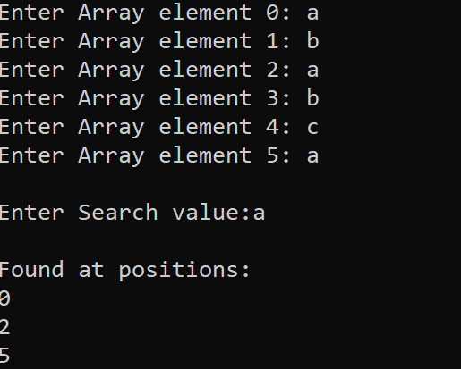 | Any black screen background with writing indicates the program running and a user having to interact with the program. Such as here I inputted the array elements. This will be what the user sees.
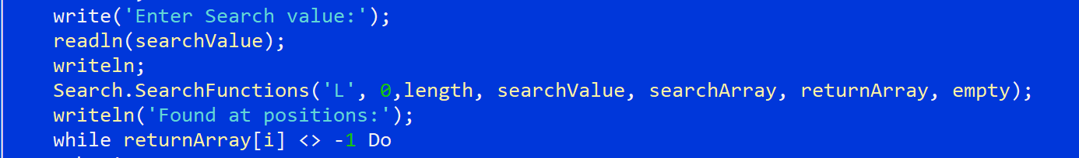 | Any blue backgrounds show evidence taken from the integrated development environment (IDE). This is done due to the way the program is written and that units cannot be run on their own. They need a program to run them so I will develop short scripts dedicated to running tests on the unit. The IDE view will be used to show evidence of what is run.
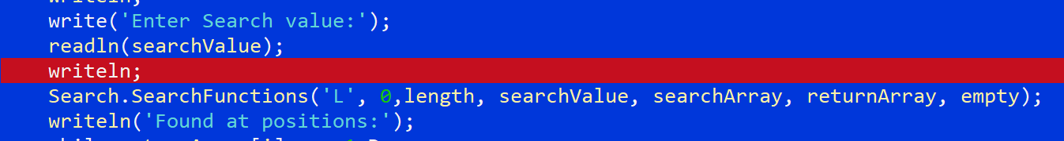 | Any code with a red bar represents that line having a breakpoint at that line, so during execution the program will pause there, this will be used to show execution of some units with no output and are just filler units to link two other units into one unit
 | Code with a purple bar represents a hit breakpoint during execution. So the computer is currently paused just before executing this line but it has executed all previous code
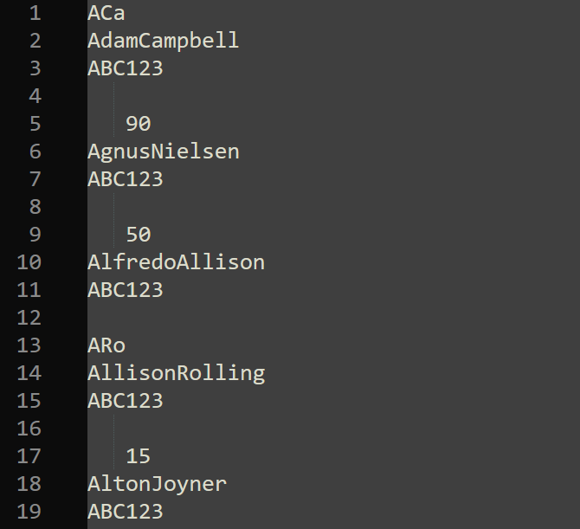 | Any pieces of evidence looking like this comes form notepad and is the output of a file in a text form so I can check that it is working. All data will be explained

Iteration 0 – Library Declarations

Aim
The aim of this iteration is to declare libraries which will be used throughout the rest of the program to shorten code in the main scripts that will be run. The user never sees this, but it will be useful for me as the programmer to get more done and keep code tidy and easy to read for any future developments.

Iteration 0.1 – Linear Search

Code
UNIT LinearSearch;
INTERFACE
USES CRT, SYSUTILS;

PROCEDURE LinearSearchFunction(low, high : LONGINT; searchValue : STRING; UserArray : ARRAY OF STRING; var returnArray : ARRAY OF INTEGER);
VAR
i, a, checkItem: LONGINT;

IMPLEMENTATION

PROCEDURE LinearSearchFunction(low, high : LONGINT; searchValue : STRING; UserArray : ARRAY OF STRING; var returnArray : ARRAY OF INTEGER);
VAR
i, a, checkItem: LONGINT;
BEGIN
i := -1;
a := 0;
// iterate through each element until end of array
REPEAT
i := i+1;
// add all positions for values matching the search value to a different array
if userArray[i] = searchValue THEN
begin
returnArray[a] := i;
a := a + 1;
end;
UNTIL (i = high);
END;

END.

Testing
Test Number | Program and Iteration | Purpose of test | Data to be entered | Expected result | Actual results | Amendments
0.1.1 | Linear search unit,  Iteration 0 | To test the linear search works on small arrays of integers finding a singular value | Array = [5,4,3,2,1,0]  Search value = 4 | 1 | 1 | n/a
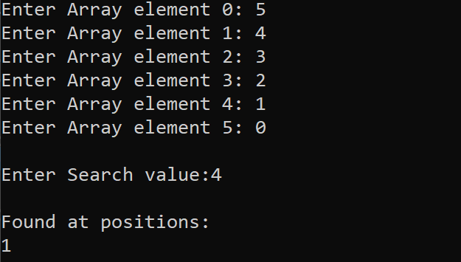
0.1.2 | Linear search unit,  Iteration 0 | Testing if it can find the first value in the array of integers | Array = [5,4,3,2,1,0]  Search value = 5 | 0 | 0 | n/a
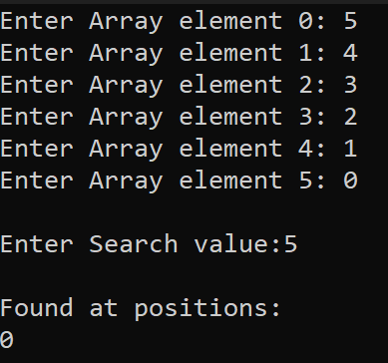
0.1.3 | Linear search unit,  Iteration 0 | Testing if it can find the last value in the array of integers | Array = [5,4,3,2,1,0]  Search value = 0 | 5 | 5 | n/a
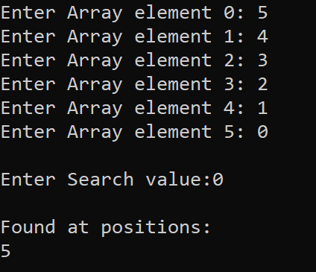
0.1.4 | Linear search unit,  Iteration 0 | Testing to return null if no values found | Array = [5,4,3,2,1,0]  Search value = 6 | n/a | n/a | n/a
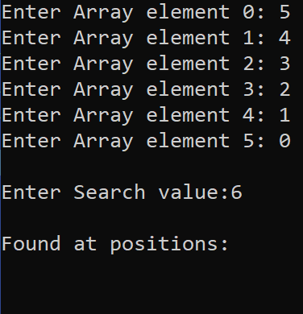

0.1.5 | Linear search unit,  Iteration 0 | Testing to see if it gets all positions for all pieces of found integers | Array = [2,2,2,1,1,0]  Search value = 1 | 3  4 | 3  4 | n/a
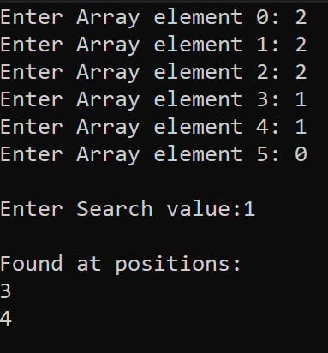
0.1.6 | Linear search unit,  Iteration 0 | Testing if it can find a string value in the array | Array = [a,b,c,d,e,f]  Search value = c | 2 | 2 | n/a
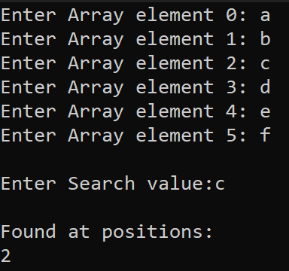

0.1.7 | Linear search unit,  Iteration 0 | Testing if it can find the first value in the array | Array = [a,b,c,d,e,f]  Search value = a | 0 | 0 | n/a
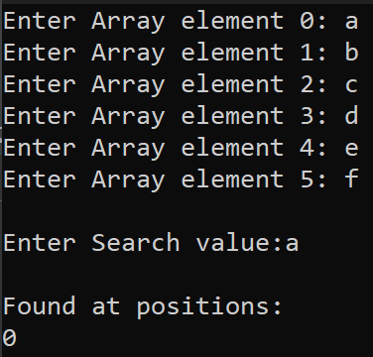
0.1.8 | Linear search unit,  Iteration 0 | Testing if it can find the last value in the array | Array = [a,b,c,d,e,f]  Search value = f | 5 | 5 | n/a
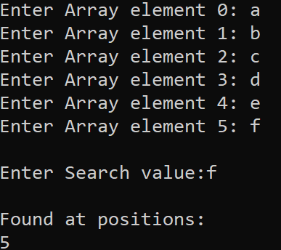

0.1.9 | Linear search unit,  Iteration 0 | Testing to return null if string is not found in array | Array = [a,b,c,d,e,f]  Search value = g | n/a | n/a | n/a
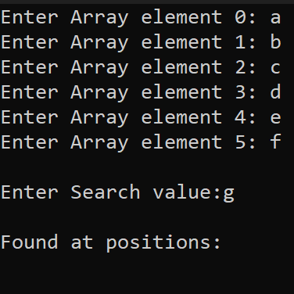
0.1.10 | Linear search unit,  Iteration 0 | Testing to see if it gets all positions for all pieces of found strings | Array = [a,b,a,b,c,a]  Search value = a | 0  2  5 | 0  2  5 | n/a
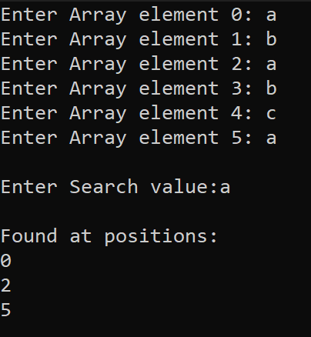

0.1.11 | Linear search unit,  Iteration 0 | Testing if it can search based on different lengths | Array = [9,8,7,6,5,4,3,2,1,0]  Search value = 8 | 1 | 1 | n/a
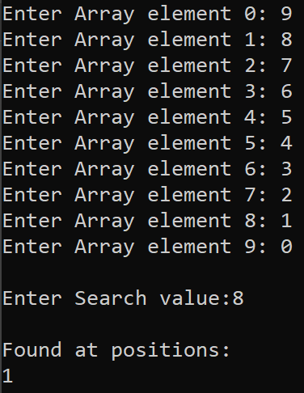

Iteration 0.2 – Binary Search

Code
UNIT BinarySearch;
INTERFACE

USES CRT, SYSUTILS;

PROCEDURE BinarySearchFunction(var UserArray, returnArray : ARRAY OF INTEGER; low, high, searchValue: INTEGER);
VAR
i, mid : LONGINT;
shouldEnd : BOOLEAN;

IMPLEMENTATION

PROCEDURE BinarySearchFunction(var UserArray, returnArray : ARRAY OF INTEGER; low, high, searchValue: INTEGER);
VAR
i, mid : LONGINT;
shouldEnd : BOOLEAN;
BEGIN
REPEAT
mid := (low+high)DIV 2;
IF UserArray[mid] <> searchValue THEN
BEGIN
IF UserArray[mid] < searchValue THEN
BEGIN
low := mid +1;
END
ELSE
BEGIN
high := mid -1;
END;
END
ELSE
BEGIN
returnArray[0] := mid;
shouldEnd := true;
END;
UNTIL (shouldEnd = true) OR (low > high);

END;

END.

Testing
Test Number | Program and Iteration | Purpose of test | Data to be entered | Expected result | Actual results | Amendments
0.2.1 | Binary search unit,  Iteration 0 | To test the Binary search works on small arrays of integers finding a singular value | Array = [2,3,4,5,6,7]  Search value = 4 | 2 | 2 | n/a
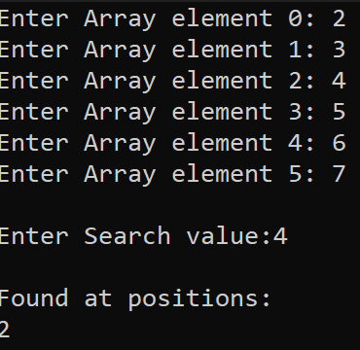
0.2.2 | Binary search unit,  Iteration 0 | Testing if it can find the first value in the array of integers | Array = [2,3,4,5,6,7]  Search value = 2 | 0 | 0 | n/a
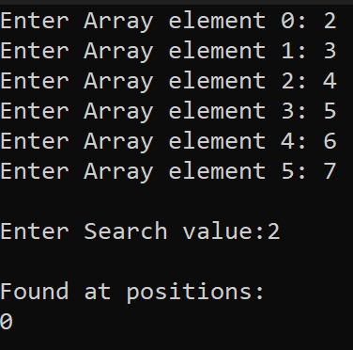
0.2.3 | Binary search unit,  Iteration 0 | Testing if it can find the last value in the array of integers | Array = [2,3,4,5,6,7]  Search value = 7 | 7 | 5 | n/a
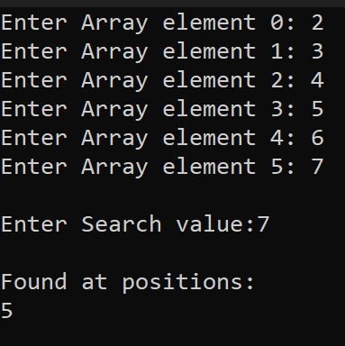
0.2.4 | Binary search unit,  Iteration 0 | Testing it correctly returning a null output if no value is found | Array = [2,3,4,5,6,7]  Search value = 8 | n/a | n/a | n/a
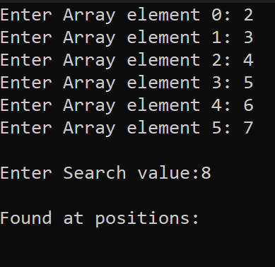

0.2.5 | Binary search unit,  Iteration 0 | Testing it correctly returning a null output if no value is found | Array = [2,3,4,5,6,7]  Search value = a | n/a | n/a | n/a
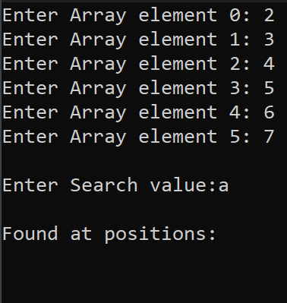
0.2.6 | Binary search unit,  Iteration 0 | Testing if it can find a string value in the array | Array = [a,b,c,d,e,f]  Search value = c | 2 | 2 | n/a
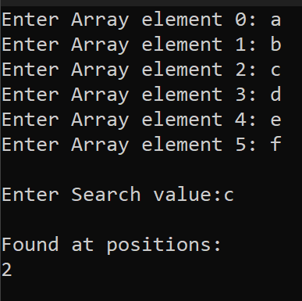

0.2.7 | Binary search unit,  Iteration 0 | Testing if it can find the first value in the array | Array = [a,b,c,d,e,f]  Search value = a | 0 | 0 | n/a
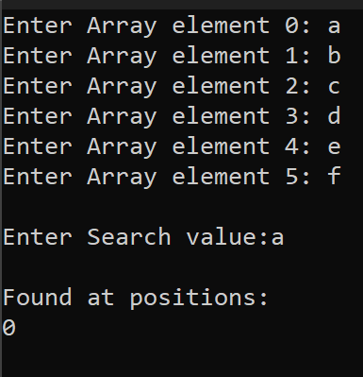
0.2.8 | Binary search unit,  Iteration 0 | Testing if it can find the last value in the array | Array = [a,b,c,d,e,f]  Search value = f | 5 | 5 | n/a
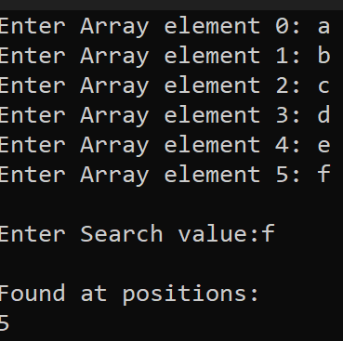

0.2.9 | Binary search unit,  Iteration 0 | Testing if it can search based on different lengths | Array = [2,3,4,5,6,7,8,9]  Search value = 8 | 6 | 6 | n/a
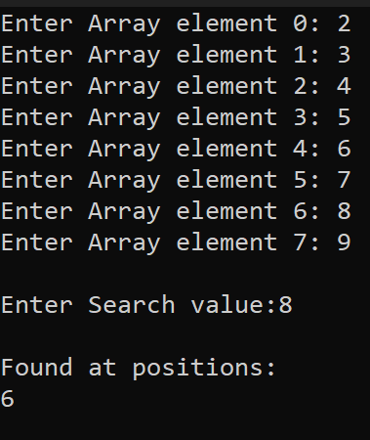

Iteration 0.3 – Search Script

Code
UNIT Search;

INTERFACE
USES CRT, SYSUTILS, BinarySearch, LinearSearch;

PROCEDURE SearchFunctions(SearchType : CHAR; min, max : LONGINT; findValue : STRING; UserArray : ARRAY OF STRING; var returnArray : ARRAY OF LONGINT);

IMPLEMENTATION

PROCEDURE SearchFunctions(SearchType : CHAR; min, max : LONGINT; findValue : STRING; UserArray : ARRAY OF STRING; var returnArray : ARRAY OF LONGINT);
BEGIN
IF SearchType = 'L' THEN
//call linear search and just pass through the data
LinearSearch.LinearSearchFunction(min,max,FindValue,UserArray,returnArray);
IF SearchType = 'B' THEN
//call linear search and just pass through the data
BinarySearch.BinarySearchFunction(min,max, FindValue,UserArray,returnArray);
END;

END.

Testing
Test Number | Program and Iteration | Purpose of test | Data to be entered | Expected result | Actual results | Amendments
0.3.1 | Searching  Iteration 0 | To test it enters the linear search script if a linear search is selected | L as the character in the call  Breakpoint at the call to the linear search | Purple bar on the linear search function | Purple bar on the linear search function | None

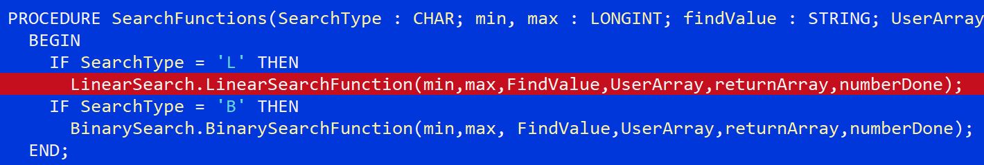

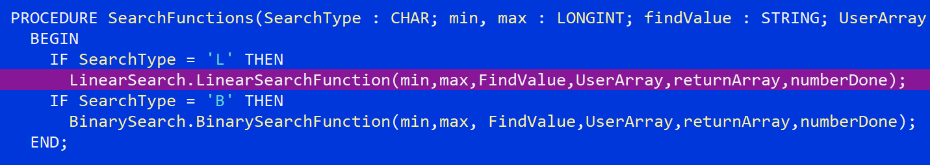

0.3.2 | Searching  Iteration 0 | To test it enters the binary search script if a linear search is selected | B as the character in the call  Breakpoint at the call to the binary search | Purple bar on the binary search function | Purple bar on the binary search function | None

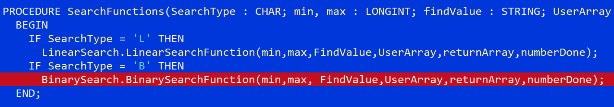

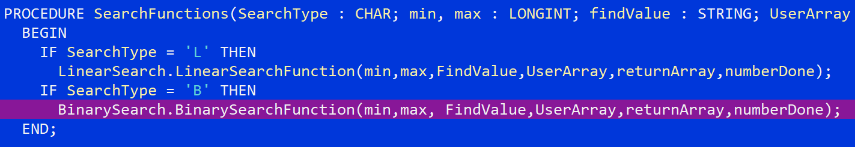

Iteration 0.4 – Loading

Code
unit loading;
interface

uses sysutils, vputils, crt, math;
//pointer to point to the value outside of this script
type rPtr = ^real;

//pre declaration of functions and procedures
function loadingText(p : pointer) : LONGINT;
var a : LONGINT;
function loadingBar(p : pointer) : LONGINT;
var percentComplete : REAL;
b,c,completeBars,uncompleteBars : LONGINT;
procedure StartLoading(loadingType : CHAR; var percentIn : real);
procedure EndLoading;
procedure silentKillLoading;

implementation
//the symbol for a spinning symbol
const LoadingSymbols : ARRAY[1..4] OF CHAR = ('/',#196,'\','|');

//local script variables
var loadingDone : BOOLEAN;
percentDone : real;
percentPtr : rptr;
startRunTime, endRunTime : TDateTime;

//the basic loading text with the spinning line
function loadingText(p : pointer) : LONGINT;
var a : LONGINT;
begin
HideCursor;
a := 1;
ClrScr;
while (not loadingDone) DO
Begin
//write loading and symbol from the array
WRITELN('Loading... ' + LoadingSymbols[a]);
//progress the loading symbol
a := a+1;
if a > 4 THEN
a := 1;
//every 0.1 secons update
Delay(100);
//rewrite the whole line
GoToXY(1,1);
DelLine;
end;

end;

function loadingBar(p : pointer) : LONGINT;
var percentComplete : REAL;
b,c,d,completeBars,uncompleteBars : LONGINT;
begin
HideCursor;
ClrScr;
//sets up the empty progress bar
Write('Progress ',#185);
for c:= 0 TO 20 DO
write(#176);
write(#204);
percentDone := 0.0*100;
completeBars := 0;

while not loadingDone DO
begin
//write the new percentage in
gotoxy(33,1);
Write(percentDone:4:0,'%');
//gets the percent done from the main script by using a series of pointers
//to point to a value outside this script so the procedure does not have to be recalled
percentDone := (percentPtr^)*100;
//calculate number of bars to fill
completeBars := floor((percentPtr^)*20);
gotoxy(11,1);
//draw that number of bars
for d := 0 to completeBars DO
write(#219);
end;
end;

procedure StartLoading(loadingType : CHAR; var percentIn : real);
begin
startRunTime := Time;
loadingDone := false;
//set a pointer to the memory address to the memory location of the percent
//memory location passed in at the start
percentPtr := @percentIn;

//choose a loading type and start a new thread so it runs in parallel
if loadingType = 'L' THEN
VPBeginThread(loadingText,1,nil)
else if loadingType = 'P' THEN
VPBeginThread(loadingBar,1,nil);
End;

procedure EndLoading;
begin
//kill the thread to stop it running
KillThread(1);
loadingDone := true;
//show end messages
WRITELN('Done!');
endRunTime := Time;
Delay(500);
ClrScr;
//state how long it took
writeln('Time elapsed: ',TimeToStr(endRunTime - startRunTime));
ShowCursor;
end;

procedure silentKillLoading;
begin
//stops the bar without displaying anything back to the user when done
KillThread(1);
loadingDone := true;
ClrScr;
ShowCursor;
end;
end.

Testing
Test Number | Program and Iteration | Purpose of test | Data to be entered | Expected result | Actual results | Amendments
0.4.1 | Loading  Iteration 0 | To test the loading text with spinning symbol works | None needed to be entered | Loading…(with changing symbol next to it) | Correct result | n/a


0.4.2 | Loading  Iteration 0 | To test the Done screen shows up when finished | None needed to be entered | Done! ☻ | Done! ☻ | n/a

0.4.3 | Loading  Iteration 0 | To test the loading time is correct | Delay of 15 seconds used | Time elapsed: 00:00:15 | Time elapsed: 00:00:15 | n/a
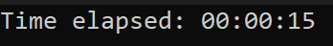
0.4.4 | Loading  Iteration 0 | Silent kill ends the loading with no output | No data needs to be entered | Blank screen | Blank screen | n/a
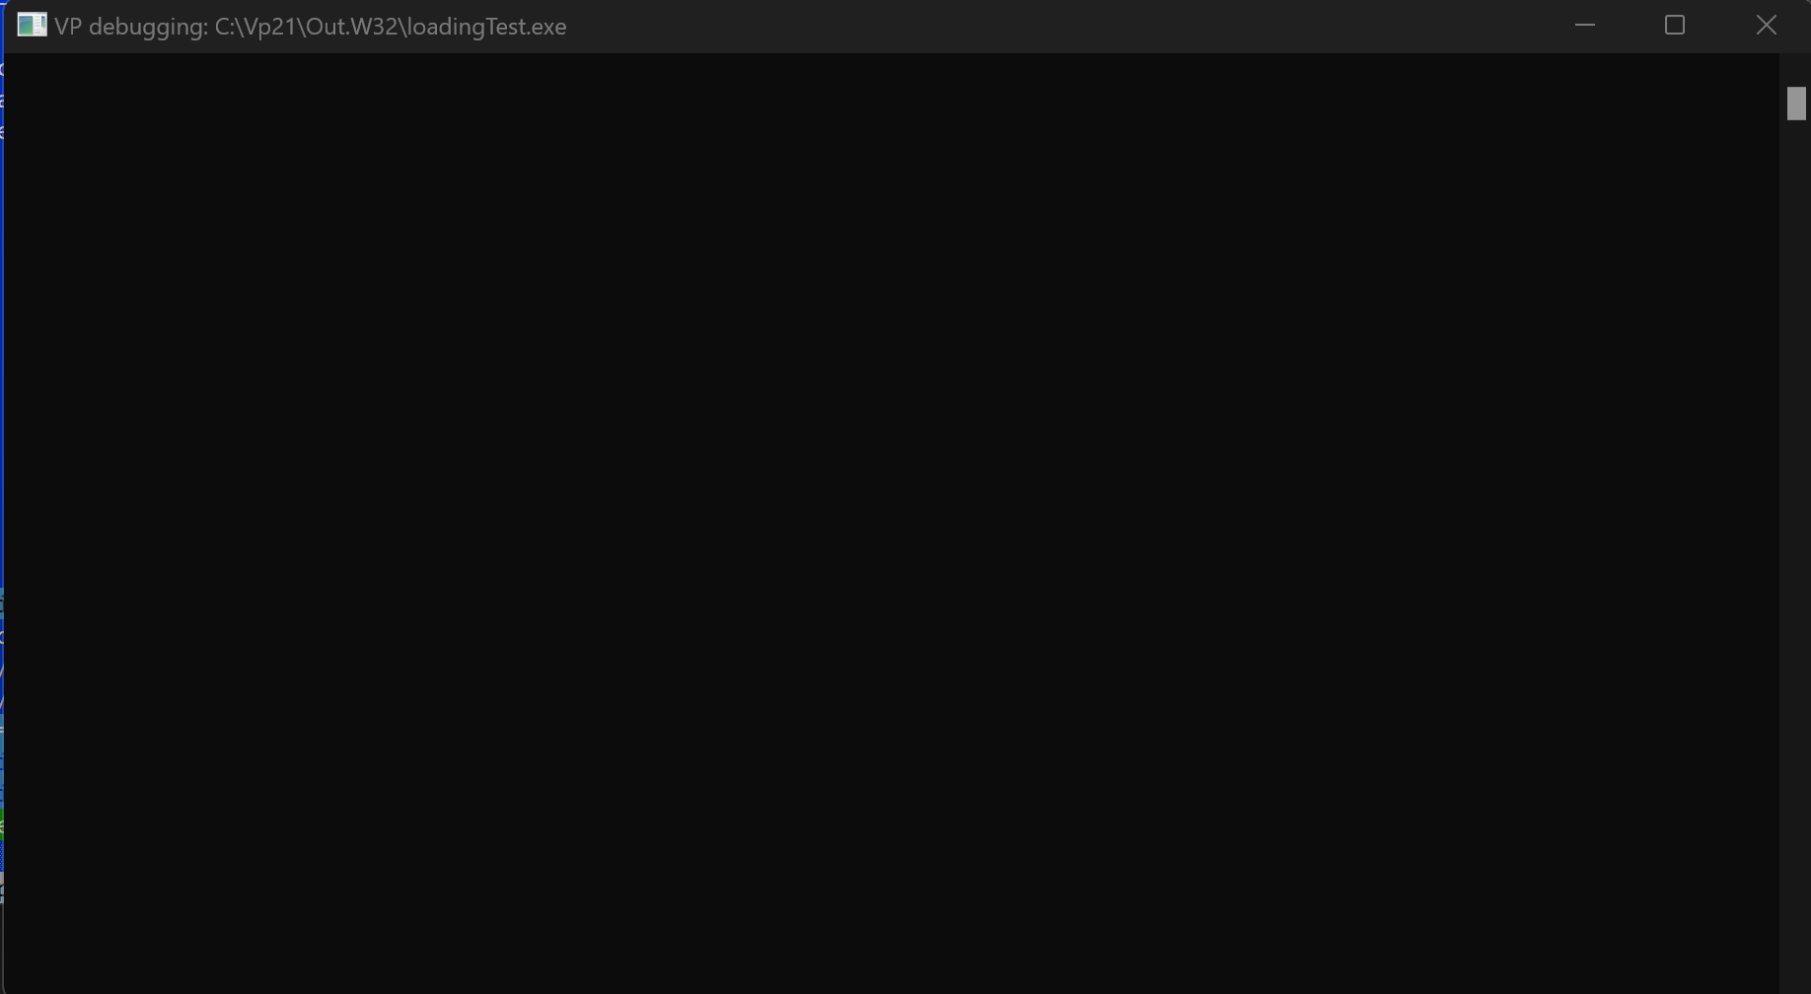
0.4.5 | Loading  Iteration 0 | To test the progress bar works | A for looping counting up out of a total of 100 | Progress ╣░░░░░░░░░░░░░░░░░░░░░╠ 0% (from 0 to 100 with correct bars) | See below | There were 21 one spaces due to the for loop which sets the spaces going from 0 to 20 which is 21 numbers so this was changed to 19 for 20 blank spaces at the start.  for c:= 0 TO 19 DO  write(#176);  Where the completed bars were being drawn in the for loop it starts from 0 to 0 which is still once to get it to run no times it needs to start at -1 and instead of that finishing at 20 it should also finish at 19. So it is now for d := o to completeBars-1.  for d := 0 to completeBars-1 DO  write(#219);  The display for percent done now also needs to be moved closer as everything moved back  gotoxy(3332,1);

Amendments:

0.4.6 | Loading  Iteration 1 | To test if the progress bar ends properly | None needed | Time elapsed: (however long it took) | See below | n/a
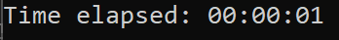
0.4.7 | Loading  Iteration 1 | Test if the progress bar ends using the silent kill | None needed | Nothing | Nothing | n/a
0.4.8 | Loading  Iteration 1 | Test if the multi-threading is handled correctly, correctly starting and ending the threads | None needed | A number of threads before the loading script is called. An increase of 1 during the loading. And a decrease by 1 back to original number after loading is ended | See below | n/a
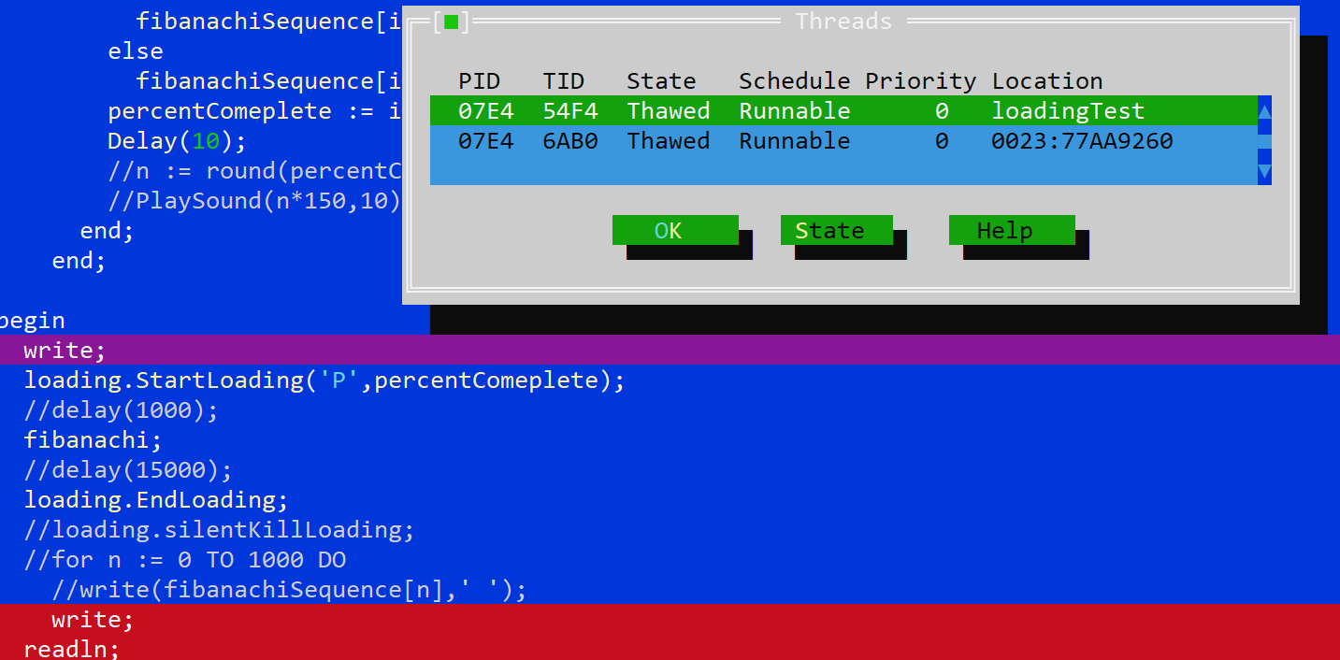
Two threads and before loading starts

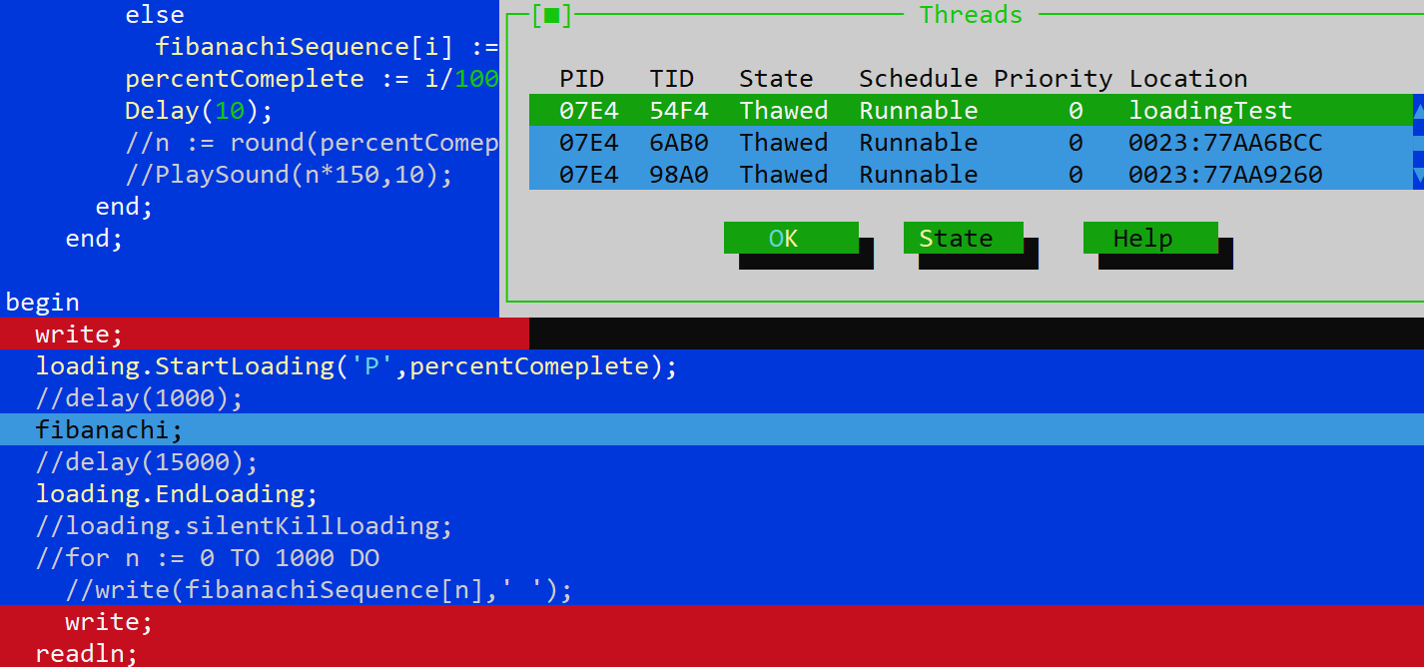
Extra thread starts with the loading procedure

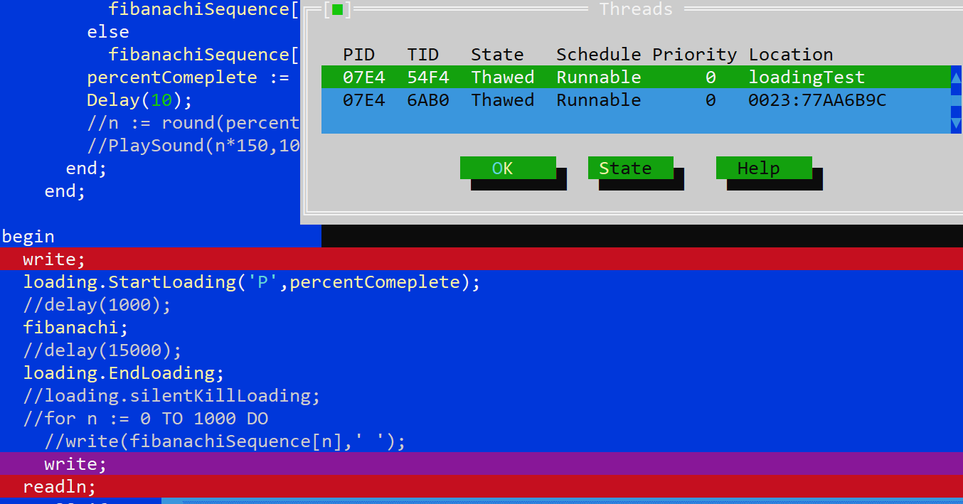
Extra thread deleted after the end of the loading

Iteration 0.5 – Log In

Code
unit LogInScreen;
interface
uses crt, sysutils, vputils; {importing built in units to help with the layout}

TYPE userPassArray = ARRAY[0..1] OF STRING; {Use one data structure to return from the unit}

VAR Username, Password : STRING; {Declaring variables}
y : LONGINT;
userPass : userPassArray;

procedure GetUsername; {declaring all the procedures in this unit and any local variables and parameters that they take}
procedure GetPassword;
var i, a : LONGINT;
key : CHAR;
procedure startLogIn(var userPassArrayr : ARRAY OF STRING);

implementation

PROCEDURE GetUsername; {The procedure that reads what the user types in for username}
begin
GotoXY(11,1);
READLN(username);
end;

PROCEDURE GetPassword;
var i,a : LONGINT;
key : CHAR;
begin
GoToXY(11,2); {Moves the cursor to the correct position}
i := 0;
HideCursor; {Hides the cursor}
password := ''; {sets the password to an empty string}
repeat {repeat until enter is pressed to submit}
key := readkey; {read the key that is pressed}
if (key = #8) THEN {Check if its the back space key}
begin
if i > 0 THEN {check if the password has more than 0 characters in it}
begin
Delete(password,i,1); {if so remove the last charachter in password}
i := i -1; {decrease the length of the password by 1}
end;
{else do nothing}
end

else if ((key >= #33) and (key < #127) and (key <> #13)) OR (key = #156) THEN {check if it is a valid character and not a spcae}
begin
password := password + key; {add the key pressed to the password}
i := i +1; {increase the length of password by 1}
end;
GoToXY(1,2); {go to the start of the password line}
DelLine; {clears the line}
Write('Password: '); {write the whole line again with the correct number of cogs}
for a := 1 TO i DO
write(#15);
until key = #13;
writeln;
end;

PROCEDURE DisplayInfo; {initial display of information that needs to be entered}
Begin
ClrScr;
WRITELN('Username: ');
WRITELN('Password: ');
GoToXY(11,1); {go to the start of username}
end;

procedure startLogIn(var userPassArrayr : ARRAY OF STRING);
begin
DisplayInfo; {Display intial information}
GetUsername; {get the username}
GetPassword; {get the password}
ClrScr; {clear the screen for the next task}
userPassArrayr[0] := username; {put the username and password into the array to be editied}
userPassArrayr[1] := password;
end;
end.

Testing
Test Number | Program and Iteration | Purpose of test | Data to be entered | Expected result | Actual results | Amendments
0.5.1 | Login  Iteration 0 | To test if the password is hidden when typing | When it asks for username type bob then press enter.  For password type abc123!”£ | Username: bob  Password: ☼☼☼☼☼☼☼☼☼ | Username: bob  Password: ☼☼☼☼☼☼☼☼☼ | None Needed
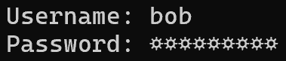
0.5.2 | Login  Iteration 0 | To test to see if the stored data is the same as the entered data | When it asks for username type bob then press enter.  For password type abc123!”£ | bob  abc123!”£ | bob  abc123!”£ | None Needed
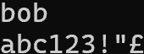
0.5.2 | Login  Iteration 0 | To test to see if the back space removes characters correctly in the hidden view | When it asks for username type bob then press enter.  For password type a1!b2”c3£  Then press back space 3 times | Username: bob  Password: ☼☼☼☼☼☼ | Username: bob  Password: ☼☼☼☼☼☼ | None Needed
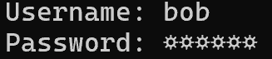
0.5.3 | Login  Iteration 0 | To test to see if the backspace removes the characters from the stored data | When it asks for username type bob then press enter.  For password type a1!b2”c3£  Then press back space 3 times | bob  a1!b2” | bob  a1!b2” | None Needed
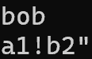

Iteration 0.6 – Write Design

Code
UNIT writeDesign;
interface
uses crt, sysutils, vputils;
procedure DrawDesign(path: STRING; delayWrite : LONGINT);
var Character : STRING;
DesignTextFile : TextFile;
implementation
procedure DrawDesign(path: STRING; delayWrite : LONGINT);
var a : LONGINT;
begin
HideCursor;
ClrScr;
//get the file to read from
ASSIGN(DesignTextFile,path);
reset(DesignTextFile);
//read each line to a max of 28 (window size)
for a := 0 to 28 DO
begin
readln(DesignTextFile, Character);
//write each line
writeln(Character);
//delay for effects
Delay(delayWrite);
end;
ShowCursor;

end;
end.

Testing
Test Number | Program and Iteration | Purpose of test | Data to be entered | Expected result | Actual results | Amendments
0.6.1 | Write Designs  Iteration 0 | This it to test if it works with full display | No data, just a text file with a design | 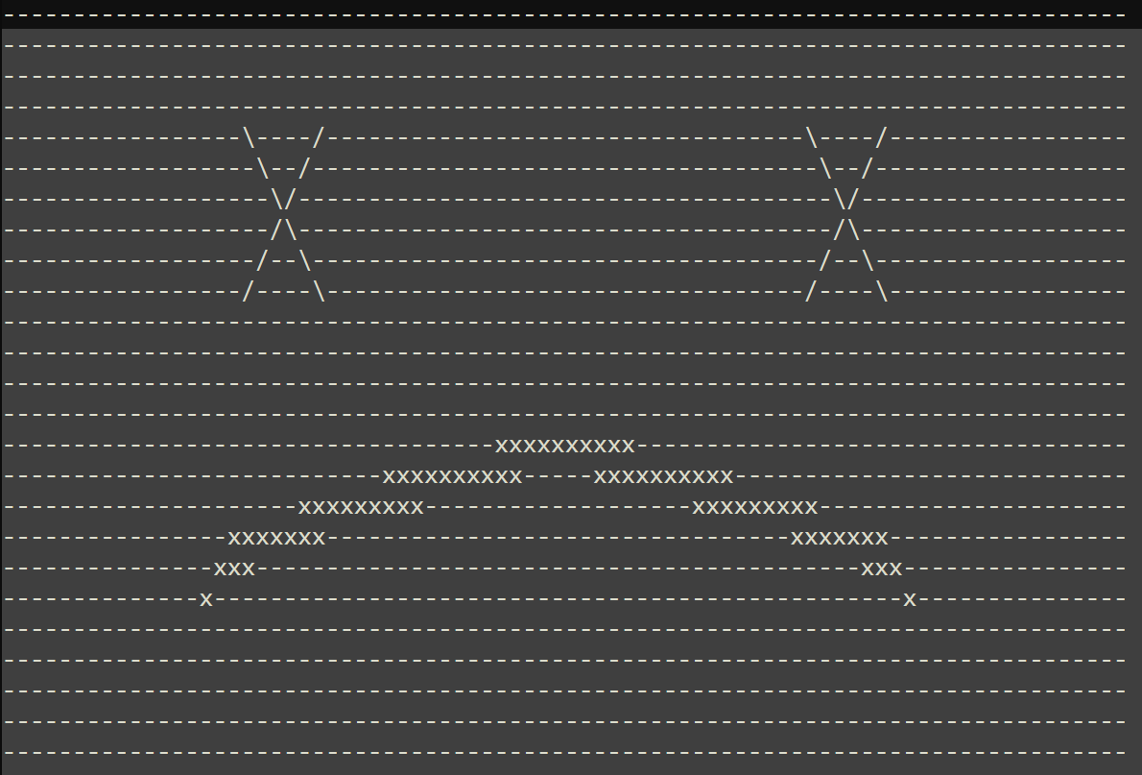 |  | n/a
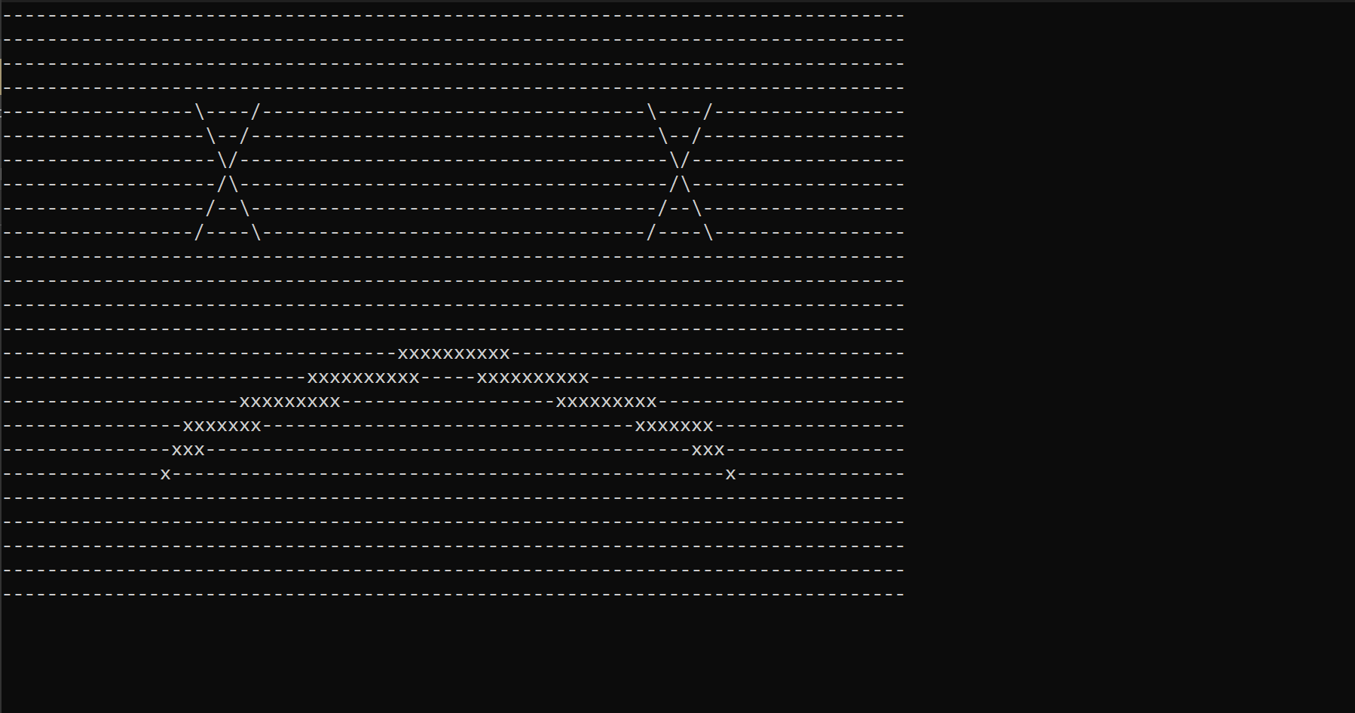
0.6.2 | Write Designs  Iteration 0 | This it to test if the animation feature works | Same file with a 100ms delay between each line |  |  | None

Mr Martin signature

0.6.3 | Write Designs  Iteration 0 | Test if it works with something that has gaps in it | A different text file design | 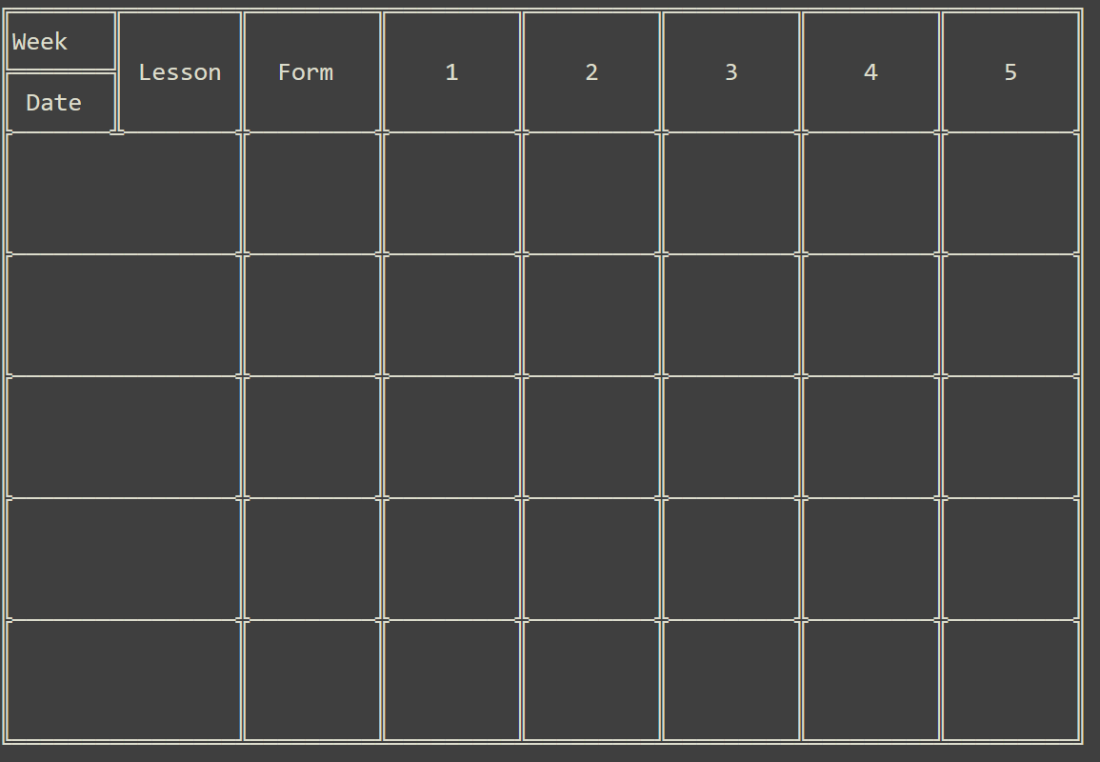 |  | n/a
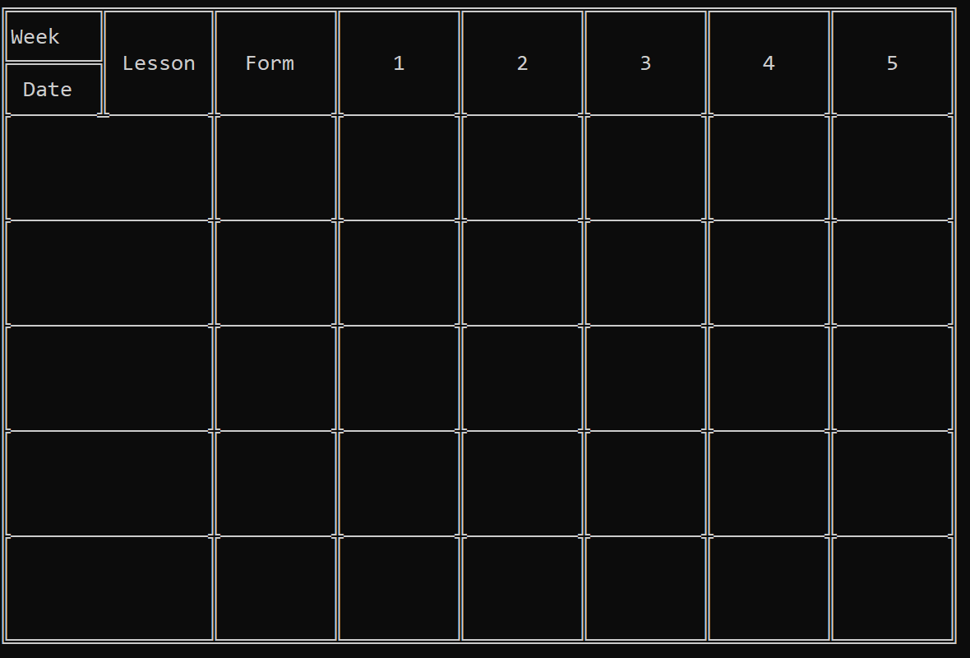

Iteration 0.7 – Cursor Grid

Code
UNIT CursorGrid;
interface
uses crt, sysutils, vputils;

var stepx , stepY, movePos, minX, minY, maxX, maxY: LONGINT;

procedure moveUp;
procedure moveDown;
procedure moveLeft;
procedure moveRight;
procedure startGrid(moveStepX, moveStepY, startX, startY : LONGINT; boundaries : ARRAY OF LONGINT; var x, y : LONGINT);
implementation
procedure moveUp;
begin
//if the cursor will stay in the boundaries set
if WhereY - stepy >= minY THEN
begin
movePos := WhereY - stepy;
GoToXY(WhereX, movePos);
end;
end;

procedure moveDown;
begin
//if the cursor will stay in the boundaries set
if WhereY + stepy <= maxY THEN
begin
movePos := WhereY + stepy;
GoToXY(WhereX, movePos);
end;
end;
procedure moveLeft;
begin
//if the cursor will stay in the boundaries set
if WhereX - stepx >= minX THEN
begin
movePos := WhereX - stepx;
GoToXY(movePos, WhereY);
end;
end;

procedure moveRight;
begin
//if the cursor will stay in the boundaries set
if WhereX + stepx <= maxX THEN
begin
movePos := WhereX + stepX;
GoToXY(movePos, WhereY);
end;
end;

procedure startGrid(moveStepX, moveStepY, startX, startY : LONGINT; boundaries : ARRAY OF LONGINT; var x, y : LONGINT);
var keyPress : char;
begin
stepX := moveStepX;
stepY := moveStepY;
minX := boundaries[0];
minY := boundaries[1];
maxX := boundaries[2];
maxY := boundaries[3];
GoToXY(startX,startY);

//key checking key presses until enter is pressed
repeat
keyPress := readkey;
if keyPress = #0 then //check if an extended key or function key
begin
//read its scan code to get which arrow key was pressed and call according procedure
case readKey of
'H' : moveUp;
'P' : moveDown;
'K' : moveLeft;
'M' : moveRight;
end;
end;
until keyPress = #13;
//corrects the return to a choice of menu option rather than spaces moved
if stepX <> 0 THEN//stops divide by 0 error
x := Round((WhereX - startX) / stepX) //round to change float to int
ELSE
x := startX;

if stepY <> 0 THEN//stops divide by 0 error
y := round((WhereY - startY) / stepY) //round to change float to int
ELSE
y := startY;
end;

end.

Testing
Test Number | Program and Iteration | Purpose of test | Data to be entered | Expected result | Actual results | Amendments
0.7.1 | Cursor Grid  Iteration 0 | To test if it can step the set amount | Set amount 2,2 | Mouse only able to step 2 spaces in each direction | See below | n/a
Initial position
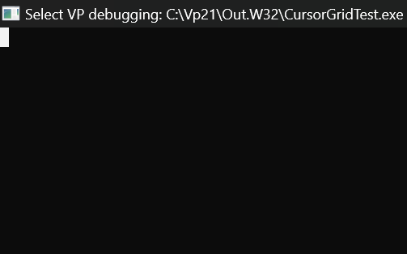

Press down once should lead to a step of 2 down
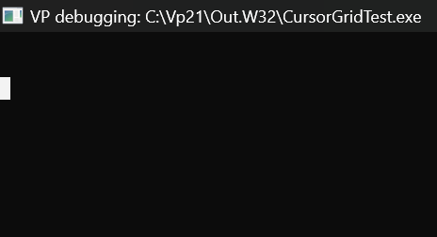
Press right once should lead to a step of 2 right
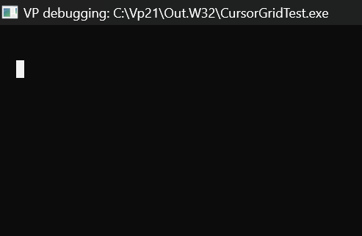

Press up once should lead to a step of 2 up
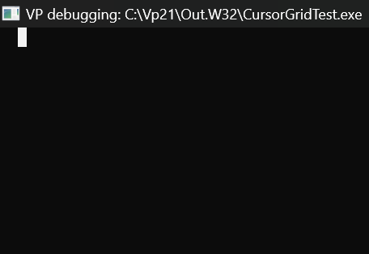
Press left once should lead to a step of 2 left
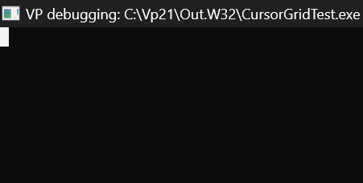
0.7.2 | Cursor Grid  Iteration 0 | To test if the boundary conditions will stop the cursor regardless of if it perfectly matches | Step 1, 2  Boundaries [1,1] and [3,4] | A max position of 3,3 before it stops it | See below | n/a
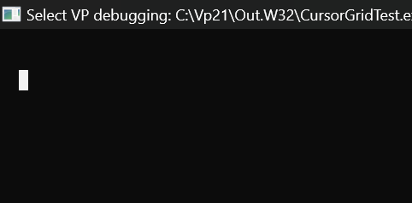
IT is currently at 3,3 and I can’t move it further in any direction
0.7.3 | Cursor Grid  Iteration 0 | TO test to see if it can start wherever | Start position at 5,4 | The cursor starts at 5,4 | See below | n/a
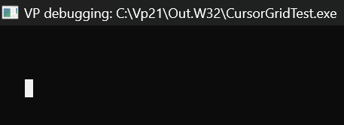
It is currently at position 5,4 which is where it starts

Iteration 0.8 – Create Menu

Code
unit createMenu;
interface
uses crt, sysutils, CursorGrid, VPUtils;

function writeMenu(startPos : ARRAY OF LONGINT; numberOfChoices : LONGINT; menuChoices: ARRAY OF STRING; optionStart : LONGINT) : LONGINT;

implementation

function writeMenu(startPos : ARRAY OF LONGINT; numberOfChoices : LONGINT; menuChoices: ARRAY OF STRING; optionStart : LONGINT) : LONGINT;
var a, x, y : LONGINT;
begin
HideCursor;

//write each menu option
for a := 0 TO numberOfChoices -1 DO
begin
//make sure it is alawys writing where it needs to
GOTOXY(startPos[0],startPos[1]+a);
writeln(a+1,': ',menuChoices[a]);
end;
ShowCursor;
Delay(100);
//start the cursor grid script with set boundary conditions and steps to allow control with arrow keys
CursorGrid.startGrid(0,1,startPos[0],startPos[1]+optionStart,[startPos[0],startPos[1],startPos[0],numberOfChoices+startPos[1]-1],x,y);
ClrScr;
writeMenu := optionStart + y;
end;

end.

Testing
Test Number | Program and Iteration | Purpose of test | Data to be entered | Expected result | Actual results | Amendments
0.8.1 | Create menu  Iteration 0 | To see if the menu can write with correct format | Menu options = [a,b,c]  Start position = [1,1]  Start Menu option = 0  Number of menu options = 3 | 1. a  2. b  3. c | 1. a  2. b  3. c | n/a
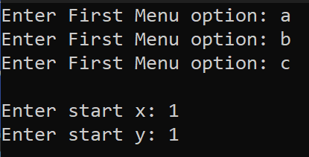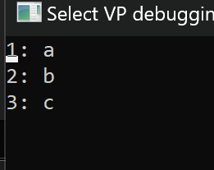
0.8.2.1 | Create menu  Iteration 0 | To see if the menu can be written on any x | Menu options = [a,b,c]  Start position = [13,1]  Start Menu option = 0  Number of menu options = 3 | 1. a  2. b  3. c | 1. a  2. b  3. c | n/a
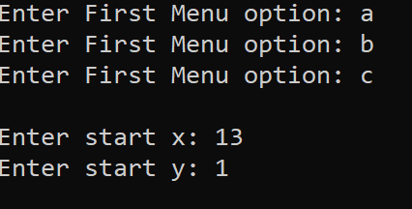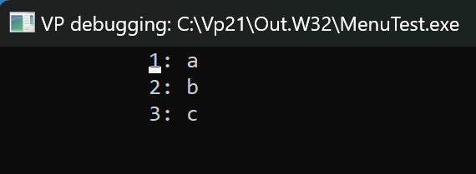
0.8.2.2 | Create menu  Iteration 0 | To see if the menu can be written on any y | Menu options = [a,b,c]  Start position = [1,7]  Start Menu option = 0  Number of menu options = 3 | 1. a  2. b  3. c | 1. a  2. b  3. c | n/a
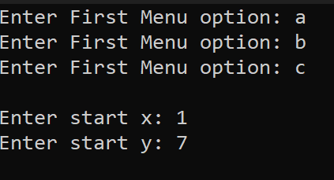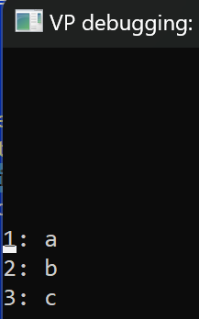
0.8.2.2 | Create menu  Iteration 0 | To see if the menu can be written on any x and y | Menu options = [a,b,c]  Start position = [5,8]  Start Menu option = 0  Number of menu options = 3 | 1. a  2. b  3. c | 1. a  2. b  3. c | n/a
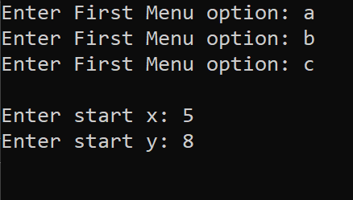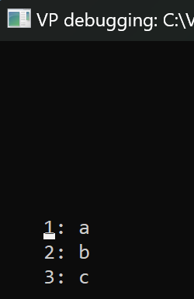
0.8.3 | Create menu  Iteration 0 | To see if the cursor can start on different values | Menu options = [a,b,c,d,e,f]  Start position = [1,1]  Start Menu option = 4  Number of menu options = 6 | 1. a  2. b  3. c  4. d  5. e  6. f | 1. a  2. b  3. c  4. d  5. e  6. f | n/a
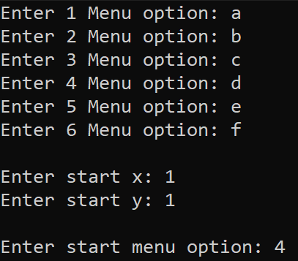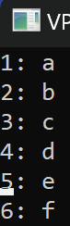

0.8.4.1 | Create menu  Iteration 0 | To see if it output the right result from which menu was selected | Menu options = [a,b,c,d,e,f]  Start position = [1,1]  Start Menu option = 0  Number of menu options = 6  Menu option to select = b | 1 | 1 | n/a
0.8.4.2 | Create menu  Iteration 0 | To see if it output the right result from which menu was selected if it is first value | Menu options = [a,b,c,d,e,f]  Start position = [1,1]  Start Menu option = 0  Number of menu options = 6  Menu option to select = a | 0 | 0 | n/a
0.8.4.3 | Create menu  Iteration 0 | To see if it output the right result from which menu was selected if it is last value | Menu options = [a,b,c,d,e,f]  Start position = [1,1]  Start Menu option = 0  Number of menu options = 6  Menu option to select = f | 5 | 5 | n/a
0.8.4.4 | Create menu  Iteration 0 | Test to see if it works if offset in the y direction | Menu options = [a,b,c,d,e,f]  Start position = [1,3]  Start Menu option = 0  Number of menu options = 6  Menu option to select = c | 2 | 2 | n/a
0.8.4.5 | Create menu  Iteration 0 | Test to see if it works if offset in the x direction | Menu options = [a,b,c,d,e,f]  Start position = [2,1]  Start Menu option = 0  Number of menu options = 6  Menu option to select = d | 3 | 3 | n/a

Review
Due to this iteration being mostly background units designed and developed to be used by me as the programmer so most of this review will be a review from the programmer.
However, the following units my client did have comments on:
Loading: My client likes the idea of having a way to see that the program is actually doing something rather than crashed or stuck in an infinite loop.
Login: My client is happy with how it works and how the password is hidden while it is being typed in. She also likes how the character that is used to hide the password is not a character that can be easily typed in so she can use all special characters in her password without being restricted.
Cursor Grid: My client likes the ability to use the arrow keys to navigate through the menus as it feels more natural for her to use and it is more intuitive

From a programmer’s perspective:
Iterations 0.1 to 0.3 allows me to search arrays whilst only calling one procedure making the code readability, it also means I only must include the search unit in the use instead of both binary and linear search.
The loading script can provide use information such as when a program breaks down, it its say at 56% I know where that is and can identify the issue faster.
The login script is very useful for me as the programmer as I can call start login from anywhere and it loads the login script and just returns the data that the user entered. This helps to keep the main program neater and more concise. This also allows for debugging of only the login script without having to go through the entire program
The write design script allows for easy graphical outputs. I can design an output in a text file and then just put the path into the procedure and it will be displayed
The cursor grid script allows for me to easily start a script which allows the use the arrow keys to navigate the screen and what is on the screen, and it returns the new position of the cursor so I can work out what was chosen
Iteration 0.8, the create menu script allows me as the programmer to pass an array of menu options that I want in the menu and it automatically writes all of them out and starts the cursor grid script to allows the user to navigate through the menu. This then returns only the menu option which was picked, which then allows me to pass that on to it relevant procedure.

Iteration 1 – Creating Initial Data

Aim
The aim of this iteration is to generate data in which I can use to test the main program and prove and check that the main program is doing the correct task. Design the generation in a way that it is randomly generated so if any data gets corrupted, I can execute the program and have a whole new set of data to work with. I will set certain parts such as the timetable and I got a list of names from online which it reads from. These are kept the same so the data has a solid structure to build off and the rest of the data can be randomly generated without causing issues. I will keep the names the same so I always know a couple of users I can use as tests even if the rest of the data about them changes. I will also do this procedurally to allow me to generate large samples of data without having to manually input all the data into the file

Code
PROGRAM CreateFiles;
uses crt, sysutils, search,sorting, loading, DisplayErrorScrn, math;

type {declaring all record types}
TimeTableRecord = RECORD
Day : LONGINT;
LessonNo : LONGINT;
ClassID : STRING[8];
end;
FormRecord = RECORD
FormID : STRING[5];
NumberInForm : LONGINT;
end;

AttendanceRecord = RECORD
StudentID : LONGINT;
Attendance : REAL;
Total : LONGINT;
NumberPresent : LONGINT;
NumberLate : LONGINT;
NumberAbsent : LONGINT;
end;

StudentsRecord = RECORD
StudentID : LONGINT;
FName : STRING[20];
SName : String[20];
Year : LONGINT;
Form : STRING[5];
Uname : String[40];
Pword : String[20];
end;

teacherRecord = RECORD
TeacherID : STRING[3];
fname : string[20];
sname : string[20];
form : string[5];
Uname : STRING[40];
PWord : STRING[20];
end;

classRecord = RECORD
ClassID : STRING[8];
Year : LONGINT;
subjectID : STRING[3];
NoOfStudents : LONGINT;
end;

subjectRecord = RECORD
SubjectID : STRING[3];
SubjectName : STRING[20];
end;

studentRegisterMarkRecord = RECORD
studentID : LONGINT;
registerMark : CHAR;
end;

registerRecord = RECORD
RegisterID : STRING[17];
LessonNo : LONGINT;
Date : TDateTime;
ClassID : STRING[8];
RegisterMarks : ARRAY[0..40] OF studentRegisterMarkRecord;
isOfstedRegister : BOOLEAN;
end;

studentClassResolverRecord = RECORD
StudentID : LONGINT;
ClassID : STRING[8];
end;
teacherSubjectResolverRecord = RECORD
TeacherID : STRING[3];
SubjectID : STRING[2];
end;

teacherClassResolverRecord = RECORD
TeacherID : STRING[3];
ClassID : STRING[6];
end;

LogInDetailsRecord = RECORD
PersonID: STRING[5];
Username: STRING[40];
Passwowrd: String[20];
end;
VAR {setting up all variables for records and files}
numberDone, total : LONGINT;

TimeTable : TimeTableRecord;
TimeTableTextFile : TextFile;
TimeTableFile : FILE OF TimeTableRecord;
TimeTableInfoFromFile : STRING;

Form : FormRecord;
FormFile : FILE OF FormRecord;

Register : registerRecord;
studentRegisterMark : studentRegisterMarkRecord;
RegisterFile : File OF registerRecord;

Attendance : AttendanceRecord;
AttendanceFile : FILE OF AttendanceRecord;
StudentFName : STRING;
NameFile : TextFile;
Student : StudentsRecord;
StudentFile : FILE OF StudentsRecord;

TeacherFileFromFile : TextFile;
TeacherFile : file of teacherRecord;
TeacherFromFile : String;
Teacher : teacherRecord;

sClass : ClassRecord;
classFile : FILE OF ClassRecord;

subject : subjectRecord;
subjectFile : FILE OF subjectRecord;

studentClassResolver : studentClassResolverRecord;
studentClassResolverFile : FILE OF studentClassResolverRecord;

teacherSubjectResolver : teacherSubjectResolverRecord;
teacherSubjectResolverFile : FILE OF teacherSubjectResolverRecord;

teacherClassResolver : teacherClassResolverRecord;
teacherClassResolverFile : FILE OF teacherClassResolverRecord;

empty, ErrCode : LONGINT; {setting up other variables for functions that require an input}
percentComplete : REAL; {variable for progress bar to track progress}

LogInDetails: LogInDetailsRecord;
LogInDetailsFile : FILE OF LogInDetailsRecord;

{setting up common array across many functions}
classIDArray : ARRAY[0..50] OF STRING;

procedure initialiseFiles;
begin
percentComplete := 0.0; {initializing percentDone and total iterations}
total := 0;
{assigning a place on the drive to the files}
ASSIGN(TimeTableTextFile,'C:\ComputerScienceCoursework\Program\files\TimeTableText.txt');
ASSIGN(TimeTableFile,'C:\ComputerScienceCoursework\Program\files\TimeTable.dta');
total:= total +51;

ASSIGN(RegisterFile,'C:\ComputerScienceCoursework\Program\files\Registers.dta');
total := total + 60;

ASSIGN(NameFile,'C:\ComputerScienceCoursework\Program\files\Names.txt');
ASSIGN(StudentFile,'C:\ComputerScienceCoursework\Program\files\Students.dta');
total := total + 140;

ASSIGN(TeacherFile,'C:\ComputerScienceCoursework\Program\files\Teachers.dta');
total := total + 51;

ASSIGN(classFile,'C:\ComputerScienceCoursework\Program\files\classes.dta');
total := total + 51;

ASSIGN(subjectFile,'C:\ComputerScienceCoursework\Program\files\subjects.dta');
total := total + 21;

ASSIGN(studentClassResolverFile,'C:\ComputerScienceCoursework\Program\files\studentClassResolver.dta');
total := total + 140;

ASSIGN(teacherSubjectResolverFile,'C:\ComputerScienceCoursework\Program\files\teacherSubjectResolver.dta');
total:= total + 51;

ASSIGN(teacherClassResolverFile,'C:\ComputerScienceCoursework\Program\files\teacherClassResolver.dta');
total := total + 51;

ASSIGN(FormFile,'C:\ComputerScienceCoursework\Program\files\forms.dta');
total := total +5;

ASSIGN(AttendanceFile,'C:\ComputerScienceCoursework\Program\files\attendanceFile.dta');

ASSIGN(LogInDetailsFile,'C:\ComputerScienceCoursework\Program\files\LogInDetails.dta');
total := total + 191;
end;

procedure closeAllFiles;
begin
{closing all files to confirm all changes are fully written and complete}
close(TimeTableTextFile);
close(TimeTableFile);
close(RegisterFile);
close(NameFile);
close(StudentFile);
close(TeacherFile);
close(classFile);
close(subjectFile);
close(studentClassResolverFile);
close(teacherSubjectResolverFile);
close(teacherClassResolverFile);
close(FormFile);
close(AttendanceFile);
close(LogInDetailsFile);
end;

procedure CreateTimeTable;

begin
reset(TimeTableTextFile); //set pointer to start of file
rewrite(TimeTableFile); //clear all exiting data in timetable file
while not EOF(TimeTableTextFile) do //iterate until all data is extracted
begin
numberDone := numberDone +1;
percentComplete := numberDone/total;
readln(TimeTableTextFile,TimeTableInfoFromFile); //get the class id
TimeTable.ClassId := TimeTableInfoFromFile; //assign it to the record variable
repeat
readln(TimeTableTextFile,TimeTableInfoFromFile);
TimeTable.LessonNo := StrToInt(TimeTableInfoFromFile);
readln(TimeTableTextFile,TimeTableInfoFromFile);
TimeTable.Day := StrToInt(TimeTableInfoFromFile);
readln(TimeTableTextFile,TimeTableInfoFromFile);
try
write(TimeTableFile,TimeTable);
finally
end;
until TimeTableInfoFromFile = 'Q'; {repeat until all dates are read and stored in the .dta file
for that class marked by a Q in the text file}
end;
end;

procedure addForms;
var a, i : LONGINT;
begin
REWRITE(FormFile); {clear all exisiting data in the form file}
for i := 0 to 3 DO {iterate for all 4, year 9 forms}
begin
numberDone := numberDone + 1;
percentComplete := numberDone / total;
form.formID := '9' + 'AA' + Chr(i +65); {create 4 unique for identifiers}
form.NumberInForm := 0; {set Number of kids in form to 0}
write(FormFile, form); {push data to file}
end;
numberDone := numberDone + 1;
percentComplete := numberDone / total;
form.formID := '12' + 'AAA'; {do the same for 1 year 12 form}
form.NumberInForm := 0;
write(FormFile,form);
reset(FormFile); {set point to start of form file}
for i := 0 to 4 DO {for every form}
begin
read(formFile,form);
timetable.classid := form.formID; {get form id into a timetable class id variable}
for a := 1 to 10 DO {add it to the file as lesson 0 for every morning in the 2 week timetabe}
begin
timetable.LessonNo := 0;
timetable.Day := a;
write(TimeTableFile, timetable); {add new data to timetable file}
end;
end;
end;

procedure createRegisters;
var a,b,c,i,randomMark,day : LONGINT; {Initizlize iterative variables, arrays and other variables for this procedure}
dayArray : ARRAY[0..320] OF STRING;
dayReturnArray : ARRAY[0..320] OF LONGINT;
studentClassResolverClassArray : ARRAY[0..1384] OF STRING;
classReturnArray : ARRAY[0..1384] OF LONGINT;
classId, startDate : STRING;
studentFormIdArray : ARRAY[0..139] OF STRING;
returnStudentFormIdArray : ARRAY[0..139] OF LONGINT;
date : TDateTime;
begin
//set up files and reset file pointers
reset(TimeTableFile);
reset(studentClassResolverFile);
RESET(StudentFIle);
rewrite(RegisterFile);
i := 0;
startDate := '13/09/2024';
//populating the arrays with the data from the files
for i := 0 To 139 DO
begin
READ(StudentFile,Student);
studentFormIdArray[i] := Student.Form;
returnStudentFormIdArray[i] := -1;
end;
i := 0;
while not(eof(TimeTableFile)) DO
begin
read(TimeTableFile,TimeTable);
dayArray[i] := IntToStr(TimeTable.day);
dayReturnArray[i] := -1;
i := i +1;
end;
i := 0;
while not(eof(studentClassResolverFile)) do
begin
read(studentClassResolverFile,studentClassResolver);
studentClassResolverClassArray[i] := studentClassResolver.ClassID;
classReturnArray[i] := -1;
i := i +1;
end;
b := 0;

// for loop for number of days with registers
for i := 0 to 29 do
begin
//gets the number day of the week and corrects to monday being 0
day := DayOfWeek(StrToDate(startDate)+b-1);
if (day = 7) OR (day = 6) THEN //if weekend decrease for loop var by 1
begin
i := i -1;
end
else
begin
numberDone := numberDone +1;
percentComplete := numberDone / total;
//clear out array for searching for classes on that day
for c := 0 TO 269 DO
dayReturnArray[c] := -1;
Search.SearchFunctions('L',0,269,IntToStr(DayOfWeek(StrToDate(startDate)+b-1)),dayArray,dayReturnArray,empty);
a := 0;
while dayReturnArray[a] <> -1 DO // for every class on that day
begin
//find and get the data about one class
SEEK(TimeTableFile,dayReturnArray[a]);
read(TimeTableFile, TimeTable);
//set register data
Register.LessonNo := TimeTable.LessonNo;
Register.Date := StrToDate(startDate)+b;
if TimeTable.LessonNo = 4 THEN
Register.isOfstedRegister := true
else
Register.isOfstedRegister := false;
Register.classID := '';
Register.classID := TimeTable.classID;
register.registerID := IntToStr(register.lessonNo) + register.classID + DateTimeToStr(register.date);
classId := format('%s',[Register.classID]);
//clear out array for searching for students in that class
for c := 0 to 1384 DO
classReturnArray[c] := -1;
Search.SearchFunctions('L',0,1384,Register.ClassID,studentClassResolverClassArray,classReturnArray,empty);
c:=0;
//for every student in that class
while classReturnArray[c] <> -1 DO
begin
//get the class with the studenet in
SEEK(studentClassResolverFile, classReturnArray[c]);
read(studentClassResolverFile, studentClassResolver);
//get the student id
studentRegisterMark.studentID := studentClassResolver.studentID;
//get the data in the attendance file
SEEK(AttendanceFile,studentClassResolver.studentID);
read(AttendanceFile,Attendance);
Attendance.Total := Attendance.Total +1;
//randomly assign the student a mark
randomMark := RANDOM(100);
if randomMark <= 90 then
begin
studentRegisterMark.registerMark := 'P';
Attendance.NumberPresent := Attendance.NumberPresent + 1;
end
else if randomMark <= 97 then
begin
studentRegisterMark.registerMark := 'L';
Attendance.NumberLate := Attendance.NumberLate + 1;
end
else
begin
studentRegisterMark.registerMark := 'A';
Attendance.NumberAbsent := Attendance.NumberAbsent + 1;
end;
//write data back to register file
Register.registerMarks[c] := studentRegisterMark;
SEEK(AttendanceFile,FilePos(AttendanceFile)-1);
Attendance.Attendance := (Attendance.NumberPresent / Attendance.Total);
write(AttendanceFile,Attendance);
c := c +1;
end;
write(RegisterFile,Register);

a := a +1;
end;
end;
b := b +1;
end;

b:= 0;
for i := 0 to 29 DO //for loop for each form
begin
//gets the number day of the week and corrects to monday being 0
day := DayOfWeek(StrToDate(startDate)+b-1);
if (day = 7) OR (day = 6) THEN //if weekend decrease for loop var by 1
begin
i := i -1;
end
else
begin
numberDone := numberDone +1;
percentComplete := numberDone / total;
//clear out array for searching for forms on that day
for c := 0 TO 320 DO
dayReturnArray[c] := -1;
Search.SearchFunctions('L',269,320,IntToStr(DayOfWeek(StrToDate(startDate)+b-1)),dayArray,dayReturnArray,empty);
a := 0;
while dayReturnArray[a] <> -1 DO// for every form on that day
begin
SEEK(TimeTableFile,dayReturnArray[a]);
read(TimeTableFile, TimeTable);
if TimeTable.LessonNo = 0 THEN
begin
//set register data
Register.LessonNo := TimeTable.LessonNo;
Register.Date := StrToDate(startDate)+b;
Register.isOfstedRegister := true;
Register.classID := '';
Register.classID := TimeTable.classID;
register.registerID := IntToStr(register.lessonNo) + register.classID + DateTimeToStr(register.date);
//clear out array for searching for students in that form
classId := format('%s',[Register.classID]);
for c := 0 TO 139 DO
returnStudentFormIdArray[c] := -1;
Search.SearchFunctions('L',0,139,Register.ClassID,studentFormIdArray,returnStudentFormIdArray,empty);
c := 0;
//for every student in that form
while returnStudentFormIdArray[c] <> -1 DO
begin
//get the class with the studenet in
SEEK(StudentFile, returnStudentFormIdArray[c]);
read(StudentFile, Student);
//get the student id
studentRegisterMark.studentID := student.studentID;
//get the data in the attendance file
SEEK(AttendanceFile,student.studentID);
read(AttendanceFile,Attendance);
Attendance.Total := Attendance.Total +1;
//randomly assign the student a mark
randomMark := RANDOM(100);
if randomMark <= 90 then
begin
studentRegisterMark.registerMark := 'P';
Attendance.NumberPresent := Attendance.NumberPresent + 1;
end
else if randomMark <= 97 then
begin
studentRegisterMark.registerMark := 'L';
Attendance.NumberLate := Attendance.NumberLate + 1;
end
else
begin
studentRegisterMark.registerMark := 'A';
Attendance.NumberAbsent := Attendance.NumberAbsent + 1;
end;
//write data back to register file
Register.registerMarks[c] := studentRegisterMark;
SEEK(AttendanceFile,FilePos(AttendanceFile)-1);
Attendance.Attendance := (Attendance.NumberPresent / Attendance.Total);
write(AttendanceFile,Attendance);
c := c +1;
end;
write(RegisterFile,Register);

end;
a := a + 1;
end;
end;
b := b + 1;
end;
end;

procedure addStudents;
var i : LONGINT;
ffname, fsname, fyear, fform, fattendance : STRING; {set up variables to read from text file into}
begin
i := 0;
RESET(FormFile); {resets pointer in form file}
read(formFIle, form); {gets the first form}
RESET(NameFile);
REWRITE(StudentFile); {clears both studenet and attendance file}
REWRITE(AttendanceFile);
for i := 0 to 119 DO {generate 120 year 9 students}
begin
if (i mod 30 = 0) and (i <> 0) THEN //changes the form every 30 students
begin
seek(formFile, (FilePos(formFile)-1));
write(FormFile,form);
READ(FormFile, form);
end;
numberDone:= numberDone +1; //update progress bar
percentComplete := numberDone/total;
Student.StudentID := i; //set student data
READLN(NameFile, student.fname); //get a first and last name from a list of names
READLN(NameFile, student.sname);
student.year := 9;
student.uname := student.fname+student.sname;
student.pword := 'ABC123';
student.form := form.formid;
form.NumberInForm := form.NumberInForm + 1;
//set attendance data
Attendance.studentId := i;
Attendance.Attendance := 1;
Attendance.Total := 0;
Attendance.NumberPresent := 0;
Attendance.NumberLate := 0;
Attendance.NumberAbsent := 0;
write(StudentFile,student); //write student and attendance data to their respective files
write(AttendanceFile, Attendance);
end;
read(FormFile, form); {get the year 12 form}
for i := 120 to 139 DO {generate 20 year 12 students}
begin
numberDone := numberDone +1; //update progress bar
percentComplete := numberDone/total;
Student.StudentID := i; //set student data
READLN(NameFile, student.fname); //get a first and last name from a list of names
READLN(NameFile, student.sname);
student.year := 12;
student.uname := student.fname+student.sname;
student.pword := 'ABC123';
form.NumberInForm := form.NumberInForm + 1;
student.form := form.formid;
//set attendance data
Attendance.studentId := i;
Attendance.Attendance := 1;
Attendance.Total := 0;
Attendance.NumberPresent := 0;
Attendance.NumberLate := 0;
Attendance.NumberAbsent := 0;
write(StudentFile,student); //append this record to the end of the student file
write(AttendanceFile, Attendance);
end;
//write changes to form file
seek(formfile, filepos(formFile)-1);
write(formfile,form);
end;

procedure addTeachers;
var i : LONGINT;
ffname, fsname, fform : STRING; {declare all variables to read from files into them}
begin
RESET(FormFile);
rewrite(TeacherFile);
for i := 0 TO 50 DO //create 51 teachers, 1 per class
begin
numberDone := numberDone + 1;
percentComplete := numberDone / total;
READLN(NameFile, teacher.Fname); //read first and surname form names file
READLN(NameFile, teacher.Sname);
Teacher.TeacherID := teacher.FName[1]+teacher.SName[1]+teacher.SName[2]; //create the teacher id as first letter of first name and forst two letters of surname
Teacher.uname := teacher.FName + teacher.SName;
Teacher.pword := 'ABC123';
write(TeacherFile,teacher);
end;
//assign teachers to forms
RESET(TeacherFile);
for i := 0 to 4 DO
begin
read(TeacherFile,teacher);
read(FormFile,form);
teacher.form := form.formID;
seek(TeacherFile,FilePos(TeacherFile)-1);
write(TeacherFile,teacher);
end;
end;

procedure createLogInFile;
begin
RESET(StudentFile); //reset file pointers for both files
RESET(TeacherFile);
REWRITE(LogInDetailsFile);
//extract login information and student id and write it to a file
while not EOF(StudentFile) do
begin
READ(StudentFile,student);
LogInDetails.PersonID := IntToStr(student.StudentID); //convert student id from int to string
LogInDetails.Username := student.Uname;
LogInDetails.Passwowrd := student.Pword;
write(LogInDetailsFile,LogInDetails);
numberDone := numberDone +1;
percentComplete := numberDone/total;
end;
while not EOF(TeacherFile) do
begin
//extract login information and student id and write it to a file
READ(TeacherFile,teacher);
LogInDetails.PersonID := teacher.teacherID;
LogInDetails.Username := teacher.Uname;
LogInDetails.Passwowrd := teacher.Pword;
write(LogInDetailsFile,LogInDetails);
numberDone := numberDone +1;
percentComplete := numberDone/total;
end;

end;

PROCEDURE createSubjects;
// create a constant array of all subjects and the subjects' id
const subjID : ARRAY[0..20] OF STRING[3] = ('Cs','Ma','Mu','Enl','Gg','Ch','Ph','Bi','DT','Dr',
'Lf','Rpe','Fr','Hi','Gm','Bs','Ar','Py','Pe','Sp','So');
subjNm : ARRAY[0..20] OF STRING[20] = ('Computer Science','Maths','Music','English','Geography','Chemistry','Physics','Biology','Design Technology','Drama',
'Life Skills','Religion, Philosophy & Ethics','French','History','German','Business Studies','Art','Physcology','Physical Education','Spanish','Sociology');
var i : LONGINT;
begin
//clear subject file
REWRITE(SubjectFile);
//for every subject write subject name and id to a file
for i := 0 TO 20 do
begin
numberDone := numberDone +1;
percentComplete := numberDone / total;
with subject do
begin
subjectID := subjID[i];
SubjectName := subjNm[i];
end;
WRITE(SubjectFile, subject);
end;
end;

PROCEDURE createClasses;
//create arrays of all classes
const yNineClassArray : ARRAY[0..43] OF STRING = ('9AT1/Ch', '9AT2/Ch', '9AT1/Bi', '9AT2/Bi', '9AT1/Ph', '9AT2/Ph', '9AAX/Ma', '9AAY/Ma', '9AAX/Enl', '9AAY/Enl', '9AAX/Lf', '9AAY/Lf',
'9AAX/RPE', '9AAY/RPE', '9AP1/Pe', '9AP2/Pe', '9BT1/Ch', '9BT2/Ch', '9BT1/Bi', '9BT2/Cp', '9BT1/Ph', '9BT2/Ph',
'9BAX/Ma', '9BAY/Ma', '9BAX/Enl', '9BAY/Enl', '9BAX/Lf', '9BAY/Lf', '9BAX/RPE', '9BAY/RPE', '9BP1/Pe', '9BP2/Pe', '9B/Fr1', '9B/Sp1', '9B/Gg1', '9B/Hi1', '9C/Dr1', '9C/Ar1', '9C/Py1',
'9C/Dt1', '9D/So1', '9D/Bs1', '9D/Mu1', '9D/Gm1');
yTwelveClassArray : ARRAY[0..6] OF STRING = ('12A/Ph1','12A/Py1','12B/Ph1','12C/Cp1','12C/Py1','12D/Mu1','12D/Cp1');
VAR i : LONGINT;
classArray : ARRAY[0..50] OF classRecord;
begin
rewrite(classFile);
//for every year 9 class
for i := 0 TO 43 DO
begin
numberDone := numberDone + 1;
percentComplete := numberDone/total;
//set year 9 class data
sClass.ClassID := yNineClassArray[i];
sClass.year := 9;
sClass.NoOfStudents := 0;
//generate the class id
val(yNineClassArray[i][8],empty,ErrCode);
if ErrCode <> 0 THEN
begin
sClass.subjectID := yNineClassArray[i][6]+yNineClassArray[i][7]+yNineClassArray[i][8];
val(sClass.subjectID[1],empty,ErrCode);
if ErrCode = 0 THEN
begin
sClass.subjectid := yNineClassArray[i][4]+yNineClassArray[i][5];
end;
end
else
sClass.subjectID := yNineClassArray[i][6]+yNineClassArray[i][7];
write(classFile, sClass);
delay(100);
end;
//generate year 12 classes
for i := 0 TO 6 DO
begin
numberDone:= numberDone +1;
percentComplete := numberDone/total;
sClass.ClassId := yTwelveClassArray[i];
sClass.year := 12;
sClass.NoOfStudents := 0;
sClass.subjectID := yTwelveClassArray[i][5]+yTwelveClassArray[i][6];
write(classFile, sClass);
end;
reset(classFile);
for i := 0 to 50 do
begin
READ(classFile, classArray[i]);
classIDArray[i] := classArray[i].classID;
end;
end;

procedure addRecordsStudentClassResolver(start, noOfAviablableClasses, maxStudents, ClasesToSortInto, year : LONGINT);
const yNineClassArray : ARRAY[0..43] OF STRING = ('9AT1/Ch', '9AT2/Ch', '9AT1/Bi', '9AT2/Bi', '9AT1/Ph', '9AT2/Ph', '9AAX/Ma', '9AAY/Ma', '9AAX/Enl', '9AAY/Enl', '9AAX/Lf', '9AAY/Lf',
'9AAX/RPE', '9AAY/RPE', '9AP1/Pe', '9AP2/Pe', '9BT1/Ch', '9BT2/Ch', '9BT1/Bi', '9BT2/Cp', '9BT1/Ph', '9BT2/Ph',
'9BAX/Ma', '9BAY/Ma', '9BAX/Enl', '9BAY/Enl', '9BAX/Lf', '9BAY/Lf', '9BAX/RPE', '9BAY/RPE', '9BP1/Pe', '9BP2/Pe', '9B/Fr1', '9B/Sp1', '9B/Gg1', '9B/Hi1', '9C/Dr1', '9C/Ar1', '9C/Py1',
'9C/Dt1', '9D/So1', '9D/Bs1', '9D/Mu1', '9D/Gm1');
yTwelveClassArray : ARRAY[0..6] OF STRING = ('12A/Ph1','12A/Py1','12B/Ph1','12C/Cp1','12C/Py1','12D/Mu1','12D/Cp1');
VAR startPoint, randomChoiceClass, i,d,l : LONGINT;
returnArray : ARRAY[0..50] OF LONGINT;
begin
RESET(classFile);
d := 0;
repeat
d := d + 1;
randomChoiceClass := RANDOM(noOfAviablableClasses); //randomly picks classes from the number of available class that student can be in
if year = 9 THEN
Search.SearchFunctions('L',0,50,yNineClassArray[start+randomChoiceClass],classIDArray,returnArray,empty) //checks the year 9 to find the class chosen
else if year = 12 THEN
Search.SearchFunctions('L',0,50,yTwelveClassArray[start+randomChoiceClass],classIDArray,returnArray,empty) //checks the year 12 to find the class chosen
else
DisplayErrorScrn.ErrScr;
SEEK(classFile, returnArray[0]); //find the class in the file
read(classFile, sClass);
if d > 10000 THEN
begin
readln;
end;
until sClass.NoOfStudents < maxStudents; //only exit if there is a place for the student in that class
l := 0;
startPoint := returnArray[0];
for l := 0 to (ClasesToSortInto * 2) -1 do //for every class connceted to that one class
begin
if year = 9 THEN
studentClassResolver.classID := yNineClassArray[start+randomChoiceClass+l]
else if year = 12 THEN
studentClassResolver.classID := yTwelveClassArray[start+randomChoiceClass+l]
else
DisplayErrorScrn.ErrScr;
write(studentClassResolverFile, studentClassResolver); //write each student and the class to the resolver file
//update number of students in that class
SEEK(classFile, startPoint + l);
read(classFile, sClass);
SEEK(classFile, FilePos(classFile)-1);
sClass.NoOfStudents := sClass.NoOfStudents + 1;
write(classFile, sClass);
l := l + 1;
end;
end;

procedure createClassStudentResolver;
const yNineClassArray : ARRAY[0..43] OF STRING = ('9AT1/Ch', '9AT2/Ch', '9AT1/Bi', '9AT2/Bi', '9AT1/Ph', '9AT2/Ph', '9AAX/Ma', '9AAY/Ma', '9AAX/Enl', '9AAY/Enl', '9AAX/Lf', '9AAY/Lf',
'9AAX/RPE', '9AAY/RPE', '9AP1/Pe', '9AP2/Pe', '9BT1/Ch', '9BT2/Ch', '9BT1/Bi', '9BT2/Cp', '9BT1/Ph', '9BT2/Ph',
'9BAX/Ma', '9BAY/Ma', '9BAX/Enl', '9BAY/Enl', '9BAX/Lf', '9BAY/Lf', '9BAX/RPE', '9BAY/RPE', '9BP1/Pe', '9BP2/Pe', '9B/Fr1', '9B/Sp1', '9B/Gg1', '9B/Hi1', '9C/Dr1', '9C/Ar1', '9C/Py1',
'9C/Dt1', '9D/So1', '9D/Bs1', '9D/Mu1', '9D/Gm1');
yTwelveClassArray : ARRAY[0..6] OF STRING = ('12A/Ph1','12A/Py1','12B/Ph1','12C/Cp1','12C/Py1','12D/Mu1','12D/Cp1');
var returnArray : ARRAY[0..51] OF LONGINT;
yearArray : ARRAY[0..30] OF LONGINT;
stringArray : ARRAY[0..51] OF STRING;
aLevelBlockChoices : ARRAY[0..2] OF STRING;
studentYear,a, d, i, startPoint, noOfAlevels, noTakingFourAlevels, randClassNo, randomSide, numberInASide, numberInBSide, randomChoiceClass : LONGINT;
oldClass, newClass : STRING;

begin
RESET(StudentFile);
RESET(classFile);
rewrite(studentClassResolverFile);
//keep track of how many students on each side of the year
numberInASide := 0;
numberInBSide := 0;
randomSide := RANDOM(2);
noTakingFourAlevels := 0;
while not(eof(StudentFile)) do //for every student
begin
numberDone := numberDone+1;
percentComplete := numberDone/total;
READ(StudentFile,student); //get the student data
studentClassResolver.studentID := student.StudentID;
if student.year = 9 THEN
begin
//pick a random side without overflowing one side
if (numberInASide < 60) AND (numberInBSide < 60) THEN
randomSide := RANDOM(2)
else if (numberInASide < 60) THEN
randomSide := 0
else if (numberInBSide < 60) THEN
randomSide := 1;
if randomSide = 0 THEN //a or b side
begin
//put students in each set of classes
numberInASide := numberInASide + 1;
//Science
addRecordsStudentClassResolver(0, 2, 30, 3, 9);
//Maths
addRecordsStudentClassResolver(6, 2, 30, 1, 9);
//Englishs
addRecordsStudentClassResolver(8, 2, 30, 3, 9);
//Pe
addRecordsStudentClassResolver(14, 2, 30, 1, 9);
end
else if randomSide = 1 THEN //a or b side
begin
//Science
numberInBSide := numberInBSide + 1;
addRecordsStudentClassResolver(16, 2, 30, 3, 9);
//Maths
addRecordsStudentClassResolver(22, 2, 30, 1, 9);
//Englishs
addRecordsStudentClassResolver(24, 2, 30, 3, 9);
//Pe
addRecordsStudentClassResolver(30, 2, 30, 1, 9);
end
else
begin
//error catching for random side assignment
writeln('A: ',numberInASide, ' B: ',numberInBSide);
Delay(3000);
DisplayErrorScrn.ErrScr;
end;
//randomly pick the optional subjects
for a := 0 to 8 do
begin
addRecordsStudentClassResolver(32 + a, 4, 30, 1, 9);
a := a + 3;
end;
end
else if (student.year = 12) THEN // year 12
begin
if noTakingFourAlevels < 5 THEN
noOfAlevels := RANDOM(10);
if noOfAlevels = 0 THEN //taking 4 a lvels
begin
noTakingFourAlevels := noTakingFourAlevels + 1;
//block a
addRecordsStudentClassResolver(0, 2, 20, 1, 12);

//block b
addRecordsStudentClassResolver(2, 1, 5, 1, 12);

//block c
addRecordsStudentClassResolver(3, 2, 20, 1, 12);

//block d
addRecordsStudentClassResolver(5, 2, 20, 1, 12);
end
else
begin
//block a
addRecordsStudentClassResolver(0, 2, 20, 1, 12);

//block c
addRecordsStudentClassResolver(3, 2, 20, 1, 12);

//block d
addRecordsStudentClassResolver(5, 2, 20, 1, 12);

end;
end;
end;
end;

PROCEDURE assignTeacherToClass;
begin
reset(classFile);
reset(teacherfile);
REWRITE(teacherClassResolverFile);
while not(eof(classFile)) DO //for each teacher
begin
numberDone := numberDone+1;
percentComplete := numberDone / total;
//assign one teacher per class
read(classFile,sClass);
read(teacherfile, teacher);
teacherClassResolver.teacherID := teacher.teacherID;
teacherClassResolver.classID := sClass.classId;
write(teacherClassResolverFile,teacherClassResolver);
end;
end;

PROCEDURE assignTeacherToSubject;
var a, b : LONGINT;
begin
RESET(TeacherFile);
reset(classFile);
REWRITE(teacherSubjectResolverFile);
while not EOF(TeacherFile) DO
begin
numberDone := numberDone+ 1;
percentComplete := numberDone / total;
read(TeacherFile,teacher);
read(classFile,sClass);
//find the class the teacher teaches and gets the subject id of that class and puts it in a resolver file
teacherSubjectResolver.teacherId := teacher.teacherID;
teacherSubjectResolver.subjectId := sClass.subjectID;
write(teacherSubjectResolverFile, teacherSubjectResolver);
end;
end;

begin
//generates a random seed
randomize;
//run each procedure
initialiseFiles;
loading.startLoading('P',percentComplete);
CreateTimetable;
addForms;
addStudents;
addTeachers;
createSubjects;
createClasses;
createClassStudentResolver;
assignTeacherToClass;
assignTeacherToSubject;
createRegisters;
createLogInFile;
readln;
closeAllFiles;
end.

Testing
Test Number | Program and Iteration | Purpose of test | Data to be entered | Expected result | Actual results | Amendments
1.1.1 | Create Files  Iteration 0 | To test the program can read from the timetable I gave it into a .dta file with the correct format | 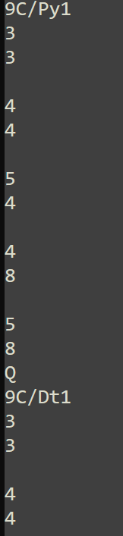  This is a small sample of the data entered | Records stored as  3  3  9C/Py1  4  4  9C/Py1  5  4  9C/Py1  4  8  9C/Py1  5  8  9C/Py1  3  3  9C/Dt1  4  4  9C/Dt1 | See below | None
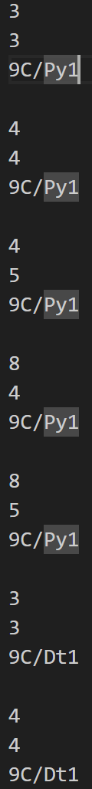
1.2.1 | Create Files  Iteration 0 | Check the forms are created and populated correctly | Input data is the timetable file | 9AAA  30  9AAB  30  9AAC  30  9AAD  30  12AAA  20 | See below |  | Supposedly no students in form 9AAD. It was not writing the last form back to the file with the updated number in students.  So after the students for loop add:  seek(formFile, (FilePos(formFile)-1));  write(FormFile,form);
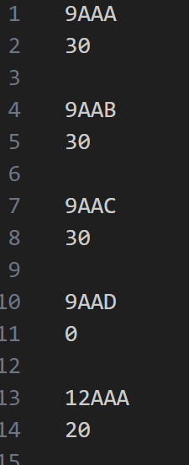
1.2.2 | Create Files  Iteration 1 | Check the forms are created and populated correctly | Input data is the timetable file | 9AAA  30  9AAB  30  9AAC  30  9AAD  30  12AAA  20 | See below | n/a
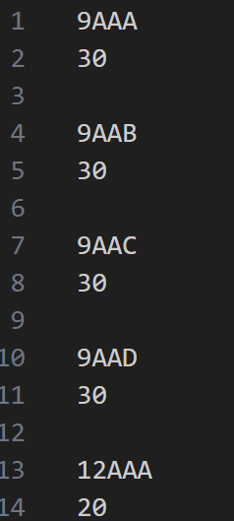
1.3.1 | Create Files  Iteration 1 | Test the students are added correctly | Text file of names generated by another script | Student ID  first name  last name  year  Form  Username: FirstName+Last Name  Password : ABC123 | See below | n/a
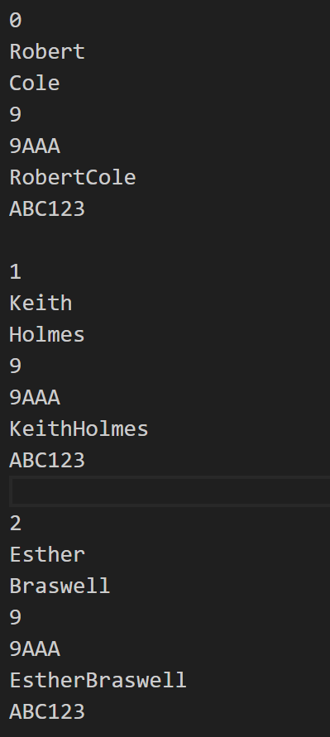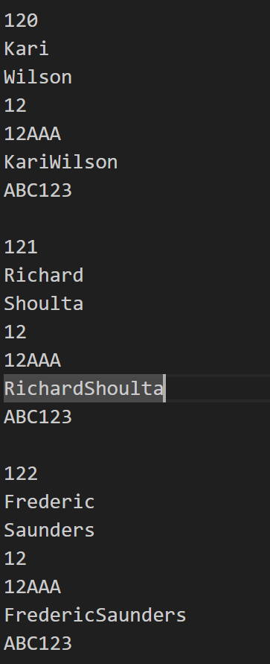

1.4.1 | Create Files  Iteration 1 | Test the teachers are added correctly | Text file of names generated by another script | Teacher ID  first name  last name  Form (might be blank)  Username: FirstName+Last Name  Password : ABC123 | See below | n/a
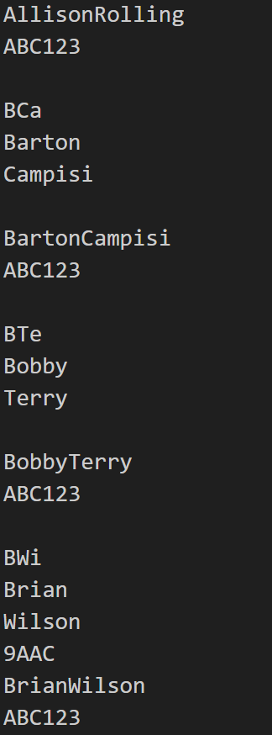
1.5.1 | Create Files  Iteration 1 | Test the subjects are stored correctly | Array of all subject names  And an array of all the subject id stored in the same order | Subject id  Subject name | See below | n/a
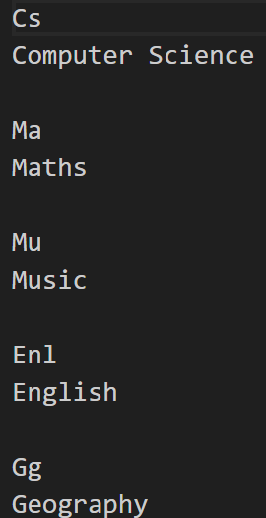
1.6.1 | Create Files  Iteration 1 | Test that the classes are stored correctly | Array of year 9 classes  And array of year 12 classes | Class ID  Year  Subject id  Number of students (30 if year 9 class else a small number of year 12s) | See below | n/a
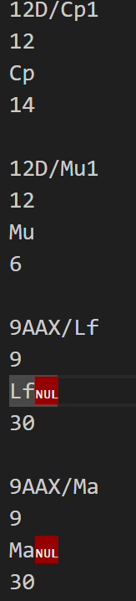
The nul characters represent an empty space in memory where the class id is too short in some places form a string of length 3 which is the max, so it leaves it blank. It is not an issue.

1.7.1 | Create Files  Iteration 1 | To test that students are correctly added to classes | Student data, and class data | Class ID  Student ID | See below | n/a
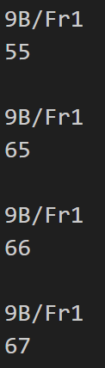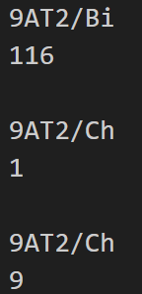
1.8.1 | Create Files  Iteration 1 | To correctly assign teachers to classes | Teacher data and class data | Teacher ID  Class ID  With one teacher to each class | See below | n/a
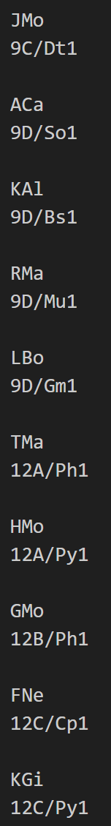
1.9.1 | Create Files  Iteration 1 | To correctly assign teachers to subjects based on the class they are in | Teacher data, class data and subject data | Teacher ID  subject ID  With the teacher’s class id matching up with the subject id | See below | n/a
all this lines up with previous evidence with the classes
1.10.1 | Create Files  Iteration 1 | To test the registers are created correctly | The timetable needs to be entered along with the student’s data, including attendance data. And the data about which student is in what class | Register id  Lesson number  Date  Class id  2d array of student id and their register mark  Is it an Ofsted register | See below | n/a
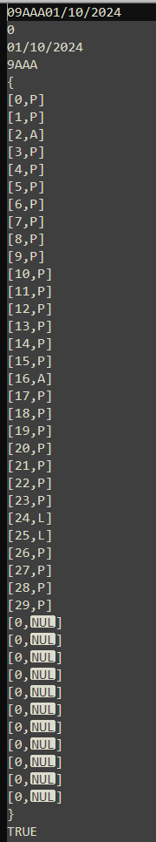
Correctly defines lesson 0 as an Ofsted register
Register marks are distributed correctly with most being present, some being late and very few being absent
[0,NUL] represents no students with no register mark as there are not anymore students in the class
1.11.1 | Create Files  Iteration 1 | To test the log in file is generated and stored correctly | Student and teacher data | Person ID (teacher/student)  Username  Password (ABC123) | See below | n/a
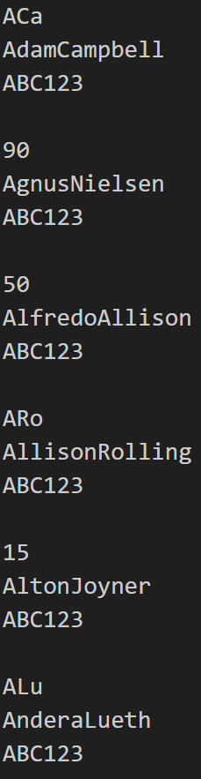

Review
During this iteration I made a script which can generate a large set of data which can be used to test the rest of the system thoroughly with accurate data. This took a long time as I wanted to ensure high data integrity. I asked my client to look at the data to ensure the data I have got is adequate for the section of the school system that I am focusing on. Her thoughts on the data were that for a full school the data is a small amount but for testing purposes she said that if the solution works with this data it should work as an actual system with the full data.

Iteration 2 – Class Structure

Aim
In this iteration I aim to develop a method to generalize code that is used for each file. Such as sorting a file or searching it. I designed this using classes and inheritance to have the general search and sort algorithm in a parent class, while all of the file specific procedures and retrieving the data from the files is done in a child class specific to each file. I will only be testing one of the classes as they are all the same with the singular difference of the record in which they are read into and how that data is put into other structures due to different data types in the record and different number of fields.

Code
For testing I will use just one of the child classes, I choose the login file as it contains fewer fields allowing for easier test data, while still having to be correctly aligned with the student and teacher file

Super Class
unit FileProcedures;
//allows constructors
{$M+}

interface

USES crt, sysutils;

TYPE
//declare class structure
Files = class
protected
upper : LONGINT;
dataArray: ARRAY[0..1400] OF STRING;
fileArray: ARRAY[0..7,0..1400] OF STRING;
public
constructor Create;
destructor Destroy; override;
procedure sort(var indexArray : ARRAY OF LONGINT);
procedure search(max, fields : LONGINT; searchValues:ARRAY OF STRING; searchFields: ARRAY OF BYTE; var returnArray : ARRAY OF LONGINT; switchLowerCase : BOOLEAN);
end;

IMPLEMENTATION

constructor Files.Create;
begin
end;
destructor Files.Destroy;
begin
end;

//sort algorithm for the files
procedure Files.sort(var indexArray : ARRAY OF LONGINT);
var TempIndex, i, code, tmp1, tmp2 : LONGINT;
TempStr : STRING;
Swaps: BOOLEAN;
begin
//bubble sort
upper := upper-1;
REPEAT
Swaps:= false;
FOR i := 0 TO upper DO
BEGIN
//checks done with the data array
IF dataArray[i] > dataArray[i+1] THEN
BEGIN
TempStr := dataArray[i];
dataArray[i] := dataArray[i+1];
dataArray[i+1] := TempStr;
Swaps := true;
//swap data in index array
TempIndex := indexArray[i];
indexArray[i] := indexArray[i+1];
indexArray[i+1] := TempIndex;
END;
END;
upper := upper -1;
UNTIL (NOT Swaps) OR (upper < 0);
end;

//search algorithm
procedure Files.search(max, fields : LONGINT; searchValues:ARRAY OF STRING; searchFields: ARRAY OF BYTE; var returnArray : ARRAY OF LONGINT; switchLowerCase : BOOLEAN);
var found : BOOLEAN;
a, b, c, returnIndex : LONGINT;
data : STRING;
begin
//linear search

if switchLowerCase then
begin
for c := 0 to fields do
begin
searchValues[c] := lowerCase(searchValues[c]);
end;
end
else
begin
for c := 0 to fields do
begin
searchValues[c] := searchValues[c];
end;
end;
a := -1;
returnIndex := 0;
//check every value in the 2d array
while a < max do
begin
a := a + 1;
//check each item in the record
for b := 0 TO (fields-1) DO
begin
if switchLowerCase then
begin
data := LowerCase(fileArray[b,a]);
end
else
begin
data := fileArray[b,a];
end;
//check if one piece of data matches
if data = searchValues[0] THEN
begin
found := true;
//check each peice of data in record against data to search for
for c := 0 to (SizeOf(searchFields)-1) do
begin
if switchLowerCase then
begin
data := LowerCase(FileArray[searchFields[c],a]);
end
else
begin
data := FileArray[searchFields[c],a];
end;
//if not all data matches continue search and dont return result
if searchValues[c] <> data THEN
begin
found := false;
break;
end;
end;
//if all data matches add index to the array of found matches
if found = true THEN
begin
returnArray[returnIndex] := a;
returnIndex := returnIndex+1;
break
end;
end;
end;
end;
end;

END.

Child Class
unit LogInProcedures;
{$M+}
interface

USES crt, sysutils, FileProcedures;

TYPE
//record type for this file
dataRecord = RECORD
PersonID: STRING[5];
Username: STRING[40];
Passwowrd: String[20];
end;

type
//declaration of class, attributes and methods
logInFile = Class(Files)
protected
dataFile: File OF dataRecord;
dataTextFile : TextFile;
indexArray: ARRAY[0..190] OF LONGINT;
recordArray: ARRAY[0..190] OF dataRecord;
public
data : dataRecord;
constructor Create;
destructor Destroy; override;
procedure SetData(iPersonID: STRING; iUsername: STRING; iPasswowrd: String);
procedure DisplayData;
procedure extractToTextFile;
procedure writeToFile;
procedure readHere;
procedure readFile(readFromPosition : LONGINT);
procedure sort;
procedure search(searchValues:ARRAY OF STRING; searchFields: ARRAY OF BYTE; var returnArray: ARRAY OF LONGINT; switchLowerCase: BOOLEAN);

end;

IMPLEMENTATION
//constructor and destructor
constructor logInFile.Create;
var a : longint;
begin
inherited Create;
ASSIGN(dataFile,'C:\ComputerScienceCoursework\Program\files\LogInDetails.dta');
ASSIGN(dataTextFile,'C:\ComputerScienceCoursework\Program\fileOuts\logInOut.txt');
RESET(dataFile);
RESET(dataTextFile);
for a := 0 TO 190 DO
begin
indexArray[a] := a;
end;
end;

destructor LogInFile.Destroy;
begin
close(dataFile);
close(dataTextFile);
inherited Destroy;
end;

//update data attribute
procedure logInFile.SetData(iPersonID: STRING;
iUsername: STRING;
iPasswowrd: String);

begin
with data do
begin
PersonID := iPersonID;
Username:=iUsername;
Passwowrd:=iPasswowrd;
end;
end;
//display data attribute
procedure logInFile.DisplayData;
begin
with data do
begin
writeln(PersonID);
writeln(Username);
writeln(Passwowrd);
writeln('-------------------------------------------------------------------------');
end;
end;
//write all data in file to text file
procedure logInFile.extractToTextFile;
begin
reset(dataFile);
rewrite(dataTextFile);
while not eof(dataFile) DO
begin
read(dataFile, data);
writeln(dataTextFile, data.PersonID);
writeln(dataTextFile, data.Username);
writeln(dataTextFile, data.Passwowrd);
writeln(dataTextFile, '');
end;
end;
//write data attribute to file
procedure logInFile.writeToFile;
begin
write(dataFile, data);
end;

//read data from file at current position
procedure logInFile.readHere;
begin
if FIlePos(dataFile) < FileSize(dataFile) then
begin
read(dataFile,data);
end;
end;
//read data from file at specified position
procedure logInFile.readFile(readFromPosition : LONGINT);
begin
if readFromPosition < FileSize(dataFile) then
begin
SEEK(dataFile,readFromPosition);
read(dataFile,data);
end;
end;
//sort the file
procedure logInFile.sort;
var a,b : LONGINT;
maxStrLen : STRING;
begin
RESET(dataFile);
upper:= 190;
//extrat the data into an array
for a := 0 TO 190 DO
begin
READ(dataFile,data);
recordArray[a] := data;
dataArray[a] := data.Username
end;
Files.sort(indexArray);
RESET(dataFile);
//write the data back to the file
for a := 0 TO 190 DO
begin
WRITE(dataFile,recordArray[indexArray[a]]);
indexArray[a] := a;
end;

end;

//search the file
procedure logInFile.search(searchValues:ARRAY OF STRING; searchFields: ARRAY OF BYTE; var returnArray : ARRAY OF LONGINT; switchLowerCase : BOOLEAN);
var a, searchResult: LONGINT;
begin
RESET(dataFile);
for a := 0 TO 190 DO
begin
read(dataFile, data);
fileArray[0,a] := data.PersonID;
fileArray[1,a] := data.Username;
fileArray[2,a] := data.Passwowrd;
end;
Files.search(190,3,searchValues, searchFields, returnArray, switchLowerCase);
end;
END.

Testing
Test Number | Program and Iteration | Purpose of test | Data to be entered | Expected result | Actual results | Amendments
2.1.1 | Class structure  Iteration 0 | To test if the object is created | None | Evidence of the object being created | See below | n/a
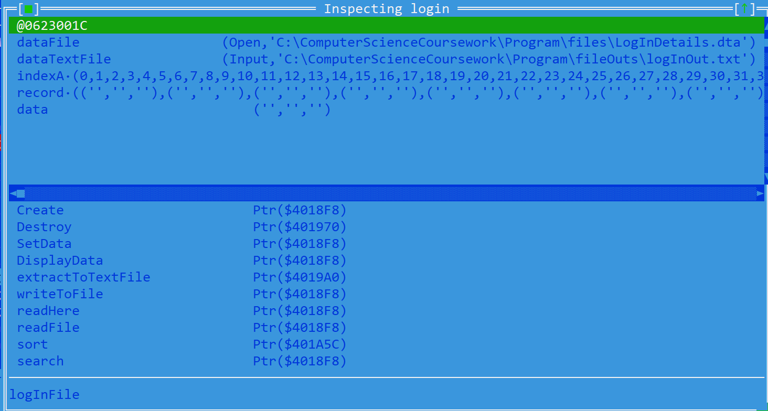
Evidence of the login identifier being a reference to an object with both attributes and methods matching those of the log in class
2.2.1 | Class structure  Iteration 0 | Test if I can set the data in the record. | Person id: 923  Username: BobStarck  Password: IronMan | The data attribute should contain this data | See below | n/a
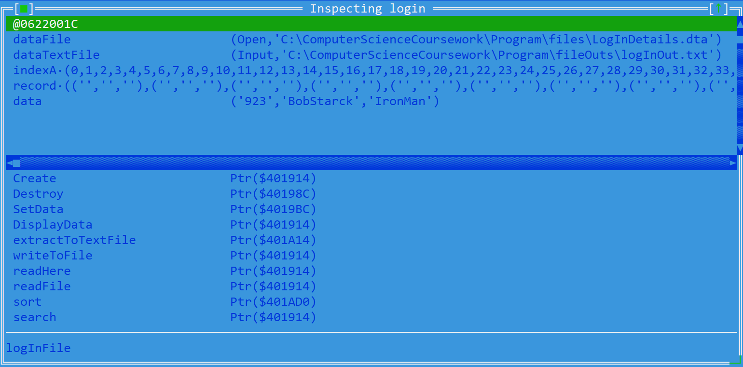
The attribute is set correctly to the data entered
2.3.1 | Class structure  Iteration 0 | To test if it correctly writes the data stored in the current record to the screen. | Person id: 923  Username: BobStarck  Password: IronMan | The data should be outputted to the console  With a method to break apart the record incase many are outputted | See below | n/a
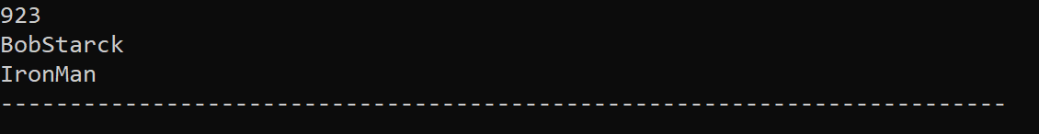

2.4.1 | Class structure  Iteration 0 | Explanation of extract to file | n/a | n/a | n/a | n/a
The method extractToTextFile is a procedure used only for me as the programmer to debug the contents of the file as it is not possible to extract the data in any other way. Evidence of this working is used in the previous iteration and is how I got the data to use as evidence. Evidence

2.5.1 | Class structure  Iteration 0 | Testing to see if I can write back to the file. The data attribute should be written to the file | Person id: 923  Username: BobStarck  Password: IronMan | The first set of data in the file should be the data that was just entered | See below
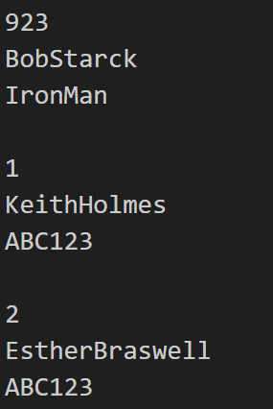
2.6.1 | Class structure  Iteration 0 | Testing the read here method | None needed | 1  KeithHolmes  ABC123  He is the next person to be stored and after the write with BobStarck it should output him next | See Below | n/a
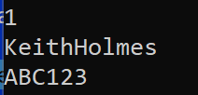
2.7.1 | Class structure  Iteration 0 | To test that the read file from a given position works | Login.readFile(3) | 3  RitaGamble  ABC123 | See below | n/a
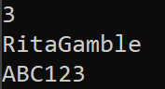

3.8.1 | Class structure  Iteration 0 | To test if the data is placed in the record array and the record id array for sorting | None | The attributes record array to contain all the records in the file and record id array to a single field for each record which will be passed to the search algorithm | See below | n/a
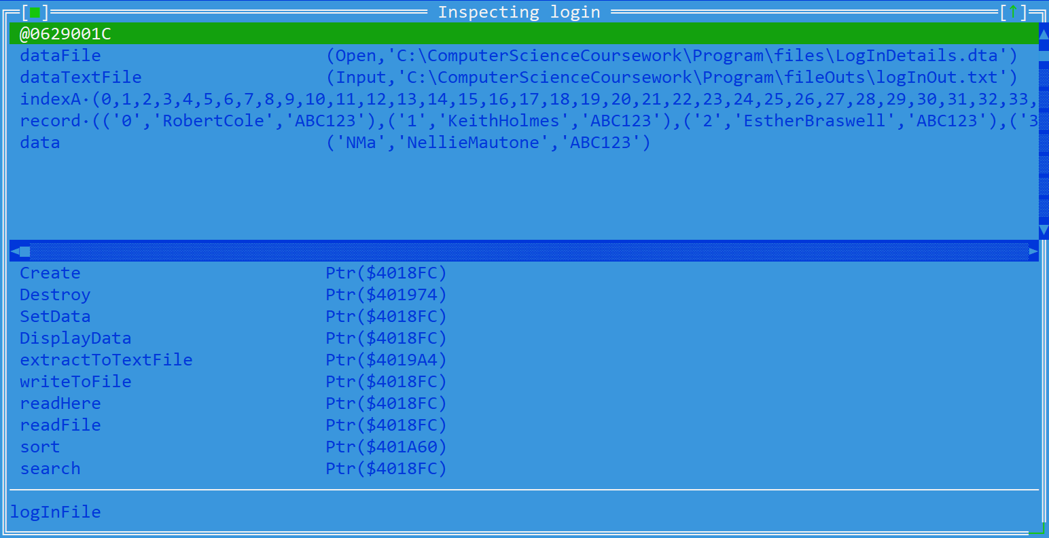
3.9.1 | Class structure  Iteration 0 | To test the file data is passed into the actual search algorithm correctly | None | A 2d array of all the data in the file |  | n/a
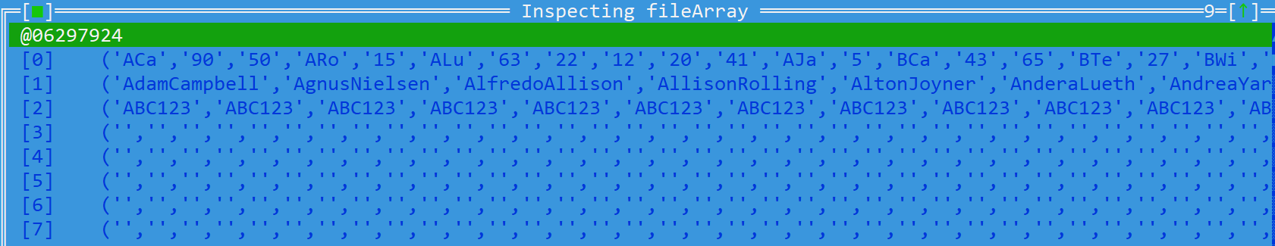
2D array storing all the data from the file
3.10.1 | Class structure  Iteration 0 | To test if the data is sorted and written back to the file when complete | None | The data should be ordered by Username | See below | n/a
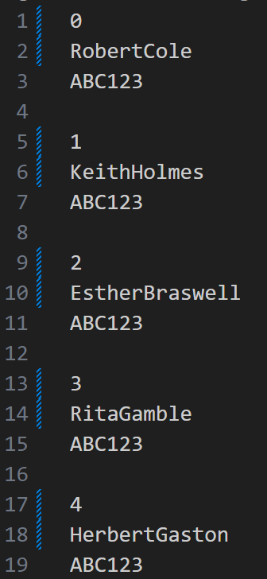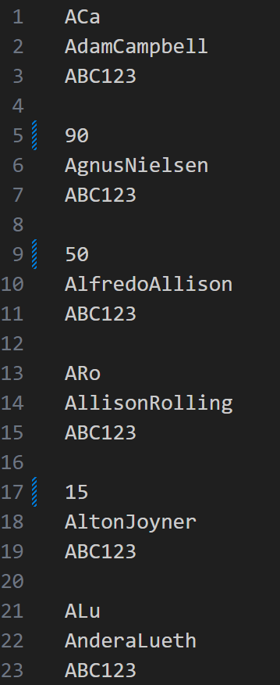
Data after sort, data is ordered by username (the second field)
Data before sort
3.11.1 | Class structure  Iteration 0 | To test if it can find the first person in the file | Search data: RobertCole  Field 1 for username | Found at positions:  0  0  RobertCole  ABC123 | See below | n/a
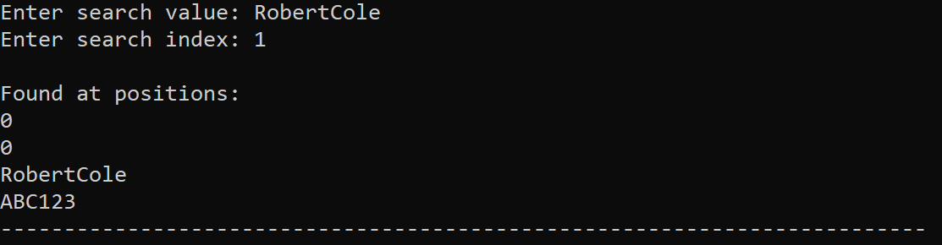
3.11.2 | Class structure  Iteration 0 | To test if it can find the any person in the file | Search data: 8  Field 0 for person id | Found at positions:  8  8  MarylouiseBrooks  ABC123 | See below | n/a
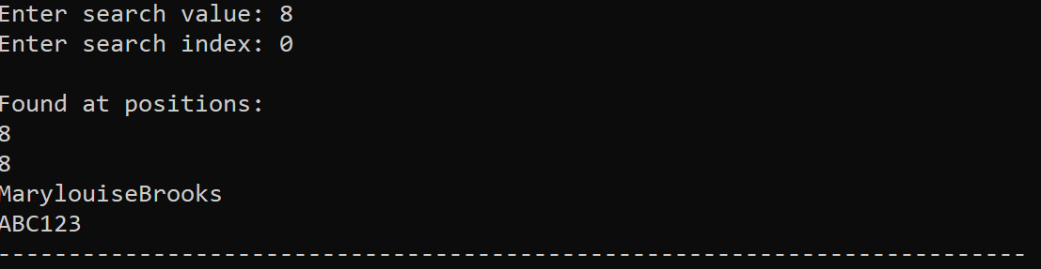
3.11.3 | Class structure  Iteration 0 | To test if it can find multiple person in the file | Search data: ABC123  Field 2 for password | Every person should be output once as all users have password ABC123 | See below | n/a
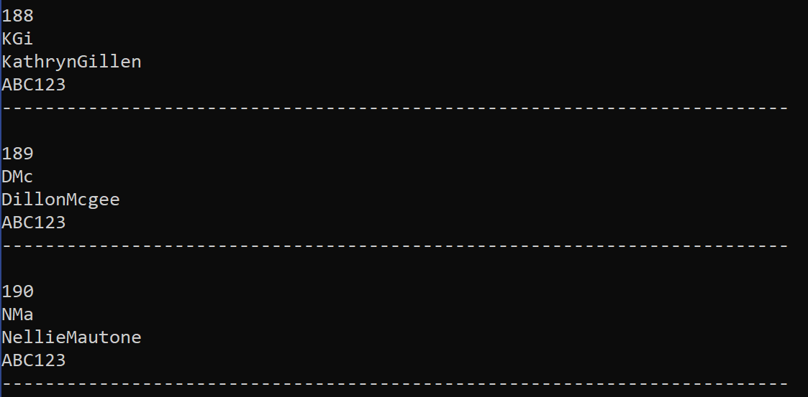
Displays all people as teachers are the last to get added and it ends at 190 people which is where it should end
3.11.4.0 | Class structure  Iteration 0 | TO test case sensitive searching | Search data : robertcole  Field 1 for username | No people found | See below | Add a parameter to bypass force lower if the search needs to be case sensitive
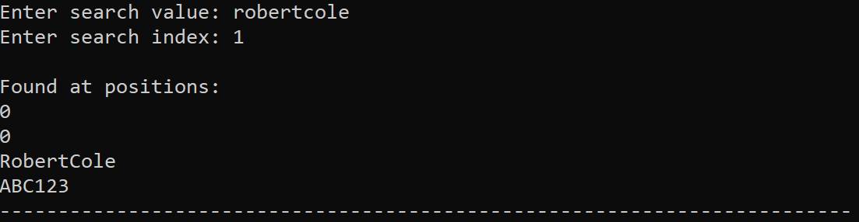

Fix:
procedure Files.search(max, fields : LONGINT; searchValues:ARRAY OF STRING; searchFields: ARRAY OF BYTE; var returnArray : ARRAY OF LONGINT; switchLowerCase : BOOLEAN);
var found : BOOLEAN;
a, b, c, returnIndex : LONGINT;
data : STRING;
begin
//linear search

if switchLowerCase then
begin
for c := 0 to fields do
begin
searchValues[c] := lowerCase(searchValues[c]);
end;
end
else
begin
for c := 0 to fields do
begin
searchValues[c] := searchFields[c];
end;
end;
a := -1;
returnIndex := 0;
//check every value in the 2d array
while a < max do
begin
a := a + 1;
//check each item in the record
for b := 0 TO (fields-1) DO
begin
if switchLowerCase then
begin
data := LowerCase(fileArray[b,a]);
end
else
begin
data := fileArray[b,a];
end;
//check if one piece of data matches
if data = searchValues[0] THEN
begin
found := true;
//check each peice of data in record against data to search for
for c := 0 to (SizeOf(searchFields)-1) do
begin
if switchLowerCase then
begin
data := LowerCase(FileArray[searchFields[c],a]);
end
else
begin
data := FileArray[searchFields[c],a];
end;
//if not all data matches continue search and dont return result
if searchValues[c] <> data THEN
begin
found := false;
break;
end;
end;
//if all data matches add index to the array of found matches
if found = true THEN
begin
returnArray[returnIndex] := a;
returnIndex := returnIndex+1;
break
end;
end;
end;
end;
end;

3.11.4.1 | Class structure  Iteration 1 | TO test case sensitive searching | Search data : robertcole  Field 1 for username | No people found | See below | n/a
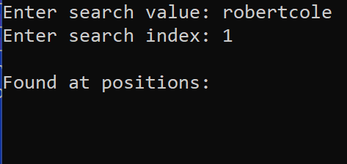
3.11.4.2 | Class structure  Iteration 1 | To test case sensitive searching in a different field | Search data : abc123  Field 2 for password | No people found | See below | n/a
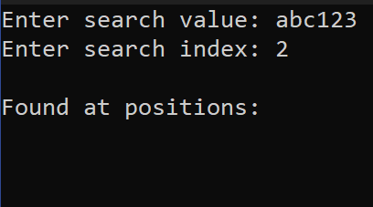
3.11.5 | Class structure  Iteration 1 | Test if it can search using multiple pieces of information | Search data : RobertCole  Field 1 for username  Search data : ABC123  Field 2 for password | Found at positions:  0  0  RobertCole  ABC123 | See below | n/a
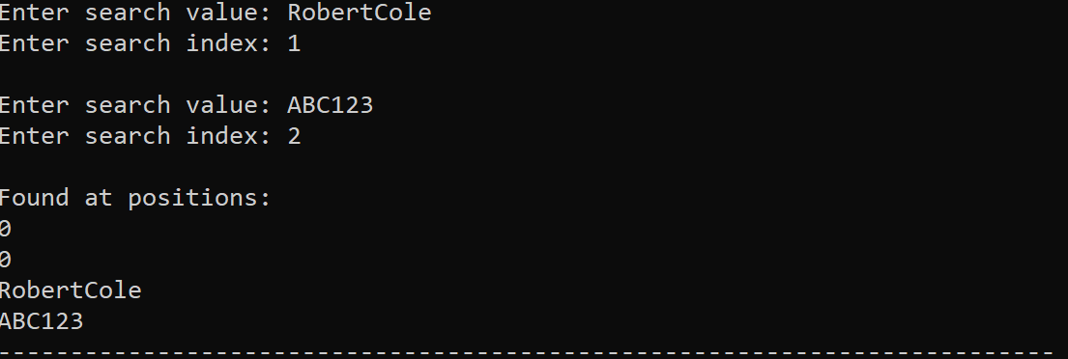

Review
This iteration is purely for use by the programmer. This class structure that I developed allows me to attach extra methods such as sorts and searches to each file allowing for more concise code in the main program. By using inheritance, I created the general sort and search algorithms and place them in a super class, and by creating a class for each file which inherits the methods of the super class each file has a sort and search algorithm attached to it. This will then allow me to just use the methods in the main script without having to write searches and sorts for each file in the main script.

Iteration 4 – Student’s Menu

Aim
The aim in this iteration is to develop a menu in which the student can interact with the system and use it. This will be done using a series of menus which the student should be able to navigate using the keyboard arrow keys. This reduces the chance of the student being able to break the program by keeping the free data input sections to a minimum.

Code
UNIT StudentsMenu;
interface
uses crt, sysutils, VPUtils, studentProcedures, timeTableProcedures,
attendancProcedures, studentClassProcedures,createMenu, writeDesign;

//declaration of all procedures and functions
procedure startStudent(inputStudentId : LONGINT);
procedure CompleteTimeTable(inputDate : TDateTime);
procedure TimeTableMenu;
procedure AttendanceMenu;
procedure LogOutMenu;
procedure mainMenu;

implementation
//declare variables local to this unit
var studentID : LONGINT;
student : StudentFIle;
attendance : AttendanceFile;
timetable : TimeTableFile;
studentClassC : studentClassFile;
studentClassReturnArray : ARRAY[0..1400] OF LONGINT;
timetableReturnArray: ARRAY[0..321] OF LONGINT;
mainMenuOptions : ARRAY[0..2] OF STRING = ('Attendance','Timetable', 'Log Out');
animationTimeTable : BOOLEAN;

//Menu for viewing attendance
procedure AttendanceMenu;
begin
Writeln('Attendance');
readln;
end;

//fill timetable with the data
procedure CompleteTimeTable(inputDate : TDateTime);
var a, b, c, day, NumberOfDays, timeDelay : LONGINT;
CurrentDate : TDateTime;
week : STRING;
stringStudentId : STRING;
//dateArray : ARRAY OF STRING;
begin
//draw basic timetable outline
if animationTimeTable = true THEN
begin
timeDelay := 100;
end
else
begin
timeDelay := 0;
end;
writeDesign.DrawDesign('C:\ComputerScienceCoursework\Program\files\TimeTableLayout.txt', timeDelay);
CurrentDate := inputDate;
day := DayOfWeek(CurrentDate-2);
HideCursor;
//write the dates with current date highlighted
for a := 0 to 4 DO
begin
GOTOXY(5,7+a*4);
if CurrentDate-day+a = Date THEN
TextColor(Yellow)
else
TextColor(White);
write(DateToStr(CurrentDate-day+a));
Delay(timeDelay);
end;
TextColor(White);
//calcualte if it is week A or week B
NumberOfDays := 0;
while StrToDateTime('13/09/2024') + NumberOfDays <> CurrentDate-day+a-1 DO
NumberOfDays := NumberOfDays +1;
NumberOfDays := NumberOfDays DIV 7;
GOTOXY(7,2);
if (NumberOfDays mod 2 = 0 )THEN
week := 'A'
else
week := 'B';
WRITE(week);
//write lessons in timetable
stringStudentId := IntToStr(studentID);
//get all classes which the student is in
studentClassC.search([stringStudentId],[1],studentClassReturnArray);
b := 0;
//for every class
while studentClassReturnArray[b] <> -1 DO
begin
//get the class id
studentClassC.readFile(studentClassReturnArray[b]);
for a := 0 to 320 DO
timetableReturnArray[a] := -1;
//find every time and day that class is on
timetable.search([studentClassC.data.ClassID],[2], timetableReturnArray);
c := 0;
while timetableReturnArray[c] <> -1 DO
begin
//get the day and time for that one time that one class is
timetable.readFile(timetableReturnArray[c]);
//test for the current week
if week = 'A' THEN
begin
//test if the class is on the correct week
if timetable.data.day < 6 THEN
begin
//got to position and write class id
GOTOXY((10*timetable.data.LessonNo+20),( 4*(timetable.data.Day-1)+7));
WRITE(Trim(TimeTable.data.ClassID));
Delay(timeDelay);
end;
end
else
begin
//test if the class is on the correct week
if timetable.data.day > 5 THEN
begin
//got to position and write class id
GOTOXY((10*timetable.data.LessonNo+20),( 4*(timetable.data.Day-6)+7));
WRITE(Trim(TimeTable.data.ClassID));
Delay(timeDelay);
end;
end;
c := c + 1;
end;
b := b + 1;
end;
//write the form data in
for a := 0 TO 4 DO
begin
GOTOXY(21, 4*a+7);
write(student.data.Form);
Delay(timeDelay);
end;
animationTimeTable := false;
end;

//Draw and populate timetable
procedure TimeTableMenu;
var StartDate : TDateTime;
begin
StartDate := Date;
CompleteTimeTable(StartDate);
readln;
end;

procedure LogOutMenu;
begin
writeln('Logging out');
Timetable.free;
studentClassC.free;
student.free;
attendance.free;

Delay(1000);
end;

//main menu
procedure mainMenu;
var choice : LONGINT;
begin
GOTOXY(0,0);
choice := 0;
//get student and attendance data at the start
student.readFile(studentID);
attendance.readFile(studentID);
//main menu display until logout selected
repeat
ClrScr;
HideCursor;
//messages welcoming and displaying overall attendance
writeln('welcome ', student.data.fname, ' ', student.data.sname, ' ');
GOTOXY(1,3);
writeln('Attendance: ', Format('%.2f', [attendance.data.attendance*100]),'%');

//create the menu and start to control it
choice := createMenu.writeMenu([1,5],3,mainMenuOptions, choice);
//test for each menu choice
case choice of
0 : AttendanceMenu;
1 : TimeTableMenu;
2 : LogOutMenu;
end;
until choice = 2;

end;

//declaration of global variables
procedure startStudent(inputStudentId : LONGINT);
var a : LONGINT;
begin
animationTimeTable := true;
//populate arrays with -1
for a := 0 TO 1400 DO
studentClassReturnArray[a] := -1;
for a := 0 to 320 DO
begin
timetableReturnArray[a] := -1;
end;
//declare file objects for this unit
timetable := TimeTableFile.create;
studentClassC := studentClassFile.create;
studentID := inputStudentId;
attendance := AttendanceFile.create;
student := StudentFile.create;
mainMenu;
end;

end.

Testing
Test Number | Program and Iteration | Purpose of test | Data to be entered | Expected result | Actual results | Amendments
4.1.1 | Student Menu  Iteration 0 | TO test if the student home screen is displayed | Username: RobertCole  Password: ABC123 | Welcome Robert Cole  Attendance: 90% (as example)  - Attendance  - Timetable  - Log Out | See below | n/a
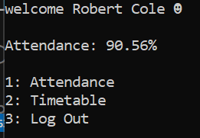
4.2.1 | Student Menu  Iteration 0 | To test if it opens the attendance menu | Username: RobertCole  Password: ABC123  Then menu option 1 | Attendance | See below | n/a
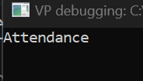
4.2.2 | Student Menu  Iteration 0 | Testing if you can return to the main menu by any key | Username: RobertCole  Password: ABC123  Then menu option 1  Any key press | Welcome Robert Cole  Attendance: 90% (as example)  - Attendance  - Timetable  - Log Out | See below | n/a
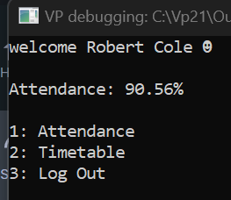
4.3.1 | Student Menu  Iteration 0 | Testing if the timetable is correctly displayed in table format with current date highlighted | Username: RobertCole  Password: ABC123  Then menu option 2  Any key press | Display of timetable with correct date highlighted and classes filled in | See below | n/a
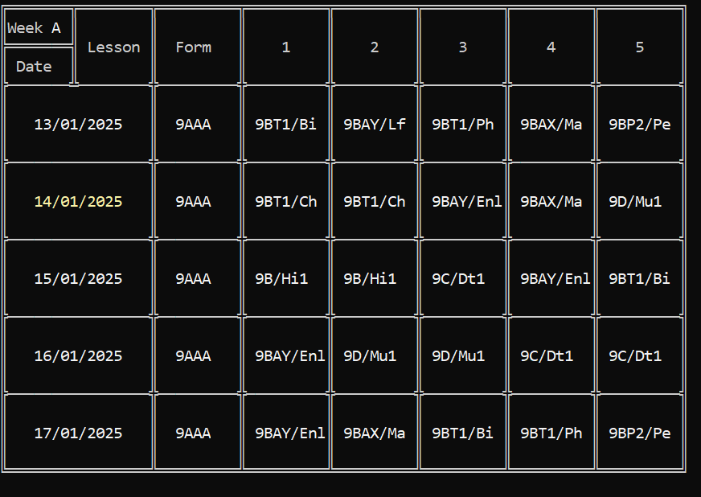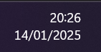

4.3.2 | Student Menu  Iteration 0 | Testing if the program works on a Monday, the first day of a new week | Username: RobertCole  Password: ABC123  Then menu option 2  Any key press | The first date should say 13/0/2025 in yellow | It shows the previous week | Change  day := DayOfWeek(CurrentDate-2);  day := DayOfWeek(CurrentDate-1)-1;  so instead of rolling the week back by one it adjusts it so that Monday is a 0 rather than sunday
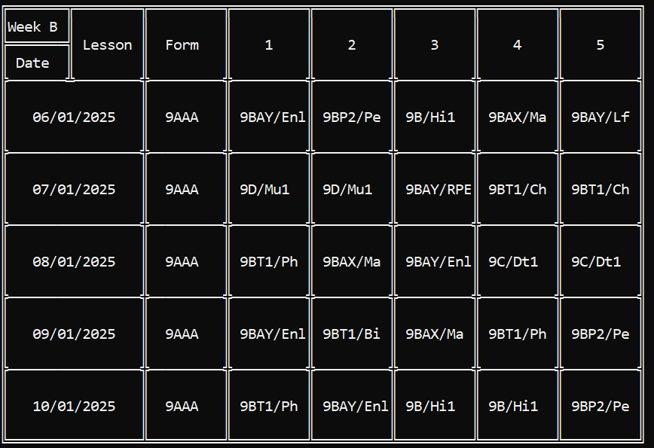
4.3.2 | Student Menu  Iteration 1 | Testing if the program works on a Monday, the first day of a new week | Username: RobertCole  Password: ABC123  Then menu option 2  Any key press | The first date should say 13/0/2025 in yellow | See below | n/a
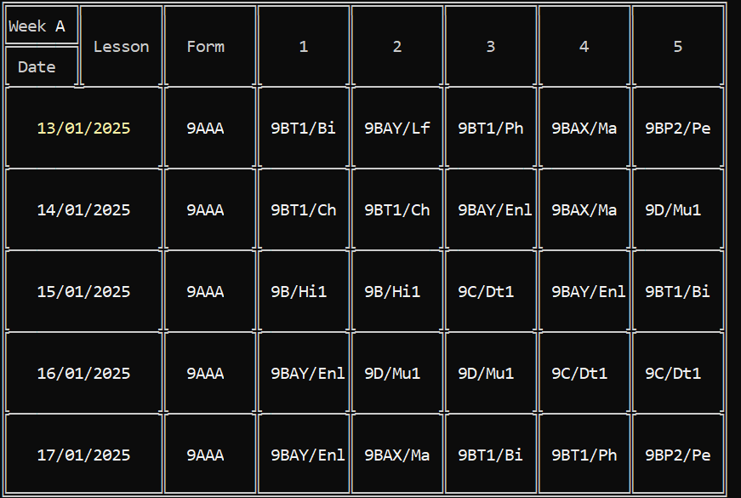

4.3.3 | Student Menu  Iteration 1 | To test the animation runs the first time it is loaded and no others | Enter the timetable menu | Slowly entering the data to create an animation | See below | n/a
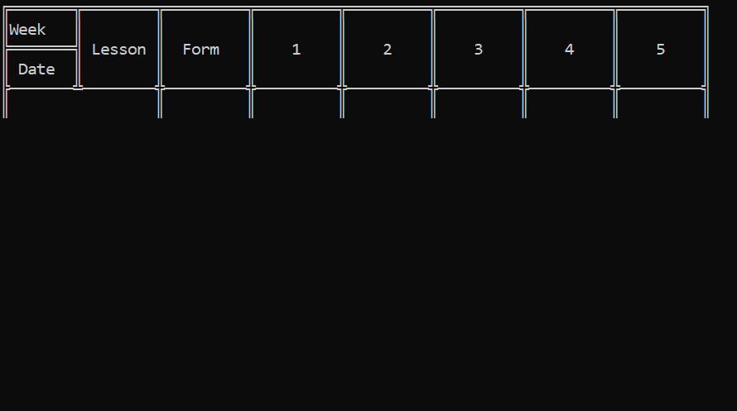

And then second time entering
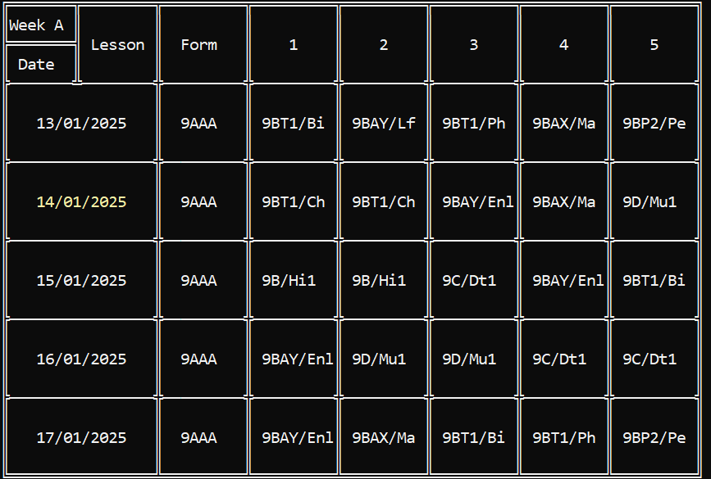
4.4.1 | Student Menu  Iteration 1 | To test the log out works | Enter the menu logout | The program terminates | See below | n/a
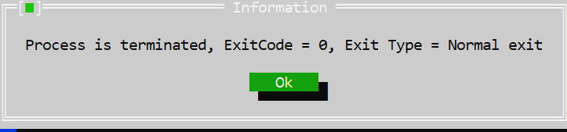

Review
My client has provided quite a lot of useful feedback. She likes the layout of the main menu and how the information is presented nice and concisely, the screen is not too cluttered with many menus. They like the menu options being named appropriately. They really like the timetable formatting and how it is laid out. They also like the quality-of-life feature which highlights the current date in yellow. They enjoy the animation of the timetable drawing itself as it is “appealing to watch”, they also like that it only happens the first time instead of every time. They like the logout button which lets you know its logging out. They however would like me to finish the attendance form as that is not complete.

Iteration 5 – Teacher’s Menu

Aim
The aim of this iteration is to develop a menu for the teacher to interact with. It will have a similar design to the student’s menu in the sense that it will be mostly controlled by menus and using the arrow keys in the menu to reduce the chance of an error by a mis tap.

Code
UNIT TeachersMenu;
interface
uses crt, sysutils;
procedure startTeacher;
implementation
//main menu
procedure startTeacher;
begin
//debug to prove it works
writeln('welcome teacher');
readln;
end;

end.

Testing
Test Number | Program and Iteration | Purpose of test | Data to be entered | Expected result | Actual results | Amendments
5.1.1 | Teachers Menu | Test if the menu is run | Logged into a teacher | Welcome teacher | See below | n/a
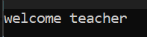

Review
My client didn’t have much to say about this other than its missing all of the functionality.

Iteration 6 – Main Program

Aim
The aim of this iteration is to make a singular program which the client will run, and it will include all aspects of the solution. This keeps the program modular by only having a small section that needs to be tested. In this iteration only the login code is run and then it chooses another unit to go into based on whether a student or teacher logged in. Keeping each part of the solution separate allows for easier testing and making sure very unit works before integrating it.

Code
PROGRAM Main;
//declare all units to be used
USES Crt, Sysutils, LogInScreen, loading, LogInProcedures,
TeachersMenu, StudentsMenu;
var userType : STRING;
intUserID : LONGINT;

//declare main program
function start:STRING;
var i, ErrCode, userIndex : LONGINT;
userId : STRING;
userDetailsArray : ARRAY[0..1] OF STRING;
logIn : logInFile;
percentDone : REAL;
logedIn : BOOLEAN;
begin
//declare login file
logIn := logInFile.create;
logIn.sort;
userIndex := -1;

//while loop to keep running log in attempts
logedIn := false;
while logedIn = false do
begin
ClrScr;
//login methods
LogInScreen.startLogIn(userDetailsArray);
logIn.search(userDetailsArray,[1,2], userIndex, false);
loading.startLoading('L', percentDone);
Delay(1000);
loading.silentKillLoading;
Delay(100);
//test username and password are valid
if userIndex = -1 THEN
begin
writeln('Username Or Password is incorrect.');
readkey;
end
else
begin
logedIn := true;
//get the user info
login.readFile(userIndex);
//test if the username and password belong to a teacher or student
userId := Trim(login.data.PersonID);
val(userid,intUserID,ErrCode);
if ErrCode <> 0 THEN
begin
start := 'T';
end
else
begin
start := 'S';
end;
end;

end;
//delete login file object
logIn.free;
end;

begin
//start login
userType := start;
if userType = 'T' THEN
//teacher menu
TeachersMenu.startTeacher
else if userType = 'S' THEN
//student menu
StudentsMenu.startStudent(intUserID)
end;
end.

Testing
Entering a valid username and password for a teacher accounts logs you into the teacher account.
Test Number | Program and Iteration | Purpose of test | Data to be entered | Expected result | Actual results | Amendments
6.1.1 | Main  Iteration 0 | To test if it passes correctly onto the student unit | Username: RobertCole  Password: ABC123 | Welcome Robert Cole  Attendance: 90% (as example)  - Attendance  - Timetable  - Log Outd | See below | n/a
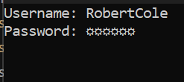
Evidence to show it brings up the login menu with data entered

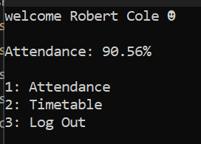
Evidence of the student menu showing up after entering valid username and password
6.2.1 | Main  Iteration 0 | To test if it passes correctly onto the teacher unit | Username: JessicaBowman  Password: ABC123 | Welcome Teacher | See below | n/a
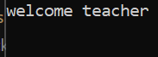

6.3.1 | Main  Iteration 0 | Test if incorrect username is entered then it requests the user to enter it again | Username: MrMartin  Password: ABC123  Evidence of invalid user data being entered to test it rejects the entered data | Username Or Password is incorrect. | See below | n/a
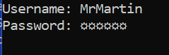
Evidence of it rejecting the information

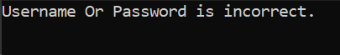

Review
My client made most of her comments in the review of iteration 0 about the login screen. But she likes the loading bit before you go into the actual menu.

