Contents
Design 2
Introduction 2
Problem Decomposition 3
Required Files and Entity Relationship Diagrams (ERDs) 4
Initial data files with justification 4
Entity Relationship Diagram 5
Linear Search 6
Top-Down-Design - Linear Search 6
Pseudocode – Linear Search 7
Binary Search 8
Top-Down Design – Binary Search 8
Pseudocode – Binary Search 9
Searching 10
Top-Down Design Searching 10
Pseudocode – Searching 11
Loading 12
Top Down Design – Loading 12
Pseudocode – Loading 14
Create Files 17
Top-Down Design - Create Files 17
Pseudocode – Create Files 22

Design

Introduction
The design of my solution should be simple and user friendly on the front end while maintaining a strong structure which can be used to easily expand the programme later. Both layout and user interactions should be simple and self-explanatory, this is to avoid complications and reduce the time the user must spend either searching through menus or working out how to input the data. Repeated delays in processes like this will cause frustration as it takes valuable time out of the user, which could be used to do other tasks. Ambiguous input methods can cause errors which can interfere with the integrity of the data and cause issues when it comes to analysing the data.
The overarching theme in the coursework will be consistent with itself, the user will always be interacting with the programme in the same way, by keyboard entry. The use of only the keyboard allows for simple entry methods which allows for menus to be navigated through faster and more easily than a mouse would allow. Being able to complete tasks fast is paramount to my solution as it will allow the user to quickly view the information without spending too much time either trying to find it or having it in an uneasily readable format.
Information in a box styled like this will be used to explain validatoin
Information in a box styled like this will be used to explain user friendliness
Information in a box styled like this will be used to explain elements of code

Problem Decomposition
The order of development will allow both my client and I to have a clear understanding of what is being done when and why. It will also allow her to query any concerns during development.
Iteration Number | Feature | Justification for order
0 | Generic Functions | This iteration will contain generic procedures such as sorts and searches of arrays. Any other extra information units such as the progress bar and loading screens. This must be the first thing to be done as it is used in future iterations and it allows time for my client to make any changes to what they want
1 | Creating initial data | All initial data must be generated before the main programme can do its tasks as all procedures in the programme rely on displaying, adding or updating the data. Thus, all the files and the data contained in them must be generated first
2 | Class Structure | To create a strong structure throughout the programme I decided to have each file as a class so I can attach my own methods to it. This must also be done before the main programme so that the main programme can take advantage of this structure.
3 | Login Menu | Before accessing any data, the user must log into an account to ensure that they can only see data they are permitted to access. Therefore, this section should be developed before the menus for each user
4 | Student Menu | The students need a base menu which they can use to access the data which my client decides that they needed to be able to see. This will directly connect to the output of the login menu script
5 | Teacher Menu | The teachers will also need their own menu to view, and add/change data as required, due the teacher menu having far more tasks to achieve io decided to do this after the student menu. This will also be a directly connected to the output of the login menu

Required Files and Entity Relationship Diagrams (ERDs)

Initial data files with justification
File Name | Justification
Timetable file | This file is required so that all the data about when which lessons are. And can therefore be used to store data about when registers where taken and feedback the data in a more readable format.
Student File | This file is required so that the data about each student can be stored and searched through as well
Attendance file | This file stores all the data about each student and their attendance, which is the main area of focus for my programme
Teacher File | Stores data about the teachers so that the teachers have an area to log into and perform teacher only actions such as taking the register.
Login details file | The log in details file is required so that searching for usernames is faster as all available logins are in one file and sorted by username so a binary search can be done on the data to increase search speeds
Form File | The form file is necessary to keep track of which student is in what form and thus give the form tutor access to the attendance data of that student in a more convenient manner
Class File | Includes the data about all the classes and what subject is taught in each class. This is required so that students can be part of a class, and so registers can be taken
Subject File | This is required so data about which subjects are available and so that classes can be filtered out by subject
Register File | This stores all the data about all registers. This is critical as to manage attendance you need to have registers to get the data to calculate the attendance from.
Student Class Resolver File | This resolves the many-to-many issue with the student and class file, where multiple students can be in 1 class and each student can be in multiple classes.
Teacher Class Resolver File | This is required to solve the issue of the many-to-many relation between the teacher and class file.
Teacher Subject Resolver File | This resolver file is required to resolve the subject file and teacher file, breaking the many-to-many relation into 2 1 to many relations

Entity Relationship Diagram
Note for sir, should there be a link here?
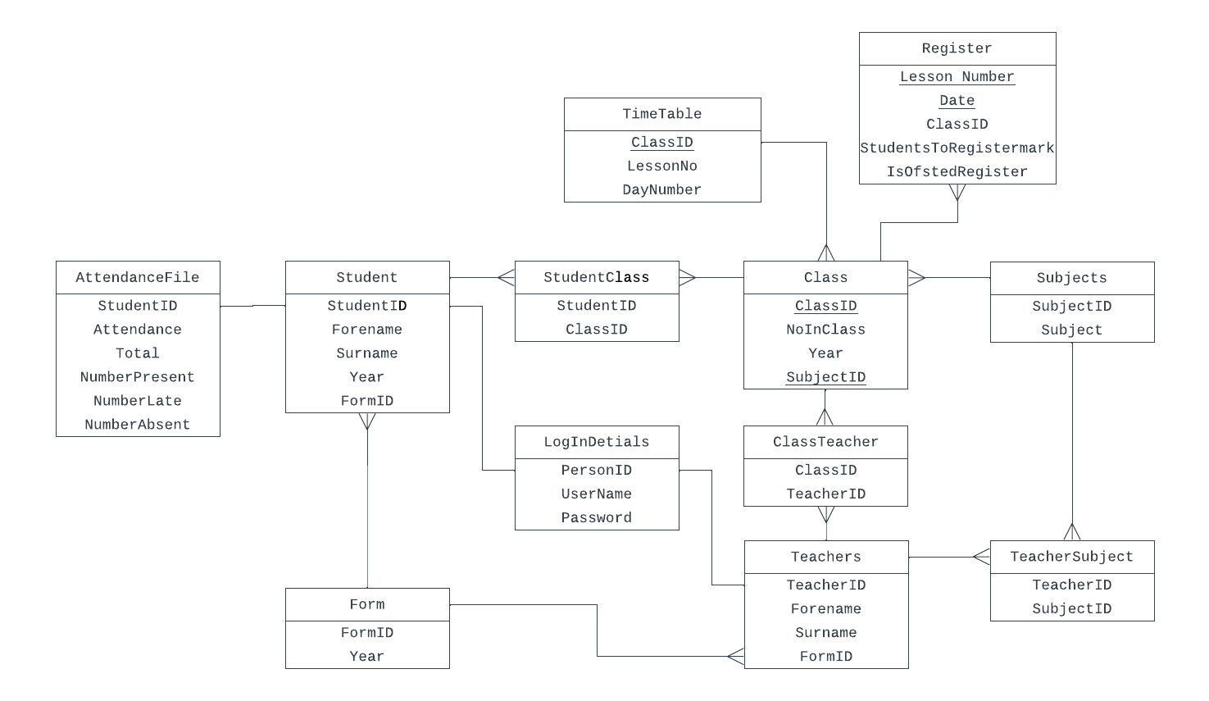

Linear Search

Top-Down-Design - Linear Search
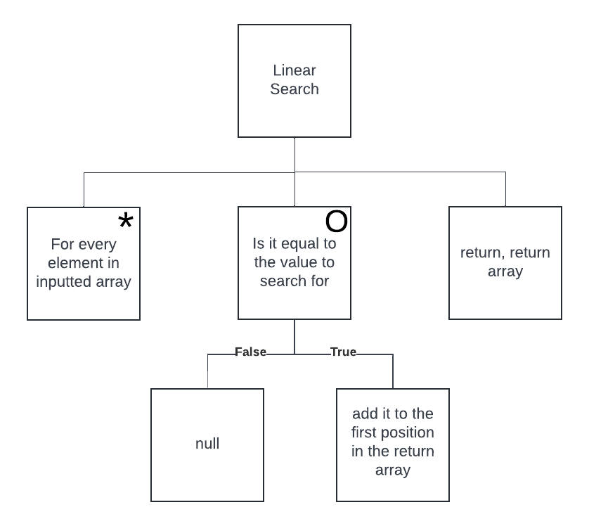
Return the array of all the positions of found values back into the main program
If the values are equal, add the index of the value to another array
Check if the value is the same as the value that is being searched for
Iterate through every item in the list inputted into the procedure

Pseudocode – Linear Search
Declares this section as a unit. So all procedures are made public and usable by other programs as long as it is declared in the use of the other programs

UNIT LinearSearch
INTERFACE

USES CRT, SYSUTILS

PROCEDURE LinearSearchFunction(low, high : LONGINT searchValue : STRING UserArray : ARRAY OF STRING var returnArray : ARRAY OF INTEGER var numberDone : LONGINT)
BEGIN
Declare counting variables for indexing the array with
i = -1
a = 0
REPEAT
i = i+1
numberDone = numberDone +1
if userArray[i] = searchValue THEN
Testing the value in the array with the value that is being searched for
begin
returnArray[a] = i
a = a + 1
end
UNTIL (i = high)
END
Add the index to an array, which in this procedure is a pointer to an array in the main program.

END.
Keep iterating until the end is marked, which is set by the programmer

Binary Search

Top-Down Design – Binary Search
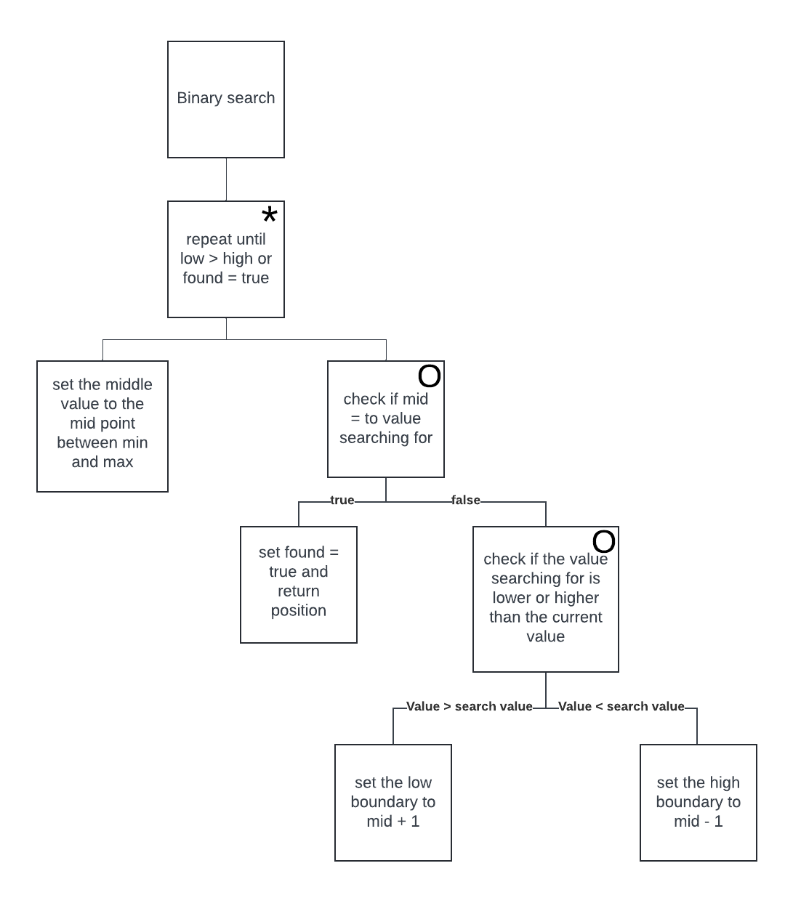
Increase the min search index to mid +1
If too high drop the max search index to the mid -1
Check which half the value is in
Cut the list in half
Repeat until either the value is found or it is not in the list if it is order

Pseudocode – Binary Search
UNIT BinarySearch

USES CRT, SYSUTILS

PROCEDURE BinarySearchFunction(UserArray, var returnArray, low, high, searchValue)
BEGIN
Start with mid as middle of array
REPEAT
mid = (low+high) DIV 2
IF UserArray[mid] != searchValue THEN
BEGIN
Test if value is not found
IF UserArray[mid] > searchValue THEN
BEGIN
low = mid +1
Find if the item of data is above or below the current middle point
END
ELSE
BEGIN
high = mid -1
END
END
ELSE
BEGIN
If value is found, set value to return array
returnArray[0] = mid
shouldEnd = true
END
Repeat until found or not in array
UNTIL (shouldEnd == true) OR (low > high)

END

END.

Searching

Top-Down Design Searching
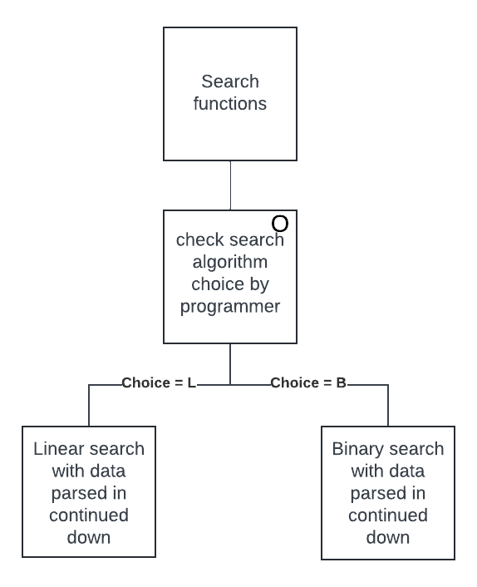
Generic procedure so only one parameters has to be changed to be able choose between linear and binary search with any other parameters remaining the same

Pseudocode – Searching
All data is parsed in to this one procedure and is then manipulated
Uses the two search algorithm units
UNIT Search

USES CRT, SYSUTILS, BinarySearch, LinearSearch

PROCEDURE SearchFunctions(SearchType, x, y, findValue, UserArray, var returnArray, var numberDone)
BEGIN
IF SearchType == 'L' THEN
LinearSearch.LinearSearchFunction(x,y,FindValue,UserArray,returnArray,numberDone)
IF SearchType == 'B' THEN
BinarySearch.BinarySearchFunction(UserArray,ReturnArray,x,y,FindValue)
END

END.
Choice between linear search and binary search, with all data automatically being parsed down

Loading

Top Down Design – Loading
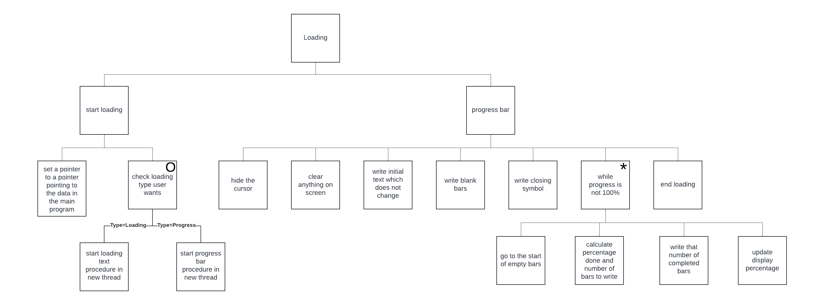
Calls the end loading function
Fill blank spaces with ░
Write
Progress╣
As a constant start that doesn’t change
Creates a pointer to the variable in the main program which stores the percent done, in real format. This is so I don’t have to keep recalling the function and it updates automatically
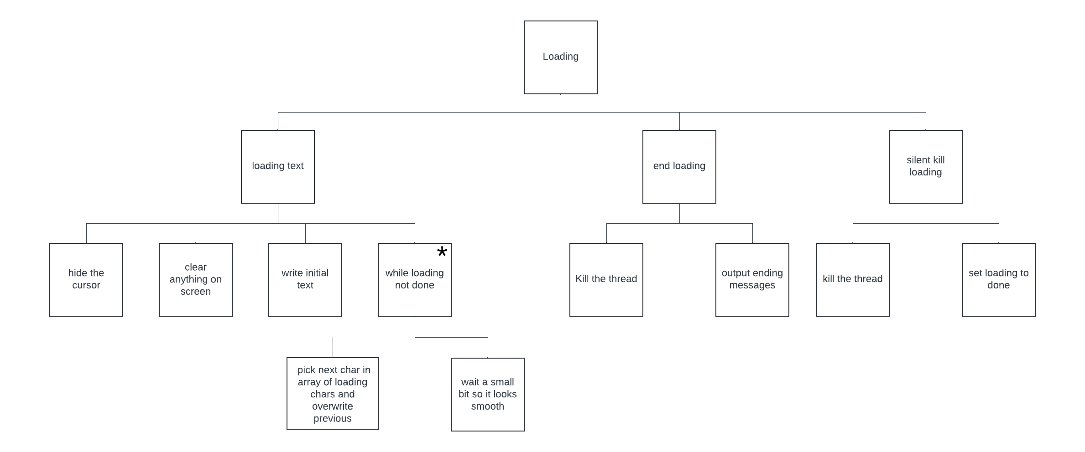
Kill the thread so the programme is flooded with random threads taking up processing power
Kill the thread so the programme is flooded with random threads taking up processing power
Writes
Loading…
Wait 100ms for changing, as its part of a thread it doesn’t stop main programme
Pick the next char from [/, —, \, |] and append it to the loading text

Pseudocode – Loading
Unit so other programmes can use its functions
unit loading

const LoadingSymbols : ARRAY[1..4] OF CHAR = ('/',#196,'\','|')

function loadingText(pointer)
Declare the array for the spinning characters
begin
HideCursor
a = 1
ClrScr
while (not loadingDone) DO
Begin
WRITELN('Loading... ' + LoadingSymbols[a])
a = a+1
if a > 4 THEN
Write Loading… with next spinning char
a = 1
Delay(100)
GoToXY(1,1)
DelLine
Increase and loop a so it goes between 1 and 4 for each char
end

end

function loadingBar(pointer) : LONGINT
begin
HideCursor
ClrScr
Write
Progress ╣░░░░░░░░░░░░░░░░░░░░╠
As the start 0 % bar

Write('Progress ',#185)
percentDone = 0.0*100
for c= 0 TO 20 DO
write(#176)
write(#204)
completeBars = 0
Go to after the progress bar and write the current percentage done

while percentDone < 100.0 DO
begin
gotoxy(33,1)
Write(percentDone:4:0,'%')
Get the new percent done and find out how many bars should be coloured in

percentDone = (percentPtr^)*100
completeBars = floor((percentPtr^)*20)
gotoxy(11,1)
for d = 0 to completeBars DO
begin
Go to start of the progress bar and write that many completed bars in

write(#219)
end
end
clrscr
EndLoading
end

procedure StartLoading(loadingType, var percentIn)
begin
Set start run time to current real world time
startRunTime = Time
loadingDone = false
Create a pointer to the memory address where the percent done is stored in the main programme
percentPtr = @percentIn
if loadingType = 'L' THEN
VPBeginThread(loadingText,1,nil)
else if loadingType = 'P' THEN
VPBeginThread(loadingBar,1,nil)
Choose the loading type and begin a new separate thread with the loading procedure running in that new thread
End

procedure EndLoading
Kill the thread with the loading procedure to save resources
begin
KillThread(1)
loadingDone = true
WRITELN('Done!☺')
Write time elapsed since start
endRunTime = Time
Delay(500)
ClrScr
writeln('Time elapsed: ',TimeToStr(endRunTime - startRunTime))
ShowCursor
end

procedure silentKillLoading
begin
Write Kill the thread with the loading procedure to save resources
elapsed since start
KillThread(1)
loadingDone = true
ClrScr
ShowCursor
Clear up any changes in the background so the user doesn’t see the changes
end
end.

Create Files

Top-Down Design - Create Files
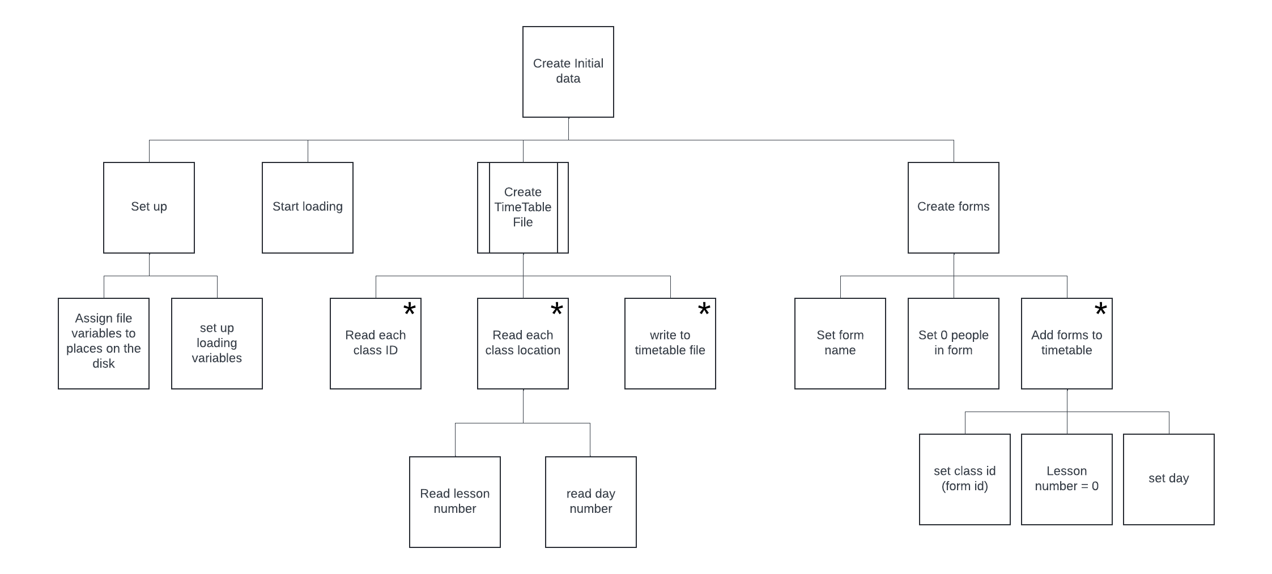
Lesson Number being 0 to 5, 5 lessons, 1 form time
Day number being from 0 to 9, 2 week alternating timetable with no option for weekends
Keep iterating until all data is extracted from the timetable text file I created from and existing timetable
Keep iterating until all data is extracted from the timetable text file I created from and existing timetable
Keep iterating until all data is extracted from the timetable text file I created from and existing timetable
This will iterate until each form is stored in the time table for every day

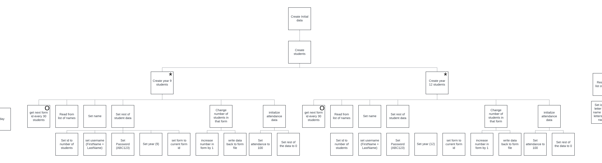
Every 30 students read next form in form file
Create 20 year 12 students as that is enough to perfectly fill every class

Create 120 year 9 students as that is enough to perfectly fill every class

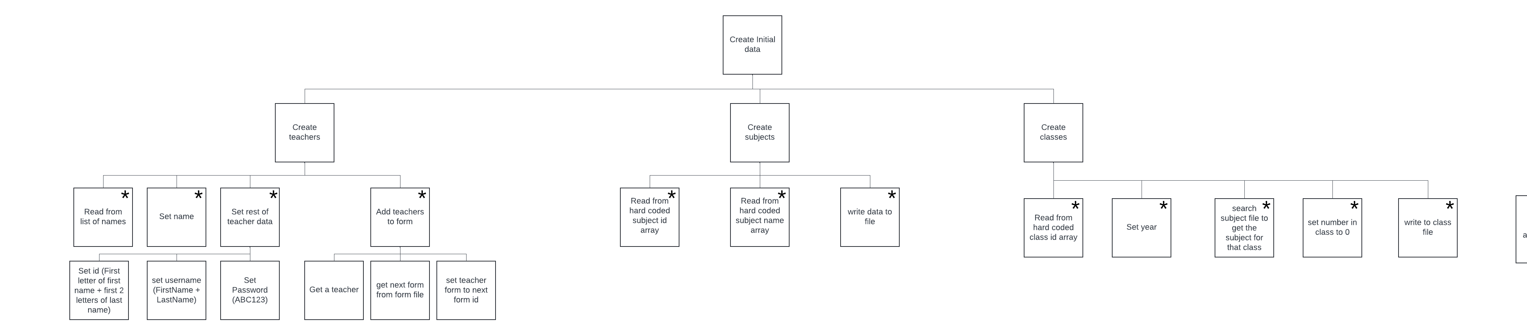
Loop until all classes are stored in the file
Create 51 teachers, 1 per class

For each teacher assign them to one class
Goes through every student assigning classes to them
Keeps trying to randomly assign a student to a class which isn’t full
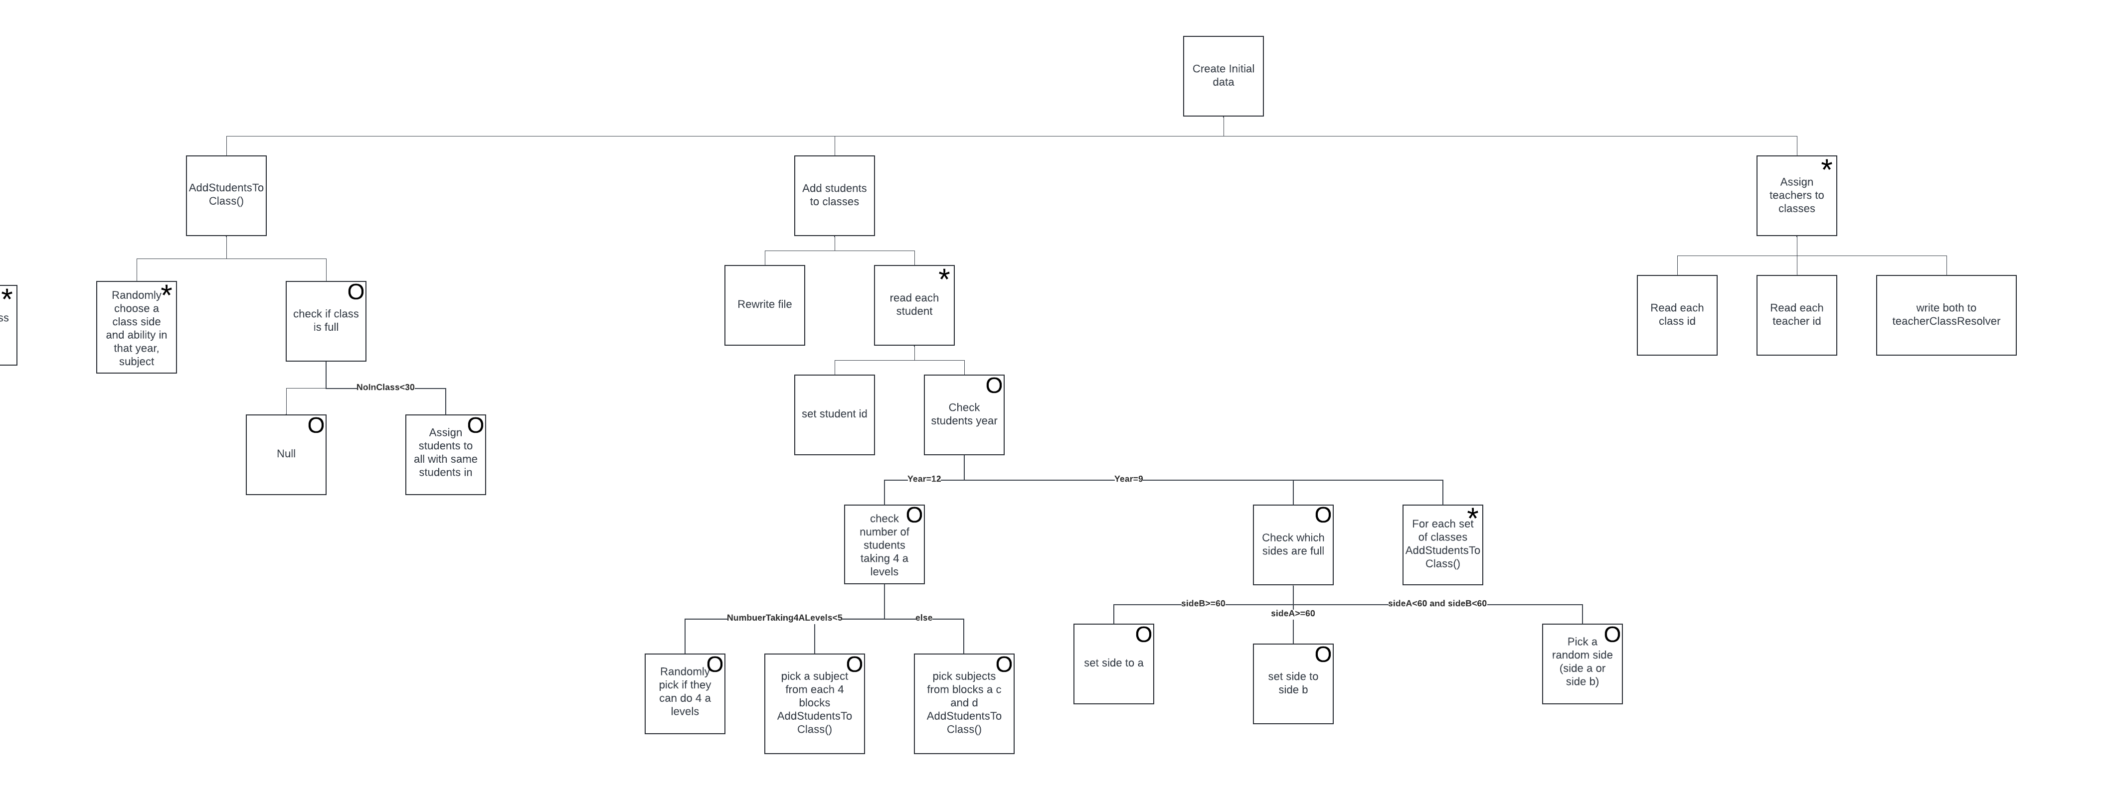
Randomly pick who is doing 4 a levels while keeping it below a set maximum
Check whether the student should be in, side A or side b without overflowing one side

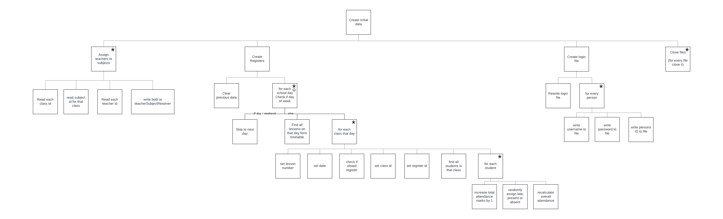
For each student in that class
For every day it is not a weekend
For every teacher find the class they teach, then the subject of that class and

Pseudocode – Create Files
Declare all the units to use in this script
PROGRAM CreateFiles
uses crt, sysutils, search, loading, DisplayErrorScrn, math
Set the loading variables up, the percent done and total tasks to do
PROCEDURE initialiseFiles //assign places on drive to identifiers
BEGIN
percentComplete = 0.0 //initializing percentDone and total iterations
total = 0
//assigning a place on the drive to the files
Reference a place on the drive where the timetable is stored in a text file
TimeTableTextFile = openRead('C:\\ComputerScienceCoursework\\Program\\files\\TimeTableText.txt')
TimeTableFile = openRead('C:\\ComputerScienceCoursework\\Program\\files\\TimeTable.dta')
total = total + 51

RegisterFile = openRead('C:\\ComputerScienceCoursework\\Program\\files\\Registers.dta')
Reference a place on the drive where a list of first and surnames are stored
total = total + 60

NameFile = openRead('C:\\ComputerScienceCoursework\\Program\\files\\Names.txt')
StudentFile = openRead('C:\\ComputerScienceCoursework\\Program\\files\\Students.dta')
total = total + 140

TeacherFile = openRead('C:\\ComputerScienceCoursework\\Program\\files\\Teachers.dta')
Assign all variables a space on the drive
total = total + 51

classFile = openRead('C:\\ComputerScienceCoursework\\Program\\files\\classes.dta')
total = total + 51

subjectFile = openRead('C:\\ComputerScienceCoursework\\Program\\files\\subjects.dta')
total = total + 21

studentClassResolverFile = openRead('C:\\ComputerScienceCoursework\\Program\\files\\studentClassResolver.dta')
total = total + 140

teacherSubjectResolverFile = openRead('C:\\ComputerScienceCoursework\\Program\\files\\teacherSubjectResolver.dta')
total = total + 51

teacherClassResolverFile = openRead('C:\\ComputerScienceCoursework\\Program\\files\\teacherClassResolver.dta')
total = total + 51

FormFile = openRead('C:\\ComputerScienceCoursework\\Program\\files\\forms.dta')
total = total + 5

AttendanceFile = openRead('C:\\ComputerScienceCoursework\\Program\\files\\attendanceFile.dta')

LogInDetailsFile = openRead('C:\\ComputerScienceCoursework\\Program\\files\\LogInDetails.dta')

total = total + 191
END

PROCEDURE closeAllFiles
BEGIN
//closing all files to confirm all changes are fully written and complete
TimeTableTextFile.close()
TimeTableFile.close()
RegisterFile.close()
Close each file to ensure that all data is successfully written to the respective files so data integrity is kept
NameFile.close()
StudentFile.close()
TeacherFile.close()
classFile.close()
subjectFile.close()
studentClassResolverFile.close()
teacherSubjectResolverFile.close()
teacherClassResolverFile.close()
FormFile.close()
AttendanceFile.close()
LogInDetailsFile.close()
END
Setup files ready to be used in this procedure
PROCEDURE CreateTimeTable
BEGIN
reset(TimeTableTextFile
Take all the data from the timetable text file
REWRITE(TimeTableFile)
//iterate UNTIL all data is extracted
WHILE NOT EOF(TimeTableTextFile) DO
BEGIN
numberDone = numberDone +1
Read the class id into the program and store it in a record
percentComplete = numberDone/total
READLINE(TimeTableTextFile,TimeTableInfoFromFile) //get the class id
//assign it to the record variable
Iterate until all days and time have been extracted from the text file into the record and written to the data file
TimeTable.ClassId = TimeTableInfoFromFile

//for when ever that class is
REPEAT
READLINE(TimeTableTextFile,TimeTableInfoFromFile)
TimeTable.LessonNo = StrToInt(TimeTableInfoFromFile)
READLINE(TimeTableTextFile,TimeTableInfoFromFile)
TimeTable.Day = StrToInt(TimeTableInfoFromFile)
READLINE(TimeTableTextFile,TimeTableInfoFromFile)
WRITE(TimeTableFile,TimeTable)
UNTIL TimeTableInfoFromFile == 'Q' //REPEAT UNTIL all dates are read and stored in the .dta file
FOR that class marked by a Q in the text file
END
END

PROCEDURE addForms
BEGIN
REWRITE(FormFile)
FOR i = 0 to 3 DO //iterate FOR all 4, year 9 forms
BEGIN
numberDone = numberDone + 1
percentComplete = numberDone / total
Create 4 year 9 forms with unique identifiers, and 0 kids in the class
//create 4 unique FOR identifiers
form.formID = '9' + 'AA' + Chr(i +65)
form.NumberInForm = 0
WRITE(FormFile, form) //push data to file
END
numberDone = numberDone + 1
percentComplete = numberDone / total
form.formID = '12' + 'AAA' //DO the same FOR 1 year 12 form
form.NumberInForm = 0
Create 1 year 12 class with similar data, but altered form identifier
WRITE(FormFile,form)
reset(FormFile) //set point to start of form file
FOR i = 0 to 4 DO //FOR every form
BEGIN
READ(formFile,form)
timetable.classid = form.formID //get form id into a timetable class id variable
FOR a = 0 to 9 DO //add it to the file as lesson 0 FOR every morning in the 2 week timetable
BEGIN
Write the when the forms are to the timetable file
timetable.LessonNo = 0
timetable.Day = a
WRITE(TimeTableFile, timetable) //add new data to timetable file
END
END
END

PROCEDURE createRegisters
BEGIN
Set data file for use to create register files
//set up files and reset file pointers
reset(TimeTableFile)
reset(studentClassResolverFile)
RESET(StudentFIle)
reWRITE(RegisterFile)
i = 0
startDate = '13/09/2024'
//populating the ARRAYs with the data from the files
Extract data from files into arrays which can be searched
FOR i = 0 To 139 DO
BEGIN
READ(StudentFile,Student)
studentFormIdArray[i] = Student.Form
returnStudentFormIdArray[i] = -1
END
i = 0
WHILE NOT(eof(TimeTableFile)) DO
BEGIN
READ(TimeTableFile,TimeTable)
dayArray[i] = IntToStr(TimeTable.day)
dayReturnArray[i] = -1
i = i +1
END
i = 0
WHILE NOT(eof(studentClassResolverFile)) DO
BEGIN
READ(studentClassResolverFile,studentClassResolver)
studentClassResolverClassArray[i] = studentClassResolver.ClassID
classReturnArray[i] = -1
i = i +1
Create 30 days of registers
END
b = 0

// FOR loop FOR number of days with registers
FOR i = 0 to 29 DO
BEGIN
Find the day number of the week correcting it to between 1 and 7
//gets the number day of the week and corrects to monday being 1
day = DayOfWeek(StrToDate(startDate)+b-1)
IF (day == 7) OR (day == 6) THEN //IF weekend decrease FOR loop VAR by 1
BEGIN
i = i -1
Check if it is a weekend, if so decrease I by 1 so day is not counted towards total
end
ELSE
Set up array for searching for all classes in current day
BEGIN
numberDone = numberDone +1
percentComplete = numberDone / total
//clear out ARRAY FOR searching FOR classes on that day
FOR c = 0 TO 269 DO
Search for all classes that day
dayReturnArray[c] = -1
Search.SearchFunctions('L',0,269,IntToStr(DayOfWeek(StrToDate(startDate)+b-1)),dayArray,dayReturnArray,empty)
a = 0
For every class found on that day
while dayReturnArray[a] != -1 DO // FOR every class on that day
BEGIN
Get day information and add that all to the register record
//find and get the data about one class
SEEK(TimeTableFile,dayReturnArray[a])
READ(TimeTableFile, TimeTable)
//set register data
Register.LessonNo = TimeTable.LessonNo
Register.Date = StrToDate(startDate)+b
Get the class id and register id and write it to the record
IF TimeTable.LessonNo == 4 THEN
Register.isOfstedRegister = true
ELSE
Register.isOfstedRegister = false
Register.classID = ''
Register.classID = TimeTable.classID
register.registerID = IntToStr(register.lessonNo) + register.classID + DateTimeToStr(register.date)
classId = format('%s',[Register.classID])
//clear out ARRAY FOR searching FOR students in that class
Flush out previous data from search so it can be used to find all student in that class
FOR c = 0 to 1384 DO
begin
classReturnArray[c] = -1
end Search.SearchFunctions('L',0,1384,Register.ClassID,studentClassResolverClassArray,classReturnArray,empty)
c=0
Find all student in that class and iterate through each of them
//FOR every student in that class
while classReturnArray[c] != -1 DO
BEGIN
//get the class with the studenet in
SEEK(studentClassResolverFile, classReturnArray[c])
READ(studentClassResolverFile, studentClassResolver)
//get the student id
studentRegisterMark.studentID = studentClassResolver.studentID
Get the students id in the 2d array of register marks
//get the data in the attendance file
SEEK(AttendanceFile,studentClassResolver.studentID)
READ(AttendanceFile,Attendance)
Attendance.Total = Attendance.Total +1
Change students total attendance marks
//ranDOmly assign the student a mark
ranDOmMark = RANDOM(100)
IF ranDOmMark <= 90 THEN
BEGIN
studentRegisterMark.registerMark = 'P'
Randomly assign the student a register mark, present, late or absent and add it to the 2d array of register marks
Attendance.NumberPresent = Attendance.NumberPresent + 1
end
ELSE IF ranDOmMark <= 97 THEN
BEGIN
studentRegisterMark.registerMark = 'L'
Attendance.NumberLate = Attendance.NumberLate + 1
end
ELSE
BEGIN
Write the student id and mark array to the record 2d array of register marks
studentRegisterMark.registerMark = 'A'
Attendance.NumberAbsent = Attendance.NumberAbsent + 1
END
//write data back to register file
Register.registerMarks[c] = studentRegisterMark
SEEK(AttendanceFile,FilePos(AttendanceFile)-1)
Attendance.Attendance = (Attendance.NumberPresent / Attendance.Total)
Recalculate students attendance
WRITE(AttendanceFile,Attendance)
Rewrite students attendance data
c = c +1
END
WRITE(RegisterFile,Register)

a = a +1
Once all students in the class are accounted for, write register record to register file
END
END
b = b +1
END
Repeat for forms

b= 0
FOR i = 0 to 29 DO //FOR loop FOR each form
BEGIN
//gets the number day of the week and corrects to monday being 0
day = DayOfWeek(StrToDate(startDate)+b-1)
IF (day == 7) OR (day == 6) THEN //IF weekend decrease FOR loop VAR by 1
BEGIN
i = i -1
end
ELSE
BEGIN
numberDone = numberDone +1
percentComplete = numberDone / total
//clear out ARRAY FOR searching FOR forms on that day
FOR c = 0 TO 320 DO
dayReturnArray[c] = -1
Search.SearchFunctions('L',269,320,IntToStr(DayOfWeek(StrToDate(startDate)+b-1)),dayArray,dayReturnArray,empty)
a = 0
while dayReturnArray[a] != -1 DO// FOR every form on that day
BEGIN
SEEK(TimeTableFile,dayReturnArray[a])
READ(TimeTableFile, TimeTable)
IF TimeTable.LessonNo == 0 THEN
BEGIN
//set register data
Register.LessonNo = TimeTable.LessonNo
Register.Date = StrToDate(startDate)+b
Register.isOfstedRegister = true
Register.classID = ''
Register.classID = TimeTable.classID
register.registerID = IntToStr(register.lessonNo) + register.classID + DateTimeToStr(register.date)
//clear out ARRAY FOR searching FOR students in that form
classId = format('%s',[Register.classID])
FOR c = 0 TO 139 DO
returnStudentFormIdArray[c] = -1
Search.SearchFunctions('L',0,139,Register.ClassID,studentFormIdArray,returnStudentFormIdArray,empty)
c = 0
//FOR every student in that form
while returnStudentFormIdArray[c] != -1 DO
BEGIN
//get the class with the studenet in
SEEK(StudentFile, returnStudentFormIdArray[c])
READ(StudentFile, Student)
//get the student id
studentRegisterMark.studentID = student.studentID
//get the data in the attendance file
SEEK(AttendanceFile,student.studentID)
READ(AttendanceFile,Attendance)
Attendance.Total = Attendance.Total +1
//ranDOmly assign the student a mark
ranDOmMark = RANDOM(100)
IF ranDOmMark <= 90 THEN
BEGIN
studentRegisterMark.registerMark = 'P'
Attendance.NumberPresent = Attendance.NumberPresent + 1
end
ELSE IF ranDOmMark <= 97 THEN
BEGIN
studentRegisterMark.registerMark = 'L'
Attendance.NumberLate = Attendance.NumberLate + 1
end
ELSE
BEGIN
studentRegisterMark.registerMark = 'A'
Attendance.NumberAbsent = Attendance.NumberAbsent + 1
END
//write data back to register file
Register.registerMarks[c] = studentRegisterMark
SEEK(AttendanceFile,FilePos(AttendanceFile)-1)
Attendance.Attendance = (Attendance.NumberPresent / Attendance.Total)
WRITE(AttendanceFile,Attendance)
c = c +1
END
WRITE(RegisterFile,Register)

END
a = a + 1
END
END
b = b + 1
END
END

PROCEDURE addStudents
VAR i : LONGINT
ffname, fsname, fyear, fform, fattendance : STRING //set up variables to read from text file into
BEGIN
Set up files for reading and writing to
i = 0
RESET(FormFile) //resets pointer in form file
READ(formFIle, form) //gets the first form
RESET(NameFile)
Create 120 year 9 students enough to fill every class perfectly
REWRITE(StudentFile) //clears both studenet and attendance file
REWRITE(AttendanceFile)
FOR i = 0 to 119 DO //generate 120 year 9 students
BEGIN
IF (i mod 30 == 0) and (i != 0) THEN //changes the form every 30 students
Check for each 30, where it is not the first student causing it to double read
BEGIN
seek(formFile, (FilePos(formFile)-1))
WRITE(FormFile,form)
Write data back to form file and read the next form data
READ(FormFile, form)
END
Set student name to names from the list of names in the names text file
numberDone= numberDone +1 //update progress bar
percentComplete = numberDone/total
Student.StudentID = i //set student data
READLN(NameFile, student.fname) //get a first and last name from a list of names
Set rest of the students personal data
READLN(NameFile, student.sname)
student.year = 9
student.uname = student.fname+student.sname
student.pword = 'ABC123'
Set student id in attendance file to the same as the student id to create a 1 to 1 link
student.form = form.formid
form.NumberInForm = form.NumberInForm + 1
//set attendance data
Attendance.studentId = i
Attendance.Attendance = 1
Attendance.Total = 0
Set rest of the attendance data
Attendance.NumberPresent = 0
Attendance.NumberLate = 0
Attendance.NumberAbsent = 0
WRITE(StudentFile,student) //write student and attendance data to their respective files
WRITE(AttendanceFile, Attendance)
Write both records to respective files
END
READ(FormFile, form) //get the year 12 form
FOR i = 120 to 139 DO //generate 20 year 12 students
BEGIN
Create 20 year 12 students and set the same data for year 9 students
numberDone = numberDone +1 //update progress bar
percentComplete = numberDone/total
Student.StudentID = i //set student data
READLN(NameFile, student.fname) //get a first and last name from a list of names
READLN(NameFile, student.sname)
student.year = 12
student.uname = student.fname+student.sname
student.pword = 'ABC123'
form.NumberInForm = form.NumberInForm + 1
student.form = form.formid
//set attendance data
Attendance.studentId = i
Attendance.Attendance = 1
Attendance.Total = 0
Attendance.NumberPresent = 0
Attendance.NumberLate = 0
Attendance.NumberAbsent = 0
WRITE(StudentFile,student) //append this record to the end of the student file
WRITE(AttendanceFile, Attendance)
END
//write changes to form file
seek(formfile, filepos(formFile)-1)
WRITE(formfile,form)
END

PROCEDURE addTeachers
VAR i : LONGINT
ffname, fsname, fform : STRING //declare all variables to read from files into them
BEGIN
Create 51 teachers, 1 teacher per 1 class
RESET(FormFile)
reWRITE(TeacherFile)
FOR i = 0 TO 50 DO //create 51 teachers, 1 per class
Get names from names text file
BEGIN
numberDone = numberDone + 1
percentComplete = numberDone / total
READLN(NameFile, teacher.Fname) //read first and surname form names file
READLN(NameFile, teacher.Sname)
Teacher.TeacherID = teacher.FName[1]+teacher.SName[1]+teacher.SName[2] //create the teacher id as first letter of first name and forst two letters of surname
set teach id to first letter of first name + first 2 letters of surname
Teacher.uname = teacher.FName + teacher.SName
Teacher.pword = 'ABC123'
Set rest of the teacher data
WRITE(TeacherFile,teacher)
END
//assign teachers to forms
RESET(TeacherFile)
FOR i = 0 to 4 DO
Pick the first 4 teachers as form tutors assigning them to 1 form each
BEGIN
READ(TeacherFile,teacher)
READ(FormFile,form)
teacher.form = form.formID
seek(TeacherFile,FilePos(TeacherFile)-1)
WRITE(TeacherFile,teacher)
END
END

PROCEDURE createLogInFile
BEGIN
RESET(StudentFile) //reset file pointers FOR both files
For every student
RESET(TeacherFile)
REWRITE(LogInDetailsFile)
//extract login information and student id and write it to a file
WHILE NOT EOF(StudentFile) DO
BEGIN
READ(StudentFile,student)
LogInDetails.PersonID = Format('%'+'5'+'s',[IntToStr(student.StudentID)]) // format the student id as a STRING
LogInDetails.Username = student.Uname
Convert the id of the student to a string without long decimal places
Set the username and password of that student and write to log in file
LogInDetails.Passwowrd = student.Pword
WRITE(LogInDetailsFile,LogInDetails)
numberDone = numberDone +1
percentComplete = numberDone/total
END
For each teacher
WHILE NOT EOF(TeacherFile) DO
BEGIN
//extract login information and student id and write it to a file
READ(TeacherFile,teacher)
LogInDetails.PersonID = teacher.teacherID
LogInDetails.Username = teacher.Uname
Set the Teacher id, username and password of that student and write to log in file
LogInDetails.Passwowrd = teacher.Pword
WRITE(LogInDetailsFile,LogInDetails)
numberDone = numberDone +1
percentComplete = numberDone/total
END

END

PROCEDURE createSubjects
// create a constant ARRAY of all subjects and the subjects' id
CONST subjID : ARRAY[0..20] OF STRING[3] = ('Cs','Ma','Mu','Enl','Gg','Ch','Ph','Bi','DT','Dr',
'Lf','Rpe','Fr','Hi','Gm','Bs','Ar','Py','Pe','Sp','So')
subjNm : ARRAY[0..20] OF STRING[20] = ('Computer Science','Maths','Music','English','Geography','Chemistry','Physics','Biology','Design Technology','Drama',
'Life Skills','Religion, Philosophy & Ethics','French','History','German','Business Studies','Art','Physcology','Physical Education','Spanish','Sociology')
Set constant array for subject ids and names

BEGIN
//clear subject file
REWRITE(SubjectFile)
//FOR every subject write subject name and id to a file
For each item in the arrays
FOR i = 0 TO 20 DO
BEGIN
numberDone = numberDone +1
percentComplete = numberDone / total
with subject DO
BEGIN
subjectID = subjID[i]
Write subject name and subject id to subject file
SubjectName = subjNm[i]
END
WRITE(SubjectFile, subject)
END
END

PROCEDURE createClasses
//create ARRAYs of all classes
CONST yNineClassArray : ARRAY[0..43] OF STRING = ('9AT1/Ch', '9AT2/Ch', '9AT1/Bi', '9AT2/Bi', '9AT1/Ph', '9AT2/Ph', '9AAX/Ma', '9AAY/Ma', '9AAX/Enl', '9AAY/Enl', '9AAX/Lf', '9AAY/Lf',
'9AAX/RPE', '9AAY/RPE', '9AP1/Pe', '9AP2/Pe', '9BT1/Ch', '9BT2/Ch', '9BT1/Bi', '9BT2/Cp', '9BT1/Ph', '9BT2/Ph',
'9BAX/Ma', '9BAY/Ma', '9BAX/Enl', '9BAY/Enl', '9BAX/Lf', '9BAY/Lf', '9BAX/RPE', '9BAY/RPE', '9BP1/Pe', '9BP2/Pe', '9B/Fr1', '9B/Sp1', '9B/Gg1', '9B/Hi1', '9C/Dr1', '9C/Ar1', '9C/Py1',
'9C/Dt1', '9D/So1', '9D/Bs1', '9D/Mu1', '9D/Gm1')
yTwelveClassArray : ARRAY[0..6] OF STRING = ('12A/Ph1','12A/Py1','12B/Ph1','12C/Cp1','12C/Py1','12D/Mu1','12D/Cp1')
Arrays of all year 9 classes in 1 array and all year 12 classes in the other
BEGIN
reWRITE(classFile)
Set class id to next value in the list
For each year 9 class
//FOR every year 9 class
FOR i = 0 TO 43 DO
BEGIN
numberDone = numberDone + 1
Set year and number of students in that class
percentComplete = numberDone/total
//set year 9 class data
sClass.ClassID = yNineClassArray[i]
sClass.year = 9
Check if the 8th character is empty
sClass.NoOfStudents = 0
If it is empty then the subject id is the last 3 characters
//generate the class id
val(yNineClassArray[i][8],empty,ErrCode)
IF ErrCode != 0 THEN
BEGIN
sClass.subjectID = yNineClassArray[i][6]+yNineClassArray[i][7]+yNineClassArray[i][8]
val(sClass.subjectID[1],empty,ErrCode)
IF ErrCode == 0 THEN
If 2nd character is a digit, if so it catches any year 12 classes in case of failure
BEGIN
sClass.subjectid = yNineClassArray[i][4]+yNineClassArray[i][5]
END
end
ELSE
sClass.subjectID = yNineClassArray[i][6]+yNineClassArray[i][7]
Write data to file
WRITE(classFile, sClass)
Otherwise the subject id is the 6th and 7th characters from the class id
delay(100)
END
//generate year 12 classes
For every year 12 class
FOR i = 0 TO 6 DO
BEGIN
numberDone= numberDone +1
Set class id from year 12 class array
percentComplete = numberDone/total
sClass.ClassId = yTwelveClassArray[i]
sClass.year = 12
sClass.NoOfStudents = 0
Set subject id from 5th and 6th digit from the class id
sClass.subjectID = yTwelveClassArray[i][5]+yTwelveClassArray[i][6]
WRITE(classFile, sClass)
END
reset(classFile)
FOR i = 0 to 50 DO
BEGIN
Create an array of all class ids for use in other procedures
READ(classFile, classArray[i])
classIDArray[i] = classArray[i].classID
Procedure to add the student to a class
END
END

PROCEDURE addRecordsStudentClassResolver(start, noOfAviablableClasses, maxStudents, ClasesToSortInto, year : LONGINT)
CONST yNineClassArray : ARRAY[0..43] OF STRING = ('9AT1/Ch', '9AT2/Ch', '9AT1/Bi', '9AT2/Bi', '9AT1/Ph', '9AT2/Ph', '9AAX/Ma', '9AAY/Ma', '9AAX/Enl', '9AAY/Enl', '9AAX/Lf', '9AAY/Lf',
'9AAX/RPE', '9AAY/RPE', '9AP1/Pe', '9AP2/Pe', '9BT1/Ch', '9BT2/Ch', '9BT1/Bi', '9BT2/Cp', '9BT1/Ph', '9BT2/Ph',
'9BAX/Ma', '9BAY/Ma', '9BAX/Enl', '9BAY/Enl', '9BAX/Lf', '9BAY/Lf', '9BAX/RPE', '9BAY/RPE', '9BP1/Pe', '9BP2/Pe', '9B/Fr1', '9B/Sp1', '9B/Gg1', '9B/Hi1', '9C/Dr1', '9C/Ar1', '9C/Py1',
Arrays of all classes
'9C/Dt1', '9D/So1', '9D/Bs1', '9D/Mu1', '9D/Gm1')
yTwelveClassArray : ARRAY[0..6] OF STRING = ('12A/Ph1','12A/Py1','12B/Ph1','12C/Cp1','12C/Py1','12D/Mu1','12D/Cp1')
BEGIN
Randomly pick a class from available classes
RESET(classFile)
REPEAT
randomChoiceClass = RANDOM(noOfAviablableClasses) //randomly picks classes from the number of available class that student can be in
IF year == 9 THEN
Search.SearchFunctions('L',0,50,yNineClassArray[start+ranDOmChoiceClass],classIDArray,returnArray,empty) //checks the year 9 to find the class chosen
Search the year parsed as a parameter for the class

ELSE IF year == 12 THEN
Search.SearchFunctions('L',0,50,yTwelveClassArray[start+ranDOmChoiceClass],classIDArray,returnArray,empty) //checks the year 12 to find the class chosen
ELSE
DisplayErrorScrn.ErrScr
Get the data about the class from the file
SEEK(classFile, returnArray[0]) //find the class in the file
READ(classFile, sClass)
UNTIL sClass.NoOfStudents < maxStudents //only exit IF there is a place FOR the student in that class
Repeat until it finds a class which is not full

l = 0
For every class which contains the same mebers
startPoint = returnArray[0]
FOR l = 0 to (ClasesToSortInto * 2) -1 DO //FOR every class connceted to that one class
BEGIN
Get each class id
IF year == 9 THEN
studentClassResolver.classID = yNineClassArray[start+ranDOmChoiceClass+l]
ELSE IF year == 12 THEN
studentClassResolver.classID = yTwelveClassArray[start+ranDOmChoiceClass+l]
ELSE
DisplayErrorScrn.ErrScr
WRITE(studentClassResolverFile, studentClassResolver) //write each student and the class to the resolver file
//update number of students in that class
Write the data of the student and the class that they should be in
SEEK(classFile, startPoint + l)
READ(classFile, sClass)
SEEK(classFile, FilePos(classFile)-1)
Update number of students in that class
sClass.NoOfStudents = sClass.NoOfStudents + 1
WRITE(classFile, sClass)
l = l + 1
END
END

PROCEDURE createClassStudentResolver
CONST yNineClassArray : ARRAY[0..43] OF STRING = ('9AT1/Ch', '9AT2/Ch', '9AT1/Bi', '9AT2/Bi', '9AT1/Ph', '9AT2/Ph', '9AAX/Ma', '9AAY/Ma', '9AAX/Enl', '9AAY/Enl', '9AAX/Lf', '9AAY/Lf',
'9AAX/RPE', '9AAY/RPE', '9AP1/Pe', '9AP2/Pe', '9BT1/Ch', '9BT2/Ch', '9BT1/Bi', '9BT2/Cp', '9BT1/Ph', '9BT2/Ph',
'9BAX/Ma', '9BAY/Ma', '9BAX/Enl', '9BAY/Enl', '9BAX/Lf', '9BAY/Lf', '9BAX/RPE', '9BAY/RPE', '9BP1/Pe', '9BP2/Pe', '9B/Fr1', '9B/Sp1', '9B/Gg1', '9B/Hi1', '9C/Dr1', '9C/Ar1', '9C/Py1',
Arrays of all classes
'9C/Dt1', '9D/So1', '9D/Bs1', '9D/Mu1', '9D/Gm1')
yTwelveClassArray : ARRAY[0..6] OF STRING = ('12A/Ph1','12A/Py1','12B/Ph1','12C/Cp1','12C/Py1','12D/Mu1','12D/Cp1')
BEGIN
RESET(StudentFile)
RESET(classFile)
REWRITE(studentClassResolverFile)
//keep track of how many students on each side of the year
numberInASide = 0
Keep track of number of students in each side and which year 12s take 4 a levels
numberInBSide = 0
noTakingFourAlevels = 0

randomSide = RANDOM(2)
For every student
Randomly pick a side

WHILE NOT(eof(StudentFile)) DO //FOR every student
BEGIN
Get the student data from the file
numberDone = numberDone+1
percentComplete = numberDone/total
READ(StudentFile,student) //get the student data
Set the student id in the student class resolver record
studentClassResolver.studentID = student.StudentID
IF student.year == 9 THEN
BEGIN
//pick a ranDOm side without overflowing one side
IF (numberInASide < 60) AND (numberInBSide < 60) THEN
Pick a random side while making sure that each side always has 60 students in it
ranDOmSide = RANDOM(2)
ELSE IF (numberInASide < 60) THEN
ranDOmSide = 0
ELSE IF (numberInBSide < 60) THEN
ranDOmSide = 1
IF ranDOmSide == 0 THEN //a or b side
BEGIN
//put students in each set of classes
numberInASide = numberInASide + 1
//Science
addRecordsStudentClassResolver(0, 2, 30, 3, 9)
//Maths
Class procedure with data to randomly pick classes to assign students to. And then write the data to the file for students in side a
addRecordsStudentClassResolver(6, 2, 30, 1, 9)
//Englishs
addRecordsStudentClassResolver(8, 2, 30, 3, 9)
//Pe
addRecordsStudentClassResolver(14, 2, 30, 1, 9)
end
ELSE IF ranDOmSide == 1 THEN //a or b side
BEGIN
//Science
numberInBSide = numberInBSide + 1
Class procedure with data to randomly pick classes to assign students to. And then write the data to the file for students in side b
addRecordsStudentClassResolver(16, 2, 30, 3, 9)
//Maths
addRecordsStudentClassResolver(22, 2, 30, 1, 9)
//Englishs
addRecordsStudentClassResolver(24, 2, 30, 3, 9)
//Pe
addRecordsStudentClassResolver(30, 2, 30, 1, 9)
end
ELSE
BEGIN
//error catching FOR ranDOm side assignment
Error catching for if sides don’t match up
writeln('A: ',numberInASide, ' B: ',numberInBSide)
Delay(3000)
DisplayErrorScrn.ErrScr
END
//ranDOmly pick the optional subjects
FOR a = 0 to 8 DO
BEGIN
addRecordsStudentClassResolver(32 + a, 4, 30, 1, 9)
Iterate through to pick one optional subject from each block.
a = a + 3
END
end
ELSE IF (student.year == 12) THEN // year 12
BEGIN
Making sure that only a max of 5 students can take 4 a levels
IF noTakingFourAlevels < 5 THEN
noOfAlevels = RANDOM(10)
IF noOfAlevels == 0 THEN //taking 4 a lvels
BEGIN
noTakingFourAlevels = noTakingFourAlevels + 1
//block a
addRecordsStudentClassResolver(0, 2, 20, 1, 12)

//block b
addRecordsStudentClassResolver(2, 1, 5, 1, 12)

Class procedure with data to randomly pick classes to assign students to. And then write the data to the file for students taking 4 a levels. 1 subject per block
//block c
addRecordsStudentClassResolver(3, 2, 20, 1, 12)

//block d
addRecordsStudentClassResolver(5, 2, 20, 1, 12)
end
ELSE
BEGIN
//block a
addRecordsStudentClassResolver(0, 2, 20, 1, 12)
Class procedure with data to randomly pick classes to assign students to. And then write the data to the file for students taking 3 a levels. 1 subject per block
//block c
addRecordsStudentClassResolver(3, 2, 20, 1, 12)

//block d
addRecordsStudentClassResolver(5, 2, 20, 1, 12)

END
END
END
END

PROCEDURE assignTeacherToClass
BEGIN
reset(classFile)
reset(teacherfile)
REWRITE(teacherClassResolverFile)
For every teacher
WHILE NOT(eof(classFile)) DO //FOR each teacher
BEGIN
numberDone = numberDone+1
Read next class
percentComplete = numberDone / total
//assign one teacher per class
Read next teacher
READ(classFile,sClass)
READ(teacherfile, teacher)
teacherClassResolver.teacherID = teacher.teacherID
Teacher class resolver record teachers id to teacher id read, and class id to class id read. Then write to file
teacherClassResolver.classID = sClass.classId
WRITE(teacherClassResolverFile,teacherClassResolver)
END
END

PROCEDURE assignTeacherToSubject
VAR a, b : LONGINT
BEGIN
RESET(TeacherFile)
reset(classFile)
REWRITE(teacherSubjectResolverFile)
For each teacher
WHILE NOT EOF(TeacherFile) DO
BEGIN
numberDone = numberDone+ 1
percentComplete = numberDone / total
Read each teacher and class
READ(TeacherFile,teacher)
READ(classFile,sClass)
//find the class the teacher teaches and gets the subject id of that class and puts it in a resolver file
teacherSubjectResolver.teacherId = teacher.teacherID
Teacher subject resolver record teachers id to teacher id read, and subject id to class id subject if of the class that was read. Then write to file
teacherSubjectResolver.subjectId = sClass.subjectID
WRITE(teacherSubjectResolverFile, teacherSubjectResolver)
END
END

Generate a random seed for all randomly generated numbers
BEGIN
//generates a random seed
Initialize all starting data
randomize
//run each PROCEDURE
initialiseFiles
loading.startLoading('P',percentComplete)
CreateTimetable
Start the progress bar
addForms
addStudents
addTeachers
createSubjects
createClasses
Call each procedure in turn to generate all the data
createClassStudentResolver
assignTeacherToClass
assignTeacherToSubject
createRegisters
createLogInFile
readln
Pause so the programmer can check everything ran correctly
closeAllFiles
end.
Run the close files procedures before ending the program

I apologise for it being submitted late the translating to pseudocode took longer than I expected
This is my largest design section done to the best of my ability so far. I do have some questions about annotation, could we arrange a meeting and discuss please. Such has how and when to go around doing them, also formatting of code as most of my code wont fit on the pages. Thank you.

