OCR PROGRAMMING
COURSEWORK
ROBERT STARCK
MAY 2025

Table of Contents
Analysis 7
Introduction 7
Problem Identification 8
Computational Methods 10
Summary table 12
Stakeholders 13
Summary table 14
Research Existing Software 15
Summary table 23
Features of Proposed Solution 24
Limitations of the Proposed Solution 25
Requirements 26
Hardware Requirements 26
Software Requirements 26
File Requirements 26
Success Criteria 28
Design 32
Introduction 32
Problem Decomposition 33
Required Files and Entity Relationship Diagrams (ERDs) 34
Initial data files with justification 34
Entity Relationship Diagram 35
Linear Search 36
Top-Down-Design - Linear Search 36
Pseudocode – Linear Search 37
Binary Search 38
Top-Down Design – Binary Search 38
Pseudocode – Binary Search 39
Searching 40
Top-Down Design Searching 40
Pseudocode – Searching 41
Loading 42
Top Down Design – Loading 42
Pseudocode – Loading 44
Create Files 47
Top-Down Design - Create Files 47
Pseudocode – Create Files 52
Class Diagram (Unified Modelling Language (UML)) 73
Files Super Class 74
Top-Down Design – Files Class 74
Pseudocode – Files Class 75
Child Class 77
Explanation of design generalization 77
Top-Down Design – Child Class 78
Pseudocode – Child Class 80
Write Design 84
Top-Down Design – Write Design 84
Pseudocode – Write Design 85
Cursor Grid 86
Top-Down Design – Cursor Grid 86
Pseudocode – Cursor Grid 88
Create Menu 90
Top-Down Design – Create Menu 90
Pseudocode – Create Menu 91
Log In Menu 92
Top-Down Design – Log in Menu 92
Pseudocode – Log in Menu 93
Student’s Menu 95
Top-Down Design – Students Menu 95
Pseudocode – Students Menu 97
Teacher’s Menu 102
Top-Down Design – Teachers Menu 102
Pseudocode – Teachers Menu 103
Main 104
Top-Down Design – Main 104
Pseudocode – Main 105
Usability Features 107
Data Dictionary 108
Test Data Plan 127
Test 1 127
Test 2 128
Test 3 129
Post Development Data 130
Iterations 131
Evidence Explanations 131
Iteration 0 – Library Declarations 133
Aim 133
Iteration 0.1 – Linear Search 134
Code 134
Testing 135
Iteration 0.2 – Binary Search 141
Code 141
Testing 143
Iteration 0.3 – Search Script 148
Code 148
Testing 149
Iteration 0.4 – Loading 151
Code 151
Testing 155
Iteration 0.5 – Log In 160
Code 160
Testing 163
Iteration 0.6 – Write Design 164
Code 164
Testing 165
Iteration 0.7 – Cursor Grid 168
Code 168
Testing 171
Iteration 0.8 – Create Menu 175
Code 175
Testing 176
Review 180
Iteration 1 – Creating Initial Data 181
Aim 181
Code 182
Testing 205
Review 218
Iteration 2 – Class Structure 219
Aim 219
Code 220
Super Class 220
Child Class 224
Testing 229
Review 239
Iteration 4 – Student’s Menu 240
Aim 240
Code 241
Testing 247
Review 253
Iteration 5 – Teacher’s Menu 254
Aim 254
Code 255
Testing 256
Review 257
Iteration 6 – Main Program 258
Aim 258
Code 259
Testing 261
Review 263
Evaluation 264
Testing to Inform Evaluation 264
Success of the Solution 268
Evaluation of solution against success criteria for client 268
Evaluation of solution against success criteria for programmer 275
Evidence of usability features 277
Maintenance and Future Development 278
Future Development of Usability features 278
Maintenance issues and limitations 279
Appendix A – Final Code 280
unit attendancProcedures; 280
UNIT BinarySearch; 286
UNIT BubbleSort; 288
unit classProcedures; 289
PROGRAM CreateFiles; 294
UNIT CursorGrid; 318
unit FileProcedures; 321
UNIT InsertionSort; 325
UNIT LinearSearch; 326
unit loading; 327
unit LogInProcedures; 331
unit LogInScreen; 336
PROGRAM Main; 339
unit registerProcedures; 342
UNIT Search; 348
unit Sorting; 349
unit studentClassProcedures; 350
unit studentProcedures; 355
UNIT StudentsMenu; 361
unit teacherProcedures; 367
UNIT TeachersMenu; 372
unit timeTableProcedures; 373
UNIT waitTime; 378
UNIT writeDesign; 380
Extra Projects 381
Project 1 – Neural Network training using backpropagation 382
Project 2 – Genetic algorithm 387
Project 3 – Reinforcement Learning using Q learning 395

Analysis

Introduction
My Client, Mrs Elliot, is a computer science teacher at Shenley Brook End School, https://www.sbeschool.org.uk. She is also a form tutor for the sixth form at Shenley. She is both my computer science teacher and form tutor. She is currently getting frustrated with the current computer system used to take and manage registers and attendance.
One of the many tasks that she must do repeatedly, as a form tutor and teacher, is to look at the attendance for every student in her form and compare it with the standards set by the school. If it is subpar, below 95%, she needs to have a word with that student. However, she has the issue of not being able to check which lessons were missed for that student and if it was an error on the teacher’s behalf, and she does not like how the student also can’t see which lessons they got marked as absent for. She also would like to be able to sort by attendance to make it easier to see who she needs to have a word with as this is not currently and option. She also does not like how she cannot amend her registers past a specific point in time if they do need to be amended, and sometimes she also forgets to do the register so having a reminder pop up would make her life much easier as well. So, she has asked me to design a new register system to replace the current system, Arbor (https://login.arbor.sc).

Problem Identification
One of the tasks my client must do is review the attendance of all the students in her form. To do this she must first log in to the existing system and into the main menu. Next, she needs to search for the student’s name in the search bar at the top. Then she needs to go to the attendance menu on the left and then into the submenu attendance menu, which will give a brief overview of the attendance of that student. Alternatively, she can go into the “marks by date” to get a timetable for the entire year for that one student with all their marks for each lesson on each day displayed. These are marked by a tick for present or characters for absences. She often does not remember which each character stands for and must hover each one every time to remind her of what they all mean. Another option she has is to download an attendance certificate which is generated by the current system to display a brief overview of the attendance at the top and more in-depth information throughout the rest of the document. She likes the brief overview of the statistics in the attendance menu and does not want that to change. However, she does not like the format of the marks by date view. One of the issues is that she cannot choose the date range; she would like to have this option. She also does not like the format in which the data of the attendance is currently displayed. Firstly, she does not like the ticks and would prefer a forward slash “/”. She also does not like the letters to display other marks as she can never remember them and has asked for a key on the side and a simpler set of characters to be used so she does not have to keep hovering over them to find out what they mean. This feature will help her out by shortening the amount of time she has to spend combing through all the data and complicated symbols whilst trying to extract the required data that she needs. She also likes the attendance certificate as it allows her to print it off and it gives her all the information in one place. She has also requested that there is a new menu in which she can see all the attendance for all students in her form. She would also prefer it if it was ordered lowest attendance to highest attendance and colour coded with red being below 92%, orange from 92% to 97% and green from 97% to 100%. This feature will save her a lot of time as she does not have to individually search up each person in her form and then navigate through all the menus to find the attendance of that one student.

Currently, in order to take the attendance register, my client must go to her timetable, click on the current lesson, without validation to check if it is the right lesson, and then click on “Take register” to start taking the register.
For getting to the register, she would like the system to know automatically what lesson is about to take place and open the register for that class as she sometimes does not remember what lesson it is and sometimes opens the incorrect register eg, wrong date. She has also requested that the system will automatically fill double lesson registers with one register instead of having to do it twice as she forgets to redo the register while in the middle of teaching. Both features provide quality of life features for my client by making the system automate more and reduce more opportunities for human error which she is struggling with now.
Once she starts taking the register, she does have the option to mark all students as present or absent and then change individual students’ records as required. When marking a student as absent it brings up another window to confirm, but this does not happen when marking a student as present. My client would like the new system to hold some of the features in their entirety, build on some others and add some more. As my client likes the “mark all as absent or present” feature, so this will be retained. However, she would like a shorthand to mark a student as “absent with a reason”, in which case it asks her for a reason, or mark “absent without reason” and no dialogue box to pop up asking for a reason for absence. She would like to retain the current system of marking students as present. Theses changes would provide an easier interface to use and make it faster for her to input all the data, thereby making it a better solution than the existing one.

The current system allows students to login and on their homepage which displays their overall attendance including authorised and unauthorised absences. However, with the current system there is no way to see where they have had those absences ie which lessons they missed. My client would like the new system to allow students to enter an area where they can see all previous lessons in a timetable form, but colour coded to display the attendance mark that they got for each lesson. My client would also prefer if there was also an option to jump to the lessons missed so that, if it was a while ago, the students don’t have to spend long periods of time looking for that lesson. This will help speed up the process for reviewing attendance, as it will be faster if the student can have review their own timetables beforehand and note any discrepancies.

In summary my client has identified the following issues:
- Issues in entering the wrong register, wrong class, wrong day etc…
- Inefficient methods to take the register, unnecessary dialogue boxes
- Inefficient methods to view students’ attendance
- An inability for students to look at their attendance in detail
By streamlining all these aspects, my client will be able to ensure that each register taken is accurate and correct for the required lesson and with minimal time spent undertaking this task. This will therefore allow more time for teaching and improved data quality for auditing and benchmarking purposes for the school.

Computational Methods
Sequencing is the computational method to describe the order of execution of tasks in a specific order to complete a task. A repetition of sequence is called iteration. In my coursework my client must, while taking the register, go through each student in turn alphabetically and mark whether they are present or not, this is sequence. And because this is repeated for all students until all students are registered, this is also an example of iteration. This is amenable to computer use due to the computational methods at use. Another example where sequence is used is when my client wants to review the attendance of each student. To view the attendance the registers must first be taken and then saved to the file, this is another example of sequence. But because she must review the attendance for all students this process must be repeated until all students in her form have had their attendance reviewed, it is also iteration. This task is also amenable to computer use due to the computational methods used to complete this task. My client also when choosing menus must go through them in a specific order to get to the section that she needs to be in to complete a specific task. This is an example of sequence and because of this, this task is amenable to computer use.

Another computational method is selection which is the process of a computer choosing a specific task based on a specific condition. In my coursework my client must choose what register mark to give each student, and different register marks lead to different outcomes, different pieces of code run. This is an example of selection. This is amenable to computer use due to the use of selection. Another example is when going through the menus, my client must make a choice on what section she wants to go into. And depending on the choice she makes different operations run, this is also an example of selection. This is also amenable to computer use due to the use of computational methods. Again, in my course work my client must also make choice on who she needs to have words with about their attendance, and various levels of attendance means different outcomes which is, again, selection. This is amenable to computer use as well due to the use of the computational method, selection. Another example of selection is the login, currently the current system checks the data that is input and then compares it against the stored data, and if it matches it lets them into that account, and then depending on the account privileges certain features will be locked or unlocked. This is another example of sequencing and that makes it amenable to computer use.
Decomposition is the breaking down of a complex task into smaller simpler tasks to make completing the main task easier. In my coursework my client breaks down one task into smaller sub tasks, one such example of this is when taking the register, she must look at each individual name then check if they are there and give them a mark. This is an example of decomposition and makes this task amenable to computer use. Another task she also must do is check students’ attendance, this is currently done by searching a student’s name, selecting them from the list of people that show up, then going into their attendance. This is another example of decomposition and makes this task also amenable to computer use.

Abstraction is the computational method which describes the action of leaving out certain details deliberately to make programming the program easier. Currently, in my coursework, my client ignores certain bits of data, for example when taking the register, she doesn’t need to see their overall attendance, or what register marks they got previously as there is no need and it will be more useless information cluttering the screen. This is an example of abstractions and makes this task amenable to computer use. Another task where she uses abstraction is when looking at the list of people in her form whose attendance she must check and talk to people about. When doing this she ignores the picture of them and most other information other than name and their attendance. This is again an example of abstraction and makes this task as well amenable to computer use.

Data storage describes how and where the data that the program needs is stored, for example: cloud or local storage. In my coursework my client inputs the data where it is then stored on the cloud so that other members of the school can access it, this is an example of data storage. This is amenable to computer use due to the computational methods at play here. My client must also be able to store lots of registers in one place which is easy to access from any device in the school. This is another example of data storage. This task is also amenable to computer use due to the computational method. Currently the files needed are, information about students, classes, registers, timetables, and teachers. These files are all linked together to help avoid redundancy and reduce the amount of space wasted. This is another example of data storage and is thus amenable to computer use.

Summary table
Computational Method | Definition | Tasks amenable to this computational method
Sequencing | Sequencing is the order in which tasks are completed to ensure the task is done correctly | - GO through each student in turn when taking the register.  - To check the attendance of a student a register must be taken first for that attendance to be correct
Iteration | Iteration is the looping of a sequence to get it done multiple times | - When taking the register my client must fill in a register mark for each student  - She must go through and find each student in her form’s attendance
Selection | Selection is the choosing of a task based on whether a condition is met or not | - If the user that logs in has teacher privileges the system will give them access to more functions  - Choosing a register mark when doing the register
Decomposition | Decomposition is the breaking down of a large task into smaller sub tasks | - Taking the register  - Checking students’ attendance
Abstraction | Is the removal of unnecessary data | - Removing certain bits of information from the students when taking the register  - Checking students’ attendance
Data Storage | Data storage is how and where the data is stored | - Stores data on the cloud currently  - All files are linked together to reduce redundancy

Stakeholders
My primary stakeholder during development will be my client, Mrs Elliot. Currently her task is to teach computer science, taking the register at the start of each lesson. This is done by selecting the current class on her timetable and then going through each student and marking down whether they are there or not. She also must manage her forms attendance, which is done by individually searching up each student in her form and checking her attendance manually and determining if it is subpar (below 95%). The proposed solution will benefit her by allowing her to change the marks of students in her form if she feels it is incorrect. This will save her time as she doesn’t have to email the sixth form team and wait for it to be changed, she also forgets to do this sometimes which causes issues with the data not being correct which means the school is not fulfilling its legal obligation to keep accurate records of students’ attendance. The proposed solution will also benefit her as while taking the lesson she can use the shorthand that will be implemented to make taking the register easier these include short hands to mark everyone as present or absent with no reason, drastically reducing the time taken to take the register and increase teaching time. The system before will output the register to the client so she can check before it is saved to the system. While checking the attendance of her form the proposed solution will provide an option to view all students in her form with their attendance next to each person, and they will be ordered from lowest to highest attendance and will be colour coded to make it easier to see. This cuts down on the time taken to do this be lowering the number of inputs to one which is just a simple select at the start to view the attendance. The proposed solution is appropriate to her needs as it cuts down on the time taken to do the register at the start of each lesson increasing the amount of teaching time and reducing the time to search though all the students on her form to see if she needs to talk to anyone with low attendance.

Another stakeholder after development will be students. The students will be a secondary stakeholder. Students will also be directly interacting with the system to check out their own attendance and which lessons were missed. Currently their task is to check their own attendance and email the sixth form if they believe there are any issues. This is currently done by them having to guess when they missed the lesson or ask their form tutor to check for them which takes time out of the other things they need to do. The proposed solution will benefit them by providing a way for them to check their own attendance and know what lessons they missed. The students will select to go into the attendance view where they will get their timetable headered with each week start and end date and then each lesson is colour coded to match the register mark that they got for that register. They can also change the view to just displayed when they have been marked absent, on what day and on what lesson. This helps my client by making the student more able to review their attendance on their own first before she must deal with it, saving time in her day to do other more important tasks.

Pastoral leaders would be a tertiary client as they would use the output of the system. Currently they take the information about the attendance of the students and must forward it on to the government and do other data manipulation with it. The current system has no straightforward way to change the data if it does need to be change and the extremely limited validation can only be done by a few people so there is low chance that the data will be validated in time. The proposed solution will benefit them as it will be providing them more accurate data as if the students can validate their own attendance and ask to get it amended sooner it will help improve the validity of the data that is received by the school management team.

Summary table
Stakeholder | Description | How will they use the solution | Why is it appropriate
My client  (primary) | - Taking the register  - Managing her form’s attendance | - They will use the new functions to cut down on the amount of time they spend filling in the empty dialogue boxes.  - They will use the new view to quickly see her whole forms’ attendance in one place. | - It is appropriate as it reduces the time spent to take the register.  - It cuts down on the time taken to check her forms attendance
Students  (primary) | - Email attendance team to get attendance marks fixed | - They will use the solution to more easily see where they have missed attendance marks so they can include that in their email to the team | - It is appropriate to their needs as it cuts down on the time, they need to get their attendance fixed because they no longer must guess when they were absent
Pastoral leaders  (tertiary) | - Review all student’s attendance and format it to send it off to the government | - They will not directly use the system, but they will use the output of the system to get more accurate data to send off to the government. | - It is appropriate to their needs as it saves them time on trying to fix students attendance.  - Get more accurate data to send off

Research Existing Software
3+ applications
Same basic functionality

Arbor other non-school register systems
See what it not does that your client wants.

{
My system is a blankity blank (register) system.
Name of the system and URL
Screen shot of main menu – gives you the features and functions.
Data capture screenshot – what data they have included.
1+ pictures of the output
What doesn’t it do?

What am I going to include and what will I leave out give reasons for both?
} repeat three times.
Summary tables

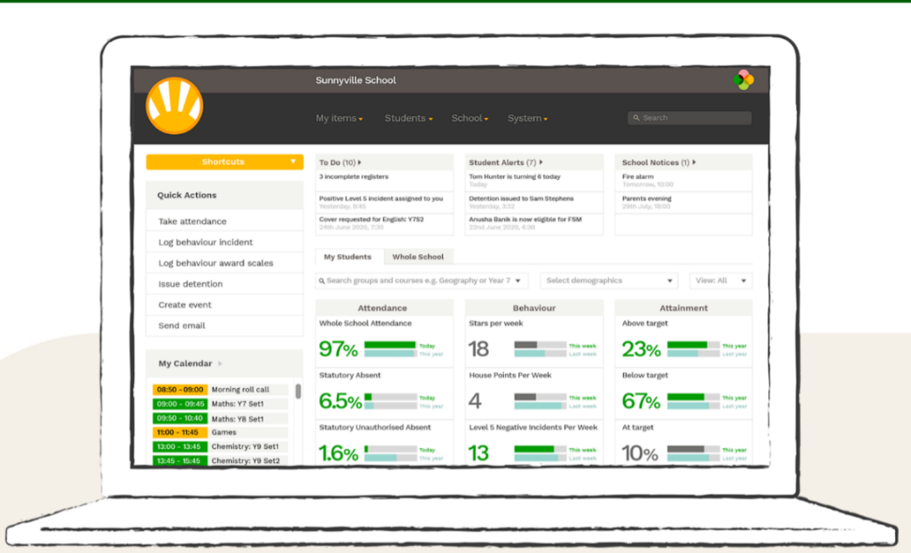
One system I am choosing to research is the current system Arbor https://arbor-education.com.
Overview of the attendance for the whole school
Preview of the calendar for that day

Arbor is used among many schools for their attendance and register system, it has features to automatically calculate a student’s attendance, their behaviour and attainment. It also has functions to show to do lists and view their timetable to name a couple of functions. They have included data about each student’s attendance, there behaviour and what grades they get in what subjects. They also store the data about the student including name, date of birth etc. Another piece of information that they store is the student’s timetable.
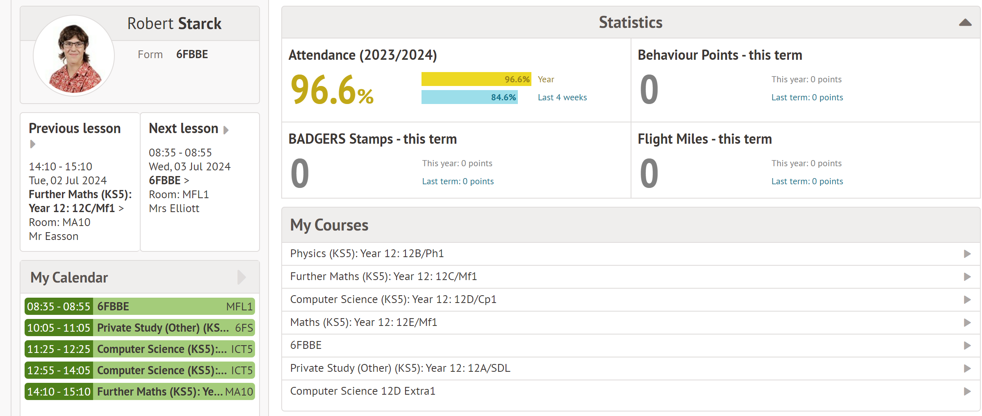
Students timetable displaying lessons for that day, and the option to view entire timetable
Student profile overview, name, form and picture
Overview of attendance for the student and is all the student can see on their attendance

The data that is output by Arbor is overall attendance for the year and attendance for the last 4 weeks. The number of badger stamps received in the year and the last term, same with behaviour points and Flight miles. It also outputs the course they do and their calendar for that day. It also states their last lesson and my next lesson above it. Aswell as displaying their Name, form, and their school picture in the top left which I have blanked out.
Arbor is however missing on the student’s side, for them to get more information about their attendance, for example where they missed lessons. It also does state where those behaviour points where from and expects the student to just know. It is also missing load of shorthand’s for teachers that would make their life much easier, such as when taking the register, the ability to mark without reason without having to enter a separate window. Also, the ability to see attendance for all students with their form, meaning they must manually search each student’s name and then navigate to where their attendance percentage is.

With respects to my coursework and what my client as asked me for, I am not going to touch on either the attainment or the behaviour part of Arbor. I will however be focusing entirely on the attendance and register systems in Arbor. I will keep the how the attendance is displayed in the student profile on their dashboard as it provides an easy way to quickly view their attendance percentage. But I will be adding functionality to the student side to allow them to see where they have missed lesson, this will be done so that my client doesn’t always have to search for each student whenever they think they have gotten an incorrect and find out where it is for them, they can just do it on their own saving my client time. For the teacher side I will be adding a view for them where it displays all the students in that teacher’s form with the student’s attendance next to their name, it will be ordered by attendance in ascending order, so lowest attendance at the top and highest attendance at the bottom. It will also be colour coded to make visualising who the form tutor needs to talk to easier and faster for her. I will also make changes to the register form, giving more options to use in the main menu rather than making submenus which popup all the time and waste time if there is nothing to fill in.

Another system I looked at was Inventry, https://inventry.co.uk/products/sign-in-solutions/.
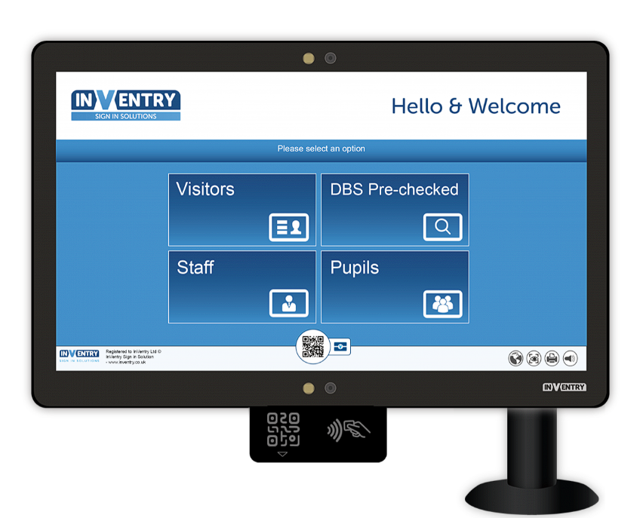
Option for students to log in
Log in for staff to access features assigned to them, such as taking registers
Inventry is also used a registration system and attendance management system which has a specific system for schools, which is what I will be researching. Inventry has functions to mark all students as present and a separate function which leads into all other options, such as late or not present. You can also click into students to see their personal details, or a club overview including what clubs they are in and their attendance for that specific club.
Option to mark all students as present
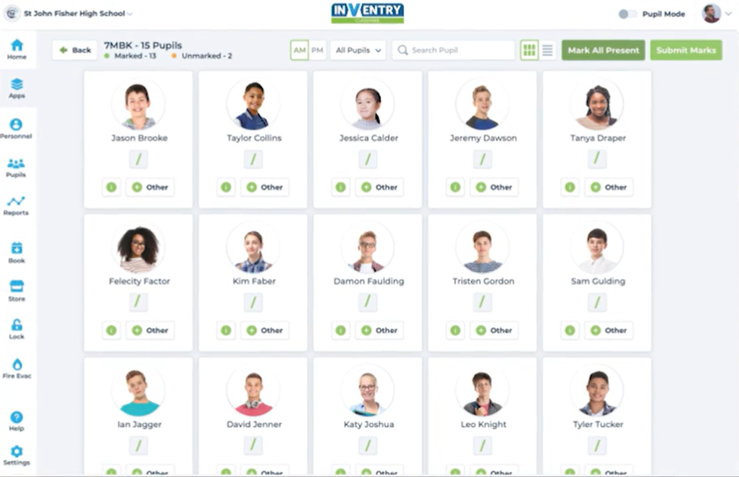
Submit register, save the register and push the changes to the data storeW
Give register marks, such as present, absent, late etc…
Mark assigned to the student
Information about the student
The data that is output to the teacher is a grid of the student’s names, pictures and then the option to mark them present, or any other mark, which opens a new window in which the teacher can enter what mark they should get. If the teacher clicks into a specific student the teacher can also see all the information about the student such as name, date of birth etc… There is also a class view where all the classes for that teacher are listed.
From this system I am going to keep the mark all as present as that is a useful feature that my client has requested in the proposed solution. I will not use the grid format that Inventry use as my client would prefer it in a list view to make it easier to just go down one each time and mark it easier. I will also keep the submit marks as that allows my client another chance to check over it. I will also leave out the button for other as my client has stated that she doesn’t want another dialogue box to have to fill in.

Another system I also investigated is called coacha, https://www.coacha.co.uk/Features/Classes-and-Registers.
Ability to view registers and see past registers
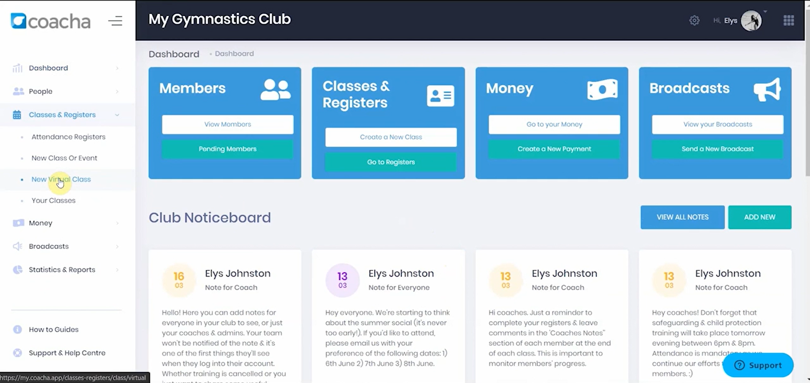
Teacher can see all members and information about them
Coacha has a lot of useful features and functions, such a way to manage members, which classes are available and each of those classes’ registers, money, and broadcasting information. Coacha has functions to mark students as present but not as late or absent with a reason.
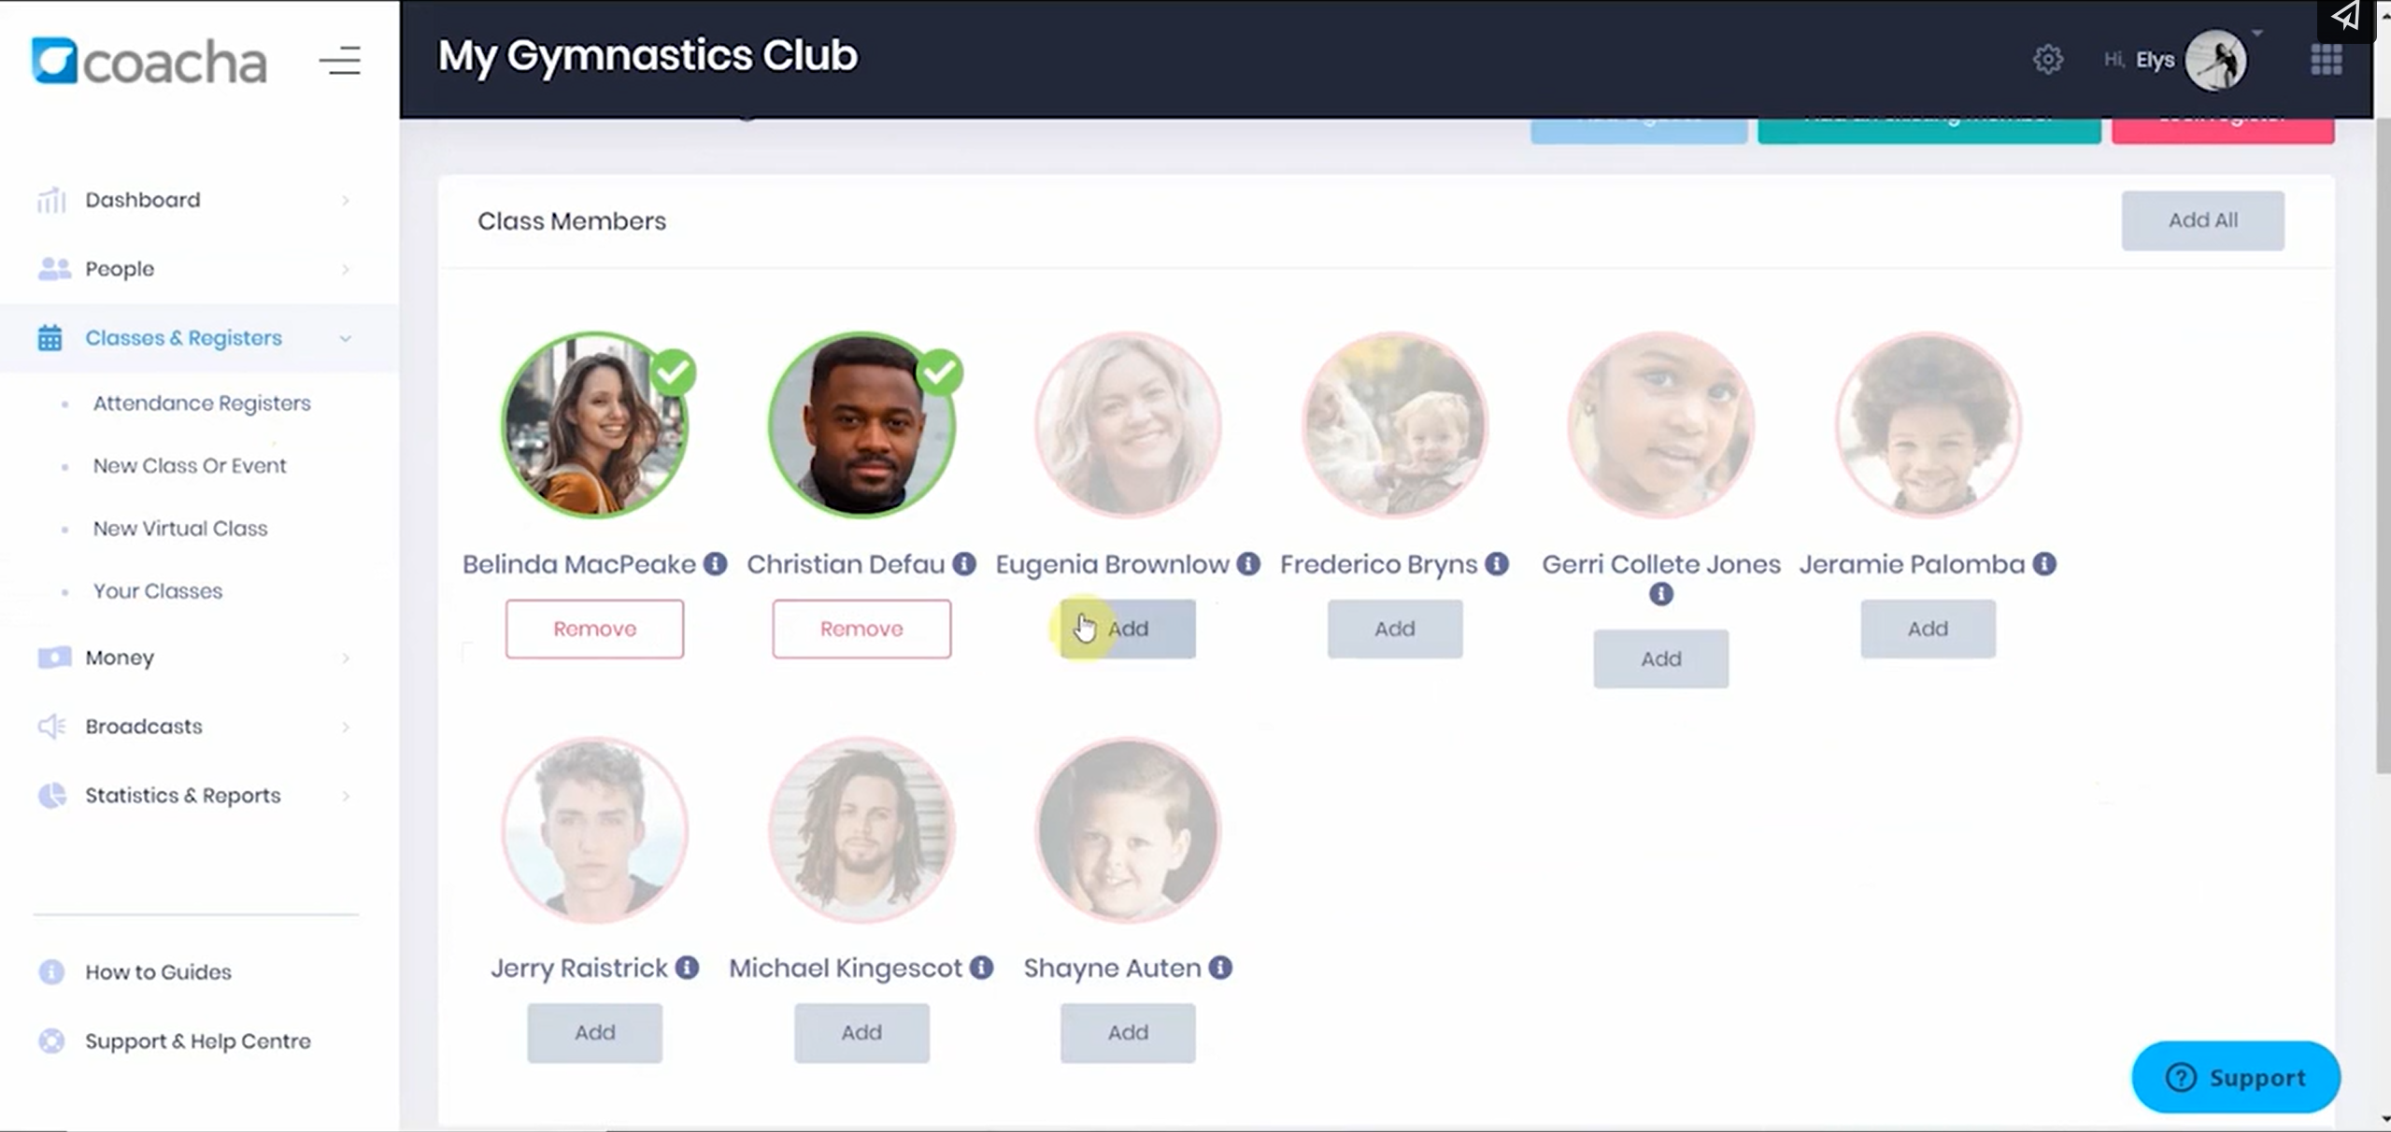
Setting the start date of the class
Ability to add people to a class
Information about the student, such as picture and name
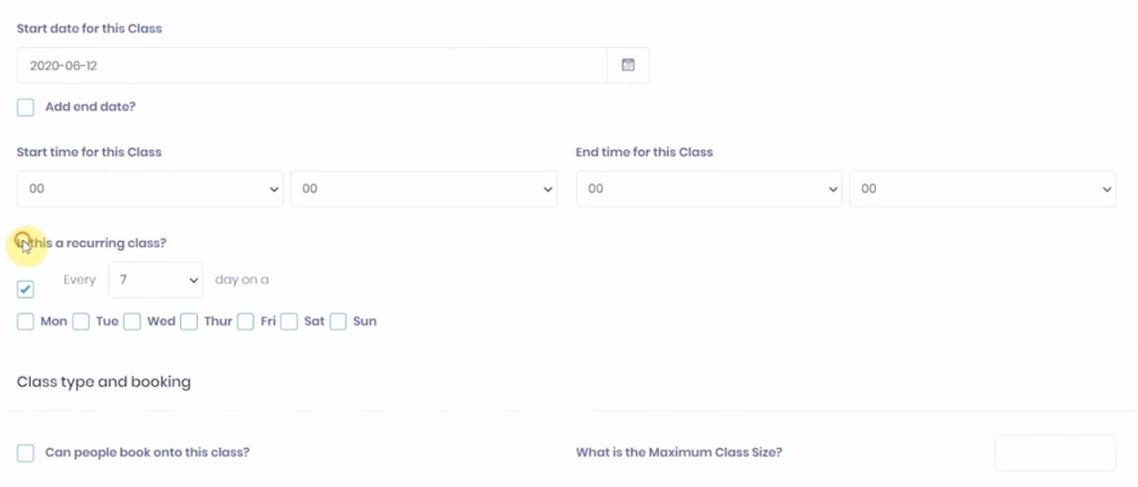
Setting if it is a recuring class and when it is set to reoccur
Setting the start and end time of the class
The data that is outputted is a grid of the student’s profile picture with the option to sign them in below using the add button. There are also options to add students to class elsewhere in the system and to create classes. The data required for that is Class name and description, start date, whether it is recurring or not and the timings for the class. To then add students to a class there is another grid of pictures of people with the option to add them below by clicking a button below their picture labelled add.
From this software I will keep the singular button to say that people are attending as quick to do and does not have any other windows. I am going to leave out the profile picture in the register as when there are more people in a class it becomes hard to see everyone, also my client has stated that they would prefer the register without them. I also do not need to add any classes so I will also be leaving that feature out as that is not what my coursework focuses on.

Summary table
Software name features wanted justification
Software name | Features wanted | Justification
Arbor | - How attendance is displayed on the student’s dashboard  - How the register is laid out for the teacher  - The attendance certificate  - The Timetable view for attendance  - The overview of attendance for a student | - It is short compact; gives all the details it needs to so there is no need to change it.  - This is in a nice list format which makes it easy to scroll down and see all the names.  - Effective way to see all the data about one student’s attendance in one place.  - Straightforward way to see where the student may have been absent.  - Also, nice and shot overview of a specific student’s attendance
Inventry | - Mark all as present button | - This makes it much faster to complete a register if you know everyone is present in the class as you only must press one button and then submit the register
Coacha | - Button to say people are attending with no extra windows | - This reduces the number of windows that you need to use which much faster than if you have an extra dialogue box which you plan to leave empty

Features of Proposed Solution
Feature | Description | Justification
Log in page | This is to restrict different people with various levels of access to only see certain features and perform certain tasks | This is so people with not the correct levels of access cannot mess with the data and cause inconsistencies in the data
Display register | This will display a list of names to the teacher when they go to take a register | This is so the teacher can call out the names and give different students the correct mark
Select different register marks | This will display a selection of characters next to each student in the register and allow the teacher to select a mark to give the student | This is so the teacher can give different register marks to different student based on whether they are present, late, or absent
Display teacher timetable | This will display the teacher timetable and highlight the current lesson that is going on | This is so the teacher can easily select the correct register to go in to and take at the correct time
Search for student | This will allow the teacher to search for a specific student by name to get an overview of their attendance | This is so, if necessary, the teacher can individually look up the student’s attendance in detail and help them locate missed lessons
Display form attendance | This will display a list of all students in that teachers form with their attendance next to their name. It will also be ordered by attendance from lowest to highest and colour coded. | This makes it easier for the teacher to check each student in her form attendance quickly and all in one place. And it is colour coded to show who she needs to talk to about their attendance
attendance certificate | This will display an entire overview of one student’s attendance in depth including percentage attendance, and a table of all register marks | This provides an entire overview of a student’s attendance in one place which makes it easier for the teacher to scan over to see where things may have been marked incorrectly
Attendance timetable (teacher) | This will display a table with lessons number as a heading and date along the side with each section of the table containing the register mark for that lesson, with it being only between specific date set by the teacher | This help to identify where a student has missed lessons or marked as late, in a concise format which can be looked over quickly
Attendance overview (teacher) | This will display some stats about a student’s attendance | This will just provide a nice overview for the teacher to quickly look at and see if they need to look deeper into where the student missed lessons
Attendance overview (student) | This will display an overview of the student’s attendance, which is just their overall percentage attendance on the student’s home page | This is so the student can quickly see their attendance and if it needs to be investigated
Attendance timetable (student) | This will display a table with lessons number as a heading and date along the side with each section of the table containing the register mark for that lesson, with it being only between specific date set by the student | This is so the student can look through on their own and see where they may have missed lessons before the teacher has to check for them saving time for the teacher

Limitations of the Proposed Solution
One limitation I have is that my current solution will have no networking functionality so it is only able to be run on one computer at any one time and any updates to files will be stored locally on my client’s pc. This is because it is a prototype and because I am focused on the main functionality of the system rather than methods to make it a viable commercial product which will only happen after the prototype is working correctly.

Another limitation of the system is that it will have minimal user interface development. This is due to during development I am focused on functionality over user interface development as this is a prototype I am developing rather than a complete system currently. The UI design will be straight forward and simple to reduce the amount of time I spend on it, so I can focus on functionality.

The fact that the system will only have a keyboard as an input to the system is another limitation as it will have limited user intractability. Again, this is because I am developing a prototype, and my focus is the core functionality of the system and making sure that is working correctly before I add more ways for the user to interact with the system.

I also will not be developing any APIs to allow my system to communicate with other systems such as emailing systems. This is another limitation as it means that anything the software cannot do cannot be easily transferred over to another system. Once again this is because I am developing a prototype not a complete solution. This means I am more focused on developing standalone functionality for the program rather than how it can utilise other systems as well. Once functionality has proven to be robust this feature can be added.

Another limitation of the proposed solution is the size of the initial data that I have is much smaller than the data that will end up being used in the fully completed system. This is again because I am developing a prototype and focusing on the functionality and not focused on incorporating all the data which would come after the prototype is approved by the client and all functionality works.

Requirements

Hardware Requirements
The hardware requirements to run the system is limited, all my client needs are a pc, a monitor, keyboard, and mouse. The mouse is only needed to initially run the application. Then the keyboard is used to operate the rest of the program as the system runs in a command window and a mouse is not supported in mou. And the monitor is used to display the output. The hardware requirements need to be low as the computer she uses at school computers which are not particularly good. Such as they do not have graphics cards and have old CPUs which can means my program has to be designed with this in mind. It also has limited RAM so I cannot use up too much memory considering the OS and other programs.

Software Requirements
The system requires a windows operating system as the program has been compiled into a .exe, but by using packages such as wine and winetrix (a Linux package used to emulate windows software in Linux) it is possible to run it on some Linux distributions. They would not need the ide as the idea is used to compile the program and is not needed to run it. It must be able to be run on windows as in school, where my client will run the program, the OS is only windows. My client would need the program to be in a .exe so windows can run it because all computers and laptops in school only run windows which require an exe.

File Requirements
- The data files required by the software are:
- The student file is the file that is used to store all the data bout the students including their name, StudentID and their attendance.
- The timetable file contains the information about the timetable, it keeps track of every class and when they all are using a combination of lesson number and day number to generate a table.
- The class file stores the information about every unique class including the class id and the subject id to make every class easily identifiable. It also stores the number of students in that class to make searching for those students easier
- Stored in the teacher file is all the information about the teachers such as their id and name.
- Stored in the subjects file is all the information about each subject, its name, and that subject id.
- The login details file stores all the information about each person’s logins and is ordered by username to make searching it easier.
- The form file is a file that stores all the information about any form/tutor groups in the school.
- The register file stores all the information about every register like when it was taken and who was there with what register mark.
- The attendance file contains all the information that the program needs to calculate a student’s attendance and stores that number.
All these files are linked together using many to one relationship as you cannot have a many to many relationships, so it is broken up into a resolver file with a many to one relationship. There is also someone to one relationship between the student and the Login details file and the teacher’s files.

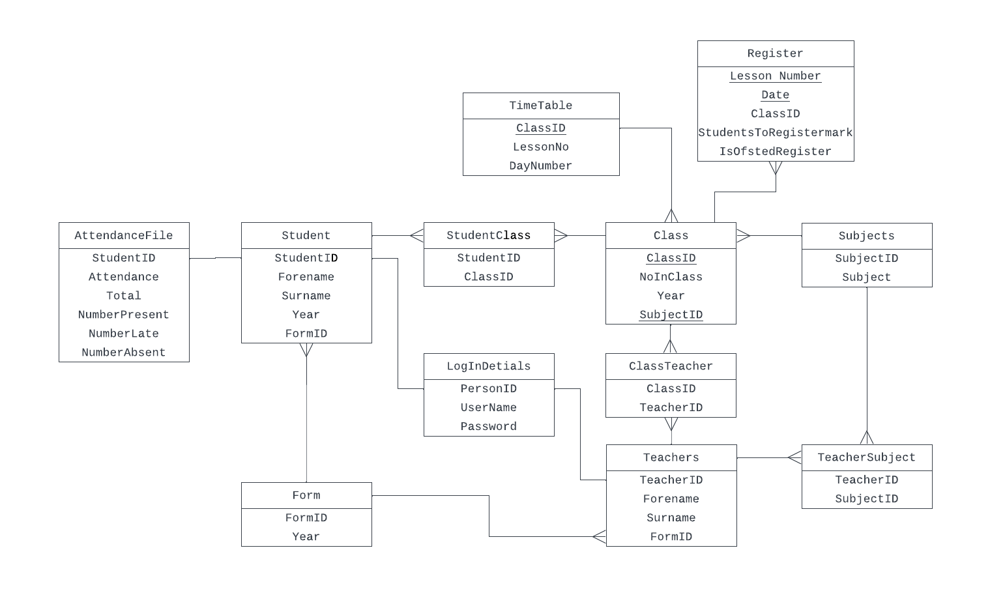
Data requirements, my client needs to store data about, normalised link relational system.

Success Criteria
Feature | Description | Measurable success criteria
Log in page | This will ask for a username and password, and depending on the status logins in depends on the tasks offered to the user | This is measurable as it should either out put a menu for a teacher or a menu for the student.  When a teacher logs in the functions will be:  View Attendance  Take a Register  And if it was a student that logs in the list of functions will be:  Attendance attendance percent: …%  Timetable
Display register | This will display a list of student’s names in that class with a choice of marks next to each student name | This is measurable as it should return all the students in the class with the options to mark them here or not  This will display the names in a format of  Name1 - [present] [absent with reason] [absent no reason] [late]  Name2 - [present] [absent with reason] [absent no reason] [late]…  And there will be the same number of names as students in that class which can be check by outputting the number of students in that class from the class file.  With a mark all as present, mark all as absent and a submit button at the bottom
Select different register marks | This will allow the user to move the cursor between each student and each option and selecting the option just by moving on to the next student. And them submitting by pressing enter | The end display will look like  Name1 - [present] [absent with reason] [absent no reason] [late]  Name2 - [present] [absent with reason] [absent no reason] [late]  Name3 - [present] [absent with reason] [absent no reason] [late]…  [Mark All Present]  [Mark All Absent]  [Submit Register]
Display teacher timetable | This will display the teachers timetable and highlight the current lesson that it is. The timetable will be displayed with day along the top with date above that and then lesson numbers down the sides | The data will look something like this with classes and the highlighted one is the current lesson that they need to do the register for
   | 01/07/24 | 02/07/2024 | 03/07/2024 | 04/07/2024 | 05/07/2024
   | Monday | Tuesday | Wednesday | Thursday | Friday
  1 | 9AT1/Ch | 9AT2/Ch | 9AT1/Ch | 9BT1/Ch
  2 | 9AT1/Ch | 9AT1/Bi |  | 9BT1/Ch
  3 |  | 9AT1/Bi | 9BT1/Bi |  | 9AT1/Ch
  4 | 9BT1/Ch |  | 9AT1/Bi | 9BT2/Bi
  5 | 9BT2/Bi |  |  | 9AT2/Ch
Search for student | There will be a search bar provided that can be typed into and will display all students which are close to what they have typed in, they can then navigate down to each student and then select the student | Search for name: R.  Robert Cole  Rita Gamble  Rose Roberts  Robert Flores…  This will refine as more letters are typed in, the selected one can then be selected by pressing enter and you will enter the overview for that student
Display form attendance | This will display a list of all students in that teachers form with their attendance next to their name and colour coded to highlight the students that need talking to. This will also be ordered from lowest attendance to highest attendance | Wendell Hulslander – 75%  Marylouise Brooks – 83%  Rose Roberts – 92%  Tracy Boyd – 95%  Velma Morris – 99.8%  This is what an example set of data should look like when looking through the teachers for attendance
attendance certificate | This will display all information about the student’s attendance. Including percentages and a table of where they missed lesson. | Name: Wendell Hulslander  Attendance: 75%  Authorised absences attendance: 89%  Unauthorised absences: 14  Lates: 12  …  IT should show the students name, attendance, attendance with authorised absences, unauthorised absences, and late marks. It should then also have a table and all marks in that year.
   | 1 | 2 | 3 | 4 | 5
  05/07/24 | /\ | L | A | L | /\
  04/07/24 | L | A | A | /\ | /\
  03/07/24 | /\ | /\ | /\ | /\ | L
  02/07/24 | L | /\ | A | /\ | /\
  01/07/24 | L | L | A | /\ | A
Attendance timetable (teacher) | This will provide a timetable for the student with all register marks for a ser period | Name: Erica Hernandez  …  This is a display of all register marks between two time periods set by the teacher when entering this view
   | 1 | 2 | 3 | 4 | 5
  05/07/24 | /\ | L | A | L | /\
  04/07/24 | L | A | /\ | /\ | /\
  03/07/24 | /\ | /\ | /\ | /\ | L
  02/07/24 | L | /\ | A | /\ | /\
  01/07/24 | /\ | /\ | /\ | /\ | A
Attendance overview (teacher) | This will bring up a display giving the name of the student, overall attendance, Attendance with authorised absences, Unauthorised absences, and late marks | Name: Ann Lavoie  Attendance: 85%  Authorised absences attendance: 93%  Unauthorised absences: 4  Lates: 2
Attendance overview (student) | This will give the student a quick overview of all their attendance statistics, which is the same as what the teacher will see. It will display overall attendance, attendance with authorised absences, Unauthorised absences, and late marks | Attendance: 89%  Authorised absences attendance: 96.4%  Unauthorised absences: 1  Lates: 0
Attendance timetable (student) | This will give the student a week-by-week view of all their register marks over the entire year which they can cycle through to see when they have missed lessons or were marked as late | This will display a 5-day week from Monday to Friday with lesson numbers as headings and it will display all the register marks that have been marked down that week. So, from my example data one example could look like this.
   | 1 | 2 | 3 | 4 | 5
  01/07/24 | /\ | L | A | /\ | /\
  02/07/24 | /\ | /\ | /\ | /\ | /\
  03/07/24 | /\ | /\ | /\ | /\ | L
  04/07/24 | /\ | /\ | /\ | /\ | /\
  05/07/24 | /\ | /\ | /\ | /\ | A
Timetable (student) | This will give the student a week-by-week view of their timetable and their classes. This is so they can cross reference what register marks they got for which class | This will display a 5-day week from Monday to Friday with lesson numbers as headings and it will display the class that the student has at that time. So, from my example data one example could look like this.
   | 1 | 2 | 3 | 4 | 5
  01/07/24 | 9AT1/Bi | 9AT1/Bi | 9D/Dt1 | 9D/Dt1 | 9AAX/Ma
  02/07/24 | 9AAX/Ma | 9ABY/En | 9B/Fr1 | 9C/Pe1 | 9C/Pe1
  03/07/24 | 9BAY/Lf | 9A/Dr1 | 9ABY/En | 9B/Fr1 | 9B/Fr1
  04/07/24 | 9D/Dt1 | 9AAX/Ma | 9A/Dr1 | 9AT1/Bi | 9ABY/En
  05/07/24 | 9ABY/En | 9C/Pe1 | 9D/Dt1 | 9AAX/Ma | 9A/Dr1

Design

Introduction
The design of my solution should be simple and user friendly on the front end while maintaining a strong structure which can be used to easily expand the programme later. Both layout and user interactions should be simple and self-explanatory, this is to avoid complications and reduce the time the user must spend either searching through menus or working out how to input the data. Repeated delays in processes like this will cause frustration as it takes valuable time out of the user, which could be used to do other tasks. Ambiguous input methods can cause errors which can interfere with the integrity of the data and cause issues when it comes to analysing the data.
The overarching theme in the coursework will be consistent with itself, the user will always be interacting with the programme in the same way, by keyboard entry. The use of only the keyboard allows for simple entry methods which allows for menus to be navigated through faster and more easily than a mouse would allow. Being able to complete tasks fast is paramount to my solution as it will allow the user to quickly view the information without spending too much time either trying to find it or having it in an uneasily readable format.
Information in a box styled like this will be used to explain validation
Information in a box styled like this will be used to explain user friendliness
Information in a box styled like this will be used to explain elements of code

Problem Decomposition
The order of development will allow both my client and I to have a clear understanding of what is being done when and why. It will also allow her to query any concerns during development.
Iteration Number | Feature | Justification for order
0 | Generic Functions | This iteration will contain generic procedures such as sorts and searches of arrays. Any other extra information units such as the progress bar and loading screens. This must be the first thing to be done as it is used in future iterations, and it allows time for my client to make any changes to what they want
1 | Creating initial data | All initial data must be generated before the main programme can do its tasks as all procedures in the programme rely on displaying, adding or updating the data. Thus, all the files and the data contained in them must be generated first
2 | Class Structure | To create a strong structure throughout the programme I decided to have each file as a class so I can attach my own methods to it. This must also be done before the main programme so that the main programme can take advantage of this structure.
3 | Student Menu | The students need a base menu which they can use to access the data which my client decides that they needed to be able to see. This will directly connect to the output of the login menu script
4 | Teacher Menu | The teachers will also need their own menu to view, and add/change data as required, due the teacher menu having far more tasks to achieve io decided to do this after the student menu. This will also be a directly connected to the output of the login menu
5.1 | Login Menu | Before accessing any data, the user must log into an account to ensure that they can only see data they are permitted to access. Therefore, this section should be developed before the menus for each user
5.2 | Main program | This will be the main program which pulls everything together and would be the program that the user will run

Required Files and Entity Relationship Diagrams (ERDs)

Initial data files with justification
File Name | Justification
Timetable file | This file is required so that all the data about when which lessons are. And can therefore be used to store data about when registers where taken and feedback the data in a more readable format.
Student File | This file is required so that the data about each student can be stored and searched through as well
Attendance file | This file stores all the data about each student and their attendance, which is the main area of focus for my programme
Teacher File | Stores data about the teachers so that the teachers have an area to log into and perform teacher only actions such as taking the register.
Login details file | The log in details file is required so that searching for usernames is faster as all available logins are in one file and sorted by username so a binary search can be done on the data to increase search speeds
Form File | The form file is necessary to keep track of which student is in what form and thus give the form tutor access to the attendance data of that student in a more convenient manner
Class File | Includes the data about all the classes and what subject is taught in each class. This is required so that students can be part of a class, and so registers can be taken
Subject File | This is required so data about which subjects are available and so that classes can be filtered out by subject
Register File | This stores all the data about all registers. This is critical as to manage attendance you need to have registers to get the data to calculate the attendance from.
Student Class Resolver File | This resolves the many-to-many issue with the student and class file, where multiple students can be in 1 class and each student can be in multiple classes.
Teacher Class Resolver File | This is required to solve the issue of the many-to-many relation between the teacher and class file.
Teacher Subject Resolver File | This resolver file is required to resolve the subject file and teacher file, breaking the many-to-many relation into 2 1 to many relations

Entity Relationship Diagram
The timetable contains information about when each class. It doesn’t have a primary key field as the primary key is a theoretical field made up of all fields so for searching you search by all fields anyways
Register file contains information about each register. Its id is a combination of lesson number, date and class id
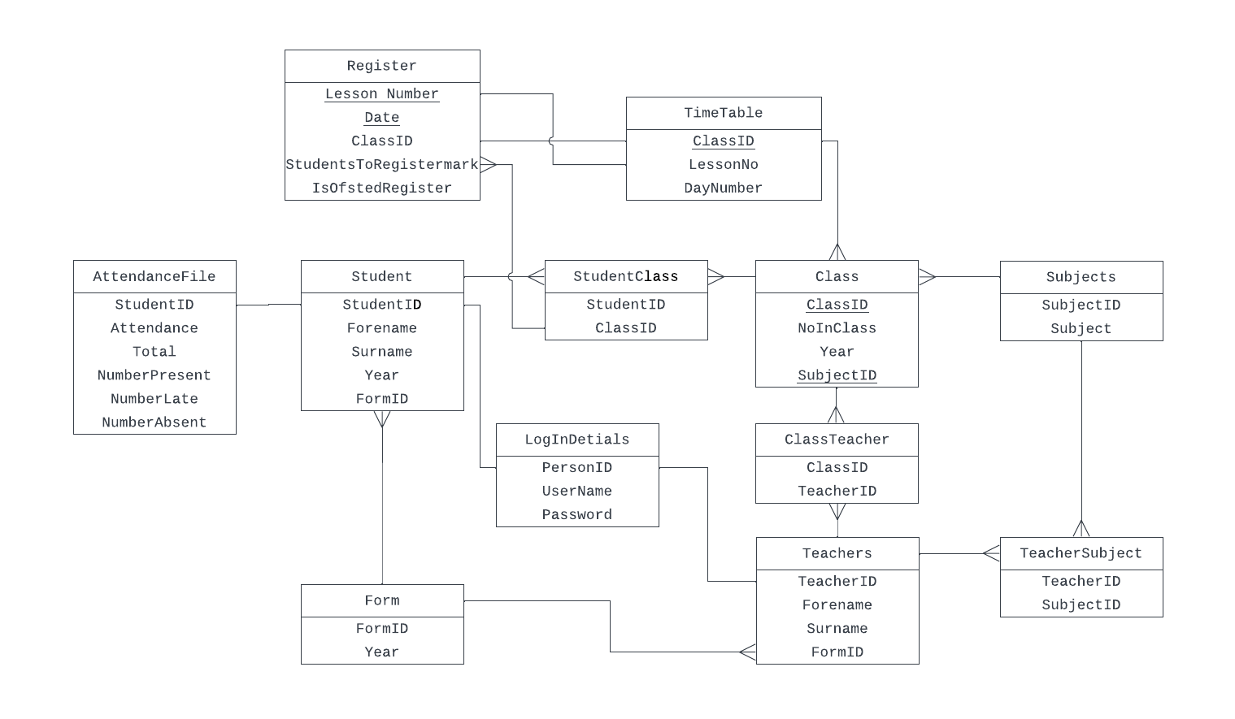
stores information about a subject and links a subject to a subject id
stores information about each class and how many students are in it. It has the foreign key subject id which is used to filter classes by subject
stores all the information about the teachers. The primary key is the teacherID field
An indexed file of both the student and teacher file to make a login file which is easier to search through
This contains information about which forms exist
The student file contains all the information about each student, primary key being student id
Contains all the information about each student. Its primary key is the foreign key, student id to create a 1 to 1 relation with the student file

Linear Search

Top-Down-Design - Linear Search
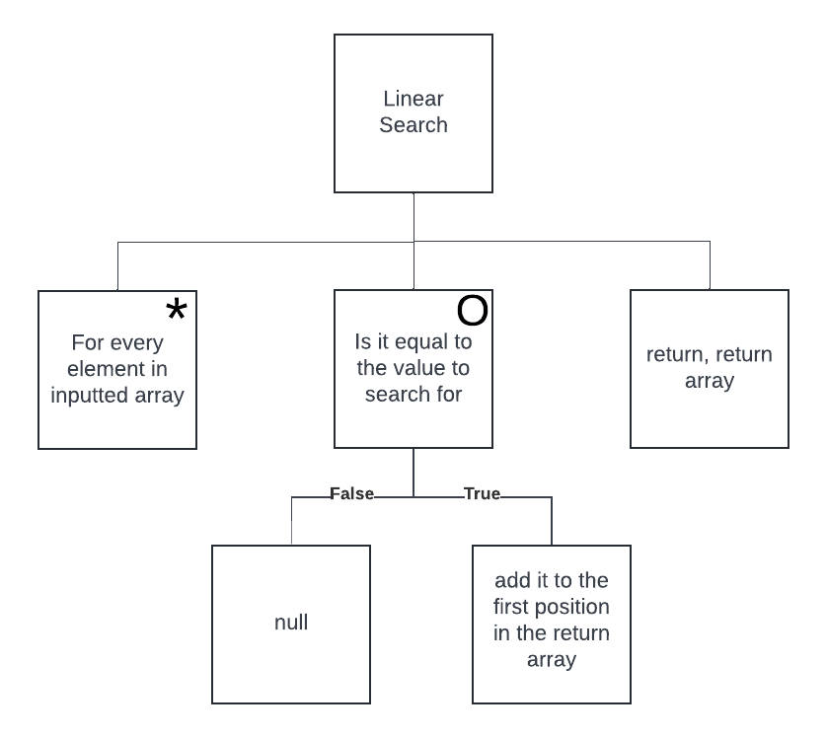
Testing
Iteration 0.1
Return the array of all the positions of found values back into the main program
If the values are equal, add the index of the value to another array
Check if the value is the same as the value that is being searched for
Iterate through every item in the list inputted into the procedure

Pseudocode – Linear Search
Declares this section as a unit. So all procedures are made public and usable by other programs as long as it is declared in the use of the other programs

UNIT LinearSearch
INTERFACE

USES CRT, SYSUTILS

PROCEDURE LinearSearchFunction(low, high, searchValue, UserArray, var returnArray, var numberDone)
BEGIN
Declare counting variables for indexing the array with
i = -1
a = 0
// iterate through each element until end of array
REPEAT
i = i+1
numberDone = numberDone +1
// add all positions for values matching the search value to a different array
if userArray[i] = searchValue THEN
Testing the value in the array with the value that is being searched for
begin
returnArray[a] = i
a = a + 1
end
UNTIL (i = high)
END
Add the index to an array, which in this procedure is a pointer to an array in the main program.

END.
Keep iterating until the end is marked, which is set by the programmer

Binary Search

Top-Down Design – Binary Search
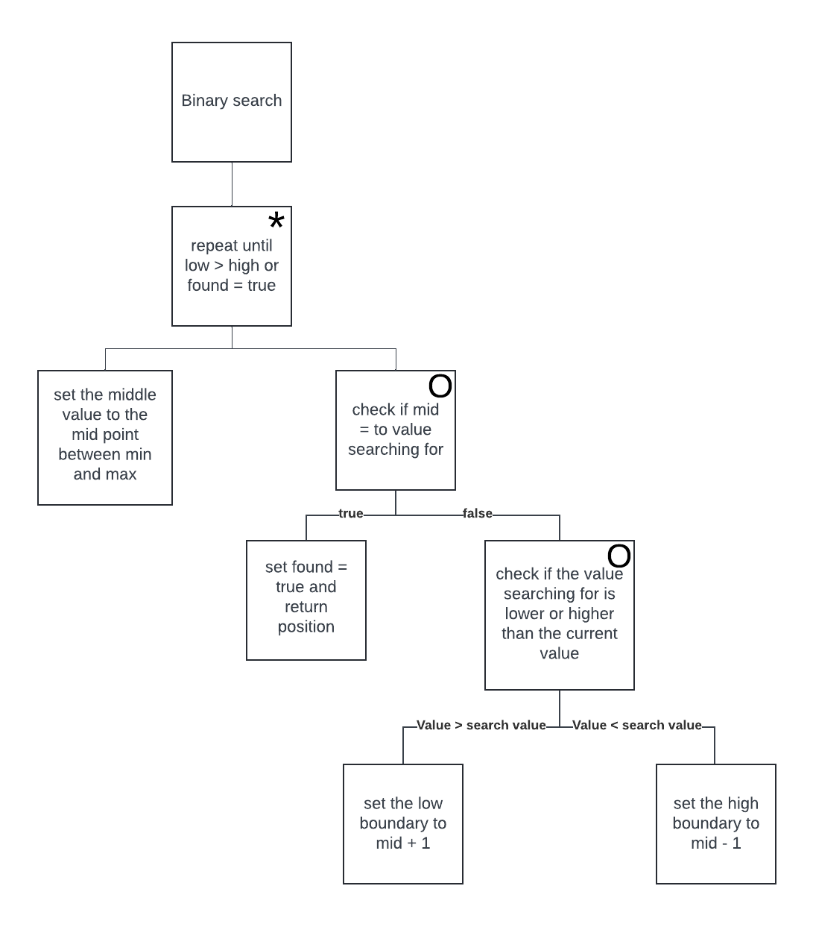
Testing
Iteration 0.2
Increase the min search index to mid +1
If too high drop the max search index to the mid -1
Check which half the value is in
Cut the list in half
Repeat until either the value is found or it is not in the list if it is order

Pseudocode – Binary Search
UNIT BinarySearch

USES CRT, SYSUTILS

PROCEDURE BinarySearchFunction(UserArray, var returnArray, low, high, searchValue)
BEGIN
Start with mid as middle of array
REPEAT
mid = (low+high) DIV 2
IF UserArray[mid] != searchValue THEN
BEGIN
Test if value is not found
IF UserArray[mid] > searchValue THEN
BEGIN
low = mid +1
Find if the item of data is above or below the current middle point
END
ELSE
BEGIN
high = mid -1
END
END
ELSE
BEGIN
If value is found, set value to return array
returnArray[0] = mid
shouldEnd = true
END
Repeat until found or not in array
UNTIL (shouldEnd == true) OR (low > high)

END

END.

Searching

Top-Down Design Searching
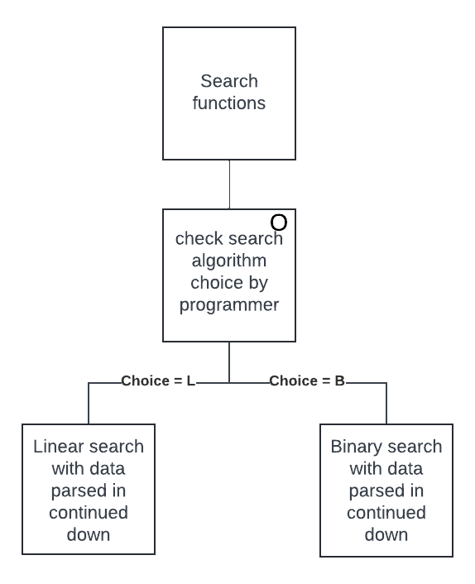
Testing
Iteration 0.3
Generic procedure so only one parameters has to be changed to be able choose between linear and binary search with any other parameters remaining the same

Pseudocode – Searching
All data is parsed in to this one procedure and is then manipulated
Uses the two search algorithm units
UNIT Search

USES CRT, SYSUTILS, BinarySearch, LinearSearch

PROCEDURE SearchFunctions(SearchType, x, y, findValue, UserArray, var returnArray, var numberDone)
BEGIN
IF SearchType == 'L' THEN
LinearSearch.LinearSearchFunction(x,y,FindValue,UserArray,returnArray,numberDone)
IF SearchType == 'B' THEN
BinarySearch.BinarySearchFunction(UserArray,ReturnArray,x,y,FindValue)
END

END.
Choice between linear search and binary search, with all data automatically being parsed down

Loading

Top Down Design – Loading
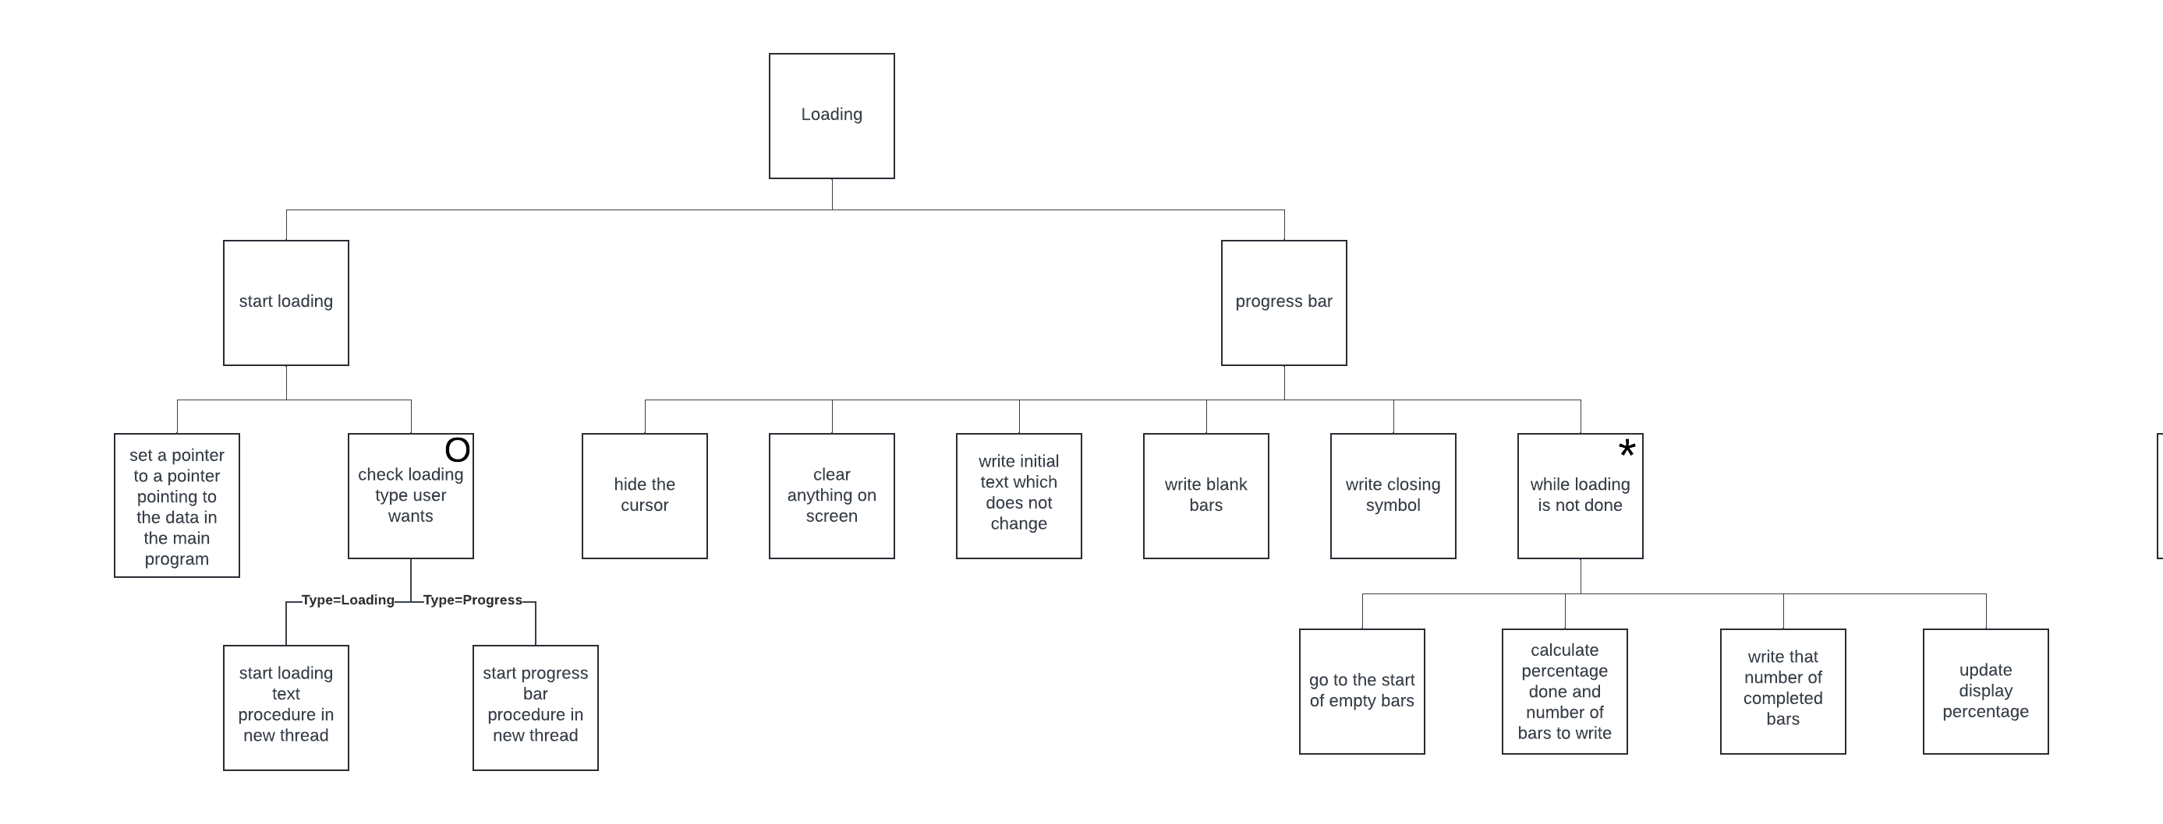
control to end the loop when another procedure is called
Fill blank spaces with ░
Write
Progress╣
As a constant start that doesn’t change
Creates a pointer to the variable in the main program which stores the percent done, in real format. This is so I don’t have to keep recalling the function and it updates automatically
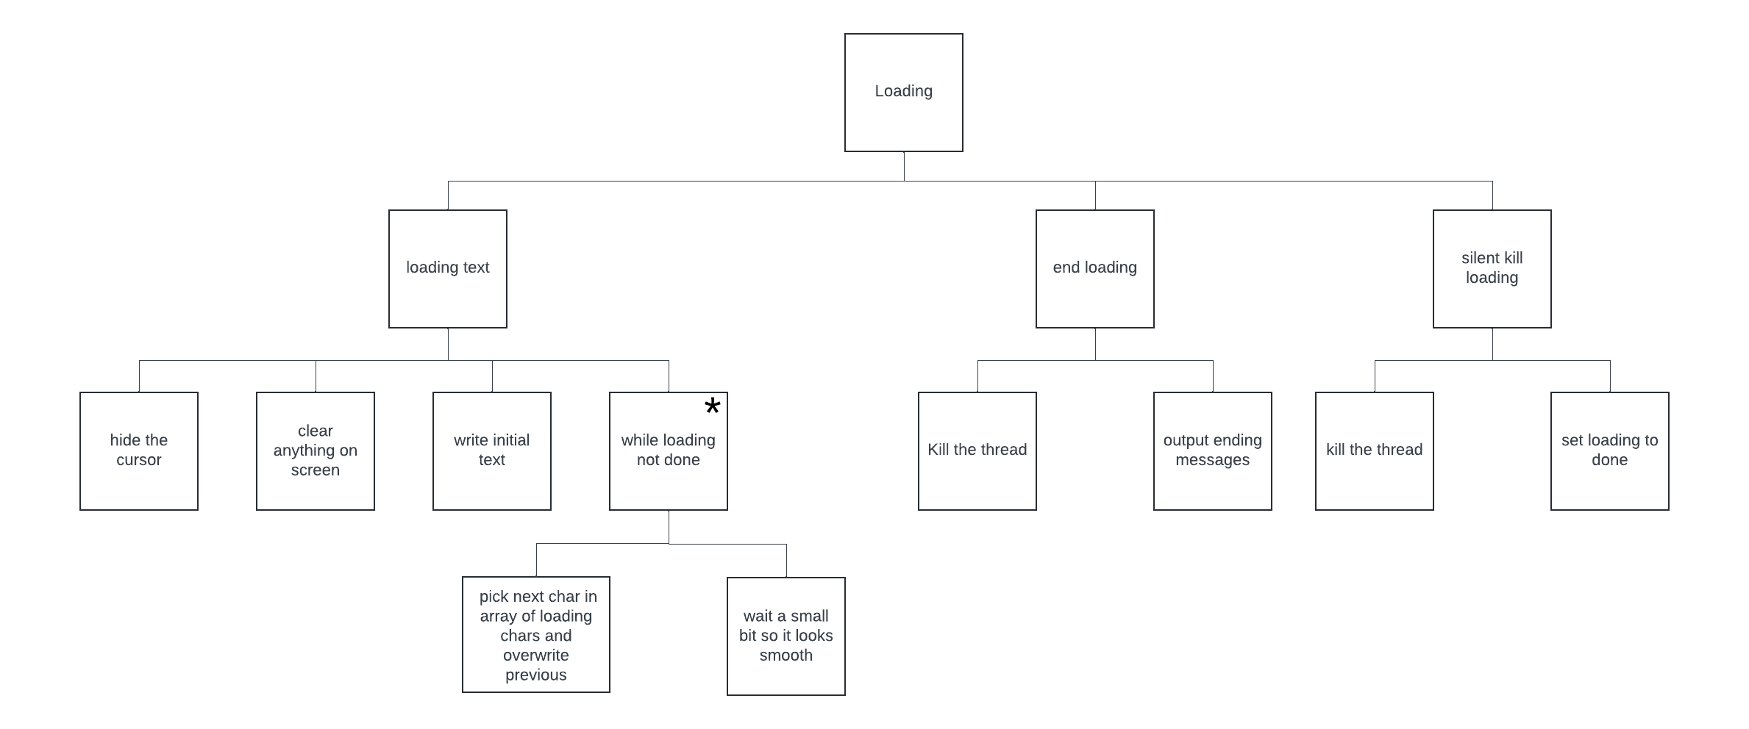
Kill the thread so the programme is flooded with random threads taking up processing power
Kill the thread so the programme is flooded with random threads taking up processing power
Writes
Loading…
Testing
Iteration 0.4
Wait 100ms for changing, as its part of a thread it doesn’t stop main programme
Pick the next char from [/, —, \, |] and append it to the loading text

Pseudocode – Loading
Unit so other programmes can use its functions
unit loading

const LoadingSymbols : ARRAY[1..4] OF CHAR = ('/',#196,'\','|')

function loadingText(pointer)
Declare the array for the spinning characters
begin
HideCursor
a = 1
ClrScr
while (!loadingDone) DO
Begin
WRITELN('Loading... ' + LoadingSymbols[a])
a = a+1
if a > 4 THEN
Write Loading… with next spinning char
a = 1
Delay(100)
GoToXY(1,1)
DelLine
Increase and loop a so it goes between 1 and 4 for each char
end

end

function loadingBar(pointer) : LONGINT
begin
HideCursor
ClrScr
Write
Progress ╣░░░░░░░░░░░░░░░░░░░░╠
As the start 0 % bar

Write('Progress ',#185)
percentDone = 0.0*100
for c= 0 TO 20 DO
write(#176)
write(#204)
completeBars = 0
Go to after the progress bar and write the current percentage done

while !loadingDone DO
begin
gotoxy(33,1)
Write(percentDone:4:0,'%')
Get the new percent done and find out how many bars should be coloured in

percentDone = (percentPtr^)*100
completeBars = floor((percentPtr^)*20)
gotoxy(11,1)
for d = 0 to completeBars DO
begin
Go to start of the progress bar and write that many completed bars in

write(#219)
end
end
end

procedure StartLoading(loadingType, var percentIn)
begin
Set start run time to current real world time
startRunTime = Time
loadingDone = false
Create a pointer to the memory address where the percent done is stored in the main programme
percentPtr = @percentIn
if loadingType = 'L' THEN
VPBeginThread(loadingText,1,nil)
else if loadingType = 'P' THEN
VPBeginThread(loadingBar,1,nil)
Choose the loading type and begin a new separate thread with the loading procedure running in that new thread so the program runs these two procedures in parallel so the loading is accurate to current progress time
End

procedure EndLoading
Kill the thread with the loading procedure to save resources
begin
KillThread(1)
loadingDone = true
WRITELN('Done!☺')
Write time elapsed since start
endRunTime = Time
Delay(500)
ClrScr
writeln('Time elapsed: ',TimeToStr(endRunTime - startRunTime))
ShowCursor
end

procedure silentKillLoading
begin
Write Kill the thread with the loading procedure to save resources
elapsed since start
KillThread(1)
loadingDone = true
ClrScr
ShowCursor
Clear up any changes in the background so the user doesn’t see the changes
end
end.

Create Files

Top-Down Design - Create Files
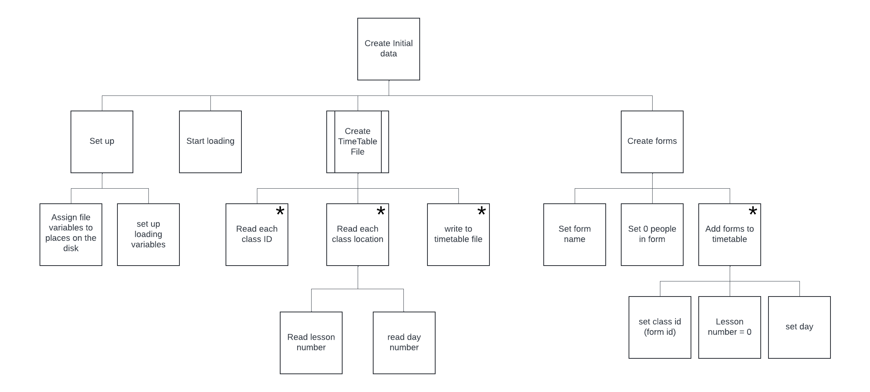
Lesson Number being 0 to 5, 5 lessons, 1 form time
Day number being from 0 to 9, 2 week alternating timetable with no option for weekends
Keep iterating until all data is extracted from the timetable text file I created from and existing timetable
Keep iterating until all data is extracted from the timetable text file I created from and existing timetable
Keep iterating until all data is extracted from the timetable text file I created from and existing timetable
This will iterate until each form is stored in the time table for every day

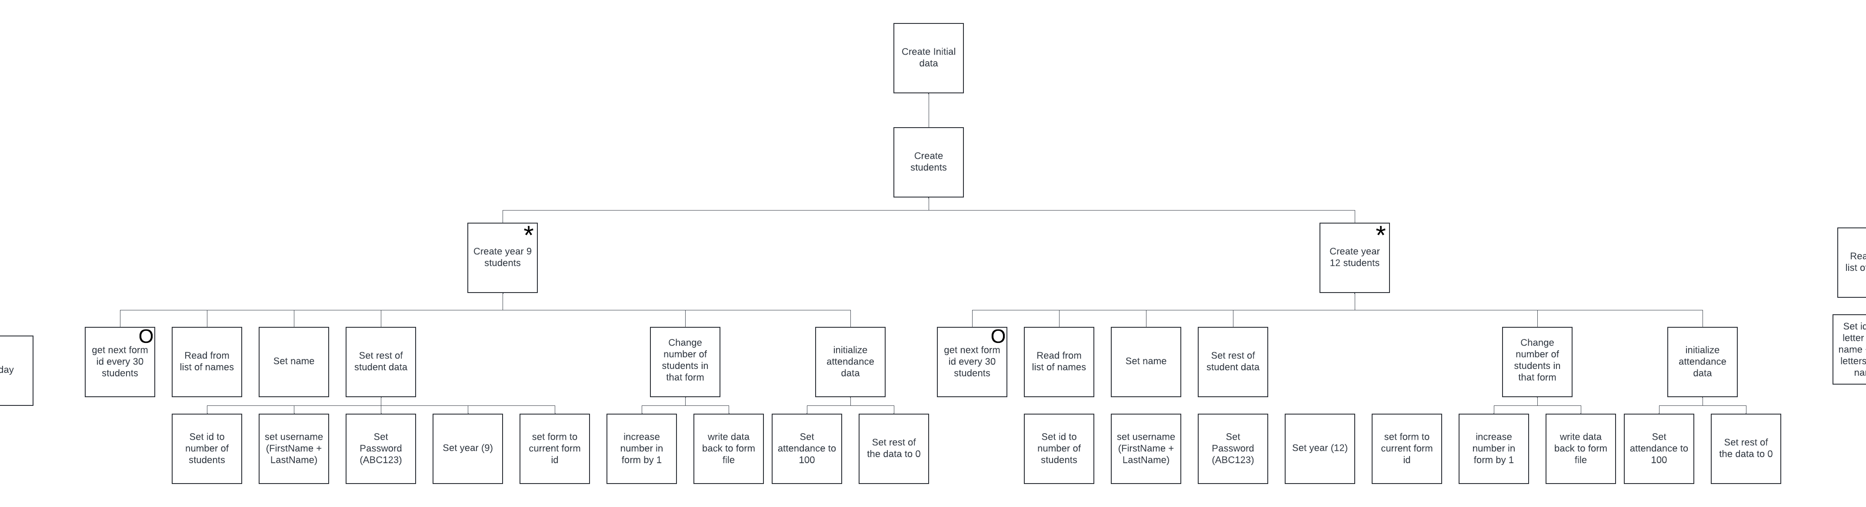
Every 30 students read next form in form file
Create 20 year 12 students as that is enough to perfectly fill every class

Create 120 year 9 students as that is enough to perfectly fill every class

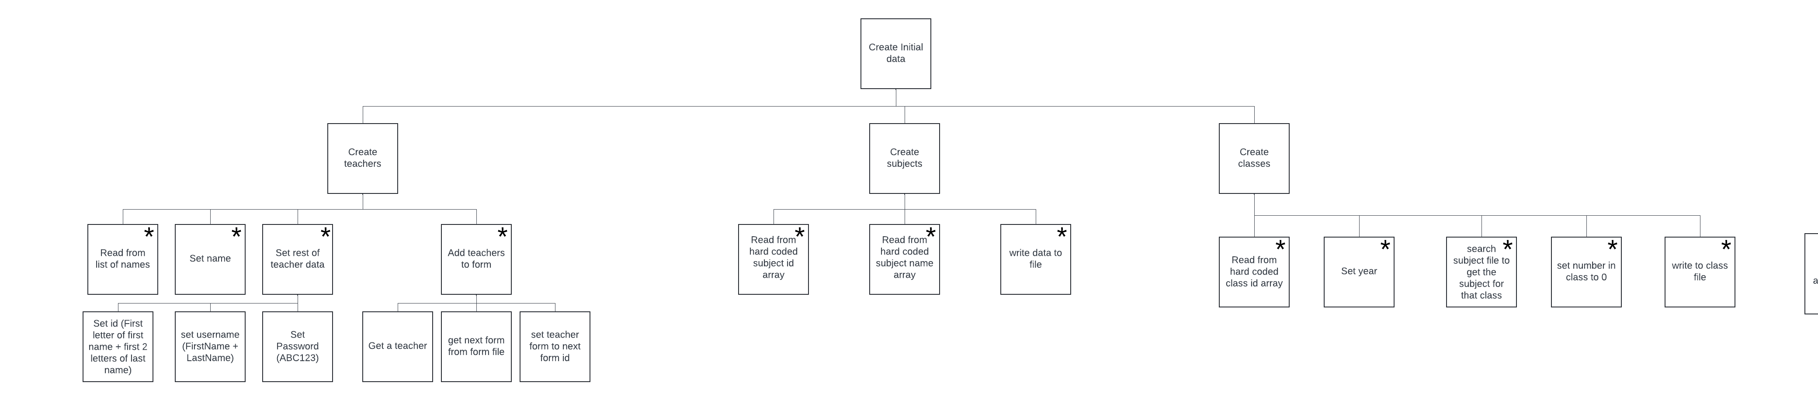
Loop until all classes are stored in the file
Create 51 teachers, 1 per class

For each teacher assign them to one class
Goes through every student assigning classes to them
Keeps trying to randomly assign a student to a class which isn’t full
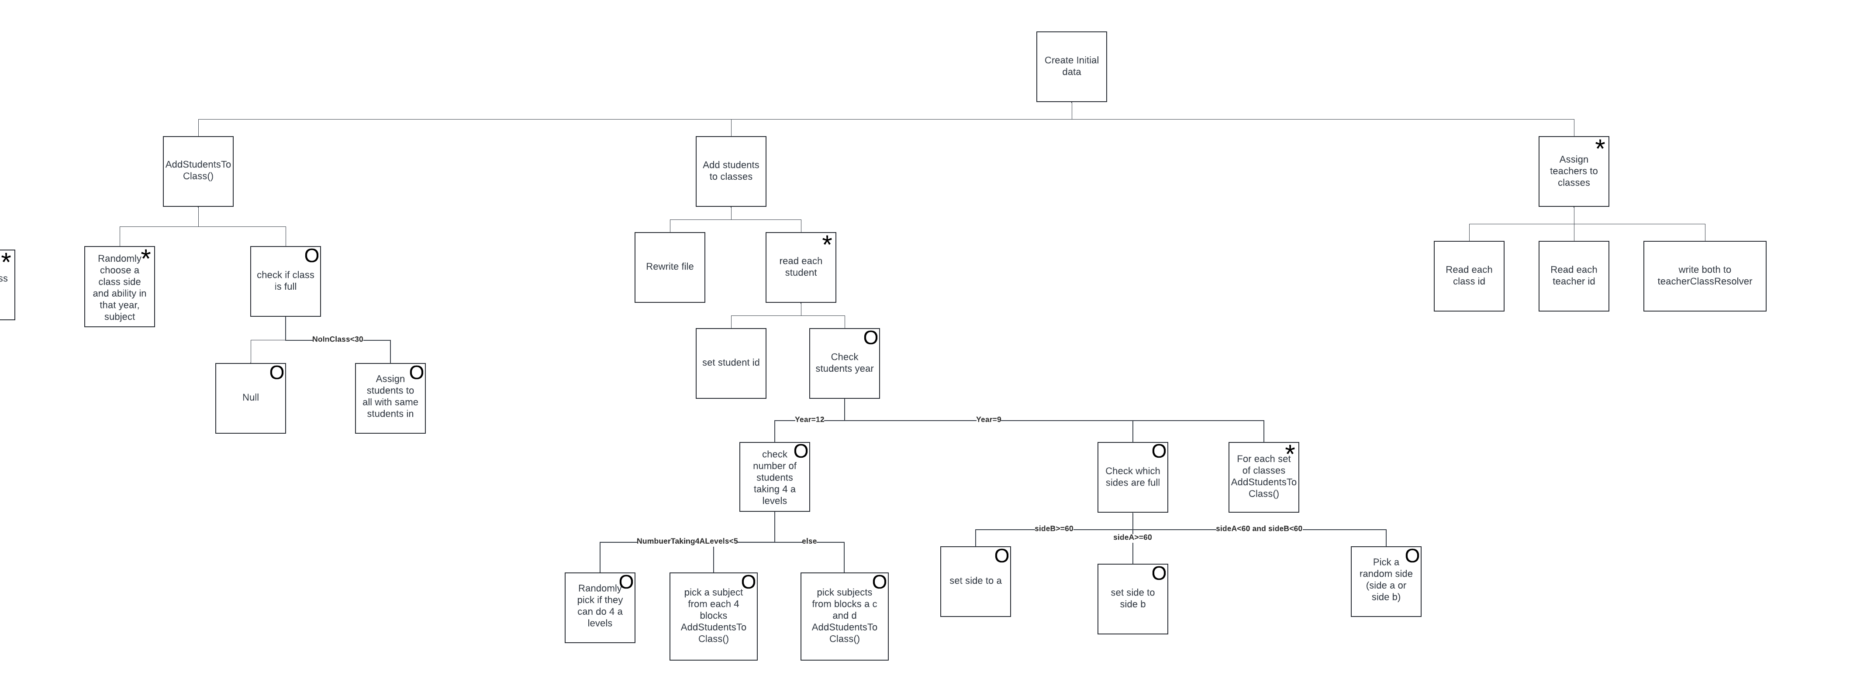
Randomly pick who is doing 4 a levels while keeping it below a set maximum
Check whether the student should be in, side A or side b without overflowing one side

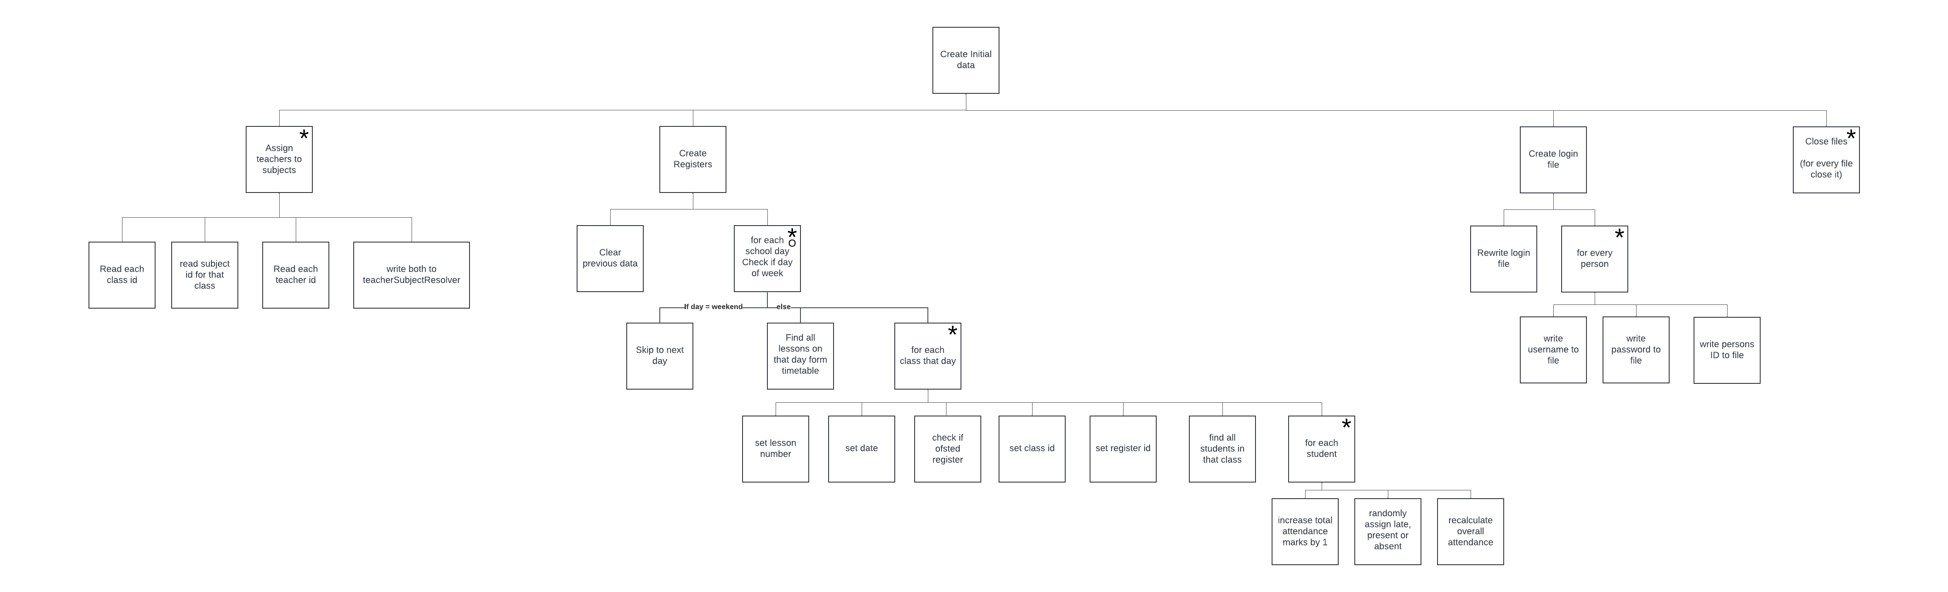
For each student in that class
For every day it is not a weekend
For every teacher find the class they teach, then the subject of that class and
Testing
Iteration 1

Pseudocode – Create Files
Declare all the units to use in this script
PROGRAM CreateFiles
uses crt, sysutils, search, loading, DisplayErrorScrn, math
Set the loading variables up, the percent done and total tasks to do
PROCEDURE initialiseFiles //assign places on drive to identifiers
BEGIN
percentComplete = 0.0 //initializing percentDone and total iterations
total = 0
//assigning a place on the drive to the files
Reference a place on the drive where the timetable is stored in a text file
TimeTableTextFile = openRead('C:\\ComputerScienceCoursework\\Program\\files\\TimeTableText.txt')
TimeTableFile = openRead('C:\\ComputerScienceCoursework\\Program\\files\\TimeTable.dta')
total = total + 51

RegisterFile = openRead('C:\\ComputerScienceCoursework\\Program\\files\\Registers.dta')
Reference a place on the drive where a list of first and surnames are stored
total = total + 60

NameFile = openRead('C:\\ComputerScienceCoursework\\Program\\files\\Names.txt')
StudentFile = openRead('C:\\ComputerScienceCoursework\\Program\\files\\Students.dta')
total = total + 140

TeacherFile = openRead('C:\\ComputerScienceCoursework\\Program\\files\\Teachers.dta')
Assign all variables a space on the drive
total = total + 51

classFile = openRead('C:\\ComputerScienceCoursework\\Program\\files\\classes.dta')
total = total + 51

subjectFile = openRead('C:\\ComputerScienceCoursework\\Program\\files\\subjects.dta')
total = total + 21

studentClassResolverFile = openRead('C:\\ComputerScienceCoursework\\Program\\files\\studentClassResolver.dta')
total = total + 140

teacherSubjectResolverFile = openRead('C:\\ComputerScienceCoursework\\Program\\files\\teacherSubjectResolver.dta')
total = total + 51

teacherClassResolverFile = openRead('C:\\ComputerScienceCoursework\\Program\\files\\teacherClassResolver.dta')
total = total + 51

FormFile = openRead('C:\\ComputerScienceCoursework\\Program\\files\\forms.dta')
total = total + 5

AttendanceFile = openRead('C:\\ComputerScienceCoursework\\Program\\files\\attendanceFile.dta')

LogInDetailsFile = openRead('C:\\ComputerScienceCoursework\\Program\\files\\LogInDetails.dta')

total = total + 191
END

PROCEDURE closeAllFiles
BEGIN
//closing all files to confirm all changes are fully written and complete
TimeTableTextFile.close()
TimeTableFile.close()
RegisterFile.close()
Close each file to ensure that all data is successfully written to the respective files so data integrity is kept
NameFile.close()
StudentFile.close()
TeacherFile.close()
classFile.close()
subjectFile.close()
studentClassResolverFile.close()
teacherSubjectResolverFile.close()
teacherClassResolverFile.close()
FormFile.close()
AttendanceFile.close()
LogInDetailsFile.close()
END
Setup files ready to be used in this procedure
PROCEDURE CreateTimeTable
BEGIN
reset(TimeTableTextFile
Take all the data from the timetable text file
REWRITE(TimeTableFile)
//iterate UNTIL all data is extracted
WHILE NOT EOF(TimeTableTextFile) DO
BEGIN
numberDone = numberDone +1
Read the class id into the program and store it in a record
percentComplete = numberDone/total
READLINE(TimeTableTextFile,TimeTableInfoFromFile) //get the class id
//assign it to the record variable
Iterate until all days and time have been extracted from the text file into the record and written to the data file
TimeTable.ClassId = TimeTableInfoFromFile

//for when ever that class is
REPEAT
READLINE(TimeTableTextFile,TimeTableInfoFromFile)
TimeTable.LessonNo = StrToInt(TimeTableInfoFromFile)
READLINE(TimeTableTextFile,TimeTableInfoFromFile)
TimeTable.Day = StrToInt(TimeTableInfoFromFile)
READLINE(TimeTableTextFile,TimeTableInfoFromFile)
WRITE(TimeTableFile,TimeTable)
UNTIL TimeTableInfoFromFile == 'Q' //REPEAT UNTIL all dates are read and stored in the .dta file
FOR that class marked by a Q in the text file
END
END

PROCEDURE addForms
BEGIN
REWRITE(FormFile)
FOR i = 0 to 3 DO //iterate FOR all 4, year 9 forms
BEGIN
numberDone = numberDone + 1
percentComplete = numberDone / total
Create 4 year 9 forms with unique identifiers, and 0 kids in the class
//create 4 unique FOR identifiers
form.formID = '9' + 'AA' + Chr(i +65)
form.NumberInForm = 0
WRITE(FormFile, form) //push data to file
END
numberDone = numberDone + 1
percentComplete = numberDone / total
form.formID = '12' + 'AAA' //DO the same FOR 1 year 12 form
form.NumberInForm = 0
Create 1 year 12 class with similar data, but altered form identifier
WRITE(FormFile,form)
reset(FormFile) //set point to start of form file
FOR i = 0 to 4 DO //FOR every form
BEGIN
READ(formFile,form)
timetable.classid = form.formID //get form id into a timetable class id variable
FOR a = 1 to 10 DO //add it to the file as lesson 0 FOR every morning in the 2 week timetable
BEGIN
Write the when the forms are to the timetable file
timetable.LessonNo = 0
timetable.Day = a
WRITE(TimeTableFile, timetable) //add new data to timetable file
END
END
END

PROCEDURE createRegisters
BEGIN
Set data file for use to create register files
//set up files and reset file pointers
reset(TimeTableFile)
reset(studentClassResolverFile)
RESET(StudentFIle)
reWRITE(RegisterFile)
i = 0
startDate = '13/09/2024'
//populating the ARRAYs with the data from the files
Extract data from files into arrays which can be searched
FOR i = 0 To 139 DO
BEGIN
READ(StudentFile,Student)
studentFormIdArray[i] = Student.Form
returnStudentFormIdArray[i] = -1
END
i = 0
WHILE NOT(eof(TimeTableFile)) DO
BEGIN
READ(TimeTableFile,TimeTable)
dayArray[i] = IntToStr(TimeTable.day)
dayReturnArray[i] = -1
i = i +1
END
i = 0
WHILE NOT(eof(studentClassResolverFile)) DO
BEGIN
READ(studentClassResolverFile,studentClassResolver)
studentClassResolverClassArray[i] = studentClassResolver.ClassID
classReturnArray[i] = -1
i = i +1
Create 30 days of registers
END
b = 0

// FOR loop FOR number of days with registers
FOR i = 0 to 29 DO
BEGIN
Find the day number of the week correcting it to between 1 and 7
//gets the number day of the week and corrects to monday being 1
day = DayOfWeek(StrToDate(startDate)+b-1)
IF (day == 7) OR (day == 6) THEN //IF weekend decrease FOR loop VAR by 1
BEGIN
i = i -1
Check if it is a weekend, if so decrease I by 1 so day is not counted towards total
end
ELSE
Set up array for searching for all classes in current day
BEGIN
numberDone = numberDone +1
percentComplete = numberDone / total
//clear out ARRAY FOR searching FOR classes on that day
FOR c = 0 TO 269 DO
Search for all classes that day
dayReturnArray[c] = -1
Search.SearchFunctions('L',0,269,IntToStr(DayOfWeek(StrToDate(startDate)+b-1)),dayArray,dayReturnArray,empty)
a = 0
For every class found on that day
while dayReturnArray[a] != -1 DO // FOR every class on that day
BEGIN
Get day information and add that all to the register record
//find and get the data about one class
SEEK(TimeTableFile,dayReturnArray[a])
READ(TimeTableFile, TimeTable)
//set register data
Register.LessonNo = TimeTable.LessonNo
Register.Date = StrToDate(startDate)+b
Get the class id and register id and write it to the record
IF TimeTable.LessonNo == 4 THEN
Register.isOfstedRegister = true
ELSE
Register.isOfstedRegister = false
Register.classID = ''
Register.classID = TimeTable.classID
register.registerID = IntToStr(register.lessonNo) + register.classID + DateTimeToStr(register.date)
classId = format('%s',[Register.classID])
//clear out ARRAY FOR searching FOR students in that class
Flush out previous data from search so it can be used to find all student in that class
FOR c = 0 to 1384 DO
begin
classReturnArray[c] = -1
end Search.SearchFunctions('L',0,1384,Register.ClassID,studentClassResolverClassArray,classReturnArray,empty)
c=0
Find all student in that class and iterate through each of them
//FOR every student in that class
while classReturnArray[c] != -1 DO
BEGIN
//get the class with the studenet in
SEEK(studentClassResolverFile, classReturnArray[c])
READ(studentClassResolverFile, studentClassResolver)
//get the student id
studentRegisterMark.studentID = studentClassResolver.studentID
Get the students id in the 2d array of register marks
//get the data in the attendance file
SEEK(AttendanceFile,studentClassResolver.studentID)
READ(AttendanceFile,Attendance)
Attendance.Total = Attendance.Total +1
Change students total attendance marks
//ranDOmly assign the student a mark
ranDOmMark = RANDOM(100)
IF ranDOmMark <= 90 THEN
BEGIN
studentRegisterMark.registerMark = 'P'
Randomly assign the student a register mark, present, late or absent and add it to the 2d array of register marks
Attendance.NumberPresent = Attendance.NumberPresent + 1
end
ELSE IF ranDOmMark <= 97 THEN
BEGIN
studentRegisterMark.registerMark = 'L'
Attendance.NumberLate = Attendance.NumberLate + 1
end
ELSE
BEGIN
Write the student id and mark array to the record 2d array of register marks
studentRegisterMark.registerMark = 'A'
Attendance.NumberAbsent = Attendance.NumberAbsent + 1
END
//write data back to register file
Register.registerMarks[c] = studentRegisterMark
SEEK(AttendanceFile,FilePos(AttendanceFile)-1)
Attendance.Attendance = (Attendance.NumberPresent / Attendance.Total)
Recalculate students attendance
WRITE(AttendanceFile,Attendance)
Rewrite students attendance data
c = c +1
END
WRITE(RegisterFile,Register)

a = a +1
Once all students in the class are accounted for, write register record to register file
END
END
b = b +1
END
Repeat for forms

b= 0
FOR i = 0 to 29 DO //FOR loop FOR each form
BEGIN
//gets the number day of the week and corrects to monday being 0
day = DayOfWeek(StrToDate(startDate)+b-1)
IF (day == 7) OR (day == 6) THEN //IF weekend decrease FOR loop VAR by 1
BEGIN
i = i -1
end
ELSE
BEGIN
numberDone = numberDone +1
percentComplete = numberDone / total
//clear out ARRAY FOR searching FOR forms on that day
FOR c = 0 TO 320 DO
dayReturnArray[c] = -1
Search.SearchFunctions('L',269,320,IntToStr(DayOfWeek(StrToDate(startDate)+b-1)),dayArray,dayReturnArray,empty)
a = 0
while dayReturnArray[a] != -1 DO// FOR every form on that day
BEGIN
SEEK(TimeTableFile,dayReturnArray[a])
READ(TimeTableFile, TimeTable)
IF TimeTable.LessonNo == 0 THEN
BEGIN
//set register data
Register.LessonNo = TimeTable.LessonNo
Register.Date = StrToDate(startDate)+b
Register.isOfstedRegister = true
Register.classID = ''
Register.classID = TimeTable.classID
register.registerID = IntToStr(register.lessonNo) + register.classID + DateTimeToStr(register.date)
//clear out ARRAY FOR searching FOR students in that form
classId = format('%s',[Register.classID])
FOR c = 0 TO 139 DO
returnStudentFormIdArray[c] = -1
Search.SearchFunctions('L',0,139,Register.ClassID,studentFormIdArray,returnStudentFormIdArray,empty)
c = 0
//FOR every student in that form
while returnStudentFormIdArray[c] != -1 DO
BEGIN
//get the class with the studenet in
SEEK(StudentFile, returnStudentFormIdArray[c])
READ(StudentFile, Student)
//get the student id
studentRegisterMark.studentID = student.studentID
//get the data in the attendance file
SEEK(AttendanceFile,student.studentID)
READ(AttendanceFile,Attendance)
Attendance.Total = Attendance.Total +1
//ranDOmly assign the student a mark
ranDOmMark = RANDOM(100)
IF ranDOmMark <= 90 THEN
BEGIN
studentRegisterMark.registerMark = 'P'
Attendance.NumberPresent = Attendance.NumberPresent + 1
end
ELSE IF ranDOmMark <= 97 THEN
BEGIN
studentRegisterMark.registerMark = 'L'
Attendance.NumberLate = Attendance.NumberLate + 1
end
ELSE
BEGIN
studentRegisterMark.registerMark = 'A'
Attendance.NumberAbsent = Attendance.NumberAbsent + 1
END
//write data back to register file
Register.registerMarks[c] = studentRegisterMark
SEEK(AttendanceFile,FilePos(AttendanceFile)-1)
Attendance.Attendance = (Attendance.NumberPresent / Attendance.Total)
WRITE(AttendanceFile,Attendance)
c = c +1
END
WRITE(RegisterFile,Register)

END
a = a + 1
END
END
b = b + 1
END
END

PROCEDURE addStudents
VAR i : LONGINT
ffname, fsname, fyear, fform, fattendance : STRING //set up variables to read from text file into
BEGIN
Set up files for reading and writing to
i = 0
RESET(FormFile) //resets pointer in form file
READ(formFIle, form) //gets the first form
RESET(NameFile)
Create 120 year 9 students enough to fill every class perfectly
REWRITE(StudentFile) //clears both studenet and attendance file
REWRITE(AttendanceFile)
FOR i = 0 to 119 DO //generate 120 year 9 students
BEGIN
IF (i mod 30 == 0) and (i != 0) THEN //changes the form every 30 students
Check for each 30, where it is not the first student causing it to double read
BEGIN
seek(formFile, (FilePos(formFile)-1))
WRITE(FormFile,form)
Write data back to form file and read the next form data
READ(FormFile, form)
END
Set student name to names from the list of names in the names text file
numberDone= numberDone +1 //update progress bar
percentComplete = numberDone/total
Student.StudentID = i //set student data
READLN(NameFile, student.fname) //get a first and last name from a list of names
Set rest of the students personal data
READLN(NameFile, student.sname)
student.year = 9
student.uname = student.fname+student.sname
student.pword = 'ABC123'
Set student id in attendance file to the same as the student id to create a 1 to 1 link
student.form = form.formid
form.NumberInForm = form.NumberInForm + 1
//set attendance data
Attendance.studentId = i
Attendance.Attendance = 1
Attendance.Total = 0
Set rest of the attendance data
Attendance.NumberPresent = 0
Attendance.NumberLate = 0
Attendance.NumberAbsent = 0
WRITE(StudentFile,student) //write student and attendance data to their respective files
WRITE(AttendanceFile, Attendance)
Write both records to respective files
END
READ(FormFile, form) //get the year 12 form
FOR i = 120 to 139 DO //generate 20 year 12 students
BEGIN
Create 20 year 12 students and set the same data for year 9 students
numberDone = numberDone +1 //update progress bar
percentComplete = numberDone/total
Student.StudentID = i //set student data
READLN(NameFile, student.fname) //get a first and last name from a list of names
READLN(NameFile, student.sname)
student.year = 12
student.uname = student.fname+student.sname
student.pword = 'ABC123'
form.NumberInForm = form.NumberInForm + 1
student.form = form.formid
//set attendance data
Attendance.studentId = i
Attendance.Attendance = 1
Attendance.Total = 0
Attendance.NumberPresent = 0
Attendance.NumberLate = 0
Attendance.NumberAbsent = 0
WRITE(StudentFile,student) //append this record to the end of the student file
WRITE(AttendanceFile, Attendance)
END
//write changes to form file
seek(formfile, filepos(formFile)-1)
WRITE(formfile,form)
END

PROCEDURE addTeachers
VAR i : LONGINT
ffname, fsname, fform : STRING //declare all variables to read from files into them
BEGIN
Create 51 teachers, 1 teacher per 1 class
RESET(FormFile)
reWRITE(TeacherFile)
FOR i = 0 TO 50 DO //create 51 teachers, 1 per class
Get names from names text file
BEGIN
numberDone = numberDone + 1
percentComplete = numberDone / total
READLN(NameFile, teacher.Fname) //read first and surname form names file
READLN(NameFile, teacher.Sname)
Teacher.TeacherID = teacher.FName[1]+teacher.SName[1]+teacher.SName[2] //create the teacher id as first letter of first name and forst two letters of surname
set teach id to first letter of first name + first 2 letters of surname
Teacher.uname = teacher.FName + teacher.SName
Teacher.pword = 'ABC123'
Set rest of the teacher data
WRITE(TeacherFile,teacher)
END
//assign teachers to forms
RESET(TeacherFile)
FOR i = 0 to 4 DO
Pick the first 4 teachers as form tutors assigning them to 1 form each
BEGIN
READ(TeacherFile,teacher)
READ(FormFile,form)
teacher.form = form.formID
seek(TeacherFile,FilePos(TeacherFile)-1)
WRITE(TeacherFile,teacher)
END
END

PROCEDURE createLogInFile
BEGIN
RESET(StudentFile) //reset file pointers FOR both files
For every student
RESET(TeacherFile)
REWRITE(LogInDetailsFile)
//extract login information and student id and write it to a file
WHILE NOT EOF(StudentFile) DO
BEGIN
READ(StudentFile,student)
LogInDetails.PersonID = Format('%'+'5'+'s',[IntToStr(student.StudentID)]) // format the student id as a STRING
LogInDetails.Username = student.Uname
Convert the id of the student to a string without long decimal places
Set the username and password of that student and write to log in file
LogInDetails.Passwowrd = student.Pword
WRITE(LogInDetailsFile,LogInDetails)
numberDone = numberDone +1
percentComplete = numberDone/total
END
For each teacher
WHILE NOT EOF(TeacherFile) DO
BEGIN
//extract login information and student id and write it to a file
READ(TeacherFile,teacher)
LogInDetails.PersonID = teacher.teacherID
LogInDetails.Username = teacher.Uname
Set the Teacher id, username and password of that student and write to log in file
LogInDetails.Passwowrd = teacher.Pword
WRITE(LogInDetailsFile,LogInDetails)
numberDone = numberDone +1
percentComplete = numberDone/total
END

END

PROCEDURE createSubjects
// create a constant ARRAY of all subjects and the subjects' id
CONST subjID : ARRAY[0..20] OF STRING[3] = ('Cs','Ma','Mu','Enl','Gg','Ch','Ph','Bi','DT','Dr',
'Lf','Rpe','Fr','Hi','Gm','Bs','Ar','Py','Pe','Sp','So')
subjNm : ARRAY[0..20] OF STRING[20] = ('Computer Science','Maths','Music','English','Geography','Chemistry','Physics','Biology','Design Technology','Drama',
'Life Skills','Religion, Philosophy & Ethics','French','History','German','Business Studies','Art','Physcology','Physical Education','Spanish','Sociology')
Set constant array for subject ids and names

BEGIN
//clear subject file
REWRITE(SubjectFile)
//FOR every subject write subject name and id to a file
For each item in the arrays
FOR i = 0 TO 20 DO
BEGIN
numberDone = numberDone +1
percentComplete = numberDone / total
with subject DO
BEGIN
subjectID = subjID[i]
Write subject name and subject id to subject file
SubjectName = subjNm[i]
END
WRITE(SubjectFile, subject)
END
END

PROCEDURE createClasses
//create ARRAYs of all classes
CONST yNineClassArray : ARRAY[0..43] OF STRING = ('9AT1/Ch', '9AT2/Ch', '9AT1/Bi', '9AT2/Bi', '9AT1/Ph', '9AT2/Ph', '9AAX/Ma', '9AAY/Ma', '9AAX/Enl', '9AAY/Enl', '9AAX/Lf', '9AAY/Lf',
'9AAX/RPE', '9AAY/RPE', '9AP1/Pe', '9AP2/Pe', '9BT1/Ch', '9BT2/Ch', '9BT1/Bi', '9BT2/Cp', '9BT1/Ph', '9BT2/Ph',
'9BAX/Ma', '9BAY/Ma', '9BAX/Enl', '9BAY/Enl', '9BAX/Lf', '9BAY/Lf', '9BAX/RPE', '9BAY/RPE', '9BP1/Pe', '9BP2/Pe', '9B/Fr1', '9B/Sp1', '9B/Gg1', '9B/Hi1', '9C/Dr1', '9C/Ar1', '9C/Py1',
'9C/Dt1', '9D/So1', '9D/Bs1', '9D/Mu1', '9D/Gm1')
yTwelveClassArray : ARRAY[0..6] OF STRING = ('12A/Ph1','12A/Py1','12B/Ph1','12C/Cp1','12C/Py1','12D/Mu1','12D/Cp1')
Arrays of all year 9 classes in 1 array and all year 12 classes in the other
BEGIN
reWRITE(classFile)
Set class id to next value in the list
For each year 9 class
//FOR every year 9 class
FOR i = 0 TO 43 DO
BEGIN
numberDone = numberDone + 1
Set year and number of students in that class
percentComplete = numberDone/total
//set year 9 class data
sClass.ClassID = yNineClassArray[i]
sClass.year = 9
Check if the 8th character is empty
sClass.NoOfStudents = 0
If it is empty then the subject id is the last 3 characters
//generate the class id
val(yNineClassArray[i][8],empty,ErrCode)
IF ErrCode != 0 THEN
BEGIN
sClass.subjectID = yNineClassArray[i][6]+yNineClassArray[i][7]+yNineClassArray[i][8]
val(sClass.subjectID[1],empty,ErrCode)
IF ErrCode == 0 THEN
If 2nd character is a digit, if so it catches any year 12 classes in case of failure
BEGIN
sClass.subjectid = yNineClassArray[i][4]+yNineClassArray[i][5]
END
end
ELSE
sClass.subjectID = yNineClassArray[i][6]+yNineClassArray[i][7]
Write data to file
WRITE(classFile, sClass)
Otherwise the subject id is the 6th and 7th characters from the class id
delay(100)
END
//generate year 12 classes
For every year 12 class
FOR i = 0 TO 6 DO
BEGIN
numberDone= numberDone +1
Set class id from year 12 class array
percentComplete = numberDone/total
sClass.ClassId = yTwelveClassArray[i]
sClass.year = 12
sClass.NoOfStudents = 0
Set subject id from 5th and 6th digit from the class id
sClass.subjectID = yTwelveClassArray[i][5]+yTwelveClassArray[i][6]
WRITE(classFile, sClass)
END
reset(classFile)
FOR i = 0 to 50 DO
BEGIN
Create an array of all class ids for use in other procedures
READ(classFile, classArray[i])
classIDArray[i] = classArray[i].classID
Procedure to add the student to a class
END
END

PROCEDURE addRecordsStudentClassResolver(start, noOfAviablableClasses, maxStudents, ClasesToSortInto, year : LONGINT)
CONST yNineClassArray : ARRAY[0..43] OF STRING = ('9AT1/Ch', '9AT2/Ch', '9AT1/Bi', '9AT2/Bi', '9AT1/Ph', '9AT2/Ph', '9AAX/Ma', '9AAY/Ma', '9AAX/Enl', '9AAY/Enl', '9AAX/Lf', '9AAY/Lf',
'9AAX/RPE', '9AAY/RPE', '9AP1/Pe', '9AP2/Pe', '9BT1/Ch', '9BT2/Ch', '9BT1/Bi', '9BT2/Cp', '9BT1/Ph', '9BT2/Ph',
'9BAX/Ma', '9BAY/Ma', '9BAX/Enl', '9BAY/Enl', '9BAX/Lf', '9BAY/Lf', '9BAX/RPE', '9BAY/RPE', '9BP1/Pe', '9BP2/Pe', '9B/Fr1', '9B/Sp1', '9B/Gg1', '9B/Hi1', '9C/Dr1', '9C/Ar1', '9C/Py1',
Arrays of all classes
'9C/Dt1', '9D/So1', '9D/Bs1', '9D/Mu1', '9D/Gm1')
yTwelveClassArray : ARRAY[0..6] OF STRING = ('12A/Ph1','12A/Py1','12B/Ph1','12C/Cp1','12C/Py1','12D/Mu1','12D/Cp1')
BEGIN
Randomly pick a class from available classes
RESET(classFile)
REPEAT
randomChoiceClass = RANDOM(noOfAviablableClasses) //randomly picks classes from the number of available class that student can be in
IF year == 9 THEN
Search.SearchFunctions('L',0,50,yNineClassArray[start+ranDOmChoiceClass],classIDArray,returnArray,empty) //checks the year 9 to find the class chosen
Search the year parsed as a parameter for the class

ELSE IF year == 12 THEN
Search.SearchFunctions('L',0,50,yTwelveClassArray[start+ranDOmChoiceClass],classIDArray,returnArray,empty) //checks the year 12 to find the class chosen
ELSE
DisplayErrorScrn.ErrScr
Get the data about the class from the file
SEEK(classFile, returnArray[0]) //find the class in the file
READ(classFile, sClass)
UNTIL sClass.NoOfStudents < maxStudents //only exit IF there is a place FOR the student in that class
Repeat until it finds a class which is not full

l = 0
For every class which contains the same mebers
startPoint = returnArray[0]
FOR l = 0 to (ClasesToSortInto * 2) -1 DO //FOR every class connceted to that one class
BEGIN
Get each class id
IF year == 9 THEN
studentClassResolver.classID = yNineClassArray[start+ranDOmChoiceClass+l]
ELSE IF year == 12 THEN
studentClassResolver.classID = yTwelveClassArray[start+ranDOmChoiceClass+l]
ELSE
DisplayErrorScrn.ErrScr
WRITE(studentClassResolverFile, studentClassResolver) //write each student and the class to the resolver file
//update number of students in that class
Write the data of the student and the class that they should be in
SEEK(classFile, startPoint + l)
READ(classFile, sClass)
SEEK(classFile, FilePos(classFile)-1)
Update number of students in that class
sClass.NoOfStudents = sClass.NoOfStudents + 1
WRITE(classFile, sClass)
l = l + 1
END
END

PROCEDURE createClassStudentResolver
CONST yNineClassArray : ARRAY[0..43] OF STRING = ('9AT1/Ch', '9AT2/Ch', '9AT1/Bi', '9AT2/Bi', '9AT1/Ph', '9AT2/Ph', '9AAX/Ma', '9AAY/Ma', '9AAX/Enl', '9AAY/Enl', '9AAX/Lf', '9AAY/Lf',
'9AAX/RPE', '9AAY/RPE', '9AP1/Pe', '9AP2/Pe', '9BT1/Ch', '9BT2/Ch', '9BT1/Bi', '9BT2/Cp', '9BT1/Ph', '9BT2/Ph',
'9BAX/Ma', '9BAY/Ma', '9BAX/Enl', '9BAY/Enl', '9BAX/Lf', '9BAY/Lf', '9BAX/RPE', '9BAY/RPE', '9BP1/Pe', '9BP2/Pe', '9B/Fr1', '9B/Sp1', '9B/Gg1', '9B/Hi1', '9C/Dr1', '9C/Ar1', '9C/Py1',
Arrays of all classes
'9C/Dt1', '9D/So1', '9D/Bs1', '9D/Mu1', '9D/Gm1')
yTwelveClassArray : ARRAY[0..6] OF STRING = ('12A/Ph1','12A/Py1','12B/Ph1','12C/Cp1','12C/Py1','12D/Mu1','12D/Cp1')
BEGIN
RESET(StudentFile)
RESET(classFile)
REWRITE(studentClassResolverFile)
//keep track of how many students on each side of the year
numberInASide = 0
Keep track of number of students in each side and which year 12s take 4 a levels
numberInBSide = 0
noTakingFourAlevels = 0

randomSide = RANDOM(2)
For every student
Randomly pick a side

WHILE NOT(eof(StudentFile)) DO //FOR every student
BEGIN
Get the student data from the file
numberDone = numberDone+1
percentComplete = numberDone/total
READ(StudentFile,student) //get the student data
Set the student id in the student class resolver record
studentClassResolver.studentID = student.StudentID
IF student.year == 9 THEN
BEGIN
//pick a ranDOm side without overflowing one side
IF (numberInASide < 60) AND (numberInBSide < 60) THEN
Pick a random side while making sure that each side always has 60 students in it
ranDOmSide = RANDOM(2)
ELSE IF (numberInASide < 60) THEN
ranDOmSide = 0
ELSE IF (numberInBSide < 60) THEN
ranDOmSide = 1
IF ranDOmSide == 0 THEN //a or b side
BEGIN
//put students in each set of classes
numberInASide = numberInASide + 1
//Science
addRecordsStudentClassResolver(0, 2, 30, 3, 9)
//Maths
Class procedure with data to randomly pick classes to assign students to. And then write the data to the file for students in side a
addRecordsStudentClassResolver(6, 2, 30, 1, 9)
//Englishs
addRecordsStudentClassResolver(8, 2, 30, 3, 9)
//Pe
addRecordsStudentClassResolver(14, 2, 30, 1, 9)
end
ELSE IF ranDOmSide == 1 THEN //a or b side
BEGIN
//Science
numberInBSide = numberInBSide + 1
Class procedure with data to randomly pick classes to assign students to. And then write the data to the file for students in side b
addRecordsStudentClassResolver(16, 2, 30, 3, 9)
//Maths
addRecordsStudentClassResolver(22, 2, 30, 1, 9)
//Englishs
addRecordsStudentClassResolver(24, 2, 30, 3, 9)
//Pe
addRecordsStudentClassResolver(30, 2, 30, 1, 9)
end
ELSE
BEGIN
//error catching FOR ranDOm side assignment
Error catching for if sides don’t match up
writeln('A: ',numberInASide, ' B: ',numberInBSide)
Delay(3000)
DisplayErrorScrn.ErrScr
END
//ranDOmly pick the optional subjects
FOR a = 0 to 8 DO
BEGIN
addRecordsStudentClassResolver(32 + a, 4, 30, 1, 9)
Iterate through to pick one optional subject from each block.
a = a + 3
END
end
ELSE IF (student.year == 12) THEN // year 12
BEGIN
Making sure that only a max of 5 students can take 4 a levels
IF noTakingFourAlevels < 5 THEN
noOfAlevels = RANDOM(10)
IF noOfAlevels == 0 THEN //taking 4 a lvels
BEGIN
noTakingFourAlevels = noTakingFourAlevels + 1
//block a
addRecordsStudentClassResolver(0, 2, 20, 1, 12)

//block b
addRecordsStudentClassResolver(2, 1, 5, 1, 12)

Class procedure with data to randomly pick classes to assign students to. And then write the data to the file for students taking 4 a levels. 1 subject per block
//block c
addRecordsStudentClassResolver(3, 2, 20, 1, 12)

//block d
addRecordsStudentClassResolver(5, 2, 20, 1, 12)
end
ELSE
BEGIN
//block a
addRecordsStudentClassResolver(0, 2, 20, 1, 12)
Class procedure with data to randomly pick classes to assign students to. And then write the data to the file for students taking 3 a levels. 1 subject per block
//block c
addRecordsStudentClassResolver(3, 2, 20, 1, 12)

//block d
addRecordsStudentClassResolver(5, 2, 20, 1, 12)

END
END
END
END

PROCEDURE assignTeacherToClass
BEGIN
reset(classFile)
reset(teacherfile)
REWRITE(teacherClassResolverFile)
For every teacher
WHILE NOT(eof(classFile)) DO //FOR each teacher
BEGIN
numberDone = numberDone+1
Read next class
percentComplete = numberDone / total
//assign one teacher per class
Read next teacher
READ(classFile,sClass)
READ(teacherfile, teacher)
teacherClassResolver.teacherID = teacher.teacherID
Teacher class resolver record teachers id to teacher id read, and class id to class id read. Then write to file
teacherClassResolver.classID = sClass.classId
WRITE(teacherClassResolverFile,teacherClassResolver)
END
END

PROCEDURE assignTeacherToSubject
VAR a, b : LONGINT
BEGIN
RESET(TeacherFile)
reset(classFile)
REWRITE(teacherSubjectResolverFile)
For each teacher
WHILE NOT EOF(TeacherFile) DO
BEGIN
numberDone = numberDone+ 1
percentComplete = numberDone / total
Read each teacher and class
READ(TeacherFile,teacher)
READ(classFile,sClass)
//find the class the teacher teaches and gets the subject id of that class and puts it in a resolver file
teacherSubjectResolver.teacherId = teacher.teacherID
Teacher subject resolver record teachers id to teacher id read, and subject id to class id subject if of the class that was read. Then write to file
teacherSubjectResolver.subjectId = sClass.subjectID
WRITE(teacherSubjectResolverFile, teacherSubjectResolver)
END
END

Generate a random seed for all randomly generated numbers
BEGIN
//generates a random seed
Initialize all starting data
randomize
//run each PROCEDURE
initialiseFiles
loading.startLoading('P',percentComplete)
CreateTimetable
Start the progress bar
addForms
addStudents
addTeachers
createSubjects
createClasses
Call each procedure in turn to generate all the data
createClassStudentResolver
assignTeacherToClass
assignTeacherToSubject
createRegisters
createLogInFile
readln
Pause so the programmer can check everything ran correctly
closeAllFiles
end.
Run the close files procedures before ending the program

Class Diagram (Unified Modelling Language (UML))
Protected so child class can access super class attributes’, but it can’t be accessed from anywhere else
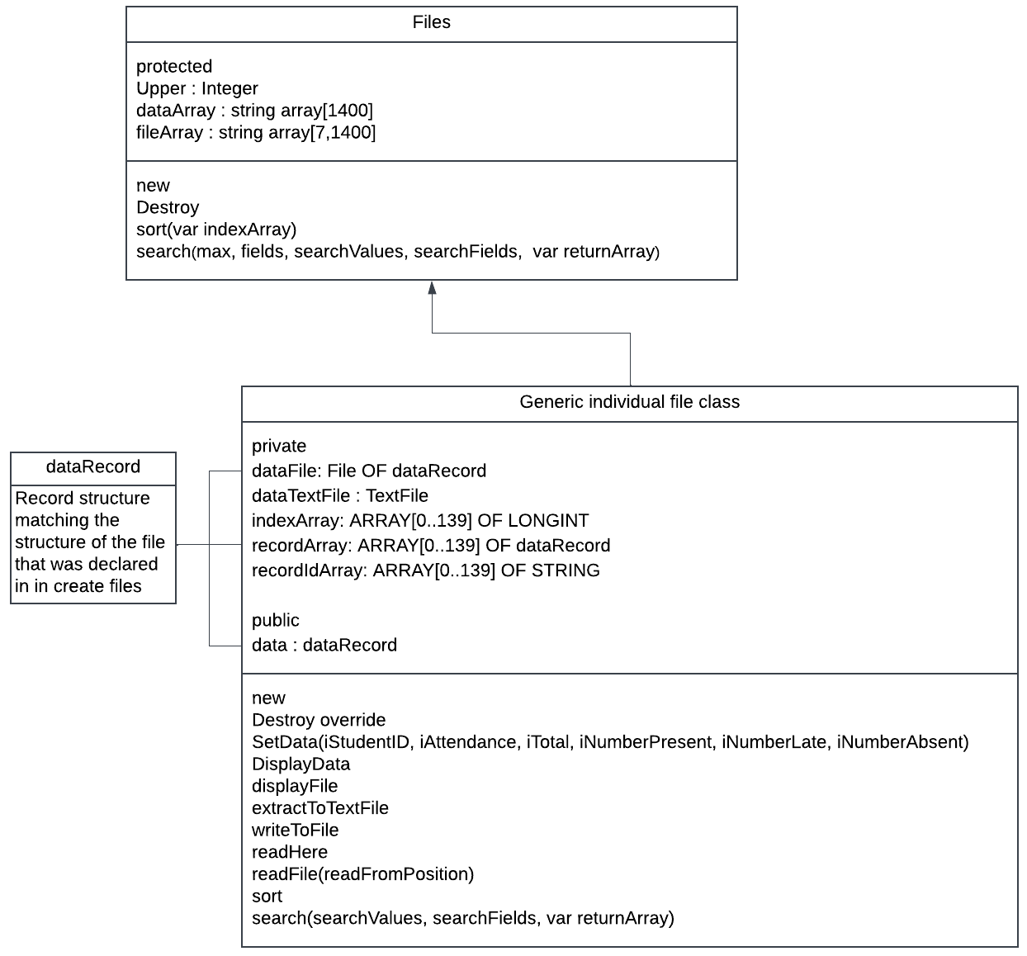
Public as it is not directly linked to the file so it is safe to leave it as public
Encapsulating the attributes by making them private and only accessible by getter and setter methods. To ensure data integrity
Each class for each file inherits the methods and attributes from the super class

Files Super Class

Top-Down Design – Files Class
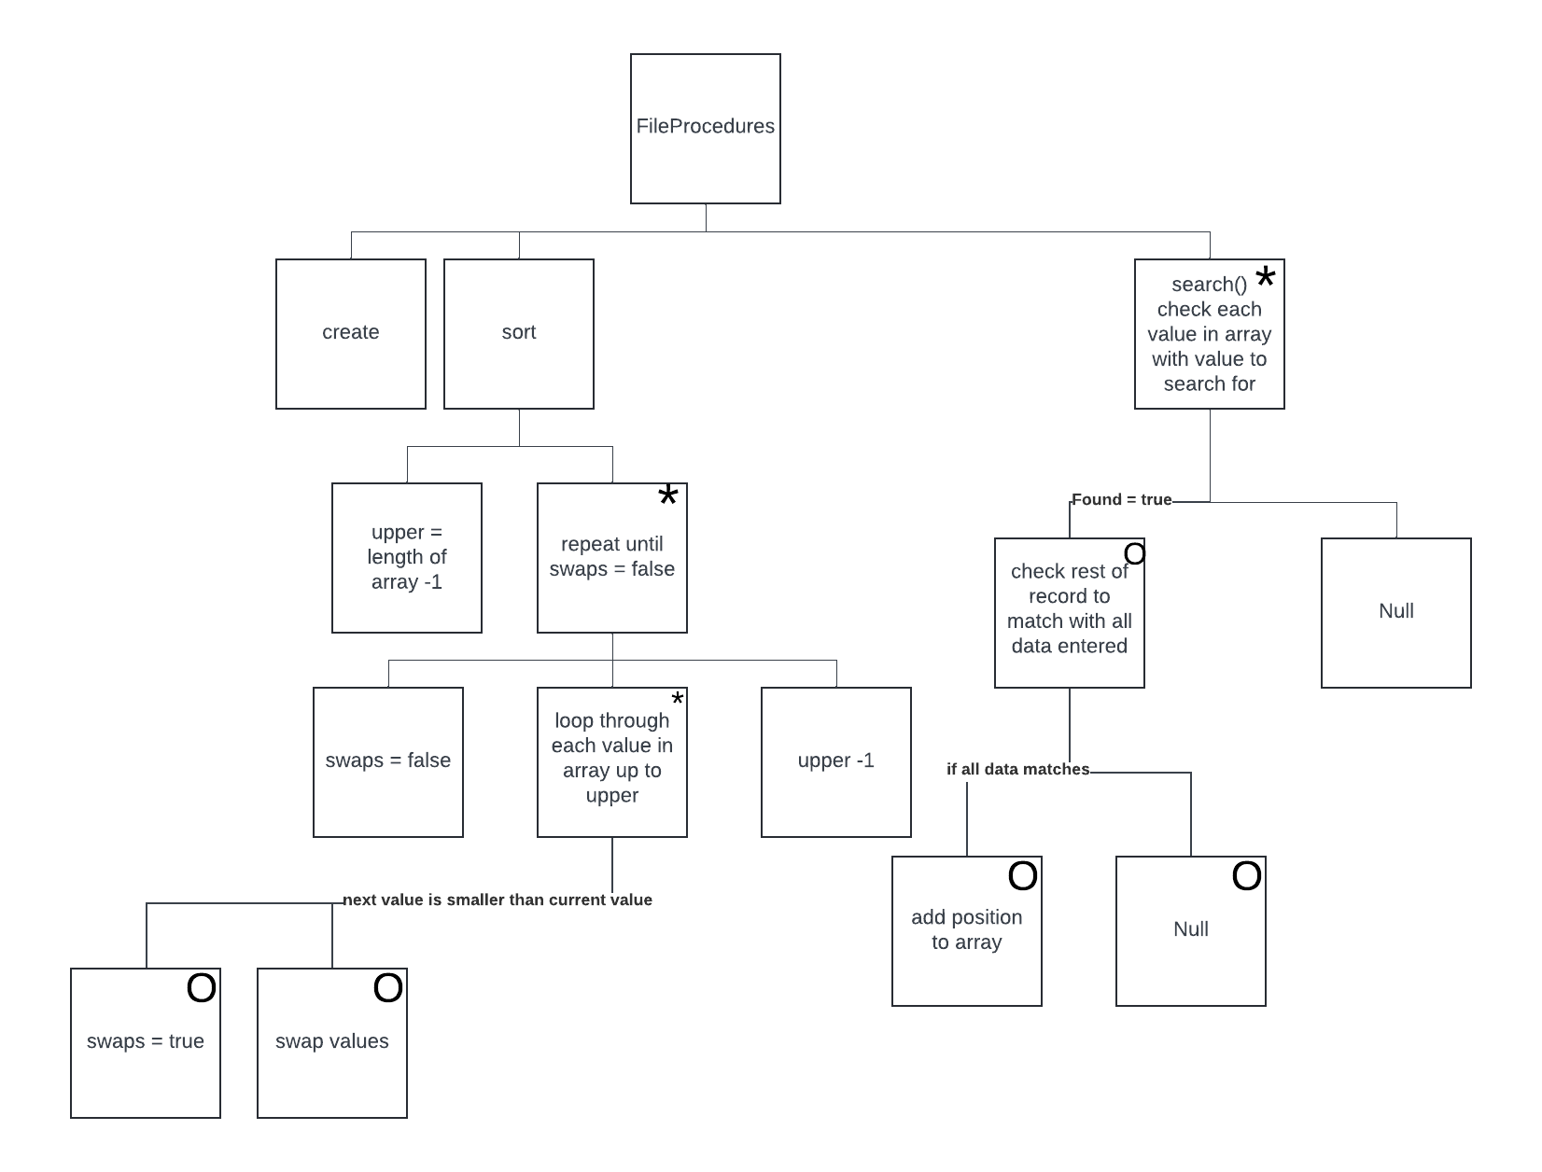
Testing
Iteration 2 Super Class
Linear search, search to find if any data in each record matches the search values
Reduces the number to sort through by 1 each time as the value at the end each time is always sorted
Keep looping through til no more swaps are made
Returns an array of all positions of found data
If found it searches the rest of the stored data with the data that needs to match
Bubble sort algorithm
Algorithm to search 2d array of data from child class
Algorithm to sort array of data from child class
Constructor method

Pseudocode – Files Class
Declare as protected so that only this class and child classes can access the attributes
unit FileProcedures
class Files
protected upper
protected array dataArray[1400]
protected array fileArray[7,1400]
Create constructor and destructor
protected procedure new()
endprocedure
protected procedure destroy()
endprocedure
Generic method to sort arrays of the files
// Bubble Sort Algorithm
protected procedure sort(var indexArray)
upper = upper - 1
repeat
Bubble sort
Swaps = FALSE
for i = 0 to upper do
// Check if the current element is greater than the next element
if dataArray[i] > dataArray[i + 1] then
Checks the data from the data array
// Swap elements in dataArray
TempStr = dataArray[i]
dataArray[i] = dataArray[i + 1]
dataArray[i + 1] = TempStr
Swaps the data around
Swaps = TRUE

// Swap corresponding elements in indexArray
TempIndex = indexArray[i]
indexArray[i] = indexArray[i + 1]
Swaps the indexes of each piece of data to keep track of changes to pass back
indexArray[i + 1] = TempIndex
endif
next i
upper = upper - 1
until !Swaps OR upper < 0
endprocedure
Arguments for length of array to search, number of fields, what value to search for in each field, which fields to be searched
// Linear Search Algorithm
protected procedure sort(max, fields, searchValues, searchFields, var returnArray)
a = -1
Only search the part of the 2d array that needs to be searched
returnIndex = 0
// Check every value in the 2D array
while a < max do
a = a + 1
// Check each item in the record
Check each item in each record to see if one match is initially found
for b = 0 to fields - 1 do
data = toLower(fileArray[b][a])
// Check if one piece of data matches
if data == toLower(searchValues[0]) then
found = TRUE
Tries to find any data in the record that doesn’t match with the data that is being searched for
// Check each piece of data in the record
for c = 0 to LEN(searchFields) - 1 do
data = toLower(fileArray[searchFields[c]][a])
// If not all data matches, continue searching
if toLower(searchValues[c]) != data then
If any data doesn’t stop searching that record and move on
found = FALSE
break
endif
next c
// If all data matches, add index to returnArray
if found == TRUE then
If all the data matches write its index to the return array.
returnArray[returnIndex] = a
returnIndex = returnIndex + 1
break
endif
endif
next b
End search of that record
endwhile
endprocedure
endclass

Child Class

Explanation of design generalization
This is a general structure for the child class, which is specific to each file, but only differs from this general structure in these ways:
- The record structure the data is read into
- The specifics of how each record must be written to the screen and to the text file
- The data that is used as the field for sorting
- Casting for storing the data in the 2d array for searching

Top-Down Design – Child Class
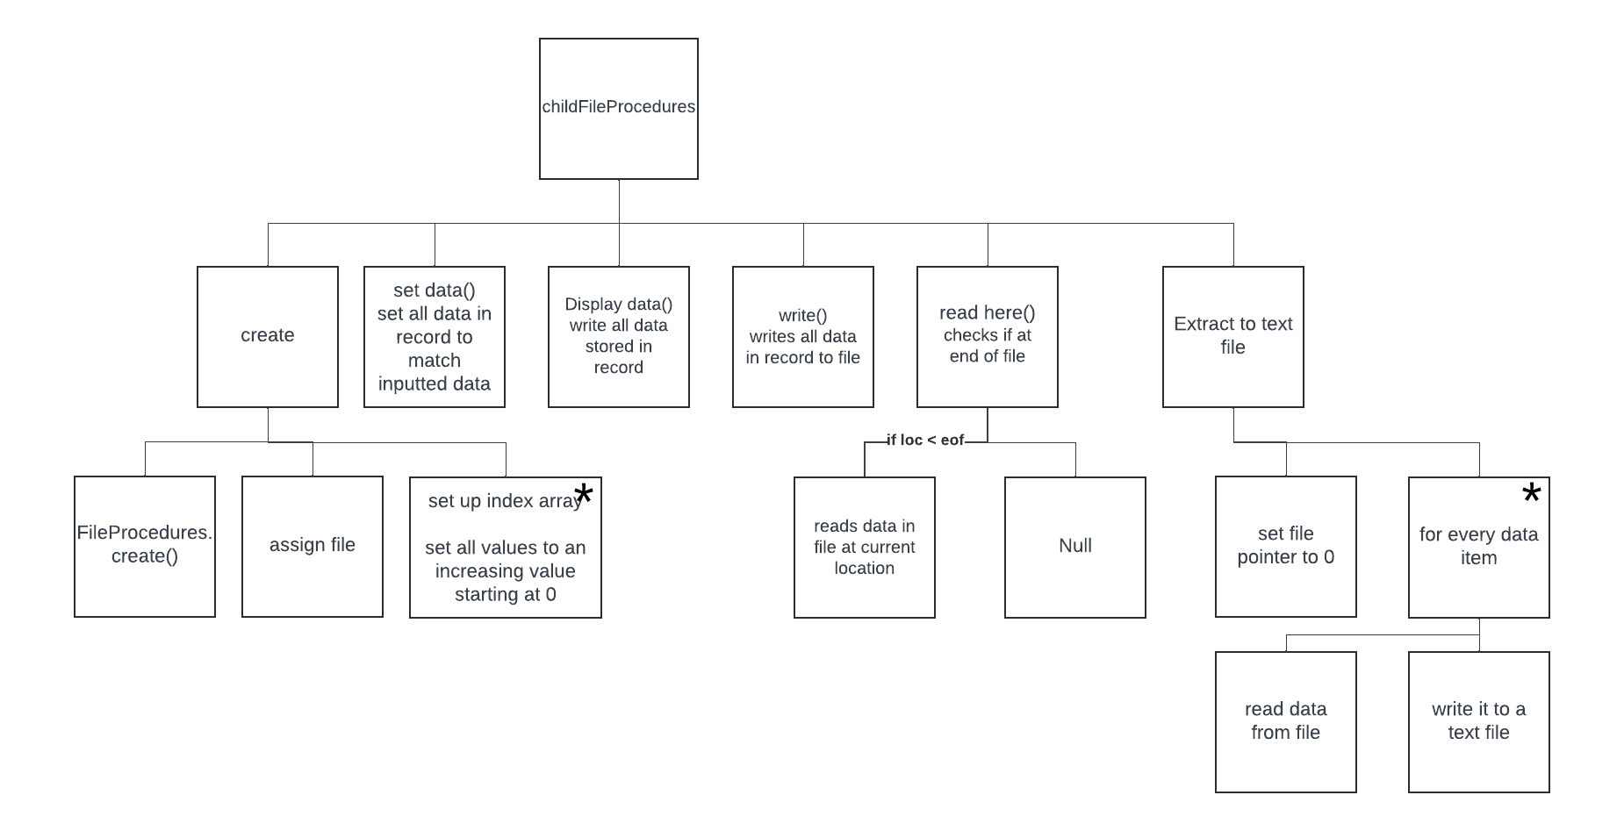
Check to see if I am trying to read past the end of a file
Create an array with data 0 to how ever many data items are in the file
Call super class constructor
Constructor to instantiate an object

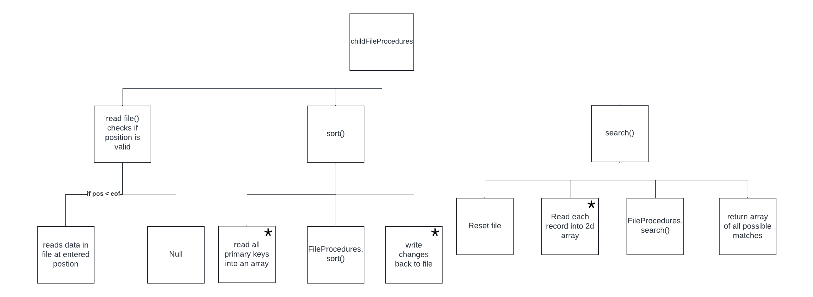
Call the parent class search function
Reset the file pointer
Check to see if I am trying to read past the end of a file
Testing
Iteration 2 Child Class
Class the super class procedure “sort” to sort the array passed in and return the array of the place of where the data has gone
Read all data items and put them into an array from the parent class

Pseudocode – Child Class
unit generalChildClass
Class definition inheriting methods and attributes from the file (super)(File Class Top Down Design) class

USES crt, sysutils, FileProcedures;

class childClass inherits Files

private dataFile
private dataTextFile
Declare attributes
private array indexArray[length of data file]
Public so it can be access outside the class, but still encapsulated as the data in the file is protected by getter and setter methoids
private array recordArray[length of data file]

public data = record(type in which is defined in the ERD)
Constructor
public procedure new
super.new
dataFile = openRead("fileLocation\\filename.dta")
dataTextFile = openRead("fileLocation\\filenameTxtOut.txt")
Assign files
RESET(dataFile);
RESET(dataFile);

for i = 0 to (length of data file) do
indexArray[i] = i
Set up index array
next i

endproceudure

public procedure Destroy
Destructor to clear memory, must destroy the parent class as well and close the files to keep any changes that may have not yet be pushed to the file
dataFile.close()
dataTextFile.close()
super.Destroy
endproceudure

public procedure SetData(each record field as parameter)
Procedure to update the record
data.field1 = arg1
data.field2 = arg2
data.field3 = arg3
// Continue for other fields...
endproceudure

public procedure displayData
Procedure to write each file out
print(data.field1)
print(data.field2)
print(data.field3)
// Continue for other fields...
endproceudure

public procedure displayFile
while !data.endOfFile do
Procedure to display the whole file to the screen
dataFile.read
print(data.field1)
print(data.field2)
print(data.field3)
// Continue for other fields...
endwhile
endproceudure

public procedure extractToTextFile
while !data.endOfFile do
Procedure to write all the data to a text file
dataFile.read
dataTextFile.writeLine(data.field1)
dataTextFile.writeLine(data.field2)
dataTextFile.writeLine(data.field3)
// Continue for other fields...
endwhile
endproceudure

Write the data record to the file
public procedure writeToFile
dataFile.write(data)
endproceudure

public procedure readHere
if FilePosition(dataFile) < FileSize(dataFile) then
Get the file data at the file pointers current location, if it is not at the end
data = dataFile.read()
endif
endproceudure

public procedure readFile(readFromPosition)
if readFromPosition < FileSize(dataFile) then
Get the file data at the location from the parameter, if it is still in the file
SEEK(dataFile,readFromPosition);
data = dataFile.read()
endif
endproceudure
Sets the upper limit for the array to be sorted
public procedure sort
dataFile.reset()
upper = numberOfRecordsInFile

// Read data into arrays
for a from 0 to (length of data file) do
Get the data into 2 arrays. 1 to sort and the other as array of original data
dataFile.read(data)
recordArray[a] = data
dataArray[a] = data.fieldToSearchBy
next a
Class the super sort procedure
// Sort the data
Files.sort(indexArray)

// Write sorted data back to the file
dataFile.reset()

for a from 0 to (length of data file) do
Write the sorted data back by getting index of the original data in the sorted order to writing to the file
dataFile.write(recordArray[indexArray[a]])
indexArray[a] = a
next a
Reset the index array
endproceudure

procedure classFile.search(searchValues, searchFields, returnArray)
dataFile.reset()
// Populate the fileArray with data and prepare returnArray
for a from 0 to (length of data file) do
dataFile.read(data)
Sort all the data into string format and store it in a 2d array to be searched
fileArray[0][a] = toLower(data.field1)
fileArray[1][a] = str(data.field2)
fileArray[2][a] = toLower(data.field3)
fileArray[3][a] = str(data.field4)
returnArray[a] = -1
next a

// Perform the search
Files.search((length of data file) +1, 4, searchValues, searchFields, returnArray)
endprocedure

endclass
Perform the search by calling the parent class search method

Write Design

Top-Down Design – Write Design
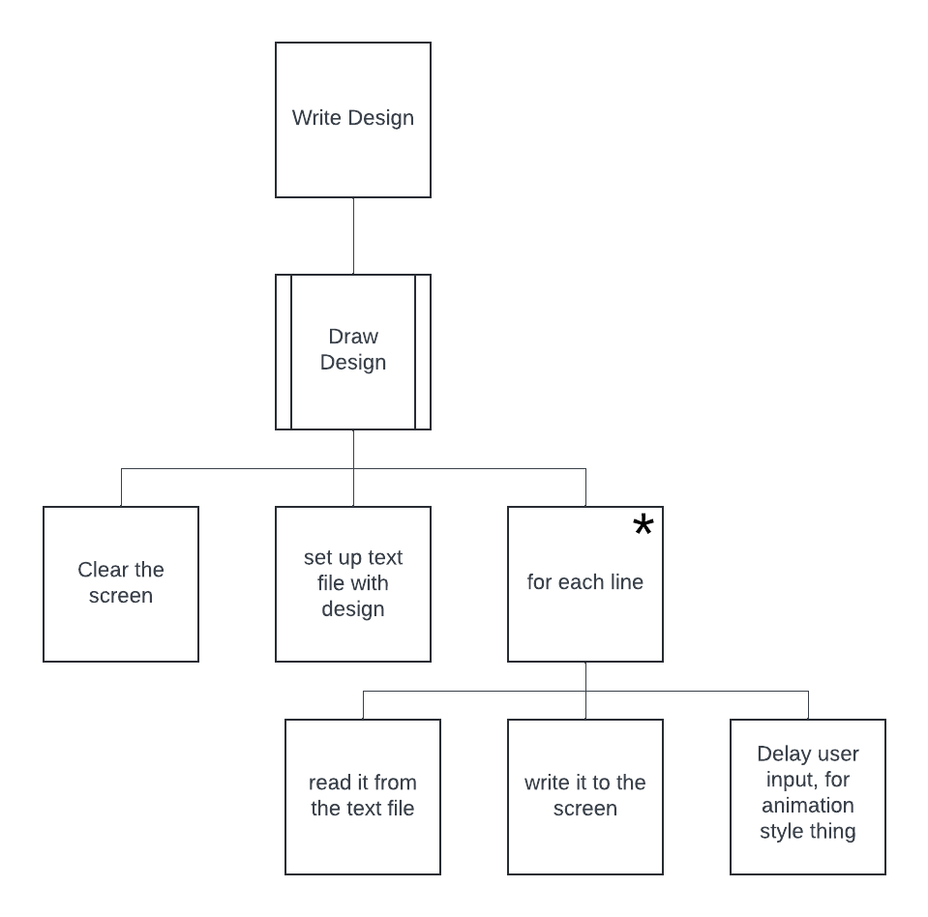
Testing
Iteration 0.6
Add a delay between each line to create an animation effect
Read each line of the design from the text file and write it to the screen
Procedure name
Sets the file pointer to the start and assigns an identifier to a place on the drive for the design text file

Pseudocode – Write Design
Unit writeDesign

Uses crt, sysutils, vputils

procedure DrawDesign(path, delayWrite)
// Initialize the file and screen
Set up screen conditions and file location
HideCursor()
ClearScreen()
DesignTextFile = openRead(path)
Write each line to the screen
// Read and display each line with a delay
for a from 0 to 28 do
DesignTextFile.readLine(Character)
print(Character)
Delay for animation
Delay(delayWrite)
next a

ShowCursor()
Endprocedure

Cursor Grid

Top-Down Design – Cursor Grid
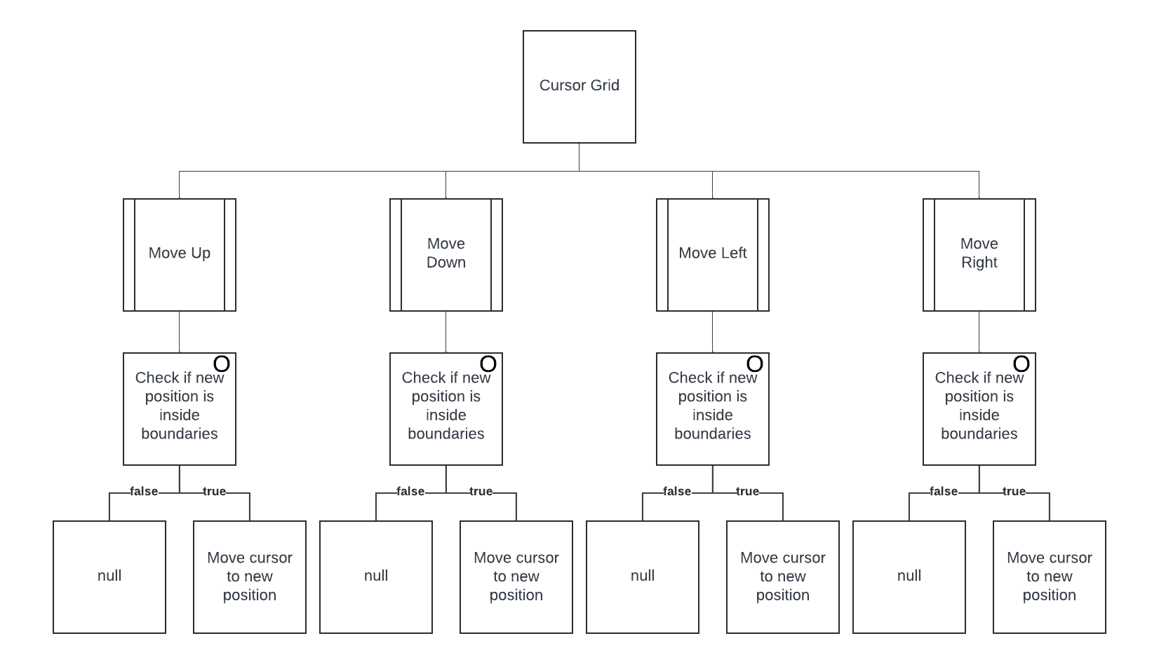
Procedures for each direction
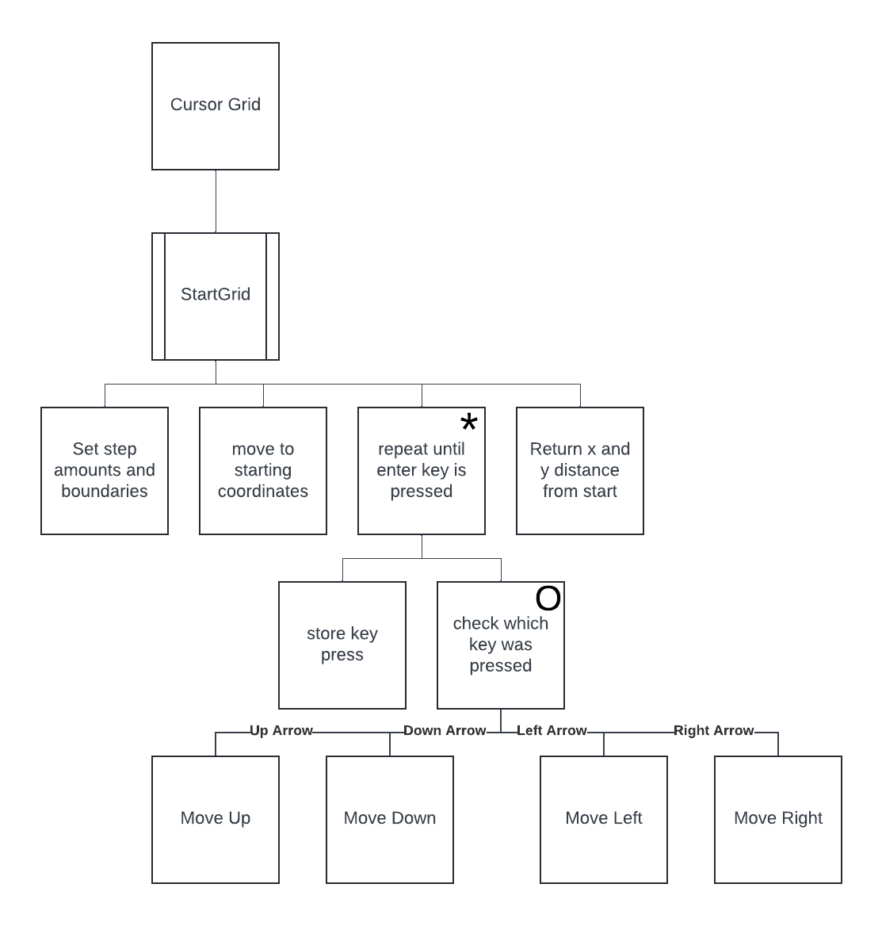
Testing
Iteration 0.7
Update parameters which were passed by reference to return both x and y
Call the procedure depending on which key was pressed
Move the cursor to the start position of the menu
Take in amounts to step in each direction. And the boundaries from an array

Pseudocode – Cursor Grid
Validating if the direction the user wants to move the cursor is still within the menu
Unit CursorGrid

// Procedure to Move the Cursor Up
procedure moveUp
if WhereY() - stepY >= minY then
movePos = WhereY() - stepY
GoToXY(WhereX(), movePos)
endif
Validating if the direction the user wants to move the cursor is still within the menu
endprocedure

// Procedure to Move the Cursor Down
procedure moveDown
if WhereY() + stepY <= maxY then
movePos = WhereY() + stepY
GoToXY(WhereX(), movePos)
endif
Validating if the direction the user wants to move the cursor is still within the menu
endprocedure

// Procedure to Move the Cursor Left
procedure moveLeft
if WhereX() - stepX >= minX then
movePos = WhereX() - stepX
GoToXY(movePos, WhereY())
endif
Validating if the direction the user wants to move the cursor is still within the menu
endprocedure

// Procedure to Move the Cursor Right
procedure moveRight
if WhereX() + stepX <= maxX then
movePos = WhereX() + stepX
GoToXY(movePos, WhereY())
endif
endprocedure

// Procedure to Initialize and Control the Grid Movement
procedure startGrid(moveStepX, moveStepY, startX, startY, boundaries, REF x, REF y)
stepX = moveStepX
Set step controls and boundaries for the cursor
stepY = moveStepY
minX = boundaries[0]
minY = boundaries[1]
maxX = boundaries[2]
maxY = boundaries[3]
Move cursor to start position
GoToXY(startX, startY)
Repeat //repeat until enter is pressed
keyPress = readKey()
Determines which arrow key was pressed
switch keyPress
case 'UpArrow':
moveUp()
case 'DownArrow':
moveDown()
case 'LeftArrow':
moveLeft()
case 'RightArrow':
moveRight()
If the enter key is pressed end loop
endswitch
until keyPress = CHR(13)
//return end position
if stepX != 0 then
x = round((WhereX() - startX) / stepX)
else
x = startX
Return the distance from the start as a number of steps from the start position
endif

if stepY != 0 then
y = round((WhereY() - startY) / stepY)
else
y = startY
endif
endprocedure

Create Menu

Top-Down Design – Create Menu
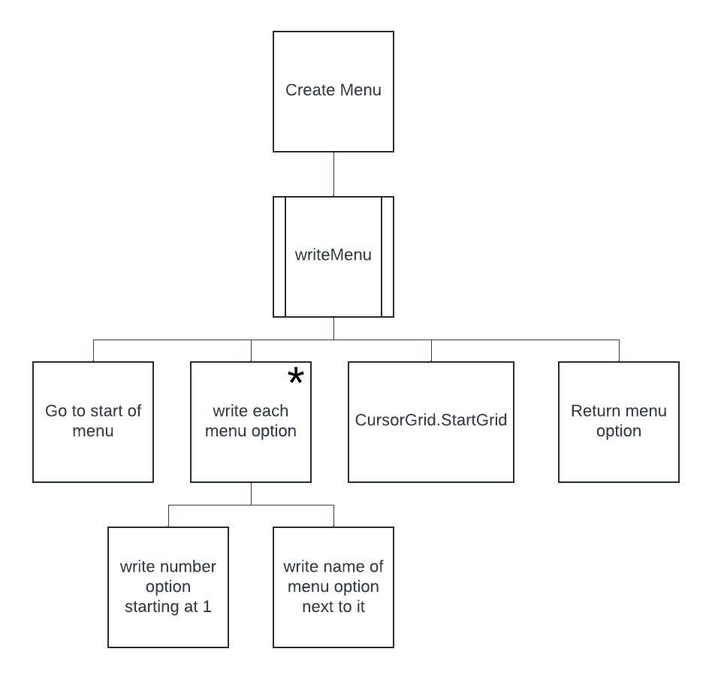
Testing
Iteration 0.8
Return which number menu option was picked
Start the cursor grid script with stepY being 1 and stepX to 0 (so left and right)
Write each menu option in the form
1: menuName
Go to the position of where the menu will start on the screen

Pseudocode – Create Menu
Unit createMenu
// Function to Write and Handle a Menu
function writeMenu(startPos, numberOfChoices, menuChoices, optionStart)
HideCursor()
Go to start position

// Display menu choices
for a from 0 to numberOfChoices - 1 do
Write each menu option out
GoToXY(startPos[0], startPos[1]+a)
print(a + 1 + ": " + menuChoices[a])
endfor

ShowCursor()
Start the cursor grid script
Delay(100)

// Start the grid for user selection
CursorGrid.startGrid(0, 1, startPos[0], startPos[1] + optionStart,
[startPos[0], startPos[1], startPos[0], numberOfChoices + startPos[1] - 1],
x, y)

ClearScreen()
return optionStart + y
Return the option that was picked
endfunction

endunit

Log In Menu

Top-Down Design – Log in Menu
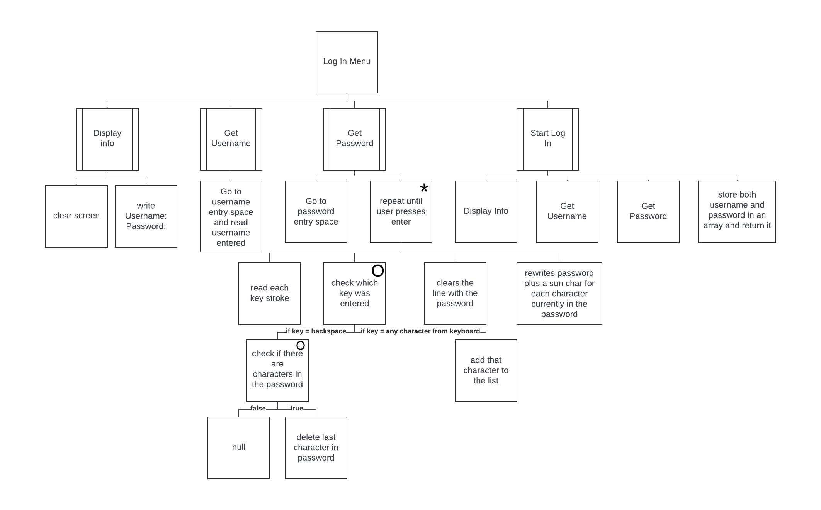
Testing
Iteration 0.5
Gives a clear indication for what needs to be entered
Control for the string which is the password
Keep reading the user inputs
1 procedure to call from other scripts so main script is not cluttered with many procedures
Short procedure to just display the main elements

Pseudocode – Log in Menu
Unit LogInScreen
Simple procedure to just read the user entered username
// Procedure to Get the Username
procedure GetUsername
GoToXY(11, 1)
Username = input() // Read the username input
endprocedure

// Procedure to Get the Password
procedure GetPassword
Create an empty string which is the current password
GoToXY(11, 2) // Move cursor to the password position
i = 0
Password = "" // Initialize password as an empty string
HideCursor()
Reads each key press individually to compare each one and to track length so characters can be written to hide actual characters typed
// Loop to process key inputs until Enter is pressed
repeat
key = readKey()
Test if the backspace is pressed

// If the key is Backspace and there are characters to delete
if key = CHR(8) then
Make sure there are still characters in the password
if i > 0 then
Password = deleteChar(Password, i) // Remove the last character
i = i - 1
Delete the last character in the password and decrease the length
endif
// If the key is a valid printable character
elseif (key >= CHR(33) and key < CHR(127) and key != CHR(13)) OR key = CHR(156) then
Password = Password + key
Limits the user inputs to only certain characters and make sure its not “enter”. (See appendix (add part) for reference for all characters)
i = i + 1
endif

// Update the password line with masked characters
Rewrites the whole line with correct number of ☼ to hide the user entered password for security
GoToXY(1, 2)
DelLine()
write("Password: ")
for a from 1 to i do
write("☼") // Masked character representation
next a
until key = CHR(13) // Loop until Enter key is pressed

writeln()
ShowCursor()
endprocedure
Writes the basic menu to the screen

// Procedure to Display Initial Information
procedure DisplayInfo
ClearScreen()
Immediate clear indication on what is happening and what the user needs to do
writeLine("Username: ")
writeLine("Password: ")
GoToXY(11, 1) // Position cursor for username entry
endprocedure

// Main Login Procedure
procedure startLogIn(userPassArrayr : byRef)
Call each procedure and return the entered data back to where it was called from
DisplayInfo() // Show initial display
GetUsername() // Capture the username
GetPassword() // Capture the password
ClearScreen() // Clear the screen for the next task
userPassArrayr[0] = Username // Store the username in the array
userPassArrayr[1] = Password // Store the password in the array
endprocedure

endunit

Student’s Menu

Top-Down Design – Students Menu
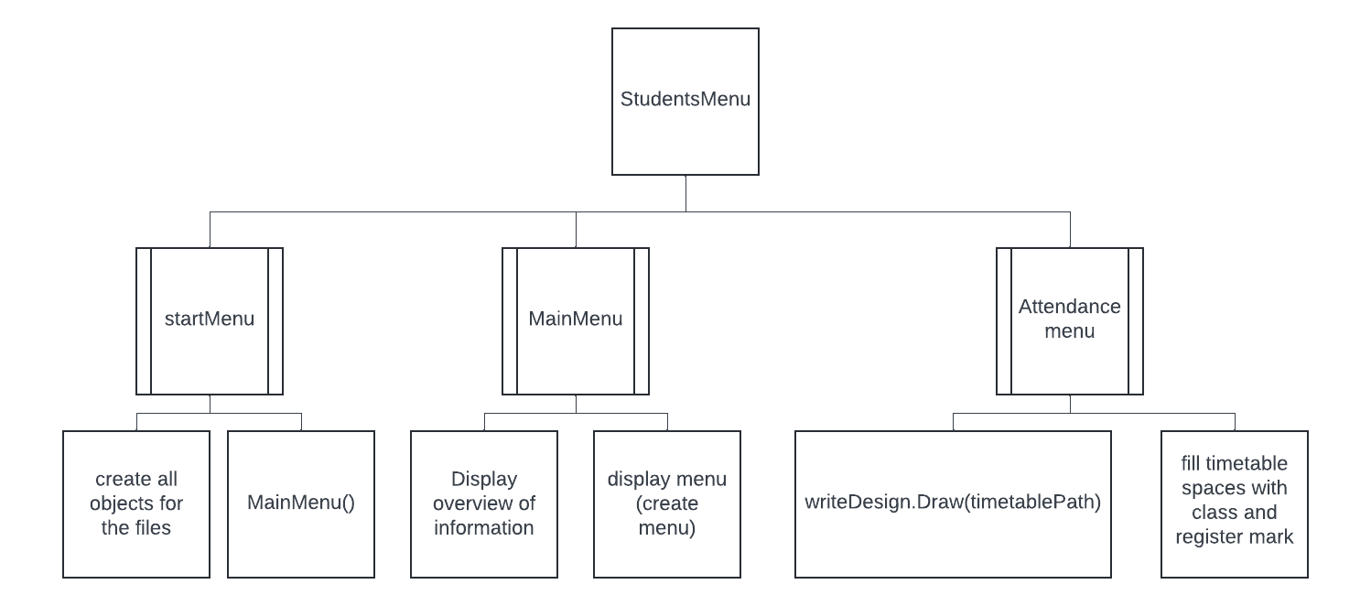
Populate each section so the student can see the class and what register mark they got for it
Write the generic timetable format
Call the create menu (menu design) script to create the menu with the interactions
Initialise all the objects so that the files have the extra procedures for searching
This is the section that is called from the main program to start the student menu

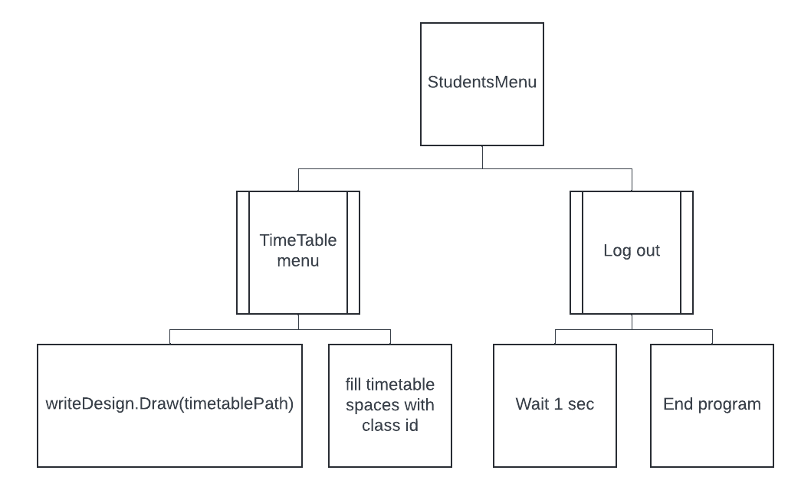
Testing
Iteration 4
Return to main program and then just end
Populate the timetable with only the class ids

Pseudocode – Students Menu
UNIT StudentsMenu
All sub programs references so that the routines can be used

uses crt, sysutils, VPUtils, studentProcedures, timeTableProcedures,
attendanceProcedures, studentClassProcedures, createMenu, writeDesign
Procedure to show attendance, not enough time to complete
// Procedure AttendanceMenu
procedure AttendanceMenu
writeLine("Attendance")
Procedure to fill the empty timetable
input()
endprocedure

// Procedure CompleteTimeTable
procedure CompleteTimeTable(inputDate)
Set the animation time if there should be an animation
if animationTimeTable == TRUE then
timeDelay = 100
else
timeDelay = 0
endif

writeDesign.DrawDesign("C:\\ComputerScienceCoursework\\Program\\files\\TimeTableLayout.txt", timeDelay)
CurrentDate = inputDate
Get the day in form as Monday is day 0
day = DayOfWeek(CurrentDate - 1) - 1
HideCursor()

// Write dates with current date highlighted
for a from 0 to 4 do
GoToXY(5, 7 + a * 4)
Write all the dates in the timetable highlighting all the current date in yellow
if CurrentDate - day + a == Date then
TextColor(YELLOW)
else
TextColor(WHITE)
endif
write(DateToStr(CurrentDate - day + a))
Delay(timeDelay)
Next a
TextColor(WHITE)

// Calculate if it is week A or week B
NumberOfDays = 0
while StrToDateTime("13/09/2024") + NumberOfDays != CurrentDate - day + a - 1 do
NumberOfDays = NumberOfDays + 1
endwhile
NumberOfDays = NumberOfDays DIV 7
GoToXY(7, 2)
Calculate if it is week a or b by finding number of weeks since start of year and seeing if it is an odd or even number
if NumberOfDays MOD 2 == 0 then
week = "A"
else
week = "B"
endif
Find every class that the student is in
write(week)

// Write lessons in timetable
stringStudentId = str(studentID)
studentClassC.search([stringStudentId], [1], studentClassReturnArray, TRUE)
b = 0
For each of those classes

while studentClassReturnArray[b] != -1 do
studentClassC.readFile(studentClassReturnArray[b])
for a from 0 to 320 do
timetableReturnArray[a] = -1
next a
timetable.search([studentClassC.data.ClassID], [2], timetableReturnArray, TRUE)
c = 0
Find every time that class in the timetable file

while timetableReturnArray[c] != -1 do
timetable.readFile(timetableReturnArray[c])

For each time the class is check If the current week is week a check to see if that class exists in week a

if week = "A" then
if timetable.data.day < 6 then
GoToXY(10 * timetable.data.LessonNo + 20, 4 * (timetable.data.Day - 1) + 7)
write(Trim(timetable.data.ClassID))
Go to the correct space in the timetable and write it in
Go to the correct space in the timetable and write it in
If it is week B then make sure that class at that time is in week B
Delay(timeDelay)
endif
else
if timetable.data.day > 5 then
GoToXY(10 * timetable.data.LessonNo + 20, 4 * (timetable.data.Day - 6) + 7)
write(Trim(timetable.data.ClassID))
Delay(timeDelay)
endif
endif
c = c + 1
endwhile
b = b + 1
endwhile

for a from 0 to 4 do
Write the form of that Student in
GoToXY(21, 4 * a + 7)
write(student.data.Form)
Delay(timeDelay)
Next a
Set animation to false so it no longer animates the drawing
animationTimeTable = FALSE
endprocedure

// Procedure TimeTableMenu
Pass the date the timetable should contain in case it needs to change from current date
procedure TimeTableMenu
StartDate = Date
CompleteTimeTable(StartDate)
input()
endprocedure

// Procedure LogOutMenu
Write logging out then wait a second as it will exit all so the program will terminate
procedure LogOutMenu
writeLine("Logging out")
Timetable.free
studentClassC.free
Free all objects from memory so it closes without any incomplete changes in memory
student.free
attendance.free

Delay(1000)
endprocedure
Main menu function while loops until logout is selected

// Procedure Main Menu
procedure mainMenu
GoToXY(0, 0)
choice = 0
Get the students main and attendance data before the loop so it is only retrieved once and only once
// Get student and attendance data at the start
student.readFile(studentID)
Write welcome message and attendance
attendance.readFile(studentID)

// Main menu loop
repeat
ClearScreen()
HideCursor()
writeLine("Welcome " + student.data.fname + " " + student.data.sname)
GoToXY(1, 3)
writeLine("Attendance: " + format("%.2f", attendance.data.attendance * 100) + "%")

choice = createMenu.writeMenu([1, 5], 3, mainMenuOptions, choice)

switch choice
case 0:
Start the menu option with options declared at the start
AttendanceMenu()
case 1:
Determine which choice was made and call appropriate routine
TimeTableMenu()
case 2:
LogOutMenu()
endswitch
until choice = 2
endprocedure
Set animation to true for the first time it is run
// Procedure Start Student
procedure startStudent(inputStudentId)
animationTimeTable = TRUE

for a from 0 to 1400 do
Pre populate this as the search will always yield the same result so no need to flush out previous data
studentClassReturnArray[a] = -1
next a

timetable = TimeTableFile.create()
studentClassC = StudentClassFile.create()
studentID = inputStudentId
attendance = AttendanceFile.create()
Instantiate all objects of files so these files can be used in the unit
student = StudentFile.create()

mainMenu()
endprocedure
Start the main menu

END UNIT

Teacher’s Menu

Top-Down Design – Teachers Menu

Testing
Iteration 5
Debug to ensure that the menu is entered

Pseudocode – Teachers Menu
UNIT TeachersMenu

IMPORT crt, sysutils

// Procedure: Start Teacher
Dummy Procedure to test that the menu is entered
procedure startTeacher
// Debug message to confirm the menu works
writeLine("Welcome teacher")
input()
endprocedure

END UNIT

Main

Top-Down Design – Main
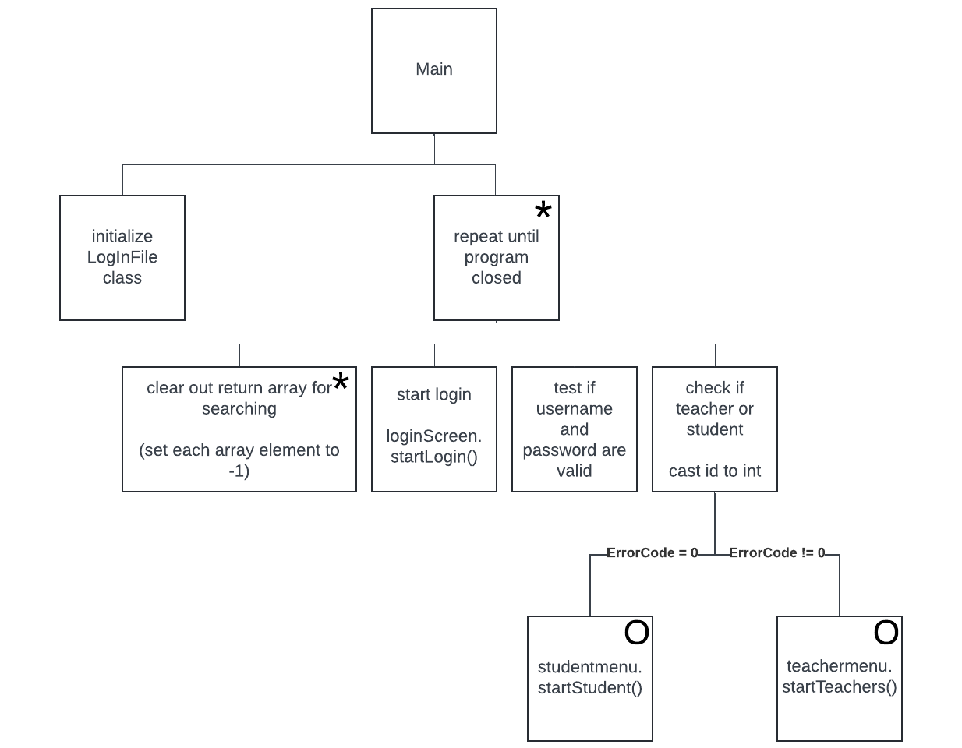
Testing
Iteration 6
Pick a user
Keep asking for login attempts until
Instantiates an object of the login class (general class structure)
Main executable script. Brings everything into one script

Pseudocode – Main
Instantiates an object of the login class (general class structure)
function start() : STRING
// Initialize login file
logIn = LogInFile.create()
logIn.sort()
Sets user position in file index to an impossible known value

userIndex[i] = -1

loggedIn = FALSE
Calls the log in screen procedure (Log In Procedure)
// Login loop
while loggedIn = FALSE do
ClearScreen()

// Call login screen for user input
Search the log in file using the search procedure in the child class for the details entered to validate in the information entered is valid
LogInScreen.startLogIn(userDetailsArray)
logIn.search(userDetailsArray, [1, 2], userIndex)
Loading text for user friendliness
// Simulate loading process
loading.startLoading("L", percentDone)
Delay(1000)
loading.silentKillLoading()
Delay(100)

// Validate username and password
if userIndex = -1 then
Checks to see if a position was found with the data entered
writeLine("Username or Password is incorrect.")
input() // Pause for feedback
else
loggedIn = TRUE
Gets the user id to test if it is a teacher or student
// Retrieve user information
logIn.readFile(userIndex)
userId = Trim(logIn.data.PersonID)

// Determine if the user is a teacher or student
val(userId, intUserID, ErrCode)
If it is not a number, then user is a teacher else a student
if ErrCode != 0 then
return "T" // Teacher
else
return "S" // Student
endif
endif
Delete the login file object to preserve memory
endwhile

// Free login object
logIn.free()
endfunction

// Main Logic
userType = start()
if userType = "T" then
// Call teacher menu
Checks which user was logged into and then starts the menu from the respective user
TeachersMenu.startTeacher()
elseif userType = "S" then
// Call student menu
StudentsMenu.startStudent(intUserID)

endif

Usability Features
Feature | Description | Justification
Clear way to enter username and password | Clear box for the user to type in the username and then immediately type in the password | I decided to add this as students will be using the system, so it allows for simple and clear access
Hidden password on entry | The password is hidden while being typed | This is to keep accounts secure as a student should not be able to access a teachers account.
Easy keyboard navigation within the menus | Allows you to use the keyboard to navigate the menu without the cursor being able to leave the menu | This is so it is clear and more like other programmes that are being used. The ability to move the cursor through a menu and select something is more intuitive to the user than typing in numbers for menu options
Tabular designs | Displaying information in a table or in similar forms such as graphical. | This is to make the data more easily readable rather than just giving all the data in the list which is very hard to read with large amounts of data
Predictive searching | As you type to search for a student or something else it provides a list of everything that matches so far | I decided to add this so that even if the teacher doesn’t know the students full name, they can start to search and then pick from a list rather than having to search specifically for one student
Colour coded attendance | In the overview of attendance for a form group the students will be sorted from lowest to highest attendance and colour coded to show if any actions should be taken | I made the choice to add this so that it is easier on the form tutor to find out who they need to talk to about their attendance rather than having to search through their entire form and being potentially being unclear on who they need to speak to

Data Dictionary
Identifier | Module | Data Structure | Data Type | Scope | Validation | Explanation | Justification
Any single character (i, j, d, a,…) | All | n/a | integer | local | None needed, iterative variable | These will be used as iterative variables for the sole purpose of counting loops | These are used to count for loops and to use a counting variable in while or repeat until loop
TimeTable | CreateFiles.pas | Record | - | Global | None, can’t input into the record data structure | Stores information about the timetable | Allows data about the timetable and when classes are to be retrieved
Day | CreateFiles.pas | Field | LONGINT | Global (TimeTable) | Taken from the text file of the timetable | A field within the timetable record | Allows classes to be on a day and a lesson number
LessonNo | CreateFiles.pas | Field | LONGINT | Global (TimeTable) | Taken from the text file of the timetable | A field within the timetable record | Allows classes to be on a day and a lesson number
ClassID | CreateFiles.pas | Field | STRING[8] | Global (TimeTable) | Taken from the text file of the timetable | A field within the timetable record | Stores information about which class is associated with the data
Form | CreateFiles.pas | Record | - | Global | None, can’t input into the record data structure | Stores information about the Forms | Allows data about the timetable and when classes are to be retrieved
FormID | CreateFiles.pas | Field | STRING[5] | Global (Form) | Must be a string of max length 5 | A field within the form record | Stores the form id, a unique identifier for each form
NumberInForm | CreateFiles.pas | Field | LONGINT | Global (Form) | Must be an int ≥ 0 | A field within the form record | Stores the number of students in the form for calculations
Register | CreateFiles.pas | Record | - | Global | None, can’t input into the record data structure | Stores the information about each register | Used to store information about each register allowing the data to be retrieved
RegisterID | CreateFiles.pas | Field | STRING[17] | Global (Register) | A combination of lesson Number Date and class ID | Stores the unique identifier for each register | This is sued to search uniquely for a specific register
LessonNo | CreateFiles.pas | Field | LONGINT | Global (Register) | Taken from the lesson number where that class resides at one time | Stores the lesson number in which that register was taken | Allows for registers to be searched by a time
Date | CreateFiles.pas | Field | TDateTime | Global (Register) | Program Generated | Stores the date on which the register was taken | Allows for registers to be searched by a time
ClassID | CreateFiles.pas | Field | STRING[8] | Global (Register) | Must match the class id in which this register is for that class | Stores the Class ID for that register | Used to search for all registers for a specific class
RegisterMarks | CreateFiles.pas | Field | ARRAY[0..40] OF studentRegisterMarkRecord | Global (Register) | Program Generated | Used to store student and their assigned register marks | This is needed to calculate the attendance of each student
isOfstedRegister | CreateFiles.pas | Field | BOOLEAN | Global (Register) | Boolean | Stores whether that register should be sent to Ofsted | This is required by my client so I need a method to store it and be able to display it back
studentRegisterMark | CreateFiles.pas | Record | - | Global | None, can’t input into the record data structure | Stores the information about a single student and their register mark | Used to store information about students and their register marks. It is used in an array in the register file
studentID | CreateFiles.pas | Field | LONGINT | Global (studentRegisterMark) | Must match with the student id in which this register mark is attached to | Stores the student id | This is to relate a single student with a register mark
registerMark | CreateFiles.pas | Field | CHAR | Global (studentRegisterMark) | A character out of list (P,L,A) to indicate which register mark they got | Stores the register mark for that student | This is to relate a single student with a register mark
Attendance | CreateFiles.pas | Record | - | Global | None, can’t input into the record data structure | Stores the information about each students attendance | Used to store information about each students attendance, allowing it to be retrieved.
StudentID | CreateFiles.pas | Field | LONGINT | Global (Attendance) | Must match with the student id in which this attendance record is attached to | Stores student id | This creates a 1 to 1 relation between the attendance file and student file to allow for easy searching between files
Attendance | CreateFiles.pas | Field | REAL | Global (Attendance) | A real number between 1 and 0 inclusive | Stores the attendance as a decimal | Used to display back to the student
Total | CreateFiles.pas | Field | LONGINT | Global (Attendance) | Must be an int ≥ 0 | Total number of available register marks | This is to calculate the attendance
NumberPresent | CreateFiles.pas | Field | LONGINT | Global (Attendance) | Must be an int ≥ 0 | Total number of present register marks | This is to calculate the attendance
NumberLate | CreateFiles.pas | Field | LONGINT | Global (Attendance) | Must be an int ≥ 0 | Total number of late register marks | This is to calculate the attendance
NumberAbsent | CreateFiles.pas | Field | LONGINT | Global (Attendance) | Must be an int ≥ 0 | Total number of absent register marks | This is to calculate the attendance
Student | CreateFiles.pas | Record | - | Global | None, can’t input into the record data structure | Store student data | Used to store information about each student
StudentID | CreateFiles.pas | Field | LONGINT | Global (Student) | Must be an int ≥ 0 | Stores student id | Unique identifier so that each student can be searched for and found easily
FName | CreateFiles.pas | Field | STRING[20] | Global (Student) | Must be a string with max length 20 | Stores first name of student | This is so a student can be searched for by first name
SName | CreateFiles.pas | Field | STRING[20] | Global (Student) | Must be a string with max length 20 | Stores last name of student | This is so a student can be searched for by last name
Year | CreateFiles.pas | Field | LONGINT | Global (Student) | Must be an int, doesn’t have to be bound but in terms of logic it should ≥ 0 | Stores the student’s year | This is so a student can be searched for by year
Form | CreateFiles.pas | Field | STRING[5] | Global (Student) | Must be a string matching to the form file | Stores the students form | This is so a student can be searched for by Form
Uname | CreateFiles.pas | Field | STRING[40] | Global (Student) | Must be a string with max length 40 | Stores the student username | Allows the student to log in using a unique username
Pword | CreateFiles.pas | Field | STRING[20] | Global (Student) | Must be a string with max length 20 | Stores the student password | Allows the student to log in using a unique password
Teacher | CreateFiles.pas | Record | - | Global | None, can’t input into the record data structure | Store teacher data | Used to store information about each teacher
TeacherID | CreateFiles.pas | Field | STRING[3] | Global (Teacher) | Must be a string with max length 3 | Stores teacher id | Unique identifier so that each teacher can be searched for and found easily
fname | CreateFiles.pas | Field | STRING[20] | Global (Teacher) | Must be a string with max length 20 | Stores first name of teacher | This is so a teacher can be searched for by first name
sname | CreateFiles.pas | Field | STRING[20] | Global (Teacher) | Must be a string with max length 20 | Stores last name of teacher | This is so a teacher can be searched for by last name
form | CreateFiles.pas | Field | STRING[5] | Global (Teacher) | Must be a string matching to the form file | Stores the teacher form | This is so a teacher can be searched for by Form
Uname | CreateFiles.pas | Field | STRING[40] | Global (Teacher) | Must be a string with max length 40 | Stores the teacher username | Allows the teacher to log in using a unique username
PWord | CreateFiles.pas | Field | STRING[20] | Global (Teacher) | Must be a string with max length 20 | Stores the teacher password | Allows the teacher to log in using a unique password
studentClass | CreateFiles.pas | Record | - | Global | None, can’t input into the record data structure | Store class data | Used to store information about classes
ClassID | CreateFiles.pas | Field | STRING[8] | Global (studentClass) | Must be a string with max length 8 | Stores class id | Unique identifier for each class so it can be found easily in the file
Year | CreateFiles.pas | Field | LONGINT | Global (studentClass) | Must be an int, doesn’t have to be bound but in terms of logic it should ≥ 0 | Stores the year of the class | So classes can be searched for by year
subjectID | CreateFiles.pas | Field | STRING[3] | Global (studentClass) | Must be a string matching a subject in the subject file | Stores the year of the subject associated with that class | So classes can be searched for by subject
NoOfStudents | CreateFiles.pas | Field | LONGINT | Global (studentClass) | Must be an int ≥ 0 | Stores the number of students in that class | This keeps track of how many students are in the class and if it is the right number or too many
subject | CreateFiles.pas | Record | - | Global | None, can’t input into the record data structure | Stores information about the subjects | Allows retrieval of data from the subject file
SubjectID | CreateFiles.pas | Field | STRING[3] | Global (subject) | Must be a string with max length 3 | Stores subject id | Allows for searching the subject file by id
SubjectName | CreateFiles.pas | Field | STRING[20] | Global (subject) | Must be a string with max length 20 | Stores subject name | Associates a subject id with a name readable for students
studentClassResolver | CreateFiles.pas | Record | - | Global | None, can’t input into the record data structure | Stores which students are in which class | Allows the retrieval of data about which classes each student is in
StudentID | CreateFiles.pas | Field | LONGINT | Global (studentClassResolver) | Must be a string matching a student in the student file | Stores the student id | Combined allow for the link between students and a class allowing the ability to read which class each student is in
ClassID | CreateFiles.pas | Field | STRING[8] | Global (studentClassResolver) | Must be a string matching a class in the class file | Stores the Class ID
teacherSubjectResolver | CreateFiles.pas | Record | - | Global | None, can’t input into the record data structure | Variable that the teacher subject record is read into | Allows the retrieval of data from the teacher subject resolver file
TeacherID | CreateFiles.pas | Field | STRING[3] | Global (teacherSubjectResolver) | Must be a string matching a teacher in the teacher file | Stores the teacher id | Associates with a specific teacher
SubjectID | CreateFiles.pas | Field | STRING[2] | Global (teacherSubjectResolver) | Must be a string matching a subject in the subject file | Stores the subject id | Associates with a specific subject
teacherClassResolver | CreateFiles.pas | Record | - | Global | None, can’t input into the record data structure | Variable that the teacher class record is read into | Allows the retrieval of data from the teacher class resolver file
TeacherID | CreateFiles.pas | Field | STRING[3] | Global (teacherClassResolver) | Must be a string matching a teacher in the teacher file | Stores the teacher id | Associates with a specific teacher
ClassID | CreateFiles.pas | Field | STRING[8] | Global (teacherClassResolver) | Must be a string matching a class in the class file | Stores the class id | Associates with a specific subject
LogInDetails | CreateFiles.pas | Record | - | Global | None, can’t input into the record data structure | Variable that the login record is read into | Allows the retrieval of data from the login file
PersonID | CreateFiles.pas | Field | STRING[5] | Global (LogInDetails) | Must be a string or converted from an int to a string matching an id in either the student or teacher file | A variable that hold the id of that person whether it is a student id or teacher id | This is to relate the information of the person with their login credentials in a separate file
Username | CreateFiles.pas | Field | STRING[40] | Global (LogInDetails) | Must be a string matching the persons id and their username | Stores the persons username | Allows the person to log in using a unique username
Passwowrd | CreateFiles.pas | Field | STRING[20] | Global (LogInDetails) | Must be a string matching the persons id and their password | Stores the persons password | Allows the person to log in using a unique password
classIDArray | CreateFiles.pas | Array | ARRAY[0..50] OF STRING | Global | From File | An array that stores all the class ids | It is used in many procedures, so it is logical to create a global array of it
dayArray | CreateFiles.pas | Array | ARRAY[0..320] OF STRING | Local (createRegisters) | From File | Stores all the days in the timetable with 1 position in the array for each class and each lesson | This is so the timetable classes can be extracted by day number
dayReturnArray | CreateFiles.pas | Array | ARRAY[0..320] OF LONGINT | Local (createRegisters) | Program generated | Stores the search result of searching the day array | This returns the list of all classes on that day and their position in the file, so they can be used for each register on a day
studentClassResolverClassArray | CreateFiles.pas | Array | ARRAY[0..1384] OF STRING | Local (createRegisters) | From File | Stores all the class ids in the student class resolver in the same array | This is so you can search the array for all instances of a specific class and get every student in that class
classReturnArray | CreateFiles.pas | Array | ARRAY[0..1384] OF LONGINT | Local (createRegisters) | Program generated | Stores the result of the search of the student class resolver file | This is required to obtain all the students in the class for the register we are currently dealing with
studentFormIdArray | CreateFiles.pas | Array | ARRAY[0..139] OF STRING | Local (createRegisters) | From File | Stores all the form ids in the form file in the same array | This is so you can search the array for all instances of a specific form and get every student in that form
returnStudentFormIdArray | CreateFiles.pas | Array | ARRAY[0..139] OF LONGINT | Local (createRegisters) | Program generated | Stores the result of the search of the form file | This is required to obtain all the students in the form for the register we are currently dealing with
subjID | CreateFiles.pas | Array | ARRAY[0..20] OF STRING[3] | Local (createSubjects) | Programmer Set | An array of all subject ids | This is to create the initial write to file so this data must be hard coded in
subjNm | CreateFiles.pas | Array | ARRAY[0..20] OF STRING[20] | Local (createSubjects) | Programmer Set | An array of all subject names | This is to create the initial write to file so this data must be hard coded in
classArray | CreateFiles.pas | Array | ARRAY[0..50] OF classRecord | Local (createClasses) | From File | Array of all classes | This is so the class id array can be formed
returnArray | CreateFiles.pas | Array | ARRAY[0..50] OF LONGINT | Local (addRecordsStudentClassResolver, createClassStudentResolver) | Program generated | Stores the result of the search for a class to put a student in | This is to store the result of a search while searching for classes to put the students into
Super Class
Files | FileProcedures.pas | Class | Files | Global | None, can’t input into the class data structure | Stores the class identifier | This is to centralize the sort and search algorithms across all files into one script
upper | FileProcedures.pas | Attribute | LONGINT | Global (Files) | Programmer Set | Upper limit in the array to stop the sort algorithm at a certain point | This stops the program trying to read null data in the array and sorting that
dataArray | FileProcedures.pas | Attribute | ARRAY[0..1400] OF STRING | Global (Files) | Program generated | Array of the data primary keys for sorting | This is so the data can be sorted according to programmer set primary key
fileArray | FileProcedures.pas | Attribute | ARRAY[0..7,0..1400] OF STRING | Global (Files) | Program generated | Array of the file from the child class | This is the array to be searched and thus the data needs to be taken from the file and placed into an array
indexArray | FileProcedures.pas | Parameter | ARRAY OF LONGINT | Local (sort) | Program generated | Stores the new order for the index | This is so the data can be written back to the file sorted
TempIndex | FileProcedures.pas | Variable | LONGINT | Local (sort) | Program generated | temporary storage to swap index elements around | This is so data can be kept track of during the sort
TempStr | FileProcedures.pas | Variable | STRING | Local (sort) | Program generated | temporary storage to swap data elements around | This is to sort the data
Swaps | FileProcedures.pas | Variable | BOOLEAN | Local (sort) | Program generated | Keeps track of any swaps that happen in the bubble sort | Check to see if swaps are made as if no swaps that means data is stored
max | FileProcedures.pas | Parameter | LONGINT | Local (search) | Programmer Set | Max elements in array to search | This is so it doesn’t read to far into the array as it will be empty and thus the program will break
fields | FileProcedures.pas | Parameter | LONGINT | Local (search) | Programmer Set | Stores number of fields to search through | This allows you to search a file with multiple criteria, specifying what and where the data should appear for more accurate results and not having to run the search many times
searchValues | FileProcedures.pas | Parameter | ARRAY OF STRING | Local (search) | List of inputs by programmer input or user input. Only constraint is it must be a string | The data to search for
searchFields | FileProcedures.pas | Parameter | ARRAY OF BYTE | Local (search) | Programmer set | The fields to search for the given data in
returnArray | FileProcedures.pas | Parameter | ARRAY OF LONGINT | Local (search) | Program generated | Array to return all positions of matching data | This so you can get a list of all a subset of data without having to run the search many times
switchLowerCase | FileProcedures.pas | Parameter | BOOLEAN | Local (search) | Programmer set | Switch to allow for forced lower case or not | This can allow case sensitive and case insensitive searches
found | FileProcedures.pas | Variable | BOOLEAN | Local (search) | Program generated | Stores whether a match has been found in the data | This is so that the program knows when it has found matching data and thus if to add current index to return array
returnIndex | FileProcedures.pas | Variable | LONGINT | Local (search) | Program generated | Counter for return array to next free location in return array | This is so no data is lost when it is being returned
data | FileProcedures.pas | Variable | STRING | Local (search) | Program generated | Stores data for current search value | This is so the data can be stored and checked against also allowing for the lowercase to only be set once
Generic Child Class
genericClassFIle | genericClassFIle.pas | Class | genericClassFIle | Global | Class structure no data input | Stores the class identifier | This is so that each file can have the record specific code inside them while sharing main sort and search algorithms through inheritance
dataRecord | LogInProcedures.pas | Record | - | Global | None, can’t input into the class data structure | Record to match the file type | So the data can be read from the file
Filed identifier for the record type matching the file | genericClassFIle.pas | Field | - | Global (dataRecord) | Validation depending on the field | Depends on the file and thus the record structure | So the data can be read from the file
dataFile | genericClassFIle.pas | Attribute | File OF dataRecord | Global (genericClassFIle) | Programmer set | A variable to store the location of the data file | This is so the program knows where the file is stored
dataTextFile | genericClassFIle.pas | Attribute | TextFile | Global (genericClassFIle) | Programmer set | A variable to store the location of the text file to write to | This is so the data can be viewed outside the program running
indexArray | genericClassFIle.pas | Attribute | ARRAY[0..190] OF LONGINT | Global (genericClassFIle) | Procedurally generated | Array to keep track of the indexes of the data | So when the data ids are sorted, the indexes of that data is also stored so that the data can be written back to the file successfully
recordArray | genericClassFIle.pas | Attribute | ARRAY[0..190] OF dataRecord | Global (genericClassFIle) | From File | Array of all records | Required to pass onto the sort and to write back into the file after the sort
data | genericClassFIle.pas | Attribute | dataRecord | Global (genericClassFIle) | From file | Store for a single record from the file | Allows the data from the file to be read into the program
searchValues | genericClassFIle.pas | Parameter | ARRAY OF STRING | Local (search) | List of inputs by programmer input or user input. Only constraint is it must be a string | The data to search for | This allows you to search a file with multiple criteria, specifying what and where the data should appear for more accurate results and not having to run the search many times
searchFields | genericClassFIle.pas | Parameter | ARRAY OF BYTE | Local (search) | Programmer set | The fields to search for the given data in
returnArray | genericClassFIle.pas | Parameter | ARRAY OF LONGINT | Local (search) | Program generated | Array to return all positions of matching data | This so you can get a list of all a subset of data without having to run the search many times
switchLowerCase | genericClassFIle.pas | Parameter | BOOLEAN | Local (search) | Programmer set | Switch to allow for forced lower case or not | This can allow case sensitive and case insensitive searches
Main
userType | Main.pas | Variable | STRING | Global | Program generated | Character to represent what user successfully logged in | This is so the code to pass over to the relevant script knows which user logged in
intUserID | Main.pas | Variable | LONGINT | Global | Program generated | Stores the user Id as an int | This is so it can be passed on to the student menu script
ErrCode | Main.pas | Variable | LONGINT | Local (start) | Program generated | A variable to test if the id is an int or not | This allows us to test if the string of the user id is an int or not allowing tests to see if the user is a teacher or student
userIndex | Main.pas | Variable | LONGINT | Local (start) | From File | Stores the output result of the search for credentials | This is so the program can identify whether the user entered credentials exist in the system
userId | Main.pas | Variable | STRING | Local (start) | From File | Stores the user id of the user found with matching credentials | This is so the user can then be filter out into either a teacher or student
userDetailsArray | Main.pas | Variable | ARRAY[0..1] OF STRING | Local (start) | Each element is a string so any input can be entered. But with the password only specific keys are allowed to be entered (all on the keyboard) | Stores the response from the user details that were input into the login screen | This is so the username and password that the user entered can be tested to see if they match with any in the files
logIn | Main.pas | Variable | logInFile | Local (start) | None needed as it’s an object | Object for the login File class | This is required so that the methods from that class can be accessed and used
percentDone | Main.pas | Variable | REAL | Local (start) | Program generated | Filler for the loading procedure | A real variable is required to be passed into the loading procedure so an empty variable must be created to accommodate this
logedIn | Main.pas | Variable | BOOLEAN | Local (start) | Program generated | Stores if the user successfully logged into an account | This is so the user can keep trying to log in until they either close the system or got a successful log in
Student Menu
studentID | StudentsMenu.pas | Variable | LONGINT | Global | From File | Stores the student id | This is so it can be used and searched for in other files
student | StudentsMenu.pas | Variable | StudentFile | Global | None needed as its an object | Object for the student File class | This is required so that the methods from that class can be accessed and used
attendance | StudentsMenu.pas | Variable | AttendanceFile | Global | None needed as its an object | Object for the attendance File class | This is required so that the methods from that class can be accessed and used
timetable | StudentsMenu.pas | Variable | TimeTableFile | Global | None needed as its an object | Object for the timetable class | This is required so that the methods from that class can be accessed and used
studentClassC | StudentsMenu.pas | Variable | studentClassFile | Global | None needed as its an object | Object for the studentClass File class | This is required so that the methods from that class can be accessed and used
studentClassReturnArray | StudentsMenu.pas | Variable | ARRAY[0..1400] OF LONGINT | Global | From File | Stores the results of searches to the studentClass file | This is needed so that if multiple occurrences are found they can be found and tested.
timetableReturnArray | StudentsMenu.pas | Variable | ARRAY[0..321] OF LONGINT | Global | From File | Stores the results of searches to the timetable file | This is needed so that if multiple occurrences are found they can be found and tested.
mainMenuOptions | StudentsMenu.pas | Variable | ARRAY[0..2] OF STRING | Global | Programmer set | Array of main menu options | This is the array which stores the names of the menu options for the student’s main menu
animationTimeTable | StudentsMenu.pas | Variable | BOOLEAN | Global | Program generated | Stores whether the animation for the timetable should be executed | This is to stop the timetable animation
inputStudentId | StudentsMenu.pas | Parameter | LONGINT | Local (startStudent) | Parameter, check will happen earlier | Stores the student id passes form the main program | This saves us having to search for the student that was logged into and just allows direct reference to that place in the file to find the students info
inputDate | StudentsMenu.pas | Parameter | TDateTime | Local (CompleteTimeTable) | Parameter, check will happen earlier | Parameter to allow entering of start date for the timetable | This will allow any date to be inputted ant the timetable will start from there
NumberOfDays | StudentsMenu.pas | Variable | LONGINT | Local (CompleteTimeTable) | Program generated | Stores the number of days since the start of the school year | This is so we can calculate how many weeks it has been and thus calculate which week it is
timeDelay | StudentsMenu.pas | Variable | LONGINT | Local (CompleteTimeTable) | Programmer Set | Sets the delay in the writing to the screen | This is so that the animation time can be change and removed if needed
CurrentDate | StudentsMenu.pas | Variable | TDateTime | Local (CompleteTimeTable) | Program generated | Current date is the passed-on data from the procedure | This is required so that the data can be manipulated and restored in the same variable
week | StudentsMenu.pas | Variable | STRING | Local (CompleteTimeTable) | From File | Stores whether it is week a or b (1st or 2nd week in 2-week timetable) | This is so that it can be outputted to let the user know which week it is
stringStudentId | StudentsMenu.pas | Variable | STRING | Local (CompleteTimeTable) | From File | Stores the student id as a string | This is so it can be passed onto the search procedure
StartDate | StudentsMenu.pas | Variable | TDateTime | Local (TimeTableMenu) | Program generated | Stores the date to pass onto the writeTimeTable procedure | This is so that different dates can be entered rather than just the current date
choice | StudentsMenu.pas | Variable | LONGINT | Local (mainMenu) | Program generated | Stores the menu option chosen | This is required to store the menu option chosen and allows the program to be passed onto the relevant procedure

Test Data Plan

Test 1
Test if a user can log into the system into the correct account with correct menu options. An example:
Username | RobertCole
Password | ABC123

This should log you into the account of Robert Cole and should display a student’s menu

Test 2
Selecting a menu option in the either the student's menu or the teacher's menu should display the result of what should be in that menu. So if timetable is selected it should display the timetable of that person. For example, if Robert Cole was to look at his timetable it should look
╔═══════╦════════╦═════════╦═════════╦═════════╦═════════╦═════════╦═════════╗
║Week B ║ ║ ║ ║ ║ ║ ║ ║
╠═══════╣ Lesson ║ Form ║ 1 ║ 2 ║ 3 ║ 4 ║ 5 ║
║ Date ║ ║ ║ ║ ║ ║ ║ ║
╠───────╩────────╬─────────╬─────────╬─────────╬─────────╬─────────╬─────────╣
║ ║ ║ ║ ║ ║ ║ ║
║ 06/01/2025 ║9AAA ║9AAX/Enl ║9AAY/Ma ║9B/Gg1 ║9AAX/RPE ║9AP2/Pe ║
║ ║ ║ ║ ║ ║ ║ ║
╠────────────────╬─────────╬─────────╬─────────╬─────────╬─────────╬─────────╣
║ ║ ║ ║ ║ ║ ║ ║
║ 07/01/2025 ║9AAA ║9D/Bs1 ║9D/Bs1 ║9AT2/Ch ║9AT2/Bi ║9AT2/Ph ║
║ ║ ║ ║ ║ ║ ║ ║
╠────────────────╬─────────╬─────────╬─────────╬─────────╬─────────╬─────────╣
║ ║ ║ ║ ║ ║ ║ ║
║ 08/01/2025 ║9AAA ║9AAY/Ma ║9AAX/Enl ║9AT2/Bi ║9C/Py1 ║9C/Py1 ║
║ ║ ║ ║ ║ ║ ║ ║
╠────────────────╬─────────╬─────────╬─────────╬─────────╬─────────╬─────────╣
║ ║ ║ ║ ║ ║ ║ ║
║ 09/01/2025 ║9AAA ║9AT2/Ph ║9AAY/Ma ║9AT2/Ch ║9AP2/Pe ║9AAX/Enl ║
║ ║ ║ ║ ║ ║ ║ ║
╠────────────────╬─────────╬─────────╬─────────╬─────────╬─────────╬─────────╣
║ ║ ║ ║ ║ ║ ║ ║
║ 10/01/2025 ║9AAA ║9AT2/Ph ║9AP2/Pe ║9B/Gg1 ║9B/Gg1 ║9AAX/Lf ║
║ ║ ║ ║ ║ ║ ║ ║
╚════════════════╩═════════╩═════════╩═════════╩═════════╩═════════╩═════════╝

Test 3
Inputting a timetable in a text file into the create files data will create all other files in relation to that new timetable. It will also convert the data from the text file into a .dta file which is stored as a series of records. For example if it input this data:
12D/Mu1
3
2

5
Class
Lesson Number
Day Number
Q – end of class section
9
Q
12C/Cp1
4
1

4
10
Q

This will be converted into records
Class | Lesson Number | Day number
12D/Mu1 | 3 | 2
12D/Mu1 | 5 | 9
12C/Cp1 | 4 | 1
12C/Cp1 | 4 | 10

Post Development Data
The data that will be after the development is complete is very similar to the data above. I made sure at the start to create very life like data that can be used to accurately test my system. So, the data above will also be used during post development but with more data surrounding it such as a larger timetable, larger number of students. Potentially different ways to sort the students into classes, but most data will be similar.

Iterations

Evidence Explanations
Evidence | Explanation
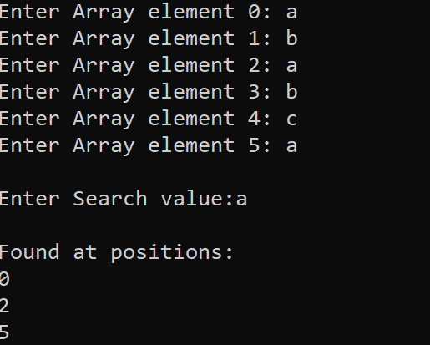 | Any black screen background with writing indicates the program running and a user having to interact with the program. Such as here I inputted the array elements. This will be what the user sees.
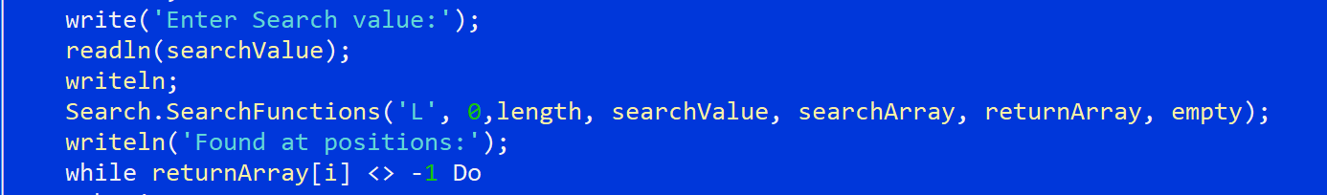 | Any blue backgrounds show evidence taken from the integrated development environment (IDE). This is done due to the way the program is written and that units cannot be run on their own. They need a program to run them so I will develop short scripts dedicated to running tests on the unit. The IDE view will be used to show evidence of what is run.
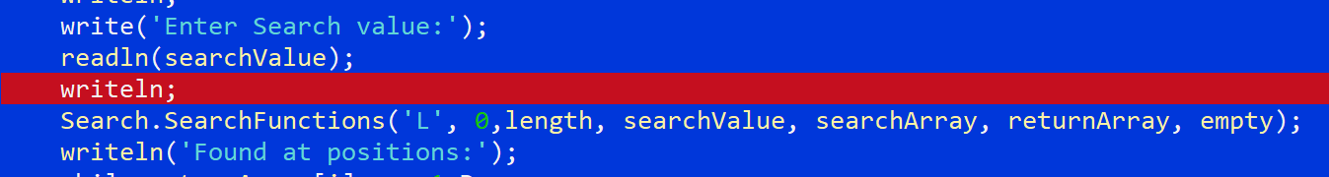 | Any code with a red bar represents that line having a breakpoint at that line, so during execution the program will pause there, this will be used to show execution of some units with no output and are just filler units to link two other units into one unit
 | Code with a purple bar represents a hit breakpoint during execution. So the computer is currently paused just before executing this line but it has executed all previous code
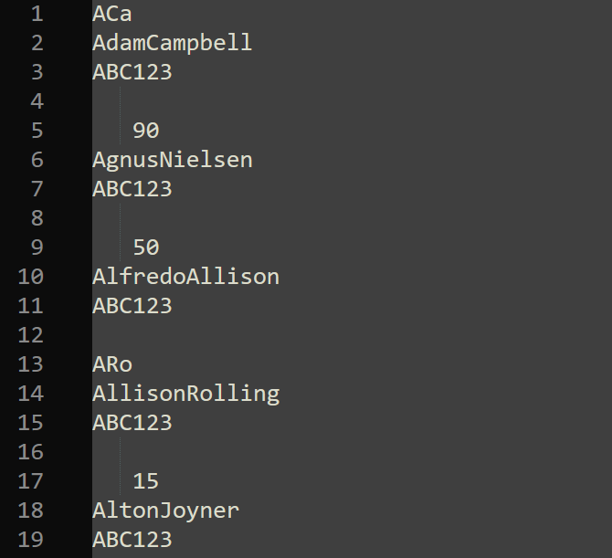 | Any pieces of evidence looking like this comes form notepad and is the output of a file in a text form so I can check that it is working. All data will be explained

Iteration 0 – Library Declarations

Aim
The aim of this iteration is to declare libraries which will be used throughout the rest of the program to shorten code in the main scripts that will be run. The user never sees this, but it will be useful for me as the programmer to get more done and keep code tidy and easy to read for any future developments.

Iteration 0.1 – Linear Search

Code
UNIT LinearSearch;
INTERFACE
USES CRT, SYSUTILS;

PROCEDURE LinearSearchFunction(low, high : LONGINT; searchValue : STRING; UserArray : ARRAY OF STRING; var returnArray : ARRAY OF INTEGER);
VAR
i, a, checkItem: LONGINT;

IMPLEMENTATION

PROCEDURE LinearSearchFunction(low, high : LONGINT; searchValue : STRING; UserArray : ARRAY OF STRING; var returnArray : ARRAY OF INTEGER);
VAR
i, a, checkItem: LONGINT;
BEGIN
i := -1;
a := 0;
// iterate through each element until end of array
REPEAT
i := i+1;
// add all positions for values matching the search value to a different array
if userArray[i] = searchValue THEN
begin
returnArray[a] := i;
a := a + 1;
Design
end;
UNTIL (i = high);
END;

END.

Testing
Test Number | Program and Iteration | Purpose of test | Data to be entered | Expected result | Actual results | Amendments
0.1.1 | Linear search unit,  Iteration 0 | To test the linear search works on small arrays of integers finding a singular value | Array = [5,4,3,2,1,0]  Search value = 4 | 1 | 1 | n/a
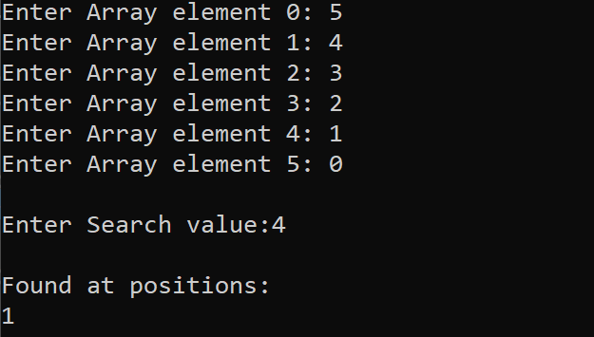
0.1.2 | Linear search unit,  Iteration 0 | Testing if it can find the first value in the array of integers | Array = [5,4,3,2,1,0]  Search value = 5 | 0 | 0 | n/a
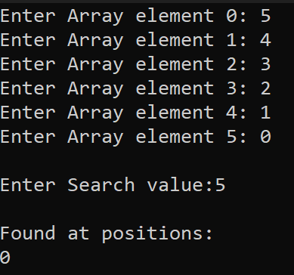
0.1.3 | Linear search unit,  Iteration 0 | Testing if it can find the last value in the array of integers | Array = [5,4,3,2,1,0]  Search value = 0 | 5 | 5 | n/a
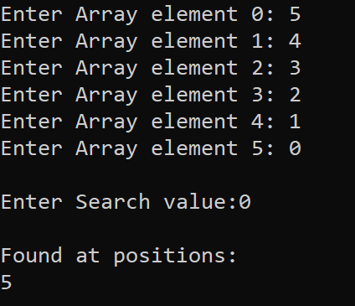
0.1.4 | Linear search unit,  Iteration 0 | Testing to return null if no values found | Array = [5,4,3,2,1,0]  Search value = 6 | n/a | n/a | n/a
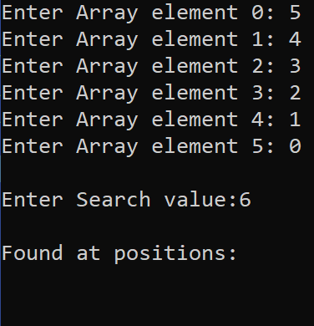

0.1.5 | Linear search unit,  Iteration 0 | Testing to see if it gets all positions for all pieces of found integers | Array = [2,2,2,1,1,0]  Search value = 1 | 3  4 | 3  4 | n/a
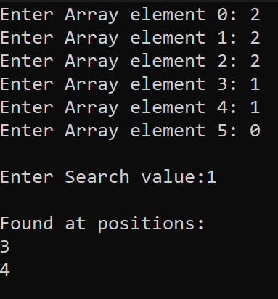

0.1.6 | Linear search unit,  Iteration 0 | Testing if it can find a string value in the array | Array = [a,b,c,d,e,f]  Search value = c | 2 | 2 | n/a
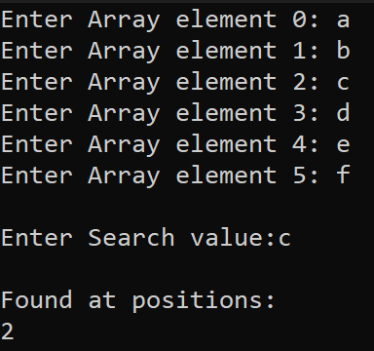

0.1.7 | Linear search unit,  Iteration 0 | Testing if it can find the first value in the array | Array = [a,b,c,d,e,f]  Search value = a | 0 | 0 | n/a
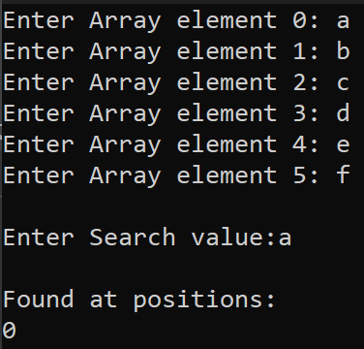
0.1.8 | Linear search unit,  Iteration 0 | Testing if it can find the last value in the array | Array = [a,b,c,d,e,f]  Search value = f | 5 | 5 | n/a
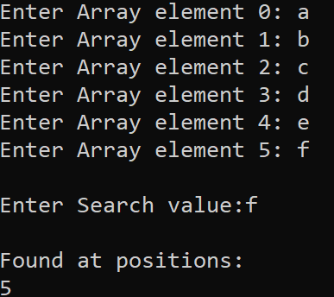

0.1.9 | Linear search unit,  Iteration 0 | Testing to return null if string is not found in array | Array = [a,b,c,d,e,f]  Search value = g | n/a | n/a | n/a
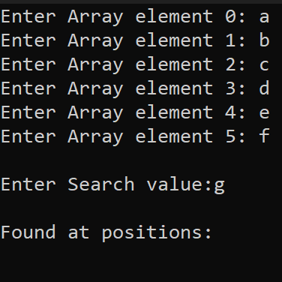
0.1.10 | Linear search unit,  Iteration 0 | Testing to see if it gets all positions for all pieces of found strings | Array = [a,b,a,b,c,a]  Search value = a | 0  2  5 | 0  2  5 | n/a
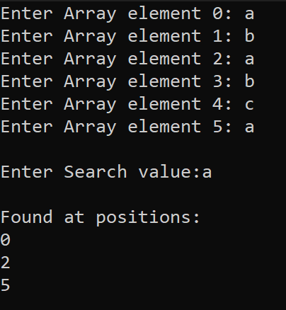

0.1.11 | Linear search unit,  Iteration 0 | Testing if it can search based on different lengths | Array = [9,8,7,6,5,4,3,2,1,0]  Search value = 8 | 1 | 1 | n/a
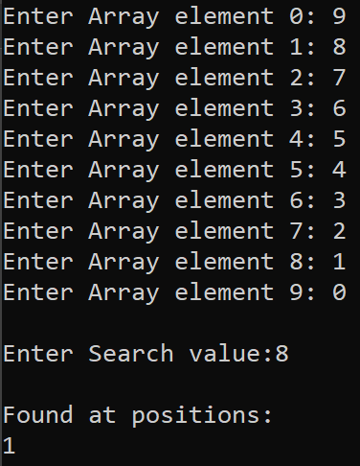
Design

Iteration 0.2 – Binary Search

Code
UNIT BinarySearch;
INTERFACE

USES CRT, SYSUTILS;

PROCEDURE BinarySearchFunction(var UserArray, returnArray : ARRAY OF INTEGER; low, high, searchValue: INTEGER);
VAR
i, mid : LONGINT;
shouldEnd : BOOLEAN;

IMPLEMENTATION

PROCEDURE BinarySearchFunction(var UserArray, returnArray : ARRAY OF INTEGER; low, high, searchValue: INTEGER);
VAR
i, mid : LONGINT;
shouldEnd : BOOLEAN;
BEGIN
REPEAT
mid := (low+high)DIV 2;
IF UserArray[mid] <> searchValue THEN
BEGIN
IF UserArray[mid] < searchValue THEN
BEGIN
low := mid +1;
END
ELSE
BEGIN
high := mid -1;
END;
END
ELSE
BEGIN
returnArray[0] := mid;
shouldEnd := true;
END;
UNTIL (shouldEnd = true) OR (low > high);

END;

END.

Design

Testing
Test Number | Program and Iteration | Purpose of test | Data to be entered | Expected result | Actual results | Amendments
0.2.1 | Binary search unit,  Iteration 0 | To test the Binary search works on small arrays of integers finding a singular value | Array = [2,3,4,5,6,7]  Search value = 4 | 2 | 2 | n/a
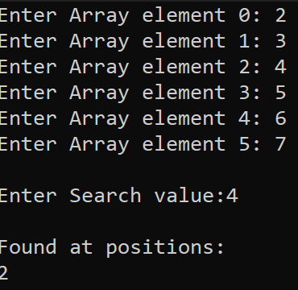
0.2.2 | Binary search unit,  Iteration 0 | Testing if it can find the first value in the array of integers | Array = [2,3,4,5,6,7]  Search value = 2 | 0 | 0 | n/a
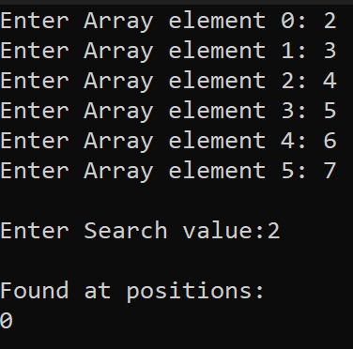
0.2.3 | Binary search unit,  Iteration 0 | Testing if it can find the last value in the array of integers | Array = [2,3,4,5,6,7]  Search value = 7 | 7 | 5 | n/a
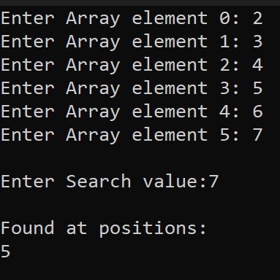
0.2.4 | Binary search unit,  Iteration 0 | Testing it correctly returning a null output if no value is found | Array = [2,3,4,5,6,7]  Search value = 8 | n/a | n/a | n/a
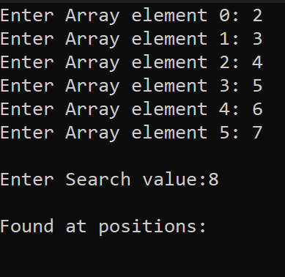

0.2.5 | Binary search unit,  Iteration 0 | Testing it correctly returning a null output if no value is found | Array = [2,3,4,5,6,7]  Search value = a | n/a | n/a | n/a
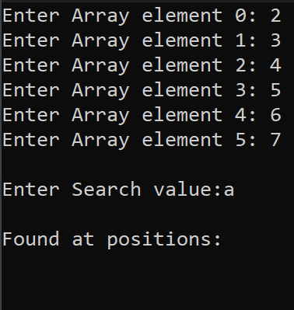
0.2.6 | Binary search unit,  Iteration 0 | Testing if it can find a string value in the array | Array = [a,b,c,d,e,f]  Search value = c | 2 | 2 | n/a
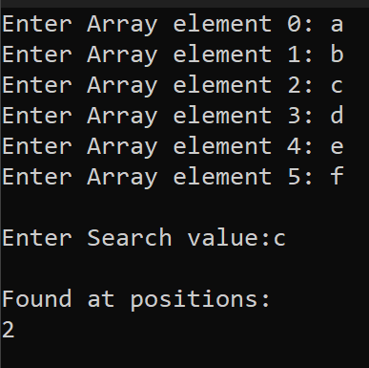

0.2.7 | Binary search unit,  Iteration 0 | Testing if it can find the first value in the array | Array = [a,b,c,d,e,f]  Search value = a | 0 | 0 | n/a
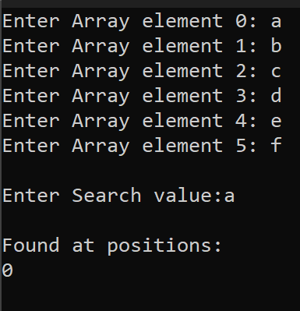
0.2.8 | Binary search unit,  Iteration 0 | Testing if it can find the last value in the array | Array = [a,b,c,d,e,f]  Search value = f | 5 | 5 | n/a
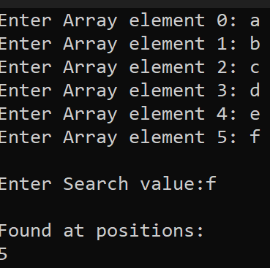

0.2.9 | Binary search unit,  Iteration 0 | Testing if it can search based on different lengths | Array = [2,3,4,5,6,7,8,9]  Search value = 8 | 6 | 6 | n/a
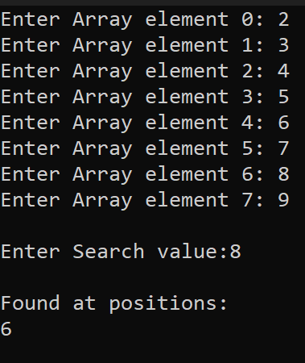

Design

Iteration 0.3 – Search Script

Code
UNIT Search;

INTERFACE
USES CRT, SYSUTILS, BinarySearch, LinearSearch;

PROCEDURE SearchFunctions(SearchType : CHAR; min, max : LONGINT; findValue : STRING; UserArray : ARRAY OF STRING; var returnArray : ARRAY OF LONGINT);

IMPLEMENTATION

PROCEDURE SearchFunctions(SearchType : CHAR; min, max : LONGINT; findValue : STRING; UserArray : ARRAY OF STRING; var returnArray : ARRAY OF LONGINT);
BEGIN
IF SearchType = 'L' THEN
//call linear search and just pass through the data
LinearSearch.LinearSearchFunction(min,max,FindValue,UserArray,returnArray);
IF SearchType = 'B' THEN
//call linear search and just pass through the data
BinarySearch.BinarySearchFunction(min,max, FindValue,UserArray,returnArray);
END;

END.

Design

Testing
Test Number | Program and Iteration | Purpose of test | Data to be entered | Expected result | Actual results | Amendments
0.3.1 | Searching  Iteration 0 | To test it enters the linear search script if a linear search is selected | L as the character in the call  Breakpoint at the call to the linear search | Purple bar on the linear search function | Purple bar on the linear search function | None

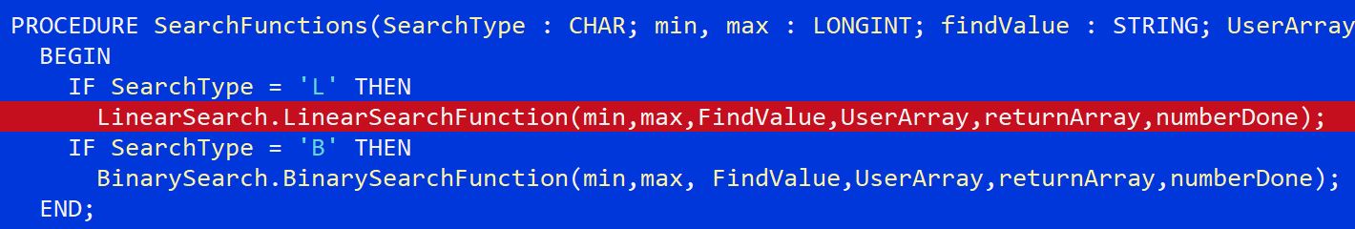

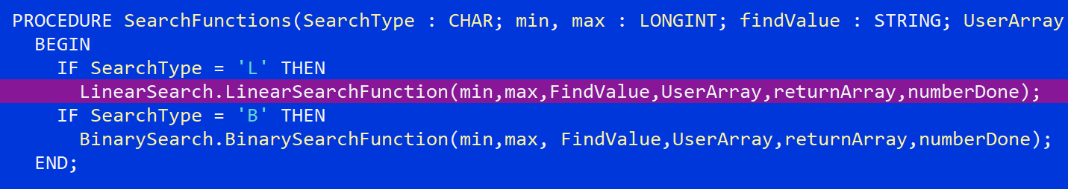

0.3.2 | Searching  Iteration 0 | To test it enters the binary search script if a linear search is selected | B as the character in the call  Breakpoint at the call to the binary search | Purple bar on the binary search function | Purple bar on the binary search function | None

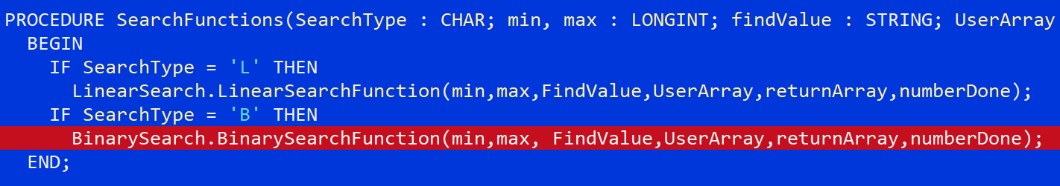

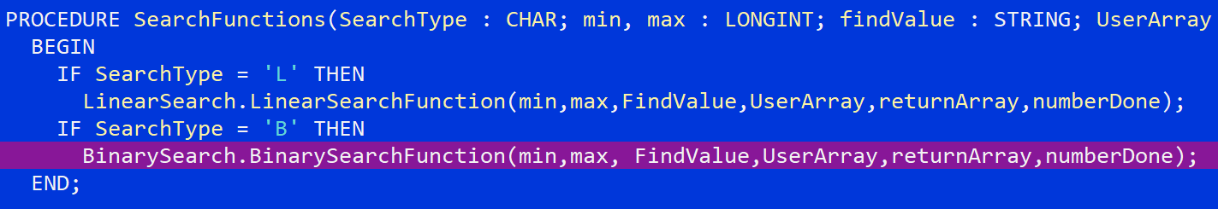

Design

Iteration 0.4 – Loading

Code
unit loading;
interface

uses sysutils, vputils, crt, math;
//pointer to point to the value outside of this script
type rPtr = ^real;

//pre declaration of functions and procedures
function loadingText(p : pointer) : LONGINT;
var a : LONGINT;
function loadingBar(p : pointer) : LONGINT;
var percentComplete : REAL;
b,c,completeBars,uncompleteBars : LONGINT;
procedure StartLoading(loadingType : CHAR; var percentIn : real);
procedure EndLoading;
procedure silentKillLoading;

implementation
//the symbol for a spinning symbol
const LoadingSymbols : ARRAY[1..4] OF CHAR = ('/',#196,'\','|');

//local script variables
var loadingDone : BOOLEAN;
percentDone : real;
percentPtr : rptr;
startRunTime, endRunTime : TDateTime;

//the basic loading text with the spinning line
function loadingText(p : pointer) : LONGINT;
var a : LONGINT;
begin
HideCursor;
a := 1;
ClrScr;
while (not loadingDone) DO
Begin
//write loading and symbol from the array
WRITELN('Loading... ' + LoadingSymbols[a]);
//progress the loading symbol
a := a+1;
if a > 4 THEN
a := 1;
//every 0.1 secons update
Delay(100);
//rewrite the whole line
GoToXY(1,1);
DelLine;
end;

end;

function loadingBar(p : pointer) : LONGINT;
var percentComplete : REAL;
b,c,d,completeBars,uncompleteBars : LONGINT;
begin
HideCursor;
ClrScr;
//sets up the empty progress bar
Write('Progress ',#185);
for c:= 0 TO 20 DO
write(#176);
write(#204);
percentDone := 0.0*100;
completeBars := 0;

while not loadingDone DO
begin
//write the new percentage in
gotoxy(33,1);
Write(percentDone:4:0,'%');
//gets the percent done from the main script by using a series of pointers
//to point to a value outside this script so the procedure does not have to be recalled
percentDone := (percentPtr^)*100;
//calculate number of bars to fill
completeBars := floor((percentPtr^)*20);
gotoxy(11,1);
//draw that number of bars
for d := 0 to completeBars DO
write(#219);
end;
end;

procedure StartLoading(loadingType : CHAR; var percentIn : real);
begin
startRunTime := Time;
loadingDone := false;
//set a pointer to the memory address to the memory location of the percent
//memory location passed in at the start
percentPtr := @percentIn;

//choose a loading type and start a new thread so it runs in parallel
if loadingType = 'L' THEN
VPBeginThread(loadingText,1,nil)
else if loadingType = 'P' THEN
VPBeginThread(loadingBar,1,nil);
End;

procedure EndLoading;
begin
//kill the thread to stop it running
KillThread(1);
loadingDone := true;
//show end messages
WRITELN('Done!');
endRunTime := Time;
Delay(500);
ClrScr;
//state how long it took
writeln('Time elapsed: ',TimeToStr(endRunTime - startRunTime));
ShowCursor;
end;

procedure silentKillLoading;
begin
//stops the bar without displaying anything back to the user when done
KillThread(1);
loadingDone := true;
ClrScr;
ShowCursor;
end;
end.

Design

Testing
Test Number | Program and Iteration | Purpose of test | Data to be entered | Expected result | Actual results | Amendments
0.4.1 | Loading  Iteration 0 | To test the loading text with spinning symbol works | None needed to be entered | Loading…(with changing symbol next to it) | Correct result | n/a


0.4.2 | Loading  Iteration 0 | To test the Done screen shows up when finished | None needed to be entered | Done! ☻ | Done! ☻ | n/a

0.4.3 | Loading  Iteration 0 | To test the loading time is correct | Delay of 15 seconds used | Time elapsed: 00:00:15 | Time elapsed: 00:00:15 | n/a
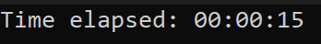
0.4.4 | Loading  Iteration 0 | Silent kill ends the loading with no output | No data needs to be entered | Blank screen | Blank screen | n/a
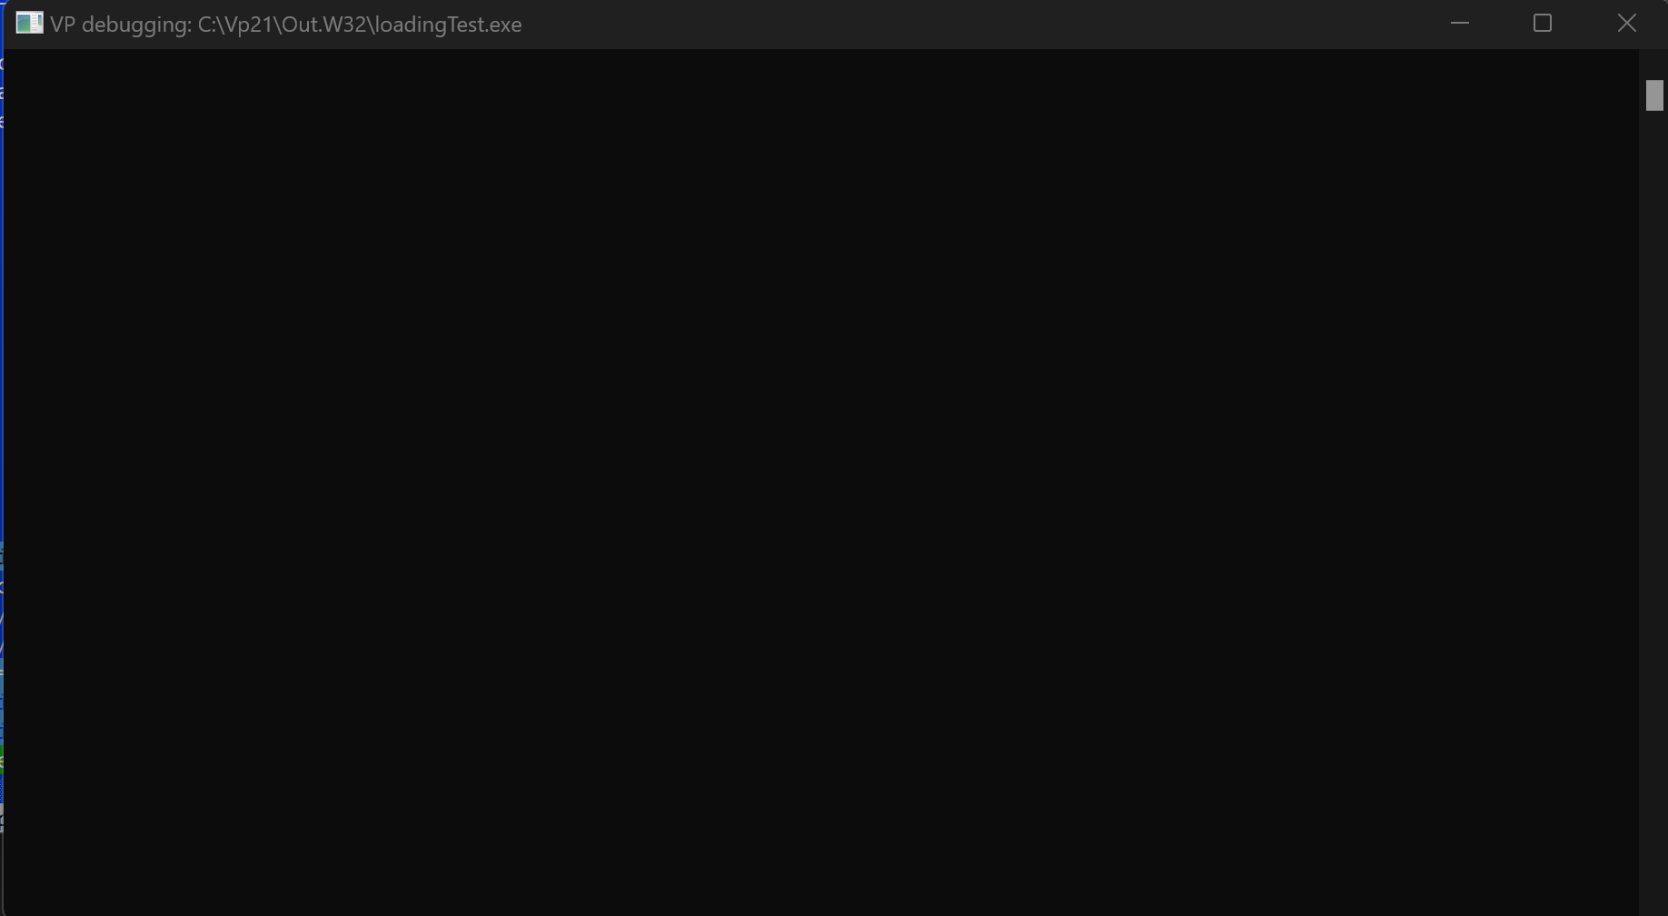
0.4.5 | Loading  Iteration 0 | To test the progress bar works | A for looping counting up out of a total of 100 | Progress ╣░░░░░░░░░░░░░░░░░░░░░╠ 0% (from 0 to 100 with correct bars) | See below | There were 21 one spaces due to the for loop which sets the spaces going from 0 to 20 which is 21 numbers so this was changed to 19 for 20 blank spaces at the start.  for c:= 0 TO 19 DO  write(#176);  Where the completed bars were being drawn in the for loop it starts from 0 to 0 which is still once to get it to run no times it needs to start at -1 and instead of that finishing at 20 it should also finish at 19. So it is now for d := o to completeBars-1.  for d := 0 to completeBars-1 DO  write(#219);  The display for percent done now also needs to be moved closer as everything moved back  gotoxy(3332,1);

Amendments:

0.4.6 | Loading  Iteration 1 | To test if the progress bar ends properly | None needed | Time elapsed: (however long it took) | See below | n/a
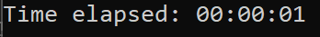
0.4.7 | Loading  Iteration 1 | Test if the progress bar ends using the silent kill | None needed | Nothing | Nothing | n/a
0.4.8 | Loading  Iteration 1 | Test if the multi-threading is handled correctly, correctly starting and ending the threads | None needed | A number of threads before the loading script is called. An increase of 1 during the loading. And a decrease by 1 back to original number after loading is ended | See below | n/a
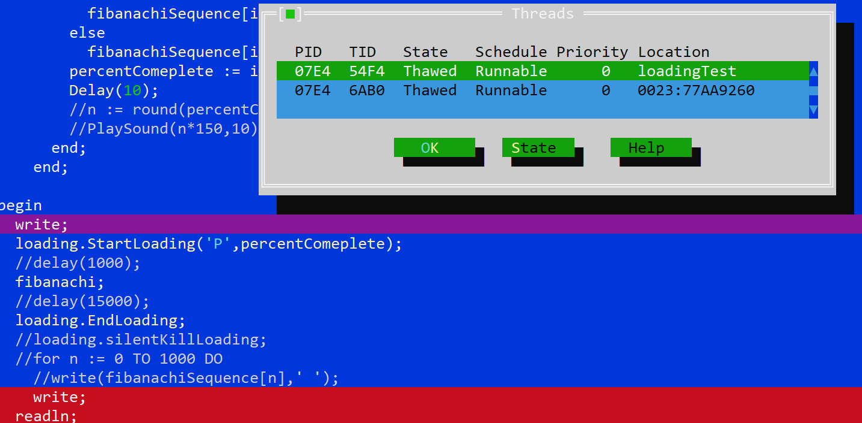
Two threads and before loading starts

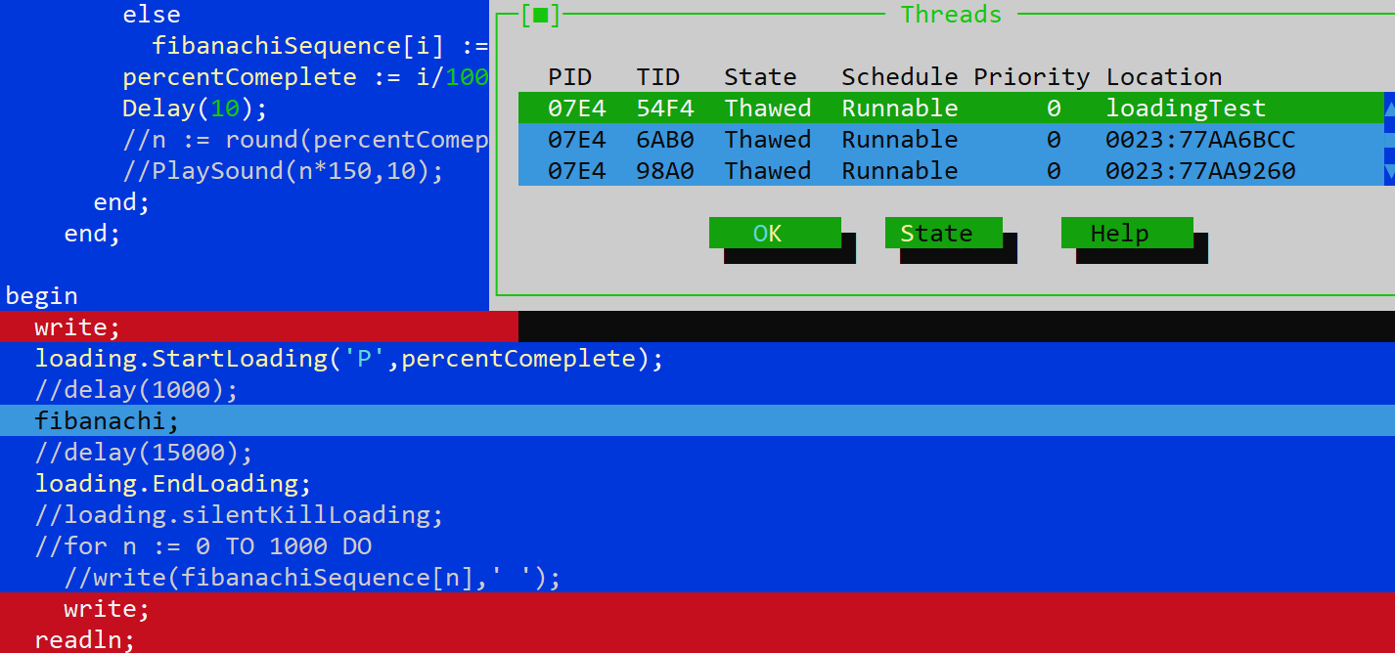
Extra thread starts with the loading procedure

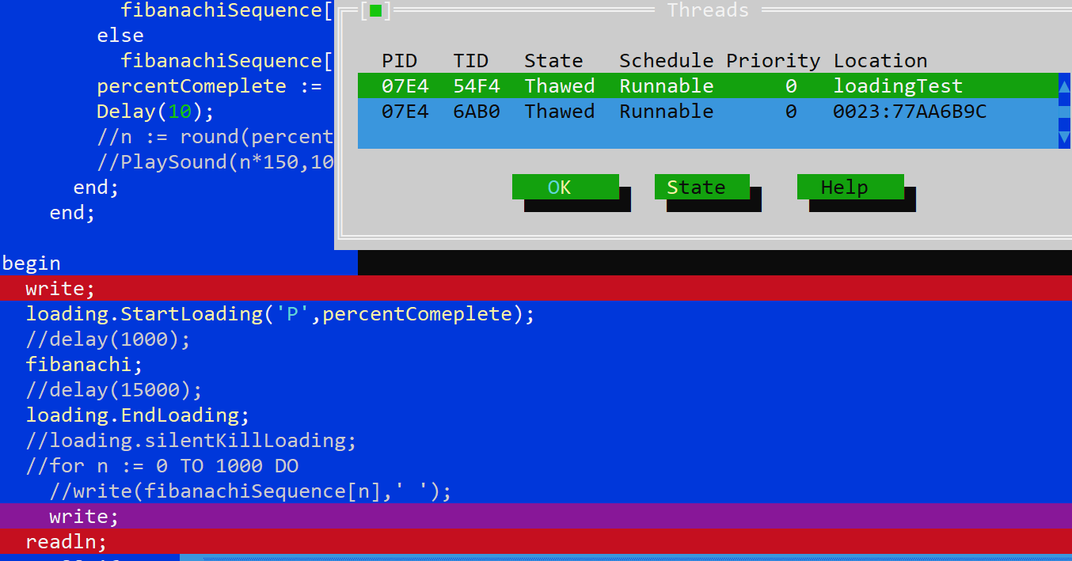
Extra thread deleted after the end of the loading

Design

Iteration 0.5 – Log In

Code
unit LogInScreen;
interface
uses crt, sysutils, vputils; {importing built in units to help with the layout}

TYPE userPassArray = ARRAY[0..1] OF STRING; {Use one data structure to return from the unit}

VAR Username, Password : STRING; {Declaring variables}
y : LONGINT;
userPass : userPassArray;

procedure GetUsername; {declaring all the procedures in this unit and any local variables and parameters that they take}
procedure GetPassword;
var i, a : LONGINT;
key : CHAR;
procedure startLogIn(var userPassArrayr : ARRAY OF STRING);

implementation

PROCEDURE GetUsername; {The procedure that reads what the user types in for username}
begin
GotoXY(11,1);
READLN(username);
end;

PROCEDURE GetPassword;
var i,a : LONGINT;
key : CHAR;
begin
GoToXY(11,2); {Moves the cursor to the correct position}
i := 0;
HideCursor; {Hides the cursor}
password := ''; {sets the password to an empty string}
repeat {repeat until enter is pressed to submit}
key := readkey; {read the key that is pressed}
if (key = #8) THEN {Check if its the back space key}
begin
if i > 0 THEN {check if the password has more than 0 characters in it}
begin
Delete(password,i,1); {if so remove the last charachter in password}
i := i -1; {decrease the length of the password by 1}
end;
{else do nothing}
end

else if ((key >= #33) and (key < #127) and (key <> #13)) OR (key = #156) THEN {check if it is a valid character and not a spcae}
begin
password := password + key; {add the key pressed to the password}
i := i +1; {increase the length of password by 1}
end;
GoToXY(1,2); {go to the start of the password line}
DelLine; {clears the line}
Write('Password: '); {write the whole line again with the correct number of cogs}
for a := 1 TO i DO
write(#15);
until key = #13;
writeln;
end;

PROCEDURE DisplayInfo; {initial display of information that needs to be entered}
Begin
ClrScr;
WRITELN('Username: ');
WRITELN('Password: ');
GoToXY(11,1); {go to the start of username}
end;

procedure startLogIn(var userPassArrayr : ARRAY OF STRING);
begin
DisplayInfo; {Display intial information}
GetUsername; {get the username}
GetPassword; {get the password}
ClrScr; {clear the screen for the next task}
userPassArrayr[0] := username; {put the username and password into the array to be editied}
userPassArrayr[1] := password;
end;
end.

Design

Testing
Test Number | Program and Iteration | Purpose of test | Data to be entered | Expected result | Actual results | Amendments
0.5.1 | Login  Iteration 0 | To test if the password is hidden when typing | When it asks for username type bob then press enter.  For password type abc123!”£ | Username: bob  Password: ☼☼☼☼☼☼☼☼☼ | Username: bob  Password: ☼☼☼☼☼☼☼☼☼ | None Needed
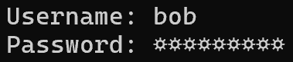
0.5.2 | Login  Iteration 0 | To test to see if the stored data is the same as the entered data | When it asks for username type bob then press enter.  For password type abc123!”£ | bob  abc123!”£ | bob  abc123!”£ | None Needed
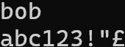
0.5.2 | Login  Iteration 0 | To test to see if the back space removes characters correctly in the hidden view | When it asks for username type bob then press enter.  For password type a1!b2”c3£  Then press back space 3 times | Username: bob  Password: ☼☼☼☼☼☼ | Username: bob  Password: ☼☼☼☼☼☼ | None Needed
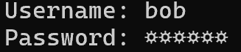
0.5.3 | Login  Iteration 0 | To test to see if the backspace removes the characters from the stored data | When it asks for username type bob then press enter.  For password type a1!b2”c3£  Then press back space 3 times | bob  a1!b2” | bob  a1!b2” | None Needed
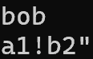
Design

Iteration 0.6 – Write Design

Code
UNIT writeDesign;
interface
uses crt, sysutils, vputils;
procedure DrawDesign(path: STRING; delayWrite : LONGINT);
var Character : STRING;
DesignTextFile : TextFile;
implementation
procedure DrawDesign(path: STRING; delayWrite : LONGINT);
var a : LONGINT;
begin
HideCursor;
ClrScr;
//get the file to read from
ASSIGN(DesignTextFile,path);
reset(DesignTextFile);
//read each line to a max of 28 (window size)
for a := 0 to 28 DO
begin
readln(DesignTextFile, Character);
//write each line
writeln(Character);
//delay for effects
Delay(delayWrite);
end;
ShowCursor;

end;
end.
Design

Testing
Test Number | Program and Iteration | Purpose of test | Data to be entered | Expected result | Actual results | Amendments
0.6.1 | Write Designs  Iteration 0 | This it to test if it works with full display | No data, just a text file with a design | 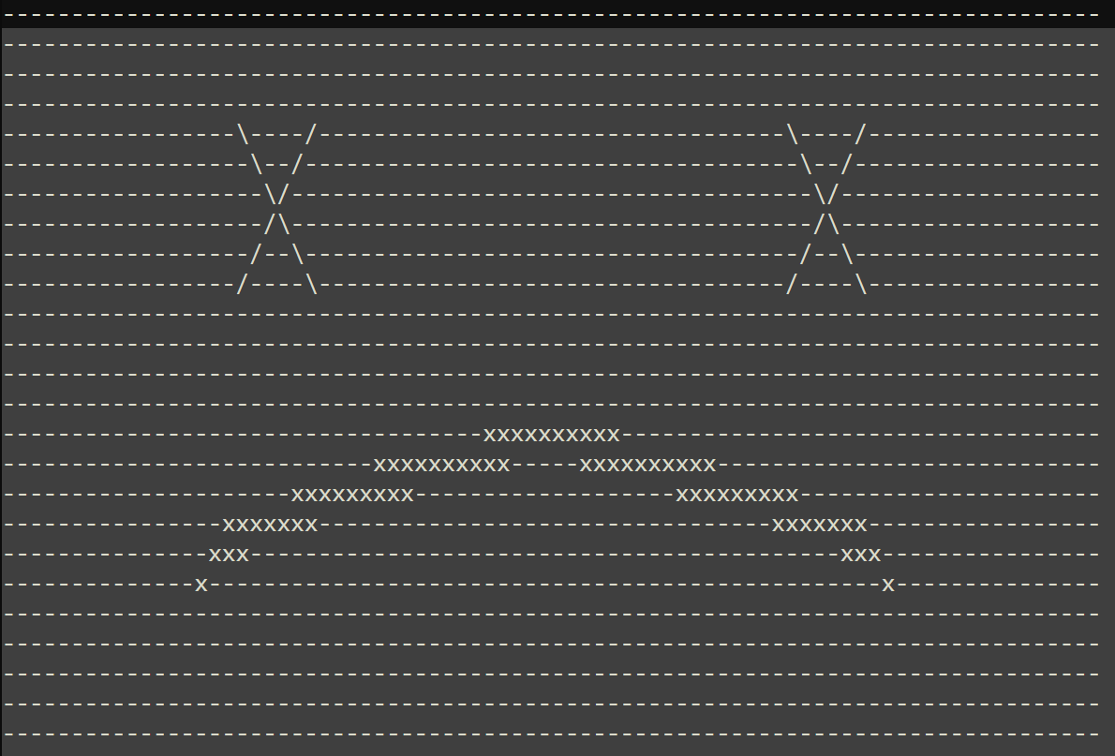 |  | n/a
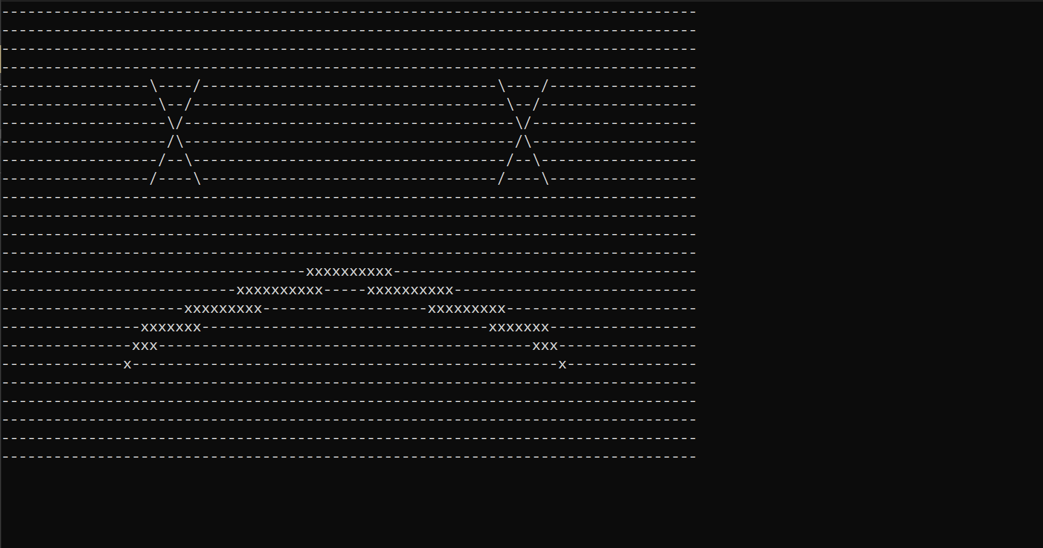
0.6.2 | Write Designs  Iteration 0 | This it to test if the animation feature works | Same file with a 100ms delay between each line |  |  | None

Mr Martin signature

0.6.3 | Write Designs  Iteration 0 | Test if it works with something that has gaps in it | A different text file design | 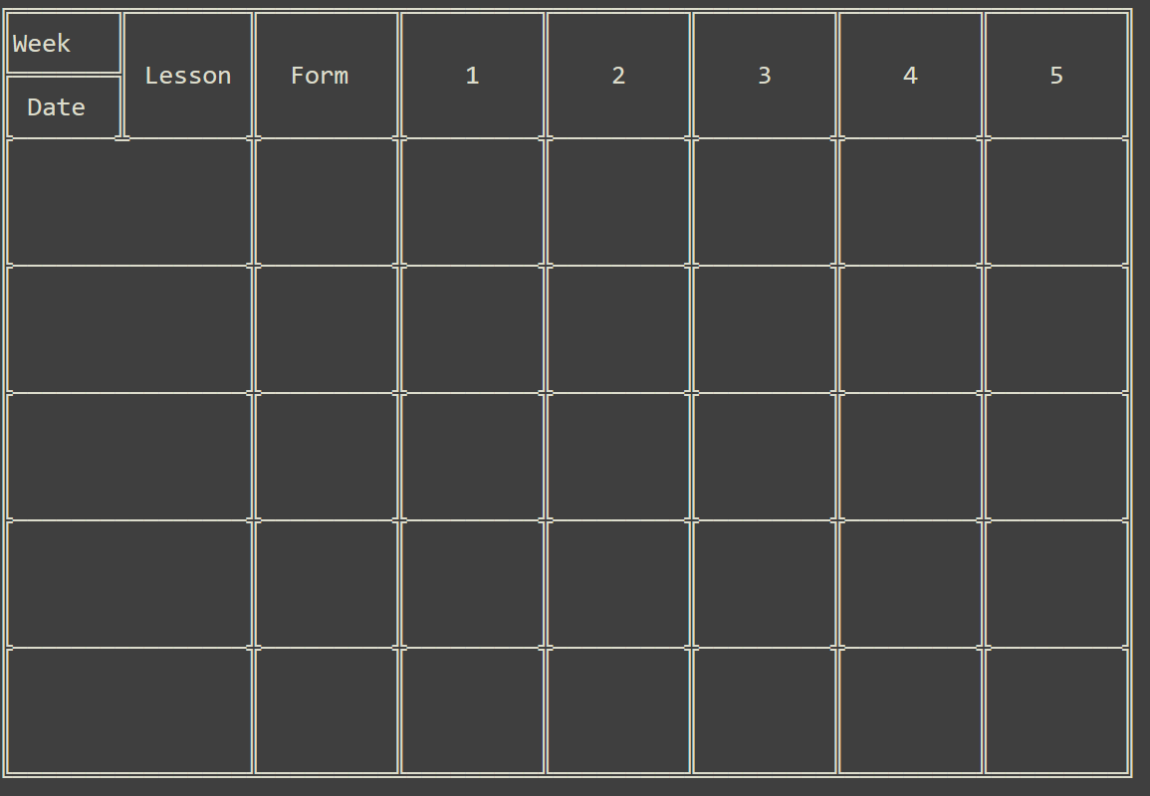 |  | n/a
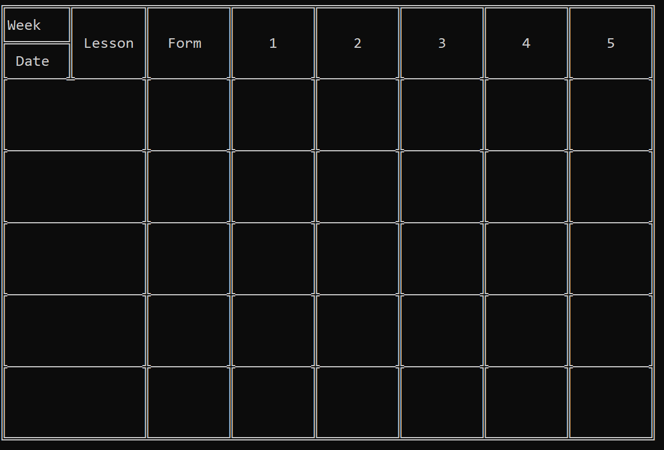
Design

Iteration 0.7 – Cursor Grid

Code
UNIT CursorGrid;
interface
uses crt, sysutils, vputils;

var stepx , stepY, movePos, minX, minY, maxX, maxY: LONGINT;

procedure moveUp;
procedure moveDown;
procedure moveLeft;
procedure moveRight;
procedure startGrid(moveStepX, moveStepY, startX, startY : LONGINT; boundaries : ARRAY OF LONGINT; var x, y : LONGINT);
implementation
procedure moveUp;
begin
//if the cursor will stay in the boundaries set
if WhereY - stepy >= minY THEN
begin
movePos := WhereY - stepy;
GoToXY(WhereX, movePos);
end;
end;

procedure moveDown;
begin
//if the cursor will stay in the boundaries set
if WhereY + stepy <= maxY THEN
begin
movePos := WhereY + stepy;
GoToXY(WhereX, movePos);
end;
end;
procedure moveLeft;
begin
//if the cursor will stay in the boundaries set
if WhereX - stepx >= minX THEN
begin
movePos := WhereX - stepx;
GoToXY(movePos, WhereY);
end;
end;

procedure moveRight;
begin
//if the cursor will stay in the boundaries set
if WhereX + stepx <= maxX THEN
begin
movePos := WhereX + stepX;
GoToXY(movePos, WhereY);
end;
end;

procedure startGrid(moveStepX, moveStepY, startX, startY : LONGINT; boundaries : ARRAY OF LONGINT; var x, y : LONGINT);
var keyPress : char;
begin
stepX := moveStepX;
stepY := moveStepY;
minX := boundaries[0];
minY := boundaries[1];
maxX := boundaries[2];
maxY := boundaries[3];
GoToXY(startX,startY);

//key checking key presses until enter is pressed
repeat
keyPress := readkey;
if keyPress = #0 then //check if an extended key or function key
begin
//read its scan code to get which arrow key was pressed and call according procedure
case readKey of
'H' : moveUp;
'P' : moveDown;
'K' : moveLeft;
'M' : moveRight;
end;
end;
until keyPress = #13;
//corrects the return to a choice of menu option rather than spaces moved
if stepX <> 0 THEN//stops divide by 0 error
x := Round((WhereX - startX) / stepX) //round to change float to int
ELSE
x := startX;

if stepY <> 0 THEN//stops divide by 0 error
y := round((WhereY - startY) / stepY) //round to change float to int
ELSE
y := startY;
end;

end.
Design

Testing
Test Number | Program and Iteration | Purpose of test | Data to be entered | Expected result | Actual results | Amendments
0.7.1 | Cursor Grid  Iteration 0 | To test if it can step the set amount | Set amount 2,2 | Mouse only able to step 2 spaces in each direction | See below | n/a
Initial position
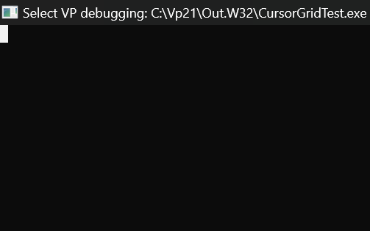

Press down once should lead to a step of 2 down
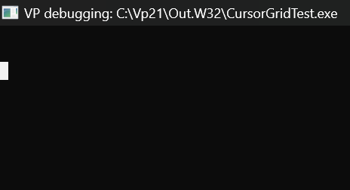
Press right once should lead to a step of 2 right
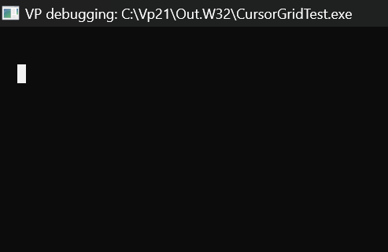

Press up once should lead to a step of 2 up
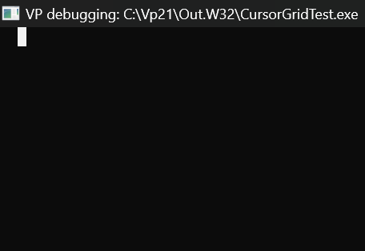
Press left once should lead to a step of 2 left
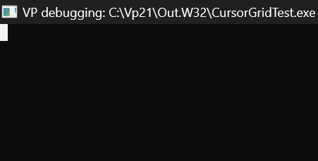
0.7.2 | Cursor Grid  Iteration 0 | To test if the boundary conditions will stop the cursor regardless of if it perfectly matches | Step 1, 2  Boundaries [1,1] and [3,4] | A max position of 3,3 before it stops it | See below | n/a
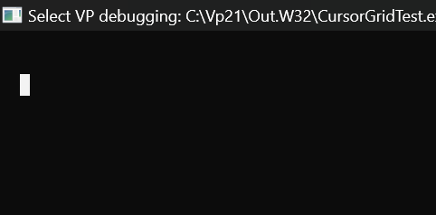
IT is currently at 3,3 and I can’t move it further in any direction
0.7.3 | Cursor Grid  Iteration 0 | TO test to see if it can start wherever | Start position at 5,4 | The cursor starts at 5,4 | See below | n/a
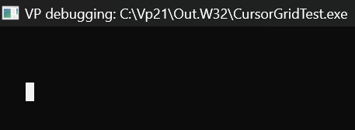
Design
It is currently at position 5,4 which is where it starts

Iteration 0.8 – Create Menu

Code
unit createMenu;
interface
uses crt, sysutils, CursorGrid, VPUtils;

function writeMenu(startPos : ARRAY OF LONGINT; numberOfChoices : LONGINT; menuChoices: ARRAY OF STRING; optionStart : LONGINT) : LONGINT;

implementation

function writeMenu(startPos : ARRAY OF LONGINT; numberOfChoices : LONGINT; menuChoices: ARRAY OF STRING; optionStart : LONGINT) : LONGINT;
var a, x, y : LONGINT;
begin
HideCursor;
Design
//write each menu option
for a := 0 TO numberOfChoices -1 DO
begin
//make sure it is alawys writing where it needs to
GOTOXY(startPos[0],startPos[1]+a);
writeln(a+1,': ',menuChoices[a]);
end;
ShowCursor;
Delay(100);
//start the cursor grid script with set boundary conditions and steps to allow control with arrow keys
CursorGrid.startGrid(0,1,startPos[0],startPos[1]+optionStart,[startPos[0],startPos[1],startPos[0],numberOfChoices+startPos[1]-1],x,y);
ClrScr;
writeMenu := optionStart + y;
end;

end.

Testing
Test Number | Program and Iteration | Purpose of test | Data to be entered | Expected result | Actual results | Amendments
0.8.1 | Create menu  Iteration 0 | To see if the menu can write with correct format | Menu options = [a,b,c]  Start position = [1,1]  Start Menu option = 0  Number of menu options = 3 | 1. a  2. b  3. c | 1. a  2. b  3. c | n/a
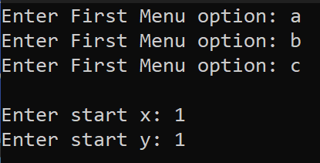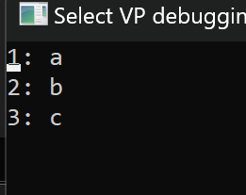
0.8.2.1 | Create menu  Iteration 0 | To see if the menu can be written on any x | Menu options = [a,b,c]  Start position = [13,1]  Start Menu option = 0  Number of menu options = 3 | 1. a  2. b  3. c | 1. a  2. b  3. c | n/a
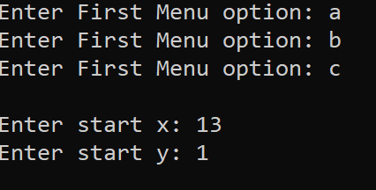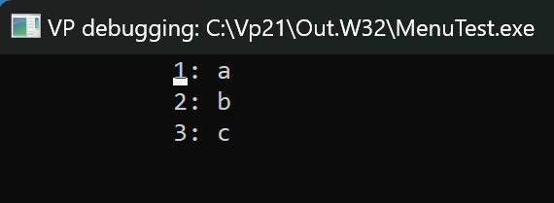
0.8.2.2 | Create menu  Iteration 0 | To see if the menu can be written on any y | Menu options = [a,b,c]  Start position = [1,7]  Start Menu option = 0  Number of menu options = 3 | 1. a  2. b  3. c | 1. a  2. b  3. c | n/a
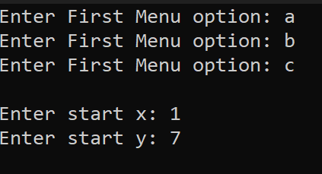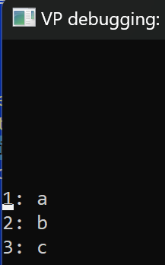
0.8.2.2 | Create menu  Iteration 0 | To see if the menu can be written on any x and y | Menu options = [a,b,c]  Start position = [5,8]  Start Menu option = 0  Number of menu options = 3 | 1. a  2. b  3. c | 1. a  2. b  3. c | n/a
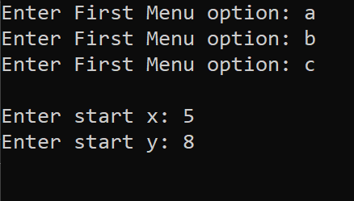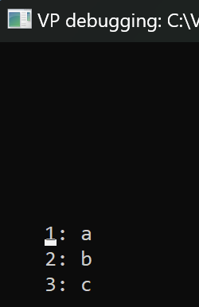
0.8.3 | Create menu  Iteration 0 | To see if the cursor can start on different values | Menu options = [a,b,c,d,e,f]  Start position = [1,1]  Start Menu option = 4  Number of menu options = 6 | 1. a  2. b  3. c  4. d  5. e  6. f | 1. a  2. b  3. c  4. d  5. e  6. f | n/a
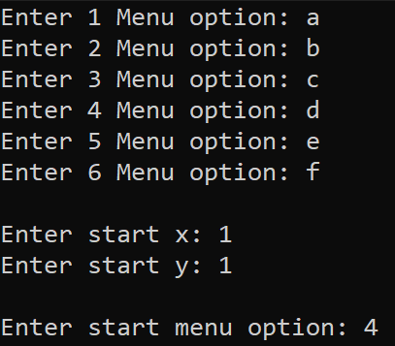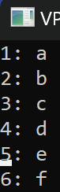

0.8.4.1 | Create menu  Iteration 0 | To see if it output the right result from which menu was selected | Menu options = [a,b,c,d,e,f]  Start position = [1,1]  Start Menu option = 0  Number of menu options = 6  Menu option to select = b | 1 | 1 | n/a
0.8.4.2 | Create menu  Iteration 0 | To see if it output the right result from which menu was selected if it is first value | Menu options = [a,b,c,d,e,f]  Start position = [1,1]  Start Menu option = 0  Number of menu options = 6  Menu option to select = a | 0 | 0 | n/a
0.8.4.3 | Create menu  Iteration 0 | To see if it output the right result from which menu was selected if it is last value | Menu options = [a,b,c,d,e,f]  Start position = [1,1]  Start Menu option = 0  Number of menu options = 6  Menu option to select = f | 5 | 5 | n/a
0.8.4.4 | Create menu  Iteration 0 | Test to see if it works if offset in the y direction | Menu options = [a,b,c,d,e,f]  Start position = [1,3]  Start Menu option = 0  Number of menu options = 6  Menu option to select = c | 2 | 2 | n/a
0.8.4.5 | Create menu  Iteration 0 | Test to see if it works if offset in the x direction | Menu options = [a,b,c,d,e,f]  Start position = [2,1]  Start Menu option = 0  Number of menu options = 6  Menu option to select = d | 3 | 3 | n/a

Design

Review
Due to this iteration being mostly background units designed and developed to be used by me as the programmer so most of this review will be a review from the programmer.
However, the following units my client did have comments on:
Loading: My client likes the idea of having a way to see that the program is actually doing something rather than crashed or stuck in an infinite loop.
Login: My client is happy with how it works and how the password is hidden while it is being typed in. She also likes how the character that is used to hide the password is not a character that can be easily typed in so she can use all special characters in her password without being restricted.
Cursor Grid: My client likes the ability to use the arrow keys to navigate through the menus as it feels more natural for her to use and it is more intuitive

From a programmer’s perspective:
Iterations 0.1 to 0.3 allows me to search arrays whilst only calling one procedure making the code readability, it also means I only must include the search unit in the use instead of both binary and linear search.
The loading script can provide use information such as when a program breaks down, it its say at 56% I know where that is and can identify the issue faster.
The login script is very useful for me as the programmer as I can call start login from anywhere and it loads the login script and just returns the data that the user entered. This helps to keep the main program neater and more concise. This also allows for debugging of only the login script without having to go through the entire program
The write design script allows for easy graphical outputs. I can design an output in a text file and then just put the path into the procedure and it will be displayed
The cursor grid script allows for me to easily start a script which allows the use the arrow keys to navigate the screen and what is on the screen, and it returns the new position of the cursor so I can work out what was chosen
Iteration 0.8, the create menu script allows me as the programmer to pass an array of menu options that I want in the menu and it automatically writes all of them out and starts the cursor grid script to allows the user to navigate through the menu. This then returns only the menu option which was picked, which then allows me to pass that on to it relevant procedure.

Iteration 1 – Creating Initial Data

Aim
The aim of this iteration is to generate data in which I can use to test the main program and prove and check that the main program is doing the correct task. Design the generation in a way that it is randomly generated so if any data gets corrupted, I can execute the program and have a whole new set of data to work with. I will set certain parts such as the timetable and I got a list of names from online which it reads from. These are kept the same so the data has a solid structure to build off and the rest of the data can be randomly generated without causing issues. I will keep the names the same so I always know a couple of users I can use as tests even if the rest of the data about them changes. I will also do this procedurally to allow me to generate large samples of data without having to manually input all the data into the file

Code
PROGRAM CreateFiles;
uses crt, sysutils, search,sorting, loading, DisplayErrorScrn, math;

type {declaring all record types}
TimeTableRecord = RECORD
Day : LONGINT;
LessonNo : LONGINT;
ClassID : STRING[8];
end;
FormRecord = RECORD
FormID : STRING[5];
NumberInForm : LONGINT;
end;

AttendanceRecord = RECORD
StudentID : LONGINT;
Attendance : REAL;
Total : LONGINT;
NumberPresent : LONGINT;
NumberLate : LONGINT;
NumberAbsent : LONGINT;
end;

StudentsRecord = RECORD
StudentID : LONGINT;
FName : STRING[20];
SName : String[20];
Year : LONGINT;
Form : STRING[5];
Uname : String[40];
Pword : String[20];
end;

teacherRecord = RECORD
TeacherID : STRING[3];
fname : string[20];
sname : string[20];
form : string[5];
Uname : STRING[40];
PWord : STRING[20];
end;

classRecord = RECORD
ClassID : STRING[8];
Year : LONGINT;
subjectID : STRING[3];
NoOfStudents : LONGINT;
end;

subjectRecord = RECORD
SubjectID : STRING[3];
SubjectName : STRING[20];
end;

studentRegisterMarkRecord = RECORD
studentID : LONGINT;
registerMark : CHAR;
end;

registerRecord = RECORD
RegisterID : STRING[17];
LessonNo : LONGINT;
Date : TDateTime;
ClassID : STRING[8];
RegisterMarks : ARRAY[0..40] OF studentRegisterMarkRecord;
isOfstedRegister : BOOLEAN;
end;

studentClassResolverRecord = RECORD
StudentID : LONGINT;
ClassID : STRING[8];
end;
teacherSubjectResolverRecord = RECORD
TeacherID : STRING[3];
SubjectID : STRING[2];
end;

teacherClassResolverRecord = RECORD
TeacherID : STRING[3];
ClassID : STRING[6];
end;

LogInDetailsRecord = RECORD
PersonID: STRING[5];
Username: STRING[40];
Passwowrd: String[20];
end;
VAR {setting up all variables for records and files}
numberDone, total : LONGINT;

TimeTable : TimeTableRecord;
TimeTableTextFile : TextFile;
TimeTableFile : FILE OF TimeTableRecord;
TimeTableInfoFromFile : STRING;

Form : FormRecord;
FormFile : FILE OF FormRecord;

Register : registerRecord;
studentRegisterMark : studentRegisterMarkRecord;
RegisterFile : File OF registerRecord;

Attendance : AttendanceRecord;
AttendanceFile : FILE OF AttendanceRecord;
StudentFName : STRING;
NameFile : TextFile;
Student : StudentsRecord;
StudentFile : FILE OF StudentsRecord;

TeacherFileFromFile : TextFile;
TeacherFile : file of teacherRecord;
TeacherFromFile : String;
Teacher : teacherRecord;

sClass : ClassRecord;
classFile : FILE OF ClassRecord;

subject : subjectRecord;
subjectFile : FILE OF subjectRecord;

studentClassResolver : studentClassResolverRecord;
studentClassResolverFile : FILE OF studentClassResolverRecord;

teacherSubjectResolver : teacherSubjectResolverRecord;
teacherSubjectResolverFile : FILE OF teacherSubjectResolverRecord;

teacherClassResolver : teacherClassResolverRecord;
teacherClassResolverFile : FILE OF teacherClassResolverRecord;

empty, ErrCode : LONGINT; {setting up other variables for functions that require an input}
percentComplete : REAL; {variable for progress bar to track progress}

LogInDetails: LogInDetailsRecord;
LogInDetailsFile : FILE OF LogInDetailsRecord;

{setting up common array across many functions}
classIDArray : ARRAY[0..50] OF STRING;

procedure initialiseFiles;
begin
percentComplete := 0.0; {initializing percentDone and total iterations}
total := 0;
{assigning a place on the drive to the files}
ASSIGN(TimeTableTextFile,'C:\ComputerScienceCoursework\Program\files\TimeTableText.txt');
ASSIGN(TimeTableFile,'C:\ComputerScienceCoursework\Program\files\TimeTable.dta');
total:= total +51;

ASSIGN(RegisterFile,'C:\ComputerScienceCoursework\Program\files\Registers.dta');
total := total + 60;

ASSIGN(NameFile,'C:\ComputerScienceCoursework\Program\files\Names.txt');
ASSIGN(StudentFile,'C:\ComputerScienceCoursework\Program\files\Students.dta');
total := total + 140;

ASSIGN(TeacherFile,'C:\ComputerScienceCoursework\Program\files\Teachers.dta');
total := total + 51;

ASSIGN(classFile,'C:\ComputerScienceCoursework\Program\files\classes.dta');
total := total + 51;

ASSIGN(subjectFile,'C:\ComputerScienceCoursework\Program\files\subjects.dta');
total := total + 21;

ASSIGN(studentClassResolverFile,'C:\ComputerScienceCoursework\Program\files\studentClassResolver.dta');
total := total + 140;

ASSIGN(teacherSubjectResolverFile,'C:\ComputerScienceCoursework\Program\files\teacherSubjectResolver.dta');
total:= total + 51;

ASSIGN(teacherClassResolverFile,'C:\ComputerScienceCoursework\Program\files\teacherClassResolver.dta');
total := total + 51;

ASSIGN(FormFile,'C:\ComputerScienceCoursework\Program\files\forms.dta');
total := total +5;

ASSIGN(AttendanceFile,'C:\ComputerScienceCoursework\Program\files\attendanceFile.dta');

ASSIGN(LogInDetailsFile,'C:\ComputerScienceCoursework\Program\files\LogInDetails.dta');
total := total + 191;
end;

procedure closeAllFiles;
begin
{closing all files to confirm all changes are fully written and complete}
close(TimeTableTextFile);
close(TimeTableFile);
close(RegisterFile);
close(NameFile);
close(StudentFile);
close(TeacherFile);
close(classFile);
close(subjectFile);
close(studentClassResolverFile);
close(teacherSubjectResolverFile);
close(teacherClassResolverFile);
close(FormFile);
close(AttendanceFile);
close(LogInDetailsFile);
end;

procedure CreateTimeTable;

begin
reset(TimeTableTextFile); //set pointer to start of file
rewrite(TimeTableFile); //clear all exiting data in timetable file
while not EOF(TimeTableTextFile) do //iterate until all data is extracted
begin
numberDone := numberDone +1;
percentComplete := numberDone/total;
readln(TimeTableTextFile,TimeTableInfoFromFile); //get the class id
TimeTable.ClassId := TimeTableInfoFromFile; //assign it to the record variable
repeat
readln(TimeTableTextFile,TimeTableInfoFromFile);
TimeTable.LessonNo := StrToInt(TimeTableInfoFromFile);
readln(TimeTableTextFile,TimeTableInfoFromFile);
TimeTable.Day := StrToInt(TimeTableInfoFromFile);
readln(TimeTableTextFile,TimeTableInfoFromFile);
try
write(TimeTableFile,TimeTable);
finally
end;
until TimeTableInfoFromFile = 'Q'; {repeat until all dates are read and stored in the .dta file
for that class marked by a Q in the text file}
end;
end;

procedure addForms;
var a, i : LONGINT;
begin
REWRITE(FormFile); {clear all exisiting data in the form file}
for i := 0 to 3 DO {iterate for all 4, year 9 forms}
begin
numberDone := numberDone + 1;
percentComplete := numberDone / total;
form.formID := '9' + 'AA' + Chr(i +65); {create 4 unique for identifiers}
form.NumberInForm := 0; {set Number of kids in form to 0}
write(FormFile, form); {push data to file}
end;
numberDone := numberDone + 1;
percentComplete := numberDone / total;
form.formID := '12' + 'AAA'; {do the same for 1 year 12 form}
form.NumberInForm := 0;
write(FormFile,form);
reset(FormFile); {set point to start of form file}
for i := 0 to 4 DO {for every form}
begin
read(formFile,form);
timetable.classid := form.formID; {get form id into a timetable class id variable}
for a := 1 to 10 DO {add it to the file as lesson 0 for every morning in the 2 week timetabe}
begin
timetable.LessonNo := 0;
timetable.Day := a;
write(TimeTableFile, timetable); {add new data to timetable file}
end;
end;
end;

procedure createRegisters;
var a,b,c,i,randomMark,day : LONGINT; {Initizlize iterative variables, arrays and other variables for this procedure}
dayArray : ARRAY[0..320] OF STRING;
dayReturnArray : ARRAY[0..320] OF LONGINT;
studentClassResolverClassArray : ARRAY[0..1384] OF STRING;
classReturnArray : ARRAY[0..1384] OF LONGINT;
classId, startDate : STRING;
studentFormIdArray : ARRAY[0..139] OF STRING;
returnStudentFormIdArray : ARRAY[0..139] OF LONGINT;
date : TDateTime;
begin
//set up files and reset file pointers
reset(TimeTableFile);
reset(studentClassResolverFile);
RESET(StudentFIle);
rewrite(RegisterFile);
i := 0;
startDate := '13/09/2024';
//populating the arrays with the data from the files
for i := 0 To 139 DO
begin
READ(StudentFile,Student);
studentFormIdArray[i] := Student.Form;
returnStudentFormIdArray[i] := -1;
end;
i := 0;
while not(eof(TimeTableFile)) DO
begin
read(TimeTableFile,TimeTable);
dayArray[i] := IntToStr(TimeTable.day);
dayReturnArray[i] := -1;
i := i +1;
end;
i := 0;
while not(eof(studentClassResolverFile)) do
begin
read(studentClassResolverFile,studentClassResolver);
studentClassResolverClassArray[i] := studentClassResolver.ClassID;
classReturnArray[i] := -1;
i := i +1;
end;
b := 0;

// for loop for number of days with registers
for i := 0 to 29 do
begin
//gets the number day of the week and corrects to monday being 0
day := DayOfWeek(StrToDate(startDate)+b-1);
if (day = 7) OR (day = 6) THEN //if weekend decrease for loop var by 1
begin
i := i -1;
end
else
begin
numberDone := numberDone +1;
percentComplete := numberDone / total;
//clear out array for searching for classes on that day
for c := 0 TO 269 DO
dayReturnArray[c] := -1;
Search.SearchFunctions('L',0,269,IntToStr(DayOfWeek(StrToDate(startDate)+b-1)),dayArray,dayReturnArray,empty);
a := 0;
while dayReturnArray[a] <> -1 DO // for every class on that day
begin
//find and get the data about one class
SEEK(TimeTableFile,dayReturnArray[a]);
read(TimeTableFile, TimeTable);
//set register data
Register.LessonNo := TimeTable.LessonNo;
Register.Date := StrToDate(startDate)+b;
if TimeTable.LessonNo = 4 THEN
Register.isOfstedRegister := true
else
Register.isOfstedRegister := false;
Register.classID := '';
Register.classID := TimeTable.classID;
register.registerID := IntToStr(register.lessonNo) + register.classID + DateTimeToStr(register.date);
classId := format('%s',[Register.classID]);
//clear out array for searching for students in that class
for c := 0 to 1384 DO
classReturnArray[c] := -1;
Search.SearchFunctions('L',0,1384,Register.ClassID,studentClassResolverClassArray,classReturnArray,empty);
c:=0;
//for every student in that class
while classReturnArray[c] <> -1 DO
begin
//get the class with the studenet in
SEEK(studentClassResolverFile, classReturnArray[c]);
read(studentClassResolverFile, studentClassResolver);
//get the student id
studentRegisterMark.studentID := studentClassResolver.studentID;
//get the data in the attendance file
SEEK(AttendanceFile,studentClassResolver.studentID);
read(AttendanceFile,Attendance);
Attendance.Total := Attendance.Total +1;
//randomly assign the student a mark
randomMark := RANDOM(100);
if randomMark <= 90 then
begin
studentRegisterMark.registerMark := 'P';
Attendance.NumberPresent := Attendance.NumberPresent + 1;
end
else if randomMark <= 97 then
begin
studentRegisterMark.registerMark := 'L';
Attendance.NumberLate := Attendance.NumberLate + 1;
end
else
begin
studentRegisterMark.registerMark := 'A';
Attendance.NumberAbsent := Attendance.NumberAbsent + 1;
end;
//write data back to register file
Register.registerMarks[c] := studentRegisterMark;
SEEK(AttendanceFile,FilePos(AttendanceFile)-1);
Attendance.Attendance := (Attendance.NumberPresent / Attendance.Total);
write(AttendanceFile,Attendance);
c := c +1;
end;
write(RegisterFile,Register);

a := a +1;
end;
end;
b := b +1;
end;

b:= 0;
for i := 0 to 29 DO //for loop for each form
begin
//gets the number day of the week and corrects to monday being 0
day := DayOfWeek(StrToDate(startDate)+b-1);
if (day = 7) OR (day = 6) THEN //if weekend decrease for loop var by 1
begin
i := i -1;
end
else
begin
numberDone := numberDone +1;
percentComplete := numberDone / total;
//clear out array for searching for forms on that day
for c := 0 TO 320 DO
dayReturnArray[c] := -1;
Search.SearchFunctions('L',269,320,IntToStr(DayOfWeek(StrToDate(startDate)+b-1)),dayArray,dayReturnArray,empty);
a := 0;
while dayReturnArray[a] <> -1 DO// for every form on that day
begin
SEEK(TimeTableFile,dayReturnArray[a]);
read(TimeTableFile, TimeTable);
if TimeTable.LessonNo = 0 THEN
begin
//set register data
Register.LessonNo := TimeTable.LessonNo;
Register.Date := StrToDate(startDate)+b;
Register.isOfstedRegister := true;
Register.classID := '';
Register.classID := TimeTable.classID;
register.registerID := IntToStr(register.lessonNo) + register.classID + DateTimeToStr(register.date);
//clear out array for searching for students in that form
classId := format('%s',[Register.classID]);
for c := 0 TO 139 DO
returnStudentFormIdArray[c] := -1;
Search.SearchFunctions('L',0,139,Register.ClassID,studentFormIdArray,returnStudentFormIdArray,empty);
c := 0;
//for every student in that form
while returnStudentFormIdArray[c] <> -1 DO
begin
//get the class with the studenet in
SEEK(StudentFile, returnStudentFormIdArray[c]);
read(StudentFile, Student);
//get the student id
studentRegisterMark.studentID := student.studentID;
//get the data in the attendance file
SEEK(AttendanceFile,student.studentID);
read(AttendanceFile,Attendance);
Attendance.Total := Attendance.Total +1;
//randomly assign the student a mark
randomMark := RANDOM(100);
if randomMark <= 90 then
begin
studentRegisterMark.registerMark := 'P';
Attendance.NumberPresent := Attendance.NumberPresent + 1;
end
else if randomMark <= 97 then
begin
studentRegisterMark.registerMark := 'L';
Attendance.NumberLate := Attendance.NumberLate + 1;
end
else
begin
studentRegisterMark.registerMark := 'A';
Attendance.NumberAbsent := Attendance.NumberAbsent + 1;
end;
//write data back to register file
Register.registerMarks[c] := studentRegisterMark;
SEEK(AttendanceFile,FilePos(AttendanceFile)-1);
Attendance.Attendance := (Attendance.NumberPresent / Attendance.Total);
write(AttendanceFile,Attendance);
c := c +1;
end;
write(RegisterFile,Register);

end;
a := a + 1;
end;
end;
b := b + 1;
end;
end;

procedure addStudents;
var i : LONGINT;
ffname, fsname, fyear, fform, fattendance : STRING; {set up variables to read from text file into}
begin
i := 0;
RESET(FormFile); {resets pointer in form file}
read(formFIle, form); {gets the first form}
RESET(NameFile);
REWRITE(StudentFile); {clears both studenet and attendance file}
REWRITE(AttendanceFile);
for i := 0 to 119 DO {generate 120 year 9 students}
begin
if (i mod 30 = 0) and (i <> 0) THEN //changes the form every 30 students
begin
seek(formFile, (FilePos(formFile)-1));
write(FormFile,form);
READ(FormFile, form);
end;
numberDone:= numberDone +1; //update progress bar
percentComplete := numberDone/total;
Student.StudentID := i; //set student data
READLN(NameFile, student.fname); //get a first and last name from a list of names
READLN(NameFile, student.sname);
student.year := 9;
student.uname := student.fname+student.sname;
student.pword := 'ABC123';
student.form := form.formid;
form.NumberInForm := form.NumberInForm + 1;
//set attendance data
Attendance.studentId := i;
Attendance.Attendance := 1;
Attendance.Total := 0;
Attendance.NumberPresent := 0;
Attendance.NumberLate := 0;
Attendance.NumberAbsent := 0;
write(StudentFile,student); //write student and attendance data to their respective files
write(AttendanceFile, Attendance);
end;
read(FormFile, form); {get the year 12 form}
for i := 120 to 139 DO {generate 20 year 12 students}
begin
numberDone := numberDone +1; //update progress bar
percentComplete := numberDone/total;
Student.StudentID := i; //set student data
READLN(NameFile, student.fname); //get a first and last name from a list of names
READLN(NameFile, student.sname);
student.year := 12;
student.uname := student.fname+student.sname;
student.pword := 'ABC123';
form.NumberInForm := form.NumberInForm + 1;
student.form := form.formid;
//set attendance data
Attendance.studentId := i;
Attendance.Attendance := 1;
Attendance.Total := 0;
Attendance.NumberPresent := 0;
Attendance.NumberLate := 0;
Attendance.NumberAbsent := 0;
write(StudentFile,student); //append this record to the end of the student file
write(AttendanceFile, Attendance);
end;
//write changes to form file
seek(formfile, filepos(formFile)-1);
write(formfile,form);
end;

procedure addTeachers;
var i : LONGINT;
ffname, fsname, fform : STRING; {declare all variables to read from files into them}
begin
RESET(FormFile);
rewrite(TeacherFile);
for i := 0 TO 50 DO //create 51 teachers, 1 per class
begin
numberDone := numberDone + 1;
percentComplete := numberDone / total;
READLN(NameFile, teacher.Fname); //read first and surname form names file
READLN(NameFile, teacher.Sname);
Teacher.TeacherID := teacher.FName[1]+teacher.SName[1]+teacher.SName[2]; //create the teacher id as first letter of first name and forst two letters of surname
Teacher.uname := teacher.FName + teacher.SName;
Teacher.pword := 'ABC123';
write(TeacherFile,teacher);
end;
//assign teachers to forms
RESET(TeacherFile);
for i := 0 to 4 DO
begin
read(TeacherFile,teacher);
read(FormFile,form);
teacher.form := form.formID;
seek(TeacherFile,FilePos(TeacherFile)-1);
write(TeacherFile,teacher);
end;
end;

procedure createLogInFile;
begin
RESET(StudentFile); //reset file pointers for both files
RESET(TeacherFile);
REWRITE(LogInDetailsFile);
//extract login information and student id and write it to a file
while not EOF(StudentFile) do
begin
READ(StudentFile,student);
LogInDetails.PersonID := IntToStr(student.StudentID); //convert student id from int to string
LogInDetails.Username := student.Uname;
LogInDetails.Passwowrd := student.Pword;
write(LogInDetailsFile,LogInDetails);
numberDone := numberDone +1;
percentComplete := numberDone/total;
end;
while not EOF(TeacherFile) do
begin
//extract login information and student id and write it to a file
READ(TeacherFile,teacher);
LogInDetails.PersonID := teacher.teacherID;
LogInDetails.Username := teacher.Uname;
LogInDetails.Passwowrd := teacher.Pword;
write(LogInDetailsFile,LogInDetails);
numberDone := numberDone +1;
percentComplete := numberDone/total;
end;

end;

PROCEDURE createSubjects;
// create a constant array of all subjects and the subjects' id
const subjID : ARRAY[0..20] OF STRING[3] = ('Cs','Ma','Mu','Enl','Gg','Ch','Ph','Bi','DT','Dr',
'Lf','Rpe','Fr','Hi','Gm','Bs','Ar','Py','Pe','Sp','So');
subjNm : ARRAY[0..20] OF STRING[20] = ('Computer Science','Maths','Music','English','Geography','Chemistry','Physics','Biology','Design Technology','Drama',
'Life Skills','Religion, Philosophy & Ethics','French','History','German','Business Studies','Art','Physcology','Physical Education','Spanish','Sociology');
var i : LONGINT;
begin
//clear subject file
REWRITE(SubjectFile);
//for every subject write subject name and id to a file
for i := 0 TO 20 do
begin
numberDone := numberDone +1;
percentComplete := numberDone / total;
with subject do
begin
subjectID := subjID[i];
SubjectName := subjNm[i];
end;
WRITE(SubjectFile, subject);
end;
end;

PROCEDURE createClasses;
//create arrays of all classes
const yNineClassArray : ARRAY[0..43] OF STRING = ('9AT1/Ch', '9AT2/Ch', '9AT1/Bi', '9AT2/Bi', '9AT1/Ph', '9AT2/Ph', '9AAX/Ma', '9AAY/Ma', '9AAX/Enl', '9AAY/Enl', '9AAX/Lf', '9AAY/Lf',
'9AAX/RPE', '9AAY/RPE', '9AP1/Pe', '9AP2/Pe', '9BT1/Ch', '9BT2/Ch', '9BT1/Bi', '9BT2/Cp', '9BT1/Ph', '9BT2/Ph',
'9BAX/Ma', '9BAY/Ma', '9BAX/Enl', '9BAY/Enl', '9BAX/Lf', '9BAY/Lf', '9BAX/RPE', '9BAY/RPE', '9BP1/Pe', '9BP2/Pe', '9B/Fr1', '9B/Sp1', '9B/Gg1', '9B/Hi1', '9C/Dr1', '9C/Ar1', '9C/Py1',
'9C/Dt1', '9D/So1', '9D/Bs1', '9D/Mu1', '9D/Gm1');
yTwelveClassArray : ARRAY[0..6] OF STRING = ('12A/Ph1','12A/Py1','12B/Ph1','12C/Cp1','12C/Py1','12D/Mu1','12D/Cp1');
VAR i : LONGINT;
classArray : ARRAY[0..50] OF classRecord;
begin
rewrite(classFile);
//for every year 9 class
for i := 0 TO 43 DO
begin
numberDone := numberDone + 1;
percentComplete := numberDone/total;
//set year 9 class data
sClass.ClassID := yNineClassArray[i];
sClass.year := 9;
sClass.NoOfStudents := 0;
//generate the class id
val(yNineClassArray[i][8],empty,ErrCode);
if ErrCode <> 0 THEN
begin
sClass.subjectID := yNineClassArray[i][6]+yNineClassArray[i][7]+yNineClassArray[i][8];
val(sClass.subjectID[1],empty,ErrCode);
if ErrCode = 0 THEN
begin
sClass.subjectid := yNineClassArray[i][4]+yNineClassArray[i][5];
end;
end
else
sClass.subjectID := yNineClassArray[i][6]+yNineClassArray[i][7];
write(classFile, sClass);
delay(100);
end;
//generate year 12 classes
for i := 0 TO 6 DO
begin
numberDone:= numberDone +1;
percentComplete := numberDone/total;
sClass.ClassId := yTwelveClassArray[i];
sClass.year := 12;
sClass.NoOfStudents := 0;
sClass.subjectID := yTwelveClassArray[i][5]+yTwelveClassArray[i][6];
write(classFile, sClass);
end;
reset(classFile);
for i := 0 to 50 do
begin
READ(classFile, classArray[i]);
classIDArray[i] := classArray[i].classID;
end;
end;

procedure addRecordsStudentClassResolver(start, noOfAviablableClasses, maxStudents, ClasesToSortInto, year : LONGINT);
const yNineClassArray : ARRAY[0..43] OF STRING = ('9AT1/Ch', '9AT2/Ch', '9AT1/Bi', '9AT2/Bi', '9AT1/Ph', '9AT2/Ph', '9AAX/Ma', '9AAY/Ma', '9AAX/Enl', '9AAY/Enl', '9AAX/Lf', '9AAY/Lf',
'9AAX/RPE', '9AAY/RPE', '9AP1/Pe', '9AP2/Pe', '9BT1/Ch', '9BT2/Ch', '9BT1/Bi', '9BT2/Cp', '9BT1/Ph', '9BT2/Ph',
'9BAX/Ma', '9BAY/Ma', '9BAX/Enl', '9BAY/Enl', '9BAX/Lf', '9BAY/Lf', '9BAX/RPE', '9BAY/RPE', '9BP1/Pe', '9BP2/Pe', '9B/Fr1', '9B/Sp1', '9B/Gg1', '9B/Hi1', '9C/Dr1', '9C/Ar1', '9C/Py1',
'9C/Dt1', '9D/So1', '9D/Bs1', '9D/Mu1', '9D/Gm1');
yTwelveClassArray : ARRAY[0..6] OF STRING = ('12A/Ph1','12A/Py1','12B/Ph1','12C/Cp1','12C/Py1','12D/Mu1','12D/Cp1');
VAR startPoint, randomChoiceClass, i,d,l : LONGINT;
returnArray : ARRAY[0..50] OF LONGINT;
begin
RESET(classFile);
d := 0;
repeat
d := d + 1;
randomChoiceClass := RANDOM(noOfAviablableClasses); //randomly picks classes from the number of available class that student can be in
if year = 9 THEN
Search.SearchFunctions('L',0,50,yNineClassArray[start+randomChoiceClass],classIDArray,returnArray,empty) //checks the year 9 to find the class chosen
else if year = 12 THEN
Search.SearchFunctions('L',0,50,yTwelveClassArray[start+randomChoiceClass],classIDArray,returnArray,empty) //checks the year 12 to find the class chosen
else
DisplayErrorScrn.ErrScr;
SEEK(classFile, returnArray[0]); //find the class in the file
read(classFile, sClass);
if d > 10000 THEN
begin
readln;
end;
until sClass.NoOfStudents < maxStudents; //only exit if there is a place for the student in that class
l := 0;
startPoint := returnArray[0];
for l := 0 to (ClasesToSortInto * 2) -1 do //for every class connceted to that one class
begin
if year = 9 THEN
studentClassResolver.classID := yNineClassArray[start+randomChoiceClass+l]
else if year = 12 THEN
studentClassResolver.classID := yTwelveClassArray[start+randomChoiceClass+l]
else
DisplayErrorScrn.ErrScr;
write(studentClassResolverFile, studentClassResolver); //write each student and the class to the resolver file
//update number of students in that class
SEEK(classFile, startPoint + l);
read(classFile, sClass);
SEEK(classFile, FilePos(classFile)-1);
sClass.NoOfStudents := sClass.NoOfStudents + 1;
write(classFile, sClass);
l := l + 1;
end;
end;

procedure createClassStudentResolver;
const yNineClassArray : ARRAY[0..43] OF STRING = ('9AT1/Ch', '9AT2/Ch', '9AT1/Bi', '9AT2/Bi', '9AT1/Ph', '9AT2/Ph', '9AAX/Ma', '9AAY/Ma', '9AAX/Enl', '9AAY/Enl', '9AAX/Lf', '9AAY/Lf',
'9AAX/RPE', '9AAY/RPE', '9AP1/Pe', '9AP2/Pe', '9BT1/Ch', '9BT2/Ch', '9BT1/Bi', '9BT2/Cp', '9BT1/Ph', '9BT2/Ph',
'9BAX/Ma', '9BAY/Ma', '9BAX/Enl', '9BAY/Enl', '9BAX/Lf', '9BAY/Lf', '9BAX/RPE', '9BAY/RPE', '9BP1/Pe', '9BP2/Pe', '9B/Fr1', '9B/Sp1', '9B/Gg1', '9B/Hi1', '9C/Dr1', '9C/Ar1', '9C/Py1',
'9C/Dt1', '9D/So1', '9D/Bs1', '9D/Mu1', '9D/Gm1');
yTwelveClassArray : ARRAY[0..6] OF STRING = ('12A/Ph1','12A/Py1','12B/Ph1','12C/Cp1','12C/Py1','12D/Mu1','12D/Cp1');
var returnArray : ARRAY[0..51] OF LONGINT;
studentYear,a, d, i, startPoint, noOfAlevels, noTakingFourAlevels, randClassNo, randomSide, numberInASide, numberInBSide, randomChoiceClass : LONGINT;
oldClass, newClass : STRING;

begin
RESET(StudentFile);
RESET(classFile);
rewrite(studentClassResolverFile);
//keep track of how many students on each side of the year
numberInASide := 0;
numberInBSide := 0;
randomSide := RANDOM(2);
noTakingFourAlevels := 0;
while not(eof(StudentFile)) do //for every student
begin
numberDone := numberDone+1;
percentComplete := numberDone/total;
READ(StudentFile,student); //get the student data
studentClassResolver.studentID := student.StudentID;
if student.year = 9 THEN
begin
//pick a random side without overflowing one side
if (numberInASide < 60) AND (numberInBSide < 60) THEN
randomSide := RANDOM(2)
else if (numberInASide < 60) THEN
randomSide := 0
else if (numberInBSide < 60) THEN
randomSide := 1;
if randomSide = 0 THEN //a or b side
begin
//put students in each set of classes
numberInASide := numberInASide + 1;
//Science
addRecordsStudentClassResolver(0, 2, 30, 3, 9);
//Maths
addRecordsStudentClassResolver(6, 2, 30, 1, 9);
//Englishs
addRecordsStudentClassResolver(8, 2, 30, 3, 9);
//Pe
addRecordsStudentClassResolver(14, 2, 30, 1, 9);
end
else if randomSide = 1 THEN //a or b side
begin
//Science
numberInBSide := numberInBSide + 1;
addRecordsStudentClassResolver(16, 2, 30, 3, 9);
//Maths
addRecordsStudentClassResolver(22, 2, 30, 1, 9);
//Englishs
addRecordsStudentClassResolver(24, 2, 30, 3, 9);
//Pe
addRecordsStudentClassResolver(30, 2, 30, 1, 9);
end
else
begin
//error catching for random side assignment
writeln('A: ',numberInASide, ' B: ',numberInBSide);
Delay(3000);
DisplayErrorScrn.ErrScr;
end;
//randomly pick the optional subjects
for a := 0 to 8 do
begin
addRecordsStudentClassResolver(32 + a, 4, 30, 1, 9);
a := a + 3;
end;
end
else if (student.year = 12) THEN // year 12
begin
if noTakingFourAlevels < 5 THEN
noOfAlevels := RANDOM(10);
if noOfAlevels = 0 THEN //taking 4 a lvels
begin
noTakingFourAlevels := noTakingFourAlevels + 1;
//block a
addRecordsStudentClassResolver(0, 2, 20, 1, 12);

//block b
addRecordsStudentClassResolver(2, 1, 5, 1, 12);

//block c
addRecordsStudentClassResolver(3, 2, 20, 1, 12);

//block d
addRecordsStudentClassResolver(5, 2, 20, 1, 12);
end
else
begin
//block a
addRecordsStudentClassResolver(0, 2, 20, 1, 12);

//block c
addRecordsStudentClassResolver(3, 2, 20, 1, 12);

//block d
addRecordsStudentClassResolver(5, 2, 20, 1, 12);

end;
end;
end;
end;

PROCEDURE assignTeacherToClass;
begin
reset(classFile);
reset(teacherfile);
REWRITE(teacherClassResolverFile);
while not(eof(classFile)) DO //for each teacher
begin
numberDone := numberDone+1;
percentComplete := numberDone / total;
//assign one teacher per class
read(classFile,sClass);
read(teacherfile, teacher);
teacherClassResolver.teacherID := teacher.teacherID;
teacherClassResolver.classID := sClass.classId;
write(teacherClassResolverFile,teacherClassResolver);
end;
end;

PROCEDURE assignTeacherToSubject;
var a, b : LONGINT;
begin
RESET(TeacherFile);
reset(classFile);
REWRITE(teacherSubjectResolverFile);
while not EOF(TeacherFile) DO
begin
numberDone := numberDone+ 1;
percentComplete := numberDone / total;
read(TeacherFile,teacher);
read(classFile,sClass);
//find the class the teacher teaches and gets the subject id of that class and puts it in a resolver file
teacherSubjectResolver.teacherId := teacher.teacherID;
teacherSubjectResolver.subjectId := sClass.subjectID;
write(teacherSubjectResolverFile, teacherSubjectResolver);
end;
end;

begin
//generates a random seed
randomize;
//run each procedure
initialiseFiles;
loading.startLoading('P',percentComplete);
CreateTimetable;
addForms;
addStudents;
addTeachers;
createSubjects;
createClasses;
createClassStudentResolver;
assignTeacherToClass;
assignTeacherToSubject;
createRegisters;
createLogInFile;
readln;
closeAllFiles;
end.

Design

Testing
Test Number | Program and Iteration | Purpose of test | Data to be entered | Expected result | Actual results | Amendments
1.1.1 | Create Files  Iteration 0 | To test the program can read from the timetable I gave it into a .dta file with the correct format | 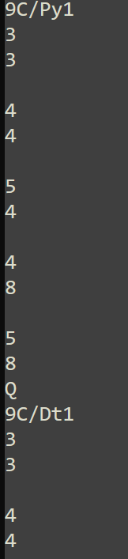  This is a small sample of the data entered | Records stored as  3  3  9C/Py1  4  4  9C/Py1  5  4  9C/Py1  4  8  9C/Py1  5  8  9C/Py1  3  3  9C/Dt1  4  4  9C/Dt1 | See below | None
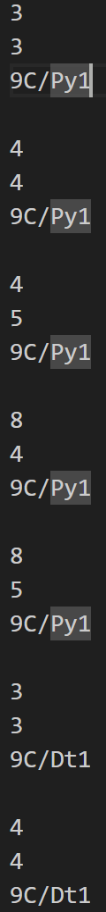
1.2.1 | Create Files  Iteration 0 | Check the forms are created and populated correctly | Input data is the timetable file | 9AAA  30  9AAB  30  9AAC  30  9AAD  30  12AAA  20 | See below |  | Supposedly no students in form 9AAD. It was not writing the last form back to the file with the updated number in students.  So after the students for loop add:  seek(formFile, (FilePos(formFile)-1));  write(FormFile,form);
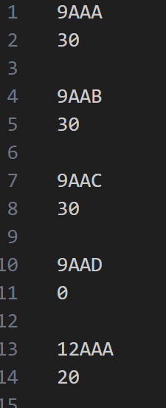
1.2.2 | Create Files  Iteration 1 | Check the forms are created and populated correctly | Input data is the timetable file | 9AAA  30  9AAB  30  9AAC  30  9AAD  30  12AAA  20 | See below | n/a
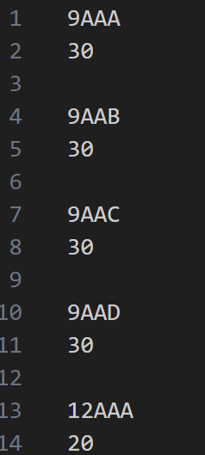
1.3.1 | Create Files  Iteration 1 | Test the students are added correctly | Text file of names generated by another script | Student ID  first name  last name  year  Form  Username: FirstName+Last Name  Password : ABC123 | See below | n/a
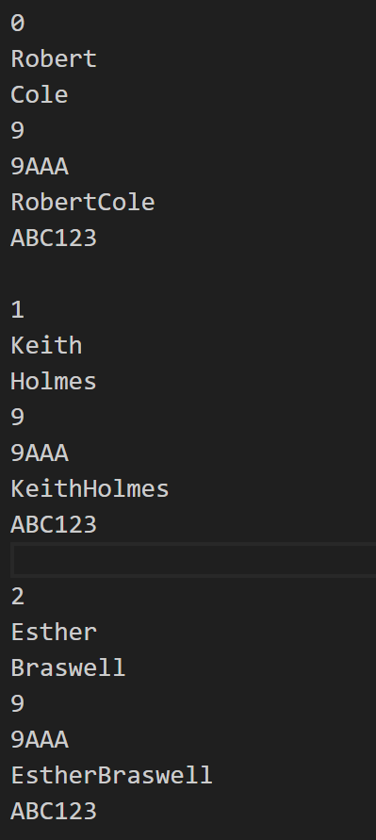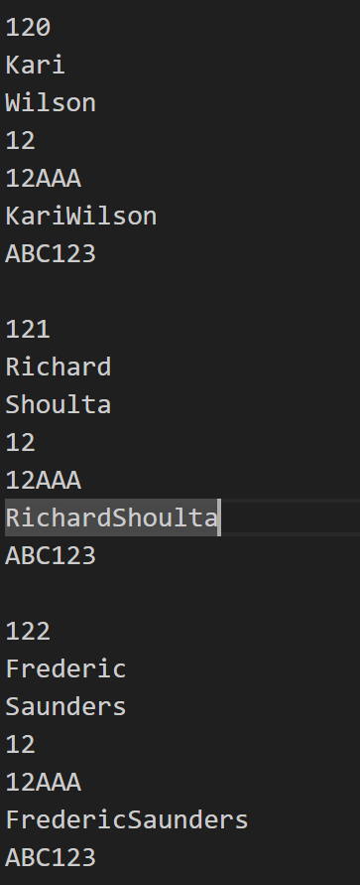

1.4.1 | Create Files  Iteration 1 | Test the teachers are added correctly | Text file of names generated by another script | Teacher ID  first name  last name  Form (might be blank)  Username: FirstName+Last Name  Password : ABC123 | See below | n/a
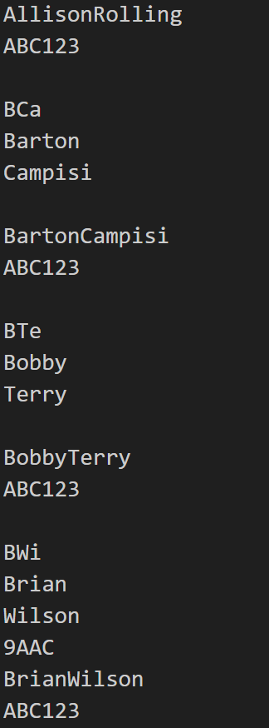
1.5.1 | Create Files  Iteration 1 | Test the subjects are stored correctly | Array of all subject names  And an array of all the subject id stored in the same order | Subject id  Subject name | See below | n/a
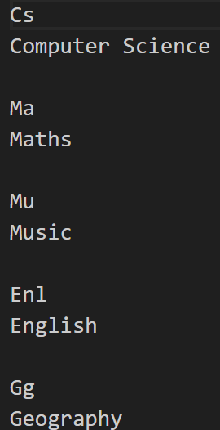
1.6.1 | Create Files  Iteration 1 | Test that the classes are stored correctly | Array of year 9 classes  And array of year 12 classes | Class ID  Year  Subject id  Number of students (30 if year 9 class else a small number of year 12s) | See below | n/a
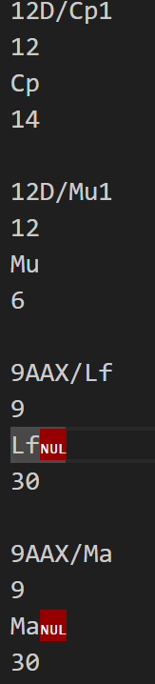
The nul characters represent an empty space in memory where the class id is too short in some places form a string of length 3 which is the max, so it leaves it blank. It is not an issue.

1.7.1 | Create Files  Iteration 1 | To test that students are correctly added to classes | Student data, and class data | Class ID  Student ID | See below | n/a
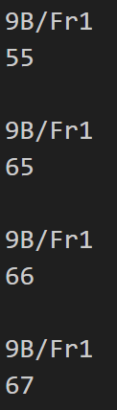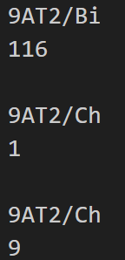
1.8.1 | Create Files  Iteration 1 | To correctly assign teachers to classes | Teacher data and class data | Teacher ID  Class ID  With one teacher to each class | See below | n/a
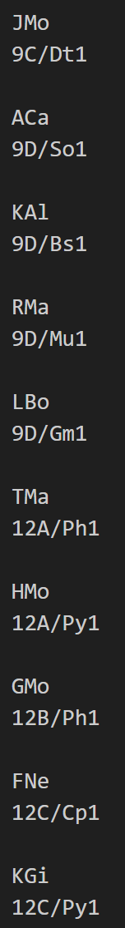
1.9.1 | Create Files  Iteration 1 | To correctly assign teachers to subjects based on the class they are in | Teacher data, class data and subject data | Teacher ID  subject ID  With the teacher’s class id matching up with the subject id | See below | n/a
all this lines up with previous evidence with the classes
1.10.1 | Create Files  Iteration 1 | To test the registers are created correctly | The timetable needs to be entered along with the student’s data, including attendance data. And the data about which student is in what class | Register id  Lesson number  Date  Class id  2d array of student id and their register mark  Is it an Ofsted register | See below | n/a
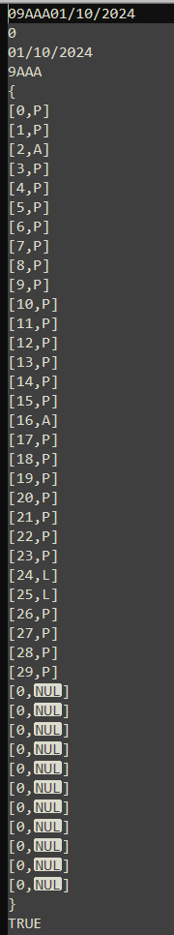
Correctly defines lesson 0 as an Ofsted register
Register marks are distributed correctly with most being present, some being late and very few being absent
[0,NUL] represents no students with no register mark as there are not anymore students in the class
1.11.1 | Create Files  Iteration 1 | To test the log in file is generated and stored correctly | Student and teacher data | Person ID (teacher/student)  Username  Password (ABC123) | See below | n/a
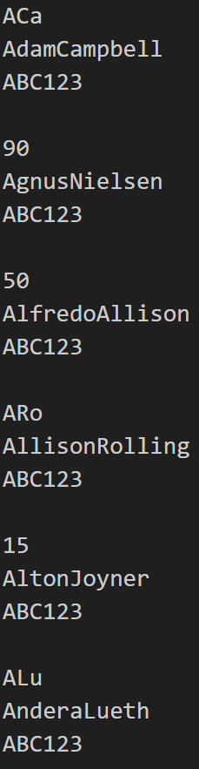
Design

Review
During this iteration I made a script which can generate a large set of data which can be used to test the rest of the system thoroughly with accurate data. This took a long time as I wanted to ensure high data integrity. I asked my client to look at the data to ensure the data I have got is adequate for the section of the school system that I am focusing on. Her thoughts on the data were that for a full school the data is a small amount but for testing purposes she said that if the solution works with this data it should work as an actual system with the full data.

Iteration 2 – Class Structure

Aim
In this iteration I aim to develop a method to generalize code that is used for each file. Such as sorting a file or searching it. I designed this using classes and inheritance to have the general search and sort algorithm in a parent class, while all of the file specific procedures and retrieving the data from the files is done in a child class specific to each file. I will only be testing one of the classes as they are all the same with the singular difference of the record in which they are read into and how that data is put into other structures due to different data types in the record and different number of fields.

Code
For testing I will use just one of the child classes, I choose the login file as it contains fewer fields allowing for easier test data, while still having to be correctly aligned with the student and teacher file

Super Class
unit FileProcedures;
//allows constructors
{$M+}

interface

USES crt, sysutils;

TYPE
//declare class structure
Files = class
protected
upper : LONGINT;
dataArray: ARRAY[0..1400] OF STRING;
fileArray: ARRAY[0..7,0..1400] OF STRING;
public
constructor Create;
destructor Destroy; override;
procedure sort(var indexArray : ARRAY OF LONGINT);
procedure search(max, fields : LONGINT; searchValues:ARRAY OF STRING; searchFields: ARRAY OF BYTE; var returnArray : ARRAY OF LONGINT; switchLowerCase : BOOLEAN);
end;

IMPLEMENTATION

constructor Files.Create;
begin
end;
destructor Files.Destroy;
begin
end;

//sort algorithm for the files
procedure Files.sort(var indexArray : ARRAY OF LONGINT);
var TempIndex, i, code, tmp1, tmp2 : LONGINT;
TempStr : STRING;
Swaps: BOOLEAN;
begin
//bubble sort
upper := upper-1;
REPEAT
Swaps:= false;
FOR i := 0 TO upper DO
BEGIN
//checks done with the data array
IF dataArray[i] > dataArray[i+1] THEN
BEGIN
TempStr := dataArray[i];
dataArray[i] := dataArray[i+1];
dataArray[i+1] := TempStr;
Swaps := true;
//swap data in index array
TempIndex := indexArray[i];
indexArray[i] := indexArray[i+1];
indexArray[i+1] := TempIndex;
END;
END;
upper := upper -1;
UNTIL (NOT Swaps) OR (upper < 0);
end;

//search algorithm
procedure Files.search(max, fields : LONGINT; searchValues:ARRAY OF STRING; searchFields: ARRAY OF BYTE; var returnArray : ARRAY OF LONGINT; switchLowerCase : BOOLEAN);
var found : BOOLEAN;
a, b, c, returnIndex : LONGINT;
data : STRING;
begin
//linear search

if switchLowerCase then
begin
for c := 0 to fields do
begin
searchValues[c] := lowerCase(searchValues[c]);
end;
end
else
begin
for c := 0 to fields do
begin
searchValues[c] := searchValues[c];
end;
end;
a := -1;
returnIndex := 0;
//check every value in the 2d array
while a < max do
begin
a := a + 1;
//check each item in the record
for b := 0 TO (fields-1) DO
begin
if switchLowerCase then
begin
data := LowerCase(fileArray[b,a]);
end
else
begin
data := fileArray[b,a];
end;
//check if one piece of data matches
if data = searchValues[0] THEN
begin
found := true;
//check each peice of data in record against data to search for
for c := 0 to (SizeOf(searchFields)-1) do
begin
if switchLowerCase then
begin
data := LowerCase(FileArray[searchFields[c],a]);
end
else
begin
data := FileArray[searchFields[c],a];
end;
//if not all data matches continue search and dont return result
if searchValues[c] <> data THEN
begin
found := false;
break;
end;
end;
//if all data matches add index to the array of found matches
if found = true THEN
begin
returnArray[returnIndex] := a;
returnIndex := returnIndex+1;
break
end;
end;
end;
Design
end;
end;

END.

Child Class
unit LogInProcedures;
{$M+}
interface

USES crt, sysutils, FileProcedures;

TYPE
//record type for this file
dataRecord = RECORD
PersonID: STRING[5];
Username: STRING[40];
Passwowrd: String[20];
end;

type
//declaration of class, attributes and methods
logInFile = Class(Files)
protected
dataFile: File OF dataRecord;
dataTextFile : TextFile;
indexArray: ARRAY[0..190] OF LONGINT;
recordArray: ARRAY[0..190] OF dataRecord;
public
data : dataRecord;
constructor Create;
destructor Destroy; override;
procedure SetData(iPersonID: STRING; iUsername: STRING; iPasswowrd: String);
procedure DisplayData;
procedure extractToTextFile;
procedure writeToFile;
procedure readHere;
procedure readFile(readFromPosition : LONGINT);
procedure sort;
procedure search(searchValues:ARRAY OF STRING; searchFields: ARRAY OF BYTE; var returnArray: ARRAY OF LONGINT; switchLowerCase: BOOLEAN);

end;

IMPLEMENTATION
//constructor and destructor
constructor logInFile.Create;
var a : longint;
begin
inherited Create;
ASSIGN(dataFile,'C:\ComputerScienceCoursework\Program\files\LogInDetails.dta');
ASSIGN(dataTextFile,'C:\ComputerScienceCoursework\Program\fileOuts\logInOut.txt');
RESET(dataFile);
RESET(dataTextFile);
for a := 0 TO 190 DO
begin
indexArray[a] := a;
end;
end;

destructor LogInFile.Destroy;
begin
close(dataFile);
close(dataTextFile);
inherited Destroy;
end;

//update data attribute
procedure logInFile.SetData(iPersonID: STRING;
iUsername: STRING;
iPasswowrd: String);

begin
with data do
begin
PersonID := iPersonID;
Username:=iUsername;
Passwowrd:=iPasswowrd;
end;
end;
//display data attribute
procedure logInFile.DisplayData;
begin
with data do
begin
writeln(PersonID);
writeln(Username);
writeln(Passwowrd);
writeln('-------------------------------------------------------------------------');
end;
end;
//write all data in file to text file
procedure logInFile.extractToTextFile;
begin
reset(dataFile);
rewrite(dataTextFile);
while not eof(dataFile) DO
begin
read(dataFile, data);
writeln(dataTextFile, data.PersonID);
writeln(dataTextFile, data.Username);
writeln(dataTextFile, data.Passwowrd);
writeln(dataTextFile, '');
end;
end;
//write data attribute to file
procedure logInFile.writeToFile;
begin
write(dataFile, data);
end;

//read data from file at current position
procedure logInFile.readHere;
begin
if FIlePos(dataFile) < FileSize(dataFile) then
begin
read(dataFile,data);
end;
end;
//read data from file at specified position
procedure logInFile.readFile(readFromPosition : LONGINT);
begin
if readFromPosition < FileSize(dataFile) then
begin
SEEK(dataFile,readFromPosition);
read(dataFile,data);
end;
end;
//sort the file
procedure logInFile.sort;
var a,b : LONGINT;
maxStrLen : STRING;
begin
RESET(dataFile);
upper:= 190;
//extrat the data into an array
for a := 0 TO 190 DO
begin
READ(dataFile,data);
recordArray[a] := data;
dataArray[a] := data.Username
end;
Files.sort(indexArray);
RESET(dataFile);
//write the data back to the file
for a := 0 TO 190 DO
begin
WRITE(dataFile,recordArray[indexArray[a]]);
indexArray[a] := a;
end;

end;

//search the file
procedure logInFile.search(searchValues:ARRAY OF STRING; searchFields: ARRAY OF BYTE; var returnArray : ARRAY OF LONGINT; switchLowerCase : BOOLEAN);
var a: LONGINT;
begin
RESET(dataFile);
for a := 0 TO 190 DO
begin
read(dataFile, data);
fileArray[0,a] := data.PersonID;
fileArray[1,a] := data.Username;
fileArray[2,a] := data.Passwowrd;
end;
Files.search(190,3,searchValues, searchFields, returnArray, switchLowerCase);
end;
END.

Design

Testing
Test Number | Program and Iteration | Purpose of test | Data to be entered | Expected result | Actual results | Amendments
2.1.1 | Class structure  Iteration 0 | To test if the object is created | None | Evidence of the object being created | See below | n/a
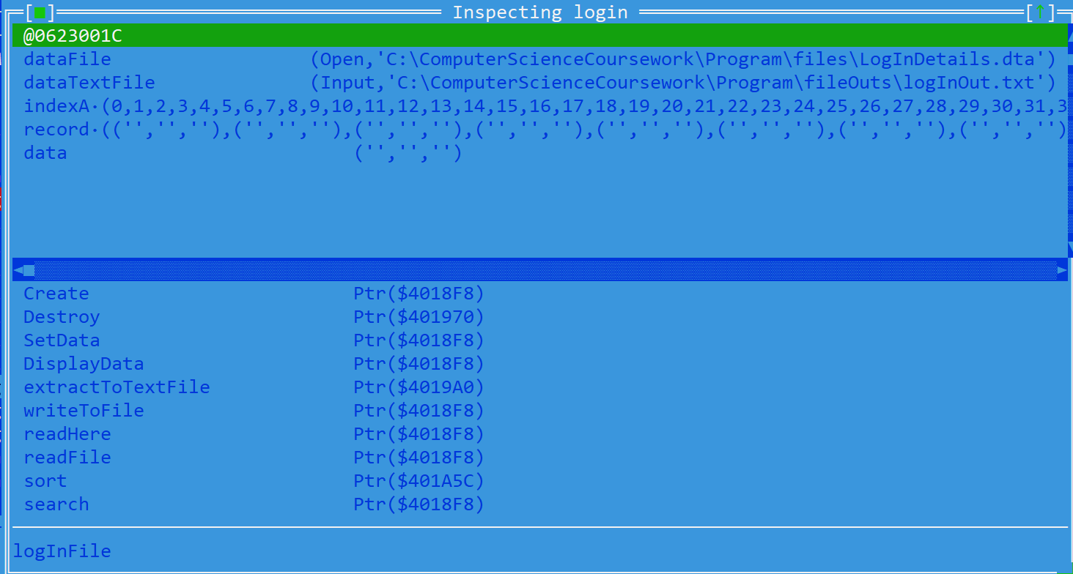
Evidence of the login identifier being a reference to an object with both attributes and methods matching those of the log in class
2.2.1 | Class structure  Iteration 0 | Test if I can set the data in the record. | Person id: 923  Username: BobStarck  Password: IronMan | The data attribute should contain this data | See below | n/a
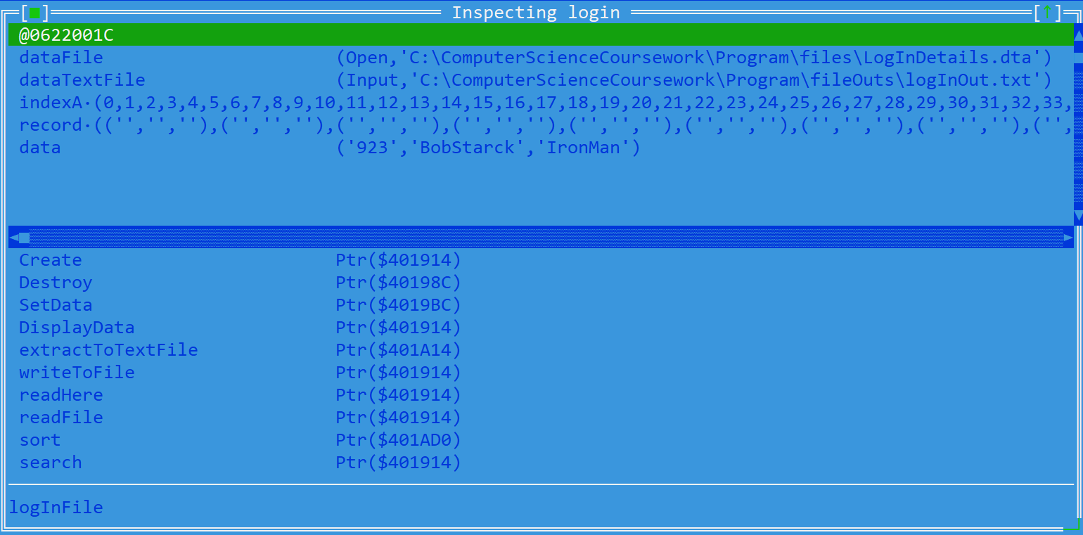
The attribute is set correctly to the data entered
2.3.1 | Class structure  Iteration 0 | To test if it correctly writes the data stored in the current record to the screen. | Person id: 923  Username: BobStarck  Password: IronMan | The data should be outputted to the console  With a method to break apart the record incase many are outputted | See below | n/a
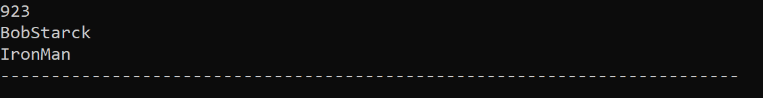

2.4.1 | Class structure  Iteration 0 | Explanation of extract to file | n/a | n/a | n/a | n/a
The method extractToTextFile is a procedure used only for me as the programmer to debug the contents of the file as it is not possible to extract the data in any other way. Evidence of this working is used in the previous iteration and is how I got the data to use as evidence. Evidence

2.5.1 | Class structure  Iteration 0 | Testing to see if I can write back to the file. The data attribute should be written to the file | Person id: 923  Username: BobStarck  Password: IronMan | The first set of data in the file should be the data that was just entered | See below
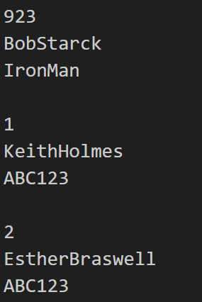
2.6.1 | Class structure  Iteration 0 | Testing the read here method | None needed | 1  KeithHolmes  ABC123  He is the next person to be stored and after the write with BobStarck it should output him next | See Below | n/a
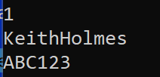
2.7.1 | Class structure  Iteration 0 | To test that the read file from a given position works | Login.readFile(3) | 3  RitaGamble  ABC123 | See below | n/a
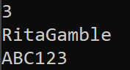

3.8.1 | Class structure  Iteration 0 | To test if the data is placed in the record array and the record id array for sorting | None | The attributes record array to contain all the records in the file and record id array to a single field for each record which will be passed to the search algorithm | See below | n/a
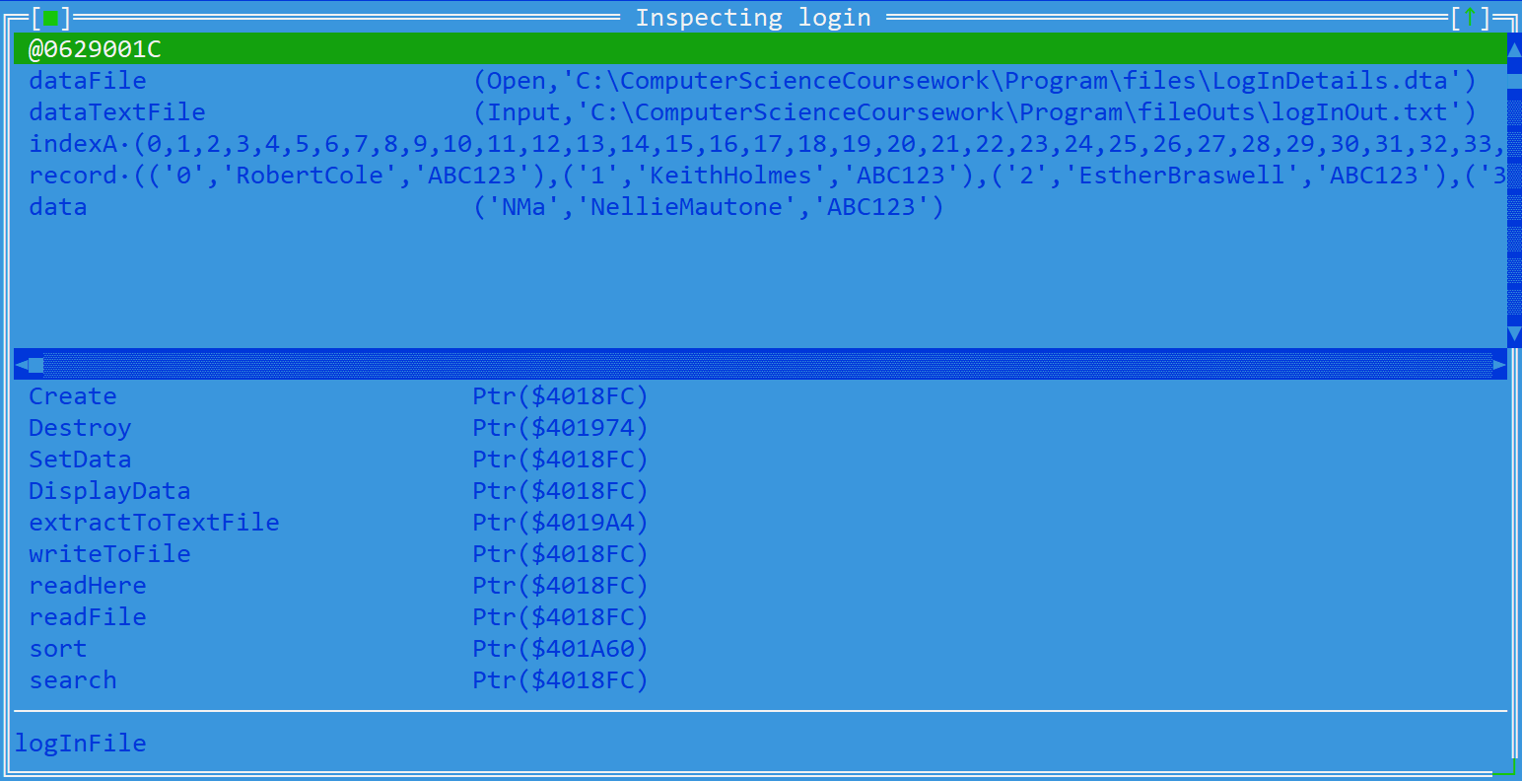
3.9.1 | Class structure  Iteration 0 | To test the file data is passed into the actual search algorithm correctly | None | A 2d array of all the data in the file |  | n/a
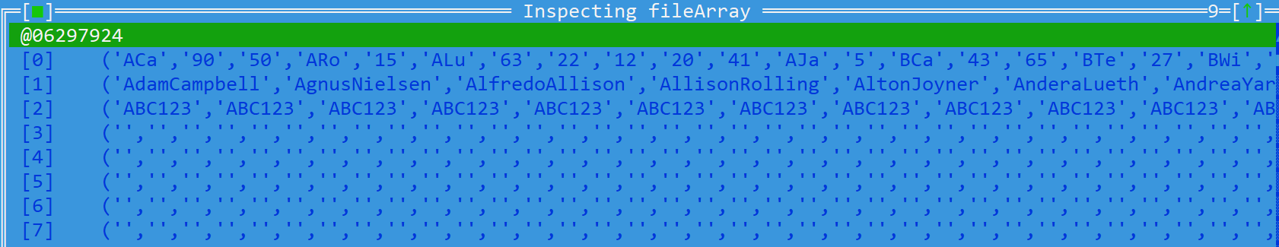
2D array storing all the data from the file
3.10.1 | Class structure  Iteration 0 | To test if the data is sorted and written back to the file when complete | None | The data should be ordered by Username | See below | n/a
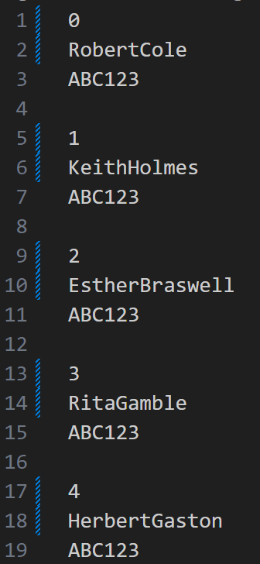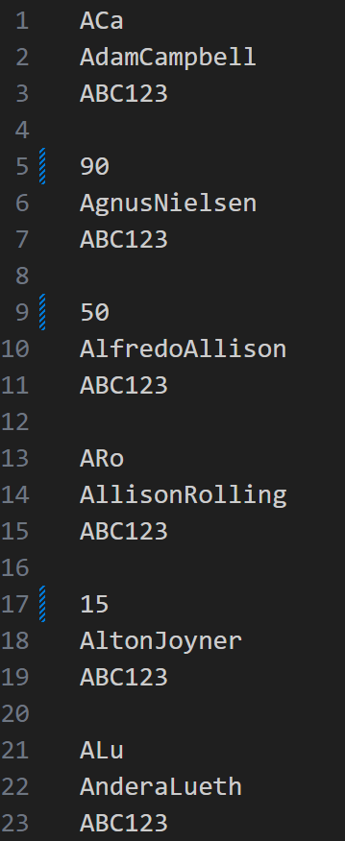
Data after sort, data is ordered by username (the second field)
Data before sort
3.11.1 | Class structure  Iteration 0 | To test if it can find the first person in the file | Search data: RobertCole  Field 1 for username | Found at positions:  0  0  RobertCole  ABC123 | See below | n/a
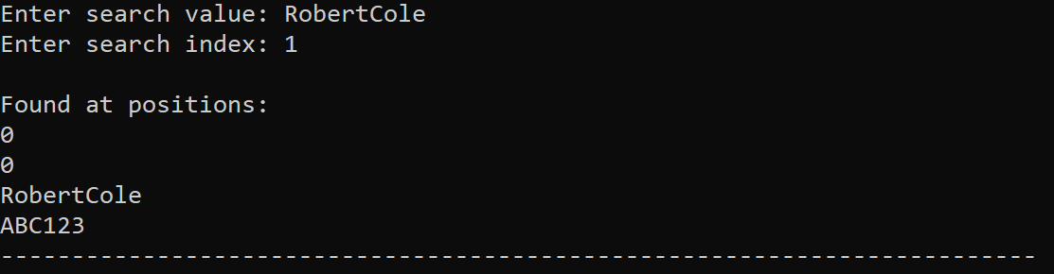
3.11.2 | Class structure  Iteration 0 | To test if it can find the any person in the file | Search data: 8  Field 0 for person id | Found at positions:  8  8  MarylouiseBrooks  ABC123 | See below | n/a
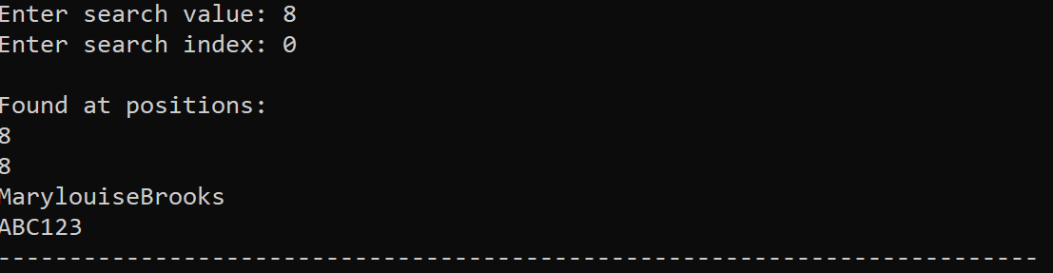
3.11.3 | Class structure  Iteration 0 | To test if it can find multiple person in the file | Search data: ABC123  Field 2 for password | Every person should be output once as all users have password ABC123 | See below | n/a
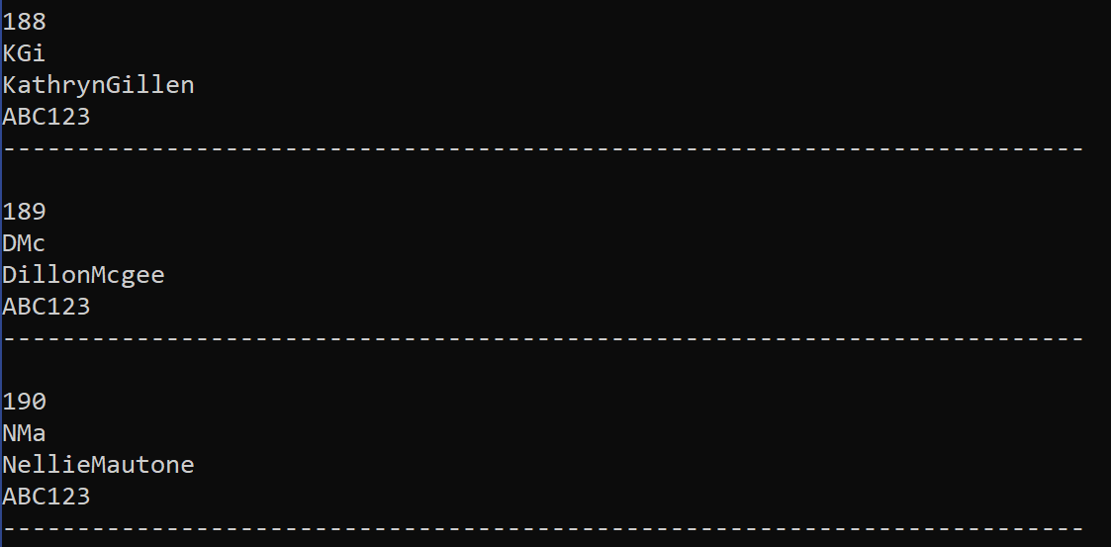
Displays all people as teachers are the last to get added and it ends at 190 people which is where it should end
3.11.4.0 | Class structure  Iteration 0 | TO test case sensitive searching | Search data : robertcole  Field 1 for username | No people found | See below | Add a parameter to bypass force lower if the search needs to be case sensitive
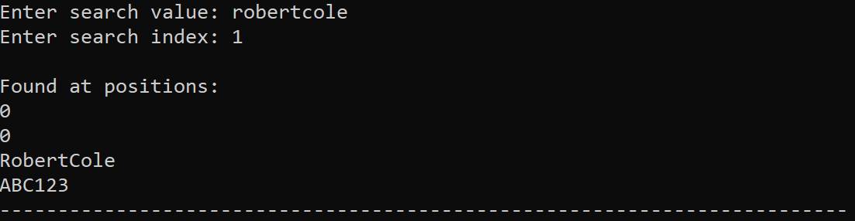

Fix:
procedure Files.search(max, fields : LONGINT; searchValues:ARRAY OF STRING; searchFields: ARRAY OF BYTE; var returnArray : ARRAY OF LONGINT; switchLowerCase : BOOLEAN);
var found : BOOLEAN;
a, b, c, returnIndex : LONGINT;
data : STRING;
begin
//linear search

if switchLowerCase then
begin
for c := 0 to fields do
begin
searchValues[c] := lowerCase(searchValues[c]);
end;
end
else
begin
for c := 0 to fields do
begin
searchValues[c] := searchFields[c];
end;
end;
a := -1;
returnIndex := 0;
//check every value in the 2d array
while a < max do
begin
a := a + 1;
//check each item in the record
for b := 0 TO (fields-1) DO
begin
if switchLowerCase then
begin
data := LowerCase(fileArray[b,a]);
end
else
begin
data := fileArray[b,a];
end;
//check if one piece of data matches
if data = searchValues[0] THEN
begin
found := true;
//check each peice of data in record against data to search for
for c := 0 to (SizeOf(searchFields)-1) do
begin
if switchLowerCase then
begin
data := LowerCase(FileArray[searchFields[c],a]);
end
else
begin
data := FileArray[searchFields[c],a];
end;
//if not all data matches continue search and dont return result
if searchValues[c] <> data THEN
begin
found := false;
break;
end;
end;
//if all data matches add index to the array of found matches
if found = true THEN
begin
returnArray[returnIndex] := a;
returnIndex := returnIndex+1;
break
end;
end;
end;
end;
end;

3.11.4.1 | Class structure  Iteration 1 | TO test case sensitive searching | Search data : robertcole  Field 1 for username | No people found | See below | n/a
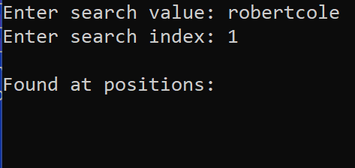
3.11.4.2 | Class structure  Iteration 1 | To test case sensitive searching in a different field | Search data : abc123  Field 2 for password | No people found | See below | n/a
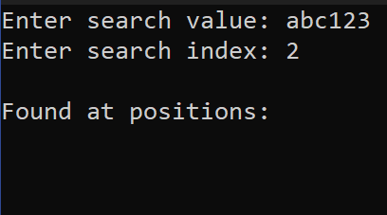
3.11.5 | Class structure  Iteration 1 | Test if it can search using multiple pieces of information | Search data : RobertCole  Field 1 for username  Search data : ABC123  Field 2 for password | Found at positions:  0  0  RobertCole  ABC123 | See below | n/a
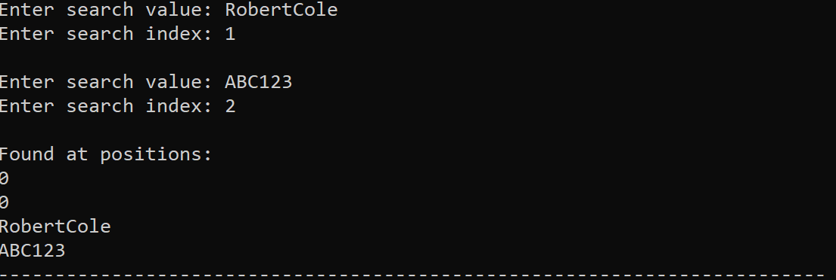

Review
This iteration is purely for use by the programmer. This class structure that I developed allows me to attach extra methods such as sorts and searches to each file allowing for more concise code in the main program. By using inheritance, I created the general sort and search algorithms and place them in a super class, and by creating a class for each file which inherits the methods of the super class each file has a sort and search algorithm attached to it. This will then allow me to just use the methods in the main script without having to write searches and sorts for each file in the main script.
Design Child Class
Design Super Class

Iteration 4 – Student’s Menu

Aim
The aim in this iteration is to develop a menu in which the student can interact with the system and use it. This will be done using a series of menus which the student should be able to navigate using the keyboard arrow keys. This reduces the chance of the student being able to break the program by keeping the free data input sections to a minimum.

Code
UNIT StudentsMenu;
interface
uses crt, sysutils, VPUtils, studentProcedures, timeTableProcedures,
attendancProcedures, studentClassProcedures,createMenu, writeDesign;

//declaration of all procedures and functions
procedure startStudent(inputStudentId : LONGINT);
procedure CompleteTimeTable(inputDate : TDateTime);
procedure TimeTableMenu;
procedure AttendanceMenu;
procedure LogOutMenu;
procedure mainMenu;

implementation
//declare variables local to this unit
var studentID : LONGINT;
student : StudentFIle;
attendance : AttendanceFile;
timetable : TimeTableFile;
studentClassC : studentClassFile;
studentClassReturnArray : ARRAY[0..1400] OF LONGINT;
timetableReturnArray: ARRAY[0..321] OF LONGINT;
mainMenuOptions : ARRAY[0..2] OF STRING = ('Attendance','Timetable', 'Log Out');
animationTimeTable : BOOLEAN;

//Menu for viewing attendance
procedure AttendanceMenu;
begin
Writeln('Attendance');
readln;
end;

//fill timetable with the data
procedure CompleteTimeTable(inputDate : TDateTime);
var a, b, c, day, NumberOfDays, timeDelay : LONGINT;
CurrentDate : TDateTime;
week : STRING;
stringStudentId : STRING;
//dateArray : ARRAY OF STRING;
begin
//draw basic timetable outline
if animationTimeTable = true THEN
begin
timeDelay := 100;
end
else
begin
timeDelay := 0;
end;
writeDesign.DrawDesign('C:\ComputerScienceCoursework\Program\files\TimeTableLayout.txt', timeDelay);
CurrentDate := inputDate;
day := DayOfWeek(CurrentDate-2);
HideCursor;
//write the dates with current date highlighted
for a := 0 to 4 DO
begin
GOTOXY(5,7+a*4);
if CurrentDate-day+a = Date THEN
TextColor(Yellow)
else
TextColor(White);
write(DateToStr(CurrentDate-day+a));
Delay(timeDelay);
end;
TextColor(White);
//calcualte if it is week A or week B
NumberOfDays := 0;
while StrToDateTime('13/09/2024') + NumberOfDays <> CurrentDate-day+a-1 DO
NumberOfDays := NumberOfDays +1;
NumberOfDays := NumberOfDays DIV 7;
GOTOXY(7,2);
if (NumberOfDays mod 2 = 0 )THEN
week := 'A'
else
week := 'B';
WRITE(week);
//write lessons in timetable
stringStudentId := IntToStr(studentID);
//get all classes which the student is in
studentClassC.search([stringStudentId],[1],studentClassReturnArray);
b := 0;
//for every class
while studentClassReturnArray[b] <> -1 DO
begin
//get the class id
studentClassC.readFile(studentClassReturnArray[b]);
for a := 0 to 320 DO
timetableReturnArray[a] := -1;
//find every time and day that class is on
timetable.search([studentClassC.data.ClassID],[2], timetableReturnArray);
c := 0;
while timetableReturnArray[c] <> -1 DO
begin
//get the day and time for that one time that one class is
timetable.readFile(timetableReturnArray[c]);
//test for the current week
if week = 'A' THEN
begin
//test if the class is on the correct week
if timetable.data.day < 6 THEN
begin
//got to position and write class id
GOTOXY((10*timetable.data.LessonNo+20),( 4*(timetable.data.Day-1)+7));
WRITE(Trim(TimeTable.data.ClassID));
Delay(timeDelay);
end;
end
else
begin
//test if the class is on the correct week
if timetable.data.day > 5 THEN
begin
//got to position and write class id
GOTOXY((10*timetable.data.LessonNo+20),( 4*(timetable.data.Day-6)+7));
WRITE(Trim(TimeTable.data.ClassID));
Delay(timeDelay);
end;
end;
c := c + 1;
end;
b := b + 1;
end;
//write the form data in
for a := 0 TO 4 DO
begin
GOTOXY(21, 4*a+7);
write(student.data.Form);
Delay(timeDelay);
end;
animationTimeTable := false;
end;

//Draw and populate timetable
procedure TimeTableMenu;
var StartDate : TDateTime;
begin
StartDate := Date;
CompleteTimeTable(StartDate);
readln;
end;

procedure LogOutMenu;
begin
writeln('Logging out');
Timetable.free;
studentClassC.free;
student.free;
attendance.free;

Delay(1000);
end;

//main menu
procedure mainMenu;
var choice : LONGINT;
begin
GOTOXY(0,0);
choice := 0;
//get student and attendance data at the start
student.readFile(studentID);
attendance.readFile(studentID);
//main menu display until logout selected
repeat
ClrScr;
HideCursor;
//messages welcoming and displaying overall attendance
writeln('welcome ', student.data.fname, ' ', student.data.sname, ' ');
GOTOXY(1,3);
writeln('Attendance: ', Format('%.2f', [attendance.data.attendance*100]),'%');

//create the menu and start to control it
choice := createMenu.writeMenu([1,5],3,mainMenuOptions, choice);
//test for each menu choice
case choice of
0 : AttendanceMenu;
1 : TimeTableMenu;
2 : LogOutMenu;
end;
until choice = 2;

end;

//declaration of global variables
procedure startStudent(inputStudentId : LONGINT);
var a : LONGINT;
begin
animationTimeTable := true;
//populate arrays with -1
for a := 0 TO 1400 DO
studentClassReturnArray[a] := -1;
for a := 0 to 320 DO
begin
timetableReturnArray[a] := -1;
end;
//declare file objects for this unit
timetable := TimeTableFile.create;
studentClassC := studentClassFile.create;
studentID := inputStudentId;
attendance := AttendanceFile.create;
student := StudentFile.create;
mainMenu;
end;

end.

Design

Testing
Test Number | Program and Iteration | Purpose of test | Data to be entered | Expected result | Actual results | Amendments
4.1.1 | Student Menu  Iteration 0 | TO test if the student home screen is displayed | Username: RobertCole  Password: ABC123 | Welcome Robert Cole  Attendance: 90% (as example)  - Attendance  - Timetable  - Log Out | See below | n/a
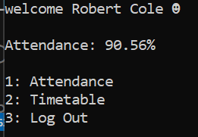
4.2.1 | Student Menu  Iteration 0 | To test if it opens the attendance menu | Username: RobertCole  Password: ABC123  Then menu option 1 | Attendance | See below | n/a
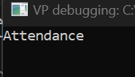
4.2.2 | Student Menu  Iteration 0 | Testing if you can return to the main menu by any key | Username: RobertCole  Password: ABC123  Then menu option 1  Any key press | Welcome Robert Cole  Attendance: 90% (as example)  - Attendance  - Timetable  - Log Out | See below | n/a
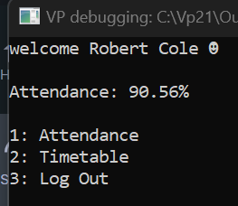
4.3.1 | Student Menu  Iteration 0 | Testing if the timetable is correctly displayed in table format with current date highlighted | Username: RobertCole  Password: ABC123  Then menu option 2  Any key press | Display of timetable with correct date highlighted and classes filled in | See below | n/a
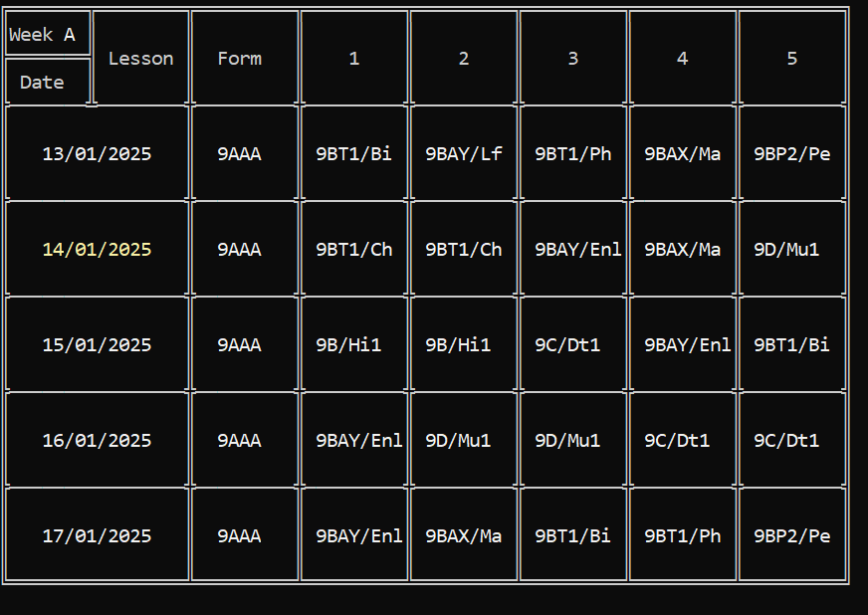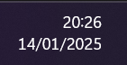

4.3.2 | Student Menu  Iteration 0 | Testing if the program works on a Monday, the first day of a new week | Username: RobertCole  Password: ABC123  Then menu option 2  Any key press | The first date should say 13/0/2025 in yellow | It shows the previous week | Change  day := DayOfWeek(CurrentDate-2);  day := DayOfWeek(CurrentDate-1)-1;  so instead of rolling the week back by one it adjusts it so that Monday is a 0 rather than sunday
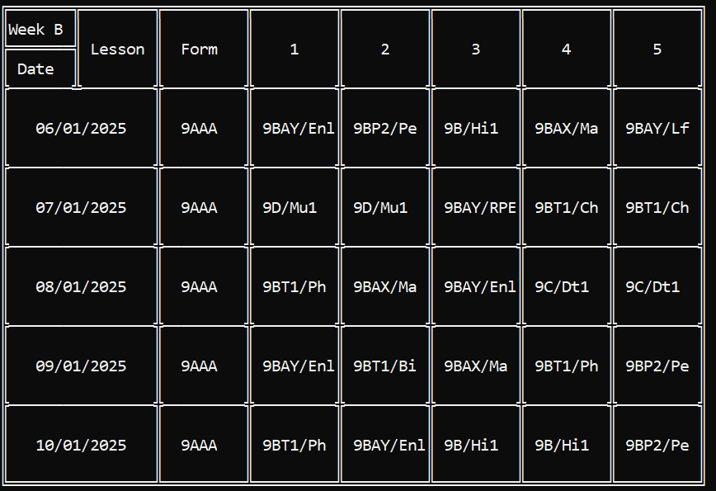
4.3.2 | Student Menu  Iteration 1 | Testing if the program works on a Monday, the first day of a new week | Username: RobertCole  Password: ABC123  Then menu option 2  Any key press | The first date should say 13/0/2025 in yellow | See below | n/a
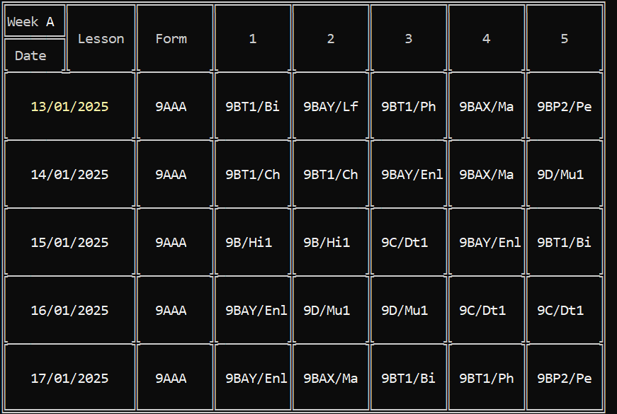

4.3.3 | Student Menu  Iteration 1 | To test the animation runs the first time it is loaded and no others | Enter the timetable menu | Slowly entering the data to create an animation | See below | n/a
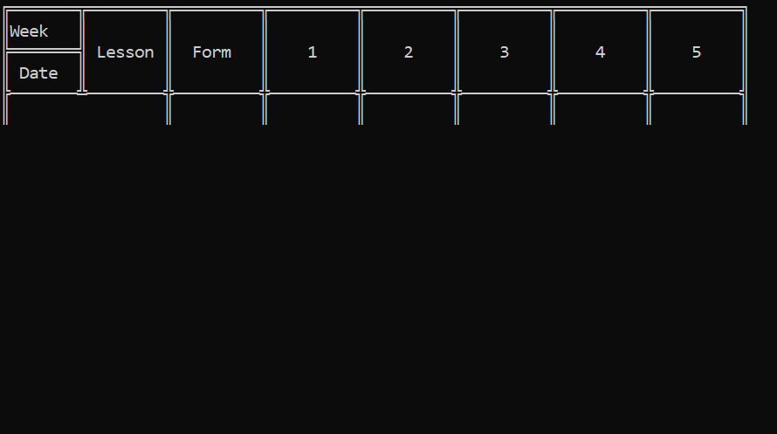

And then second time entering
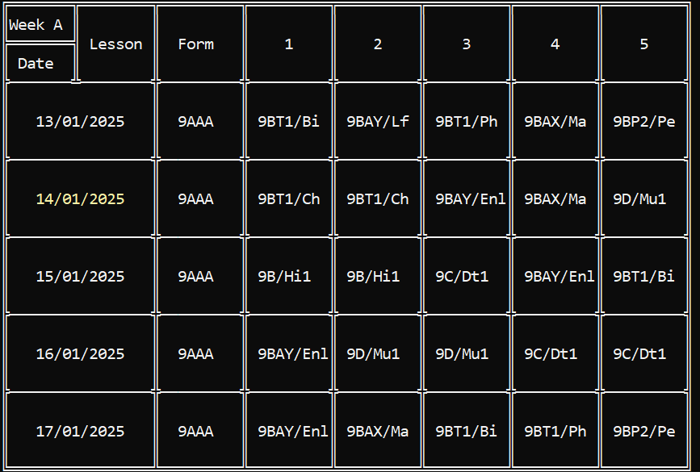
4.4.1 | Student Menu  Iteration 1 | To test the log out works | Enter the menu logout | The program terminates | See below | n/a
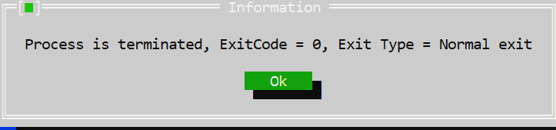
 |  |  |  |  |  | Design

Review
My client has provided quite a lot of useful feedback. She likes the layout of the main menu and how the information is presented nice and concisely, the screen is not too cluttered with many menus. They like the menu options being named appropriately. They really like the timetable formatting and how it is laid out. They also like the quality-of-life feature which highlights the current date in yellow. They enjoy the animation of the timetable drawing itself as it is “appealing to watch”, they also like that it only happens the first time instead of every time. They like the logout button which lets you know its logging out. They however would like me to finish the attendance form as that is not complete.

Iteration 5 – Teacher’s Menu

Aim
The aim of this iteration is to develop a menu for the teacher to interact with. It will have a similar design to the student’s menu in the sense that it will be mostly controlled by menus and using the arrow keys in the menu to reduce the chance of an error by a mis tap.

Code
UNIT TeachersMenu;
interface
uses crt, sysutils;
procedure startTeacher;
implementation
//main menu
procedure startTeacher;
begin
//debug to prove it works
writeln('welcome teacher');
readln;
end;

end.

Design

Testing
Test Number | Program and Iteration | Purpose of test | Data to be entered | Expected result | Actual results | Amendments
5.1.1 | Teachers Menu | Test if the menu is run | Logged into a teacher | Welcome teacher | See below | n/a
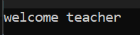

Design

Review
My client didn’t have much to say about this other than its missing all the functionality.

Iteration 6 – Main Program

Aim
The aim of this iteration is to make a singular program which the client will run, and it will include all aspects of the solution. This keeps the program modular by only having a small section that needs to be tested. In this iteration only the login code is run and then it chooses another unit to go into based on whether a student or teacher logged in. Keeping each part of the solution separate allows for easier testing and making sure very unit works before integrating it.

Code
PROGRAM Main;
//declare all units to be used
USES Crt, Sysutils, LogInScreen, loading, LogInProcedures,
TeachersMenu, StudentsMenu;
var userType : STRING;
intUserID : LONGINT;

//declare main program
function start:STRING;
var i, ErrCode, userIndex : LONGINT;
userId : STRING;
userDetailsArray : ARRAY[0..1] OF STRING;
logIn : logInFile;
percentDone : REAL;
logedIn : BOOLEAN;
begin
//declare login file
logIn := logInFile.create;
logIn.sort;
userIndex := -1;

//while loop to keep running log in attempts
logedIn := false;
while logedIn = false do
begin
ClrScr;
//login methods
LogInScreen.startLogIn(userDetailsArray);
logIn.search(userDetailsArray,[1,2], userIndex, false);
loading.startLoading('L', percentDone);
Delay(1000);
loading.silentKillLoading;
Delay(100);
//test username and password are valid
if userIndex = -1 THEN
begin
writeln('Username Or Password is incorrect.');
readkey;
end
else
begin
logedIn := true;
//get the user info
login.readFile(userIndex);
//test if the username and password belong to a teacher or student
userId := Trim(login.data.PersonID);
val(userid,intUserID,ErrCode);
if ErrCode <> 0 THEN
begin
start := 'T';
end
else
begin
start := 'S';
end;
end;

end;
//delete login file object
logIn.free;
end;

begin
Design
//start login
userType := start;
if userType = 'T' THEN
//teacher menu
TeachersMenu.startTeacher
else if userType = 'S' THEN
//student menu
StudentsMenu.startStudent(intUserID)
end;
end.

Testing
Entering a valid username and password for a teacher accounts logs you into the teacher account.
Test Number | Program and Iteration | Purpose of test | Data to be entered | Expected result | Actual results | Amendments
6.1.1 | Main  Iteration 0 | To test if it passes correctly onto the student unit | Username: RobertCole  Password: ABC123 | Welcome Robert Cole  Attendance: 90% (as example)  - Attendance  - Timetable  - Log Outd | See below | n/a
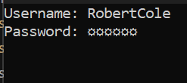
Evidence to show it brings up the login menu with data entered

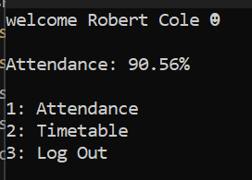
Evidence of the student menu showing up after entering valid username and password
6.2.1 | Main  Iteration 0 | To test if it passes correctly onto the teacher unit | Username: JessicaBowman  Password: ABC123 | Welcome Teacher | See below | n/a
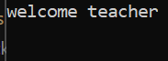

6.3.1 | Main  Iteration 0 | Test if incorrect username is entered then it requests the user to enter it again | Username: MrMartin  Password: ABC123  Evidence of invalid user data being entered to test it rejects the entered data | Username Or Password is incorrect. | See below | n/a
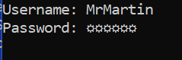
Evidence of it rejecting the information

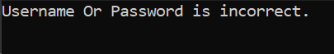
Design

Review
My client made most of her comments in the review of iteration 0 about the login screen. But she likes the loading bit before you go into the actual menu.

Evaluation

Testing to Inform Evaluation
For post development testing, I have put together a selection of tasks that the user could want to do whilst using the solution. I have documented these tasks with a test plan below. The data that I selected to test the scenario has been included during the iterative development stage. All the data that will be used here has been tested independently and all subset of the task has been tested independently as well.
Test | Scenario | Justification | Data Used
1 | Teacher wants to log into the system | All teacher options and data access should not be accessible by students. So, by having an account system with secure log ins stops students being able to access data they should not be able to access | Username: JessicaBowman  Password: ABC123
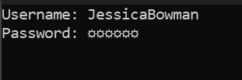
Functionality of hiding the password as the user types it keeps accounts secure from other people
Clear space to enter username and password which is similar to other systems that exist

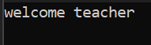
This shows evidence of functionality by entering the teacher menu
Robustness is tested in iteration 0.5 where the log in scripts is fully tested

2 | Student wants to log into the system | The system contains information about the student that the student will want access to. Such as being able to view their timetable or attendance. So, by having an account system and a log in system it allows for students to log into their own space and view only their data | Username: RobertCole  Password: ABC123
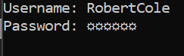
Functionality of hiding the password as the user types it keeps accounts secure from other people

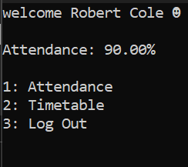
Robustness is tested in iteration 0.5 where the log in scripts is fully tested
This shows evidence of functionality by entering the student menu

3 | Students wanting to be able to view their timetable | Each student needs to know which class they have an when it is so that they can cross reference that with their attendance marks or if they need to know what lessons they have and when. | Username: RobertCole  Password: ABC123  Select menu option 2
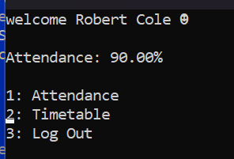
The cursor is constrained to the menu options demonstrating robustness of the solution
Menu controlled by the arrow keys and then pressing enter to select making it more user friendly and convenient to use

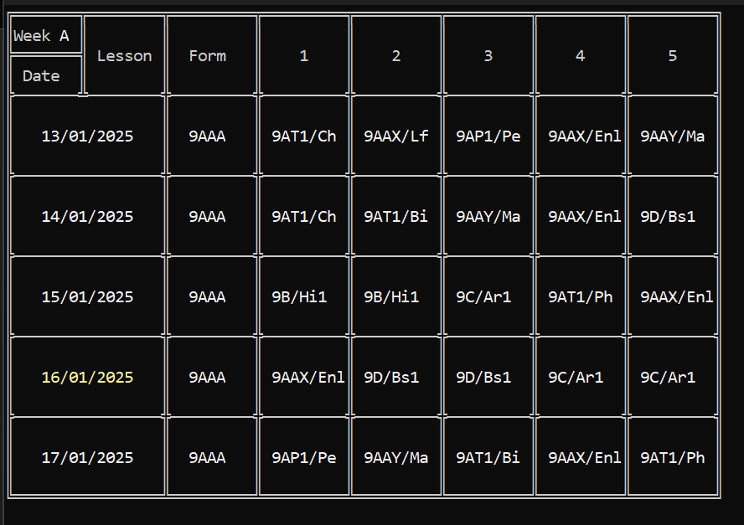
Timetable is displayed in a way which is easy for the user to interpret and get the data they need easily
Highlights the current date to allow the user to easily see which day it is
Functionality of the menu displayed as it displays the timetable

Success of the Solution
In creating a solution for my client, the following success criteria identified below were met. However, in developing the solution there were many complex success criteria that had to be met by the programmer to start working on the client success criteria

Evaluation of solution against success criteria for client
Success Criteria (Feature) | Description | Measurable Criterion | Criteria met? | Evidence of test data | Future Development
Log in page | This will ask for a username and password, and depending on the status logins in depends on the tasks offered to the user | This is measurable as it should either out put a menu for a teacher or a menu for the student.  When a teacher logs in the functions will be:  View Attendance  Take a Register  And if it was a student that logs in the list of functions will be:  Attendance attendance percent: …%  Timetable | This criterion is partially met the login works for both student and teachers. And the student menu is complete with a slight redesign of the UI. But there is no teacher menu | Iterations 0.5 and 6 shows the log in section working. Iteration 4 shows the students menu. And iteration 5 shows that there is no teacher menu yet. This evidence shows that the criterion was partially met as some of the procedures were completed but not all. | . The menu design will be like the students though and can be easily completed using the create menu script demonstrated in iteration 0.8
Display register | This will display a list of student’s names in that class with a choice of marks next to each student name | This is measurable as it should return all the students in the class with the options to mark them here or not  This will display the names in a format of  Name1 - [present] [absent with reason] [absent no reason] [late]  Name2 - [present] [absent with reason] [absent no reason] [late]…  And there will be the same number of names as students in that class which can be check by outputting the number of students in that class from the class file.  With a mark all as present, mark all as absent and a submit button at the bottom | This criterion was not met. | There is no evidence to show as no part of this section has been developed yet. | For future development the craeteMenu script could be modified to allow for horizontal menus in different designs
Select different register marks | This will allow the user to move the cursor between each student and each option and selecting the option just by moving on to the next student. And them submitting by pressing enter | The end display will look like  Name1 - [present] [absent with reason] [absent no reason] [late]  Name2 - [present] [absent with reason] [absent no reason] [late]  Name3 - [present] [absent with reason] [absent no reason] [late]…  [Mark All Present]  [Mark All Absent]  [Submit Register] | This criterion was not met | There is no evidence to support any of this being done | A menu linking script could be used along with the cursor grid script to control the cursor in such a way that allows you to select each different option for each student. Or you can run it in a while loop storing the results in a 2d array corresponding to the position selected and looping until submit register is pressed
Display teacher timetable | This will display the teachers timetable and highlight the current lesson that it is. The timetable will be displayed with day along the top with date above that and then lesson numbers down the sides | The data will look something like this with classes and the highlighted one is the current lesson that they need to do the register for | This criterion was partially met. The timetable was redesigned to having the dates down the side and the lesson number on the top. Also, the timetable was never complete for the teacher but is very similar to the student one. | Evidence in Iteration 0.6 shows that the generic timetable can be written out. Then evidence in iteration 4 for the students shows that code has been developed to fill the timetable with data. This shows that it is partially met
   | 01/07/24 | 02/07/2024 | 03/07/2024 | 04/07/2024 | 05/07/2024
  1 | 9AT1/Ch | 9AT2/Ch | 9AT1/Ch | 9BT1/Ch
  2 | 9AT1/Ch | 9AT1/Bi |  | 9BT1/Ch
  3 |  | 9AT1/Bi | 9BT1/Bi |  | 9AT1/Ch
  4 | 9BT1/Ch |  | 9AT1/Bi | 9BT2/Bi
  5 | 9BT2/Bi |  |  | 9AT2/Ch
Search for student | There will be a search bar provided that can be typed into and will display all students which are close to what they have typed in, they can then navigate down to each student and then select the student | Search for name: R  Robert Cole  Rita Gamble  Rose Roberts  Robert Flores…  This will refine as more letters are typed in, the selected one can then be selected by pressing enter and you will enter the overview for that student | This criterion has not been met | No evidence | For future development you can do a repeat until loop with a read key for the user typing in. Then using a string subset search, search student file for that substring. Then write all results storing in an array that resets itself each time a key is pressed. If the Down key is pressed then convert the list of names into a menu which the user can then select from
Display form attendance | This will display a list of all students in that teachers form with their attendance next to their name and colour coded to highlight the students that need talking to. This will also be ordered from lowest attendance to highest attendance | Wendell Hulslander – 75%  Marylouise Brooks – 83%  Rose Roberts – 92%  Tracy Boyd – 95%  Velma Morris – 99.8%  This is what an example set of data should look like when looking through the teachers for attendance | This criterion is not met | There is no evidence for any section of this. | For future development a search can be done on the students file to get all the students in that form and then an insertion sort can be done to sort the students by attendance with lowest attendance first with the student id attached to the attendance using parallel arrays. This array can then be iterated through with a case statement to control the colour of the text to write all students and their attendance
attendance certificate | This will display all information about the student’s attendance. Including percentages and a table of where they missed lesson. | Name: Wendell Hulslander  Attendance: 75%  Authorised absences attendance: 89%  Unauthorised absences: 14  Lates: 12  …  IT should show the students name, attendance, attendance with authorised absences, unauthorised absences, and late marks. It should then also have a table and all marks in that year. | This criterion was partially met, all the independent sections of this can be easily achieved. The table can be easily written using writeDesign. The filling for the table is already done and the information at the top is just read and write from the file | In the iteration 4 there is demonstration of a timetable being filled in. There is also evidence of being able to read and write attendance data. And iteration 4 shows an example of writing out the timetable. These pieces of evidence show that some of this is done just scattered in other places | For future development reads and writes from the attendance file can display the information at the top. writeDesign can be used to draw the table. A similar algorithm to the one that fills out the students timetable can be used for the attendance marks. And then using a cursor grid you can use the output of that to change the start date in the timetable by a week at a time
   | 1 | 2 | 3 | 4 | 5
  05/07/24 | /\ | L | A | L | /\
  04/07/24 | L | A | A | /\ | /\
  03/07/24 | /\ | /\ | /\ | /\ | L
  02/07/24 | L | /\ | A | /\ | /\
  01/07/24 | L | L | A | /\ | A
Attendance timetable (teacher) | This will provide a timetable for the student with all register marks for a ser period | Name: Erica Hernandez  …  This is a display of all register marks between two time periods set by the teacher when entering this view | This criterion was not met | There is no evidence for anything similar to this except the timetable layout shown in iteration 4. Showing that this criterion was not met due to it lacking the critical information | This would be a copy of what the student would see, so I would make a procedure in writeDesigns to write the attendance data starting on a certain date for a week
   | 1 | 2 | 3 | 4 | 5
  05/07/24 | /\ | L | A | L | /\
  04/07/24 | L | A | /\ | /\ | /\
  03/07/24 | /\ | /\ | /\ | /\ | L
  02/07/24 | L | /\ | A | /\ | /\
  01/07/24 | /\ | /\ | /\ | /\ | A
Attendance overview (teacher) | This will bring up a display giving the name of the student, overall attendance, Attendance with authorised absences, Unauthorised absences, and late marks | Name: Ann Lavoie  Attendance: 85%  Authorised absences attendance: 93%  Unauthorised absences: 4  Lates: 2 | This criterion is not met | No evidence | For future development, after selecting Attendance overview in the students’ options after the teacher searched for that student. Just read the attendance data for that student and write it out
Attendance overview (student) | This will give the student a quick overview of all their attendance statistics, which is the same as what the teacher will see. It will display overall attendance, attendance with authorised absences, Unauthorised absences, and late marks | Attendance: 89%  Authorised absences attendance: 96.4%  Unauthorised absences: 1  Lates: 0 | This criterion is partially met. In the main menu for the students, that students overall attendance is displayed at the top. | Evidence for this is shown in iteration 4. There is no entire overview for the students attendance. But in the main menu it does show overall attendance. This shows that some of the data can be outputted thus proving the criterion was partially met | For future development a sub menu in the students attendance menu, then another option called “attendance overview” which then reads from the attendance file and displays the information out.
Attendance timetable (student) | This will give the student a week-by-week view of all their register marks over the entire year which they can cycle through to see when they have missed lessons or were marked as late | This will display a 5-day week from Monday to Friday with lesson numbers as headings and it will display all the register marks that have been marked down that week. So, from my example data one example could look like this. | This criterion was not met | No evidence | For future development reads and writes from the attendance file can display the information at the top. writeDesign can be used to draw the table. A similar algorithm to the one that fills out the students timetable can be used for the attendance marks. And then using a cursor grid you can use the output of that to change the start date in the timetable by a week at a time
   | 1 | 2 | 3 | 4 | 5
  01/07/24 | /\ | L | A | /\ | /\
  02/07/24 | /\ | /\ | /\ | /\ | /\
  03/07/24 | /\ | /\ | /\ | /\ | L
  04/07/24 | /\ | /\ | /\ | /\ | /\
  05/07/24 | /\ | /\ | /\ | /\ | A
Timetable (student) | This will give the student a week-by-week view of their timetable and their classes. This is so they can cross reference what register marks they got for which class | This will display a 5-day week from Monday to Friday with lesson numbers as headings and it will display the class that the student has at that time. So, from my example data one example could look like this. | This criterion has been fully met. In the students menu they can select timetable to view their timetable for that week. | This is shown in iteration 4 which shows evidence of the students timetable being displayed in the correct format. Which proves this to be fully met by outputting the same result | n/a
   | 1 | 2 | 3 | 4 | 5
  01/07/24 | 9AT1/Bi | 9AT1/Bi | 9D/Dt1 | 9D/Dt1 | 9AAX/Ma
  02/07/24 | 9AAX/Ma | 9ABY/En | 9B/Fr1 | 9C/Pe1 | 9C/Pe1
  03/07/24 | 9BAY/Lf | 9A/Dr1 | 9ABY/En | 9B/Fr1 | 9B/Fr1
  04/07/24 | 9D/Dt1 | 9AAX/Ma | 9A/Dr1 | 9AT1/Bi | 9ABY/En
  05/07/24 | 9ABY/En | 9C/Pe1 | 9D/Dt1 | 9AAX/Ma | 9A/Dr1

Evaluation of solution against success criteria for programmer
Success Criteria (Feature) | Description | Measurable Criterion | Criteria met? | Evidence of test data | Future Developments
Developing a data set with as much realism as possible | Develop a set a of data that mimics a real set of data from a school. This data set is also very large to see if my solution can cope with large amounts of data like it will have to in school | The data should match what my client has access to and uses for the registration system. So, it is based on client feedback. There should also be large amount data, which is more than 100 students, full timetable with multiple class on at each time | When the CreateFiles.pas  A series of files is created with all the data that is needed for the system to operate. I asked my client to review the data, and she said that this data is adequate for the system | Iteration 1 shows evidence of all the data being generated correctly for each file which then got approved by my client | n/a
Developing a general sort and search algorithm for the files | Each file should be able to be sorted and searched. Since .dta file are stored using records you have to read each file into a different variable with the structure that matches that of the file being read | This is measurable by having a single search and sort algorithm that each file can use to search and sort itself. | This criterion was also fully met. The class structure that I developed for each file uses inheritance to have a generic search and sort algorithm which each child class having specific methods to extract the data from the files | Iteration 2 shows the development of my class structure for the files. It also shows the sorts and searchers working showing the criterion is fully met. | n/a
Developing a module to control the cursor | Due to the solution containing controls with the cursor it was necessary to develop a universal script which could be used to control the cursor in many ways such as bounding conditions, different step sizes and starting positions. | With a single call, using parameters to control step size, boundaries and start position the script should allow the user to control the cursor for as long as they need until the press enter to submit. The script should then return the new position of the cursor for further handling | This criterion was fully met. When the script runs it allows full control of the cursor using the arrow keys and exits when you press enter | Iteration 0.7 for the cursor control. And to prove it returns the correct position there is evidence in iteration 0.8 with a menu to help prove it. The evidence shows the success of this criterion by demonstrating that the user can control the cursor. | n/a
Develop a method to design an interface in a text file and then have that written to the screen | Due to the solution containing needing to contain many tables and other graphical forms it would be simpler to design an outline of the structure in a text file and have that written to the screen to then be filled with data | Design a method to take a text file or file path to a text file and write out the design inside the text file with a method to add delays into the output to add an animation effect | This criterion was fully met. When I call the writeDesign script passing in a path to a text file, it will read that and display it to the screen | Iteration 0.6 shows evidence for creating a UI procedure. This shows this by running different designs through it proving it can do any text file thus meaning the criterion | n/a

Evidence of usability features
Usability feature | Description | Evidence | Success of usability feature
Clear way to enter username and password | Clear box for the user to type in the username and then immediately type in the password | Evidence of this is shown in iteration 0.5 which is where I test in depth the login screen | This was very effective as a useability feature due to the design of it mimicking most other forms of login making it intuitive to use and operate.
Hidden password on entry | The password is hidden while being typed | Evidence for this is also shown in iteration 0.5 | This was also very effective as a usability feature as it hides the password so other people cannot log into your account
Easy keyboard navigation within the menus | Allows you to use the keyboard to navigate the menu without the cursor being able to leave the menu | Evidence for this is shown in iteration 0.7 where I test the menu creation and the cursor moving functions which is tested in more depth in iteration 0.6 | This was partially effective as a usability feature as while it is nice and intuitive to use the most common method of navigation is the mouse making it only partially effective
Tabular designs | Displaying information in a table or in similar forms such as graphical. | Evidence of this is shown in both iteration 0.6 and iteration 4 which also shows evidence of the table being completed | This was a very effective usability feature as the most common way of represent data is in a table due to it being easy to read and interpret for everyone making this a highly effective usability feature
Predictive searching | As you type to search for a student or something else it provides a list of everything that matches so far | There is no evidence for this feature as I ran out of time to develop it | This is not a very effective usability feature as it doesn’t exist so it can not be used machining it ineffective
Colour coded attendance | In the overview of attendance for a form group the students will be sorted from lowest to highest attendance and colour coded to show if any actions should be taken | There is no evidence for this feature as I ran out of time to develop it | This is not a very effective usability feature as it doesn’t exist so it can not be used machining it ineffective

Maintenance and Future Development

Future Development of Usability features
Usability feature | Description | Future development plan
Predictive searching | As you type to search for a student or something else it provides a list of everything that matches so far | I plan to develop this in such a way where you can press the down arrow key, and it swaps to you selecting from the list of names rather then you having to press enter and then it brings you to a new page of options before resetting. I also need to adjust some parts in in the cursor grid or redesign it to act more like a switchboard for key binds where you can match any key to a list of functions.
Colour coded attendance | In the overview of attendance for a form group the students will be sorted from lowest to highest attendance and colour coded to show if any actions should be taken | I plan to actually develop it so it can actually be used as a feature.

Maintenance issues and limitations
The way in which I designed the solution is modular by nature, almost everything is contained in another unit (another script which hold procedures) making it very modular and easy to expand on. The file class structure while modular and new child classes can easily be created for new files by copying and pasting the existing ones and just changing the record type. However, I use static array types to reference the data in the file which only during testing is going to be of a fixed size and in deployment will be constantly changing. This does cause limitations with expandability of the files but in future development a linked list could be used instead of an array so the data can be stored in a dynamic structure rather than a static one which causes limitations. I also use linear searches for all of my searches, which for some cases is necessary as multiple pieces of data can match the search criteria, but as the data size grows this will take longer and longer to complete, so in the future some searches can be binary searches to cut down on search time

Appendix A – Final Code

unit attendancProcedures;
interface

USES crt, sysutils, FileProcedures;

TYPE
dataRecord = RECORD
StudentID : LONGINT;
Attendance : REAL;
Total : LONGINT;
NumberPresent : LONGINT;
NumberLate : LONGINT;
NumberAbsent : LONGINT;
end;

type
AttendanceFile = Class(Files)
private
dataFile: File OF dataRecord;
dataTextFile : TextFile;
indexArray: ARRAY[0..139] OF LONGINT;
recordArray: ARRAY[0..139] OF dataRecord;
public
data : dataRecord;
constructor Create;
destructor Destroy; override;
procedure SetData(iStudentID : LONGINT; iAttendance : REAL; iTotal : LONGINT; iNumberPresent : LONGINT; iNumberLate : LONGINT; iNumberAbsent : LONGINT);
procedure DisplayData;
procedure displayFile;
procedure extractToTextFile;
procedure writeToFile;
procedure readHere;
procedure readFile(readFromPosition : LONGINT);
procedure sort;
procedure search(searchValues:ARRAY OF STRING; searchFields: ARRAY OF BYTE; var returnArray: ARRAY OF LONGINT; switchLowerCase: BOOLEAN);

end;

IMPLEMENTATION

constructor AttendanceFile.Create;
var a : longint;
begin
inherited Create;
ASSIGN(dataFile,'C:\ComputerScienceCoursework\Program\files\attendanceFile.dta');
ASSIGN(dataTextFile,'C:\ComputerScienceCoursework\Program\fileOuts\attendanceOut.txt');
RESET(dataFile);
RESET(dataTextFile);
for a := 0 TO 139 DO
begin
indexArray[a] := a;
end;
end;

destructor AttendanceFile.Destroy;
begin
close(dataFile);
close(dataTextFile);
inherited Destroy;
end;

procedure AttendanceFile.SetData(iStudentID : LONGINT; iAttendance : REAL; iTotal : LONGINT; iNumberPresent : LONGINT; iNumberLate : LONGINT; iNumberAbsent : LONGINT);

begin
with data do
begin
StudentID := iStudentID;
Attendance := iAttendance;
Total := iTotal;
NumberPresent := iNumberPresent;
NumberLate := iNumberLate;
NumberAbsent := iNumberAbsent;
end;
end;

procedure AttendanceFile.DisplayData;
begin
with data do
begin
writeln(StudentID);
writeln(Attendance);
writeln(Total);
writeln(NumberPresent);
writeln(NumberLate);
writeln(NumberAbsent);
writeln('-------------------------------------------------------------------------');
end;
end;

procedure AttendanceFile.displayFile;
var a : LONGINT;
begin
reset(dataFile);
while not (eof(dataFile)) do
begin
READ(dataFile,data);
with data do
begin
writeln(StudentID);
writeln(Attendance);
writeln(Total);
writeln(NumberPresent);
writeln(NumberLate);
writeln(NumberAbsent);
writeln('-------------------------------------------------------------------------');
end;
end;
end;

procedure AttendanceFile.extractToTextFile;
begin
reset(dataFile);
rewrite(dataTextFile);
while not eof(dataFile) do
begin
read(dataFile, data);
writeln(dataTextFile, data.StudentID);
writeln(dataTextFile, data.Attendance);
writeln(dataTextFile, data.Total);
writeln(dataTextFile, data.NumberPresent);
writeln(dataTextFile, data.NumberLate);
writeln(dataTextFile, data.NumberAbsent);
writeln(dataTextFile, '');
end;
end;

procedure AttendanceFile.writeToFile;
begin
write(dataFile, data);
end;

procedure AttendanceFile.readHere;
begin
if FIlePos(dataFile) < FileSize(dataFile) then
begin
read(dataFile,data);
end;
end;

procedure AttendanceFile.readFile(readFromPosition : LONGINT);
begin
if readFromPosition < FileSize(dataFile) then
begin
SEEK(dataFile,readFromPosition);
read(dataFile,data);
end;
end;

procedure AttendanceFile.sort;
var a,b : LONGINT;
maxStrLen : STRING;
begin
RESET(dataFile);
upper:= 139;
for a := 0 TO 139 DO
begin
READ(dataFile,data);
recordArray[a] := data;
dataArray[a] := Format('%'+'3'+'s',[IntToStr(data.StudentID)]);
end;
Files.sort(indexArray);
RESET(dataFile);
for a := 0 TO 139 DO
begin
WRITE(dataFile,recordArray[indexArray[a]]);
indexArray[a] := a;
end;

end;

procedure AttendanceFile.search(searchValues:ARRAY OF STRING; searchFields: ARRAY OF BYTE; var returnArray : ARRAY OF LONGINT; switchLowerCase : BOOLEAN);
var a: LONGINT;
begin
RESET(dataFile);
for a := 0 TO 139 DO
begin
read(dataFile, data);
Str(data.StudentID, fileArray[0,a]);
Str(data.Attendance, fileArray[1,a]);
Str(data.Total, fileArray[2,a]);
Str(data.NumberPresent, fileArray[3,a]);
Str(data.NumberLate, fileArray[4,a]);
Str(data.NumberAbsent, fileArray[5,a]);
end;
Files.search(139,6,searchValues, searchFields, returnArray, switchLowerCase);
end;

END.

UNIT BinarySearch;
INTERFACE

USES CRT, SYSUTILS;

PROCEDURE BinarySearchFunction(low, high : LONGINT; searchValue : STRING; UserArray : ARRAY OF STRING; var returnArray : ARRAY OF INTEGER; var numberDone : LONGINT);
VAR
i, mid : LONGINT;
shouldEnd : BOOLEAN;

IMPLEMENTATION

PROCEDURE BinarySearchFunction(low, high : LONGINT; searchValue : STRING; UserArray : ARRAY OF STRING; var returnArray : ARRAY OF INTEGER; var numberDone : LONGINT);
VAR
i, mid : LONGINT;
shouldEnd : BOOLEAN;
BEGIN
REPEAT
mid := (low+high)DIV 2;
IF UserArray[mid] <> searchValue THEN
BEGIN
IF UserArray[mid] < searchValue THEN
BEGIN
low := mid +1;
END
ELSE
BEGIN
high := mid -1;
END;
END
ELSE
BEGIN
returnArray[0] := mid;
shouldEnd := true;
END;
UNTIL (shouldEnd = true) OR (low > high);

END;

END.

UNIT BubbleSort;
INTERFACE

USES CRT, SYSUTILS;

PROCEDURE BubbleSortFunction(VAR UserArray : ARRAY OF STRING; low, upper: LONGINT);

VAR
i : LONGINT;
Temp : STRING;
Swaps : BOOLEAN;

IMPLEMENTATION

PROCEDURE BubbleSortFunction(VAR UserArray : ARRAY OF STRING; low, upper: LONGINT);
BEGIN
upper := upper-1;
REPEAT
Swaps:= false;
FOR i := 0 TO upper DO
BEGIN
IF UserArray[i] > UserArray[i+1] THEN
BEGIN
Temp := UserArray[i];
UserArray[i] := UserArray[i+1];
UserArray[i+1] := Temp;
Swaps := true;
END;
END;
upper := upper -1;
UNTIL (NOT Swaps) OR (upper < 0);
END;

END.

unit classProcedures;
interface

USES crt, sysutils, FileProcedures;

TYPE
dataRecord = RECORD
ClassID : STRING[8];
Year : LONGINT;
subjectID : STRING[3];
NoOfStudents : LONGINT;
end;

type
classFile = Class(Files)
private
dataTextFile : TextFile;
dataFile: File OF dataRecord;
indexArray: ARRAY[0..51] OF LONGINT;
recordArray: ARRAY[0..51] OF dataRecord;
public
data : dataRecord;
constructor Create;
destructor Destroy; override;
procedure SetData(iClassID : STRING; iYear : LONGINT; isubjectID : STRING; iNoOfStudents : LONGINT);
procedure DisplayData;
procedure displayFile;
procedure extractToTextFile;
procedure writeToFile;
procedure readHere;
procedure readFile(readFromPosition : LONGINT);
procedure sort;
procedure search(searchValues:ARRAY OF STRING; searchFields: ARRAY OF BYTE; var returnArray: ARRAY OF LONGINT; switchLowerCase: BOOLEAN);

end;

IMPLEMENTATION

constructor classFile.Create;
var a : longint;
begin
inherited Create;
ASSIGN(dataFile,'C:\ComputerScienceCoursework\Program\files\classes.dta');
ASSIGN(dataTextFile,'C:\ComputerScienceCoursework\Program\fileOuts\classesOut.txt');
RESET(dataFile);
RESET(dataTextFile);
for a := 0 TO 51 DO
begin
indexArray[a] := a;
end;
end;

destructor classFile.Destroy;
begin
close(dataFile);
close(dataTextFile);
inherited Destroy;
end;

procedure classFile.SetData(iClassID : STRING; iYear : LONGINT; isubjectID : STRING; iNoOfStudents : LONGINT);
begin
with data do
begin
ClassID := iClassID;
Year := iYear;
subjectID := isubjectID;
NoOfStudents := iNoOfStudents;
end;
end;

procedure classFile.DisplayData;
begin
with data do
begin
writeln(ClassID);
writeln(Year);
writeln(subjectID);
writeln(NoOfStudents);
writeln('-------------------------------------------------------------------------');
end;
end;

procedure classFile.displayFile;
var a : LONGINT;
begin
reset(dataFile);
while not (eof(dataFile)) do
begin
READ(dataFile,data);
with data do
begin
writeln(ClassID);
writeln(Year);
writeln(subjectID);
writeln(NoOfStudents);
writeln('-------------------------------------------------------------------------');
end;
end;
end;

procedure classFile.extractToTextFile;
begin
reset(dataFile);
rewrite(dataTextFile);
while not eof(dataFile) DO
begin
read(dataFile, data);
writeln(dataTextFile, data.ClassID);
writeln(dataTextFile, data.Year);
writeln(dataTextFile, data.subjectID);
writeln(dataTextFile, data.NoOfStudents);
writeln(dataTextFile, '');
end;
end;

procedure classFile.writeToFile;
begin
write(dataFile, data);
end;

procedure classFile.readHere;
begin
if FIlePos(dataFile) < FileSize(dataFile) then
begin
read(dataFile,data);
end;
end;

procedure classFile.readFile(readFromPosition : LONGINT);
begin
if readFromPosition < FileSize(dataFile) then
begin
SEEK(dataFile,readFromPosition);
read(dataFile,data);
end;
end;

procedure classFile.sort;
var a,b : LONGINT;
maxStrLen : STRING;
begin
RESET(dataFile);
upper:= 51;
for a := 0 TO 51 DO
begin
READ(dataFile,data);
recordArray[a] := data;
dataArray[a] := Format('%'+'8'+'s',[(data.classID)]);
end;
Files.sort(indexArray);
RESET(dataFile);
for a := 0 TO 51 DO
begin
WRITE(dataFile,recordArray[indexArray[a]]);
indexArray[a] := a;
end;

end;

procedure classFile.search(searchValues:ARRAY OF STRING; searchFields: ARRAY OF BYTE; var returnArray : ARRAY OF LONGINT; switchLowerCase : BOOLEAN);
var a: LONGINT;
begin
RESET(dataFile);
for a := 0 TO 51 DO
begin
read(dataFile, data);
fileArray[0,a] := LowerCase(data.classID);
Str(data.Year, fileArray[1,a]);
fileArray[2,a] := LowerCase(data.subjectID);
Str(data.NoOfStudents, fileArray[3,a]);
returnArray[a] := -1;
end;
Files.search(51,4,searchValues, searchFields, returnArray, switchLowerCase);
end;

END.

PROGRAM CreateFiles;
uses crt, sysutils, search,sorting, loading, DisplayErrorScrn, math;

type {declaring all record types}
TimeTableRecord = RECORD
Day : LONGINT;
LessonNo : LONGINT;
ClassID : STRING[8];
end;
FormRecord = RECORD
FormID : STRING[5];
NumberInForm : LONGINT;
end;

AttendanceRecord = RECORD
StudentID : LONGINT;
Attendance : REAL;
Total : LONGINT;
NumberPresent : LONGINT;
NumberLate : LONGINT;
NumberAbsent : LONGINT;
end;

StudentsRecord = RECORD
StudentID : LONGINT;
FName : STRING[20];
SName : String[20];
Year : LONGINT;
Form : STRING[5];
Uname : String[40];
Pword : String[20];
end;

teacherRecord = RECORD
TeacherID : STRING[3];
fname : string[20];
sname : string[20];
form : string[5];
Uname : STRING[40];
PWord : STRING[20];
end;

classRecord = RECORD
ClassID : STRING[8];
Year : LONGINT;
subjectID : STRING[3];
NoOfStudents : LONGINT;
end;

subjectRecord = RECORD
SubjectID : STRING[3];
SubjectName : STRING[20];
end;

studentRegisterMarkRecord = RECORD
studentID : LONGINT;
registerMark : CHAR;
end;

registerRecord = RECORD
RegisterID : STRING[17];
LessonNo : LONGINT;
Date : TDateTime;
ClassID : STRING[8];
RegisterMarks : ARRAY[0..40] OF studentRegisterMarkRecord;
isOfstedRegister : BOOLEAN;
end;

studentClassResolverRecord = RECORD
StudentID : LONGINT;
ClassID : STRING[8];
end;
teacherSubjectResolverRecord = RECORD
TeacherID : STRING[3];
SubjectID : STRING[2];
end;

teacherClassResolverRecord = RECORD
TeacherID : STRING[3];
ClassID : STRING[8];
end;

LogInDetailsRecord = RECORD
PersonID: STRING[5];
Username: STRING[40];
Passwowrd: String[20];
end;
VAR {setting up all variables for records and files}
numberDone, total : LONGINT;

TimeTable : TimeTableRecord;
TimeTableTextFile : TextFile;
TimeTableFile : FILE OF TimeTableRecord;
TimeTableInfoFromFile : STRING;

Form : FormRecord;
FormFile : FILE OF FormRecord;

Register : registerRecord;
studentRegisterMark : studentRegisterMarkRecord;
RegisterFile : File OF registerRecord;

Attendance : AttendanceRecord;
AttendanceFile : FILE OF AttendanceRecord;
StudentFName : STRING;
NameFile : TextFile;
Student : StudentsRecord;
StudentFile : FILE OF StudentsRecord;

TeacherFileFromFile : TextFile;
TeacherFile : file of teacherRecord;
TeacherFromFile : String;
Teacher : teacherRecord;

sClass : ClassRecord;
classFile : FILE OF ClassRecord;

subject : subjectRecord;
subjectFile : FILE OF subjectRecord;

studentClassResolver : studentClassResolverRecord;
studentClassResolverFile : FILE OF studentClassResolverRecord;

teacherSubjectResolver : teacherSubjectResolverRecord;
teacherSubjectResolverFile : FILE OF teacherSubjectResolverRecord;

teacherClassResolver : teacherClassResolverRecord;
teacherClassResolverFile : FILE OF teacherClassResolverRecord;

empty, ErrCode : LONGINT; {setting up other variables for functions that require an input}
percentComplete : REAL; {variable for progress bar to track progress}

LogInDetails: LogInDetailsRecord;
LogInDetailsFile : FILE OF LogInDetailsRecord;

{setting up common array across many functions}
classIDArray : ARRAY[0..50] OF STRING;

procedure initialiseFiles;
begin
percentComplete := 0.0; {initializing percentDone and total iterations}
total := 0;
{assigning a place on the drive to the files}
ASSIGN(TimeTableTextFile,'C:\ComputerScienceCoursework\Program\files\TimeTableText.txt');
ASSIGN(TimeTableFile,'C:\ComputerScienceCoursework\Program\files\TimeTable.dta');
total:= total +51;

ASSIGN(RegisterFile,'C:\ComputerScienceCoursework\Program\files\Registers.dta');
total := total + 60;

ASSIGN(NameFile,'C:\ComputerScienceCoursework\Program\files\Names.txt');
ASSIGN(StudentFile,'C:\ComputerScienceCoursework\Program\files\Students.dta');
total := total + 140;

ASSIGN(TeacherFile,'C:\ComputerScienceCoursework\Program\files\Teachers.dta');
total := total + 51;

ASSIGN(classFile,'C:\ComputerScienceCoursework\Program\files\classes.dta');
total := total + 51;

ASSIGN(subjectFile,'C:\ComputerScienceCoursework\Program\files\subjects.dta');
total := total + 21;

ASSIGN(studentClassResolverFile,'C:\ComputerScienceCoursework\Program\files\studentClassResolver.dta');
total := total + 140;

ASSIGN(teacherSubjectResolverFile,'C:\ComputerScienceCoursework\Program\files\teacherSubjectResolver.dta');
total:= total + 51;

ASSIGN(teacherClassResolverFile,'C:\ComputerScienceCoursework\Program\files\teacherClassResolver.dta');
total := total + 51;

ASSIGN(FormFile,'C:\ComputerScienceCoursework\Program\files\forms.dta');
total := total +5;

ASSIGN(AttendanceFile,'C:\ComputerScienceCoursework\Program\files\attendanceFile.dta');

ASSIGN(LogInDetailsFile,'C:\ComputerScienceCoursework\Program\files\LogInDetails.dta');
total := total + 191;
end;

procedure closeAllFiles;
begin
{closing all files to confirm all changes are fully written and complete}
close(TimeTableTextFile);
close(TimeTableFile);
close(RegisterFile);
close(NameFile);
close(StudentFile);
close(TeacherFile);
close(classFile);
close(subjectFile);
close(studentClassResolverFile);
close(teacherSubjectResolverFile);
close(teacherClassResolverFile);
close(FormFile);
close(AttendanceFile);
close(LogInDetailsFile);
end;

procedure CreateTimeTable;

begin
reset(TimeTableTextFile); //set pointer to start of file
rewrite(TimeTableFile); //clear all exiting data in timetable file
while not EOF(TimeTableTextFile) do //iterate until all data is extracted
begin
numberDone := numberDone +1;
percentComplete := numberDone/total;
readln(TimeTableTextFile,TimeTableInfoFromFile); //get the class id
TimeTable.ClassId := TimeTableInfoFromFile; //assign it to the record variable
repeat
readln(TimeTableTextFile,TimeTableInfoFromFile);
TimeTable.LessonNo := StrToInt(TimeTableInfoFromFile);
readln(TimeTableTextFile,TimeTableInfoFromFile);
TimeTable.Day := StrToInt(TimeTableInfoFromFile);
readln(TimeTableTextFile,TimeTableInfoFromFile);
try
write(TimeTableFile,TimeTable);
finally
end;
until TimeTableInfoFromFile = 'Q'; {repeat until all dates are read and stored in the .dta file
for that class marked by a Q in the text file}
end;
end;

procedure addForms;
var a, i : LONGINT;
begin
REWRITE(FormFile); {clear all exisiting data in the form file}
for i := 0 to 3 DO {iterate for all 4, year 9 forms}
begin
numberDone := numberDone + 1;
percentComplete := numberDone / total;
form.formID := '9' + 'AA' + Chr(i +65); {create 4 unique for identifiers}
form.NumberInForm := 0; {set Number of kids in form to 0}
write(FormFile, form); {push data to file}
end;
numberDone := numberDone + 1;
percentComplete := numberDone / total;
form.formID := '12' + 'AAA'; {do the same for 1 year 12 form}
form.NumberInForm := 0;
write(FormFile,form);
reset(FormFile); {set point to start of form file}
for i := 0 to 4 DO {for every form}
begin
read(formFile,form);
timetable.classid := form.formID; {get form id into a timetable class id variable}
for a := 1 to 10 DO {add it to the file as lesson 0 for every morning in the 2 week timetabe}
begin
timetable.LessonNo := 0;
timetable.Day := a;
write(TimeTableFile, timetable); {add new data to timetable file}
end;
end;
end;

procedure createRegisters;
var a,b,c,i,randomMark,day : LONGINT; {Initizlize iterative variables, arrays and other variables for this procedure}
dayArray : ARRAY[0..320] OF STRING;
dayReturnArray : ARRAY[0..320] OF LONGINT;
studentClassResolverClassArray : ARRAY[0..1384] OF STRING;
classReturnArray : ARRAY[0..1384] OF LONGINT;
classId, startDate : STRING;
studentFormIdArray : ARRAY[0..139] OF STRING;
returnStudentFormIdArray : ARRAY[0..139] OF LONGINT;
date : TDateTime;
begin
//set up files and reset file pointers
reset(TimeTableFile);
reset(studentClassResolverFile);
RESET(StudentFIle);
rewrite(RegisterFile);
i := 0;
startDate := '13/09/2024';
//populating the arrays with the data from the files
for i := 0 To 139 DO
begin
READ(StudentFile,Student);
studentFormIdArray[i] := Student.Form;
returnStudentFormIdArray[i] := -1;
end;
i := 0;
while not(eof(TimeTableFile)) DO
begin
read(TimeTableFile,TimeTable);
dayArray[i] := IntToStr(TimeTable.day);
dayReturnArray[i] := -1;
i := i +1;
end;
i := 0;
while not(eof(studentClassResolverFile)) do
begin
read(studentClassResolverFile,studentClassResolver);
studentClassResolverClassArray[i] := studentClassResolver.ClassID;
classReturnArray[i] := -1;
i := i +1;
end;
b := 0;

// for loop for number of days with registers
for i := 0 to 29 do
begin
//gets the number day of the week and corrects to monday being 0
day := DayOfWeek(StrToDate(startDate)+b-1);
if (day = 7) OR (day = 6) THEN //if weekend decrease for loop var by 1
begin
i := i -1;
end
else
begin
numberDone := numberDone +1;
percentComplete := numberDone / total;
//clear out array for searching for classes on that day
for c := 0 TO 269 DO
dayReturnArray[c] := -1;
Search.SearchFunctions('L',0,269,IntToStr(DayOfWeek(StrToDate(startDate)+b-1)),dayArray,dayReturnArray,empty);
a := 0;
while dayReturnArray[a] <> -1 DO // for every class on that day
begin
//find and get the data about one class
SEEK(TimeTableFile,dayReturnArray[a]);
read(TimeTableFile, TimeTable);
//set register data
Register.LessonNo := TimeTable.LessonNo;
Register.Date := StrToDate(startDate)+b;
if TimeTable.LessonNo = 4 THEN
Register.isOfstedRegister := true
else
Register.isOfstedRegister := false;
Register.classID := '';
Register.classID := TimeTable.classID;
register.registerID := IntToStr(register.lessonNo) + register.classID + DateTimeToStr(register.date);
classId := format('%s',[Register.classID]);
//clear out array for searching for students in that class
for c := 0 to 1384 DO
classReturnArray[c] := -1;
Search.SearchFunctions('L',0,1384,Register.ClassID,studentClassResolverClassArray,classReturnArray,empty);
c:=0;
//for every student in that class
while classReturnArray[c] <> -1 DO
begin
//get the class with the studenet in
SEEK(studentClassResolverFile, classReturnArray[c]);
read(studentClassResolverFile, studentClassResolver);
//get the student id
studentRegisterMark.studentID := studentClassResolver.studentID;
//get the data in the attendance file
SEEK(AttendanceFile,studentClassResolver.studentID);
read(AttendanceFile,Attendance);
Attendance.Total := Attendance.Total +1;
//randomly assign the student a mark
randomMark := RANDOM(100);
if randomMark <= 90 then
begin
studentRegisterMark.registerMark := 'P';
Attendance.NumberPresent := Attendance.NumberPresent + 1;
end
else if randomMark <= 97 then
begin
studentRegisterMark.registerMark := 'L';
Attendance.NumberLate := Attendance.NumberLate + 1;
end
else
begin
studentRegisterMark.registerMark := 'A';
Attendance.NumberAbsent := Attendance.NumberAbsent + 1;
end;
//write data back to register file
Register.registerMarks[c] := studentRegisterMark;
SEEK(AttendanceFile,FilePos(AttendanceFile)-1);
Attendance.Attendance := (Attendance.NumberPresent / Attendance.Total);
write(AttendanceFile,Attendance);
c := c +1;
end;
write(RegisterFile,Register);

a := a +1;
end;
end;
b := b +1;
end;

b:= 0;
for i := 0 to 29 DO //for loop for each form
begin
//gets the number day of the week and corrects to monday being 0
day := DayOfWeek(StrToDate(startDate)+b-1);
if (day = 7) OR (day = 6) THEN //if weekend decrease for loop var by 1
begin
i := i -1;
end
else
begin
numberDone := numberDone +1;
percentComplete := numberDone / total;
//clear out array for searching for forms on that day
for c := 0 TO 320 DO
dayReturnArray[c] := -1;
Search.SearchFunctions('L',269,320,IntToStr(DayOfWeek(StrToDate(startDate)+b-1)),dayArray,dayReturnArray,empty);
a := 0;
while dayReturnArray[a] <> -1 DO// for every form on that day
begin
SEEK(TimeTableFile,dayReturnArray[a]);
read(TimeTableFile, TimeTable);
if TimeTable.LessonNo = 0 THEN
begin
//set register data
Register.LessonNo := TimeTable.LessonNo;
Register.Date := StrToDate(startDate)+b;
Register.isOfstedRegister := true;
Register.classID := '';
Register.classID := TimeTable.classID;
register.registerID := IntToStr(register.lessonNo) + register.classID + DateTimeToStr(register.date);
//clear out array for searching for students in that form
classId := format('%s',[Register.classID]);
for c := 0 TO 139 DO
returnStudentFormIdArray[c] := -1;
Search.SearchFunctions('L',0,139,Register.ClassID,studentFormIdArray,returnStudentFormIdArray,empty);
c := 0;
//for every student in that form
while returnStudentFormIdArray[c] <> -1 DO
begin
//get the class with the studenet in
SEEK(StudentFile, returnStudentFormIdArray[c]);
read(StudentFile, Student);
//get the student id
studentRegisterMark.studentID := student.studentID;
//get the data in the attendance file
SEEK(AttendanceFile,student.studentID);
read(AttendanceFile,Attendance);
Attendance.Total := Attendance.Total +1;
//randomly assign the student a mark
randomMark := RANDOM(100);
if randomMark <= 90 then
begin
studentRegisterMark.registerMark := 'P';
Attendance.NumberPresent := Attendance.NumberPresent + 1;
end
else if randomMark <= 97 then
begin
studentRegisterMark.registerMark := 'L';
Attendance.NumberLate := Attendance.NumberLate + 1;
end
else
begin
studentRegisterMark.registerMark := 'A';
Attendance.NumberAbsent := Attendance.NumberAbsent + 1;
end;
//write data back to register file
Register.registerMarks[c] := studentRegisterMark;
SEEK(AttendanceFile,FilePos(AttendanceFile)-1);
Attendance.Attendance := (Attendance.NumberPresent / Attendance.Total);
write(AttendanceFile,Attendance);
c := c +1;
end;
write(RegisterFile,Register);

end;
a := a + 1;
end;
end;
b := b + 1;
end;
end;

procedure addStudents;
var i : LONGINT;
ffname, fsname, fyear, fform, fattendance : STRING; {set up variables to read from text file into}
begin
i := 0;
RESET(FormFile); {resets pointer in form file}
read(formFIle, form); {gets the first form}
RESET(NameFile);
REWRITE(StudentFile); {clears both studenet and attendance file}
REWRITE(AttendanceFile);
for i := 0 to 119 DO {generate 120 year 9 students}
begin
if (i mod 30 = 0) and (i <> 0) THEN //changes the form every 30 students
begin
seek(formFile, (FilePos(formFile)-1));
write(FormFile,form);
READ(FormFile, form);
end;
numberDone:= numberDone +1; //update progress bar
percentComplete := numberDone/total;
Student.StudentID := i; //set student data
READLN(NameFile, student.fname); //get a first and last name from a list of names
READLN(NameFile, student.sname);
student.year := 9;
student.uname := student.fname+student.sname;
student.pword := 'ABC123';
student.form := form.formid;
form.NumberInForm := form.NumberInForm + 1;
//set attendance data
Attendance.studentId := i;
Attendance.Attendance := 1;
Attendance.Total := 0;
Attendance.NumberPresent := 0;
Attendance.NumberLate := 0;
Attendance.NumberAbsent := 0;
write(StudentFile,student); //write student and attendance data to their respective files
write(AttendanceFile, Attendance);
end;
seek(formFile, (FilePos(formFile)-1));
write(FormFile,form);
read(FormFile, form); {get the year 12 form}
for i := 120 to 139 DO {generate 20 year 12 students}
begin
numberDone := numberDone +1; //update progress bar
percentComplete := numberDone/total;
Student.StudentID := i; //set student data
READLN(NameFile, student.fname); //get a first and last name from a list of names
READLN(NameFile, student.sname);
student.year := 12;
student.uname := student.fname+student.sname;
student.pword := 'ABC123';
form.NumberInForm := form.NumberInForm + 1;
student.form := form.formid;
//set attendance data
Attendance.studentId := i;
Attendance.Attendance := 1;
Attendance.Total := 0;
Attendance.NumberPresent := 0;
Attendance.NumberLate := 0;
Attendance.NumberAbsent := 0;
write(StudentFile,student); //append this record to the end of the student file
write(AttendanceFile, Attendance);
end;
//write changes to form file
seek(formfile, filepos(formFile)-1);
write(formfile,form);
end;

procedure addTeachers;
var i : LONGINT;
ffname, fsname, fform : STRING; {declare all variables to read from files into them}
begin
RESET(FormFile);
rewrite(TeacherFile);
for i := 0 TO 50 DO //create 51 teachers, 1 per class
begin
numberDone := numberDone + 1;
percentComplete := numberDone / total;
READLN(NameFile, teacher.Fname); //read first and surname form names file
READLN(NameFile, teacher.Sname);
Teacher.TeacherID := teacher.FName[1]+teacher.SName[1]+teacher.SName[2]; //create the teacher id as first letter of first name and forst two letters of surname
Teacher.uname := teacher.FName + teacher.SName;
Teacher.pword := 'ABC123';
write(TeacherFile,teacher);
end;
//assign teachers to forms
RESET(TeacherFile);
for i := 0 to 4 DO
begin
read(TeacherFile,teacher);
read(FormFile,form);
teacher.form := form.formID;
seek(TeacherFile,FilePos(TeacherFile)-1);
write(TeacherFile,teacher);
end;
end;

procedure createLogInFile;
begin
RESET(StudentFile); //reset file pointers for both files
RESET(TeacherFile);
REWRITE(LogInDetailsFile);
//extract login information and student id and write it to a file
while not EOF(StudentFile) do
begin
READ(StudentFile,student);
//LogInDetails.PersonID := Format('%'+'5'+'s',[IntToStr(student.StudentID)]); // format the student id as a string
LogInDetails.PersonID := IntToStr(student.StudentID);
LogInDetails.Username := student.Uname;
LogInDetails.Passwowrd := student.Pword;
write(LogInDetailsFile,LogInDetails);
numberDone := numberDone +1;
percentComplete := numberDone/total;
end;
while not EOF(TeacherFile) do
begin
//extract login information and student id and write it to a file
READ(TeacherFile,teacher);
LogInDetails.PersonID := teacher.teacherID;
LogInDetails.Username := teacher.Uname;
LogInDetails.Passwowrd := teacher.Pword;
write(LogInDetailsFile,LogInDetails);
numberDone := numberDone +1;
percentComplete := numberDone/total;
end;

end;

PROCEDURE createSubjects;
// create a constant array of all subjects and the subjects' id
const subjID : ARRAY[0..20] OF STRING[3] = ('Cs','Ma','Mu','Enl','Gg','Ch','Ph','Bi','DT','Dr',
'Lf','Rpe','Fr','Hi','Gm','Bs','Ar','Py','Pe','Sp','So');
subjNm : ARRAY[0..20] OF STRING[20] = ('Computer Science','Maths','Music','English','Geography','Chemistry','Physics','Biology','Design Technology','Drama',
'Life Skills','Religion, Philosophy & Ethics','French','History','German','Business Studies','Art','Physcology','Physical Education','Spanish','Sociology');
var i : LONGINT;
begin
//clear subject file
REWRITE(SubjectFile);
//for every subject write subject name and id to a file
for i := 0 TO 20 do
begin
numberDone := numberDone +1;
percentComplete := numberDone / total;
with subject do
begin
subjectID := subjID[i];
SubjectName := subjNm[i];
end;
WRITE(SubjectFile, subject);
end;
end;

PROCEDURE createClasses;
//create arrays of all classes
const yNineClassArray : ARRAY[0..43] OF STRING = ('9AT1/Ch', '9AT2/Ch', '9AT1/Bi', '9AT2/Bi', '9AT1/Ph', '9AT2/Ph', '9AAX/Ma', '9AAY/Ma', '9AAX/Enl', '9AAY/Enl', '9AAX/Lf', '9AAY/Lf',
'9AAX/RPE', '9AAY/RPE', '9AP1/Pe', '9AP2/Pe', '9BT1/Ch', '9BT2/Ch', '9BT1/Bi', '9BT2/Cp', '9BT1/Ph', '9BT2/Ph',
'9BAX/Ma', '9BAY/Ma', '9BAX/Enl', '9BAY/Enl', '9BAX/Lf', '9BAY/Lf', '9BAX/RPE', '9BAY/RPE', '9BP1/Pe', '9BP2/Pe', '9B/Fr1', '9B/Sp1', '9B/Gg1', '9B/Hi1', '9C/Dr1', '9C/Ar1', '9C/Py1',
'9C/Dt1', '9D/So1', '9D/Bs1', '9D/Mu1', '9D/Gm1');
yTwelveClassArray : ARRAY[0..6] OF STRING = ('12A/Ph1','12A/Py1','12B/Ph1','12C/Cp1','12C/Py1','12D/Mu1','12D/Cp1');
VAR i : LONGINT;
classArray : ARRAY[0..50] OF classRecord;
begin
rewrite(classFile);
//for every year 9 class
for i := 0 TO 43 DO
begin
numberDone := numberDone + 1;
percentComplete := numberDone/total;
//set year 9 class data
sClass.ClassID := yNineClassArray[i];
sClass.year := 9;
sClass.NoOfStudents := 0;
//generate the class id
val(yNineClassArray[i][8],empty,ErrCode);
if ErrCode <> 0 THEN
begin
sClass.subjectID := yNineClassArray[i][6]+yNineClassArray[i][7]+yNineClassArray[i][8];
val(sClass.subjectID[1],empty,ErrCode);
if ErrCode = 0 THEN
begin
sClass.subjectid := yNineClassArray[i][4]+yNineClassArray[i][5];
end;
end
else
sClass.subjectID := yNineClassArray[i][6]+yNineClassArray[i][7];
write(classFile, sClass);
//delay(100);
end;
//generate year 12 classes
for i := 0 TO 6 DO
begin
numberDone:= numberDone +1;
percentComplete := numberDone/total;
sClass.ClassId := yTwelveClassArray[i];
sClass.year := 12;
sClass.NoOfStudents := 0;
sClass.subjectID := yTwelveClassArray[i][5]+yTwelveClassArray[i][6];
write(classFile, sClass);
end;
reset(classFile);
for i := 0 to 50 do
begin
READ(classFile, classArray[i]);
classIDArray[i] := classArray[i].classID;
end;
end;

procedure addRecordsStudentClassResolver(start, noOfAviablableClasses, maxStudents, ClasesToSortInto, year : LONGINT);
const yNineClassArray : ARRAY[0..43] OF STRING = ('9AT1/Ch', '9AT2/Ch', '9AT1/Bi', '9AT2/Bi', '9AT1/Ph', '9AT2/Ph', '9AAX/Ma', '9AAY/Ma', '9AAX/Enl', '9AAY/Enl', '9AAX/Lf', '9AAY/Lf',
'9AAX/RPE', '9AAY/RPE', '9AP1/Pe', '9AP2/Pe', '9BT1/Ch', '9BT2/Ch', '9BT1/Bi', '9BT2/Cp', '9BT1/Ph', '9BT2/Ph',
'9BAX/Ma', '9BAY/Ma', '9BAX/Enl', '9BAY/Enl', '9BAX/Lf', '9BAY/Lf', '9BAX/RPE', '9BAY/RPE', '9BP1/Pe', '9BP2/Pe', '9B/Fr1', '9B/Sp1', '9B/Gg1', '9B/Hi1', '9C/Dr1', '9C/Ar1', '9C/Py1',
'9C/Dt1', '9D/So1', '9D/Bs1', '9D/Mu1', '9D/Gm1');
yTwelveClassArray : ARRAY[0..6] OF STRING = ('12A/Ph1','12A/Py1','12B/Ph1','12C/Cp1','12C/Py1','12D/Mu1','12D/Cp1');
VAR startPoint, randomChoiceClass, i,d,l : LONGINT;
returnArray : ARRAY[0..50] OF LONGINT;
begin
RESET(classFile);
d := 0;
repeat
d := d + 1;
randomChoiceClass := RANDOM(noOfAviablableClasses); //randomly picks classes from the number of available class that student can be in
if year = 9 THEN
Search.SearchFunctions('L',0,50,yNineClassArray[start+randomChoiceClass],classIDArray,returnArray,empty) //checks the year 9 to find the class chosen
else if year = 12 THEN
Search.SearchFunctions('L',0,50,yTwelveClassArray[start+randomChoiceClass],classIDArray,returnArray,empty) //checks the year 12 to find the class chosen
else
DisplayErrorScrn.ErrScr;
SEEK(classFile, returnArray[0]); //find the class in the file
read(classFile, sClass);
if d > 10000 THEN
begin
readln;
end;
until sClass.NoOfStudents < maxStudents; //only exit if there is a place for the student in that class
l := 0;
startPoint := returnArray[0];
for l := 0 to (ClasesToSortInto * 2) -1 do //for every class connceted to that one class
begin
if year = 9 THEN
studentClassResolver.classID := yNineClassArray[start+randomChoiceClass+l]
else if year = 12 THEN
studentClassResolver.classID := yTwelveClassArray[start+randomChoiceClass+l]
else
DisplayErrorScrn.ErrScr;
write(studentClassResolverFile, studentClassResolver); //write each student and the class to the resolver file
//update number of students in that class
SEEK(classFile, startPoint + l);
read(classFile, sClass);
SEEK(classFile, FilePos(classFile)-1);
sClass.NoOfStudents := sClass.NoOfStudents + 1;
write(classFile, sClass);
l := l + 1;
end;
end;

procedure createClassStudentResolver;
const yNineClassArray : ARRAY[0..43] OF STRING = ('9AT1/Ch', '9AT2/Ch', '9AT1/Bi', '9AT2/Bi', '9AT1/Ph', '9AT2/Ph', '9AAX/Ma', '9AAY/Ma', '9AAX/Enl', '9AAY/Enl', '9AAX/Lf', '9AAY/Lf',
'9AAX/RPE', '9AAY/RPE', '9AP1/Pe', '9AP2/Pe', '9BT1/Ch', '9BT2/Ch', '9BT1/Bi', '9BT2/Cp', '9BT1/Ph', '9BT2/Ph',
'9BAX/Ma', '9BAY/Ma', '9BAX/Enl', '9BAY/Enl', '9BAX/Lf', '9BAY/Lf', '9BAX/RPE', '9BAY/RPE', '9BP1/Pe', '9BP2/Pe', '9B/Fr1', '9B/Sp1', '9B/Gg1', '9B/Hi1', '9C/Dr1', '9C/Ar1', '9C/Py1',
'9C/Dt1', '9D/So1', '9D/Bs1', '9D/Mu1', '9D/Gm1');
yTwelveClassArray : ARRAY[0..6] OF STRING = ('12A/Ph1','12A/Py1','12B/Ph1','12C/Cp1','12C/Py1','12D/Mu1','12D/Cp1');
var returnArray : ARRAY[0..51] OF LONGINT;
studentYear,a, d, i, startPoint, noOfAlevels, noTakingFourAlevels, randClassNo, randomSide, numberInASide, numberInBSide, randomChoiceClass : LONGINT;
oldClass, newClass : STRING;

begin
RESET(StudentFile);
RESET(classFile);
rewrite(studentClassResolverFile);
//keep track of how many students on each side of the year
numberInASide := 0;
numberInBSide := 0;
randomSide := RANDOM(2);
noTakingFourAlevels := 0;
while not(eof(StudentFile)) do //for every student
begin
numberDone := numberDone+1;
percentComplete := numberDone/total;
READ(StudentFile,student); //get the student data
studentClassResolver.studentID := student.StudentID;
if student.year = 9 THEN
begin
//pick a random side without overflowing one side
if (numberInASide < 60) AND (numberInBSide < 60) THEN
randomSide := RANDOM(2)
else if (numberInASide < 60) THEN
randomSide := 0
else if (numberInBSide < 60) THEN
randomSide := 1;
if randomSide = 0 THEN //a or b side
begin
//put students in each set of classes
numberInASide := numberInASide + 1;
//Science
addRecordsStudentClassResolver(0, 2, 30, 3, 9);
//Maths
addRecordsStudentClassResolver(6, 2, 30, 1, 9);
//Englishs
addRecordsStudentClassResolver(8, 2, 30, 3, 9);
//Pe
addRecordsStudentClassResolver(14, 2, 30, 1, 9);
end
else if randomSide = 1 THEN //a or b side
begin
//Science
numberInBSide := numberInBSide + 1;
addRecordsStudentClassResolver(16, 2, 30, 3, 9);
//Maths
addRecordsStudentClassResolver(22, 2, 30, 1, 9);
//Englishs
addRecordsStudentClassResolver(24, 2, 30, 3, 9);
//Pe
addRecordsStudentClassResolver(30, 2, 30, 1, 9);
end
else
begin
//error catching for random side assignment
writeln('A: ',numberInASide, ' B: ',numberInBSide);
Delay(3000);
DisplayErrorScrn.ErrScr;
end;
//randomly pick the optional subjects
for a := 0 to 8 do
begin
addRecordsStudentClassResolver(32 + a, 4, 30, 1, 9);
a := a + 3;
end;
end
else if (student.year = 12) THEN // year 12
begin
if noTakingFourAlevels < 5 THEN
noOfAlevels := RANDOM(10);
if noOfAlevels = 0 THEN //taking 4 a lvels
begin
noTakingFourAlevels := noTakingFourAlevels + 1;
//block a
addRecordsStudentClassResolver(0, 2, 20, 1, 12);

//block b
addRecordsStudentClassResolver(2, 1, 5, 1, 12);

//block c
addRecordsStudentClassResolver(3, 2, 20, 1, 12);

//block d
addRecordsStudentClassResolver(5, 2, 20, 1, 12);
end
else
begin
//block a
addRecordsStudentClassResolver(0, 2, 20, 1, 12);

//block c
addRecordsStudentClassResolver(3, 2, 20, 1, 12);

//block d
addRecordsStudentClassResolver(5, 2, 20, 1, 12);

end;
end;
end;
end;

PROCEDURE assignTeacherToClass;
begin
reset(classFile);
reset(teacherfile);
REWRITE(teacherClassResolverFile);
while not(eof(classFile)) DO //for each teacher
begin
numberDone := numberDone+1;
percentComplete := numberDone / total;
//assign one teacher per class
read(classFile,sClass);
read(teacherfile, teacher);
teacherClassResolver.teacherID := teacher.teacherID;
teacherClassResolver.classID := sClass.classId;
write(teacherClassResolverFile,teacherClassResolver);
end;
end;

PROCEDURE assignTeacherToSubject;
var a, b : LONGINT;
begin
RESET(TeacherFile);
reset(classFile);
REWRITE(teacherSubjectResolverFile);
while not EOF(TeacherFile) DO
begin
numberDone := numberDone+ 1;
percentComplete := numberDone / total;
read(TeacherFile,teacher);
read(classFile,sClass);
//find the class the teacher teaches and gets the subject id of that class and puts it in a resolver file
teacherSubjectResolver.teacherId := teacher.teacherID;
teacherSubjectResolver.subjectId := sClass.subjectID;
write(teacherSubjectResolverFile, teacherSubjectResolver);
end;
end;

begin
//generates a random seed
randomize;
//run each procedure
initialiseFiles;
loading.startLoading('P',percentComplete);
CreateTimetable;
addForms;
addStudents;
addTeachers;
createSubjects;
createClasses;
createClassStudentResolver;
assignTeacherToClass;
assignTeacherToSubject;
createRegisters;
createLogInFile;
closeAllFiles;
loading.EndLoading;
readln;
end.

UNIT CursorGrid;
interface
uses crt, sysutils, vputils;

var stepx , stepY, movePos, minX, minY, maxX, maxY: LONGINT;

procedure moveUp;
procedure moveDown;
procedure moveLeft;
procedure moveRight;
procedure startGrid(moveStepX, moveStepY, startX, startY : LONGINT; boundaries : ARRAY OF LONGINT; var x, y : LONGINT);

implementation
procedure moveUp;
begin
//if the cursor will stay in the boundaries set
if WhereY - stepy >= minY THEN
begin
movePos := WhereY - stepy;
GoToXY(WhereX, movePos);
end;
end;

procedure moveDown;
begin
//if the cursor will stay in the boundaries set
if WhereY + stepy <= maxY THEN
begin
movePos := WhereY + stepy;
GoToXY(WhereX, movePos);
end;
end;

procedure moveLeft;
begin
//if the cursor will stay in the boundaries set
if WhereX - stepx >= minX THEN
begin
movePos := WhereX - stepx;
GoToXY(movePos, WhereY);
end;
end;

procedure moveRight;
begin
//if the cursor will stay in the boundaries set
if WhereX + stepx <= maxX THEN
begin
movePos := WhereX + stepX;
GoToXY(movePos, WhereY);
end;
end;

procedure startGrid(moveStepX, moveStepY, startX, startY : LONGINT; boundaries : ARRAY OF LONGINT; var x, y : LONGINT);
var keyPress : char;
begin
stepX := moveStepX;
stepY := moveStepY;
minX := boundaries[0];
minY := boundaries[1];
maxX := boundaries[2];
maxY := boundaries[3];
GoToXY(startX,startY);
//key checking key presses until enter is pressed
repeat
keyPress := readkey;
if keyPress = #0 then //check if an extended key or function key
begin
case readKey of //read its scan code to get which arrow key was pressed and call according procedure
'H' : moveUp;
'P' : moveDown;
'K' : moveLeft;
'M' : moveRight;
end;
end;
until keyPress = #13;
//corrects the return to a choice of menu option rather than spaces moved
if stepX <> 0 THEN//stops divide by 0 error
x := Round((WhereX - startX) / stepX) //round to change float to int
ELSE
x := startX;

if stepY <> 0 THEN//stops divide by 0 error
y := round((WhereY - startY) / stepY) //round to change float to int
ELSE
y := startY;
end;

end.

unit FileProcedures;
//allows constructors
{$M+}

interface

USES crt, sysutils;

TYPE
//declare class structure
Files = class
protected
upper : LONGINT;
dataArray: ARRAY[0..1400] OF STRING;
fileArray: ARRAY[0..7,0..1400] OF STRING;
public
constructor Create;
destructor Destroy; override;
procedure sort(var indexArray : ARRAY OF LONGINT);
procedure search(max, fields : LONGINT; searchValues:ARRAY OF STRING; searchFields: ARRAY OF BYTE; var returnArray : ARRAY OF LONGINT; switchLowerCase : BOOLEAN);
end;

IMPLEMENTATION

constructor Files.Create;
begin
end;

destructor Files.Destroy;
begin
end;

//sort algorithm for the files
procedure Files.sort(var indexArray : ARRAY OF LONGINT);
var TempIndex, i, code, tmp1, tmp2 : LONGINT;
TempStr : STRING;
Swaps: BOOLEAN;
begin
//bubble sort
upper := upper-1;
REPEAT
Swaps:= false;
FOR i := 0 TO upper DO
BEGIN
//checks done with the data array
IF dataArray[i] > dataArray[i+1] THEN
BEGIN
TempStr := dataArray[i];
dataArray[i] := dataArray[i+1];
dataArray[i+1] := TempStr;
Swaps := true;
//swap data in index array
TempIndex := indexArray[i];
indexArray[i] := indexArray[i+1];
indexArray[i+1] := TempIndex;
END;
END;
upper := upper -1;
UNTIL (NOT Swaps) OR (upper < 0);
end;

//search algorithm
procedure Files.search(max, fields : LONGINT; searchValues:ARRAY OF STRING; searchFields: ARRAY OF BYTE; var returnArray : ARRAY OF LONGINT; switchLowerCase : BOOLEAN);
var found : BOOLEAN;
a, b, c, returnIndex : LONGINT;
data : STRING;
begin
//linear search
//check if the search is case sensitive
if switchLowerCase then
begin
searchValues[0] := LowerCase(searchValues[0]);
end;
else
begin
searchValues[0] := searchValues[0];
end;
a := -1;
returnIndex := 0;
//check every value in the 2d array
while a < max do
begin
a := a + 1;
//check each item in the record
for b := 0 TO (fields-1) DO
begin
if switchLowerCase then
begin
data := LowerCase(fileArray[b,a]);
end
else
begin
data := fileArray[b,a];
end;
//check if one piece of data matches
if data = searchValues[0] THEN
begin
found := true;
//check each peice of data in record against data to search for
for c := 0 to (SizeOf(searchFields)-1) do
begin
if switchLowerCase then
begin
data := LowerCase(FileArray[searchFields[c],a]);
end
else
begin
data := FileArray[searchFields[c],a];
end;
//if not all data matches continue search and dont return result
if searchValues[c] <> data THEN
begin
found := false;
break;
end;
end;
//if all data matches add index to the array of found matches
if found = true THEN
begin
returnArray[returnIndex] := a;
returnIndex := returnIndex+1;
break
end;
end;
end;
end;
end;

END.

UNIT InsertionSort;
interface
uses crt, sysutils;

PROCEDURE InsertionSortFunction(VAR UserArray : ARRAY OF STRING; low, upper: LONGINT);
VAR
i,position : LONGINT;
temp : STRING;

IMPLEMENTATION

PROCEDURE InsertionSortFunction(VAR UserArray : ARRAY OF STRING; low, upper: LONGINT);
BEGIN
FOR i := 0 TO upper DO
BEGIN
temp := UserArray[i];
position := i;
while (position >= 0) AND (userArray[position-1] > temp) DO
begin
userarray[position] := userarray[position-1];
position := position -1;
end;
userarray[position] := temp;
end;
end;
end.

UNIT LinearSearch;
INTERFACE

USES CRT, SYSUTILS;

PROCEDURE LinearSearchFunction(low, high : LONGINT; searchValue : STRING; UserArray : ARRAY OF STRING; var returnArray : ARRAY OF INTEGER; var numberDone : LONGINT);
VAR
i, a,checkItem: LONGINT;

IMPLEMENTATION

PROCEDURE LinearSearchFunction(low, high : LONGINT; searchValue : STRING; UserArray : ARRAY OF STRING; var returnArray : ARRAY OF INTEGER; var numberDone : LONGINT);
VAR
i, a,checkItem: LONGINT;
BEGIN
i := -1;
a := 0;
REPEAT
i := i+1;
numberDone := numberDone +1;
if userArray[i] = searchValue THEN
begin
returnArray[a] := i;
a := a + 1;
//writeln('confirm');
end;
UNTIL (i = high);
END;

END.

unit loading;
interface

uses sysutils, vputils, crt, math;
//pointer to point to the value outside of this script
type rPtr = ^real;

//pre declaration of functions and procedures
function loadingText(p : pointer) : LONGINT;
var a : LONGINT;
function loadingBar(p : pointer) : LONGINT;
var percentComplete : REAL;
b,c,completeBars,uncompleteBars : LONGINT;
procedure StartLoading(loadingType : CHAR; var percentIn : real);
procedure EndLoading;
procedure silentKillLoading;

implementation
//the symbol for a spinning symbol
const LoadingSymbols : ARRAY[1..4] OF CHAR = ('/',#196,'\','|');

//local script variables
var loadingDone : BOOLEAN;
percentDone : real;
percentPtr : rptr;
startRunTime, endRunTime : TDateTime;

//the basic loading text with the spinning line
function loadingText(p : pointer) : LONGINT;
var a : LONGINT;
begin
HideCursor;
a := 1;
ClrScr;
while (not loadingDone) DO
Begin
//write loading and symbol from the array
WRITELN('Loading... ' + LoadingSymbols[a]);
//progress the loading symbol
a := a+1;
if a > 4 THEN
a := 1;
//every 0.1 secons update
Delay(100);
//rewrite the whole line
GoToXY(1,1);
DelLine;
end;

end;

function loadingBar(p : pointer) : LONGINT;
var percentComplete : REAL;
b,c,d,completeBars,uncompleteBars : LONGINT;
begin
HideCursor;
ClrScr;
//sets up the empty progress bar
Write('Progress ',#185);
for c:= 0 TO 19 DO
write(#176);
write(#204);
percentDone := 0.0*100;
completeBars := 0;
while not LoadingDone DO
begin
//write the new percentage in
gotoxy(32,1);
Write(percentDone:4:0,'%');
//gets the percent done from the main script by using a series of pointers
//to point to a value outside this script so the procedure does not have to be recalled
percentDone := (percentPtr^)*100;
//calculate number of bars to fill
completeBars := floor((percentPtr^)*20);
gotoxy(11,1);
//draw that number of bars
for d := 0 to completeBars-1 DO
begin
write(#219);
end;
end;
end;

procedure StartLoading(loadingType : CHAR; var percentIn : real);
begin
startRunTime := Time;
loadingDone := false;
//set a pointer to the memory address to the memory location of the percent
//memory location passed in at the start
percentPtr := @percentIn;

//choose a loading type and start a new thread so it runs in parallel
if loadingType = 'L' THEN
VPBeginThread(loadingText,1,nil)
else if loadingType = 'P' THEN
VPBeginThread(loadingBar,1,nil);
End;

procedure EndLoading;
begin
//kill th thread to stop it running
KillThread(1);
loadingDone := true;
//show end messages
WRITELN('Done!');
endRunTime := Time;
Delay(500);
ClrScr;
//state how long it took
writeln('Time elapsed: ',TimeToStr(endRunTime - startRunTime));
ShowCursor;
end;

procedure silentKillLoading;
begin
//stops the bar without displaying anything back to the user when done
KillThread(1);
loadingDone := true;
ClrScr;
ShowCursor;
end;
end.

unit LogInProcedures;
{$M+}
interface

USES crt, sysutils, FileProcedures;

TYPE
//record type for this file
dataRecord = RECORD
PersonID: STRING[5];
Username: STRING[40];
Passwowrd: String[20];
end;

type
//declaration of class, attributes and methods
logInFile = Class(Files)
protected
dataFile: File OF dataRecord;
dataTextFile : TextFile;
indexArray: ARRAY[0..190] OF LONGINT;
recordArray: ARRAY[0..190] OF dataRecord;
public
data : dataRecord;
constructor Create;
destructor Destroy; override;
procedure SetData(iPersonID: STRING; iUsername: STRING; iPasswowrd: String);
procedure DisplayData;
procedure extractToTextFile;
procedure writeToFile;
procedure readHere;
procedure readFile(readFromPosition : LONGINT);
procedure sort;
procedure search(searchValues:ARRAY OF STRING; searchFields: ARRAY OF BYTE; var returnArray: ARRAY OF LONGINT; switchLowerCase: BOOLEAN);
end;

IMPLEMENTATION
//constructor and destructor
constructor logInFile.Create;
var a : longint;
begin
inherited Create;
ASSIGN(dataFile,'C:\ComputerScienceCoursework\Program\files\LogInDetails.dta');
ASSIGN(dataTextFile,'C:\ComputerScienceCoursework\Program\fileOuts\logInOut.txt');
RESET(dataFile);
RESET(dataTextFile);
for a := 0 TO 190 DO
begin
indexArray[a] := a;
end;
end;

destructor LogInFile.Destroy;
begin
close(dataFile);
close(dataTextFile);
inherited Destroy;
end;

//update data attribute
procedure logInFile.SetData(iPersonID: STRING;
iUsername: STRING;
iPasswowrd: String);

begin
with data do
begin
PersonID := iPersonID;
Username:=iUsername;
Passwowrd:=iPasswowrd;
end;
end;
//display data attribute
procedure logInFile.DisplayData;
begin
with data do
begin
writeln(PersonID);
writeln(Username);
writeln(Passwowrd);
writeln('-------------------------------------------------------------------------');
end;
end;
//write all data in file to text file
procedure logInFile.extractToTextFile;
begin
reset(dataFile);
rewrite(dataTextFile);
while not eof(dataFile) DO
begin
read(dataFile, data);
writeln(dataTextFile, data.PersonID);
writeln(dataTextFile, data.Username);
writeln(dataTextFile, data.Passwowrd);
writeln(dataTextFile, '');
end;
end;
//write data attribute to file
procedure logInFile.writeToFile;
begin
write(dataFile, data);
end;

//read data from file at current position
procedure logInFile.readHere;
begin
if FIlePos(dataFile) < FileSize(dataFile) then
begin
read(dataFile,data);
end;
end;
//read data from file at specified position
procedure logInFile.readFile(readFromPosition : LONGINT);
begin
if readFromPosition < FileSize(dataFile) then
begin
SEEK(dataFile,readFromPosition);
read(dataFile,data);
end;
end;
//sort the file
procedure logInFile.sort;
var a,b : LONGINT;
maxStrLen : STRING;
begin
RESET(dataFile);
upper:= 190;
//extrat the data into an array
for a := 0 TO 190 DO
begin
READ(dataFile,data);
recordArray[a] := data;
dataArray[a] := data.Username
end;
Files.sort(indexArray);
RESET(dataFile);
//write the data back to the file
for a := 0 TO 190 DO
begin
WRITE(dataFile,recordArray[indexArray[a]]);
indexArray[a] := a;
end;

end;
//search the file
procedure logInFile.search(searchValues:ARRAY OF STRING; searchFields: ARRAY OF BYTE; var returnArray : ARRAY OF LONGINT; switchLowerCase : BOOLEAN);
var a: LONGINT;
begin
RESET(dataFile);
for a := 0 TO 190 DO
begin
read(dataFile, data);
fileArray[0,a] := data.PersonID;
fileArray[1,a] := data.Username;
fileArray[2,a] := data.Passwowrd;
end;
Files.search(190,3,searchValues, searchFields, returnArray, switchLowerCase);
end;
END.

unit LogInScreen;
interface
uses crt, sysutils, vputils; {importing built in units to help with the layout}

TYPE userPassArray = ARRAY[0..1] OF STRING; {Use one data structure to return from the unit}

VAR Username, Password : STRING; {Declaring variables}
y : LONGINT;
userPass : userPassArray;

procedure GetUsername; {declaring all the procedures in this unit and any local variables and parameters that they take}
procedure GetPassword;
var i, a : LONGINT;
key : CHAR;
procedure startLogIn(var userPassArrayr : ARRAY OF STRING);

implementation

PROCEDURE GetUsername; {The procedure that reads what the user types in for username}
begin
GotoXY(11,1);
READLN(username);
end;

PROCEDURE GetPassword;
var i,a : LONGINT;
key : CHAR;
begin
GoToXY(11,2); {Moves the cursor to the correct position}
i := 0;
HideCursor; {Hides the cursor}
password := ''; {sets the password to an empty string}
repeat {repeat until enter is pressed to submit}
key := readkey; {read the key that is pressed}
if (key = #8) THEN {Check if its the back space key}
begin
if i > 0 THEN {check if the password has more than 0 characters in it}
begin
Delete(password,i,1); {if so remove the last charachter in password}
i := i -1; {decrease the length of the password by 1}
end;
{else do nothing}
end

else if ((key >= #33) and (key < #127) and (key <> #13)) OR (key = #156) THEN {check if it is a valid character and not a spcae}
begin
password := password + key; {add the key pressed to the password}
i := i +1; {increase the length of password by 1}
end;
GoToXY(1,2); {go to the start of the password line}
DelLine; {clears the line}
Write('Password: '); {write the whole line again with the correct number of cogs}
for a := 1 TO i DO
write(#15);
until key = #13;
writeln;
end;

PROCEDURE DisplayInfo; {initial display of information that needs to be entered}
Begin
ClrScr;
WRITELN('Username: ');
WRITELN('Password: ');
GoToXY(11,1); {go to the start of username}
end;

procedure startLogIn(var userPassArrayr : ARRAY OF STRING);
begin
DisplayInfo; {Display intial information}
GetUsername; {get the username}
GetPassword; {get the password}
ClrScr; {clear the screen for the next task}
userPassArrayr[0] := username; {put the username and password into the array to be editied}
userPassArrayr[1] := password;
end;
end.

PROGRAM Main;
//declare all units to be used
USES Crt, Sysutils, LogInScreen, loading, LogInProcedures,
teacherProcedures, TeachersMenu, StudentsMenu, waitTime;
var userType : STRING;
intUserID : LONGINT;

//declare main program
function start:STRING;
var i, ErrCode, attempts, userIndex : LONGINT;
userId : STRING;
userDetailsArray : ARRAY[0..1] OF STRING;
logIn : logInFile;
teacher : TeacherFile;
percentDone : REAL;
logedIn : BOOLEAN;
begin
//declare login file
logIn := logInFile.create;
logIn.sort;
userIndex := -1;
//delete in write up (debug)
teacher := teacherFile.create;
teacher.readHere;
teacher.DisplayData;
readln;

attempts := 0;
//while loop to keep running log in attempts
logedIn := false;
while logedIn = false do
begin
ClrScr;
//login methods
LogInScreen.startLogIn(userDetailsArray);
logIn.search(userDetailsArray,[1,2], userIndex, false);
loading.startLoading('L', percentDone);
Delay(1000);
loading.silentKillLoading;
Delay(100);
//test username and password are valid
if userIndex = -1 THEN
begin
writeln('Username Or Password is incorrect.');
readkey;
end
else
begin
logedIn := true;
//get the user info
login.readFile(userIndex);
//test if the username and password belong to a teacher or student
userId := Trim(login.data.PersonID);
val(userid,intUserID,ErrCode);
if ErrCode <> 0 THEN
begin
start := 'T';
end
else
begin
start := 'S';
end;
end;
attempts := attempts + 1;
case attempts of
3 : waitTime.waitForTime('Too many attempts', 0);
5 : waitTime.waitForTime('Too many attempts', 1);
7 : waitTime.waitForTime('Too many attempts', 2);
9 : waitTime.waitForTime('Too many attempts', 3);
10 : waitTime.waitForTime('Too many attempts', 4);
11 : waitTime.waitForTime('Too many attempts', 5);
12 : start := '';
end;
end;
//delete login file object
logIn.free;
end;

begin
//start login
userType := start;
if userType = 'T' THEN
//teacher menu
TeachersMenu.startTeacher
else if userType = 'S' THEN
//student menu
StudentsMenu.startStudent(intUserID)
else
writeln('Too many incorrect attempts :(');
end.

unit registerProcedures;
interface

USES crt, sysutils, FileProcedures;

TYPE
studentRegisterMarkRecord = RECORD
studentID : LONGINT;
registerMark : CHAR;
end;
dataRecord = RECORD
RegisterID : STRING[17];
LessonNo : LONGINT;
Date : TDateTime;
ClassID : STRING[8];
RegisterMarks : ARRAY[0..40] OF studentRegisterMarkRecord;
isOfstedRegister : BOOLEAN;
end;

type
registerFile = Class(Files)
private
dataFile: File OF dataRecord;
dataTextFile : TextFile;
indexArray: ARRAY[0..1000] OF LONGINT;
recordArray: ARRAY[0..1000] OF dataRecord;
studentRegisterMark : studentRegisterMarkRecord;
public
data : dataRecord;
constructor Create;
destructor Destroy; override;
procedure SetData(iRegisterID : STRING; iLessonNo : LONGINT; iDate : TDateTime; iClassID : STRING; iRegisterMarks : ARRAY OF studentRegisterMarkRecord; iisOfstedRegister : BOOLEAN);
procedure DisplayData;
procedure displayFile;
procedure extractToTextFile;
procedure writeToFile;
procedure readHere;
procedure readFile(readFromPosition : LONGINT);
procedure sort;
procedure search(searchValues:ARRAY OF STRING; searchFields: ARRAY OF BYTE; var returnArray: ARRAY OF LONGINT; switchLowerCase: BOOLEAN);

end;

IMPLEMENTATION

constructor registerFile.Create;
var a : longint;
begin
inherited Create;
ASSIGN(dataFile,'C:\ComputerScienceCoursework\Program\files\Registers.dta');
ASSIGN(dataTextFile,'C:\ComputerScienceCoursework\Program\fileOuts\regOut.txt');
RESET(dataFile);
RESET(dataTextFile);
for a := 0 TO 1000 DO
begin
indexArray[a] := a;
end;
end;

destructor registerFile.Destroy;
begin
close(dataFile);
close(dataTextFile);
inherited Destroy;
end;

procedure registerFile.SetData(iRegisterID : STRING; iLessonNo : LONGINT; iDate : TDateTime; iClassID : STRING; iRegisterMarks : ARRAY OF studentRegisterMarkRecord; iisOfstedRegister : BOOLEAN);
begin
with data do
begin
RegisterID := iRegisterID;
LessonNo := iLessonNo;
Date := iDate;
ClassID := iClassID;
//RegisterMarks := iRegisterMarks;
isOfstedRegister := iisOfstedRegister;
end;
end;

procedure registerFile.DisplayData;
var i : LONGINT;
begin
READ(dataFile,data);
with data do
begin
writeln(RegisterID);
writeln(LessonNo);
writeln(Date);
writeln(ClassID);
writeln('{');
for i := 0 TO 40 DO
begin
studentRegisterMark := RegisterMarks[i];
writeln(studentRegisterMark.studentID);
writeln(studentRegisterMark.RegisterMark);
end;
writeln('}');
writeln(isOfstedRegister);
writeln('-------------------------------------------------------------------------');
end;
end;

procedure registerFile.displayFile;
var a, i : LONGINT;
begin
reset(dataFile);
rewrite(dataTextFile);
while not (eof(dataFile)) do
begin
READ(dataFile,data);
with data do
begin
writeln(RegisterID);
writeln(LessonNo);
writeln(Date);
writeln(ClassID);
writeln('{');
for i := 0 TO 40 DO
begin
studentRegisterMark := data.RegisterMarks[i];
writeln(studentRegisterMark.studentID);
writeln(studentRegisterMark.RegisterMark);
end;
writeln('}');
writeln(isOfstedRegister);
writeln('-------------------------------------------------------------------------');
end;

end;
end;

procedure registerFile.extractToTextFile;
var i : LONGINT;
begin
reset(dataFile);
rewrite(dataTextFile);
while not eof(dataFile) do
begin
read(dataFile, data);
writeln(dataTextFile, data.RegisterID);
writeln(dataTextFile, IntToStr(data.LessonNo));
writeln(dataTextFile, DateTimeToStr(data.Date));
writeln(dataTextFile, data.classID);
writeln(dataTextFile, '{');
for i := 0 TO 40 DO
begin
studentRegisterMark := data.RegisterMarks[i];
write(dataTextFile, '[');
write(dataTextFile, studentRegisterMark.studentID);
write(dataTextFile, ',');
write(dataTextFile, studentRegisterMark.RegisterMark);
writeln(dataTextFile, ']');
end;
writeln(dataTextFile, '}');
writeln(dataTextFile, data.isOfstedRegister);
end;
end;

procedure registerFile.writeToFile;
begin
write(dataFile, data);
end;

procedure registerFile.readHere;
begin
if FIlePos(dataFile) < FileSize(dataFile) then
begin
read(dataFile,data);
end;
end;

procedure registerFile.readFile(readFromPosition : LONGINT);
begin
if readFromPosition < FileSize(dataFile) then
begin
SEEK(dataFile,readFromPosition);
read(dataFile,data);
end;
end;

procedure registerFile.sort;
var a,b : LONGINT;
maxStrLen : STRING;
begin
RESET(dataFile);
upper:= 1000;
for a := 0 TO 1000 DO
begin
READ(dataFile,data);
recordArray[a] := data;
dataArray[a] := Format('%'+'20'+'s',[(data.RegisterID)]);
end;
Files.sort(indexArray);
RESET(dataFile);
for a := 0 TO 1000 DO
begin
WRITE(dataFile,recordArray[indexArray[a]]);
indexArray[a] := a;
end;

end;

procedure registerFile.search(searchValues:ARRAY OF STRING; searchFields: ARRAY OF BYTE; var returnArray : ARRAY OF LONGINT; switchLowerCase : BOOLEAN);
var a: LONGINT;
begin
RESET(dataFile);
for a := 0 TO 1000 DO
begin
read(dataFile, data);
fileArray[0,a] := data.RegisterID;
Str(data.LessonNo, fileArray[1,a]);
fileArray[2,a] := DateTimeToStr(data.Date);
fileArray[3,a] := data.classID;
returnArray[a] := -1;
end;
Files.search(1000,4,searchValues, searchFields, returnArray, switchLowerCase);
end;

END.

UNIT Search;

INTERFACE
USES CRT, SYSUTILS, BinarySearch, LinearSearch;

PROCEDURE SearchFunctions(SearchType : CHAR; min, max : LONGINT; findValue : STRING; UserArray : ARRAY OF STRING; var returnArray : ARRAY OF LONGINT; var numberDone : LONGINT);

IMPLEMENTATION

PROCEDURE SearchFunctions(SearchType : CHAR; min, max : LONGINT; findValue : STRING; UserArray : ARRAY OF STRING; var returnArray : ARRAY OF LONGINT; var numberDone : LONGINT);
BEGIN
IF SearchType = 'L' THEN
LinearSearch.LinearSearchFunction(min,max,FindValue,UserArray,returnArray,numberDone);
IF SearchType = 'B' THEN
BinarySearch.BinarySearchFunction(min,max, FindValue,UserArray,returnArray,numberDone);
END;

END.

unit Sorting;
interface
USES CRT, SYSUTILS, BubbleSort,InsertionSort;

procedure sortFunction(sortType : CHAR; var UserArray : ARRAY OF STRING; lower, upper : LONGINT);

IMPLEMENTATION

PROCEDURE sortFunction(sortType : CHAR; var UserArray : ARRAY OF STRING; lower, upper : LONGINT);
begin
if sortType = 'I' THEN
InsertionSort.InsertionSortFunction(UserArray, lower, upper)
else if sortType = 'B' THEN
BubbleSort.BubbleSortFunction(UserArray, lower, upper)
else
writeln('You are an idot. Put I or B.');
end;

END.

unit studentClassProcedures;
interface

USES crt, sysutils, FileProcedures;

TYPE
dataRecord = RECORD
StudentID : LONGINT;
ClassID : STRING[8];
end;

type
studentClassFile = Class(Files)
private
dataTextFile : TextFile;
dataFile: File OF dataRecord;
indexArray: ARRAY[0..1384] OF LONGINT;
recordArray: ARRAY[0..1384] OF dataRecord;
public
data : dataRecord;
constructor Create;
destructor Destroy; override;
procedure SetData(iStudentID : LONGINT; iClassID : STRING);
procedure DisplayData;
procedure displayFile;
procedure extractToTextFile;
procedure writeToFile;
procedure readHere;
procedure readFile(readFromPosition : LONGINT);
procedure sort;
procedure search(searchValues:ARRAY OF STRING; searchFields: ARRAY OF BYTE; var returnArray: ARRAY OF LONGINT; switchLowerCase: BOOLEAN);

end;

IMPLEMENTATION

constructor studentClassFile.Create;
var a : longint;
begin
inherited Create;
ASSIGN(dataFile,'C:\ComputerScienceCoursework\Program\files\studentClassResolver.dta');
ASSIGN(dataTextFile,'C:\ComputerScienceCoursework\Program\fileOuts\outStudentClass.txt');
RESET(dataFile);
RESET(dataTextFile);
for a := 0 TO 1384 DO
begin
indexArray[a] := a;
end;
end;

destructor studentClassFile.Destroy;
begin
close(dataFile);
close(dataTextFile);
inherited Destroy;
end;

procedure studentClassFile.SetData(iStudentID : LONGINT; iClassID : STRING);
begin
with data do
begin
ClassID := iClassID;
StudentID := iStudentID;
end;
end;

procedure studentClassFile.DisplayData;
begin
writeln(data.ClassID);
writeln(data.StudentID);
writeln('-------------------------------------------------------------------------');
end;

procedure studentClassFile.displayFile;
var a : LONGINT;
begin
reset(dataFile);
rewrite(dataTextFile);
while not (eof(dataFile)) do
begin
READ(dataFile,data);
with data do
begin
writeln(ClassID);
writeln(StudentID);
writeln('-------------------------------------------------------------------------');
end;
writeln(dataTextFile, data.ClassID);
writeln(dataTextFile, IntToStr(data.StudentID));
end;
close(dataTextFile);
end;

procedure studentClassFile.extractToTextFile;
begin
reset(dataFile);
rewrite(dataTextFile);
while not eof(dataFile) do
begin
read(dataFile, data);
writeln(dataTextFile, data.ClassID);
writeln(dataTextFile, data.StudentID);
writeln(dataTextFile, '');
end;
end;

procedure studentClassFile.writeToFile;
begin
write(dataFile, data);
end;

procedure studentClassFile.readHere;
begin
if FIlePos(dataFile) < FileSize(dataFile) then
begin
read(dataFile,data);
end;
end;

procedure studentClassFile.readFile(readFromPosition : LONGINT);
begin
if readFromPosition < FileSize(dataFile) then
begin
SEEK(dataFile,readFromPosition);
read(dataFile,data);
end;
end;

procedure studentClassFile.sort;
var a,b : LONGINT;
maxStrLen : STRING;
begin
RESET(dataFile);
upper:= 1384;
for a := 0 TO 1384 DO
begin
READ(dataFile,data);
recordArray[a] := data;
dataArray[a] := Format('%'+'8'+'s',[(data.classID)]);
end;
Files.sort(indexArray);
RESET(dataFile);
for a := 0 TO 1384 DO
begin
WRITE(dataFile,recordArray[indexArray[a]]);
indexArray[a] := a;
end;

end;

procedure studentClassFile.search(searchValues:ARRAY OF STRING; searchFields: ARRAY OF BYTE; var returnArray : ARRAY OF LONGINT; switchLowerCase : BOOLEAN);
var a: LONGINT;
begin
RESET(dataFile);
a := 0;
while not EOF(dataFile) DO
begin
read(dataFile, data);
fileArray[0,a] := data.classID;
Str(data.StudentID, fileArray[1,a]);
returnArray[a] := -1;
a := a + 1;
end;
Files.search(a+1,2,searchValues, searchFields, returnArray, switchLowerCase);
end;
END.

unit studentProcedures;
interface

USES crt, sysutils, FileProcedures;

TYPE
StudentsRecord = RECORD
StudentID : LONGINT;
FName : STRING[20];
SName : String[20];
Year : LONGINT;
Form : STRING[5];
Uname : String[40];
Pword : String[20];
end;

type
StudentFile = Class(Files)
private
dataFile: File OF StudentsRecord;
dataTextFile : TextFile;
indexArray: ARRAY[0..139] OF LONGINT;
recordArray: ARRAY[0..139] OF StudentsRecord;
public
data : StudentsRecord;
constructor Create;
destructor Destroy; override;
procedure SetData(StudentId : LONGINT; FirstName: STRING; SurName : STRING; SYear : LONGINT; SForm : STRING; SUname : String; SPword : String);
procedure DisplayData;
procedure displayFile;
procedure extractToTextFile;
procedure writeToFile;
procedure readHere;
procedure readFile(readFromPosition : LONGINT);
procedure sort;
procedure search(searchValues:ARRAY OF STRING; searchFields: ARRAY OF BYTE; var returnArray: ARRAY OF LONGINT; switchLowerCase: BOOLEAN);

end;

IMPLEMENTATION

constructor StudentFile.Create;
var a : longint;
begin
inherited Create;
ASSIGN(dataFile,'C:\ComputerScienceCoursework\Program\files\Students.dta');
ASSIGN(dataTextFile,'C:\ComputerScienceCoursework\Program\fileOuts\outStudents.txt');
RESET(dataFile);
RESET(dataTextFile);
for a := 0 TO 139 DO
begin
indexArray[a] := a;
end;
end;

destructor StudentFile.Destroy;
begin
close(dataFile);
close(dataTextFile);
inherited Destroy;
end;

procedure StudentFile.SetData(StudentId : LONGINT;
FirstName : STRING;
SurName : STRING;
SYear : LONGINT;
SForm : STRING;
SUname : String;
SPword : String);

begin
with data do
begin
StudentID := StudentId;
FName := FirstName;
SName := SurName;
Year := SYear;
Form := SForm;
Uname := SUname;
Pword := SPword;
end;
end;

procedure StudentFile.DisplayData;
begin
with data do
begin
writeln(StudentID);
writeln(FName);
writeln(SName);
writeln(Year);
writeln(Form);
writeln(Uname);
writeln(PWord);
writeln('-------------------------------------------------------------------------');
end;
end;

procedure StudentFile.displayFile;
var a : LONGINT;
begin
reset(dataFile);
while not (eof(dataFile)) do
begin
READ(dataFile,data);
with data do
begin
writeln(StudentID);
writeln(FName);
writeln(SName);
writeln(Year);
writeln(Form);
writeln(Uname);
writeln(PWord);
writeln('-------------------------------------------------------------------------');
end;
end;
end;

procedure StudentFile.extractToTextFile;
begin
reset(dataFile);
rewrite(dataTextFile);
while not eof(dataFile) do
begin
read(dataFile, data);
writeln(dataTextFile, data.StudentID);
writeln(dataTextFile, data.FName);
writeln(dataTextFile, data.SName);
writeln(dataTextFile, data.Year);
writeln(dataTextFile, data.Form);
writeln(dataTextFile, data.Uname);
writeln(dataTextFile, data.PWord);
writeln(dataTextFile, '');
end;
end;

procedure StudentFile.writeToFile;
begin
write(dataFile, data);
end;

procedure StudentFile.readHere;
begin
if FIlePos(dataFile) < FileSize(dataFile) then
begin
read(dataFile,data);
end;
end;

procedure StudentFile.readFile(readFromPosition : LONGINT);
begin
if readFromPosition < FileSize(dataFile) then
begin
SEEK(dataFile,readFromPosition);
read(dataFile,data);
end;
end;

procedure StudentFile.sort;
var a,b : LONGINT;
maxStrLen : STRING;
begin
RESET(dataFile);
upper:= 139;
for a := 0 TO 139 DO
begin
READ(dataFile,data);
recordArray[a] := data;
maxStrLen :='3';
dataArray[a] := Format('%'+maxStrLen+'s',[IntToStr(data.StudentID)]);
end;
Files.sort(indexArray);
RESET(dataFile);
for a := 0 TO 139 DO
begin
WRITE(dataFile,recordArray[indexArray[a]]);
indexArray[a] := a;
end;

end;

procedure StudentFile.search(searchValues:ARRAY OF STRING; searchFields: ARRAY OF BYTE; var returnArray : ARRAY OF LONGINT; switchLowerCase : BOOLEAN);
var a: LONGINT;
begin
RESET(dataFile);
for a := 0 TO 139 DO
begin
read(dataFile, data);
Str(data.StudentID, fileArray[0,a]);
fileArray[1,a] := data.FName;
fileArray[2,a] := data.SName;
Str(data.Year, fileArray[3,a]);
fileArray[4,a] := data.Form;
fileArray[5,a] := data.Uname;
fileArray[6,a] := data.PWord;
returnArray[a] := -1;
end;
Files.search(139,7,searchValues, searchFields, returnArray, switchLowerCase);
end;

END.

UNIT StudentsMenu;
interface
uses crt, sysutils, VPUtils, studentProcedures, timeTableProcedures,
attendancProcedures, studentClassProcedures,createMenu, writeDesign;

//declaration of all procedures and functions
procedure startStudent(inputStudentId : LONGINT);
procedure CompleteTimeTable(inputDate : TDateTime);
procedure TimeTableMenu;
procedure AttendanceMenu;
procedure LogOutMenu;
procedure mainMenu;

implementation
//declare variables local to this unit
var studentID : LONGINT;
student : StudentFIle;
attendance : AttendanceFile;
timetable : TimeTableFile;
studentClassC : studentClassFile;
studentClassReturnArray : ARRAY[0..1400] OF LONGINT;
timetableReturnArray: ARRAY[0..321] OF LONGINT;
mainMenuOptions : ARRAY[0..2] OF STRING = ('Attendance','Timetable', 'Log Out');
animationTimeTable : BOOLEAN;

//Menu for viewing attendance
procedure AttendanceMenu;
begin
Writeln('Attendance');
readln;
end;

//fill timetable with the data
procedure CompleteTimeTable(inputDate : TDateTime);
var a, b, c, day, NumberOfDays, timeDelay : LONGINT;
CurrentDate : TDateTime;
week : STRING;
stringStudentId : STRING;
//dateArray : ARRAY OF STRING;
begin
//draw basic timetable outline
if animationTimeTable = true THEN
begin
timeDelay := 100;
end
else
begin
timeDelay := 0;
end;
writeDesign.DrawDesign('C:\ComputerScienceCoursework\Program\files\TimeTableLayout.txt', timeDelay);
CurrentDate := inputDate;
day := DayOfWeek(CurrentDate-1)-1;
HideCursor;
//write the dates with current date highlighted
for a := 0 to 4 DO
begin
GOTOXY(5,7+a*4);
if CurrentDate-day+a = Date THEN
TextColor(Yellow)
else
TextColor(White);
write(DateToStr(CurrentDate-day+a));
Delay(timeDelay);
end;
TextColor(White);
//calcualte if it is week A or week B
NumberOfDays := 0;
while StrToDateTime('13/09/2024') + NumberOfDays <> CurrentDate-day+a-1 DO
NumberOfDays := NumberOfDays +1;
NumberOfDays := NumberOfDays DIV 7;
GOTOXY(7,2);
if (NumberOfDays mod 2 = 0 )THEN
week := 'A'
else
week := 'B';
WRITE(week);
//write lessons in timetable
stringStudentId := IntToStr(studentID);
//get all classes which the student is in
studentClassC.search([stringStudentId],[1],studentClassReturnArray, true);
b := 0;
//for every class
while studentClassReturnArray[b] <> -1 DO
begin
//get the class id
studentClassC.readFile(studentClassReturnArray[b]);
for a := 0 to 320 DO
timetableReturnArray[a] := -1;
//find every time and day that class is on
timetable.search([studentClassC.data.ClassID],[2], timetableReturnArray, true);
c := 0;
while timetableReturnArray[c] <> -1 DO
begin
//get the day and time for that one time that one class is
timetable.readFile(timetableReturnArray[c]);
//test for the current week
if week = 'A' THEN
begin
//test if the class is on the correct week
if timetable.data.day < 6 THEN
begin
//got to position and write class id
GOTOXY((10*timetable.data.LessonNo+20),( 4*(timetable.data.Day-1)+7));
WRITE(Trim(TimeTable.data.ClassID));
Delay(timeDelay);
end;
end
else
begin
//test if the class is on the correct week
if timetable.data.day > 5 THEN
begin
//got to position and write class id
GOTOXY((10*timetable.data.LessonNo+20),( 4*(timetable.data.Day-6)+7));
WRITE(Trim(TimeTable.data.ClassID));
Delay(timeDelay);
end;
end;
c := c + 1;
end;
b := b + 1;
end;
//write the form data in
for a := 0 TO 4 DO
begin
GOTOXY(21, 4*a+7);
write(student.data.Form);
Delay(timeDelay);
end;
animationTimeTable := false;
end;

//Draw and populate timetable
procedure TimeTableMenu;
var StartDate : TDateTime;
begin
StartDate := Date;
CompleteTimeTable(StartDate);
readln;
end;

procedure LogOutMenu;
begin
writeln('Logging out');
Timetable.free;
studentClassC.free;
student.free;
attendance.free;
Delay(1000);
end;

//main menu
procedure mainMenu;
var choice : LONGINT;
begin
GOTOXY(0,0);
choice := 0;
//get student and attendance data at the start
student.readFile(studentID);
attendance.readFile(studentID);
//main menu display until logout selected
repeat
ClrScr;
HideCursor;
//messages welcoming and displaying overall attendance
writeln('welcome ', student.data.fname, ' ', student.data.sname, ' ');
GOTOXY(1,3);
writeln('Attendance: ', Format('%.2f', [attendance.data.attendance*100]),'%');

//create the menu and start to control it
choice := createMenu.writeMenu([1,5],3,mainMenuOptions, choice);
//test for each menu choice
case choice of
0 : AttendanceMenu;
1 : TimeTableMenu;
2 : LogOutMenu;
end;
until choice = 2;

end;

//declaration of global variables
procedure startStudent(inputStudentId : LONGINT);
var a : LONGINT;
begin
animationTimeTable := true;
//populate arrays with -1
for a := 0 TO 1400 DO
studentClassReturnArray[a] := -1;
//declare file objects for this unit
timetable := TimeTableFile.create;
studentClassC := studentClassFile.create;
studentID := inputStudentId;
attendance := AttendanceFile.create;
student := StudentFile.create;
mainMenu;
end;

end.

unit teacherProcedures;
interface

USES crt, sysutils, FileProcedures;

TYPE
TeacherRecord = RECORD
TeacherID : STRING[3];
FName : string[20];
SName : string[20];
Form : string[5];
Uname : STRING[40];
PWord : STRING[20];
end;

type
TeacherFile = Class(Files)
private
dataFile: File OF TeacherRecord;
dataTextFile : TextFile;
indexArray: ARRAY[0..50] OF LONGINT;
recordArray: ARRAY[0..50] OF TeacherRecord;
public
data : TeacherRecord;
constructor Create;
destructor Destroy; override;
procedure SetData(TeacherID : LONGINT; FirstName: STRING; SurName : STRING; SForm : STRING; SUname : String; SPword : String);
procedure DisplayData;
procedure extractToTextFile;
procedure writeToFile;
procedure readHere;
procedure readFile(readFromPosition : LONGINT);
procedure sort;
procedure search(searchValues:ARRAY OF STRING; searchFields: ARRAY OF BYTE; var returnArray: ARRAY OF LONGINT; switchLowerCase: BOOLEAN);

end;

IMPLEMENTATION

constructor TeacherFile.Create;
var a : longint;
begin
inherited Create;
ASSIGN(dataFile,'C:\ComputerScienceCoursework\Program\files\Teachers.dta');
ASSIGN(dataTextFile,'C:\ComputerScienceCoursework\Program\fileOuts\outTeachers.txt');
RESET(dataFile);
RESET(dataTextFile);
for a := 0 TO 139 DO
begin
indexArray[a] := a;
end;
end;

destructor TeacherFile.Destroy;
begin
close(dataFile);
close(dataTextFile);
inherited Destroy;
end;

procedure TeacherFile.SetData(TeacherID : LONGINT;
FirstName : STRING;
SurName : STRING;
SForm : STRING;
SUname : String;
SPword : String);

begin
with data do
begin
TeacherID := TeacherID;
FName := FirstName;
SName := SurName;
Form := SForm;
Uname := SUname;
Pword := SPword;
end;
end;

procedure TeacherFile.DisplayData;
begin
with data do
begin
writeln(TeacherID);
writeln(FName);
writeln(SName);
writeln(Form);
writeln(Uname);
writeln(PWord);
writeln('-------------------------------------------------------------------------');
end;
end;

procedure TeacherFile.extractToTextFile;
begin
reset(dataFile);
rewrite(dataTextFile);
while not eof(dataFile) do
begin
read(dataFile, data);
writeln(dataTextFile, data.TeacherID);
writeln(dataTextFile, data.FName);
writeln(dataTextFile, data.SName);
writeln(dataTextFile, data.Form);
writeln(dataTextFile, data.Uname);
writeln(dataTextFile, data.PWord);
writeln(dataTextFile, '');
end;
end;

procedure TeacherFile.writeToFile;
begin
write(dataFile, data);
end;

procedure TeacherFile.readHere;
begin
if FilePos(dataFile) < FileSize(dataFile) then
begin
read(dataFile,data);
end;
end;

procedure TeacherFile.readFile(readFromPosition : LONGINT);
begin
if readFromPosition < FileSize(dataFile) then
begin
SEEK(dataFile,readFromPosition);
read(dataFile,data);
end;
end;

procedure TeacherFile.sort;
var a,b : LONGINT;
maxStrLen : STRING;
begin
RESET(dataFile);
upper:= 50;
for a := 0 TO 50 DO
begin
READ(dataFile,data);
dataArray[a] := data.teacherID;
recordArray[a] := data;
end;
Files.sort(indexArray);
RESET(dataFile);
for a := 0 TO 50 DO
begin
WRITE(dataFile,recordArray[indexArray[a]]);
indexArray[a] := a;
end;

end;

procedure TeacherFile.search(searchValues:ARRAY OF STRING; searchFields: ARRAY OF BYTE; var returnArray : ARRAY OF LONGINT; switchLowerCase : BOOLEAN);
var a: LONGINT;
begin
RESET(dataFile);
for a := 0 TO 50 DO
begin
read(dataFile, data);
fileArray[0,a] := data.TeacherID;
fileArray[1,a] := data.FName;
fileArray[2,a] := data.SName;
fileArray[4,a] := data.Form;
fileArray[5,a] := data.Uname;
fileArray[6,a] := data.PWord;
returnArray[a] := -1;
end;
Files.search(50,7,searchValues, searchFields, returnArray, switchLowerCase);
end;

END.

UNIT TeachersMenu;
interface
uses crt, sysutils;
procedure startTeacher;
implementation
//main menu
procedure startTeacher;
begin
//debug to prove it works
writeln('welcome teacher');
readln;
end;

end.

unit timeTableProcedures;
interface

USES crt, sysutils, FileProcedures;

TYPE
TimeTableRecord = RECORD
Day : LONGINT;
LessonNo : LONGINT;
ClassID : STRING[8];
end;

type
TimeTableFile = Class(Files)
private
dataFile: File OF TimeTableRecord;
dataTextFile : TextFile;
indexArray: ARRAY[0..320] OF LONGINT;
recordArray: ARRAY[0..320] OF TimeTableRecord;
public
data : TimeTableRecord;
constructor Create;
destructor Destroy; override;
procedure SetData(iDay : LONGINT;
iLessonNo : LONGINT;
iClassID : STRING);
procedure DisplayData;
procedure displayFile;
procedure extractToTextFile;
procedure writeToFile;
procedure readHere;
procedure readFile(readFromPosition : LONGINT);
procedure sort;
procedure search(searchValues:ARRAY OF STRING; searchFields: ARRAY OF BYTE; var returnArray: ARRAY OF LONGINT; switchLowerCase: BOOLEAN);

end;

IMPLEMENTATION

constructor TimeTableFile.Create;
var a : longint;
begin
inherited Create;
ASSIGN(dataFile,'C:\ComputerScienceCoursework\Program\files\TimeTable.dta');
ASSIGN(dataTextFile,'C:\ComputerScienceCoursework\Program\fileOuts\outTimeTable.txt');
RESET(dataFile);
RESET(dataTextFile);
for a := 0 TO 319 DO
begin
indexArray[a] := a;
end;
end;

destructor TimeTableFile.Destroy;
begin
close(dataFile);
close(dataTextFile);
inherited Destroy;
end;

procedure TimeTableFile.SetData(iDay : LONGINT;
iLessonNo : LONGINT;
iClassID : STRING);

begin
with data do
begin
Day := iDay;
LessonNo := iLessonNo;
ClassID := iClassID;
end;
end;

procedure TimeTableFile.DisplayData;
begin
with data do
begin
writeln(day);
writeln(lessonNo);
writeln(ClassID);
writeln('-------------------------------------------------------------------------');
end;
end;

procedure TimeTableFile.extractToTextFile;
begin
reset(dataFile);
rewrite(dataTextFile);
while not eof(dataFile) do
begin
read(dataFile, data);
writeln(dataTextFile, data.day);
writeln(dataTextFile, data.lessonNo);
writeln(dataTextFile, data.ClassID);
writeln(dataTextFile, '');
end;
end;

procedure TimeTableFile.displayFile;
var a : LONGINT;
begin
reset(dataFile);
while not (eof(dataFile)) do
begin
READ(dataFile,data);
with data do
begin
writeln(day);
writeln(lessonNo);
writeln(ClassID);
writeln('-------------------------------------------------------------------------');
end;
end;
end;

procedure TimeTableFile.writeToFile;
begin
write(dataFile, data);
end;

procedure TimeTableFile.readHere;
begin
if FIlePos(dataFile) < FileSize(dataFile) then
begin
read(dataFile,data);
end;
end;

procedure TimeTableFile.readFile(readFromPosition : LONGINT);
begin
if readFromPosition < FileSize(dataFile) then
begin
SEEK(dataFile,readFromPosition);
read(dataFile,data);
end;
end;

procedure TimeTableFile.sort;
var a,b : LONGINT;
maxStrLen : STRING;
begin
RESET(dataFile);
upper:= 319;
for a := 0 TO 319 DO
begin
READ(dataFile,data);
recordArray[a] := data;
dataArray[a] := IntToStr(data.day);
end;
Files.sort(indexArray);
RESET(dataFile);
for a := 0 TO 319 DO
begin
WRITE(dataFile,recordArray[indexArray[a]]);
indexArray[a] := a;
end;

end;

procedure TimeTableFile.search(searchValues:ARRAY OF STRING; searchFields: ARRAY OF BYTE; var returnArray : ARRAY OF LONGINT; switchLowerCase : BOOLEAN);
var a: LONGINT;
begin
RESET(dataFile);
for a := 0 TO 319 DO
begin
read(dataFile, data);
if a > 310 THEN
write;
Str(data.day, fileArray[0,a]);
Str(data.LessonNo, fileArray[1,a]);
fileArray[2,a] := data.ClassID;
returnArray[a] := -1;
end;
Files.search(319,3,searchValues, searchFields, returnArray, switchLowerCase);
end;

END.

UNIT waitTime;

interface
uses crt, sysutils, vputils, math;

procedure waitForTime(message : STRING; timeIndex : LONGINT);
var a : LONGINT;
implementation

var waitArray : ARRAY[0..5] OF LONGINT = (30, 60, 300, 600, 1800, 3600);

procedure waitForTime(message : String; timeIndex : LONGINT);
var a : LONGINT;
begin
HideCursor;
ClrScr;
Writeln(message, ' please wait');
for a := 0 TO waitArray[timeIndex] do
begin

if Ceil((waitArray[timeIndex]-a)/60) >= 10 then
begin
GOTOXY(1,2);
write(Ceil((waitArray[timeIndex]-a)/60), ' minutes');
end
else if Ceil((waitArray[timeIndex]-a)/60) > 1 then
begin
GOTOXY(1,2);
write('0');
write(Ceil((waitArray[timeIndex]-a)/60), ' minutes');
end
else if waitArray[timeIndex]-a >= 10 then
begin
GOTOXY(1,2);
DelLine;
write(waitArray[timeIndex]-a, ' seconds');
end
else
begin
GOTOXY(1,2);
DelLine;
write('0');
write(waitArray[timeIndex]-a, ' seconds');
end;
Delay(1000);
end;
end;

end.

UNIT writeDesign;
interface
uses crt, sysutils, vputils;
procedure DrawDesign(path: STRING; delayWrite : LONGINT);
var Character : STRING;
DesignTextFile : TextFile;
implementation
procedure DrawDesign(path: STRING; delayWrite : LONGINT);
var a : LONGINT;
begin
HideCursor;
ClrScr;
//get the file to read from
ASSIGN(DesignTextFile,path);
reset(DesignTextFile);
//read each line to a max of 28 (window size)
for a := 0 to 28 DO
begin
readln(DesignTextFile, Character);
//write each line
writeln(Character);
//delay for effects
Delay(delayWrite);
end;
ShowCursor;

end;
end.

Extra Projects
https://github.com/GreenFrog-Hub?tab=repositories

Project 1 – Neural Network training using backpropagation
Goal:
To design and code a program which can take a set of points and plot a line of degree one less than the number of points. So, for 4 points a cubic of form $ax^{3}+bx^{2}+cx+d=0$ will be plotted to the points. The goal is to get this line as close as possible to all the points.

Design:
The only method to achieve this result and calculate suitable coefficients is to guess, many times, and calculate how wrong you are. The method of improving this is by making an initial guess and calculating how wrong you are, then based on how wrong you are, then calculating how to tweak each of the coefficients to get closer to the desired function.
This can be accomplished using a neural network and then backpropagating to find out how to tweak each coefficient to get closer to the solution.
The neural networks will take all the coefficients and data point coordinates as inputs. This network will then output the total loss, the sum of the squared difference from the curve to the data points.

Code:
import numpy as np
from tqdm import tqdm
from time import sleep
import random

class Network:
def __init__(self, data, passes, learnRate):
self.data = data
self.dataX = np.zeros(len(self.data))
self.dataY = np.zeros(len(self.data))
self.coef = np.random.randint(-300,300,len(data))
#self.coef = np.random.randn(2)
#self.coef[0] = random.randint(-600,600)

self.passes = passes
for i in range(len(self.data)):
self.dataX.put(i, self.data[i][0])
self.dataY.put(i, self.data[i][1])
self.passes = passes
self.learnRate = learnRate

self.graph = []

def train(self):
self.losses = []
self.deltaLoss = 5
self.prevLoss = 0
for i in tqdm(range(self.passes)):
self.grad = np.zeros(len(self.data))
self.delatY = np.zeros(len(self.data))
self.dataYHat = np.zeros(len(self.data))
self.forwardPass()
self.backPass()
self.tweak()
self.deltaLoss = self.totalLoss - self.prevLoss
self.prevLoss = self.totalLoss
# self.MinLoss = self.totalLoss
# if self.deltaLoss > 10000:
# self.exitCondition = 1
# else:
# self.exitCondition = 0

def forwardPass(self):
for i in range(len(self.dataX)):
self.yHat = np.dot(self.coef, self.dataX[i])
self.dataYHat.put(i, self.yHat)
self.delatY = self.dataYHat- self.dataY
self.totalLoss = np.sum(self.delatY**2)

def backPass(self):
self.grad = 2*self.delatY * self.dataX

def tweak(self):
mag = np.linalg.norm(self.grad)
self.coef = self.coef - self.learnRate *self.grad

Testing:
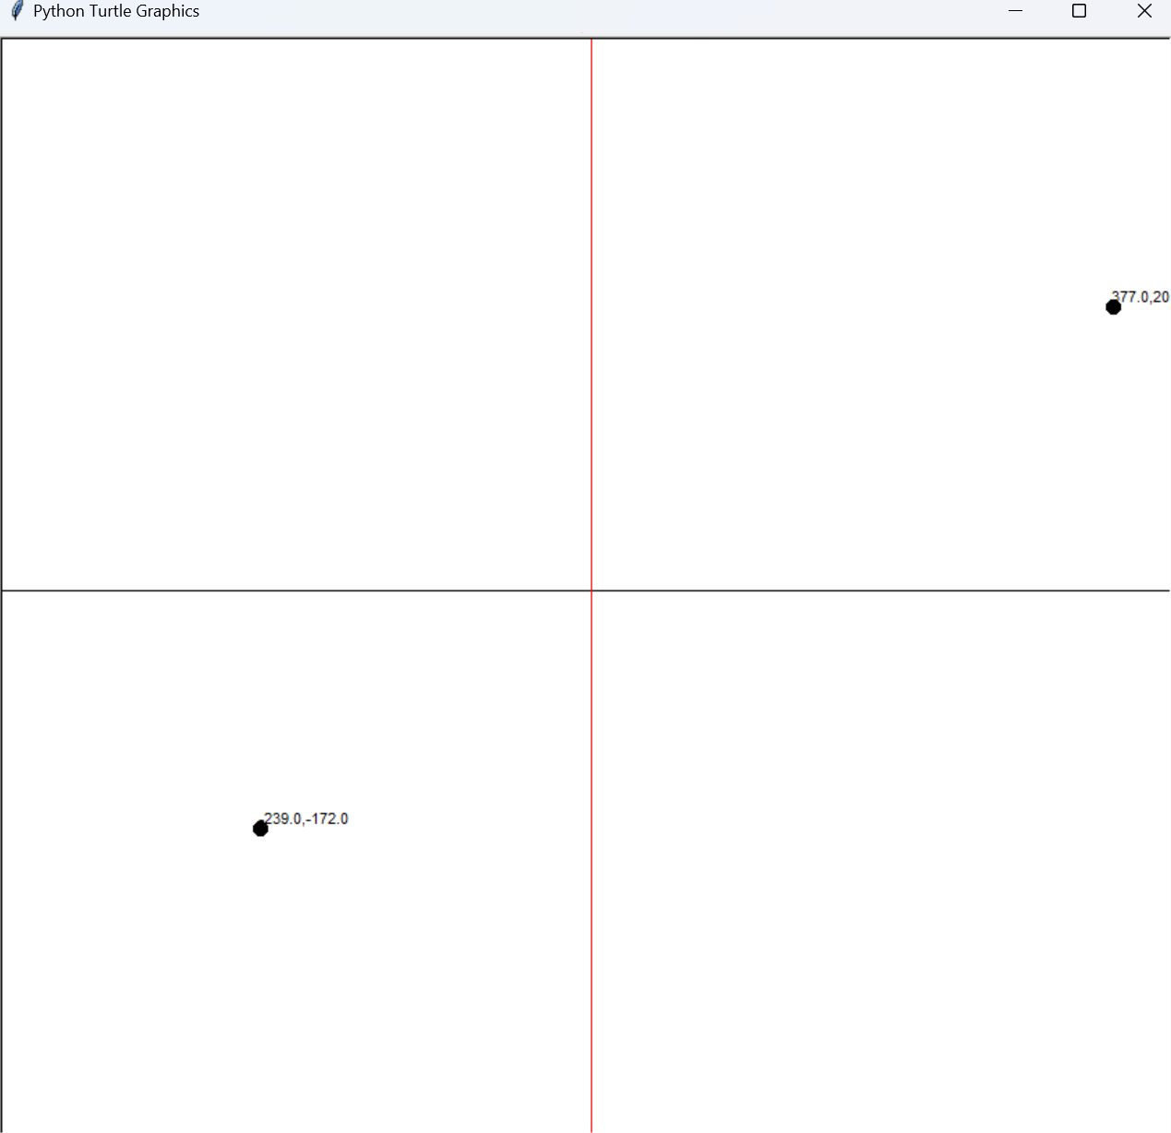
This with 1000000 passes estimated these coefficients which relates to y = -4.267E+03 X + 7.1966E-1. Which results in the red line which is visibly wrong. This is due to the backpropagation algorithm being wrong.
I then spent 5 days redoing it 5 times and ended up with this algorithm

Code:
import numpy as np
from tqdm import tqdm
from time import sleep
import random
import turtle

class Network:
def __init__(self, data, passes, learnRate):
self.data = data
self.dataXs = []
self.dataX = np.zeros(len(self.data))
self.dataY = np.zeros(len(self.data))
self.coef = np.random.randn(len(self.data))

self.passes = passes
for i in range(len(self.data)):
self.dataX = np.zeros(len(self.data))
self.dataX.put(0, 1)
for j in range(1, len(self.data)):
self.dataX.put(j, self.data[i][0]**j)
self.dataXs.append(self.dataX)
self.dataY.put(i, self.data[i][1])
self.passes = passes
self.learnRate = learnRate

def train(self):
self.losses = np.zeros(self.passes)
self.iteration = np.zeros(self.passes)
for i in tqdm(range(self.passes)):
self.grad = np.zeros(len(self.data))
self.deltaYHat = np.zeros(len(self.data))
self.dataYHat = np.zeros(len(self.data))
self.lossVector = np.zeros(len(self.data))
self.forwardPass()
self.backPass()
self.tweak()
self.losses.put(i, self.loss*1000)
self.iteration.put(i, i)

def forwardPass(self):
for i in range(len(self.data)):
self.dataYHat.put(i, np.dot(self.dataXs[i],self.coef))
self.deltaYHat.put(i, self.dataYHat[i]-self.dataY[i])
self.lossVector.put(i, self.deltaYHat[i]**2)
self.loss = np.sum(self.lossVector)

def backPass(self):
for i in range(len(self.data)):
yVector = np.zeros(len(self.data))
for j in range(len(self.data)):
yVector.put(j, self.deltaYHat[i])
self.grad += 2*yVector*self.dataXs[i]

def tweak(self):
self.coef = self.coef - self.learnRate * self.grad

Testing:
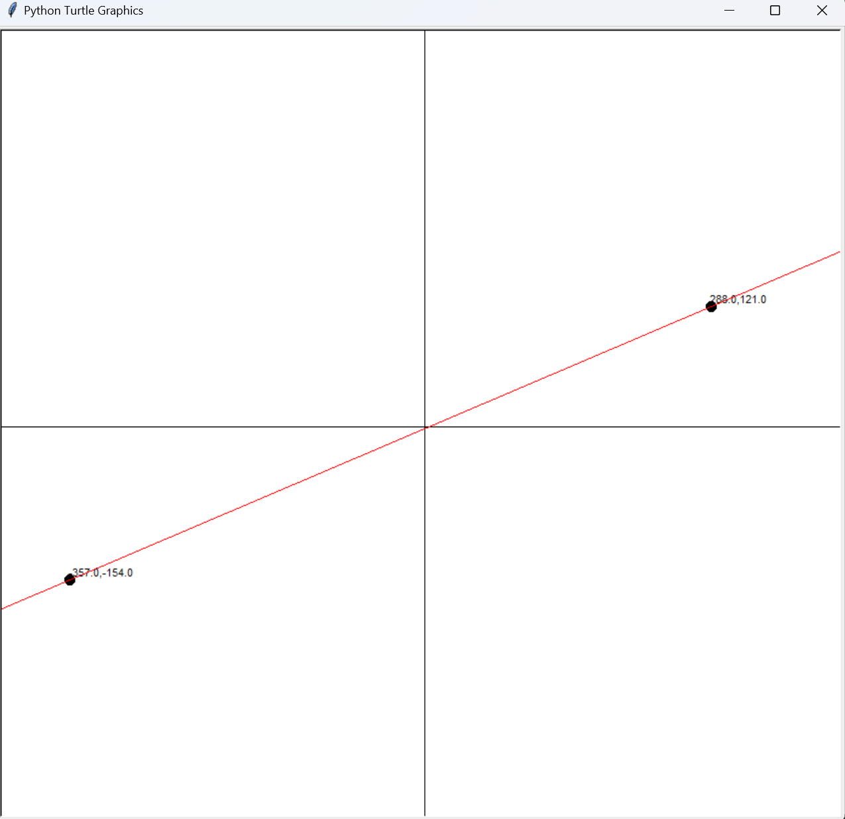
This leads to this results which is very good for 2 points
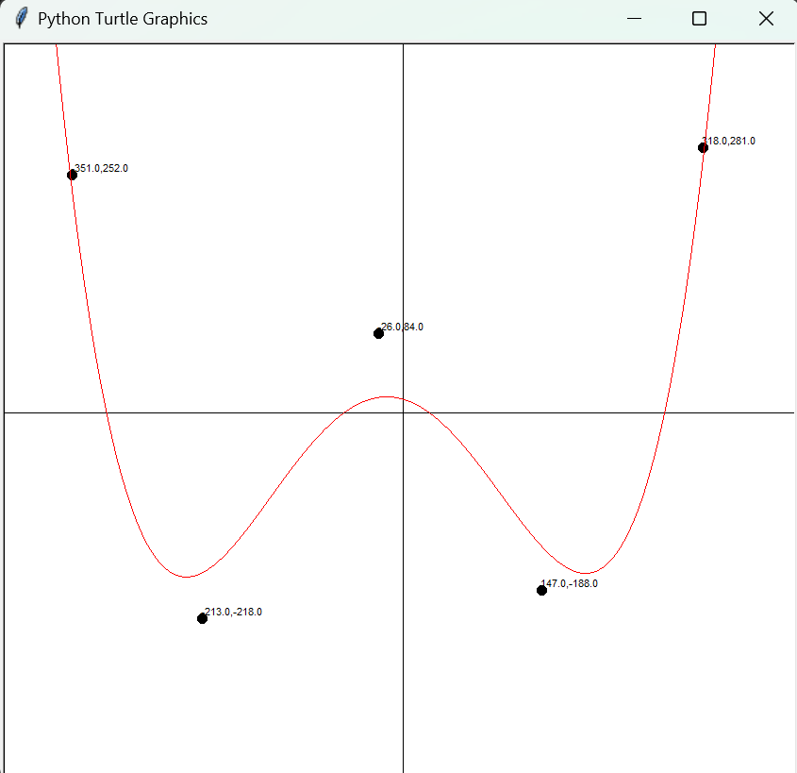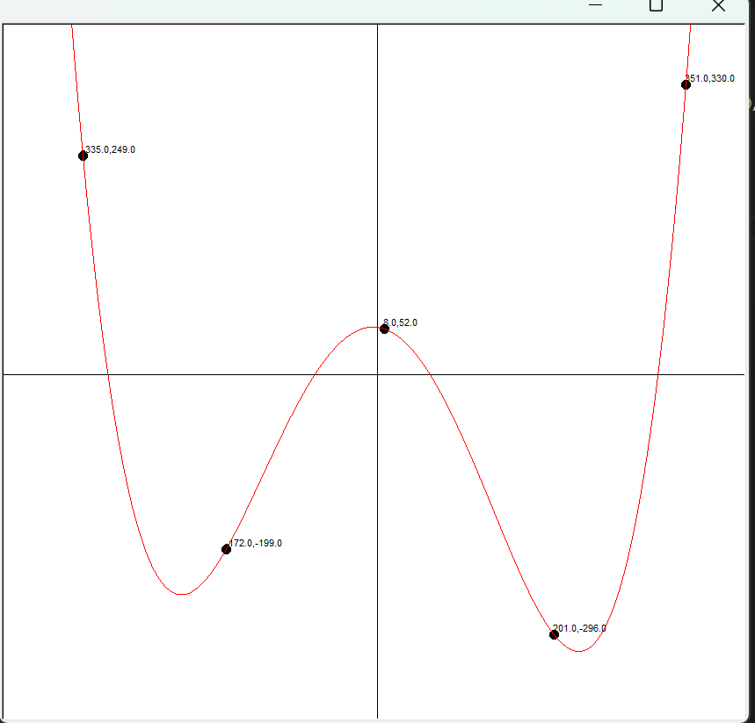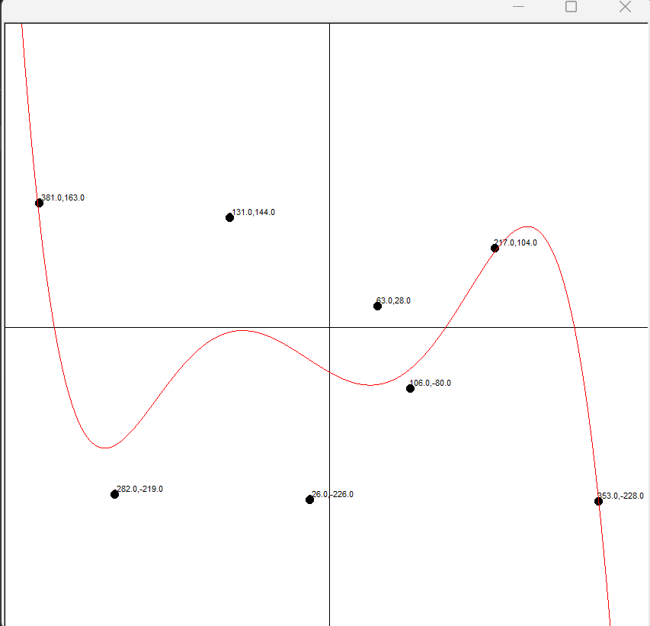
As shown above with a higher number of points results tend to vary a lot more, but the curve still roughly matches to the curves. This issue can be solved by running more iterations allowing it longer to train and find better values which more accurately fit the data.

Project 2 – Genetic algorithm
Goal: To get a population of agents to navigate an environment which contains obstacles. The agent should not need any prior knowledge of the environment, such as position of obstacles or position of end goal. They should also move by taking steps in any direction with no confinement to direction and how big the step is.

Design: This objective can be achieved by creating a population of agents, dots in this scenario, with a series of forces in an array which is the substitute for a brain. Each frame the agent will apply the next force in brain. To train the agents faster the fitness function, a solid definition for how “good” each agent is, is important. The fitness functions I designed is as follows. If the agent does not make it to the end goal its fitness is $\frac{1}{{\left|distance to end goal\right|}^{2}}$ , if they do make it to the end goal there fitness is equal to $1+\frac{10000}{{number of steps}^{2}}$ , this makes sure that if an agent reaches the goal it has a much higher chance of being bread to make the next generation. This ensures that good genes (moves) are passed on, so the population increases over generations. It is also important to not always choose just the agent with the lowest fitness as there can sometimes be other methods which are eventually faster but need more time to develop. Another important factor is to always keep the champion, the best performing agent, of the previous generation this stops the population regressing and unlearning moves.
Code:
Brain
import numpy as np
from random import random, uniform
import math

class Brain:
def __init__(self, size):
self.size = size
self.directions = []

self.step = 0
self.randomize()

def randomize(self):
for i in range(0, self.size):
self.randAng= uniform(0,2*math.pi)
self.direction = []
self.direction.append(math.cos(self.randAng))
self.direction.append(math.sin(self.randAng))
self.directions.append(self.direction.copy())

def clone(self):
self.clone = Brain(self.size)
self.clone.directions = self.directions
return self.clone

def mutate(self, change):
self.mutationRate = 0.03
for i in range(0,self.size):
self.rand = uniform(0,1)
if self.rand < self.mutationRate:
self.randAng= uniform(0,2*math.pi)
self.direction = []
self.direction.append(math.cos(self.randAng))
self.direction.append(math.sin(self.randAng))
self.directions[i] = self.direction.copy()

Agent Script

import pyglet as pg
import numpy as np
import brain
import math
from random import uniform

class Dots:
def __init__(self, width, height, startPos, goal, maxSteps, walls):
self.width = width
self.height = height
self.pos = np.copy(startPos)
self.vel = np.zeros(2)
self.acc = np.zeros(2)
self.maxSteps = maxSteps

self.sprite = pg.shapes.Circle(self.pos[0], self.pos[1], 2, color=(255,255,255))
self.brain = brain.Brain(self.maxSteps)

self.reachedGoal = False
self.dead = False
self.hitWall = False

self.goal = goal

self.fitness = 0

self.walls = walls

def calcFitness(self):
if self.reachedGoal == True:
self.fitness = 1+(10000/self.brain.step**2)
else:
self.distanceToGoal = math.sqrt((self.goal[0]-self.pos[0])**2 + (self.goal[1]-self.pos[1])**2)
self.fitness = 1/(self.distanceToGoal)

def move(self):
if len(self.brain.directions) >self.brain.step:
self.acc = self.direction = np.asarray(self.brain.directions[self.brain.step])
self.brain.step += 1
self.vel += self.acc
else:
self.vel = 0
self.mag = np.linalg.norm(self.vel)
if self.mag > 5:
for i in range(0, len(self.vel)):
self.vel[i] = self.vel[i]/(self.mag/5)
self.pos += self.vel
self.sprite.x = self.pos[0]
self.sprite.y = self.pos[1]

def update(self):
if (self.pos[0] < 2 or self.pos[1] < 2 or self.pos[0] > self.width-2 or self.pos[1] > self.height-2):
self.dead = True
elif math.sqrt((self.goal[0]-self.pos[0])**2 + (self.goal[1]-self.pos[1])**2) < 5:
self.reachedGoal = True
elif len(self.brain.directions) <= self.brain.step:
self.dead = True
for i in self.walls:
if i.checkCollision(self.pos[0], self.pos[1]):
self.dead = True
self.hitWall = True
break
if self.dead != True and self.reachedGoal != True:
self.move()

self.sprite.draw()

def breed(self):
self.babyBrain = brain.Brain(self.maxSteps)
for i in range(0, len(self.brain.directions)):
self.babyBrain.directions[i] = self.brain.directions[i]
return self.babyBrain

def setBestDot(self):
self.sprite.color = (255,255,0)
self.sprite.radius = 6

Population control script
from Dots import Dots
from random import random, uniform
import numpy as np

class Population:
def __init__(self, size, width, height, startPos,goal, max,change, walls):
self.size = size
self.width = width
self.height = height
self.goal = goal
self.startPos = np.copy(startPos)
self.dotArray = []
self.gen = 0
self.maxSteps = max
self.change = change
self.minStep=10000
self.walls = walls
self.timesNoDotMadeIt = 0
for i in range(0, self.size):
self.dotArray.append(Dots(width, height, self.startPos, goal, self.maxSteps, self.walls))

def updateDots(self):
for i in range(0, len(self.dotArray)):
if self.dotArray[i].brain.step > self.minStep:
self.dotArray[i].dead = True
else:
self.dotArray[i].update()

def allDead(self):
for i in range(0, len(self.dotArray)):
if self.dotArray[i].dead == False and self.dotArray[i].reachedGoal == False:
return False
return True

def clacFitness(self):
for i in range(0, len(self.dotArray)):
self.dotArray[i].calcFitness()
if self.gen > 50 and self.dotArray[i].hitWall:
self.dotArray[i].fitness = self.dotArray[i].fitness/5

def naturalSelection(self):
self.calcFitnessSum()
self.newBrainArray = []

self.gen += 1

for i in range(0, len(self.dotArray)-1):

#select parent
self.parent = self.selectParent()

#make baby
self.newBrainArray.append(self.parent.breed())

self.getBestDot()
self.newBrainArray.append(self.bestDot.breed())

if self.numberOfDotsMakingit() > 0:
self.timesNoDotMadeIt = 0
else:
if self.gen > 50:
if self.numberOfDotsMakingit() == 0:
self.timesNoDotMadeIt += 1
if self.timesNoDotMadeIt > 5:
self.maxSteps += 5
self.dotArray = []
for i in range(0, self.size):
self.dotArray.append(Dots(self.width, self.height, self.startPos, self.goal, self.maxSteps, self.walls))
self.dotArray[i].brain = self.newBrainArray[i]
self.dotArray[self.size-1].setBestDot()

def calcFitnessSum(self):
self.totalFitness = 0
for i in range(0, len(self.dotArray)):
self.totalFitness += self.dotArray[i].fitness * 100

def selectParent(self):
randomChoice = uniform(0, self.totalFitness)

runningSum = 0
for i in range(0, len(self.dotArray)):
runningSum += self.dotArray[i].fitness*100
if runningSum > randomChoice:
return self.dotArray[i]

def mutateDemBabies(self):
for i in range(0, len(self.dotArray)-1):
self.dotArray[i].brain.mutate(self.change)

def getBestDot(self):
max = 0
maxIndex = 0
for i in range(0, len(self.dotArray)):
currentDot = self.dotArray[i]
if self.dotArray[i].fitness > max:
max = self.dotArray[i].fitness
maxIndex = i

self.bestDot = self.dotArray[maxIndex]

if self.bestDot.reachedGoal == True:
self.minStep = self.bestDot.brain.step

def numberOfDotsMakingit(self):
numberMadeIt = 0
for i in range(0, len(self.dotArray)):
if self.dotArray[i].reachedGoal:
numberMadeIt += 1
return numberMadeIt

Testing:
In the first test the dots never actually made it. This is due to the dots having to move too far around the second wall and thus further away from the goal thus giving them a lower fitness. This is an inherit issue with the algorithm, if the path a single dot has to take is too long and too estrange from the path the probability of it being taken is so low that it will never happen. This can be solved by adding points where if the dots make it there they gain an extra reward. This will allow the user to assist the ai to find a path or the path that the user wants the ai to take.
In the second training the ai makes it with out too much difficulty. It did need extra steps originally to reach the goal, which is more beneficial as it knows where to go and then optimises the route which is faster for the ai to do.

Project 3 – Reinforcement Learning using Q learning
Goal: To train an agent to navigate an environment based on a punishment reward system.

Design: The environment will be a grid in which the agent can move up down left or right in. This environment will contain obstacles which reset the agent on collision, a start points which will always be top left and a goal which is always bottom right. A table of all possible states and all possible actions from each state must be stored with a value determining how good that action from that state is. This table will have all values initially set to 0. The reward for each action will be as follows, moving to a blank square yields a reward of -10, to encourage the agent to get to the goal faster. Hitting an obstacle will yield a reward of -1000 to heavily discourage hitting an obstacle. Then reaching the goal yields a reward of 10000. The agent will make a decision on the action by using the epsilon-greedy policy, which is at the start all the decisions made are random but as time goes on the agent will pick more of the highest valued action until it always picks the best action which should lead it to the goal. The way it calculates the value for the action in that state uses Q Learning formula. This is done by taking the previous value for that action and adding, the reward of taking that action + the maximum action from the previous state multiplied by the discount factor and subtracted by the action just taken all multiplied by the learning rate. After enough actions the agent will update the table with values that if followed will lead the agent to the goal.

Code:
Main:
import pyglet as pg
from pyglet.window import key, mouse
import cell, agent, random
from time import sleep
import Training

# Create a window
window = pg.window.Window(width = 1040, height = 1040)

maze = ["WWWWWWWWWWWWWWWWWWWW",
"W W",
"W W",
"W W",
"W W",
"W W",
"W W",
"W W",
"W W",
"W W",
"W W",
"W W",
"W W",
"W W",
"W W",
"W W",
"W W",
"W W",
"W GW",
"WWWWWWWWWWWWWWWWWWWW",]

tileArray=[]
for i in range(0,len(maze)):
for j in range(0,len(maze[i])):
tileArray.append(cell.cell(maze[i][j],j,i))

start = False
@window.event
def on_mouse_press(x, y, button, modifiers):
xCoord = int(x//52)
yCoord = int((1040-y)//52)
if maze[yCoord][xCoord] != "W" and maze[yCoord][xCoord] != "G" and start == False:
if button == mouse.LEFT:
s = list(maze[yCoord])
s[xCoord] = "O"
maze[yCoord] = "".join(s)

tileArray[yCoord*20 + xCoord] = cell.cell("O", xCoord, yCoord)
elif button == mouse.RIGHT:
s = list(maze[yCoord])
s[xCoord] = " "
maze[yCoord] = "".join(s)

tileArray[yCoord*20 + xCoord] = cell.cell(" ", xCoord, yCoord)
elif button == mouse.MIDDLE:
s = list(maze[yCoord])
s[xCoord] = "S"
maze[yCoord] = "".join(s)

tileArray[yCoord*20 + xCoord] = cell.cell("S", xCoord, yCoord)

#lermin = agent.Agent(grid=maze)
lermins = []
for i in range(0,250):
lermins.append(agent.Agent(grid=maze))

QLearn = Training.train(10000, tileArray)

@window.event
def on_key_press(symbol, modifiers):
global start
if symbol == key.Q:
QLearn.printQTable()
elif symbol == key.ENTER:
start = True

def draw(dt):
window.clear()
for i in tileArray:
i.update()
if start:
for i in range(0,len(lermins)):
action = 0
action = QLearn.chooseAction(lermins[i].getPos())
if action == 1:
lermins[i].moveRight()
elif action == 2:
lermins[i].moveLeft()
elif action == 3:
lermins[i].moveUp()
elif action == 4:
lermins[i].moveDown()
elif action > 4:
print("shit")
if action != -1:
QLearn.updateQTable(lermins[i].getPos())
else:
lermins[i].setPos(1,1)
QLearn.nextEpisode()
if tileArray[lermins[i].getPos()].cellType == "G":
lermins[i].setPos(1,1)
elif tileArray[lermins[i].getPos()].cellType == "O":
lermins[i].setPos(1,1)
lermins[i].update()

pg.clock.schedule_interval(draw, 1/1200)
pg.app.run()

Training:
import numpy as np
import random

class train:
def __init__(self, maxEpochs, tileArray):
self.states = 324
self.actions = 4
self.goalState = 324
self.QTable = np.zeros((self.states,self.actions))

self.discount = 0.95
self.learnRate = 0.85

self.maxExplorationProb = 1
self.minExplorationProb = 0.00
self.decayFactor = 0.01

self.maxEpochs = maxEpochs
self.epoch = 0
self.episode = 0
self.steps = 0

self.tileArray = tileArray

def printQTable(self):
print(self.QTable)

def nextEpisode(self):
self.episode +=1

#print(self.episode,"-",self.steps)
self.steps=0

def chooseAction(self, playerPos):
self.action = 0
self.prevPlayerPos = playerPos
self.gridPos = []
self.gridPos.append(playerPos%20)
self.gridPos.append(playerPos//20)
self.currentState = self.gridPos[0]-1 + (self.gridPos[1]-1) * 18
explorationProb = self.minExplorationProb + (self.maxExplorationProb - self.minExplorationProb)* np.exp(-self.decayFactor*self.episode)
self.steps += 1
if random.uniform(0,1) < explorationProb:
self.action = random.randint(1,self.actions)
else:
self.action = np.argmax(self.QTable[self.currentState])+1
if self.steps > 256:
self.action = -1
return self.action

def updateQTable(self, playerPos):
self.prevPos = self.currentState
self.gridPos = []
self.gridPos.append(playerPos%20)
self.gridPos.append(playerPos//20)
self.currentState = self.gridPos[0]-1 + (self.gridPos[1]-1) * 18
if self.tileArray[playerPos].cellType == "G":
self.reward = 100000
self.nextEpisode()
elif self.tileArray[playerPos].cellType == " ":
self.reward = -10
elif self.tileArray[playerPos].cellType == "S":
self.reward = 4
elif self.tileArray[playerPos].cellType == "O":
self.reward = -1000
self.nextEpisode()
else:
self.reward = 0
print("whoops")
self.QTable[self.prevPos][self.action-1] = self.QTable[self.prevPos][self.action-1] + \
self.learnRate * (self.reward + self.discount * np.max(self.QTable[self.currentState]) - self.QTable[self.prevPos][self.action-1])
self.tileArray[self.prevPlayerPos].weight = np.average(self.QTable[self.prevPos])

Testing:
In the first training session, there are 10 ais all training a hive mind to learn the environment faster and thus they find a path faster. However, this quite slow and is sped up but 5 times in the footage.
In the next training I added 190 ai so there are now 200 and they can learn the area much faster and thus find an optimal route faster. However, in this example it doesn’t find and optimal route as the small chance that it never travels along that route. This could be done by adjusting the hyperparameter so that the chance it takes a random route is increased and thus it will explore routes like that and thus will always find the optimal path
In the next example it is the same setup, but it does find the optimal path
In the final example I added obstacles in which the ai also must avoid. If the ai hits a spike it is reset. With 200 ai all working together they can really easily find the path to the goal. It learns that hitting the spike is bad and thus tends to do that less and follows the path that will always lead it to the goal

