ROBERT STARCK

Extra Projects
https://github.com/GreenFrog-Hub?tab=repositories
Project 1 – Neural Network training using backpropagation
Goal:
To design and code a program which can take a set of points and plot a line of degree one less than the number of points. So, for 4 points a cubic of form $ax^{3}+bx^{2}+cx+d=0$ will be plotted to the points. The goal is to get this line as close as possible to all the points.

Design:
The only method to achieve this result and calculate suitable coefficients is to guess, many times, and calculate how wrong you are. The method of improving this is by making an initial guess and calculating how wrong you are, then based on how wrong you are, then calculating how to tweak each of the coefficients to get closer to the desired function.
This can be accomplished using a neural network and then backpropagating to find out how to tweak each coefficient to get closer to the solution.
The neural networks will take all the coefficients and data point coordinates as inputs. This network will then output the total loss, the sum of the squared difference from the curve to the data points.

Code:
import numpy as np
from tqdm import tqdm
from time import sleep
import random

class Network:
def __init__(self, data, passes, learnRate):
self.data = data
self.dataX = np.zeros(len(self.data))
self.dataY = np.zeros(len(self.data))
self.coef = np.random.randint(-300,300,len(data))
#self.coef = np.random.randn(2)
#self.coef[0] = random.randint(-600,600)

self.passes = passes
for i in range(len(self.data)):
self.dataX.put(i, self.data[i][0])
self.dataY.put(i, self.data[i][1])
self.passes = passes
self.learnRate = learnRate

self.graph = []

def train(self):
self.losses = []
self.deltaLoss = 5
self.prevLoss = 0
for i in tqdm(range(self.passes)):
self.grad = np.zeros(len(self.data))
self.delatY = np.zeros(len(self.data))
self.dataYHat = np.zeros(len(self.data))
self.forwardPass()
self.backPass()
self.tweak()
self.deltaLoss = self.totalLoss - self.prevLoss
self.prevLoss = self.totalLoss
# self.MinLoss = self.totalLoss
# if self.deltaLoss > 10000:
# self.exitCondition = 1
# else:
# self.exitCondition = 0

def forwardPass(self):
for i in range(len(self.dataX)):
self.yHat = np.dot(self.coef, self.dataX[i])
self.dataYHat.put(i, self.yHat)
self.delatY = self.dataYHat- self.dataY
self.totalLoss = np.sum(self.delatY**2)

def backPass(self):
self.grad = 2*self.delatY * self.dataX

def tweak(self):
mag = np.linalg.norm(self.grad)
self.coef = self.coef - self.learnRate *self.grad

Testing:
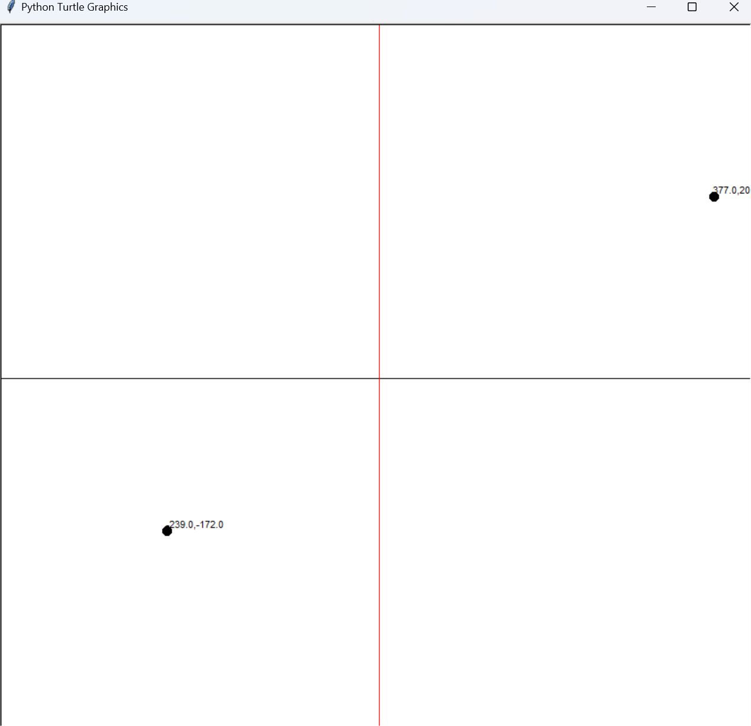
This with 1000000 passes estimated these coefficients which relates to y = -4.267E+03 X + 7.1966E-1. Which results in the red line which is visibly wrong. This is due to the backpropagation algorithm being wrong.
I then spent 5 days redoing it 5 times and ended up with this algorithm

Code:
import numpy as np
from tqdm import tqdm
from time import sleep
import random
import turtle

class Network:
def __init__(self, data, passes, learnRate):
self.data = data
self.dataXs = []
self.dataX = np.zeros(len(self.data))
self.dataY = np.zeros(len(self.data))
self.coef = np.random.randn(len(self.data))

self.passes = passes
for i in range(len(self.data)):
self.dataX = np.zeros(len(self.data))
self.dataX.put(0, 1)
for j in range(1, len(self.data)):
self.dataX.put(j, self.data[i][0]**j)
self.dataXs.append(self.dataX)
self.dataY.put(i, self.data[i][1])
self.passes = passes
self.learnRate = learnRate

def train(self):
self.losses = np.zeros(self.passes)
self.iteration = np.zeros(self.passes)
for i in tqdm(range(self.passes)):
self.grad = np.zeros(len(self.data))
self.deltaYHat = np.zeros(len(self.data))
self.dataYHat = np.zeros(len(self.data))
self.lossVector = np.zeros(len(self.data))
self.forwardPass()
self.backPass()
self.tweak()
self.losses.put(i, self.loss*1000)
self.iteration.put(i, i)

def forwardPass(self):
for i in range(len(self.data)):
self.dataYHat.put(i, np.dot(self.dataXs[i],self.coef))
self.deltaYHat.put(i, self.dataYHat[i]-self.dataY[i])
self.lossVector.put(i, self.deltaYHat[i]**2)
self.loss = np.sum(self.lossVector)

def backPass(self):
for i in range(len(self.data)):
yVector = np.zeros(len(self.data))
for j in range(len(self.data)):
yVector.put(j, self.deltaYHat[i])
self.grad += 2*yVector*self.dataXs[i]

def tweak(self):
self.coef = self.coef - self.learnRate * self.grad

Testing:
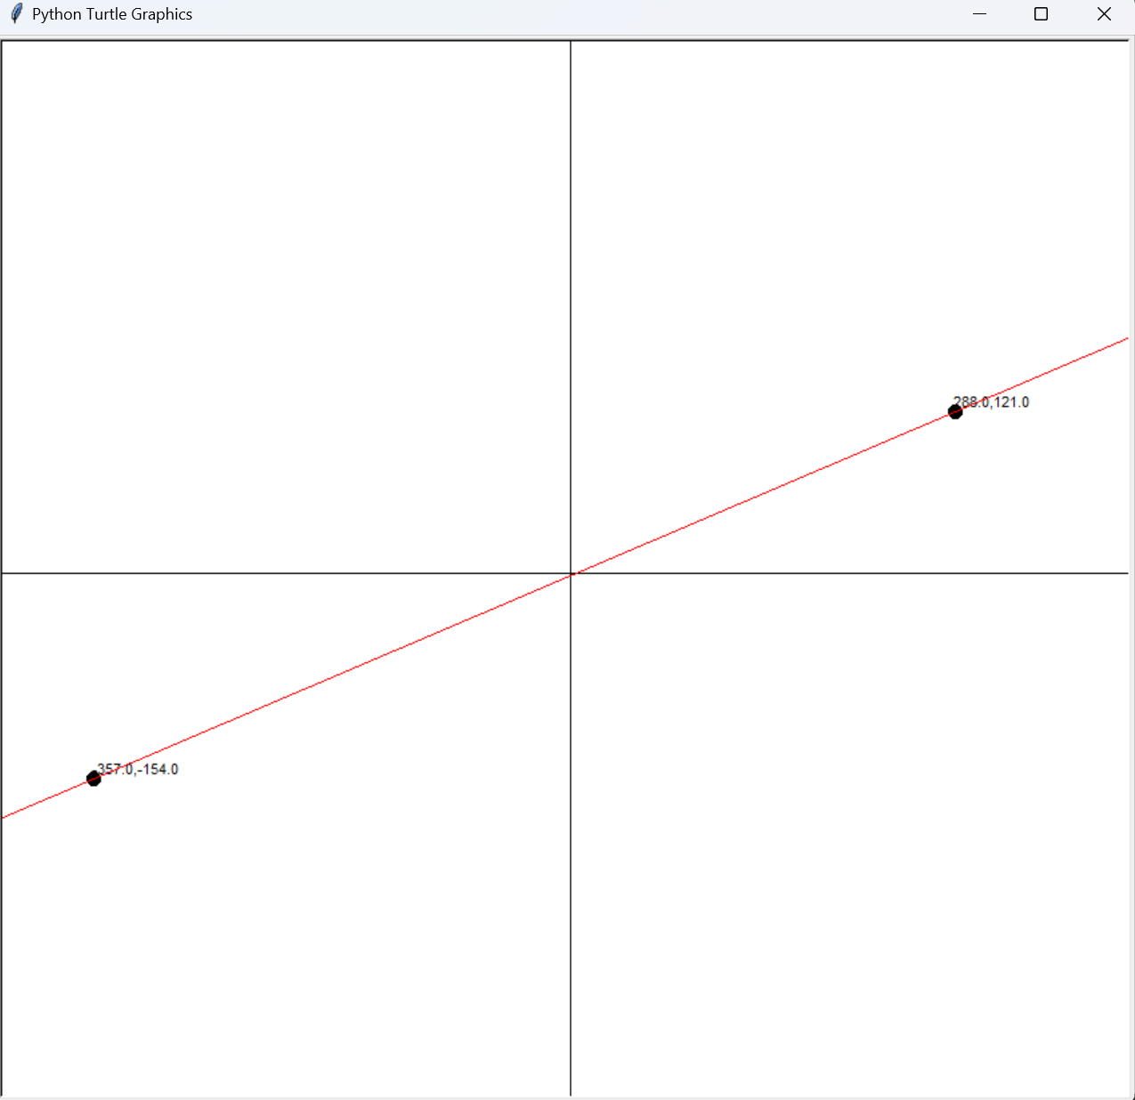
This leads to this results which is very good for 2 points
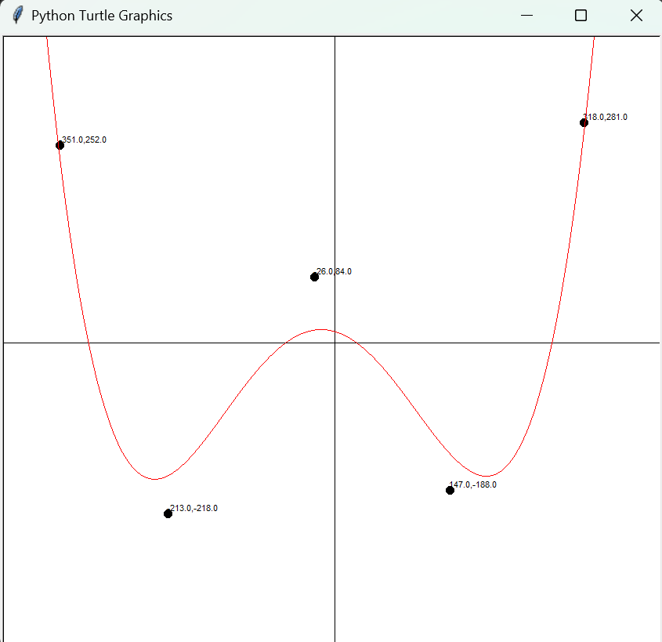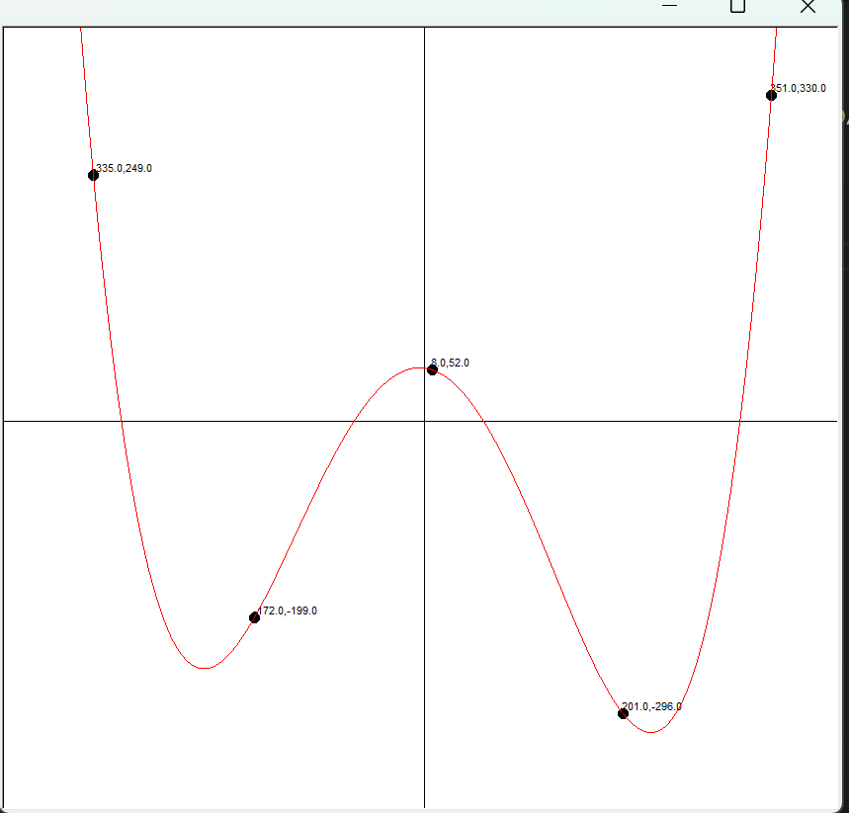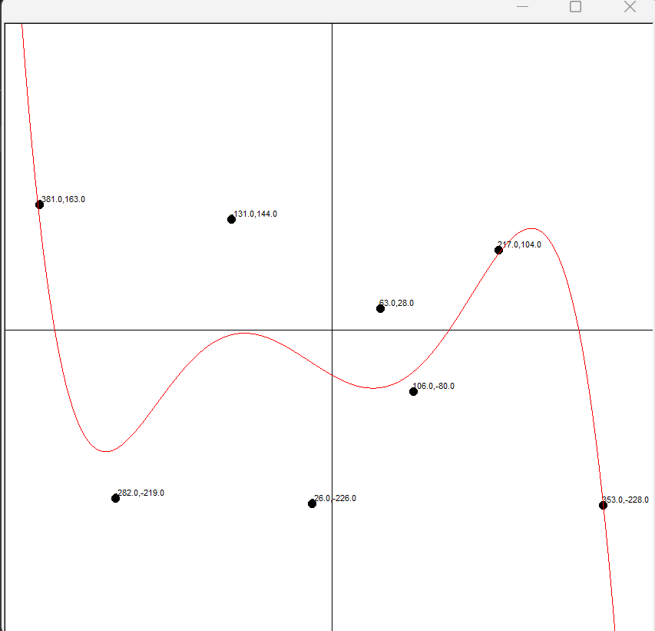
As shown above with a higher number of points results tend to vary a lot more, but the curve still roughly matches to the curves. This issue can be solved by running more iterations allowing it longer to train and find better values which more accurately fit the data.

Project 2 – Genetic algorithm
Goal: To get a population of agents to navigate an environment which contains obstacles. The agent should not need any prior knowledge of the environment, such as position of obstacles or position of end goal. They should also move by taking steps in any direction with no confinement to direction and how big the step is.

Design: This objective can be achieved by creating a population of agents, dots in this scenario, with a series of forces in an array which is the substitute for a brain. Each frame the agent will apply the next force in brain. To train the agents faster the fitness function, a solid definition for how “good” each agent is, is important. The fitness functions I designed is as follows. If the agent does not make it to the end goal its fitness is $\frac{1}{{\left|distance to end goal\right|}^{2}}$ , if they do make it to the end goal there fitness is equal to $1+\frac{10000}{{number of steps}^{2}}$ , this makes sure that if an agent reaches the goal it has a much higher chance of being bread to make the next generation. This ensures that good genes (moves) are passed on, so the population increases over generations. It is also important to not always choose just the agent with the lowest fitness as there can sometimes be other methods which are eventually faster but need more time to develop. Another important factor is to always keep the champion, the best performing agent, of the previous generation this stops the population regressing and unlearning moves.
Code:
Brain
import numpy as np
from random import random, uniform
import math

class Brain:
def __init__(self, size):
self.size = size
self.directions = []

self.step = 0
self.randomize()

def randomize(self):
for i in range(0, self.size):
self.randAng= uniform(0,2*math.pi)
self.direction = []
self.direction.append(math.cos(self.randAng))
self.direction.append(math.sin(self.randAng))
self.directions.append(self.direction.copy())

def clone(self):
self.clone = Brain(self.size)
self.clone.directions = self.directions
return self.clone

def mutate(self, change):
self.mutationRate = 0.03
for i in range(0,self.size):
self.rand = uniform(0,1)
if self.rand < self.mutationRate:
self.randAng= uniform(0,2*math.pi)
self.direction = []
self.direction.append(math.cos(self.randAng))
self.direction.append(math.sin(self.randAng))
self.directions[i] = self.direction.copy()

Agent Script

import pyglet as pg
import numpy as np
import brain
import math
from random import uniform

class Dots:
def __init__(self, width, height, startPos, goal, maxSteps, walls):
self.width = width
self.height = height
self.pos = np.copy(startPos)
self.vel = np.zeros(2)
self.acc = np.zeros(2)
self.maxSteps = maxSteps

self.sprite = pg.shapes.Circle(self.pos[0], self.pos[1], 2, color=(255,255,255))
self.brain = brain.Brain(self.maxSteps)

self.reachedGoal = False
self.dead = False
self.hitWall = False

self.goal = goal

self.fitness = 0

self.walls = walls

def calcFitness(self):
if self.reachedGoal == True:
self.fitness = 1+(10000/self.brain.step**2)
else:
self.distanceToGoal = math.sqrt((self.goal[0]-self.pos[0])**2 + (self.goal[1]-self.pos[1])**2)
self.fitness = 1/(self.distanceToGoal)

def move(self):
if len(self.brain.directions) >self.brain.step:
self.acc = self.direction = np.asarray(self.brain.directions[self.brain.step])
self.brain.step += 1
self.vel += self.acc
else:
self.vel = 0
self.mag = np.linalg.norm(self.vel)
if self.mag > 5:
for i in range(0, len(self.vel)):
self.vel[i] = self.vel[i]/(self.mag/5)
self.pos += self.vel
self.sprite.x = self.pos[0]
self.sprite.y = self.pos[1]

def update(self):
if (self.pos[0] < 2 or self.pos[1] < 2 or self.pos[0] > self.width-2 or self.pos[1] > self.height-2):
self.dead = True
elif math.sqrt((self.goal[0]-self.pos[0])**2 + (self.goal[1]-self.pos[1])**2) < 5:
self.reachedGoal = True
elif len(self.brain.directions) <= self.brain.step:
self.dead = True
for i in self.walls:
if i.checkCollision(self.pos[0], self.pos[1]):
self.dead = True
self.hitWall = True
break
if self.dead != True and self.reachedGoal != True:
self.move()

self.sprite.draw()

def breed(self):
self.babyBrain = brain.Brain(self.maxSteps)
for i in range(0, len(self.brain.directions)):
self.babyBrain.directions[i] = self.brain.directions[i]
return self.babyBrain

def setBestDot(self):
self.sprite.color = (255,255,0)
self.sprite.radius = 6

Population control script
from Dots import Dots
from random import random, uniform
import numpy as np

class Population:
def __init__(self, size, width, height, startPos,goal, max,change, walls):
self.size = size
self.width = width
self.height = height
self.goal = goal
self.startPos = np.copy(startPos)
self.dotArray = []
self.gen = 0
self.maxSteps = max
self.change = change
self.minStep=10000
self.walls = walls
self.timesNoDotMadeIt = 0
for i in range(0, self.size):
self.dotArray.append(Dots(width, height, self.startPos, goal, self.maxSteps, self.walls))

def updateDots(self):
for i in range(0, len(self.dotArray)):
if self.dotArray[i].brain.step > self.minStep:
self.dotArray[i].dead = True
else:
self.dotArray[i].update()

def allDead(self):
for i in range(0, len(self.dotArray)):
if self.dotArray[i].dead == False and self.dotArray[i].reachedGoal == False:
return False
return True

def clacFitness(self):
for i in range(0, len(self.dotArray)):
self.dotArray[i].calcFitness()
if self.gen > 50 and self.dotArray[i].hitWall:
self.dotArray[i].fitness = self.dotArray[i].fitness/5

def naturalSelection(self):
self.calcFitnessSum()
self.newBrainArray = []

self.gen += 1

for i in range(0, len(self.dotArray)-1):

#select parent
self.parent = self.selectParent()

#make baby
self.newBrainArray.append(self.parent.breed())

self.getBestDot()
self.newBrainArray.append(self.bestDot.breed())

if self.numberOfDotsMakingit() > 0:
self.timesNoDotMadeIt = 0
else:
if self.gen > 50:
if self.numberOfDotsMakingit() == 0:
self.timesNoDotMadeIt += 1
if self.timesNoDotMadeIt > 5:
self.maxSteps += 5
self.dotArray = []
for i in range(0, self.size):
self.dotArray.append(Dots(self.width, self.height, self.startPos, self.goal, self.maxSteps, self.walls))
self.dotArray[i].brain = self.newBrainArray[i]
self.dotArray[self.size-1].setBestDot()

def calcFitnessSum(self):
self.totalFitness = 0
for i in range(0, len(self.dotArray)):
self.totalFitness += self.dotArray[i].fitness * 100

def selectParent(self):
randomChoice = uniform(0, self.totalFitness)

runningSum = 0
for i in range(0, len(self.dotArray)):
runningSum += self.dotArray[i].fitness*100
if runningSum > randomChoice:
return self.dotArray[i]

def mutateDemBabies(self):
for i in range(0, len(self.dotArray)-1):
self.dotArray[i].brain.mutate(self.change)

def getBestDot(self):
max = 0
maxIndex = 0
for i in range(0, len(self.dotArray)):
currentDot = self.dotArray[i]
if self.dotArray[i].fitness > max:
max = self.dotArray[i].fitness
maxIndex = i

self.bestDot = self.dotArray[maxIndex]

if self.bestDot.reachedGoal == True:
self.minStep = self.bestDot.brain.step

def numberOfDotsMakingit(self):
numberMadeIt = 0
for i in range(0, len(self.dotArray)):
if self.dotArray[i].reachedGoal:
numberMadeIt += 1
return numberMadeIt

Testing:
In the first test the dots never actually made it. This is due to the dots having to move too far around the second wall and thus further away from the goal thus giving them a lower fitness. This is an inherit issue with the algorithm, if the path a single dot has to take is too long and too estrange from the path the probability of it being taken is so low that it will never happen. This can be solved by adding points where if the dots make it there they gain an extra reward. This will allow the user to assist the ai to find a path or the path that the user wants the ai to take.
In the second training the ai makes it with out too much difficulty. It did need extra steps originally to reach the goal, which is more beneficial as it knows where to go and then optimises the route which is faster for the ai to do.

Project 3 – Reinforcement Learning using Q learning
Goal: To train an agent to navigate an environment based on a punishment reward system.

Design: The environment will be a grid in which the agent can move up down left or right in. This environment will contain obstacles which reset the agent on collision, a start points which will always be top left and a goal which is always bottom right. A table of all possible states and all possible actions from each state must be stored with a value determining how good that action from that state is. This table will have all values initially set to 0. The reward for each action will be as follows, moving to a blank square yields a reward of -10, to encourage the agent to get to the goal faster. Hitting an obstacle will yield a reward of -1000 to heavily discourage hitting an obstacle. Then reaching the goal yields a reward of 10000. The agent will make a decision on the action by using the epsilon-greedy policy, which is at the start all the decisions made are random but as time goes on the agent will pick more of the highest valued action until it always picks the best action which should lead it to the goal. The way it calculates the value for the action in that state uses Q Learning formula. This is done by taking the previous value for that action and adding, the reward of taking that action + the maximum action from the previous state multiplied by the discount factor and subtracted by the action just taken all multiplied by the learning rate. After enough actions the agent will update the table with values that if followed will lead the agent to the goal.

Code:
Main:
import pyglet as pg
from pyglet.window import key, mouse
import cell, agent, random
from time import sleep
import Training

# Create a window
window = pg.window.Window(width = 1040, height = 1040)

maze = ["WWWWWWWWWWWWWWWWWWWW",
"W W",
"W W",
"W W",
"W W",
"W W",
"W W",
"W W",
"W W",
"W W",
"W W",
"W W",
"W W",
"W W",
"W W",
"W W",
"W W",
"W W",
"W GW",
"WWWWWWWWWWWWWWWWWWWW",]

tileArray=[]
for i in range(0,len(maze)):
for j in range(0,len(maze[i])):
tileArray.append(cell.cell(maze[i][j],j,i))

start = False
@window.event
def on_mouse_press(x, y, button, modifiers):
xCoord = int(x//52)
yCoord = int((1040-y)//52)
if maze[yCoord][xCoord] != "W" and maze[yCoord][xCoord] != "G" and start == False:
if button == mouse.LEFT:
s = list(maze[yCoord])
s[xCoord] = "O"
maze[yCoord] = "".join(s)

tileArray[yCoord*20 + xCoord] = cell.cell("O", xCoord, yCoord)
elif button == mouse.RIGHT:
s = list(maze[yCoord])
s[xCoord] = " "
maze[yCoord] = "".join(s)

tileArray[yCoord*20 + xCoord] = cell.cell(" ", xCoord, yCoord)
elif button == mouse.MIDDLE:
s = list(maze[yCoord])
s[xCoord] = "S"
maze[yCoord] = "".join(s)

tileArray[yCoord*20 + xCoord] = cell.cell("S", xCoord, yCoord)

#lermin = agent.Agent(grid=maze)
lermins = []
for i in range(0,250):
lermins.append(agent.Agent(grid=maze))

QLearn = Training.train(10000, tileArray)

@window.event
def on_key_press(symbol, modifiers):
global start
if symbol == key.Q:
QLearn.printQTable()
elif symbol == key.ENTER:
start = True

def draw(dt):
window.clear()
for i in tileArray:
i.update()
if start:
for i in range(0,len(lermins)):
action = 0
action = QLearn.chooseAction(lermins[i].getPos())
if action == 1:
lermins[i].moveRight()
elif action == 2:
lermins[i].moveLeft()
elif action == 3:
lermins[i].moveUp()
elif action == 4:
lermins[i].moveDown()
elif action > 4:
print("shit")
if action != -1:
QLearn.updateQTable(lermins[i].getPos())
else:
lermins[i].setPos(1,1)
QLearn.nextEpisode()
if tileArray[lermins[i].getPos()].cellType == "G":
lermins[i].setPos(1,1)
elif tileArray[lermins[i].getPos()].cellType == "O":
lermins[i].setPos(1,1)
lermins[i].update()

pg.clock.schedule_interval(draw, 1/1200)
pg.app.run()

Training:
import numpy as np
import random

class train:
def __init__(self, maxEpochs, tileArray):
self.states = 324
self.actions = 4
self.goalState = 324
self.QTable = np.zeros((self.states,self.actions))

self.discount = 0.95
self.learnRate = 0.85

self.maxExplorationProb = 1
self.minExplorationProb = 0.00
self.decayFactor = 0.01

self.maxEpochs = maxEpochs
self.epoch = 0
self.episode = 0
self.steps = 0

self.tileArray = tileArray

def printQTable(self):
print(self.QTable)

def nextEpisode(self):
self.episode +=1

#print(self.episode,"-",self.steps)
self.steps=0

def chooseAction(self, playerPos):
self.action = 0
self.prevPlayerPos = playerPos
self.gridPos = []
self.gridPos.append(playerPos%20)
self.gridPos.append(playerPos//20)
self.currentState = self.gridPos[0]-1 + (self.gridPos[1]-1) * 18
explorationProb = self.minExplorationProb + (self.maxExplorationProb - self.minExplorationProb)* np.exp(-self.decayFactor*self.episode)
self.steps += 1
if random.uniform(0,1) < explorationProb:
self.action = random.randint(1,self.actions)
else:
self.action = np.argmax(self.QTable[self.currentState])+1
if self.steps > 256:
self.action = -1
return self.action

def updateQTable(self, playerPos):
self.prevPos = self.currentState
self.gridPos = []
self.gridPos.append(playerPos%20)
self.gridPos.append(playerPos//20)
self.currentState = self.gridPos[0]-1 + (self.gridPos[1]-1) * 18
if self.tileArray[playerPos].cellType == "G":
self.reward = 100000
self.nextEpisode()
elif self.tileArray[playerPos].cellType == " ":
self.reward = -10
elif self.tileArray[playerPos].cellType == "S":
self.reward = 4
elif self.tileArray[playerPos].cellType == "O":
self.reward = -1000
self.nextEpisode()
else:
self.reward = 0
print("whoops")
self.QTable[self.prevPos][self.action-1] = self.QTable[self.prevPos][self.action-1] + \
self.learnRate * (self.reward + self.discount * np.max(self.QTable[self.currentState]) - self.QTable[self.prevPos][self.action-1])
self.tileArray[self.prevPlayerPos].weight = np.average(self.QTable[self.prevPos])

Testing:
In the first training session, there are 10 ais all training a hive mind to learn the environment faster and thus they find a path faster. However, this quite slow and is sped up but 5 times in the footage.
In the next training I added 190 ai so there are now 200 and they can learn the area much faster and thus find an optimal route faster. However, in this example it doesn’t find and optimal route as the small chance that it never travels along that route. This could be done by adjusting the hyperparameter so that the chance it takes a random route is increased and thus it will explore routes like that and thus will always find the optimal path
In the next example it is the same setup, but it does find the optimal path
In the final example I added obstacles in which the ai also must avoid. If the ai hits a spike it is reset. With 200 ai all working together they can really easily find the path to the goal. It learns that hitting the spike is bad and thus tends to do that less and follows the path that will always lead it to the goal

