NutriGuide Site Plan

Kalob Rust

WDD 130

Overview

Purpose
To help people read and understand nutrition Labels

Audience
Anyone who has questions about how to read nutrition labels

Branding

Website Logo
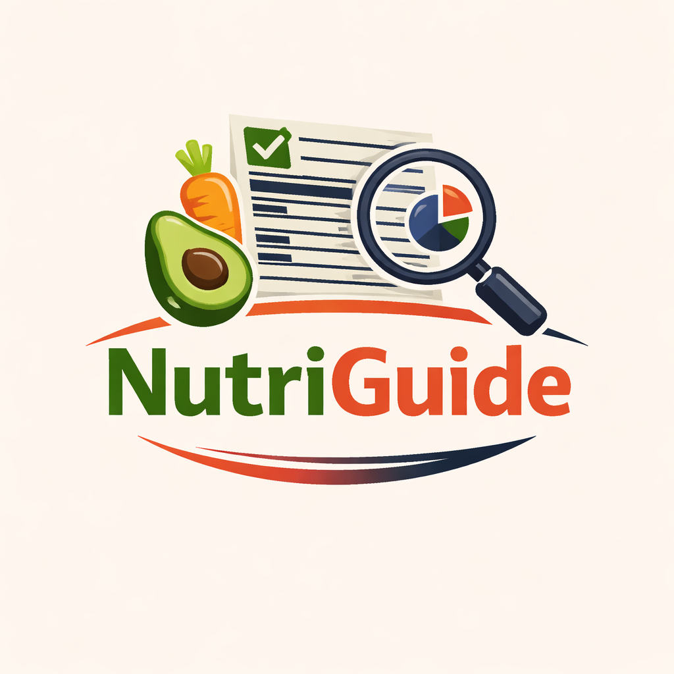

Style Guide

Color Palette
Primary | Secondary | Accent 1 | Accent 2
#4CAF50 | #F9F6EE | #FF7043 | #2C3E50

Typography

Heading Font: Montserrat

Paragraph Font: Open Sans

Navigation
Home · Nutrition Labels · Meal Guide

Content

teaches users how to read a nutrition label and how to make good meal choices. It includes a hero section with a headline and intro text, a step-by-step guide to understanding the nutrition label (serving size, calories, % daily value, nutrients to limit, and nutrients to get enough of), and a meal choices section showing how to build a balanced plate with fruits, vegetables, lean protein, and whole grains. The page also includes three smart swap examples comparing less healthy foods to better alternatives.

Wireframes

