research Paper Presentation (10%) Group Assignment (Groups of 2)

**The 10-minute presentation PowerPoint in Week 5** Attendance Compulsory

Submission of the **PowerPoint file** to Moodle by **Week 5 Monday 27 March 2023 by 4:30pm**

**Overview:**

1. **The group will then read, understand, critically analyse and summarise the key points of the paper and provide a brief description of the proposed solution/approach, results of their in-depth analysis as well as any open issues and directions for future work 然后，该小组将阅读、理解、批判性地分析和总结论文的要点，并简要描述所提出的解决方案/方法、深入分析的结果以及任何未解决的问题和未来工作的方向**

**The paper titled “Building a Crowdsensing Platform Based on Spatio-Temporal Fencing” proposes the concept of spatio-temporal fencing, which restricts the time and area of sensing, and constructs a crowdsensing platform based on this concept. The platform simplifies the definition of the request and makes it easy to use, because the request can be basically defined only by setting the spatio-temporal fencing and the sensor to be used. Spatio-temporal fencing can make it clear to collaborators when and where sensing will take place, and provide sense of security by reducing privacy barriers caused by concerns about data provision and sensing. The paper also describes the design, implementation, and verification of the operation of this platform.**

**This research paper proposes the concept of spatio-temporal fencing, which restricts the time and area of sensing, and constructs a crowdsensing platform based on this concept. The platform simplifies the definition of the request and makes it easy to use, because the request can be basically defined only by setting the spatio-temporal fencing and the sensor to be used. Spatio-temporal fencing can make it clear to collaborators when and where sensing will take place, and provide a sense of security by reducing privacy barriers caused by concerns about data provision and sensing. The paper also describes the details of the crowdsensing platform based on spatio-temporal fencing, Lavlus, and its implementation. The contribution of this paper is the proposal, design and implementation of a system that aims to stimulate research and surveys using crowdsensing as a type of crowdsourcing. The paper also discusses related research on crowdsensing platforms and the issues that arise when implementing crowdsensing.**

**这篇研究论文提出了时空围栏的概念，该概念限制了感知的时间和区域，并基于此概念构建了一个众包感知平台。该平台简化了请求的定义并易于使用，因为请求基本上只能通过设置时空围栏和要使用的传感器来定义。时空围栏可以使合作者清楚地知道何时何地进行感知，并通过减少有关数据提供和感知的隐私障碍来提供安全感。本文还描述了基于时空围栏的众包感知平台Lavlus及其实现的详细信息。本文的贡献是提出、设计和实现了一种旨在将众包感知作为一种众包类型来刺激研究和调查的系统。本文还讨论了有关众包感知平台的相关研究以及实施众包感知时出现的问题。**

**provide a brief description of the proposed solution/approach**

**This document is about a research paper titled “Building a Crowdsensing Platform Based on Spatio-Temporal Fencing”. The paper proposes the concept of spatio-temporal fencing, which restricts the time and area of sensing, and constructs a crowdsensing platform based on this concept. The paper focuses on convenience and sense of security to address the issue of improving and maintaining collaborator motivation. 这篇文献是一篇名为“基于时空围栏构建群智感知平台”的研究论文。该论文提出了时空围栏的概念，它限制了感知的时间和区域，并基于此概念构建了一个群智感知平台。本文重点关注便利性和安全感，以解决提高和维持合作者动机的问题**

**some possible directions are:**

**Evaluating the performance and usability of Lavlus with real-world crowdsensing scenarios and users 1.**

**Exploring different incentive mechanisms to motivate collaborators to participate in crowdsensing tasks 1.**

**Enhancing the security and privacy protection measures for sensing data and user information 1.**

**Extending spatio-temporal fencing to support more complex shapes and conditions for sensing areas and times 2.**

**通过真实世界的群智感知场景和用户评估 Lavlus 的性能和可用性。**

**探索不同的激励机制，以激励合作者参与群智感知任务。**

**加强对感知数据和用户信息的安全和隐私保护措施。**

**扩展时空围栏，支持更复杂的形状和条件，用于感知区域和时间。**

1. **he assessment will consider the quality of contents, extracting the key points, and the depth of the analysis as well as the quality of the presentation in terms of preparedness and clarity 评估将考虑内容质量、提取关键点、分析的深度以及准备和清晰度方面的演示质量**

**Slide**

1. The title slide (your first slide): your names and IDs, unit code, semester and year, and the selected paper’s title and its authors (Due to the time limit, you do NOT need to include an Outline)

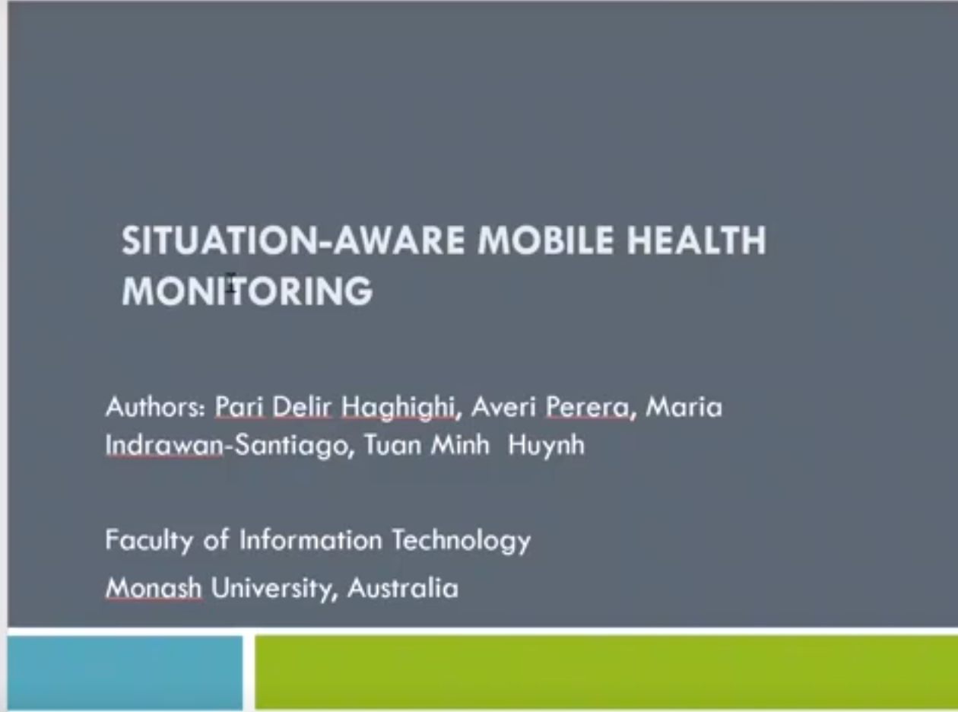

1. Introduction/Background: a very brief description of the research area and the problem/s that the paper aims to address. In addition to this paper, you need to CITE TWO other conference or journal papers in this slide and provide their details in References. Refer to this guide about referencing and citation: <https://www.monash.edu/it/current-students/resources-and-support/style-guide/referencing> Each group member is responsible for finding and citing one of these two papers 介绍/背景：对研究领域和论文旨在解决的问题的非常简短的描述。除了本文之外，您还需要在这张幻灯片中引用另外两篇会议或期刊论文，并在参考文献中提供它们的详细信息，两三句概括

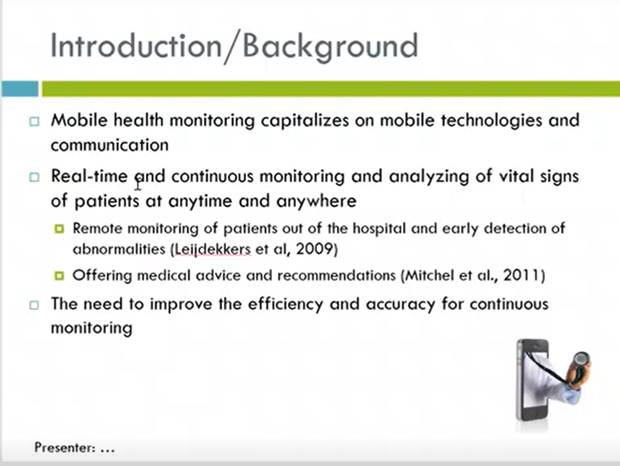

The main question in this document is how to improve and maintain the motivation of collaborators in crowdsensing by providing them with convenience and a sense of security.

The authors propose the concept of spatio-temporal fencing, which restricts the time and area of sensing, and construct a crowdsensing platform based on this concept.

This platform simplifies the definition of requests for requesters and makes it clear to collaborators when and where sensing will take place, reducing privacy barriers caused by concerns about data provision and sensing

主要问题是如何通过为合作者提供便利和安全感来提高和维持合作者在群智感知中的积极性。

作者提出了时空围栏的概念，它限制了感知的时间和区域，并基于此概念构建了一个群智感知平台。

该平台简化了请求者对请求的定义，并使合作者清楚感知将在何时何地进行，减少了由于担心数据提供和感知而引起的隐私障碍

The research area is **mobile and ubiquitous systems**, which are computing and networking systems that can be accessed anytime and anywhere by various devices. The document aims to address one main problem: 研究领域是移动和普遍系统，这些是可以通过各种设备随时随地访问的计算和网络系统

- How to build a **crowdsensing platform** based on **spatio-temporal fencing**, which is a method of restricting the time and area of sensing, and how to provide convenience and sense of security to the requesters and collaborators of crowdsensing. 如何基于时空围栏构建一个群智感知平台，这是一种限制感知时间和区域的方法，并如何为群智感知的请求者和合作者提供便利和安全感

This research paper is in the area of mobile and ubiquitous computing, specifically focusing on crowdsensing. The paper aims to address the problem of improving and maintaining collaborator motivation in crowdsensing tasks by proposing the concept of spatio-temporal fencing and constructing a crowdsensing platform based on this concept. The platform simplifies the definition of the request and makes it easy to use, while providing a sense of security to collaborators by reducing privacy barriers caused by concerns about data provision and sensing. 这篇研究论文属于移动和普适计算领域，专注于群智感知。本文旨在通过提出时空围栏的概念并基于此概念构建群智感知平台，解决提高和维持群智感知任务中合作者动机的问题。该平台简化了请求的定义，使其易于使用，同时通过减少由于担心数据提供和感知而引起的隐私障碍，为合作者提供安全感。

Jinwei Liu, Haiying Shen, Husnu S. Narman, Wingyan Chung, and Zongfang Lin. 2018. A Survey of Mobile Crowdsensing Techniques: A Critical Component for The Internet of Things. ACM Trans. Cyber-Phys. Syst. 2, 3, Article 18 (July 2018), 26 pages. <https://doi.org/10.1145/3185504>

Wang, Z., Hu, J., Lv, R., Wei, J., Wang, Q., Yang, D., & Qi, H. (2018). Personalized privacy-preserving task allocation for mobile crowdsensing. *IEEE Transactions on Mobile Computing*, *18*(6), 1330-1341.<https://ieeexplore.ieee.org/abstract/document/8423074>

1. Proposed Approach/Solution: a very brief description of the approach (it can be a framework/architecture/platform/approach/method) with avoiding discussing details and only mentioning the key components and key innovation.提议的方法/解决方案：对方法（可以是框架/架构/平台/方法/方法）的非常简短的描述，避免讨论细节，只提及关键组件和关键创新 问题解决，按步骤开始，综合解决方案，图也可以（可以引用其他人解决办法）

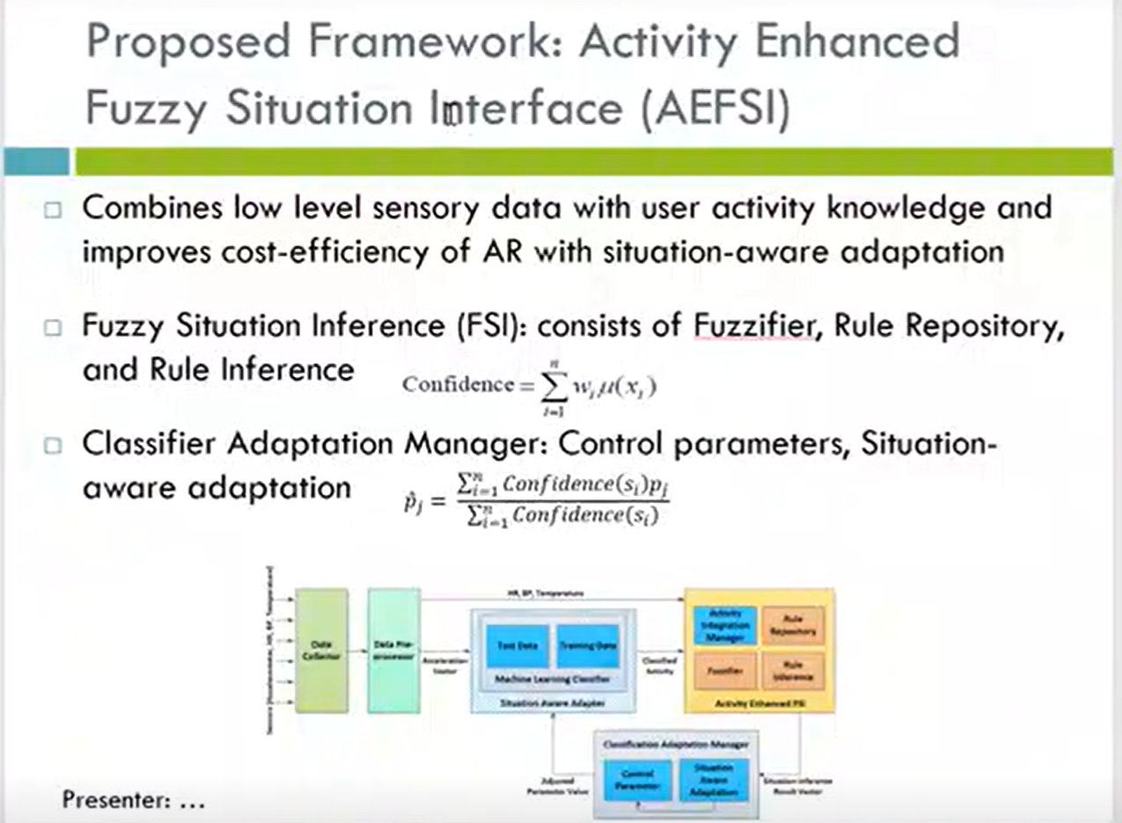

The approach is to design and implement a **crowdsensing platform** called **Lavlus**, which allows requesters to define crowdsensing tasks by setting up **spatio-temporal fencing** and choosing the sensors to be used. The platform also allows collaborators to participate in crowdsensing tasks by installing a common smartphone application that automatically performs sensing when they enter or exit the spatio-temporal fencing. The platform aims to provide convenience and sense of security to both requesters and collaborators by simplifying the task definition and reducing the privacy barriers. 该方法是设计和实现一个名为 Lavlus 的群智感知平台，允许请求者通过设置时空围栏并选择要使用的传感器来定义群智感知任务。该平台还允许合作者通过安装通用的智能手机应用程序来参与群智感知任务，当他们进入或退出时空围栏时，应用程序会自动执行感知。该平台旨在通过简化任务定义和减少隐私障碍，为请求者和合作者提供便利性和安全感。

The key components of Lavlus are:

- The **requester interface**, which allows requesters to define crowdsensing tasks by setting up spatio-temporal fencing and choosing the sensors to be used. The interface also provides feedback on the task progress and results.

- The **collaborator application**, which allows collaborators to participate in crowdsensing tasks by installing a common smartphone application that automatically performs sensing when they enter or exit the spatio-temporal fencing. The application also provides feedback on the task participation and rewards.

- The **platform server**, which manages the crowdsensing tasks and coordinates the communication between requesters and collaborators. The server also performs data processing and analysis on the collected sensor data.

Lavlus 的关键组件包括：

请求者界面，允许请求者通过设置时空围栏并选择要使用的传感器来定义群智感知任务。该界面还提供有关任务进度和结果的反馈。

合作者应用程序，允许合作者通过安装通用的智能手机应用程序来参与群智感知任务，当他们进入或退出时空围栏时，应用程序会自动执行感知。该应用程序还提供有关任务参与和奖励的反馈。

平台服务器，管理群智感知任务并协调请求者和合作者之间的通信。服务器还对收集到的传感器数据进行数据处理和分析

The key innovation of Lavlus is:

- The use of **spatio-temporal fencing** as a novel way of defining crowdsensing tasks that reduces the complexity and increases the flexibility for requesters and collaborators. Spatio-temporal fencing allows requesters to specify when and where sensing should be performed, and allows collaborators to sense only when they are in proximity to the task area. This reduces the privacy concerns and battery consumption for collaborators, and improves the quality and quantity of sensor data for requesters.

Lavlus 的关键创新是：

使用时空围栏作为一种新颖的定义群智感知任务的方式，减少了请求者和合作者的复杂性并增加了灵活性。时空围栏允许请求者指定何时何地进行感知，并允许合作者仅在靠近任务区域时进行感知。这减少了合作者的隐私担忧和电池消耗，并改善了请求者传感器数据的质量和数量

1. Evaluation: a very brief description of the evaluation method or the experiment, and the results without going into details 评估：对评估方法或实验的非常简短的描述，以及没有详细说明的结果 对比当前solution可不可以，评价标准，或者引用他人评价

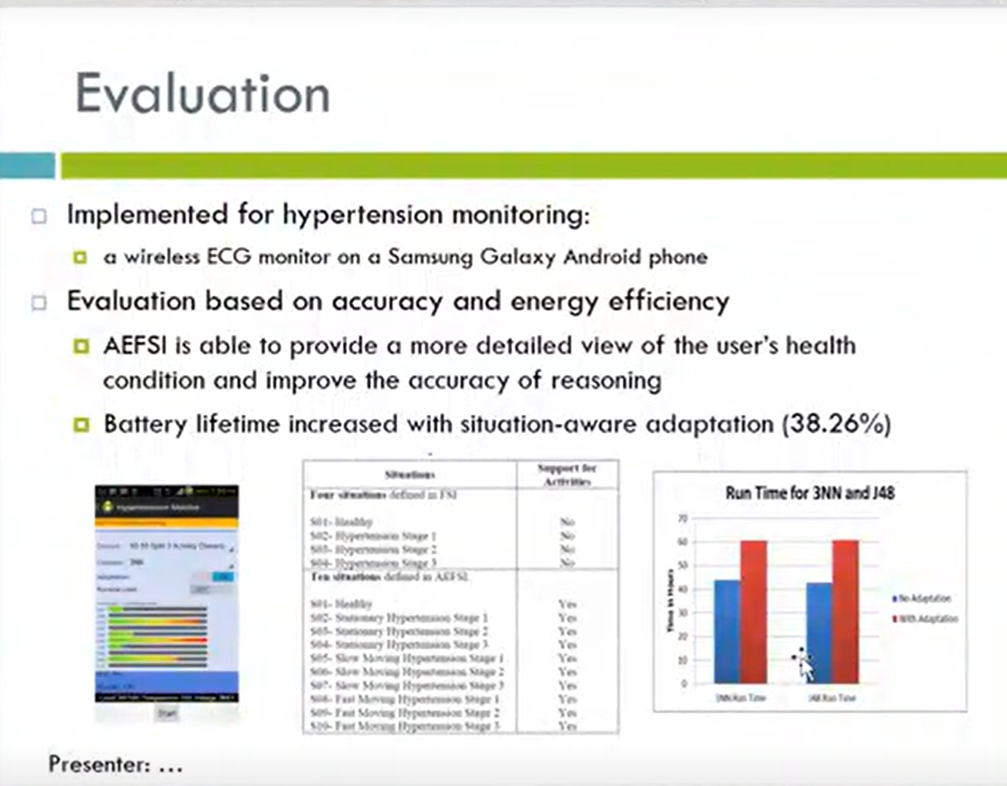

1. Analysis and Discussion (Conclusion): Your in-depth analysis results and judgement on the paper. You need to mention: i) the key contributions of this work, ii) the key limitations of this work, and iii) open issues (at least two) for further research Analysis and Discussion (Conclusion)：你对论文的深入分析结果和判断。您需要提及：i) 这项工作的主要贡献，ii) 这项工作的主要局限性，以及 iii) 有待进一步研究的未解决问题（至少两个）引用他人判断

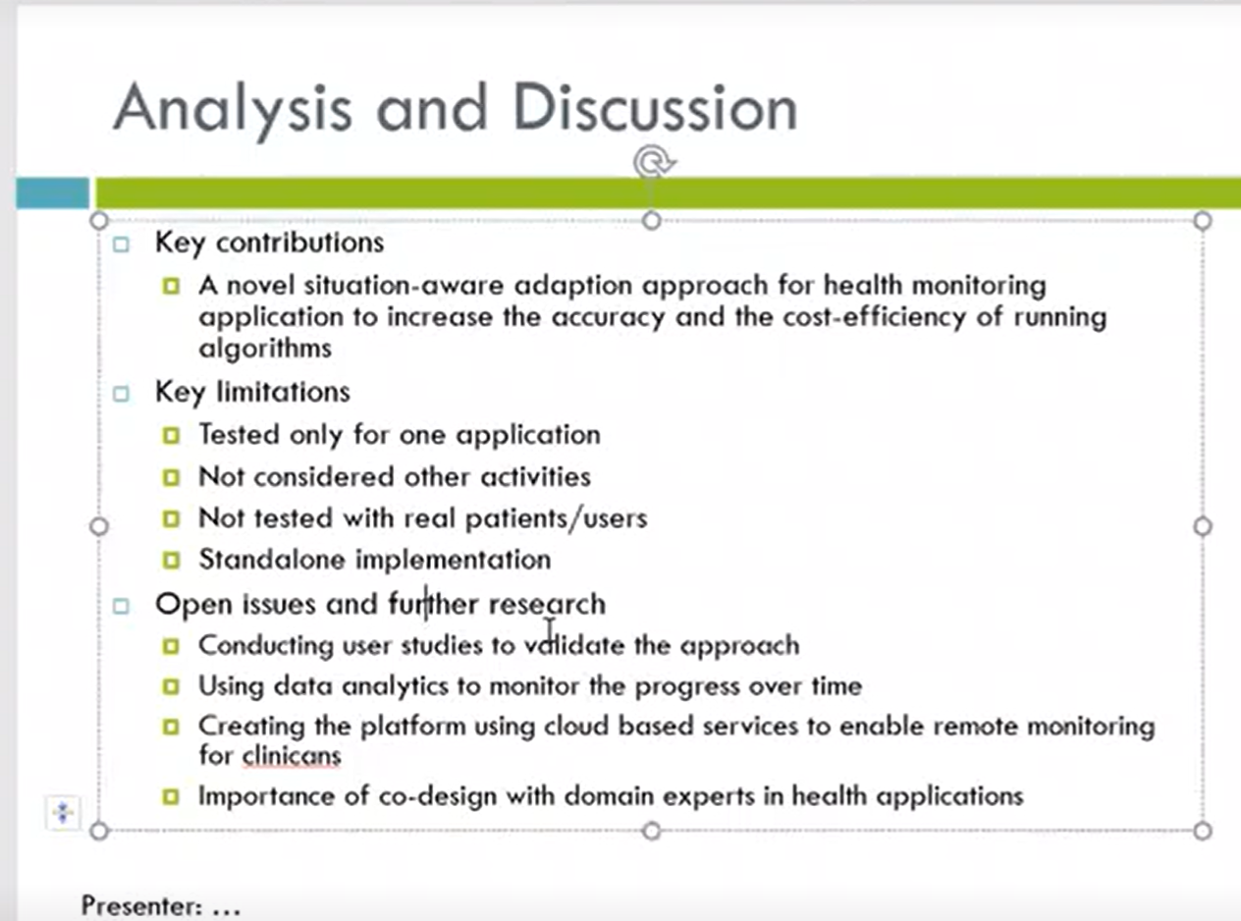

1. References: In the References slide, you will list the paper you presented, AND two other papers that you will reference in the Introduction/Background slide (Step 2). You need to use the APA style (refer to this guide about the APA style: <https://www.monash.edu/it/current-students/resources-and-support/style-guide/referencing>) Please add the group member name to each of these two papers in References 参考资料：在参考资料幻灯片中，您将列出您展示的论文，以及您将在简介/背景幻灯片（第 2 步）中引用的另外两篇论文。您需要使用APA风格（关于APA风格请参考本指南：[https://www.monash.edu/it/current-students/resources-and-support/style-guide/referencing）](https://www.monash.edu/it/current-students/resources-and-support/style-guide/referencing%EF%BC%89%E8%AF%B7%E6%B7%BB%E5%8A%A0%E7%BE%A4%E7%BB%84%E6%88%90%E5%91%98%E5%8F%82%E8%80%83%E6%96%87%E7%8C%AE%E4%B8%AD%E8%BF%99%E4%B8%A4%E7%AF%87%E8%AE%BA%E6%96%87%E7%9A%84%E5%90%8D%E5%AD%97)

请添加群组成员参考文献中这两篇论文的名字

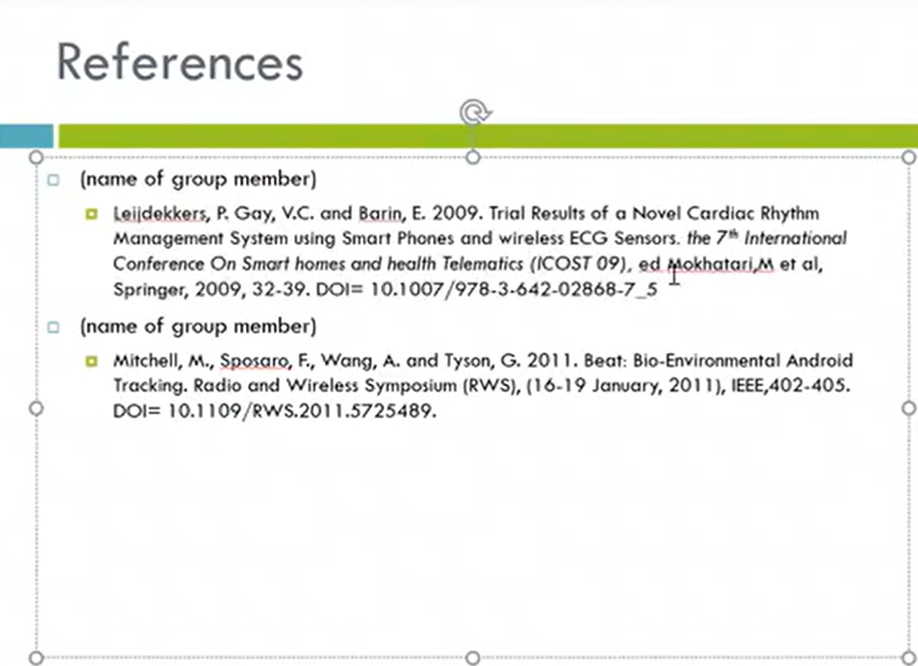

Presentation: week5

1. In the Week 5 lab, on-campus students will present their slides in the class and online students present the slides online using Zoom in 10 minutes (about 5 minutes allocated for each member). In each slide’s footnote, add the name of the presenter (the group member name). You tutor will ask one question from each group member at the end of the presentation. All students must attend the lab in Week 5 and listen to all the presentations to support their classmates. 在第 5 周的实验室中，校内学生将在课堂上展示他们的幻灯片，在线学生将在 10 分钟内使用 Zoom 在线展示幻灯片（每个成员分配约 5 分钟）。 在每张幻灯片的脚注中，添加演示者的姓名（小组成员姓名）。 在演示结束时，您的导师将向每个小组成员提出一个问题。 所有学生都必须在第 5 周参加实验室并听取所有演示以支持他们的同学。

Hello everyone, My name is SHIXIN huang and this is my partner Kailiu we are from Lab 03.

Our presentation topic today is Building a Crowdsensing Platform Based on Spatio-Temporal Fencing

Now let’s begin

The research area is **mobile and ubiquitous systems**, which are computing and networking systems that can be accessed anytime and anywhere by various devices.

And according to Liu’s paper in 2018. Mobile crowdsensing serves as a critical building block for emerging Internet of Things (IoT) applications

The main question in this paper- How to build a **crowdsensing platform** based on **spatio-temporal fencing**, which is a method of restricting the time and area of sensing, and how to provide convenience and sense of security to the requesters and collaborators of crowdsensing

From (Wang et al,2018) the location protection for task allocation in mobile crowdsensing has not been well explored

The approach is to design and implement a crowdsensing platform called Lavlus, which allows requesters to define crowdsensing tasks by setting up spatio-temporal fencing and choosing the sensors to be used. The platform also allows collaborators to participate in crowdsensing tasks by installing a common smartphone application that automatically performs sensing when they enter or exit the spatio-temporal fencing. The platform aims to provide convenience and sense of security to both requesters and collaborators by simplifying the task definition and reducing the privacy barriers.

该方法是设计和实现一个名为 Lavlus 的群智感知平台，允许请求者通过设置时空围栏并选择要使用的传感器来定义群智感知任务。该平台还允许合作者通过安装通用的智能手机应用程序来参与群智感知任务，当他们进入或退出时空围栏时，应用程序会自动执行感知。该平台旨在通过简化任务定义和减少隐私障碍，为请求者和合作者提供便利性和安全感。

The key components of Lavlus are:

- The requester interface, which allows requesters to define crowdsensing tasks by setting up spatio-temporal fencing and choosing the sensors to be used. The interface also provides feedback on the task progress and results.

- The collaborator application, which allows collaborators to participate in crowdsensing tasks by installing a common smartphone application that automatically performs sensing when they enter or exit the spatio-temporal fencing. The application also provides feedback on the task participation and rewards.

- The platform server, which manages the crowdsensing tasks and coordinates the communication between requesters and collaborators. The server also performs data processing and analysis on the collected sensor data.

Lavlus 的关键组件包括：

请求者界面，允许请求者通过设置时空围栏并选择要使用的传感器来定义群智感知任务。该界面还提供有关任务进度和结果的反馈。

合作者应用程序，允许合作者通过安装通用的智能手机应用程序来参与群智感知任务，当他们进入或退出时空围栏时，应用程序会自动执行感知。该应用程序还提供有关任务参与和奖励的反馈。

平台服务器，管理群智感知任务并协调请求者和合作者之间的通信。服务器还对收集到的传感器数据进行数据处理和分析

The key innovation of Lavlus is:

- The use of spatio-temporal fencing as a novel way of defining crowdsensing tasks that reduces the complexity and increases the flexibility for requesters and collaborators. Spatio-temporal fencing allows requesters to specify when and where sensing should be performed, and allows collaborators to sense only when they are in proximity to the task area. This reduces the privacy concerns and battery consumption for collaborators, and improves the quality and quantity of sensor data for requesters.

Lavlus 的关键创新是：

使用时空围栏作为一种新颖的定义群智感知任务的方式，减少了请求者和合作者的复杂性并增加了灵活性。时空围栏允许请求者指定何时何地进行感知，并允许合作者仅在靠近任务区域时进行感知。这减少了合作者的隐私担忧和电池消耗，并改善了请求者传感器数据的质量和数量