**★★☆☆☆**

**題組：基礎48題**

**題號：Q12406 - Help Dexter**

**整理者：陳紫淇**

**學號：ADT105142**

**使用語言:C++**

**解題日期：2018年8月28日**



**題目:**

You know Dexter, right? He is a very talented young scientist. He has a huge lab hidden inside his building. He made all possible security arrangement to keep his naughty sister Dee Dee away from his lab. But she always finds a way into the lab. One day Dee Dee came to the lab and started her usual work, messing up Dexter’s lab! Dexter was working on a very important project, so he begged to her and said, “Please!!! Not today. I will do anything for you, but please leave this lab today!!!” Dee Dee was waiting for this chance, she said, “Ok, you do my homework I won’t disturb you today.” What can Dexter do? He agreed. Dee Dee said, “My teacher told me to write down 17 numbers. First one single digit number, second one two digit number, ..., n-th one n digit number. They will consist of only digit 1 and 2 and the n-th number should be divisible by 2n.” Dexter thought, “I have very little time to finish the project. I can’t waste my time for this silly problem, I have bigger problem to think!” So, he sent the modified version of this problem to you. Hurry up, Dee Dee is waiting.

**Input**

Input starts with an integer T (≤ 300), denoting the number of test cases. Each case starts with two integers: p q (1 ≤ p, q ≤ 17).

**Output**

For each case, print the case number first. Then you have to find two integers (smallest and largest) which have p digits and is divisible by 2q . The integers should contain only 1’s and 2’s. If no result is found, print ‘impossible’. If there is only one integer, then print that integer. Otherwise print both integers (first the smallest one then the largest one) separated by a single space.

**Sample Input**

3

2 2

2 1

2 3

**Sample Output**

Case 1: 12

Case 2: 12 22

Case 3: impossible

**問題描述：**

你認識 Dexter 的，不是嗎？他是一個非常有天分的年輕科學家。他家有一個隱藏的大型實驗室。他用盡了可能的保全措施來防止他那淘氣的姊姊 Dee Dee 進入他的實驗室。但她總是可以溜進去。有一天 Dee Dee 來到了實驗室並一如往常開始在實驗室搗亂！Dexter 正在進行一項重要的研究計劃，於是他乞求她說：「今天別鬧了，只要妳離開，我什麼都答應妳!!!」，Dee Dee 見機不可失，她說：「老師要我寫下 17 個數字。第一個一位數，第二個兩位數， ...，第 **n** 個 **n** 位數。這些數字的每一位數只能是 1 或 2，而且第 **n** 位數必需要被 **2n** 整除。」Dexter 心想：「我的研究計劃迫在眉睫，我不能再浪費時間在這可笑的問題上，我有更大的問題要去思考！」於是，他把這個調整過的問題交給你。動作快點，Dee Dee 在等著你呢！

**Input**

輸入的開始有一整數 **T (≤ 300)**，表示測資的筆數。

每筆測資含有兩個整數：**p q ( 1 ≤ p, q ≤ 17 )**。

**Output**

針對每筆測資，先印出測資編號。然後你必須找到兩個 (最小的與最大的) **p** 位數且可被 **2q** 整除的整數。這些整數只能包含 1 和 2。如果找不到，請印「**impossible**」。如果只有一個符合條件的整數，只要印出那整數即可，否則兩個都要印出 (先最小的，再最大的)，以一個空白隔開。

**Sample Input**

3

2 2

2 1

2 3

**Sample Output**

Case 1: 12

Case 2: 12 22

Case 3: impossible

**解法:**

**找出所有的可能並一一檢查**

建立一棵樹來找出所有可能，如下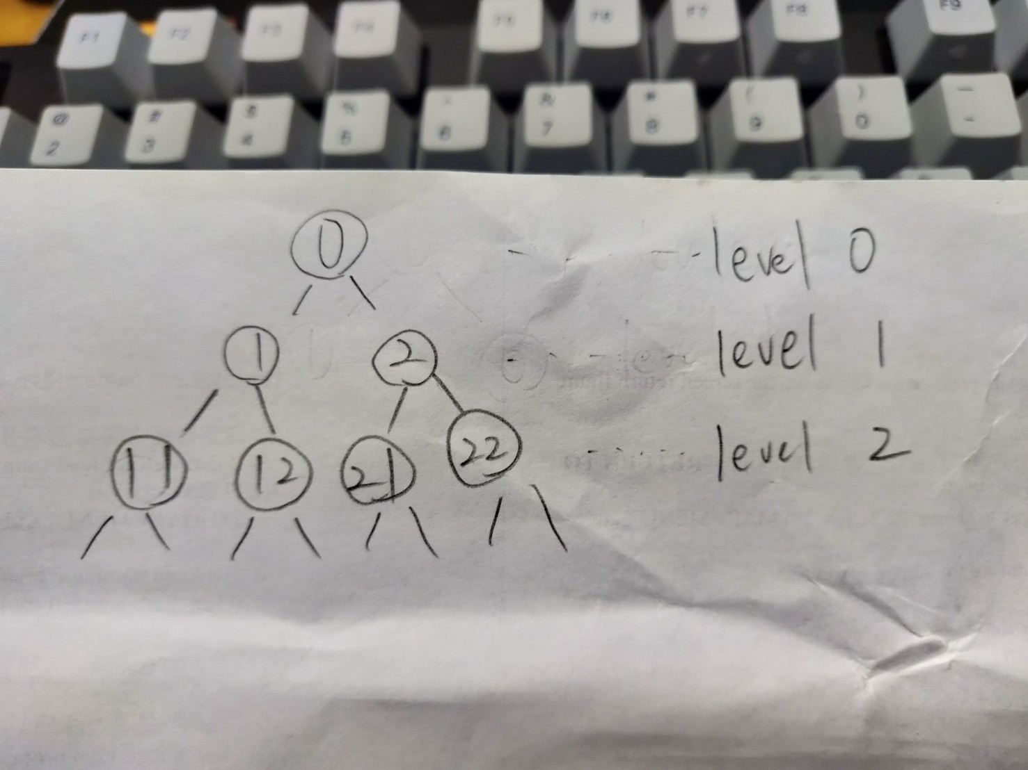

**解法範例：**

1. 令target為**2q**，max與min用來記錄目前找到最大與最小的數
2. 建立一函式(dfs)，傳入level與num

首先判斷level是否等於題目給的p位數

若是，則判斷num是否能整除目標(**2q**)，能整除則與max,min比較並更新max,min

若level不等於p，則呼叫自己，將level+1，num增加一個位數(1或2)

3.主函數中設定完target之後，呼叫dfs(0,0) 即可完成整個搜尋程序

**討論：**

1. 最高可能到17位數，要使用long long int
2. 一開始max設定為0，min設定為10的17次方(上限)，

C++寫法為1e17

|  |
| --- |
| #include <stdio.h>  #include <math.h>  void dfs(int,long long int);  int T,p,q;  long long int max,min,target;  int main()  {  scanf("%d", &T); //測資的筆數  int cases=0;  while(T--)  {  cases=cases+1;  scanf("%d%d", &p, &q);  max=0;  min=1e17; //10的17次方  target=pow(2, q); //2的q次方  dfs(0,0);    printf("Case %d: ",cases);  if(max==0 && min==1e17) //表示沒有找到任何符合的數  printf("impossible");  else  {  if(min==max)  printf("%lld",min);  else  printf("%lld %lld",min,max);  }  printf("\n");  }  }  void dfs(int level,long long int num)  {  if(level==p)  {  if(num%target==0)  {  if(num>max)  max=num;  if(num<min)  min=num;  }  return;  }  dfs(level+1,num*10+1);  dfs(level+1,num*10+2);  } |