**Group report**

**-Name of the Game-**

**from**

**Florian Bertele**

**Lars Kalkuhl**

**Patrick Beinlich**

**Patrick Engesser**

**Philipp Grüger**

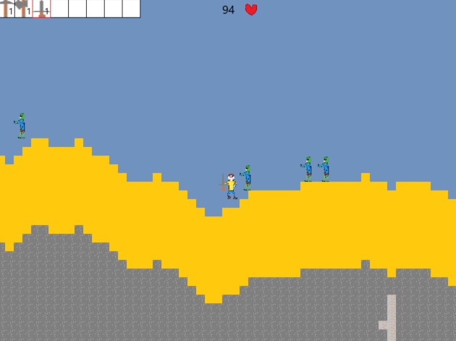

Informatik – Game programming

Professor: Prof. Dr. Thorsten Hasbargen

summer semester 2018

**Summary**

1. Organization
2. Game description – players point of view
3. User interface – how is the game played
4. Technical information
5. **Organization**

As a group, we decided to create an open world game. The basic ideas were as follows:

* the world consists of “blocks” (all kinds of material)
* the world switches between day and night
* zombies will spawn during the night
* the avatar can move, jump, fight zombies and die
* the avatar has access to tools that help mining ang fighting
* “blocks” can be mined and replaced
* “blocks” can be used to build objects

At the beginning of the project we decided to split the work, so that everyone can start right away working on his part. We used GitHub to keep everyone up to date and to communicate updates and changes as fast as possible. Besides that, we also had regular personal meetings in which we discussed the current state of the game and obstacles that we personally faced. To figure out how we could split the work, we first drew a class diagram:

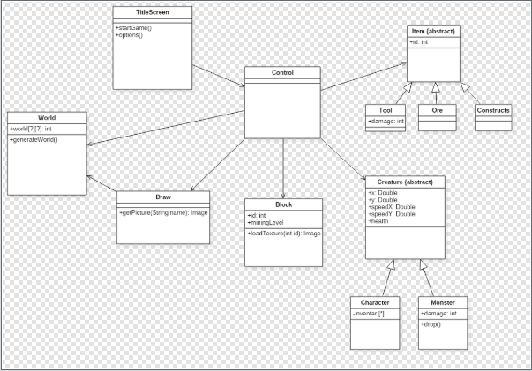

We decided to use the JavaFX framework for the graphical part.

After the first meeting we split the work as follows:

Florian Bertele movement and zombies

Lars Kalkuhl graphics and saving

Patrick Beinlich world generation

Patrick Engesser items and blocks

Philipp Grüger option-menu and sounds

1. **Game description – players point of view**

**Start of the game**

When started, the game shows a title screen in which the player can select to start a new game, as well as loading an old one (if existing). There is also the option to change the settings such as visuals (size of the screen), sound (on and off) and controls (!?). If the player decides to start a new game, he must pick a name for the generated world. After that he can use the already generated string for the seed placement, or he can choose an own one. After the player hits the start button, a short loading screen will appear, and the world is generated. The avatar will now be placed randomly into the world.

**The world**

The world consists of different kind of blocks with different characteristics.

The world switches between day and night after a specific time. During the night a specific number of zombie’s spawns randomly at different locations. These zombie´s will run towards the avatar and try to catch him.

The avatar has an inventory which can hold up to 32 different items. These items stack individually. The first 8 items are always shown on the screen and can be used with specific keys, to see the complete inventory the player must press a button. The player can switch these items within the inventory to place them into the always visible slots.

**Sounds**

There are different sounds for all actions that can occur. We also have a sound running during the title screen (start of the game).

**Physical engine**

The game has an inbuild gravity. The avatar and the non-player-characters will fall through air and water blocks (at the same speed -> no swimming). They also both have a hitbox and a specified amount of health points (the avatar has 100 and the zombies 1). The blocks don’t fall under this, they can be placed everywhere, if there was an air block before. The placement can also only take place within a specific radius outgoing from the position of the avatar.

1. **User interface – how is the game played**

The player can move completely free through the world. There is no “specific” goal. The main objective for the player is to be creative and survive during the night phases of the game.

**Controls**

* “a” -> move left - “esc” -> open menu
* “d” -> move right - “1” to “8” -> use inventory items
* “space bar” -> jump - left mouse on blocks -> mine
* “e” -> open inventory - left mouse with a weapon -> attack

**Actions**

* If the player wants to mine a block, he must equip the right tool (with the right mining level) and press with the left mouse on the block multiple times.
* If the player wants to place a block, he must switch the block to a useable inventory slot and press the corresponding key (“1” to “8”). Now equipped with the block, he must find free space (air blocks) and with the mouse to it. Then he must press the right mouse button.
* To attack, the player must equip a weapon, point the mouse into the right direction and press the left mouse button.
* If a zombie hits a player, he loses 1 health point
* If the player hits a zombie with a weapon, the zombie instantly dies
* When the player presses “esc”, a menu pops up. There he can save the game, continue the game, change settings and leave the game.

1. **Technical information**