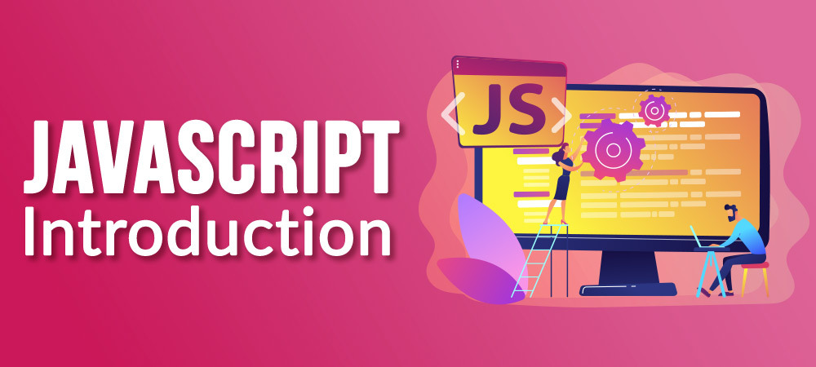

JavaScript is a lightweight, cross-platform, single-threaded, and interpreted compiled programming language which is also known as the scripting language for webpages. It is well-known for the development of web pages, and many non-browser environments also use it. JavaScript is a [weakly typed language](https://www.geeksforgeeks.org/type-systemsdynamic-typing-static-typing-duck-typing/)(dynamically typed). JavaScript can be used for [Client-side](https://www.geeksforgeeks.org/server-side-client-side-programming/) developments as well as [Server-side](https://www.geeksforgeeks.org/server-side-client-side-programming/) developments. JavaScript is both an imperative and declarative type of language. JavaScript contains a standard library of objects, like [Array](https://www.geeksforgeeks.org/arrays-in-javascript/), [Date](https://www.geeksforgeeks.org/javascript-date-objects/), and [Math](https://www.geeksforgeeks.org/javascript-math-object/), and a core set of language elements like [operators](https://www.geeksforgeeks.org/javascript-operators/), control structures, and [statements](https://www.geeksforgeeks.org/javascript-statements/).

1. Client-side: It supplies objects to control a browser and its [Document Object Model (DOM).](https://www.geeksforgeeks.org/dom-document-object-model/) Like if client-side extensions allow an application to place elements on an HTML form and respond to user events such as mouse clicks, form input, and page navigation. Useful libraries for the client side are [AngularJS](https://www.geeksforgeeks.org/introduction-to-angularjs/), [ReactJS](https://www.geeksforgeeks.org/react-js-introduction-working/), [VueJS,](https://www.geeksforgeeks.org/vue-js/) and so many others.
2. Server-side: It supplies objects relevant to running JavaScript on a server. For if the server-side extensions allow an application to communicate with a database, and provide continuity of information from one invocation to another of the application, or perform file manipulations on a server. The useful framework which is the most famous these days is [node.js](https://www.geeksforgeeks.org/introduction-to-nodejs/).
3. Imperative language – In this type of language we are mostly concerned about how it is to be done. It simply controls the flow of computation. The procedural programming approach, object, oriented approach comes under this as async await we are thinking about what is to be done further after the async call.
4. Declarative programming – In this type of language we are concerned about how it is to be done, basically here logical computation requires. Her main goal is to describe the desired result without direct dictation on how to get it as the arrow function does.

JavaScript can be added to your HTML file in [two ways](https://www.geeksforgeeks.org/where-to-put-javascript-in-an-html-document/):

1. Internal JS: We can add JavaScript directly to our HTML file by writing the code inside the <script> tag. The <script> tag can either be placed inside the <head> or the <body> tag according to the requirement.
2. [External JS](https://www.geeksforgeeks.org/what-is-external-javascript/): We can write JavaScript code in another files having an extension.js and then link this file inside the <head> tag of the HTML file in which we want to add this code.

**History of JavaScript**

It was created in 1995 by Brendan Eich while he was an engineer at Netscape. It was originally going to be named LiveScript but was renamed. Unlike most programming languages, JavaScript language has no concept of input or output. It is designed to run as a scripting language in a host environment, and it is up to the host environment to provide mechanisms for communicating with the outside world. The most common host environment is the browser.

**Features of JavaScript**

According to a recent survey conducted by Stack Overflow, JavaScript is the most popular language on earth.   
With advances in browser technology and JavaScript having moved into the server with Node.js and other frameworks, JavaScript is capable of so much more.

**Here are a few things that we can do with JavaScript**

1. JavaScript was created in the first place for DOM manipulation. Earlier websites were mostly static, after JS was created dynamic Web sites were made.
2. Functions in JS are objects. They may have properties and methods just like other objects. They can be passed as arguments in other functions.
3. Can handle date and time.
4. Performs Form Validation although the forms are created using HTML.
5. No compiler is needed.